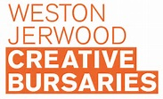

5 tips for socio-economic diversity in workforces in the arts
Fair access to working in the arts is one of the most urgent issues facing the sector today, with those from lower socio-economic backgrounds still vastly underrepresented amongst the artists and employees of UK theatres, festivals, galleries and arts organisations of all kinds.
The ‘working class’ make up 35% of the working population but as this graphic shows, the proportion nosedives when it comes to employment in the arts:
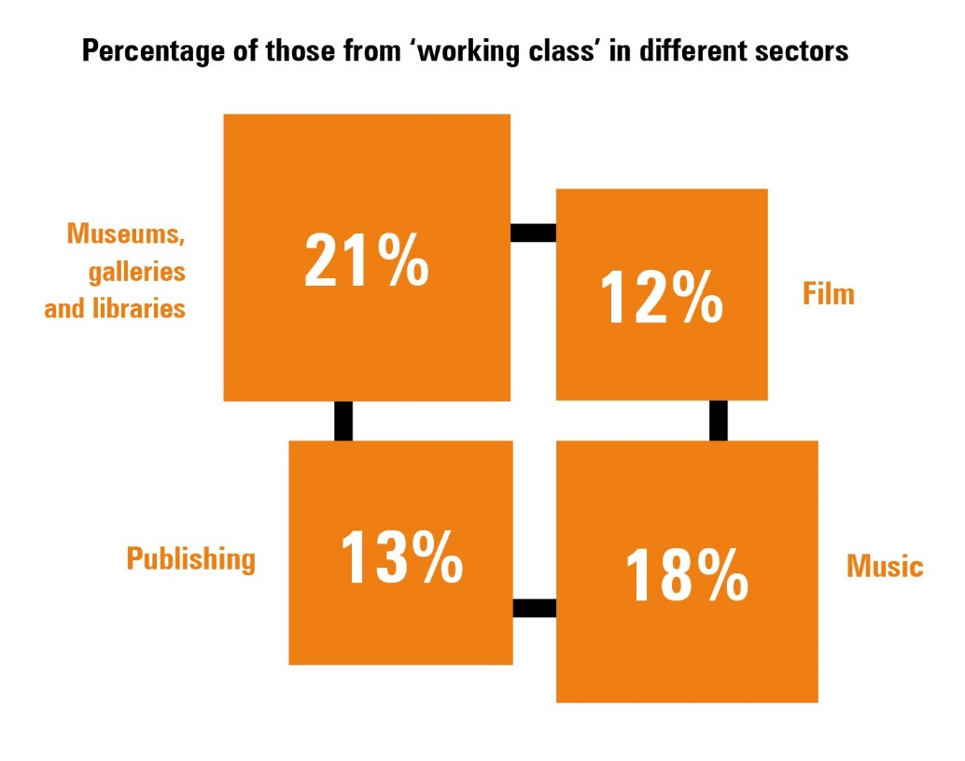
Jerwood Arts has worked with the Bridge Group to create Socio-Economic Diversity and Inclusion in the Arts: A Toolkit for Employers which builds on the foundation’s experience over almost a decade of running the Weston Jerwood Creative Bursaries to help more young people from low income backgrounds get into arts jobs.
Here’s our top 5 tips for employers:
- Measure socio-economic background and publish what you find.

Step one is to understand the most robust way to measure the socio-economic background of your staff, freelancers and artists. Questions of class are never far from headlines in the arts, but there is limited independent guidance on how to monitor socio-economic background and devise staff surveys.

The Bridge Group, however, have undertaken extensive research, in partnership with the Cabinet Office, on how to do this and maintain high ethical standards. Based on this research, we advise that organisations should include the following questions in their equal opportunities monitoring forms for applicants and their existing workforce (employed and freelance, artists and administrators):

- Type of school attended at age 11-16
- Free School Meal (FSM) eligibility
- Parental experience of higher education
- Parental occupation when you were aged 14

- Create spaces for conversations about taste, talent and merit.
Language matters, especially since many terms in common use around issues of diversity can be loaded with value judgements.
Bridge Group research on definitions of talent chimes with our own experience of working on the Weston Jerwood Creative Bursaries programme with Hosts and Fellows.
There is ambiguity about how we define and identify concepts like ‘talent’ and ‘merit’ – not to mention how we talk about ‘diversity’ – and this lies at the heart of many of the challenges relating to improving socio-economic diversity and inclusion.
For example, when we talk about needing to be ‘passionate’ to work in the arts, how do we evidence that ‘passion’? Is it synonymous with having enjoyed Shakespeare plays since an early age, or having spent the long summer holidays taking a prestigious, but unpaid, internship overseas? Or, is it the ability to contribute new ideas to creative processes, or engage fully in how art can reflect and affect people and society?

- Create a more inclusive organisational culture

Having conversations about ‘taste’, ‘talent’ and ‘merit’ should help you understand the lived experiences of those from lower socio-economic backgrounds. It should support the majority group in realising how they can be part of creating a more inclusive culture in your organisation.

Often in life, and especially at work, people naturally want to do what feels most comfortable and familiar; this inclination has a clear impact on advancing diversity and inclusion. Engaging with the unfamiliar and choosing to do what will lead to the most impactful and innovative outcome, rather than what feels most comfortable, will be key to making long term, positive change.

Informal sponsorship, whereby senior people informally support and advocate for the next generation, can often mean that those from majority groups get ahead because senior people are naturally inclined to offer support to people most like them. Focus on ending this kind of unofficial patronage: it is an example of ‘affinity bias’ that plays a huge role in the arts where individuals’ tastes can lead to the exclusion of those with from different backgrounds who may have different perspectives. Raise awareness and create a curious, caring culture where informal connections between those in positions of power to recruit, programme and select staff and artists can be questioned to ensure decisions are based on potential and not background.

- Cease unpaid or unadvertised internships, jobs and opportunities

Any form of unpaid or very low paid work favours those who can rely on other financial means. And as those who undertake unpaid opportunities have a much higher chance of being hired and offered paid opportunities off the back of it, you are narrowing entry routes from the outset for those who have outside financial support. An associated and similarly unhelpful practice is unadvertised internships, jobs and opportunities which are available only to those within your existing networks.

Creative & Cultural Skills and Arts Council England have produced arts sector specific guidance on what distinguishes a volunteer opportunity from a role that should, by law, be paid; and best practice regarding the differences between internships, apprenticeships and volunteering.7 Use this to inform how you design and offer all your early-career opportunities. Think how everyone you let in through the back door will disadvantage someone without those connections. Even small actions have big consequences.

- Create more inclusive recruitment processes

You will, no doubt, have a statement on your job application template saying you encourage applications from all; yet, not receive high quality applications from ‘all’.

Our work has shown that first impressions count and taking the time to thoroughly review your recruitment process end to end – from the creation of the job description and candidate specification to how you will conduct the interview and selection process – can have a significant effect upon the candidates and artists you attract.

Investing in developing an inclusive recruitment process that nurtures all is the single most powerful change you can make to the long-term equality and diversity of the sector.Things to think about when working to create a more inclusive recruitment process range from hidden barriers to biases, to including a letter from your CEO or Artistic Director celebrating the value of a diverse workforce.

Case studies

1: Battersea Arts Centre, London, Charlotte Turton, Head of People & Development

My main piece of advice when you are thinking about changing your recruitment practices is to make hard and fast rules, in line with the values of your organisation, and stick to them! In 2014 BAC made a solid commitment to pay all employees London Living Wage salaries and to provide regular entry-level opportunities across our traineeships, apprentices and junior level roles.

We don’t offer unpaid opportunities (apart from 1 – 2 weeks’ work experience for those at school) and we see ourselves as a learning organisation, supporting our staff to develop and grow in and beyond the organisation, which in turn creates new opportunities for those just starting out. We are now developing an in-house survey measuring the socio-economic background of our staff. We are using the Civil Service case study’s list of 5 questions which have been thoroughly researched and tested so finally there is a set of measures we can adopt and test out.

We are also following their guidance in providing the rationale behind these questions and not compressing the data. We are looking to collect this data on an annual basis so we can see how we compare to the national averages. We see this very much as part of the journey we have been on since we shifted our approach in 2014. We are always tweaking our language and making incremental changes.

We would advise others to start somewhere that feels possible and build (and learn!) from there. There are resources available that weren’t available 5 years ago. Start using these early on in your journey so you can capture your baseline and track progress, but most of all, keep the discussion open, welcoming and ongoing. When we were recruiting for our new Artistic Director/CEO at the end of 2018, we wanted it to be really open and encourage lots of people to apply. Here’s an example of a video we tweeted during the recruitment campaign, which we aim to do more of in the future: “Only 2 and a half weeks left until applications close to become our new Artistic Director and C.E.O. – here’s Fiona and Henri from our Young Peoples’ projects telling you to apply!”

2. Cambridge Junction Daniel Brine, ex-Director of Cambridge Junction, now Director of Norfolk & Norwich Festival

At Cambridge Junction, what we learnt in recruitment alongside WJCB we also applied to our casual staff recruitment. One thing we did, which I got good feedback on and still do, is to always write a welcome letter from me. In it I emphasise that we want to hear from candidates who may have different backgrounds and believe they have transferable skills relevant to the post. We also did posters in local community venues. The thing with the most impact was the introduction of the Living Wage. Because of WJCB we reviewed all our salaries and as a result, raised the salaries of our lowest paid permanent staff so that they were paid living wage or better.

We weren’t able to apply Living Wage to all casual staff but we created a statement saying that we were striving to make the change in the future (to implement it immediately would have cost us around £40k pa). Coming to Norfolk and Norwich Festival, one of the first things I did was to raise salaries to Living Wage or higher. This was quite a jump for some junior staff and I could only afford it through an organisational restructure. I also introduced a new trainee programme, which we’re piloting now.

The traineeships run for 18 months and are designed to ‘overlap’ so that current trainees have six months to ‘train’ and ‘handover’ to the new trainee. The ‘rotation’ works really well as each trainee gets to work on two festivals. We have two strands – one in production & programme and one in communication & development.

For more details and case studies see SOCIO-ECONOMIC DIVERSITY AND INCLUSION IN THE ARTS: A TOOLKIT FOR EMPLOYERS (https://jerwoodarts.org/wp-content/uploads/2019/07/Toolkit_Digital.pdf)

