


Clore Leadership-AHRC Online Research Library Paper
Bridging Schools and Community Music Teachers: Case Studies of Blended Practices in and out of schools

Author: Selana Kong
Supervisor/s: Graham Welch,
Music Department, Institute of Education, University College London
Year paper completed: 2015
Leadership Content Theme/s: Inclusive Leadership Practice, Coaching and Mentoring
AHRC Subject Area/s: Policy Arts Management and Creative Industries, Music and Society
A note on contents:
Since 2005 Clore Leadership and AHRC have partnered to offer a diverse range of cultural leaders the opportunity to produce a piece of extended research relating to leadership and to their specific cultural discipline. These papers, published from 2023 onward on the Clore Leadership-AHRC online research library, reflect an important contribution to the field and we are extremely pleased to make them available to practitioners, scholars, and other interested parties. We recognise that this research library contains a range of terminologies and outlooks: these are reflective of the significant and ongoing changes within the cultural sector over the past 20 years. As such we urge readers to recognise that the authors’ thinking and language may have shifted since completion of these papers, or may be in the process of shifting as consequence of their enquiries.

Craft practice: Blending personal experience and received knowledge

An AHRC presentation by Selana Kong

“You have to allow yourself to be that person that is a musician again
rather than just somebody who enjoys music.”

(Community choir director)

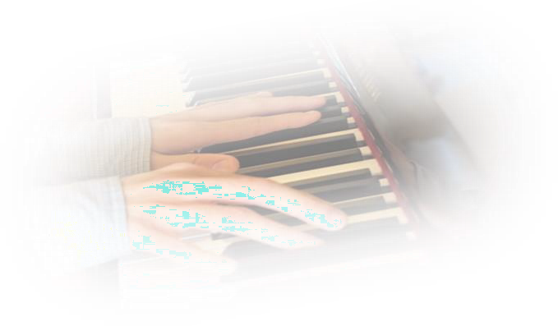
Selana Kong, Hong Kong Scholar on the Clore Leadership programme, conducted an AHRC-funded research, with Professor Graham Welch of the Institute of Education, University of London. Between September 2015 to February 2016, she interviewed eleven UK musicians who reflected on how they became a musician and developed their music career.

Many ways to become a musician
There are no clear entry routes to developing a professional career in music. Some musicians follow a traditional path by receiving knowledge from formal lessons and music degrees, a second group learned music informally through personal experiences. What unify them is a deep love for music and a self-concept as a musician.

Two theories for understanding intelligences

The entity theory treats intelligences as fixed. People who see intelligences in this way see themselves and other as either ‘musical’ or ‘unmusical’. They would not make an extra effort to overcome challenges in learning or teaching music. The incremental theory treats intelligences as changeable. People who has an incremental view of intelligences see themselves as learners and they empower others to learn. This incremental belief is supported by this AHRC research.

Despite of being called a “crow” by his primary school music teacher, one of the musicians in this research became a performing and recording musician through a “DIY” philosophy. For many years, he has been a part of the ISME Community Music Commission who believes that “everybody has the right and the ability to make, create, and enjoy their own music”.

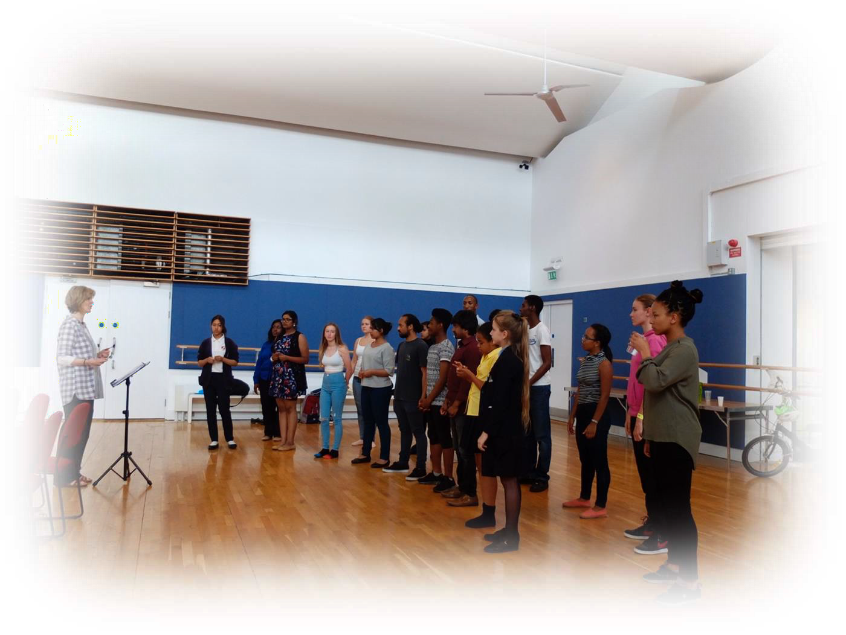
Jane Wheeler, Founder and Director of Living Song in East London, challenges limiting assumptions about what young people can achieve.

The environment
Musicians learn music from accumulated experiences within their homes, schools and communities.

Resilience
Musicians who develop a strong musical self- concept believe that musicality is not an option but a part of human design. They reframe challenges and make positive musical experiences happen. They believe that complex musical goals, rather than a favourable environment, make them happy and strong.

Parental support
Home musical environment was mostly positive for all musicians except for one. Her parent stopped her from studying music in the university because it was not socially acceptable for women to become musicians in the 1970s.

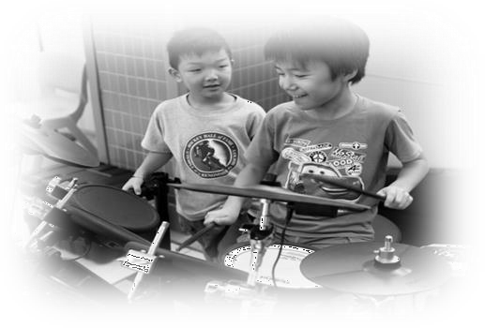
Six musicians highlighted that parental support was a key factor in their musical development. Some parents took their children to musical events and discussed matters related to music with them. Seven musicians had private music lesson and two musicians were taught to play the piano by their parents.

Musical culture in schools
School musical cultures were mostly negative: only one musician experienced very lively music cultures in his primary and secondary schools. There were many orchestras and choirs and he had a lot of opportunities to learn from older students. He particularly enjoyed the school music tours to Europe.
Three musicians had extremely bad musical experiences in school music education. One female musician had a drum teacher who said that “girls should not be playing drums”. Another female musician was bullied about playing musical instruments. One male musician was humiliated by his music teacher. Fortunately, they all found their way back to music later on in life.

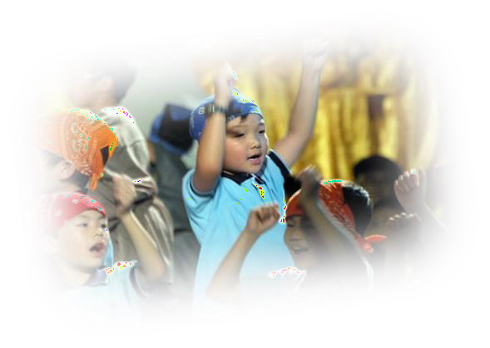
“I was humiliated for two years in front of my primary school classmates because I couldn’t pitch [melodies]… I was called a ‘crow’. I didn’t like that … music education should not be something that puts people off from music.” (Community Musician)

Music qualifications
All musicians made conscious decisions to become a musician. Four musicians studied music in conservatoires, colleges or universities; four musicians were trained as music teachers with either a Postgraduate Certificate in Education (PGCE) or a Bachelor of Education (Hons) degree. They valued receiving knowledge and building professional relations with colleagues.

Reflection
Personal experiences can be gained by thinking systematically about how to apply received knowledge in new situations. What musicians must realize is that reflection can take different forms for different people at different times. Most musicians would
‘reflection-on-action’ but ‘reflection-in-action’ is more important for musicians who teach different groups of people.

“Practitioners should learn after the task, and also during it, adapting activities in the moment to suit the changing need of the group”
(Community musicians)

Musicians are encouraged to reflect with others in order to articulate complex personal experiences.

Institutional Culture

Institutions who are responsible in educating musicians need to provide more time for reflection and many opportunities for cross-genre collaborations. They should also legitimize students’ personal experiences and interests while providing further knowledge.
“It’s people that make an institution… I understand why we need to use technology [in distance learning] but you need to have that real physical
connection.”
(Music educator)

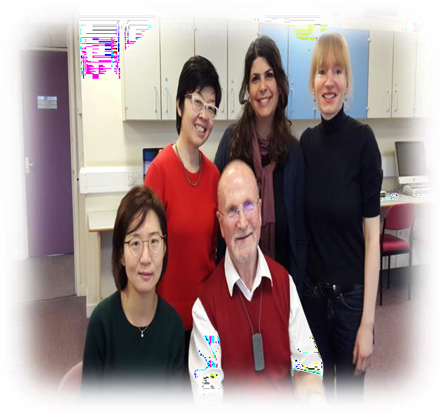
Professor Graham Welch with colleagues at the Institute of Education, University College of London.

Finding their own path
Five musicians pursued non-music degrees, including Community Drama, Business Studies, Theatrical Costume Design, Community Studies and Theatre Studies.
They learned music through personal experiences and they integrate other art forms into music.

Open to opportunities
Many cultural organizations, such as More Music in Morecambe, can make a big impact on people who are open to opportunities and challenges. They offer workshops and performance opportunities for all ages and all ability levels. They also provide leadership training for young people.

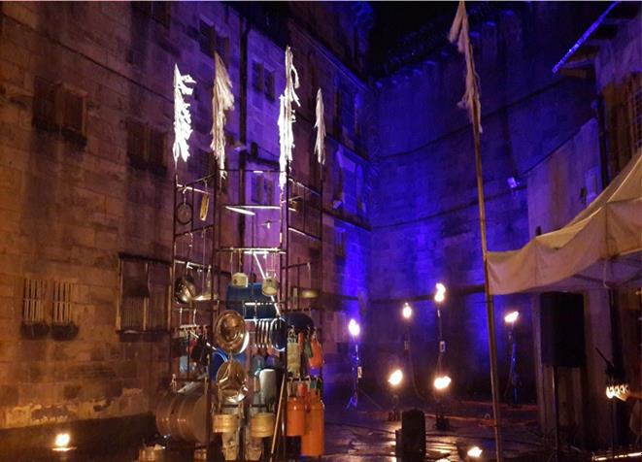
This performance in Light Up Lancaster 2015 was a collaboration between cross-genre musicians and community artists in More Music.


Music organizations such as More Music in Morecambe offer music training for people from all walks of life.
“I suppose in hindsight I was ‘open to it’. And music is always everywhere. I was probably open to [music] landing.”
(Music facilitator)

DIY (Do-it-yourself)
Four musicians taught themselves how to play and write music. Three musicians did not learned music until they were adults. Two musicians expressed difficulties in reading music and music technology enabled them to play and compose music without notation-based skills.

Music technology has enabled more people to play and compose music.

Portfolio career
Musicians reach transition points when family commitments change or when fear and uncertainties set in. Some musicians drop out of their music career while others persevere. They acquire new skills in a range of ways such as conducting, composing, playing new instruments, working in different genres or training in community music.
“I would be a workshop leader…I have been a performer … studio teacher… project manager… team- leader… consultant, I am a trainer, an evaluator…I get paid for all these things.
And each of them informs or feds the other ones. They all work together.”
(Community musician)
All musicians in this research has a portfolio career with performing, teaching and leading workshops and composing as core roles.
They view portfolio career as useful and necessary for all musicians.
“Professional musicians most likely have a portfolio career that can embrace up to four central musical roles of composer, performer, leader and teacher”
(Creating a Land with Music, Youth Music, 2002, p.3).

Stay in touch
The assumption that music qualifications, such as a music degree, are sufficient for a lifetime is not supported by this research. Musicians will encounter wider non- musical development challenges, for example around networking, memberships, advice, personal identity, income and employment management.
Musicians who stay in touch with each other get more support and employment opportunities.

Be patient
The process of become a musician can occur over a lengthy period of time and musician’s confidence and skills usually improve with age and experience.
“I couldn’t be doing what I am doing today if I hadn’t had that very slow learning process offered to me. I need the
time…the opportunity.”
(Composer)

Be confident
Musicians, especially those who play rock, folk or jazz music, need to be confident with their musical skills. Besides learning more skills, they also need to look after their personal well-being and manage their time. Remember:
“You have to allow yourself to be that person that is a musician again rather than just somebody who enjoys music.”

