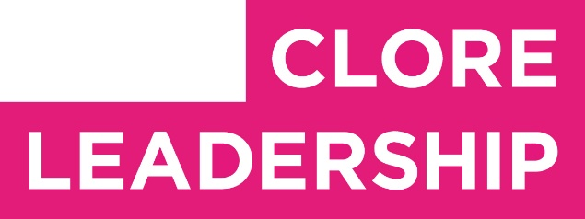
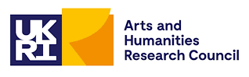

Clore Leadership-AHRC Online Research Library Paper
The role of cultural leadership in decolonising community wealth
Author: Cecilia Wee
Supervisor/s: Amit Rai,
Queen Mary University of London
Year paper completed: 2023
Leadership Content Theme/s: Inclusive Leadership Practice, Leadership Styles, Sector Insights
AHRC Subject Area/s: Policy Arts Management and Creative Industries, Community Art (including Art and Health)
A note on contents:
Since 2005 Clore Leadership and AHRC have partnered to offer a diverse range of cultural leaders the opportunity to produce a piece of extended research relating to leadership and to their specific cultural discipline. These papers, published from 2023 onward on the Clore Leadership-AHRC online research library, reflect an important contribution to the field and we are extremely pleased to make them available to practitioners, scholars, and other interested parties. We recognise that this research library contains a range of terminologies and outlooks: these are reflective of the significant and ongoing changes within the cultural sector over the past 20 years. As such we urge readers to recognise that the authors’ thinking and language may have shifted since completion of these papers, or may be in the process of shifting as consequence of their enquiries.
Unless otherwise stated, research papers included in the Clore Leadership-AHRC Online Research Library have not been formally peer reviewed or published in an academic journal.

Dr Cecilia Wee

The role of cultural leadership in decolonising community wealth
February 2023

Abstract
This paper reports on a practice-based participatory action research project exploring how cultural practices and cultural leadership can support more equitable circulation of wealth and resources within UK communities.
The project draws on the author’s ongoing research and creative interventions into radical philanthropic processes, community-centric approaches to fundraising and resource generation in the UK, with reference to international initiatives and traditions. Utilising arts- based methods to conduct participatory action research, the project is informed by decolonial practices of cultural production, community-based forms of cultural learning, community organising, radical philanthropy and liberatory understandings of economics as ‘making home’ (from the Greek ‘oikonomia’: oikos ‘house’ and nomos ‘managing’).
The report outlines the conception, development and delivery of Edition #1 of Our Community Inheritance, a creative action research project exploring more equitable resource circulation, initiated by the author and made with local communities. Edition #1 of Our Community Inheritance was developed in collaboration with NHS Grenfell Health and Wellbeing Service and Grenfell impacted communities over a period of 5 months from August-December 2022.

Acknowledgments
This research was made possible through a grant from the Arts and Humanities Research Council and Clore Leadership.
My thanks to everyone who has generously supported and contributed to this research, including: Dani Admiss, Angela Ainsworth, Gargi Bhattacharyya, Linda Bloomfield, Polly Brannan, Ruth Catlow, Clare Doran, Sue Duggins, Sue Flowers, Marc Garrett, Max Haiven, George Harding, Nurull Islam, Rukhsana Jahangir, Ursula Kelly, Jane Lawson, Jessica Mankena, Marie-Anne McQuay, Ravista Mehta, Reem Michael, Jade Montserrat, Polly Moseley, Sasha Nagra, Amanda Parker, Hannah Paterson, Stephanie Polsky, Eva Rowson, Lena Simic, Moyra Samuels, Nicola Triscott, the vacuum cleaner, Cassie Thornton, Toya Walker, Tomomi Yoshida. Special thanks to the NHS Grenfell Health and Wellbeing Service team, Service User Involvement Team and Grenfell impacted communities, and my research supervisor Amit Rai.

Introduction
My research starts from an activist perspective and that of praxis, in other words that we are able to, as Paulo Freire says, ‘reflect and act upon the world in order to transform it’.¹ Moreover, my inquiry takes the view that despite differences in opinion and approaches, the sometimes contained and constrained space of cultural production has a crucial place in creating a more just and equitable world. And that culture makes another world possible.
Indeed, cultural production - particularly when working with and celebrating the viewpoints of historically marginalised and underserved communities - is and can be a form of futuring, a form of transformative, prefigurative politics² that builds bridges towards worlds, environments and societies that we want to live in, as we go.

Focussing on historically marginalised and underserved communities, specifically, individuals who identify as part of Global Ethnic Majorities, d/Deaf, disabled and neurodivergent, LGBTQIA+, migrant and working-class communities is germane to my work. Moreover, my perspective comes from working as an equalities activist with artists, arts organisations and trade unions, and is further informed by my lived experience as a South East Asian, mental health disabled woman with 20 years’ experience as an independent curator, producer, researcher, educator, coach and artist working as an employee and freelancer with arts and cultural organisations across performance, music, visual arts and design practices.

This research project builds on my ongoing research and interventions into the long-term impacts of the financial crisis, radical philanthropic processes, community-centric approaches to fundraising and resource generation in the UK and internationally. It is also informed by my exploration of decolonising cultural production and alternative, community- based forms of cultural learning.
This research is timely given current funding challenges for the arts / culture and the community organising sectors, and the ongoing impacts of the cost of living crisis, particularly on marginalised and underrepresented communities (namely, people who identify as part of Global Ethnic Majorities, d/Deaf, disabled and neurodivergent, LGBTQIA+, migrant and/or working-class).
At the core of this project is lifting up and valuing the experiences, knowledge and skills of marginalised and underrepresented communities.³ Instead of framing these communities as being in deficit, or primarily as beneficiaries, my research aims to rethink resourcing and what communities want and need to thrive.

¹ Paulo Freire, Pedagogy of the Oppressed. New York: Penguin, 1972, p.52
² Carl Boggs, ‘Marxism, Prefigurative Communism, and the Problem of Workers’ Control.’ Radical America 11, 1977, p.100
³ This celebration of experiences of marginalised and underrepresented communities was a key framework for the report I authored, ‘Fostering Equity in the Visual Arts Sector – Fair and Equitable research report’, Contemporary Visual Arts Network England, 2022. https://cvan.art/fair-equitable- research-report/

Methodology
The methodology for this research project stems from my values as a practitioner and researcher, as part of, and in solidarity with historically underrepresented and marginalised communities who are at the centre of movements towards equity. My modes of working and action are therefore underpinned and informed by the work of the international Design Justice Network⁴, liberatory pedagogies as articulated by activists such as Paulo Freire and a seminal report ‘Why am I Always Being Researched?’⁵ on power relationships between communities, funders and researchers, by the impact investment philanthropists Chicago Beyond.

Understanding myself as a participant embedded within ongoing systems of extraction yet with some agency to contribute to social change motivates my aim to develop horizontal relationships of mutuality, reciprocity and commoning⁶ with those I work with. Hence, this project uses participatory action research as a multifaceted research methodology that acknowledges and embraces experimentation, creative methods, solidarity with lived experience, research-based action and reflection with (rather than ‘for’) communities. As Joanne Rappaport states, ‘participatory researchers constructed a methodology that would foster horizontal relationships, erasing distinctions between researchers and “the researched,” encouraging a dialogue between academic and people’s knowledge, and transforming research into a tool of consciousness-raising and political organising.’⁷ Participatory action research’s emphasis on participants, collaboration, democratic models and change making⁸ align well with the vision of this research project to explore the role of cultural leadership in enriching our communities and contributing to more equitable distributions of community wealth, through creative experiments in community philanthropy and resource generation.

My key research question was: How can cultural leadership facilitate more equitable circulation of wealth and generation of resources, especially in support of communities who have been historically marginalised and underrepresented?

My secondary research questions were:

- How can community-centric practice-based research identify and enable broader definitions of community resources?
- How can intersectional conversations about wealth journeys within hyperlocal communities raise awareness of how racism, ableism, transphobia, classism, impact wealth and economic outcomes?

⁴ https://designjustice.org
⁵ Chicago Beyond, ‘Why am I Always Being Researched?’ 2019 https://chicagobeyond.org/wp- content/uploads/2019/05/ChicagoBeyond_2019Guidebook.pdf
⁶ Amit S. Rai & Will Essilfie, 'This is not ‘interesting’ research: Authentically Co-Creating Participatory Action Research in UK’s Post-Covid Creative Industries', forthcoming 2023
⁷ Joanne Rappaport, ‘Cowards don't make history: Orlando Fals Borda and the origins of participatory action research’. Durham, NC: Duke University Press, 2020, p.xvii.
⁸ Rachel Pain, Geoff Whitman, David Milledge & Lune Rivers Trust, Participatory Action Research Toolkit, Durham University, 2012 https://localtrust.org.uk/wp- content/uploads/2019/03/local_trust_par_toolkit.pdf

- How can intergenerational community resource building and solidarity work be explored through creative participatory learning methods?
I took a practice-based approach to these research questions, utilising the research period to develop and deliver a participatory action research project, Edition #1 of Our Community Inheritance. The research period allowed me to test real-world viability, interest and value of the project.

This practice-based approach allowed project stakeholders to experiment with and experience how participatory grant-making, participatory decision-making, community-centric creative practice and experiments in decolonising knowledge could tangibly work and how these concepts relate to participants’ own practices, ways of working and living.

This research grant and project have allowed the development of Our Community Inheritance, a creative action research project exploring more equitable resource circulation, with local communities, which has become the current focus of my creative practice.

Edition #1 of Our Community Inheritance was originally commissioned by Sunlight Doesn’t Need a Pipeline festival, curated by Dani Admiss for Stanley Picker Gallery, Kingston University. I developed this in collaboration with NHS Grenfell Health and Wellbeing Service and Grenfell impacted communities. The partnership with the NHS Grenfell Health and Wellbeing Service and Grenfell impacted communities came about through my previous work with Moyra Samuels, local activist and Community Connector for the Grenfell Health and Wellbeing Service.

I worked with art, community and health professionals from the NHS Grenfell Health and Wellbeing Service, over a period of 5 months from August-December 2022. This began with a development period where we discussed shared aims, existing approaches taken by NHS Grenfell Health and Wellbeing Service and how the proposed workshops would be understood and received by Grenfell impacted communities, including people who use the Dedicated Service.⁹

I convened workshops with participants from Grenfell impacted communities at ACAVA studios and Morley College. Participants included market stall holders, artists, gardeners, community organisers, community health and social workers, young people from the Service User Involvement Team¹⁰ and users of the Dedicated Service.

I presented interim results of the project at the Sunlight Doesn’t Need a Pipeline festival, Stanley Picker Gallery, Kingston University in October 2022, together with NHS Grenfell Health and Wellbeing Service and members of the Grenfell impacted communities who had participated in the workshops.

⁹ The NHS Grenfell Health and Wellbeing Dedicated Service was designed with and for the bereaved and survivors of the Grenfell Tower fire and Grenfell Walk, to support and coordinate access to emotional and physical wellbeing health services https://grenfellwellbeing.cnwl.nhs.uk
¹⁰ ‘The Service User Involvement Team was formed in 2018, and consists of Adult Service User Consultants, Young People Service Representatives and clinicians who are engaged in a process of coproduction in the design and delivery of GHWS’. https://grenfellwellbeing.cnwl.nhs.uk/about/service-user-consultants

At the same time, I undertook research into participatory grantmaking, radical philanthropic practices, arts-based participatory action research, involving desk research and interviews with practitioners.

I completed my planned work with NHS Grenfell Health and Wellbeing Service and Grenfell impacted communities in January 2023, evaluating Edition #1 of Our Community Inheritance and handing future plans back to the community.

To conclude this research project, I conducted a Lab discussion workshop with cultural producers involved with oral history, participatory decision making, community organising, community learning and arts projects and decolonial approaches to inequality. The purpose of the Lab workshop was to reflect on Edition #1 of Our Community Inheritance and discuss cultural methodologies in place based social action and participatory action research. The Lab workshop was facilitated by my research supervisor Dr Amit Rai.

Influences
Our Community Inheritance draws on the knowledge, experience and richness of a number of varied practices, stakeholders and resources.
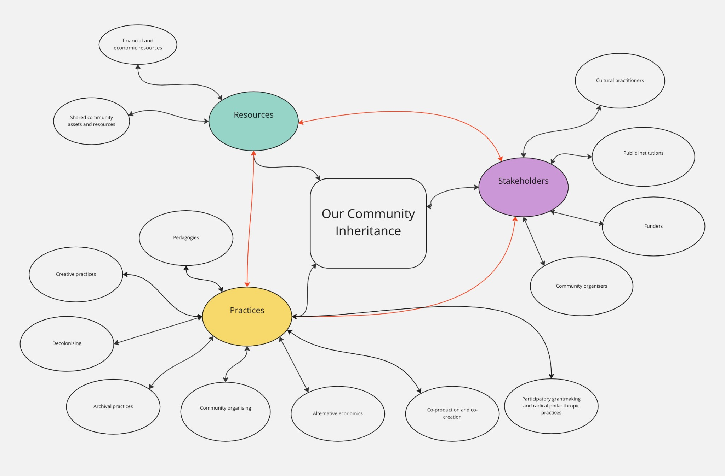

Our Community Inheritance has been in gestation for several years, building on my ongoing research and interventions into the long-term impacts of the 2008 global financial crisis, alternative economics, complementary currencies and alternative funding infrastructures for arts and culture. Our Community Inheritance is influenced by the glorious work of many artists, designers, activists and theorists who are working against the long-embedded tropes of white, male, hetero, able-bodied, neurotypical, middle/upper class power as exclusively shaping what constitutes wealth and resource in our communities. These artists, designers, activists and theorists provide insightful critique of capital, land and labour in its various forms, offering alternative ways of being, models and visions that contribute to the creation of more just and inclusive communities.

For instance, Gargi Bhattacharyya’s work shines a light on how contemporary capitalism - as a legacy of the British empire - impacts communities in different ways¹¹; Edgar Villenueva’s concepts of ‘money as medicine’¹² and decolonising wealth as ‘closing the (racial) wealth gap’ have been fundamental to my framing of giving and resourcing; J.K Gibson-Graham’s iceberg model of economy¹³ builds on Hazel Henderson’s love economy layer cake to

¹¹ I interviewed Gargi as part of my commission for the Sunlight Doesn’t Need a Pipeline project. See Cecilia Wee. 'Livability - A conversation between Gargi Bhattacharyya and Cecilia Wee', Sunlight Doesn't Need a Pipeline newsletter, 2022 https://sunlightdoesntneedapipeline.substack.com/p/livability
¹² Edgar Villenueva, Decolonising Wealth - indigenous wisdom to heal divides and restore balance, Berrett-Koehler, 2018.
¹³ JK Gibson-Graham (ed.), The Handbook of Diverse Economies, Edward Elgar, 2020

articulate forms of labour beyond official markets. Gibson-Graham discuss the labour, knowledge and expertise that we and our communities give, that are not valued because they escape being accounted for within official economic figures and ciphers of value.
Historical and contemporary experiments in community and complementary currencies and mutual credit systems have also sought to redraw the parameters of what we consider to be valuable, namely, our relationships and partnerships as humans.

Radical philanthropy initiatives such as The Giving Project (in the US), Resourcing Racial Justice and the Edge Fund (in the UK) challenge the dominance of scarcity economics, whilst also centring and lifting up historically underrepresented and marginalised communities. Similarly, the work of the Design Justice Network and equitable listening practices as championed by Nusrat Faizullah and Farzana Khan¹⁴ aim to remake the circulation of power and agency between project managers (or funders) and ‘beneficiaries’ towards co-production and co-creation.

Artistic projects such as Kathrin Böhm’s work on the Centre for Plausible Economies, the Radical Renewable Art and Activism Fund (now Glasgow Community Energy project), Raju Rage’s Under/Valued Energetic Economy project and the Arte Util project have also been important references in developing this project.

Before detailing how Our Community Inheritance intends to work and has worked in Edition #1, I discuss some trends in practices and projects in subject areas that inform my work.

¹⁴ Nusrat Faizullah and Farzana Khan, ‘Who Has Gained? Moving from Extractive to Equitable Listening’, The Listening Fund, 2020, https://www.thelisteningfund.org/wp- content/uploads/2021/02/who-has-gained-the-listening-fund-extract1.pdf

Inequality, wealth and inheritance
The Covid-19 pandemic highlighted the impact and extent of inequalities within UK society, and prompted awareness-raising and public discourse across news media and academic research about how historically marginalised and underserved communities are disproportionately impacted by such crises.

The inequalities that we see today are the result of ideological and political decisions, stemming from and exacerbated by successive governments’ austerity policies and the long- term impacts of the 2008 global financial crisis. As early as 2012, epidemiologists Martin McKee et al, detailed the demonstrable negative impacts and human costs of the 2008 global financial crisis. When comparing health data, they noted worse health outcomes - including higher rates of suicide - in countries that imposed austerity measures, in comparison with countries that responded to the crisis with a fiscal stimulus.¹⁵

The financialisation of everyday life since the 2008 global financial crisis and the concomitant acceleration of wealth and income inequality has been outlined by numerous writers on economics and capitalism, notably for this research, Jason W Moore and Max Haiven.¹⁶

Feminist writer Silvia Federici states,
‘It is no accident, then, that long before the Wall Street meltdown, a variety of economists and social theorists warned that the marketization of all spheres of life is detrimental to the market’s well-functioning, for markets too, the argument goes, depend on the existence of non-monetary relations like confidence, trust, and gift giving. In brief, capital is learning about the virtues of the common good.’¹⁷

Indeed, an increasing number of economic commentators have asserted that trickle-down economics is not working.¹⁸ According to a Resolution Foundation report, in 2017 the gap in wealth between the wealthiest tenth of households and the poorest 40 per cent of households in the UK was second only to the USA, at 107 times median disposable income,¹⁹ with the majority of the increase tied to passive income, such as rises in property prices and the value of other assets.

¹⁵ Martin McKee, Marina Karanikolos, Paul Belcher, David Stuckler. ‘Austerity: A Failed Experiment on the People of Europe’, reprinted in Cecilia Wee, Olaf Arndt, Janneke Schoenbach (eds).
Supramarkt – How to Frack the Fatal Forces of the Capitalocene, Irene Publishing, 2015, pp.271-282. ¹⁶ Jason W. Moore. Capitalism in the Web of Life: Ecology and the Accumulation of Capital. Verso Books, 2015. Max Haiven. Art After Money, Money After Art: Creative Strategies Against Financialization. Pluto Press, 2018.
¹⁷ Silvia Federici. ‘Feminism and the Politics of the Commons’, in Craig Hughes, Stevie Peace and Kevin Van Meter for the Team Colors Collective (eds), Uses of a WorldWind, Movement, Movements, and Contemporary Radical Currents in the United States, AK Press, 2010. p.3
¹⁸ Michael Gove, Secretary of State for Levelling Up has publicly discussed this in 2022. See James Coe. 'Trickle Down Economics Doesn’t Work: Michael Gove, New Public Management and the Levelling Up White Paper' Blog, Heseltine Institute for Public Policy, Practice and Place, University of Liverpool, 2022 https://www.liverpool.ac.uk/heseltine-institute/blog/trickle-down-economics-doesnt- work/
¹⁹ Molly Broome & Jack Leslie. 'Arrears fears: The distribution of UK household wealth and the impact on families', Resolution Foundation, July 2022, p.13 https://www.resolutionfoundation.org/app/uploads/2022/07/Arrears-fears.pdf

I note that the measure of inequality cited here is wealth, rather than income inequality, which is more frequently referenced in discussions of economic inequality. Whilst income levels reflect an individual’s leverage in the labour market, wealth does not. Moreover, wealth can be held and therefore can be passed on between individuals and generations, as can its corollary, debt: ‘holding wealth not only permits people to smooth their consumption and insure against risk, but also confers direct benefits for personal wellbeing and life chances (and those of someone’s descendants).’²⁰ The barriers faced by historically marginalised communities, particularly individuals who identify as Global Ethnic Majorities, d/Deaf, disabled and neurodivergent, LGBTQIA+, migrant and working-class, are materially evident in the lesser share of wealth held in these communities,²¹ which has both intergenerational causes and impacts. In other words, prejudice and discrimination across protected characteristics²² and lower socio-economic backgrounds compound wealth inequality, individually and systemically. The extremes of wealth distribution in UK society mean that we have different experiences, understandings and perceptions of the role of money in our lives and how it circulates through communities. For instance, contrary to narratives of meritocracy, wealth journeys are not linear. This is particularly the case for those who are migrants and may have had to leave behind assets, used their assets to embark on their migration journey, and/or had to adapt their expectations and skills to a different role or sector in the UK labour market.

These factors pose challenges and opportunities for the development of Our Community Inheritance. For example, the term ‘inheritance’ has predominantly financial connotations (such as ‘inheritance tax’) and is often associated with an individual’s relationship to the state; and is seen as having relevance to people with considerable sums of financial wealth, rather than eliciting broader interpretations of the passing on of intergenerational knowledge, skill and experience.

It’s hard to talk about wealth
We are not accustomed to talking about wealth in British culture. Discussions of wealth are often infused with feelings of shame; of not having enough, as well as feeling one has excess; embarrassment and reticence to declare or even discuss what privileges one enjoys. Although well-established discourse around working class pride exists, there are few

²⁰ Resolution Foundation, ‘The UK’s wealth distribution and characteristics of high-wealth households’, December 2020, p.3, https://www.resolutionfoundation.org/app/uploads/2020/12/The- UKs-wealth-distribution.pdf. The report goes on to state that, ‘households of Black African ethnicity are least likely to have net wealth over the £500,000 threshold, and four times less likely than those of White ethnicity.’ p.21
²¹ ‘The impact of inequality almost inevitably leads to a higher likelihood of poverty and the poverty premium. This is particularly noticeable for those who have intersectional characteristics, who are the most vulnerable to both poverty and poverty premiums.’ Sara Davies and David Collings, 'The Inequality of Poverty', University of Bristol’s Personal Finance Research Centre, 2021, p.10 https://fairbydesign.com/wp-content/uploads/2021/02/The-Inequality-of-Poverty-Full-Report.pdf
²² According to the Equality Act 2010, the nine protected characteristics are age, disability, gender reassignment, marriage and civil partnership, pregnancy and maternity, race, religion or belief, sex, and sexual orientation. See Equality Act 2010, part 2, c.1. https://www.legislation.gov.uk/ukpga/2010/15/part/2/chapter/1

opportunities to have open, non-judgemental, intersectional conversations²³ about wealth. The Poverty Truth Commission model, which was first launched in Scotland in 2009, provides an unique structure to talk about money in daily life and has now been established in 27 towns and cities across the UK. The model brings together people with lived experience of poverty and leaders within the town, city or region, to collectively ‘understand the nature of poverty, what are some of the underlying issues that create poverty and explore creative ways of addressing them.’²⁴ The Poverty Truth Commission model crucially reminds us of the importance of building space to hold difficult conversations and create dialogues that connect us.

The astounding collective, cooperative and civic action of mutual aid groups and other support systems during the Covid-19 pandemic was fundamental to survival in our communities. Some of the support structures that developed out of the pandemic’s exceptional circumstances have now morphed and become embedded into ongoing community support initiatives such as the rise of community pantries. Perhaps, what was extraordinary at the time was the level of mass participation²⁵ in this form of community organising and peer to peer community support.

The current cost of living crisis, coming after the Covid-19 pandemic, is a crucial inflection point in relation to how money mediates our personal and collective relationships. The cost of living crisis is having a huge impact on both middle and lower income earners, with massive material and psychological impacts at individual, organisational, community, local, regional and national scale. Widespread uncertainty about the UK’s economic future, job security, the effects of high inflation and sky-high energy bills mean that people are not able to plan what money they will have in the future and leading to many feeling unsure about whether they can share this. A Charities Aid Foundation report in 2022 noted a continued decrease in charitable giving since 2016 and found that 1 in 8 people plan to cut back on charitable giving,²⁶ because of their reduced discretionary spending power.

The enormity of the situation means feelings of powerlessness, anxiety, a focus on individual economic survival and a perceived lack of agency to change or transform what is happening are pervasive. At the same time, skilled fundraisers are leaving fundraising as a sector, a consequence of several factors including, the pressures of habitually being told ‘no’, having to accept gifts from sources that are not mission aligned, economic struggles due to the cost of living crisis and the transactional nature of how fundraising currently operates.²⁷

²³ My perspective on intersectionality was developed through my work on the Fair and Equitable pilot programme for Contemporary Visual Arts Network England, see Cecilia Wee, ‘Fostering Equity in the Visual Arts Sector – Fair and Equitable research report’, Contemporary Visual Arts Network England: 2022, pp.22-25 https://cvan.art/fair-equitable-research-report/
²⁴ Poverty Truth Network, ‘What is a poverty truth commission?’ https://povertytruthnetwork.org/commissions/what-is-a-poverty-truth-commission/
²⁵ Anne Power and Ellie Benton, ‘Where next for Britain’s 4,300 mutual aid groups?’, May 2021 https://blogs.lse.ac.uk/covid19/2021/05/06/where-next-for-britains-4300-mutual-aid-groups/
²⁶ Charities Aid Foundation, UK Giving Report, 2022 https://www.cafonline.org/docs/default- source/about-us-research/uk_giving_2022.pdf
²⁷ Monique Curry-Mims & Valerie Johnson. 'Disrupting Fundraising', Beyond Philanthropy podcast, February 2023

The cost of living crisis hit at exactly the same time as this research period, causing a shift in language and framing of Our Community Inheritance. As a result, there was a huge sensitivity around the use of terms such as ‘wealth’ and ‘riches’. The project had to be contextualised carefully, particularly for participants from low-income backgrounds or marginalised communities. Communicating the project in accessible language, in alignment with the community’s perspectives, was fundamental to working with NHS Grenfell Health and Wellbeing Service and members of the Grenfell impacted communities.

Talking about decolonisation today
A plethora of decolonising initiatives, research and conversations are taking place in the UK today. Decolonising work is a developing and contested field, a field in motion.

My approach to and understanding of decolonisation is strongly influenced by the work of Edgar Villenueva, Indigenous US-based philanthropy sector worker. In his book, Decolonising Wealth, Villenueva describes decolonising as a process that does not rest on destruction but aims to build more connective cultures of relation and belonging.²⁸ For him, the scope of decolonising work takes in not only financial and economic systems but also comprises unpicking how colonial values and mindsets have become embedded into the physical and tangible architecture of society, and the organisational design of our institutions. Contemporary institutions have been moulded through and by colonial logics, which have influenced all areas of our lives. For instance, Villenueva states that the ‘location, architecture and design [of colonial buildings] support colonising tactics of division, control, exploitation. I call these spaces “ivory towers”’.²⁹ Decolonising is thus about developing and bringing to the fore other ways of being, that would organise our environments, systems and institutions in ways that are based on ‘integration, interdependence, reciprocity and relationship’ instead of ‘separation, competition and exploitation.’³⁰

There is a need to develop public discourse and interventions to cultivate better understanding of the term ‘decolonising’. The meaning and relevance of the term ‘decolonising’ is still subject to much debate and varied interpretation, with people uncertain how it relates to them. Therefore, the words ‘decolonising’ and ‘decolonisation’ were not explicitly referenced in the delivery of Edition #1 of Our Community Inheritance.

Our Community Inheritance sits within broader explorations of decolonising wealth that have gained currency in recent years, especially since the resurgence of the UK Black Lives Matter movement in 2020. For example, the Museums Association’s programme on decolonising collections; Bristol University’s current consultation on its report ‘The Legacies of Slavery’ that identifies how a considerable proportion of the wealth used to found the institution depended on the transatlantic slave trade; funders including Joseph Rowntree Foundation have published statements acknowledging their links to slavery and are aiming to transform their grant giving practices to support communities that have been harmed due their founding company’s historic actions. These instances highlight institutional stories and histories of institutional wealth - unpacking these are an important catalyst to examining and countering structural oppression, looking to building redistributive cultural practices.

Despite the mainstreaming of calls for racial justice (particularly since the murder of George Floyd), the admission of institutional racism within UK society and more open discourse about the barriers faced by people from Global Ethnic Majorities - especially Black people and people who are racialised as Black - UK society has not had a widespread ‘reckoning’ with its colonial past and involvement in slavery. Initiatives such as Museum Detox, Charity So White and the BAME online conferences on fundraising are educating and raising

²⁸ Edgar Villenueva, Decolonising Wealth - indigenous wisdom to heal divides and restore balance, Berrett-Koehler, 2018, p.34
²⁹ Ibid. p,42
³⁰ Ibid. p,45

consciousness of systemic racism within the cultural, non-profit, charitable and fundraising sectors and proposing how to make changes. However, such work is also stymied by a backdrop of increasing politicisation of decolonising work as part of the ‘culture wars’. When Oliver Dowden (Culture Secretary at the time), wrote to national museums, galleries and other cultural funding bodies in September 2020 outlining the government's position on contested heritage, his statement undeniably functioned as a warning sign to them that 'as publicly funded bodies, you should not be taking actions motivated by activism or politics.'³¹

Consequently, conversations in the UK about the more established (and arguably less controversial) fields of equity (or equality), diversity and inclusion - which are operationalised within institutional contexts - are much more commonplace than conversations about justice and decolonising³². As such, and as a result of the gradual speed of work interrogating how today’s institutions directly link to the institutions involved in the transatlantic slave trade, the through line between the violence of colonialism and the continued violence against Black
people today is subject to erasure and remains contested. Olúfẹ́ mi Táíwò reminds us that ‘the unjust world order we have is the outcome of five centuries of human action – it would be an incredible achievement to undo this evil in half that time’.³³

My research aligns with Olúfẹ́ mi Táíwò’s constructive view of reparations as ‘build[ing] a just world, where the places that inherited the liabilities of yesterday ought to shell out the most for constructing a better world’³⁴, a project of future-making, transformation and praxis. Such
conception of reparations involves assessing current resources, analysing how and why problems or lack within a place exist and asking questions about what can be done to change the current flows of resource distribution.

There is a real need to create space for highlighting and deconstructing the insidious ways in which colonial legacies continue to shape power divisions and ways of living. It is important to pause, reflect, and discuss our experiences in order to identify and envision alternative futures. Our Community Inheritance aims for communities to be at the centre of such investigation, driving this forward, pressing pause where more reflection and interrogation needs to take place, and allowing action to emerge where the community feels it is needed.

³¹ Oliver Dowden, 'HM Government Position on Contested Heritage,' September 2020 https://www.gov.uk/government/publications/letter-from-culture-secretary-on-hm-government-position- on-contested-heritage
³² The need for ‘an expansive notion of diversity that seeks out redistributive justice' informed by the work of writers such as Sara Ahmed is discussed in Natalie Wreyford, Dave O’Brien, Tamsyn Dent, 'Creative Majority: An APPG for Creative Diversity report on ‘What Works’ to support, encourage and improve diversity, equity and inclusion in the creative sector. A report for the All Party Parliamentary Group for Creative Diversity, 2021, p.46
https://www.kcl.ac.uk/cultural/resources/reports/creative-majority-report-v2.pdf
33 Olúfẹ́ mi Táíwò, Reconsidering Reparations, Oxford University Press, 2021, p.199
34 Olúfẹ́ mi Táíwò – ‘The Constructive View of Reparations and Philosophical Frameworks of Global Justice’, Georgetown Journal of International Affairs, December 2022 https://gjia.georgetown.edu/2022/12/07/the-constructive-view-of-reparations-and-philosophical-
frameworks-of-global-justice-with-professor-olufemi-o-taiwo/

Cultural interventions and decolonising practices
Both in the UK and internationally, there is a growing body of creative projects, artworks, exhibitions and initiatives centring the lives and experiences of Global Ethnic Majorities, rethinking and unpacking decolonising, and building creative infrastructures for the liberation of historically underrepresented and marginalised communities. Taking on a multitude of standpoints - often curious, exploratory, speculative, generous or euphoric - this work is critical as it is often authored from positions outside the institution and reminds us that decolonisation isn’t just about institutions, it’s about our communities and relationships: ‘the reclamation of resources, visibility and voice [by artists and artsworkers] is a decolonial process of refusing the paternalism of organisational logics. What forms of resistance and refusal can we practice that simultaneously enable us to thrive?’³⁵

Coming out of a visit to Sonia Boyce’s exhibition ‘Feeling Her Way’ at Turner Contemporary, Margate (commissioned by the British Council for the 2022 British Pavilion at Venice Biennale and building on Boyce’s personal archive of Black British female musicians), a new friend excitedly said to me, ‘What do I do with all these feelings now?’ I was struck by this comment and the important underlying message, that art makes us feel, opens our minds (and perhaps even our hearts) to difference, the unknown, and the future. Museums, educational curriculum, institutions and public symbols of power tend to dominate discussions of decolonising, which has the effect of relegating decolonising work to a realm of the symbolic, impersonal or out of reach. Art and creative practice is transformational in this regard as they bring us closer to feeling, enabling us to understand practices of decolonising in relation to people’s lives and experiences. For me, Selina Thompson’s phenomenal installation Race Cards (2015), consisting of a collection of 1000 questions about race written by the artist over 24 hours, contained a question that has inspired my work every day for the last four years, ‘what does a decolonised mind look like?’

Storytelling, archiving, immersive and speculative design, hacking and creating infrastructures are all ways in which cultural practice and leadership explore, reframe and decolonise our relationship to wealth capture, accumulation and circulation within communities.

A notable act of storytelling of wealth and ritual liberation was Alinah Azadeh’s Burning The Books project (2013-2015) which toured the UK. In each location, Azadeh opened a Book of Debts asking members of the community to contribute. The entries were then read and ritually burned at each location, as a powerful witness, manifestation and attempt to help people dissipate the secretive burden of debt they experience every day.
Unearthing narratives of forgotten ancestors can not only connect us back to histories of marginalised communities but also values communities as archivists, historians and knowledge centres. The ‘Do you remember Olive Morris?’ project (2006-2010), which started with this extremely simple question to the Brixton community, was initiated by artist Ana Laura Lopez de la Torre. Over several years it uncovered the largely untold history of Brixton-based Black activist Olive Morris who co-founded the Brixton Black Women's Group,

³⁵ Cecilia Wee. ‘Casting Spells’, Producing Liveness in Interesting Times, the uncultured, 2023, p.4 https://www.the-uncultured.com/uploads/1/3/2/2/132249368/the_uncultured_-
_pliit_2_casting_spells_v4.pdf

was part of the British Black Panther Movement, fought against state and police repression and died aged 27. Together, the artist and community created an exhibition at Gasworks in South London, had Olive Morris featured on the Brixton Pound community currency in 2015, initiated the Olive Morris Collection archives and the Remembering Olive Collective, which has subsequently set up the Olive Morris Memorial Award for young activists.
The South London-based art, design and architecture studio Resolve Collective reimagines definitions of learning and decolonise notions of knowledge exchange. Resolve Collective’s work often involves examining and hacking everyday objects of globalised production (scaffolding, stackable plastic crates etc), taking them as starting points for developing narratives and research about historical and contemporary narratives that connect the Global North and South. Their reparative approach to design and architecture, centring communities of colour and communities of resistance, develops spaces of co-creation where all participants, regardless of profession, age or class are invited to contribute their ideas and knowledge.

Healing Justice London focus on creating liberatory support structures for those harmed by the oppressive, violent systems and institutions of contemporary society. They disrupt defined models of arts and cultural organisations as being restricted to specialist, programmatic offers. Instead, they take a heterogenous, eclectic strategy to address issues of intersectional harms, building in person and virtual communities that value, celebrate and centre marginalised communities, especially Black and brown folx. Originated by artists and creative practitioners, Healing Justice London’s work manifests as programmes encompassing education, social action, health and wellbeing practices, research and work that does not ‘look like’ conventional arts and cultural practices.
The Arts Collaboratory is an international network of 24 arts projects and organisations in the Global South, plus two funders, facilitated by Casco Art Institute in Utrecht, Netherlands.
This decentralised network of organisations is working towards solidarity, mutuality through the management of collective funds, collaborative research, projects, knowledge making and resources that span affection, care, energy, time, aesthetic opinions, critiques as well as money: ‘All the organisations in Arts Collaboratory continue to be affected by the trauma of colonialism as it is a logical progression, the structures of capitalism in our organisational contexts perpetuate this trauma even after each respective country’s “independence” from, or the removal of colonial power’.³⁶
Across the UK, artist-led projects and initiatives such as these are growing alongside exhibitions, commissions, residencies and projects authored and funded by institutions, notably the Decolonising Art Institute, University of the Arts London; Stuart Hall Foundation; Museums Association and National Trust.

³⁶ Arts Collaboratory, ‘The Future Plan: Paradigm Shift in the Post-Colonial and Neo-Liberal Context’ https://artscollaboratory.org/future-plan/

Community level interventions
The term ‘community’ connotes many often contradictory and opposing ideas and sentiments - such as: the pressure to carry on things that came before us, how perceptions of outsideness change when coming in to a new community or through relocation, changing jobs, sectors, life changes; the positive and negative associations of inherited wisdom and ancestral passing down of knowledge; communities who have been sidelined within Western, Global North contexts; breaking intergenerational patterns of disenfranchisement and violence; values that have been passed down to us from influential people in our lives; a sharing, scaling up and scaling together of resources within a given place.

The significance of organising and making change at the neighbourhood level has been recently discussed and referenced through initiatives such as the ‘15 minute neighbourhood’ and by a number of community organisations, notably the Birmingham-based Civic Square. In their text about the 10 year plan for Civic Square they write, ‘are our neighbourhoods resilient to the futures, opportunities and deep structural threats that are emerging? We believe the neighbourhood to be an exciting, legitimate, creative and tangible unit of change, if designed with intention, care, generosity and our future structural risks at the forefront of our minds and built upon the long history of neighbourhood level work in the UK.’³⁷ At the human scale of neighbourhood, we can ‘think global and act local’, holding our networks of community through change, with a sense of ownership and space for different types of active participation - so that communities can grow and determine their civic space.

By situating questions of wealth and the economic at the community level, we unpack and make visible both the structures, types and tropes of value that are inherent and operating within our society. We currently see these questions being raised in the UK through the mass industrial action taking place across education, healthcare, public services (including strikes by cultural workers who are members of the PCS union) and transport sector, where workers are demanding that they are recompensed fairly for the value that they give and provide to keep society alive.

Place based giving schemes are at the nexus of community /place and resource generation. They have been cited as positive methods of civic engagement, capable of building capacity in the voluntary and community organising sectors, connecting community-level philanthropy to local development priorities.³⁸ Some of the impetus of place based social action and place based giving schemes has been motivated and supported by government and public funders.³⁹ However, these schemes have arguably built upon existing grassroots activity and innovation within communities and the ambitions of particular funders, particularly those in London.

Terminology in other territories is slightly different – for instance in North America, place based giving schemes are also called community funds. An inspiring example of such

³⁷ Civic Square (2020—2030), 2020 https://civicsquare.cc/2020/03/09/civic-square-2020-2030/
³⁸ Charities Aid Foundation, ‘Growing Place-Based Giving, End of Programme Report to DCMS’ August 2020 https://www.cafonline.org/docs/default-source/about-us-publications/growing-place- based-giving-end-of-programme-report.pdf
³⁹ UK Government, 'Collection: Place Based Social Action Programme' https://www.gov.uk/government/collections/place-based-social-action-programme

scheme is The Giving Project - a radical community fundraising project taking place in nine grant-making organisations in North America. The programme brings together a cross-class, cross-race, gender-diverse, intergenerational group of people to reflect on power, privilege and race identity, examine where their wealth comes from, meeting and assessing grantseekers and fundraising to support social justice projects. This model invites those with inherited wealth and class privilege to consciously embed themselves and their resources within a context of grassroots organising and cycles of giving and receiving.

Whilst interest in place based giving and place based social action is growing, this work is still deemed fringe within public discourse. There is an opportunity for cultural leadership to contribute to this movement and to stimulate interest in place-based approaches. The activities of archiving and mapping community resources are of value in themselves, creating rich community-led conversations and constituting acts of decolonising knowledge. Such forms of informal, peer learning in the name of mutuality serve to connect us more deeply to change within our communities, ‘what distinguishes peer-driven change from even these peer-centric approaches is that it emphasises people’s mutuality, where peers share information, connections, and funding to achieve their goals’.⁴⁰

⁴⁰ Rohit Menezes, Simon Morfit, Willa Seldon & Bill Breen, 'When Peers Work Together to Drive Social Change', Stanford Social Innovation Review, June 2020 https://ssir.org/articles/entry/when_peers_work_together_to_drive_social_change

Participatory grantmaking
Collective and collaborative decision making by communities about how money and resources are to be spent have long and multiple traditions across the world, linking to participatory budgeting initiatives and the Porto Alegre model that developed in the late 1980s after the Brazilian dictatorship; community currency projects that examine how residents and businesses can benefit when money circulates within a defined geographic area; collective savings or savings clubs such as the pardner system that was popular in UK Caribbean communities; and funding initiatives such as The Edge Fund in the UK, where all applicants become members who in turn make funding decisions. All of these disparate practices aim to re-centre communities closest to the issues and de-centre the dominance of white, cis-gendered, non-disabled, heterosexual, middle and upper-class models of power within fundraising and philanthropy.

Within a Western and Global North context, many of the current waves of disruption within philanthropy and fundraising, such as the international Community-Centric Fundraising movement, championed by non-profit activist and changemaker Vu Le, have their roots in initiatives birthed during the 1970s.For example, the US-based Funding Exchange and Haymarket Wealth Conferences in the 1980s and 90s were important for (young) people from inherited wealth to discuss, think about and challenge their privilege around money.⁴¹

The rise of participatory grantmaking and in particular, the involvement of people with lived experiences, are perhaps the most significant recent turns within fundraising and resource distribution practices. The principles and foundational practices of participatory grantmaking have been detailed by Hannah Paterson, Head of Funding for the UK portfolio of the National Lottery Community Fund, in her groundbreaking report ‘Grassroots Grantmaking: embedding participatory approaches in funding’⁴². She describes participatory grantmaking as, ‘a great way to engage a wide number of people and predominantly used in place-based setting by inviting a whole community to engage. This is obviously a very democratic approach but it has been critiqued as it is likely to result in the more popular projects, or
the most confident and interesting presenters getting funding’.⁴³ Since the publication of her report, Paterson has become the convenor for the participatory grantmaking Community of Practice, a network of around 1,200 funders across the world involved in participatory grant making, including 100 funds in the UK. Providing a space for workers within the philanthropy sector to reflect, with regular peer support meetings, deeper dives into special topics, a buddy system, and mailing list, the Community of Practice aims to make changes within the philanthropic sector, and is of particular value to practitioners working in large institutions who wish to practice philanthropy in alignment with their personal and organisational values.

As discussed in Paterson’s report, models of participatory grantmaking vary from representative participation models (such as Camden Giving) to rolling collective models

⁴¹ Chuck Collins, Pam Rogers, Joan Garner. Robin Hood Was Right: A Guide to Giving Your Money for Social Change. W.W. Norton, 2000.
⁴² Hannah Paterson, ‘Grassroots Grantmaking: embedding participatory approaches in funding’, A Winston Churchill Fellowship report, 2020 https://hannahpatersoncom.files.wordpress.com/2020/11/grassroots-grantmaking-embedding- participatory-approaches-in-funding.pdf
⁴³ Ibid, p.18

(like Edge Fund UK), through to closed collective models (similar to the process I deployed in Edition #1 of Our Community Inheritance), direct transfers and crowdfunding.⁴⁴ Common to all of these approaches is the involvement of ‘community panellists’ - individuals from the community closest to the issue who are ‘experts’ with lived experience. Unfortunately, community panellists being asked to contribute their lived experience to the grantmaking process (the participatory bit of ‘participatory grantmaking’) are often not paid for their time and effort, despite being the ones who are making the work happen – for some funders this is due to the lack of clear systems for paying people who receive benefits.

Community panel processes clearly need to be inclusive, decolonising conventional perspectives on who is an expert, who has power and knowledge within the community, in order to ensure that we do not revert to listening and involving those who are most vocal. Ensuring resource for panellists to be part of a conversation and process is vital. This is so that participatory grantmaking can bring in those who are most impacted by the issues and who face barriers to participation, precisely because of the issues that participatory grantmaking schemes are trying to address.
The slow pace of policy change in large organisations like the National Lottery Community Fund, can make it difficult to bring about meaningful change in the sector. However, there are some organisations, such as Camden Giving, that are modelling excellent practices.
Having conducted fifteen rounds of participatory grantmaking, mainly funded by local businesses, Camden Giving aim to ensure that their grantmaking practices do not further harm individuals from marginalised communities, and positively contribute to the skilling and experience of their community panellists: ‘We know that it is unfair that some people hold significantly more money than others, within this context is this process / intervention / action just?’⁴⁵ Some of these practices include: provision of access and care when facilitating participation of people from the community with lived experience, as well as onboarding and outboarding community panellists so that they can articulate their experiences of participatory grantmaking in their CVs and utilise their knowledge in other domains.
Arts and cultural practices have a potentially powerful role in grantmaking, with opportunities to build creative practice into every part of the grantmaking cycle from design through to storytelling and documentation, to help capture the emotion and feeling of decision making, with the hope of opening the black box on how institutions interface with and manage money. Our Community Inheritance is aligned with these aims of opening up public consciousness about how we catalyse conversations, participate in and shift wealth distribution in our communities.

⁴⁴ Ibid, pp.19-21
⁴⁵ Camden Giving, 'Practical Ideas for Participatory Grantmaking' London Funders, p.7 https://static1.squarespace.com/static/5f1940ec39f7473088deb8ae/t/6037cd9fd905f26716c2e44c/161 4269859149/Participatory+Grant-Making+Toolkit+%288%29.pdf

Our Community Inheritance: a provocation for action
Our Community Inheritance is initiated by Dr Cecilia Wee, made with local communities, bringing together decolonial approaches to cultural production, knowledge from community organising, radical, community-centric approaches to fundraising and liberatory understandings of economics as ‘making home’.
Working with local partners, each ‘edition’ of Our Community Inheritance develops a conversation about resources, wealth and what is valued within a local community, creating hyperlocal archives that document understandings of diverse, intergenerational knowledge and wealth and makes community-generated proposals responding to what our communities need to thrive. Our Community Inheritance works with communities on journeys to develop and enact decolonising community resources, through cultural activity and community organising.
Whilst acknowledging how some communities have been historically underserved and discriminated against through dominant power, Our Community Inheritance aims to affirm and value all the ways in which communities have different types of wealth, counting not only financial but also cultural, social, environmental wealth and health. The project is a creative process, undertaking public mapping of heritage and intergenerational experiences within a local community. It creates new relationships between creative practitioners and communities, rejecting extractive histories of social practice to think about how we build affiliation, visibility and resource so that more collective practices and initiatives can flourish. Part of this is working with communities to develop opportunities for participatory budgeting and experiments in wealth redistribution.
In contrast to decolonising projects authored and initiated by major institutions, Our Community Inheritance aims to tell non-institutional stories about where wealth comes from, in other words stories of wealth from the perspective of people, their families and communities. Each iteration of Our Community Inheritance is a weaving of unheard and new stories and creative process with a local community.
Our Community Inheritance also aims to build in exit strategies so that local communities learn how to conduct this research and process themselves. Our Community Inheritance aims to lay the foundations for the creation of community funds and a community resourcing movement similar to The Giving Project.

Influenced by Edgar Villenueva’s statement that ‘questions about what is working well are energising’⁴⁶, Our Community Inheritance asks:
- How can we support, amplify and work with initiatives that our communities have already facilitated, are proud of and invested in?
- What types of resource cooperation are needed for us to thrive in these times of multiple crises?
- If, as Villenueva suggests, money can be a tool of love within our communities, what role could arts and culture have in shifting our attitudes and the ways we relate to money?

⁴⁶ Edgar Villenueva, Decolonising Wealth - indigenous wisdom to heal divides and restore balance, Berrett-Koehler, 2018, p.131

- How can we reframe wealth redistribution as enriching and strengthening our communities?
- How can decolonisation projects and practices be impactful as processes of
redistributive, creative justice?
- How to create a collaborative process of turning towards liberation, as a means to celebrate and pass on our deep knowledge, wealth and experiences?
- Where and what could we change if we step into our roles as ancestors-in-waiting?

Case study: Edition #1 of Our Community Inheritance
“Our Community Inheritance created a rare environment of mutual respect between generations and people from different walks of life to hold each other’s experiences within the community, gently disagree, practice endurance and engage in laughter, creativity and fun in the process. Through a strengths-based arts-led approach, participants gained self- esteem, increased confidence, and their attitudes and outlooks improved.” NHS Grenfell Health and Wellbeing Service.

Exploring the idea of community inheritance was extremely important for Grenfell impacted communities, as communities working towards healing and justice, where formal justice has been lacking. Our Community Inheritance found alignment with NHS Grenfell Health and Wellbeing Service as we all wanted to affirm the strengths, relationships, knowledge and energy of the local community, as a means to heal, lift up and create pathways for the future.

At the heart of the collaboration were intergenerational, intersectional workshops with Grenfell impacted communities to explore what intergenerational inheritance, in all its forms, means for the community. The aim was to think about all that we learn and gain from our cultures and heritage, across generations, to reframe our understandings of financial, spiritual, environmental, emotional, physical and psychological health, wealth and inheritance.

We invited workshop participants to share with us their stories and experiences of intergenerational knowledge, talent and wealth in the community. We asked people about their superpowers and the knowledge, skills and gifts they have learnt from older and younger generations, mapping these community assets. Participants made these visible and tangible through conversation and creative media, responding through mapping, writing, drawing and model making. This archival exercise served as a valuable form of reflection and celebration of the incredible skills and the infectious energy of the community.

In addition to this archival conversation, we invited participants to offer their proposals about what would be beautiful, inspiring, useful, valuable, for their community, building on the various community assets they had identified and exploring what they could bring to make it happen.

There was a diversity of perspectives and experiences from participants including older people, young people and community activists. The discussion examined what climate justice means within the context of Nottingdale, North Kensington; local communities as self- organising knowledge hubs; the history of activism in the local area; struggles against inequality and racism spanning several generations; the long-term impacts of the Westway; the lack of good quality education; the lack of publicly accessible green spaces and play spaces; the loss of affordable healthy food as a consequence of successive waves of gentrification.

The workshops provided an open and non-judgmental space for community activists to honestly reflect and think through community dynamics, different opinions and approaches, as a means of identifying strengths, struggles and needs as individuals and of the people they work with. Participants reflected on how the local community has developed modes of

resilience over generations, recognising the need to work together to support a broad spectrum of activities and initiatives for the community, affirming the importance of activism in every form. Alongside this, participants reflected that they wanted to ensure that future generations could inherit and benefit from conditions that are healthy, supportive and safe. There was a strong sense that much of the community’s activism and organising came from wanting to ‘pay it forward’, to support and invest in young people, by creating environments where young people can learn, experience and thrive. Community organisers collectively acknowledged that whilst their personal passions influence the focus of their projects, they held a shared objective of passing on ‘skills for living’ to other generations.

Participants produced proposals for small-scale projects that respond to what the community needs to thrive:
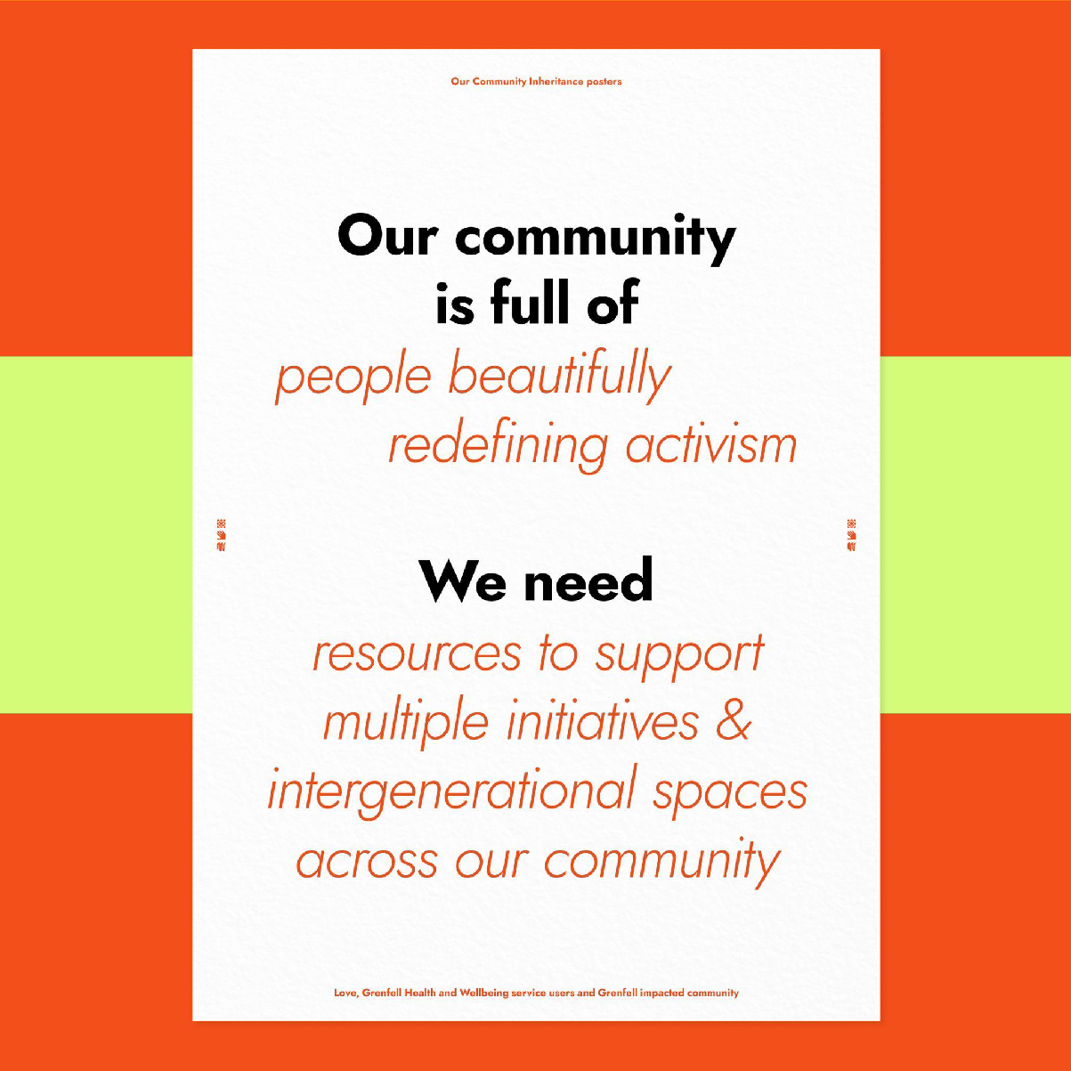
Alt text: Poster text says, Our community is full of people beautifully redefining activism. We need resources to support multiple initiatives and intergenerational spaces across our community

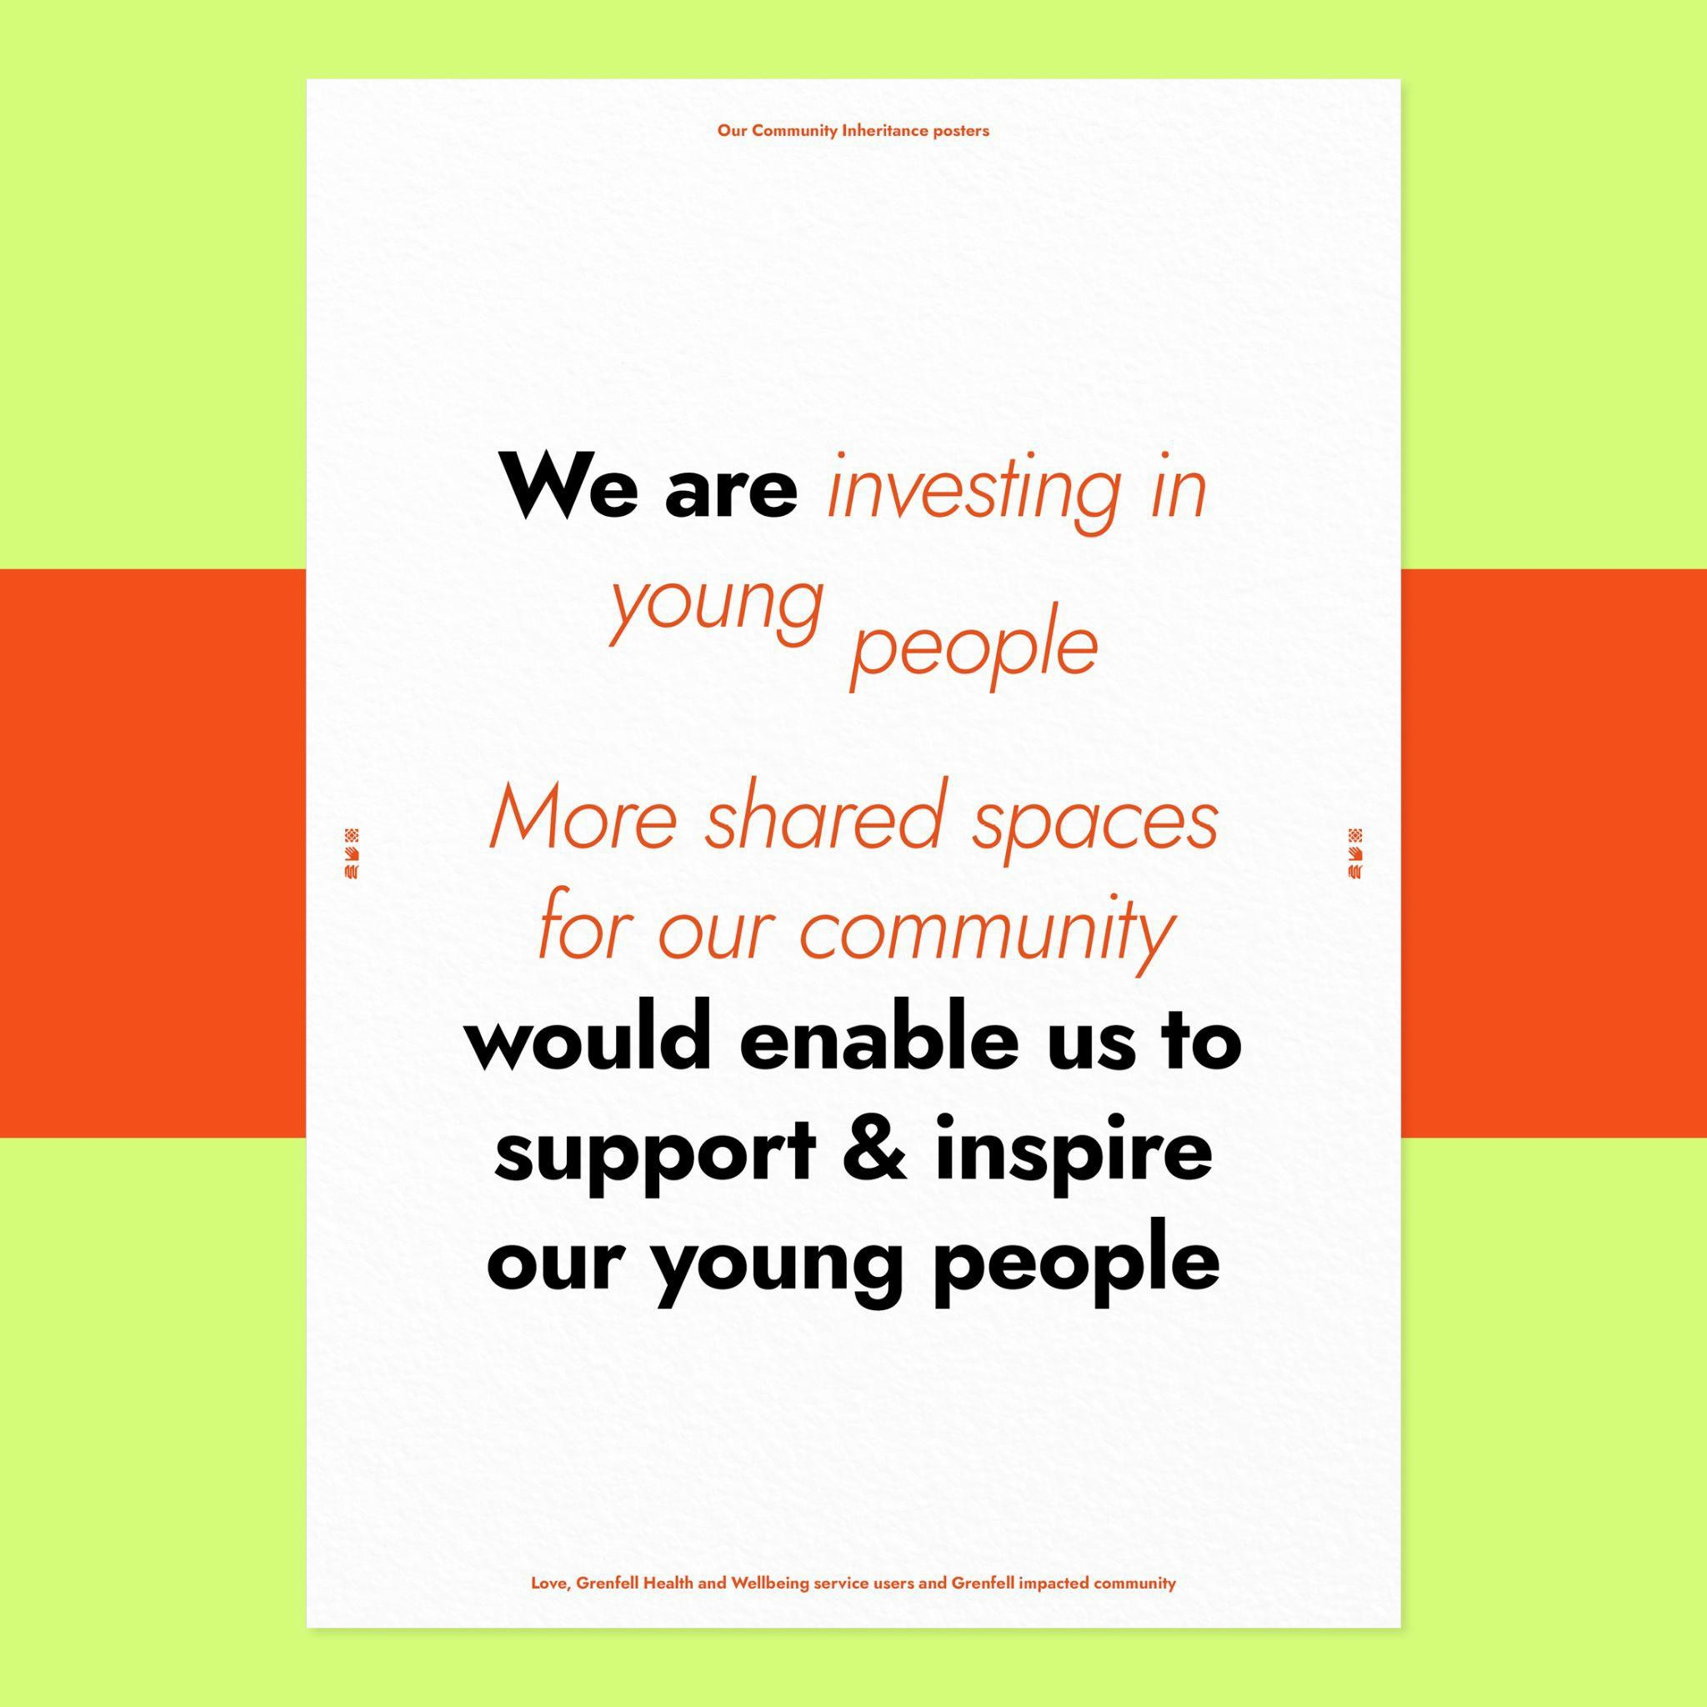
Alt text: Poster text says, We are investing in young people. More shared spaces for our community would enable us to support and inspire our young people

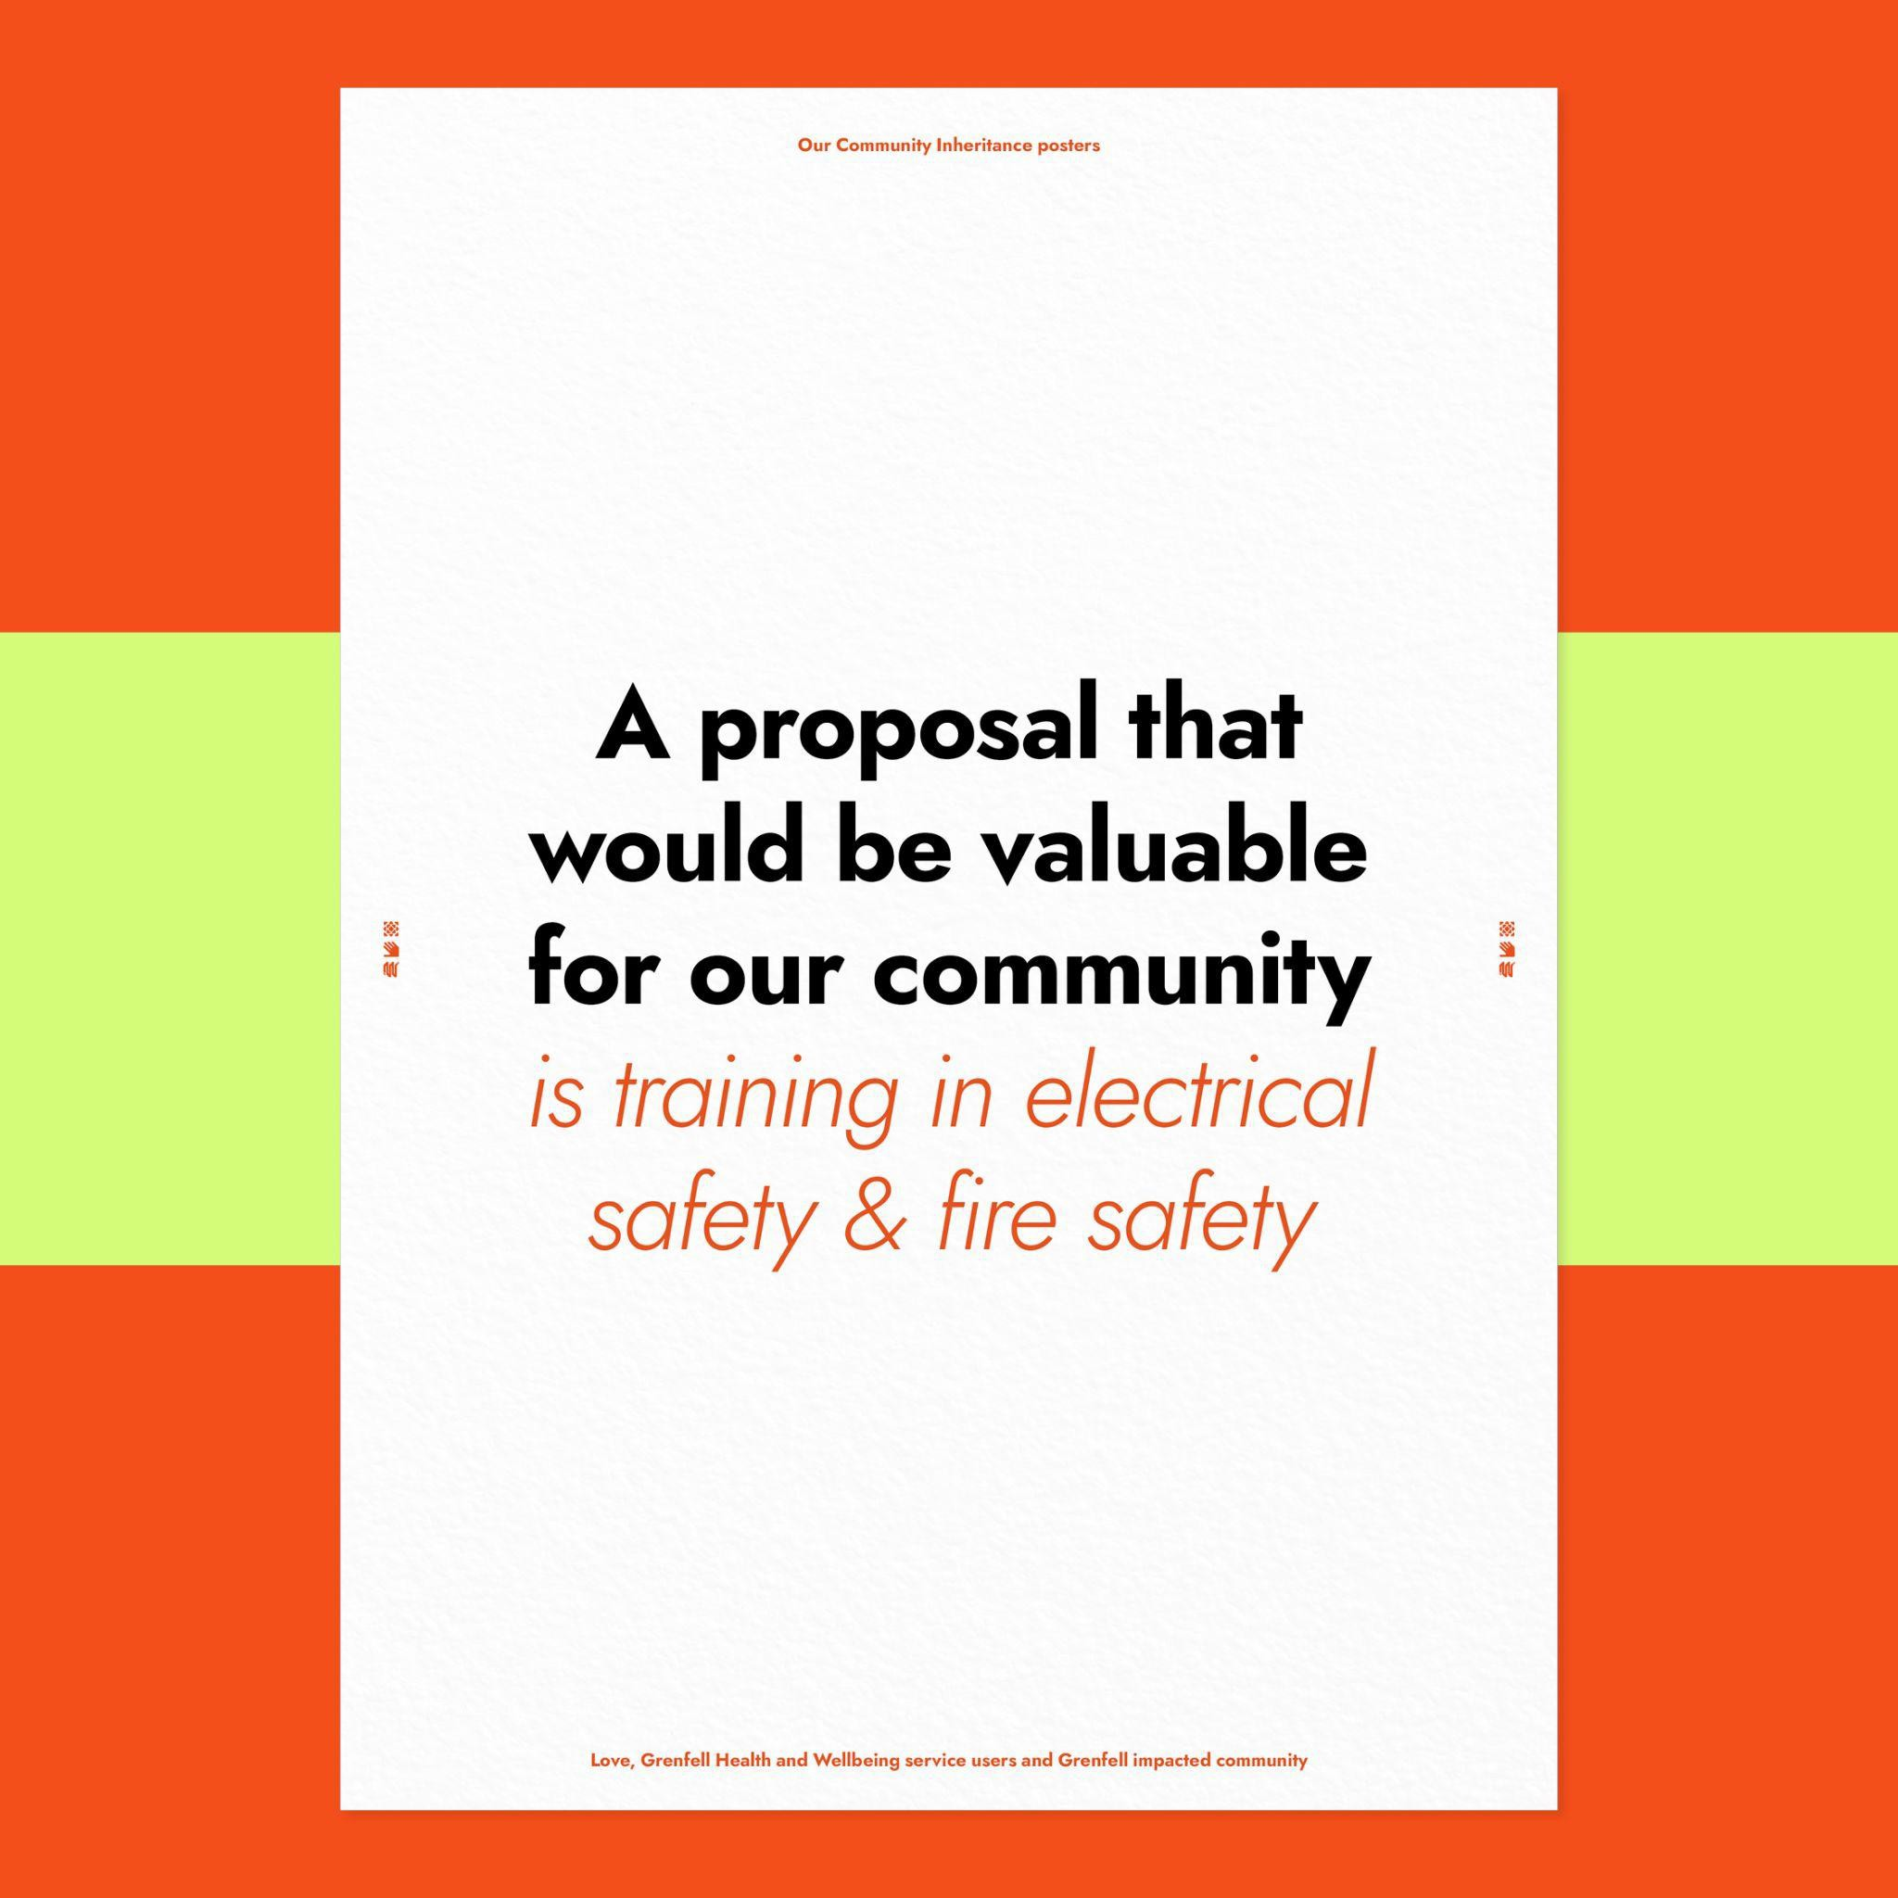
Alt text: Poster says, A proposal that would be valuable for our community is training in electrical safety and fire safety

These proposals for community projects were shared at the Sunlight Doesn’t Need a Pipeline festival at the Stanley Picker Gallery on 7 October 2022, alongside a series of objects made by workshop participants and the communities they work with.
Each object tells a story about the intergenerational knowledge and wealth that the Nottingdale, North Kensington community wants to acknowledge. Through this presentation, the audience was also invited to reflect on and narrate their own story of intergenerational knowledge and wealth.

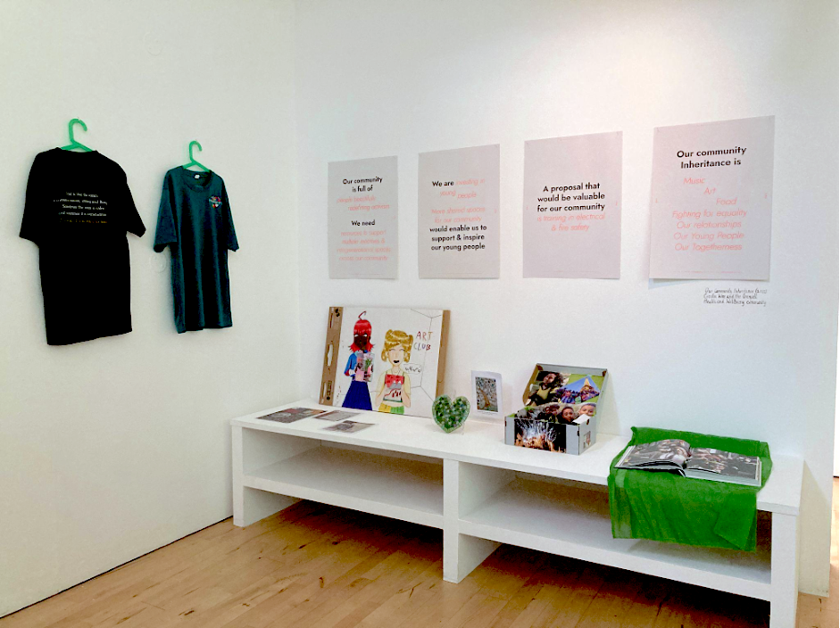
Alt text: objects exhibited in the corner space of a white walled gallery. On the left, two T- shirts hang from the wall, black t-shirt with white text, one green t-shirt with Swimunity logo; on the right, objects sit on top of white low long bench: three texts with photos; drawing of an art club; green heart mosaic; memory box filled with photos of people, open coffee table book; four posters with black and pink text hang on the wall above.

T-shirts from Swimunity CIC, set up in the wake of the Grenfell fire to provide free swimming workshops, conveyed their mission of helping young people face their fears, connect with nature and learn to keep themselves safe. On the back of a Swimunity T-shirt is printed: ‘Grief is like the ocean; it comes in waves, ebbing and flowing. Sometimes the water is calm, and sometimes it is overwhelming. All we can do is learn to swim.’

The green heart mosaic made by artist Tomomi Yoshida is part of ongoing mosaic making practices in the community. Tomomi and fellow artist Emily Fuller worked with hundreds of members of the community to co-create the Grenfell Memorial Community Mosaic: Walking as One project, a series of 39 mosaics featuring the word ‘Justice’ in different languages laid into the pavement along the route of the Silent Walk. The project was completed in June 2022 to commemorate the fifth anniversary of the Grenfell Tower fire.

Since October 2017, Solidarity Sports (who work primarily with young people referred by social services) has been organising trips to honour and commemorate the Hashim Family. The family needlessly lost three children (including Firdaws) and their parents in the Grenfell Tower fire. The memory box features photos of young people visiting Disneyland Paris, a dream that Firdaws was not able to fulfil. The memory box is both an archive of togetherness

and hope within a young community, as well as a commitment from adults to continue resourcing these opportunities for young people.
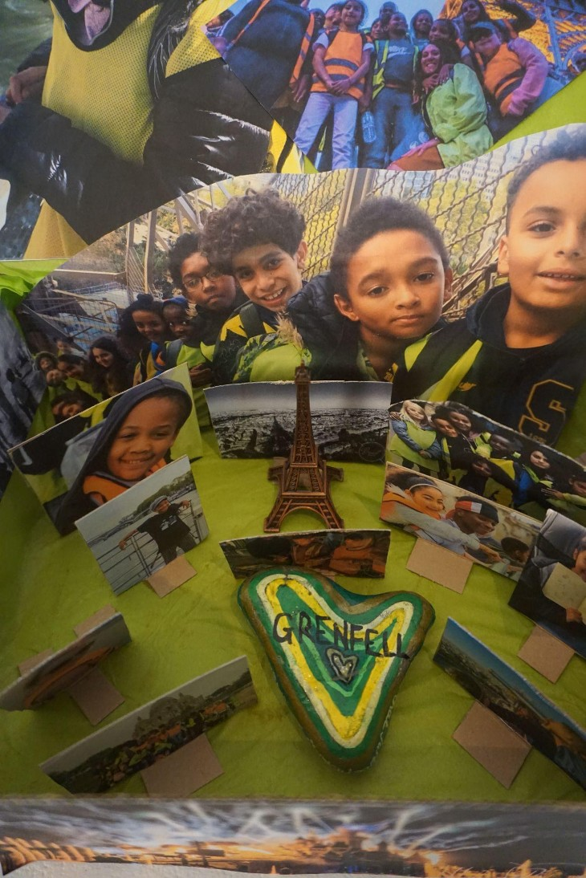

Alt text: photos of smiling groups of children from different ethnic backgrounds placed upright in a box. The photos are of varying sizes. In the middle of the image is a heart-shaped stone painted with shades of green and the word ‘Grenfell’ and a small statue of the Eiffel Tower.

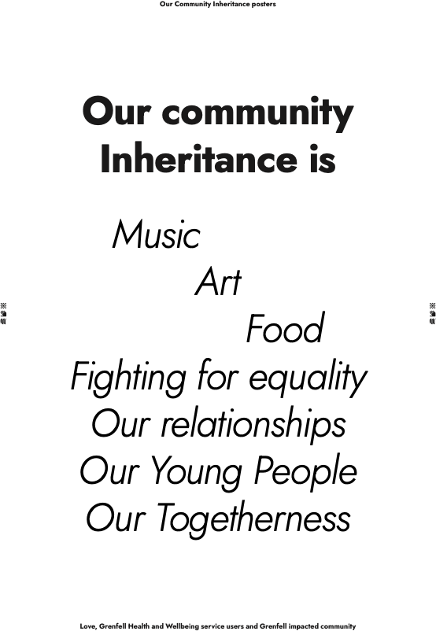

Alt text: Poster text says: Our Community Inheritance is Music, Art, Food, Looking out for one another, Organising and getting things done, Fighting for equality, Our relationships, Our Young People, Our Togetherness, Love, Grenfell Health and Wellbeing service users and Grenfell impacted community

Local contexts of climate justice:
When we think about climate justice in relation to the communities impacted by the Grenfell disaster, we need to take in the wider context of urban planning in west London, particularly the construction of the giant elevated flyover, the Westway. When it was created, the Westway demolished homes, displaced families, cut communities in North Kensington into two, brought noise and air pollution, and disruption, with 47,000 cars a day within the first few months of opening.

More than 50 years since its completion, the long-term impacts of the Westway are ongoing poor quality environmental conditions, and poor health outcomes for communities living between and underneath the Westway. As is the case with most major roads in London (and across the UK), levels of Nitrogen Dioxide (NO2) along the Westway regularly exceed EU annual limits. Despite protests from the local community about the dangerous levels of NO2 and proper use of the land directly underneath and adjacent to the Westway, the Westway Sports Centre is sited directly underneath the flyover, as are pitches for outdoor sports including football, cricket and tennis. These conditions have undoubtedly impacted the health of local residents. That local residents, including young children, are forced to exercise under and near the Westway is a direct consequence of authorities failing to provide a healthy environment and access to green spaces for the community, and that such provision is often not a priority for authorities within low income urban contexts.

The catastrophic failure of governments and authorities to provide safe, liveable environments for people in the Nottingdale community is symptomatic of wider failures of British governments, including climate destruction as a result of colonial pillage, migration due to unsustainable economic conditions and untenable habitats, ghettoisation of swathes of the population, particularly those racialised as non-white and from low-income backgrounds due to gentrification and rising housing costs. Cultures of institutional neglect by authorities who were tasked with providing safe environments for residents, including vulnerable people in their charge, are layered upon complex histories and dynamics of classism, racism and migration in these neighbourhoods of West London. The injustice of the Grenfell fire brings climate justice home to us in the urban Global North.

The activists and organisers I met through Our Community Inheritance are part of a long and powerful line of grassroots organisers in the North Kensington community, fighting for and trying to create safe, liveable environments, namely -
- Equal access to green spaces,
- Equal access to well-resourced municipal amenities, including schools and leisure spaces,
- Housing that is safe, secure and well maintained,
- Environments where definitions of safety and security are not tied to practices of overpolicing and surveillance,
- Streets that are free from pollution,
- Streets where residents feel safe to use no/low carbon forms of transport such as walking and cycling when travelling locally,
- Equal access to affordable and healthy food.
Without equal access to these things within our communities, what is climate justice? This is what climate justice looks like for those who live in underserved urban areas of the Global North.

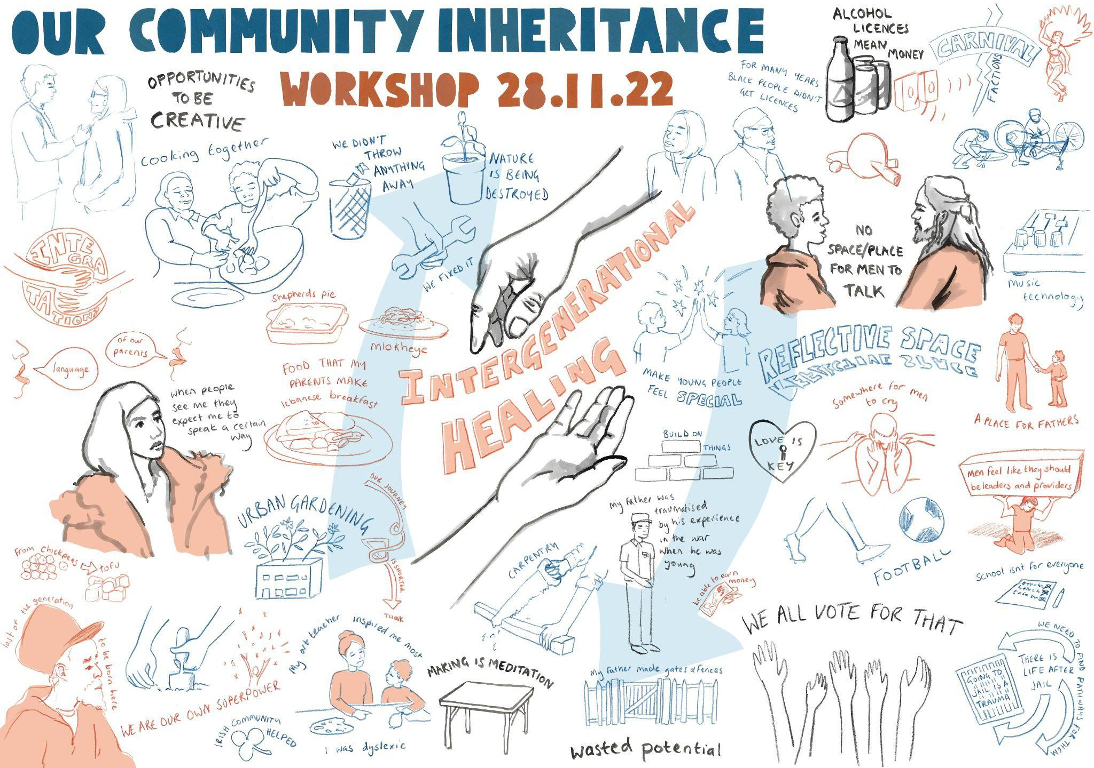

Alt text: visual notes from Our Community Inheritance workshop, blue and orange hand drawn text and images on white background, including two hands holding the words ‘intergenerational healing’. Visual notes by Toya Walker.

Impacts and outcomes

The strengths-based approach of Our Community Inheritance gave participants confidence and a positive vocabulary to speak about and accept contradictions and differences within the community in a non-confrontational way, allowing participants to reflect on and share their personal stories and life experiences.
The project was highly successful in creating open and generative conversations with community members and local activists, broaching sensitive topics without reinforcing divisions. The workshops allowed participants to engage in critical thinking and active disagreements, whilst also successfully facilitating a valuable cross-cultural fertilisation of views, generating productive conversations between members of the community who might otherwise not connect with one another, who would usually not feel comfortable or confident to speak about their experiences in public. The NHS Grenfell Health and Wellbeing Service team noted that the workshops were a rare opportunity for older Caribbean men to develop community proposals with Hijabi 17 year old women. The workshops resulted in local activists and participants exploring ideas that they could bring forward in their own initiatives.
The NHS Grenfell Health and Wellbeing Service team noted that the project’s use of art and language encouraged participants to relate to their experiences in a different way:

- Participants’ self-esteem and self-awareness increased through exploring and sharing their perspectives and heritage stories,
- Participants benefited from self-directed learning - reflecting on aspects of their personal history they are curious about but may never have had the opportunity or encouragement to explore,
- There was increased peer-learning and connection between community members across generations and social groups,
- There was increased understanding of complex and sensitive topics affecting communities,
- The project nurtured new, generative and responsive relationships between creative practitioners, partners and community participants,
- The project helped identify meaningful areas for community action and change through collective conversation, building capacity for community activists,
- The project enabled the community to build experiments in participatory and inclusive community decision-making.

After a five month-month working process, Edition #1 of OCI identified several key projects for the community to take forward: an all-ages art club; an independent reflective space for community activists; safe, low-cost means for young people to access the natural environment, and a safe, reflective space for men to explore their emotions. Drawing on participatory budgeting principles and frameworks⁴⁷, community participants voted to support a proposal to create a safe, reflective space for men, which will receive £1000 seed funding.

As a team, we were clear about the scope of this project: we were very mindful about not replicating projects that already exist in the community, communicating clearly that projects with a clinical health need could be developed and supported through the NHS Grenfell Health and Wellbeing Service, and that whilst limited by time and resource, Our Community Inheritance could make an intervention to support the Grenfell impacted communities to create more resources. Edition #1 has now been handed back to the NHS Grenfell Health and Wellbeing Service and Grenfell impacted communities.

The initial commissioned project budget from Sunlight Doesn’t Need a Pipeline, curated by Dani Admiss, was £1500. Cecilia decided to take a fee of £500 to lead and facilitate the project and designate the rest of the project budget of £1000 to seed fund a project with Grenfell impacted communities. Cecilia’s extended work with Grenfell impacted communities, including the writing of this report, is being supported by a small research grant from Clore Fellowship and Arts and Humanities Research Council.

⁴⁷ Our Community Inheritance essentially operated a closed collective model of participatory grantmaking, see Hannah Paterson, ‘Grassroots Grantmaking: embedding participatory approaches in funding’, A Winston Churchill Fellowship report, 2020, p.20 https://hannahpatersoncom.files.wordpress.com/2020/11/grassroots-grantmaking-embedding- participatory-approaches-in-funding.pdf

Conclusions
‘We celebrate the solidarity economies that are already in existence and all those who are producers but not recognised as such, who are (un-)professionally creating resource and value within their communities.’⁴⁸

This research project tested and evidenced the value and need for Our Community Inheritance.

Findings - what the project suggested and revealed:
- Our Community Inheritance is particularly relevant in the current political climate because of multiple factors: high levels of inequality and division within public life; increasing focus on the neighbourhood level as the locus to make social change; a need for better understanding of existing assets, resources and wealth distribution within local communities; and an increasing reluctance within the funded charitable sector of undertaking activity that could be deemed as political or campaigning within community organising activities.
- Community organiser participants valued spaces for organisers to come together to discuss what is happening in their community and embraced the use of creative methods as opening up new paths of knowing and being
- Arts-based methodologies and frameworks are useful for participants to articulate contradictions, problematics and differences within their communities, and how they want to change the places where they live
- As a 2022 survey shows, third sector, non-profit and community organisations are increasingly concerned about censure by government ministers and the Charity Commission over activities that could be viewed as ‘illegitimate’ political activities or campaigning.⁴⁹ In this context, creative projects, arts-based approaches and cultural leadership have a bigger role to play today within community organising, as a way to explore and articulate a range of perspectives on issues that may be considered as controversial.

Edition #1 of Our Community Inheritance was a positive example of using cultural approaches to community organising practice, showcasing and embodying the difference that cultural leadership can make to how communities share experience, knowledge and stories. The project demonstrated the contributions of community organisers and activists in a participatory action research project exploring more equitable wealth distribution. Using arts-based methods (as core to participatory action research) was effective and impactful for Our Community Inheritance. As a non-cognitive intervention, art connects to an emotional space and allows us to relate to our experiences in a different way where the body does the talking. As a result, what participants shared was changed and different.

⁴⁸ Cecilia Wee. ‘Casting Spells’, Producing Liveness in Interesting Times, the uncultured, 2023, p.7 https://www.the-uncultured.com/uploads/1/3/2/2/132249368/the_uncultured_-
_pliit_2_casting_spells_v4.pdf
⁴⁹ Tony Chapman, 'Third Sector Trends in England and Wales 2022: relationships, influencing and collaboration', Community Foundation, 2022 https://www.stchads.ac.uk/wp- content/uploads/2023/02/Third-Sector-Trends-in-England-and-Wales-2022-relationships-influencing- and-collaboration.pdf

The co-creative process of Our Community Inheritance complemented the co-productive approach of the NHS Grenfell Health and Wellbeing Service, where young people and adult service users can become Service User Involvement Team consultants who are paid and co-create further activities within the service. The project identified and activated resources that already are present in the community, building capacity so that these physical or immaterial resources can circulate more freely. The project does not call for the shrinking of state support for underrepresented and marginalised communities but instead, it recognises that by collaborating and supporting intersectional, intergenerational conversations about wealth redistribution, we can create cultures of belonging. In this way, communities can achieve so much more.

Our Community Inheritance aims to make the case that wealth redistribution is relevant to everyone, speaking to the importance of understanding how and why economic crises affect different people in different ways, and the need for empathy, solidarity, and listening. It emphasises the interconnectedness of economic issues with lived experiences, and works towards redistributive, rather than extractive, cultural production. The project initiates a practice of inheritance making, where the process of a community coming together is an inheritance that can be left as a gift to future generations. Our Community Inheritance creates a generative space for reimagining shared civic resources. It is an attempt to create a more just and equitable circulation of resources in communities, because (in the words of Cornel West) ‘justice is what love looks like in public’.

Bibliography
Hans Abbing, Why are Artists Poor?: The Exceptional Economy of the Arts. Amsterdam University Press, 2014

Arts Collaboratory ‘The Future Plan: Paradigm Shift in the Post-Colonial and Neo-Liberal Context’ https://artscollaboratory.org/future-plan/
Jacques Attali, Noise: The Political Economy of Music, University Of Minnesota Press, 1985 Carl Boggs, ‘Marxism, Prefigurative Communism, and the Problem of Workers’ Control.’
Radical America 11, 1977, p.100

Molly Broome & Jack Leslie. 'Arrears fears: The distribution of UK household wealth and the impact on families', Resolution Foundation, July 2022, https://www.resolutionfoundation.org/app/uploads/2022/07/Arrears-fears.pdf

adrienne maree brown, Emergent Strategy: Shaping Change, Changing Worlds, AK Press, 2017

Camden Giving, 'Practical Ideas for Participatory Grantmaking' London Funders, https://static1.squarespace.com/static/5f1940ec39f7473088deb8ae/t/6037cd9fd905f26716c2 e44c/1614269859149/Participatory+Grant-Making+Toolkit+%288%29.pdf

Tony Chapman, 'Third Sector Trends in England and Wales 2022: relationships, influencing and collaboration', Community Foundation, 2022, https://www.stchads.ac.uk/wp- content/uploads/2023/02/Third-Sector-Trends-in-England-and-Wales-2022-relationships- influencing-and-collaboration.pdf

Charities Aid Foundation, UK Giving Report, 2022, https://www.cafonline.org/docs/default- source/about-us-research/uk_giving_2022.pdf

Charities Aid Foundation, ‘Growing Place-Based Giving, End of Programme Report to DCMS’ August 2020 https://www.cafonline.org/docs/default-source/about-us- publications/growing-place-based-giving-end-of-programme-report.pdf
Chicago Beyond, ‘Why am I Always Being Researched?’ 2019
https://chicagobeyond.org/wp-content/uploads/2019/05/ChicagoBeyond_2019Guidebook.pdf

Chuck Collins, Pam Rogers, Joan Garner. Robin Hood Was Right: A Guide to Giving Your Money for Social Change. W.W. Norton, 2000.

Civic Square (2020—2030), 2020 https://civicsquare.cc/2020/03/09/civic-square-2020-2030/

Monique Curry-Mims & Valerie Johnson. 'Disrupting Fundraising', Beyond Philanthropy podcast, February 2023.

Sara Davies and David Collings, 'The Inequality of Poverty', University of Bristol’s Personal Finance Research Centre, 2021, https://fairbydesign.com/wp-content/uploads/2021/02/The- Inequality-of-Poverty-Full-Report.pdf

Design Justice Principles https://designjustice.org/read-the-principles

Oliver Dowden, 'HM Government Position on Contested Heritage', September 2020, https://www.gov.uk/government/publications/letter-from-culture-secretary-on-hm- government-position-on-contested-heritage

Equality Act 2010, https://www.legislation.gov.uk/ukpga/2010/15/part/2/chapter/1

Nusrat Faizullah and Farzana Khan, ‘Who Has Gained? Moving from Extractive to Equitable Listening’, The Listening Fund, 2020, https://www.thelisteningfund.org/wp- content/uploads/2021/02/who-has-gained-the-listening-fund-extract1.pdf

Silvia Federici. ‘Feminism and the Politics of the Commons’, in Craig Hughes, Stevie Peace and Kevin Van Meter for the Team Colors Collective (eds), Uses of a WorldWind, Movement, Movements, and Contemporary Radical Currents in the United States. AK Press, 2010. www.commoner.org.uk

Fidelity Charitable, Future of Philanthropy report, 2021 https://www.fidelitycharitable.org/content/dam/fc-public/docs/resources/2021-future-of- philanthropy-summary.pdf
Paulo Freire, Pedagogy of the Oppressed. Penguin, 1972.

JK Gibson-Graham (ed.), The Handbook of Diverse Economies. Edward Elgar, 2020.

Max Haiven. Art After Money, Money After Art: Creative Strategies Against Financialization.
Pluto Press, 2018.

Stefano Harney & Fred Moten, The Undercommons: Fugitive Planning & Black Study. Minor Compositions, 2013

Rae Johnson & Nkem Ndefo, When Agreement is Not Consent, Medium, 2021, https://medium.com/rae-x-nkem/when-agreement-is-not-consent-118e8d2f279e
Kojo Koram, Uncommon Wealth: Britain and the Aftermath of Empire. John Murray Press, 2022.
Kris Manjapra, Black Ghost of Empire: The Long Death of Slavery and the Failure of Emancipation. Scribner, 2022.

Martin McKee, Marina Karanikolos, Paul Belcher, David Stuckler. ‘Austerity: A Failed Experiment on the People of Europe’, reprinted in Cecilia Wee, Olaf Arndt, Janneke Schoenbach (eds). Supramarkt – How to Frack the Fatal Forces of the Capitalocene, Irene Publishing, 2015, pp.271-282.

Rohit Menezes, Simon Morfit, Willa Seldon & Bill Breen, 'When Peers Work Together to Drive Social Change', Stanford Social Innovation Review, June 2020, https://ssir.org/articles/entry/when_peers_work_together_to_drive_social_change
Jason W. Moore. Capitalism in the Web of Life: Ecology and the Accumulation of Capital.
Verso Books, 2015.

Julian Myrick, Robert Phiddian and Tully Barnett, What Matters? - Talking Value in Australian Culture. Monash University Publishing, 2018
Rachel Pain, Geoff Whitman, David Milledge & Lune Rivers Trust, Participatory Action Research Toolkit, Durham University, 2012 http://communitylearningpartnership.org/wp- content/uploads/2017/01/PARtoolkit.pd

Hannah Paterson, ‘Grassroots Grantmaking: embedding participatory approaches in funding’, A Winston Churchill Fellowship report, 2020, https://hannahpatersoncom.files.wordpress.com/2020/11/grassroots-grantmaking- embedding-participatory-approaches-in-funding.pdf

Leah Lakshmi Piepzna-Samarasinha, Beyond Survival: Strategies and Stories from the Transformative Justice Movement, AK Press, 2020

Poverty Truth Network, ‘What is a poverty truth commission?’ https://povertytruthnetwork.org/commissions/what-is-a-poverty-truth-commission/

Anne Power and Ellie Benton, ‘Where next for Britain’s 4,300 mutual aid groups?’, May 2021, https://blogs.lse.ac.uk/covid19/2021/05/06/where-next-for-britains-4300-mutual-aid- groups/
Amit S. Rai & Will Essilfie, 'This is not ‘interesting’ research: Authentically Co-Creating Participatory Action Research in UK’s Post-Covid Creative Industries', forthcoming, 2023

Joanne Rappaport, ‘Cowards don't make history: Orlando Fals Borda and the origins of participatory action research’. Duke University Press, 2020

Resolution Foundation, ‘The UK’s wealth distribution and characteristics of high-wealth households’, December 2020, https://www.resolutionfoundation.org/app/uploads/2020/12/The-UKs-wealth-distribution.pdf

Olúfẹ́ mi Táíwò ‘The Constructive View of Reparations and Philosophical Frameworks of Global Justice’, Georgetown Journal of International Affairs, December 2022, https://gjia.georgetown.edu/2022/12/07/the-constructive-view-of-reparations-and- philosophical-frameworks-of-global-justice-with-professor-olufemi-o-taiwo/

Olúfẹ́ mi Táíwò, Reconsidering Reparations. Oxford University Press, 2021

Cassie Thornton, The Hologram: Feminist, Peer-to-Peer Health for a Post-Pandemic Future,
Pluto Press, 2020

UK Government, 'Collection: Place Based Social Action Programme' https://www.gov.uk/government/collections/place-based-social-action-programme

Edgar Villenueva, Decolonising Wealth - indigenous wisdom to heal divides and restore balance, Berrett-Koehler, 2018.

Cecilia Wee. ‘Casting Spells’, Producing Liveness in Interesting Times, the uncultured, 2023, https://www.the-uncultured.com/uploads/1/3/2/2/132249368/the_uncultured_-
_pliit_2_casting_spells_v4.pdf

Cecilia Wee. 'Livability - A conversation between Gargi Bhattacharyya and Cecilia Wee', Sunlight Doesn't Need a Pipeline newsletter, 2022 https://sunlightdoesntneedapipeline.substack.com/p/livability

Cecilia Wee. ‘Fostering Equity in the Visual Arts Sector – Fair and Equitable research report’, Contemporary Visual Arts Network England, 2022, https://cvan.art/fair-equitable- research-report/

Cecilia Wee, Jade Montserrat, Michelle Williams Gamaker and others. ‘We need collectivity against structural and institutional racism in the cultural sector’, Arts Professional, June 2020, https://www.artsprofessional.co.uk/magazine/article/we-need-collectivity-against- structural-and-institutional-racism-cultural-sector

Cecilia Wee. ‘How do we have a conversation about where wealth comes from?’ Vanishing Points, Live Art Development Agency & Diverse Actions, 2020, pp.53-58.

Natalie Wreyford, Dave O’Brien, Tamsyn Dent. 'Creative Majority: An APPG for Creative Diversity report on ‘What Works’ to support, encourage and improve diversity, equity and inclusion in the creative sector.’ A report for the All Party Parliamentary Group for Creative Diversity, 2021,
https://www.kcl.ac.uk/cultural/resources/reports/creative-majority-report-v2.pdf

Zandra Yeaman, ‘Curating Discomfort’, The Hunterian, 2021, http://hunterian.academicblogs.co.uk/curating-discomfort/

