Clore Leadership-AHRC Online Research Library Paper
Cable Ties: Reconnecting Communities Through Heritage Activism
Author: Julia Twomlow
Supervisor/s: Jamie Hampson,
School of Humanities, University of Exeter
Year paper completed: 2023
Leadership Content Theme/s: Inclusive Leadership Practice, Sector Insights
AHRC Subject Area/s: Cultural Geography, Heritage Management
A note on contents:
Since 2005 Clore Leadership and AHRC have partnered to offer a diverse range of cultural leaders the opportunity to produce a piece of extended research relating to leadership and to their specific cultural discipline. These papers, published from 2023 onward on the Clore Leadership-AHRC online research library, reflect an important contribution to the field and we are extremely pleased to make them available to practitioners, scholars, and other interested parties. We recognise that this research library contains a range of terminologies and outlooks: these are reflective of the significant and ongoing changes within the cultural sector over the past 20 years. As such we urge readers to recognise that the authors’ thinking and language may have shifted since completion of these papers, or may be in the process of shifting as consequence of their enquiries.
Unless otherwise stated, research papers included in the Clore Leadership-AHRC Online Research Library have not been formally peer reviewed or published in an academic journal.

Cable Ties
Reconnecting Communities Through Heritage Activism

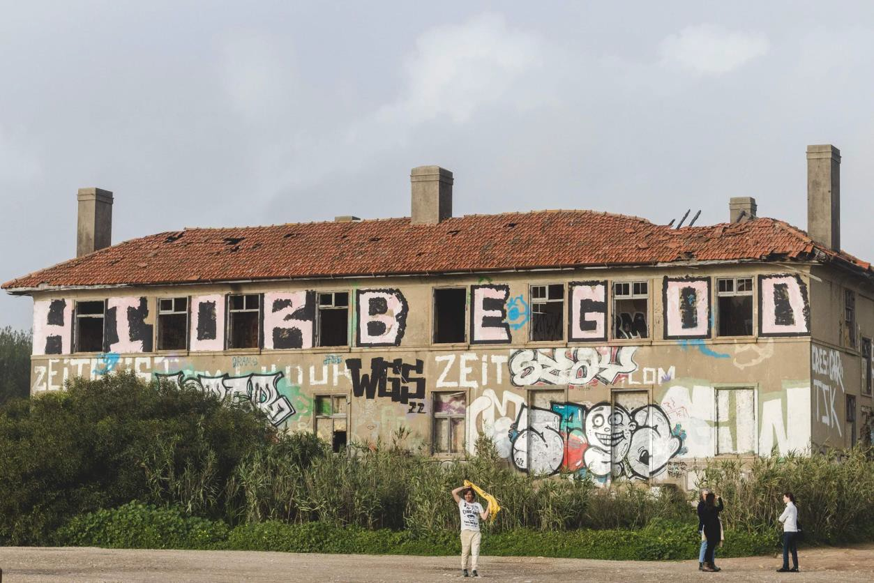
Cover Photo: Historic building of the former Carcavelos Telegraph Station, now in a state of dereliction. Photo by M.C. Twomlow, Dec. 2022.

Julia Twomlow University of Exeter

January 2023

Contents
Contents 2
Table of Figures 3
- Introduction 4
Report Structure 5
- Methodology 6
- A Brief History of Carcavelos Telegraph Station 8
Location and Ownership Today 14
- Key Stakeholders 15
Alves Ribeiro Construções 15
St Julian’s School 15
SOS Quinta dos Ingleses 16
The Municipality of Cascais 16
- Related Factors 17
Environmentalism 17
Cultural Significance 19
- Research Findings 21
First Impressions 21
A Wicked Problem 26
The Need for a New Narrative 28
- Dissemination and Conclusion 29
Bibliography 30

Table of Figures
Figure 1:Postcard showing the cable hut where submarine cables came ashore near Carcavelos beach, c. 1920. Private collection. From: (SOS Quinta dos Ingleses, 2021) 9
Figure 2: Inauguration of the Submarine Cable in the Azores. Source: St Julian's School Archive. 9
Figure 3: Cricket match at Carcavelos Telegraph Station, date unknown. Source: St Julian's School Archive. 10
Figure 4: Photograph of football team members in front of Carcavelos quarters, circa 1901. Source: PK Porthcurno Archive, PHO///5808 11
Figure 5: Group photograph of staff on the front steps of the Palacio, Carcavelos Telegraph Station, circa 1930. Source: PK Porthcurno Archive. PHO///5804 12
Figure 6: Map showing position of the Quinta dos Ingleses and St Julian's School in relation to the coast.(Ecosia Maps, 2023) 14
Figure 7: Entrance to St Julian's School, decorated for Christmas, 2022. Photo by M.C. Twomlow, Dec. 2022 15
Figure 8: Praia de Carcavelos surf beach. Photo by M.C. Twomlow, Dec. 2022 17
Figure 9: Woodland at the Quinta dos Ingleses, Carcavelos. Photo by M.C. Twomlow, Dec. 2022 19
Figure 10: Rubble and fly-tipping pervades the woodland site at Quinta dos Ingleses. Photo by M.C. Twomlow, Dec. 2022 22
Figure 11: Derelict building that once formed part of the historic Carcavelos Telegraph Station. Photo by M.C. Twomlow, Dec. 2022 22
Figure 12: Guerrilla planting at the Quinta dos Ingleses is a regular activity of the SOS group. Photo by M.C. Twomlow, Dec. 2022 23
Figure 13: Avenida Marginal and Carcavelos beach beyond, as seen from the Quinta dos Ingleses. Flooding was evident on the day of our visit. Photo by M.C. Twomlow, Dec. 2022 24
Figure 14: Praia de Carcavelos surf beach. Photo by M.C. Twomlow, Dec. 2022 24
Figure 15: Graffitied concrete sewage pipe at the Quinta dos Ingleses, Carcavelos. Debris from an abandoned development attempt and now part of the landscape. Photo by M.C. Twomlow, Dec. 2022 27

Introduction
In October 2021, PK Porthcurno, Museum of Global Communications, received an email, addressed simply “Dear Sirs”. It had come to our general email address and had been forwarded to the engagement team for a response. Unsure what to do with it in the context of their work, the email was eventually forwarded to me as the museum director and a keen researcher in my own right. The message was instantly intriguing. It came from Carcavelos in Portugal, a coastal town some 18km north of Lisbon. Carcavelos (code name CAR) is significant for us because it was home to the next submarine cable station from Porthcurno (code name PK) on the ‘Red Sea Line’, the original 1870 cable which linked Britain with India. It opened: “Let us start by sharing a (hi)story with you, one that starts at a time when you were at the one end of a cable, and we were at the other end. Please hear us and hopefully you’ll want, like us, to reunite that cable again.”

The group that had sent the email called themselves ‘SOS Quinta Dos Ingleses’. Quinta Dos Ingleses translates roughly as ‘Farm of the English’; a nickname that the land acquired locally in the nineteenth century because of its association with the cable station and the influence on the area of the English telegraph workers who resided there. The email explained that the 52-hectare site of the Quinta was under threat of major redevelopment and that the group had come together, from concerned members of the local community, to campaign for the preservation of this significant heritage site as “the last green stronghold of the Estoril coast” (Duarte, 2021). Hearing of our own work at Porthcurno, both around heritage and the environment, the group was approaching us now to request our support and collaboration with their campaign. My reply reached them just before Christmas 2021, expressing my interest in their story and recognising the synergies. The email correspondence between our two cable stations started there, some fifty years after the last telegraph message travelled between the two stations.

The reason for my particular interest in the evolving story at Carcavelos was that it appeared to mirror in many ways the experience and journey we were on at Porthcurno. On a personal level, I was already fully embedded in a dissertation with the University of Exeter which explored the heritage significance of Porthcurno as a site, beyond the historic buildings and collections, and the role that it had to play in terms of museum activism and agency in our community and developing historical consciousness. It also reflected my interest in the global network of communities associated with communications heritage and a desire to reach beyond our remote coastal location and connect to those places again.

In the summer of 2022, a research opportunity arose with the Clore Leadership Programme to access funding from the Arts and Heritage Research Council. As a former Clore Fellow, I was eligible to apply to the programme and my proposal was accepted. Using the title “Cable Ties”, I initially planned to find and approach communities in and around the last few stations of the original Red Sea Line: Carcavelos, Malta and Gibraltar. As my enquiries commenced, I quickly realised that Carcavelos would be enough on its own. The size of the site at Carcavelos and the level of existing community involvement far outweighed anything that I could identify at the other two former cable stations. Given the scope of my research, I decided to focus on Carcavelos. The following paper describes my research findings, reflections, and the future relationship and actions that I anticipate will arise from it.

Report Structure
After a brief description of my methodology, I begin by providing a contextual history of the site at Carcavelos, specifically in relation to the cable station, including present day ownership. This is followed by a description of the key stakeholder groups. This is followed by a description of related factors including environmental and economic concerns, and cultural/heritage significance. I follow this with an outline of my research findings, starting with my first impressions during the visit and leading into my assessment of the complex nature of the “wicked problem” faced at the site and the potential use of transdisciplinary approaches in tackling them. This section concludes with a discussion of the importance of cultural storytelling and the possible need for a new narrative at the Quinta.

The final section describes the dissemination and legacy of my research findings including the potential to take positive action via PK Porthcurno to assist, via transdisciplinary projects, in breaking the impasse at Carcavelos.

Methodology
My research began in the archives at PK Porthcurno, investigating and reading material within the museum collections to establish a background knowledge of the site at Carcavelos and its relationship to the wider historical communications network, including Porthcurno.

This period of desk top research was followed by a weeklong trip to Portugal, to both Carcavelos and Lisbon. I had intended to complete this visit earlier in the research period but unexpected time pressures at work relating to sudden changes in the museum sector funding landscape in Cornwall, forced me to postpone my trip till December 2022. Then, a couple of days before leaving for Portugal, I sustained an accident at work which resulted in an open fracture of my hand. Fortunately, I received the go ahead from the hospital to continue with my trip, but I was glad of the support of my husband and daughter who travelled with me. As an undergraduate student photographer with a particular interest in environmental concerns, my daughter’s assistance was especially useful as she was able to photograph the Quinta for me whilst I was in meetings and conducting interviews.
Her photography is credited in the report wherever it is used.

During my visit to the site at Carcavelos, I was able to meet with members of the community involved with SOS Quinta Dos Ingleses ¹ and with staff and parents at St Julian’s School². My visit included a tour of the 52-hectare site and meetings with members of SOS, both collectively and as individuals. I was also invited on two occasions to St Julian’s School, which occupies an area of land at the centre of the Quinta. My visits there included a detailed tour of the school buildings and grounds. I then had the opportunity to meet and talk with staff members, including the new headteacher, and a parent member of the St Julian’s Association, the organisation that owns the school. St Julian’s School is currently celebrating its 90th anniversary and whilst visiting I took part in a detailed interview about the history of the school and the wider Quinta, and its relationship to Porthcurno Telegraph Station. Although I met with committee members of the St Julian’s Association that owns the school, I was not able to meet with the current owners of the main area of the Quinta, a major private construction and development company called Alves Ribeiro Construções.³

My stay in Carcavelos was followed by a visit to Lisbon to meet with members of ANACOM, the national regulatory body for communications in Portugal (ANACOM, 2023). ANACOM owns and

¹ https://en.sosquintadosingleses.com/quemsomos
² https://www.stjulians.com/
³ https://alvesribeiro.pt/en/

funds Portugal’s national communications museum in Lisbon, the Museu das Comunicações⁴ and is also involved in most heritage plans and developments across Portugal which touch on communications history. PK Porthcurno has a Memorandum of Understanding with ANACOM which I signed myself in 2019, which outlines a spirit of collaboration and mutual support between the two institutions. My aim with this meeting was to understand their level of interest and engagement with developments in Carcavelos as I felt they could be influential with any further progress at the site.

Following the various visits, meetings, interviews and desk top research, I reflected on my findings, using a perspective I had developed during my M.Res. dissertation research early in 2022. This epistemological approach is broadly self-reflective and considers the agency of the individual as a cultural leader, adapting their craft, skills and experience gathered elsewhere, within a new and unfamiliar setting. My intention had been to capture and record these personal reflections within a working journal. However, the changes to my research timescale which had come about due to workplace pressures, meant that the period of research was necessarily truncated and intensified, and a reflective journal was not possible. Instead, I wrote up my personal notes and have included these under a section titled First Impressions under the Research Findings area of the report.

⁴ https://www.fpc.pt/en/

A Brief History of Carcavelos Telegraph Station
The Quinta Dos Ingleses (Farm of the English) is a local nickname that refers to the former site of the Carcavelos Telegraph Station, on the coast of Portugal some 16km north of Lisbon, in the municipality of Cascais. Carcavelos cable station was founded in 1870 when the land and buildings of the “Quinta Nova”, as it was then called, were purchased by the British-owned Falmouth, Gibraltar and Malta Telegraph Company (later the Eastern Telegraph Company) (Lisboa, 2015).
Carcavelos was to be one of several intermediary telegraph stations on a new cable that was being laid between Britain and India. The route of the cable, which came to be known as the Red Sea Line, was Porthcurno in Britain, to Bombay (Mumbai) in India, via Carcavelos, Gibraltar, Malta, Alexandria, Suez, and Aden. Effectively linking Britain directly with its Empire, the impact of this cable on international trade, politics, and diplomacy would be profound. Messages would previously have been sent by Packet Ships from Britain and it could take up to six weeks for a letter to arrive in Bombay. The new cable now meant that a message could be received in around nine minutes. Just 10 years later in 1880, there was almost 100,000 miles of undersea telegraph cable connecting the world.

The Quinta Nova de Santo António, as the site at Carcavelos was originally called, was an agricultural estate founded in the 18th century and owned by the Alagoa family (Lisboa, 2019). The farm had previously been used for production of a famous and distinctive Carcavelos dessert wine. The land, including its substantial Palacio, was rented and then finally purchased by the Falmouth, Gibraltar and Malta Telegraph Company in March 1870. Two months later, a team of ten telegraphers set sail from Liverpool to form the first cohort of staff for the new cable station in Carcavelos. In June 1870, the final section of the cable, joining Carcavelos and Porthcurno, was completed. Measuring 824 nautical miles long, it started out from Carcavelos on 2nd June 1870 and arrived in Porthcurno six days later. At Carcavelos, in the presence of the Portuguese King and Queen, the shore-end of the new cable was laid on 3rd June with much celebration (Tyson, 1944). It came up into a cable hut on the sandy beach before passing underground into the new cable station in the former Palacio in the Quinta Nova which, in the early days, housed everything for the station including the rather primitive staff accommodation and the telegraph instrument room, which was installed in the former ballroom. As the site developed and grew in importance, so the Palacio was extended, and more buildings added to the site including purpose-built accommodation for married men and their families.

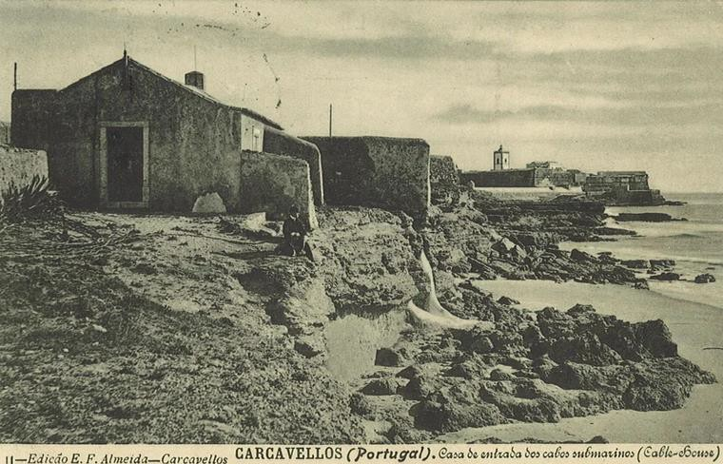
Figure 1:Postcard showing the cable hut where submarine cables came ashore near Carcavelos beach, c. 1920. Private collection. From: (SOS Quinta dos Ingleses, 2021)

When the station first opened, mirror galvanometers were used to receive messages. This was a relatively a slow method, but in June 1871, the Thomson Siphon Recorder was brought in to Carcavelos to improve speed and accuracy. Sir William Thomson himself oversaw the installation. Gradually, more cables were introduced including a duplication of the “Por-Car-One” Carcavelos to Porthcurno cable with the “Por-Car-Two” in 1872 (Barty-King, 1979, p. 120). This was followed by Porthcurno to Vigo via Carcavelos in 1873, Carcavelos to Pernambuco (Brazil) via Madeira and Cape Verde Islands in 1874, Carcavelos to Azores in 1893 ( Fundação Portuguesa das Comunicações, 2015). The arrival of the Brazil cable was a particularly important development and from this point and necessitated a substantial increase in staff numbers at the station.
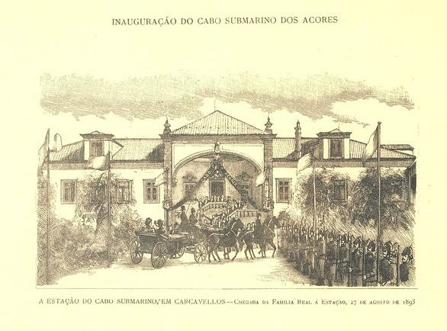
Figure 2: Inauguration of the Submarine Cable in the Azores. Source: St Julian's School Archive.

As far as the Eastern Telegraph Company was concerned, Carcavelos served the additional important function of acting as a finishing school for “probationers” trained in Porthcurno, before posting them to stations in the Far East. This was effectively their first foreign posting, which for many was the reason they had signed up to this exciting new career. As Goodall wrote nostalgically in The Zodiac magazine in 1944, “In spite of all the changes that have come with the passage of the years, there will still be, for the great majority of our readers, a magic in the word Carcavelos, as there is in Porthcurno. The latter might be described as the nursery of the cable service, but Carcavelos was the first contact with the world overseas, and the first actual realization of the lure of foreign service which had been the determining factor in their choice of a career.” (Goodall, 1944).

However, after the initial glamour of a foreign posting, the reality bit hard and there were significant problems at Carcavelos with discipline and staff retention. Like Porthcurno, the remote location and lack of organised “amusements” caused considerable discontent with one station manager describing life at the station as a “living death”. Complaints to the Eastern Telegraph Company executive were rebuffed with the excuse that “the company cannot be expected to pay the staff and amuse them as well”. However, in 1871, there was some small concession when a billiard table was installed in the Staff Mess. A library followed and by 1874, a cricket club had formed. This was the beginning of what was to be a new and unforeseen impact of the telegraph station in Carcavelos as beyond its developing role in global communications, the social and cultural impact of the English telegraphers living within the community proved to be considerable. Translated from the original Portuguese, historian Mario Lisboa explains, “The practice of sports was of enormous importance both for the entertainment of employees and, with its development, in relations with Portuguese society, namely in terms of collective sports.” (Lisboa, 2019, p. 49).
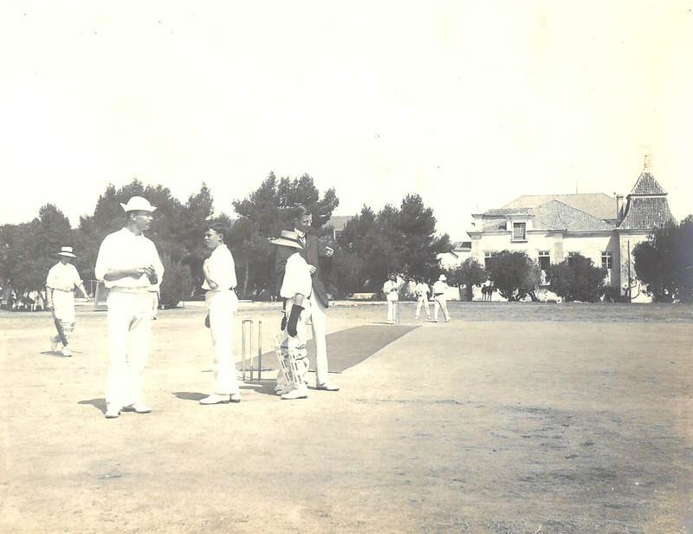
Figure 3: Cricket match at Carcavelos Telegraph Station, date unknown. Source: St Julian's School Archive.

After cricket, other sports followed which were previously little known in Portugal, including tennis, football and cycling. The football ground at the Quinta Nova was the first in Portugal and the game found an appeal with the Portuguese who first played against the staff of the cable station in mixed Anglo-Portuguese teams, before forming clubs of their own. The tennis courts at the station were also popular, with the King Carlos of Portugal himself coming there to play. Along with a new interest in team sports, adopted from the English telegraph workers, came the beginnings of the idolisation of the sportsman as hero. According to Lisboa et al, “This phenomenon gave origin to a previously unheard of cultural core in Portugal. Thus, a new identity started to be built in Carcavelos and its surrounding areas.” (Silva, Lisboa, & Martins Naia, 2013, p. 327). Alongside sport., amateur dramatics, English Fairs and dances were also a regular form of entertainment. In the 1920s, a large recreation hall was built with a stage and bar.
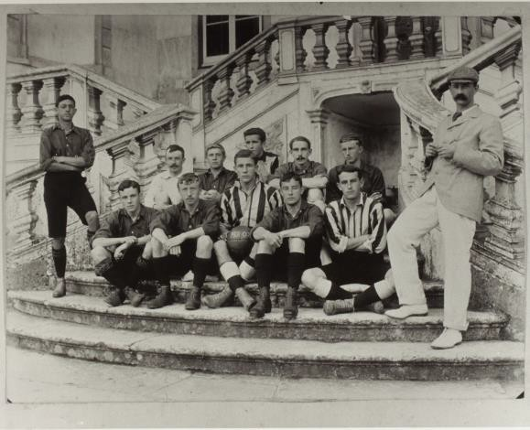
Figure 4: Photograph of football team members in front of Carcavelos quarters, circa 1901. Source: PK Porthcurno Archive, PHO///5808.
These developments at Carcavelos mirrored the community in Porthcurno in many ways where the formation of the “Exiles Club” as a pneumonic community, drawn together by their isolated circumstances and lack of facilities, became the collective identity for sports and other activities.
Homegrown entertainment in the form of theatre, music and team sport, became a mainstay of life at Porthcurno station (Twomlow, 2022) and, as the probationers moved abroad, so they took these amusements with them as a dominant feature of station life and the beginnings of a dispersed

imagined community of telegraph workers (Lee, 2014). It is therefore unsurprising that “Quinta Dos Ingleses” came to replace “Quinta Nova” as the local name for the cable station site, reflecting the influence of the station staff on the hosting community.

Relations between the English cable workers and their Portuguese neighbours were not always amicable. In 1890, the crisis over Mozambique caused an increase in anti-English feelings and there were demonstrations in Lisbon around the British Consulate. The ETC advised staff at Carcavelos not to leave the station grounds and a curfew was introduced. Soldiers were also employed to stand guard at the station for a brief period.

However, it was not just British staff working at the Carcavelos station. By 1883 local people began to find employment there, with the Eastern Telegraph Company advertising vacancies in the local press and recruiting Portuguese probationers. However, it was during the First World War that Portuguese staff numbers increased significantly and rose steadily thereafter. By 1924 the staff numbers had reached a maximum of 155, with nearly a third Portuguese to two thirds English.
Portugal’s neutrality during World War Two meant that the station at Carcavelos was relatively safe from attack, unlike the station in Singapore. It did not receive the level of attention that Porthcurno had, where the station in its entirety was relocated into specially dug underground bunkers.
However, Carcavelos was nonetheless strategically important to keeping communications open and secure.
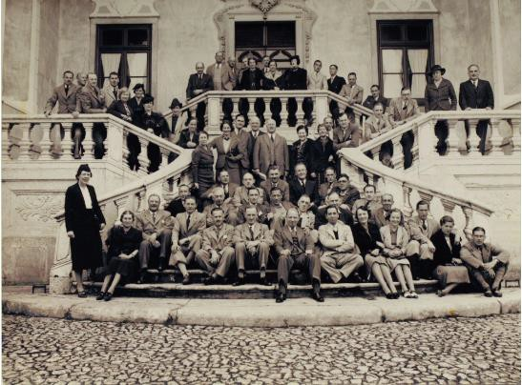
Figure 5: Group photograph of staff on the front steps of the Palacio, Carcavelos Telegraph Station, circa 1930. Source: PK Porthcurno Archive. PHO///5804.

In 1932, a British school was established on the cable station site at Carcavelos. This was not unique for the Eastern Telegraph Company. In Porthcurno, a small private school was set for children of the staff to attend. It was much later when children were sent to the local primary school. Similarly, there was a school on Ascension Island that had been established previously by the British Navy and which was then used for Cable and Wireless families. It meant that families did not necessarily need to send their children back to England to boarding school. However, St Julian’s School at Carcavelos was different in that it was independent of the company and was established under the progressive Parents’ National Educational Union (PNEU) education system.

Gradually from the 1920s, operations at Carcavelos started to wind down. This was prompted by the invention of the Regenerator System (Regen) in 1925 which meant that telegraph machines could now send and receive messages automatically with less need for operatives (Moyle, 2008, p. 22). The result was a huge reduction in staff across the company, with stations requiring fewer engineers. In 1932, with just nine British members of the workforce, the Staff Mess at Carcavelos station was closed. Eventually, technological advances made the telegraph stations themselves redundant. On 31st December 1970, the station at Carcavelos was closed after. Porthcurno also closed as a telegraph station in the same year. Both had seen a full century of service.

After the closure of the station, St Julian’s School remained on the site; an independent charity and now one of the largest international schools in Portugal, now celebrating its 90th anniversary. The rest of the Quinta land was sold by Cable & Wireless to Lisbon-based construction company Alves Ribeiro Construções. Plan and proposals over the redevelopment of the land have been circulating since the 1960s, creating considerable controversy and public opposition. Today the long-term future of the site remains uncertain, however in 2014, plans submitted by Alves Ribeiro Construes for redevelopment of the Quinta were approved by the Municipality of Cascais. The proposal included 850 apartments, arranged into blocks up to 9 storeys high, three hotels, a substantial shopping mall and the subsequent loss of all but ten hectares of woodland and green space (SOS: Quinta-Ingleses, 2019).

Location and Ownership Today
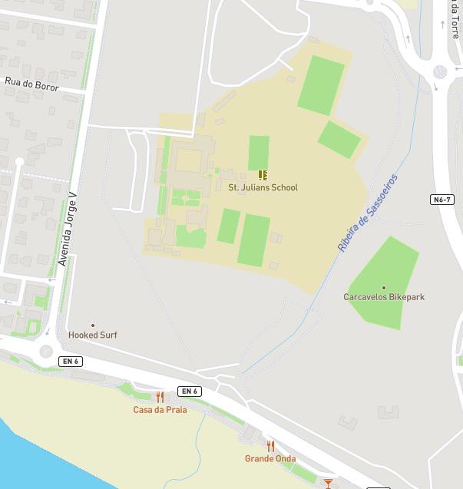
Figure 6: Map showing position of the Quinta dos Ingleses and St Julian's School in relation to the coast.(Ecosia Maps, 2023)
Primarily woodland, the 52-hectare site of the Quinta dos Ingleses is situated close to the coast in Carcavelos, Cascais, and is one of the last areas of open, undeveloped ground in the area. The Quinta is separated from the popular surf beach at Carcavelos by the EN 6, or Avenida Marginal, which is reputed to be one of the busiest roads in Portugal (see Fig 6).

Today, the Quinta dos Ingleses is a contested space with three main stakeholders. Once owned entirely by the Eastern Telegraph Company, ownership is now held between two bodies: Alves Ribeiro Construes and the St Julian’s School Association. The relatively small area owned by the school includes the historic Palacio, courtyard and quadrangle, associated school buildings and playing fields. The remainder and majority of the site belongs to Alves Ribeiro Construções; the school forming an island within the Alves Ribeiro Construes property. However, while they have no rights attributed by ownership, the biggest user group, and therefore a significant stakeholder of the Quinta, is the local community, represented in part by SOS Quinta dos Ingleses. In addition to the three main stakeholders, a fourth party, the Municipality of Cascais, wields considerable power and influence over the future of the Quinta.

Key Stakeholders

Alves Ribeiro Construções
Alves Ribeiro is a large, privately owned Portuguese construction company founded in in 1941. The company operates in both the private and public sector and has an international presence in Brazil and Angola, although most of their trade is within Portugal. According to the company website, in 2021 they had a nett value of 400,587,000 euros (Alves Ribiero Construction, 2021). Interestingly,
the company’s earliest work related to communications routes and airfields. Their ownership of the Quinta dos Ingleses dates from the 1960s when the site, with the exception of the school, was purchased from the Eastern Telegraph Company. However, some buildings belonging to the school and in regular use, are situated on land belonging to Alves Ribeiro.

St Julian’s School
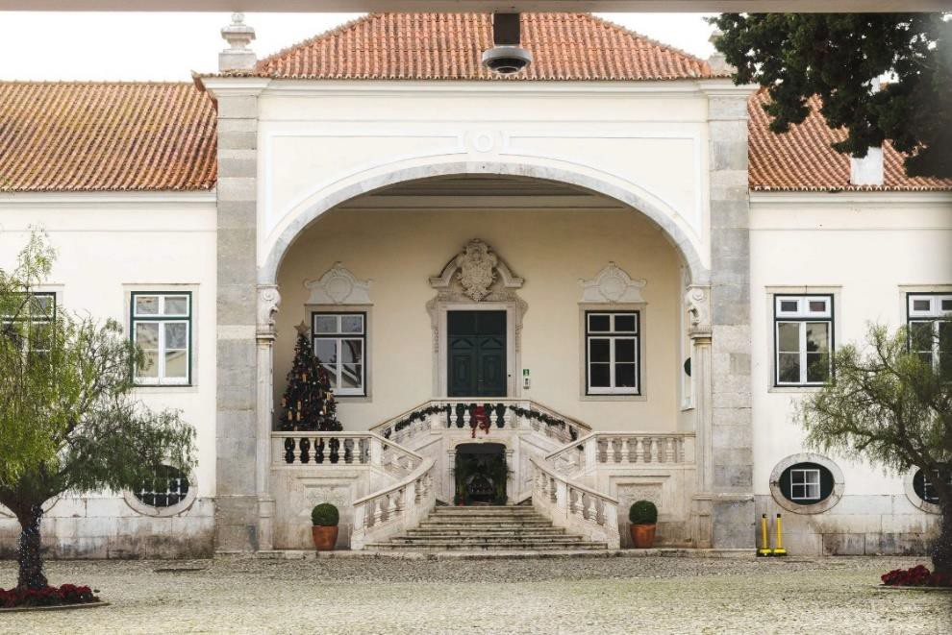
Figure 7: Entrance to St Julian's School, decorated for Christmas, 2022. Photo by M.C. Twomlow, Dec. 2022.
Established in 1932, St Julian’s is a fee-paying day school which sits at the centre of the Quinta dos Ingleses with access to the surrounding town and link roads via two avenues which cross land owned by Alves Ribeiro Construções (see Fig 6). While considered ‘British’ in terms of its education system and history, the school has an international student body, with intake from 45 different countries.
The curriculum covers ages 3 to 18 years, with around 1500 pupils on the register at any given time. The school occupies the historic Palacio (see Fig 7), which was part of the original farm complex of the Quinta Nova, and which became the buildings and accommodation for the original Carcavelos Cable Station owned by the Eastern Telegraph Company. The school is now owned and governed by the St Julian’s School Association; a voluntary, non-profit making organisation with a membership of approximately nine elected governors (St Julian's School, 2023). The Association has responsibility,

not only for policy and educational decision-making, but also for the upkeep and development of the school buildings and site.

SOS Quinta dos Ingleses
SOS Quinta dos Ingleses is an environmental association formally constituted in June 2021 to fight for the preservation of the Quinta dos Ingleses as a green space, upholding its historical, cultural, environmental, arboreal and landscape integrity (SOS Quinta dos Ingleses, 2021). The core group has twenty active members from professional backgrounds who describe themselves as concerned citizens of Cascais, intent on informing and engaging the local population with saving the Quinta (SOS Quinta dos Ingleses, 2021). They use a combination of lobbying and environmental activism to further their campaign.

The Municipality of Cascais
Cascais is the government district in which Carcavelos is situated. While the Municipality has no explicit interest in the Quinta dos Ingleses, theirs is possibly the deciding vote on its future. In 2021, the Portuguese Government passed a resolution undertaking to work towards “Local Protected Landscape” status for Quinta dos Ingleses. However, the authority to grant this status sits with the Municipality. To date, they show no signs of upholding the resolution on the grounds that the compensation payable to the owners, Alves Ribeiro, would be prohibitive.

Related Factors
Arguments over the future of the Quinta dos Ingleses have been raging since 1970. However, the world today is not the same as it was fifty ears ago and the context has changed. As an outsider, it appears, that plans for the Quinta dos Ingleses have not moved on in line with changing social and economic considerations. What is being proposed has been described as “A 20th century project inadequate for the 21st century challenges” (SOS: Quinta-Ingleses, 2019). So, what are the current factors that should be considered in relation to the future of the Quinta?

Environmentalism
The Quinta dos Ingleses is situated close to the famous Estoril coastline in the district of Cascais, with just a road width between its borders and the Praia de Carcavelos. Praia de Carcavelos is reputedly Portugal’s “first-surfed and often best beachbreak” (Surfline, 2023). The largest and most popular beach on the Lisbon coast, it has near legendary status and a thriving surf culture, even in winter. As a popular beach-focussed tourist destination, Carcavelos has parallels to Porthcurno beyond its cable history. As a resident and business manager in Porthcurno, I recognise the importance of
“surfonomics” to our local economy; meaning the financial contribution of surf culture to the local economy (Save the Waves, 2015-2023). I deduce from this that Carcavelos beach must have a similar financial role to play for its residents, business owners and the Municipality.
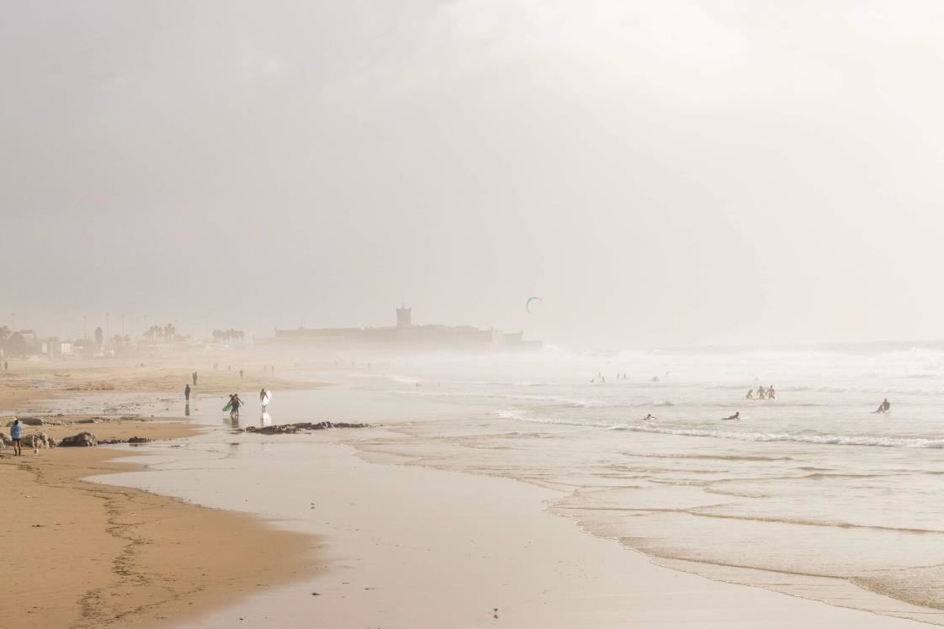
Figure 8: Praia de Carcavelos surf beach. Photo by M.C. Twomlow, Dec. 2022.

In the initial approval of the development proposals at the Quinta dos Ingleses in 2014, the Municipality of Cascais denied that there would be any negative impact on the beach and surf conditions caused by the plans. However, SOS Salvem o Surf (Save our Surf), an established
Portuguese NGO association akin to Britain’s Surfers Against Sewage, stepped up to challenge the decision. Their mission is the protection of Portugal’s coastline (Surfers Against Sewage, 2015). Salvem o Surf commissioned their own investigation into the likely impact of the development at Quinta dos Ingleses, disputing the findings of the local authority which said that the beach would not be adversely affected by the proposals. Instead, the research conducted by Salvem o Surf concluded that the cumulative effects of the development would create a spiral of negative impacts on the beach and its suitability for surfing, including changes to the landscape and topography, to aerodynamics, prevailing wind, air quality and increased traffic and population density (Lima, Alves, & Navas, 2014). The loss or degradation of the popular surf beach would impact negatively on surf culture and its related economic benefits locally.

In addition to dramatic changes to the beach at Carcavelos, if plans go ahead, the redevelopment of the Quinta dos Ingleses will result in the loss of most of the woodland and natural space in the 52- hectare site, along with its playing fields, grassy areas and a stream which runs through, as highlighted by SOS Quinta dos Ingleses (SOS: Quinta-Ingleses, 2019). The impact on both biodiversity and community wellbeing is central to their campaign, as is its secondary economic role.

In her blogpost on the Quinta dos Ingleses, Lilla Schottner, friend of the SOS group, highlights the importance of green spaces and parks in urban areas, not only the mental and physical health benefits they bring, but their role in community cohesion and the economic value they bring (Schottner, 2022). Schottner’s position on environmental economics is not new; debates around the interrelationship of the economy and environment have been ongoing since the 1960. However, when Alves Ribeiro bought the Quinta fifty years ago, environmental economics would have been considered a fringe theory at best. Until more recently, traditional economic theories have prevailed, which essentially ignore the interrelationship of the economy and the environment. In his review of the economics of biodiversity, commissioned by HM Treasury, the economist Professor Sir Partha Dasgupta questions conventional economic models as caricatures of the real world, limiting our ability to conceptualise alternative economic futures (Dasgupta, 2021). Dasgupta encourages our
role as “citizen investors”, working to counter the traditional loyalty of our neighbours to an

economic model that fosters unrealistic notions of unlimited global growth without adverse impact on the biosphere. To do this, he suggests, demands a high level of self-responsibility, but it also it requires that we “develop an affection for Nature and its processes”.
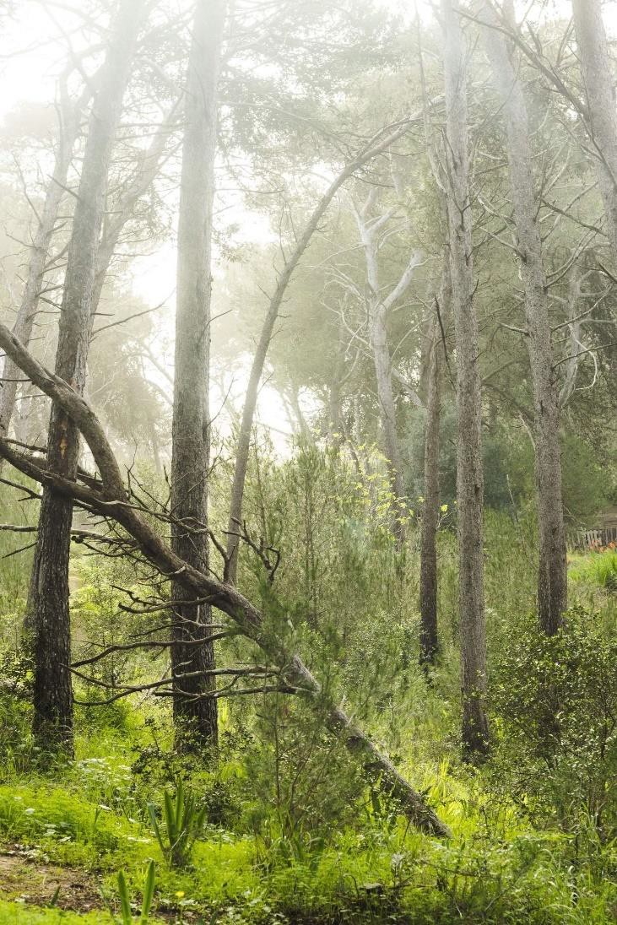
Figure 9: Woodland at the Quinta dos Ingleses, Carcavelos. Photo by M.C. Twomlow, Dec. 2022.

Cultural Significance
While environmental concerns have been at the forefront of the campaign championed by SOS Quinta dos Ingleses, the unique heritage of the Quinta is a dual factor and one that prompted them to reach out to PK Porthcurno. In the UK, we use the term “Heritage Significance” to refer to “The value of a heritage asset to this and future generations because of its heritage interest.” (Ministry of Housing, Communities & Local Government, 2021). At Porthcurno, our “Heritage Significance” is recognised and well documented through such tools as museum accreditation, listed building status, collection designation, and the awarding of Area of Outstanding Natural Beauty and International Dark Skies Park to the wider area around Porthcurno. The assessment of Heritage Significance is useful in deciding suitable conservation measures and facilitating public engagement with the

physical site for planning decisions but, as I argued in my MRes dissertation, it has its limitations (Twomlow, 2022).

Instead, the term “Cultural Significance”, as used in Scotland (Scottish Government, 2021) and Australia (ICOMOS , 2013) for heritage sites, allows for a more nuanced approach which considers both tangible and intangible aspects of a site, meaning the “aesthetic, historic, scientific, social or spiritual value for past, present or future generations” (ICOMOS , 2013). Cultural significance is therefore intrinsic to the place itself and allows that its importance can be both tangible and
intangible, embodying different things for different people. Therefore, for the Quinta dos Ingleses, it is the interplay between people, place and activities, between heritage and nature, and between past and present, that makes the site culturally significant.

Research Findings

First Impressions
We arrived at Carcavelos on the first day of our visit and were greeted Rita Duarte, the person who had first emailed in 2021 and reached out to us at PK Porthcurno. Rita took us to meet with other members of SOS Quinta dos Ingleses over lunch. They are an impressive group of individuals, enthusiastic and highly motivated with a wide range of professional experience including communications, law, engineering and environmental activism. Following lunch, they were keen to take us straight to the Quinta for a guided tour of the 52-hectare site. Boots were mandatory as the Lisbon coast had been experiencing its worst flooding for decades.

On arriving, Rita expressed her exasperation at the sight of some new fly-tipping. The SOS volunteers regularly organised clean ups of the site, she explained, but within days more rubbish would appear including large objects like furniture and vehicles. It felt deliberate, she said, like the owners were allowing the Quinta to become abandoned and degraded in order that local people would be worn down and accept their development plans.

As we got out of the car, a man proceeded to pull down his trousers and defecate on the ground less than 20 metres away from us, in full view. This kind of behaviour was not unusual it seemed. Nearby was a makeshift campsite with vans and tents. One was home to a Venezuelan family with a small child who had arrived in Carcavelos with nowhere else to go. Rita worried at how they were coping in the terrible weather. As we continued through the large site, the SOS group pointed out where attempts had previously been made by Alves Ribeiro to start development works. In places, ground was strewn with rubble, large ditches and deep holes gaped dangerously where pipes were once intended to go, and abandoned lengths of sewer now stood, adorned with the ubiquitous graffiti, like a bizarre sculpture park.

As we ventured further across the park, we came upon the former staff quarters of the telegraph station, substantial residential buildings which once would have housed several families. The houses now stand derelict (see Fig. 11), rooves open to the skies, doors, windows and floors missing. My daughter’s attempts to obtain closeup photos prompted a quick warning from Rita, as apparently
these houses were now notorious locations for what she termed “male prostitution”. While we stood there, a small group of men eyed us suspiciously and remarks were shouted at us about the presence of the camera.

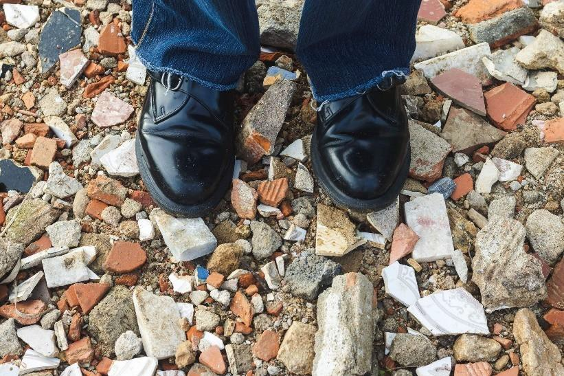
Figure 10: Rubble and fly-tipping pervades the woodland site at Quinta dos Ingleses. Photo by M.C. Twomlow, Dec. 2022.

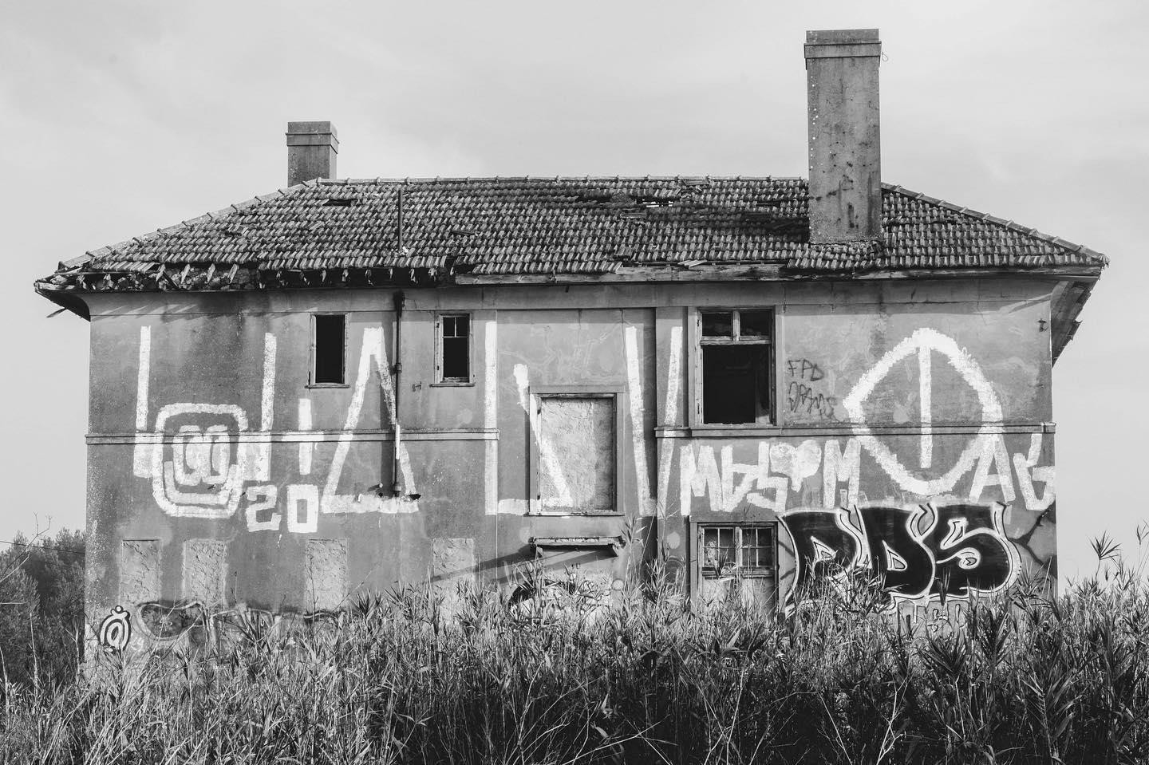
Figure 11: Derelict building that once formed part of the historic Carcavelos Telegraph Station. Photo by M.C. Twomlow, Dec. 2022.

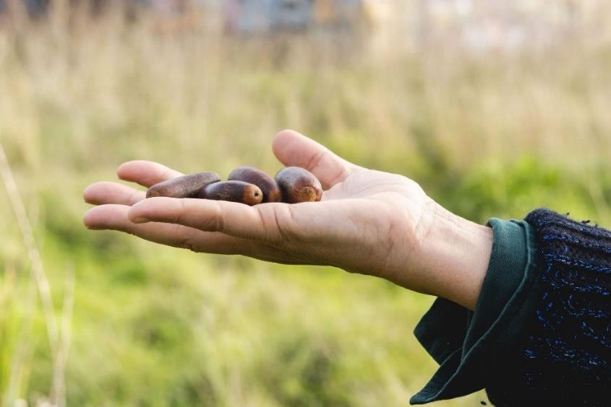
Figure 12: Guerrilla planting at the Quinta dos Ingleses is a regular activity of the SOS group. Photo by M.C. Twomlow, Dec.
2022.
We stopped for a moment to carry out some “guerrilla planting” as the SOS members explained. They were taking every opportunity to protect and renew the precious woodland including planting acorns around the site (see Fig 12).

At the coastal edge of the Quinta, the site meets the main EN 6 road, also known as the Avenida Marginal. Hugging the Estoril coastline and linking Lisbon with Cascais, the Marginal has a reputation as one of the busiest and most dangerous roads in Portugal. The width of the Marginal is all that lies between the Quinta dos Ingleses and Carcavelos beach, one of the largest and most popular surf beaches in Cascais. We cross to the beach via an underpass and, once on the promenade, I am struck by its similarity to Cornwall. Surf culture is another thing that unites us as communities.

My first impression of the Quinta dos Ingleses and the people trying to save it is of the enormity of the task they have ahead. Responding to their emails at home in Porthcurno, I had not fully appreciated the scale of the site nor the extent of the redevelopment plans. I had not understood how close it is to the beach and the town, how the school is nestled in the centre, surrounded by wooded green space but also by dilapidation and dereliction. I couldn’t help agreeing with SOS - the neglect was palpable, deliberate. I was fully aware that some of these volunteers had been involved with the project for nearly ten years, and I was impressed by their tenacity and persistence in the face of so many obstacles.

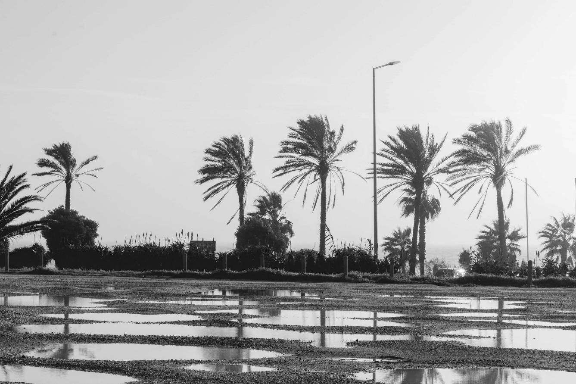
Figure 13: Avenida Marginal and Carcavelos beach beyond, as seen from the Quinta dos Ingleses. Flooding was evident on the day of our visit. Photo by M.C. Twomlow, Dec. 2022.
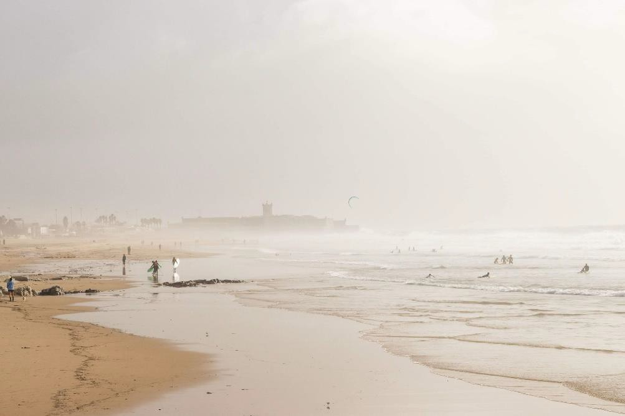
Figure 14: Praia de Carcavelos surf beach. Photo by M.C. Twomlow, Dec. 2022.

On the second day of my visit, I had been invited to St Julian’s School. This invitation had come to me independently of the SOS group. Researching the 90th anniversary of the school, they had come across our website and online archive at PK Porthcurno and approached us for help accessing photographs for an exhibition they were compiling. Making the most of my visit to Carcavelos, I had agreed to take part in an interview which was to be recorded for their anniversary. The interview took place over a couple of days and in between I was able to take in more of the school and understand its relationship to the wider Quinta site.

What struck me was the passion and enthusiasm that the staff and parents I met had for the school and for its unique history. They were also keen to re-establish links with Porthcurno and appreciated the wider relevance of the Quinta site. What I also came to understand was the compromised and uncomfortable position in which St Julian’s School Association found itself. Essentially occupying an island within Alves Ribeiro land, they are beholden to the development company both for access to the school and for some of their buildings, which are situated on land outside of the school curtilage. They also have serious concerns over the condition of some of their older buildings, and I wondered if there had been implied promises from the developers that all would be made good for the school if they avoided rocking the boat. However, the price of submissiveness would be high, and one member of the Association commented on how awful it would be for the school to have high rise apartment blocks and hotels constructed right on their boundaries, replacing the current vista of green park and woodland. It struck me that the interests of the school were more sympathetic with those of the SOS group, but there appeared to be little contact between the two, despite direct approaches from the chair of SOS, Manuel Valadas Preto (also a parent at the school) to the new headteacher, inviting a dialogue.

Over the next few days of my trip, further meetings and visits took place with both the school and SOS group. I was puzzled at the lack of awareness there seemed to be between the two, given the closeness of their interests. The school purported a lack of knowledge of SOS, as if it were a minor interest group that had recently appeared rather than a movement with a legal constitution that had managed to organise a 9,000 person strong petition to the Municipality and a human chain demonstration around the 52 hectare site (SOS Quinta dos Ingleses, 2021). Members of SOS expressed frustration and distrust of the school, questioning why they would not engage in a dialogue with them and surprise at y reports that the school appeared to share the same concerns about the planned developments. I tended to agree with the SOS members that the school’s failure

to engage directly with the debate was concerning. I wondered if they fully appreciated their own agency in the matter and potential to affect positive change.

During the trip, I was unable to meet with the Cascais Municipality although we had previously approached the mayor in 2021 with a letter from the chair at PK Porthcurno expressing our concerns at the development plans and urging them to support the government resolution to grant the land protected status Our letter did not receive a response. I also did not attempt to meet with anyone from Alves Ribeiro as I considered that my relatively poor understanding of the issues might do more harm than good. I also knew that members of SOS had recently sat down for a dialogue with the company, in November 2022, but had come away dissatisfied. Instead, I arranged to meet with old friends at ANACOM, the communications industry regulators in Portugal and owners/funders of the national Museu das Comunicações in Lisbon. PK Porthcurno has a memorandum of Understanding with ANACOM, signed in 2019, and based on our mutual interest and concern with communications heritage. I had previously raised the question of Carcavelos with my contacts at ANACOM and had received a lukewarm response. I was keen to talk to them again face to face to dig deeper. We did this over lunch but once again my attempt to open a dialogue was thwarted. They advised me that it was not something we should get involved with and that the SOS group members had ulterior
motives. I couldn’t help thinking that the ulterior motive of wanting to safeguard a heritage site for your community was a worthy aim, but it was clear that the conversation was closed, and I retreated to what I considered was safer ground, enquiring about the museum in Lisbon. However, this also proved sensitive as it appeared ANACOM was about to withdraw its funding and that the collections would need to be dispersed. I left the meeting with more questions than answers.

A Wicked Problem
From my research visit, it has become clear that an impasse has been reached. The developers want their money, the community want their green space, the school want stability and security, and the local authority, who hold the key, seem unwilling to intercede. While I was unable to meet with representatives of the Municipality or the construction company on this occasion, I was able to meet with representatives of both the school and the SOS community. What emerged was a high level of mistrust and a lack of open communications between the different factions. While this was not altogether surprising, it was clearly feeding the problem and adding to its complexity. My meeting with my contacts at ANACOM added to my concerns. As the custodians of Portugal’s national communications museum and collections, I had hoped to arouse their interest and garner their support, so their refusal to discuss it was troubling. Possibly, the situation in Carcavelos was deemed too political for them to become involved with. Given that the national government of Portugal had

recently made clear its ambition for the safeguarding of the Quinta dos Ingleses as a “Local Protected Landscape”, I was surprised at ANACOM’s lack of engagement with the matter.

From my observations and research, it appears to me that the social complexity created by the entrenched stakeholders’ positions in relation to the Quinta dos Ingleses is compounded by the apparent reluctance of the Municipality to adopt a position of moral responsibility and help find a solution. In turn this is exacerbated by the reluctance of other influential groups, like ANACOM, to take a stance. This combination of factors leads me to conclude that the trouble at Quinta dos Ingleses is what could be termed a “wicked problem”, by which I mean it is not intrinsically evil but “diabolic” in terms of its resistance to normal methods of resolution (Rittel & Webber, 1973).

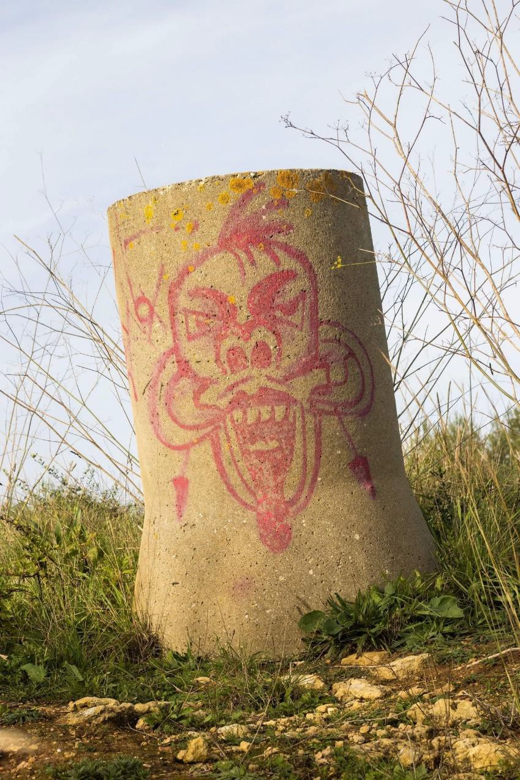
Figure 15: Graffitied concrete sewage pipe at the Quinta dos Ingleses, Carcavelos. Debris from an abandoned development attempt and now part of the landscape. Photo by M.C. Twomlow, Dec. 2022.

According to Brown, Harris and Russell, “wicked problems” often need a transdisciplinary approach (Brown, Harris, & Russell, 2010). This means an approach that embraces complexity and uncertainty, acknowledges the local context, is based on intercommunication and collaboration, and is action focussed. Linking theory to professional practice, transdisciplinarity is a practical, real-world approach to “achieving innovative goals” (Lawrence, 2010, p. 20). I believe this is where PK could help. Our own success in marrying heritage and environmental activism around the powerful notion of the connected planet is as relevant to Carcavelos as to Porthcurno. PK’s accredited museum status, designated collection, historic site and experience offer a credible and independent voice and the chance to create a positive new narrative for the Quinta dos Ingleses, helping to shift perspectives towards a shared resolution.

The Need for a New Narrative
When I visited Carcavelos in December 2022, the Lisbon coast was experiencing its worst flooding in decades with roads underwater and the capital inaccessible for days. Flooding is now all too common in Britain, but it is new and frightening in Portugal. In the face of such incontrovertible evidence, the question of the Quinta’s future seemed even more prescient. How could local people and the Municipality allow this last substantial green space to be lost under concrete? It seemed unfathomable that it was even being considered. However, engaging with climate change as a subject can be difficult.

According to climate change communications specialist, George Marshall, the difficulty in motivating people behind environmental action stems from our apparent inability or unwillingness to fully engage with the subject matter (Marshall, 2015). Human nature, and therefore society, appears hard-wired to ignore perceived existential threats (Beck, 1992). Greer suggests that what is needed is a new way of talking about the future, new cultural stories and narrative by which we can bring people together (Greer, 2008). It occurred to me that this may be part of the wicked problem at Quinta dos Ingleses. Alongside the conflicting interests and entrenched positions of the stakeholder, the narrative of loss is simply too difficult to engage with. What is needed is a new narrative.

I recall attending a lecture in 2013 by Chris Barnatt, of Nottingham University, for the Clore Leadership Programme when I was facilitating a Clore Short Course. Barnatt suggested that it is our role as cultural leaders to foster new and positive narratives for the future. This idea has always stuck with me. After all, if there is one thing we are good at, it is telling stories.

Dissemination and Conclusion
While I was visiting Carcavelos, I had the opportunity of taking part in an interview for St Julian’s School about the history of Carcavelos Telegraph Station and its relationship to Porthcurno. The interview was longer than I had expected, but there was a lot to talk about; a century long shared story between our two communities. I perceived a genuine appetite to know more, and I was delighted when they invited me back to join the school community again in July 2023 for the close of the anniversary celebrations. We undertook to exchange archival material digitally and link up over a future exhibition.

Similarly with the SOS Quinta dos Ingleses group, there has now been a visit in both directions and shared blogs and social media posts. My return visit in July will be to discuss next steps with both the school and the SOS group and hopefully assist in furthering the dialogue with ANACOM. I believe that through my visit, trust has been established between both PK Porthcurno and SOS Quinta dos Ingleses, and between PK Porthcurno and St Julian’s School, and I hope to use this fortunate position to try and bring the two together to work collaboratively in future.

As well as the exhibition and archive exchange, I am offering them two transdisciplinary project ideas as a starting point to tackling the wicked problem and breaking the impasse. The first is a relatively simple one – a message passed between PK Porthcurno and Carcavelos in the form of an artist intervention with its respective schools, connecting the primary age children directly with each other in the digital realm with the creation of animated film, letters, and stories. The second is more ambitious and that is to replicate the first cable landing of 1870 by send a sailing ship between our stations with a crew of thirty young people from Cornwall and Cascais. The training ship will follow the route of the last section of the Red Sea Line, with the young crew learning about the history of global communications and gaining a historical consciousness of the part their communities played. At the same time, they will be studying and monitoring the ocean and asking questions, in the spirit of Dasgupta’s “citizen investors”, carrying with them a new story of community collaboration and global connectedness.

Bibliography
Fundação Portuguesa das Comunicações. (2015). The Submarine Cable in a Sea of Connectivity.
Lisbon.
Alves Ribiero Construction. (2021). Group Financial Data. Retrieved January 27, 2023, from Alves Ribiero Construction: https://www.alvesribeiro.pt/en/group/financial-data/11
ANACOM. (2023). Who we are. Retrieved from ANACOM: https://www.anacom.pt/render.jsp?categoryId=1680
Barty-King, H. (1979). Girdle Round the Earth: The Story of Cable & Wireless. London: William Heinemann Ltd.
Beck, U. (1992). Risk Society: Towards a New Modernity. (M. Ritter, Trans.) London: Sage. Brown, V. A., Harris, J. A., & Russell, J. Y. (2010). Tackling Wicked Problems Through the
Transdiciplinary Imagination. Abingdon, Oxon: Earthscan.
Dasgupta, P. (2021). The Economics of Biodiversity: The Dasgupta Review: Abridged Version. London: Crown copyright. Retrieved from https://assets.publishing.service.gov.uk/government/uploads/system/uploads/attachment_ data/file/962785/The_Economics_of_Biodiversity_The_Dasgupta_Review_Full_Report.pdf
Duarte, R. (2021, October 29). Email: Submarine Telegraph Cable Station - Carcavelos. Carcavelos.
Ecosia Maps. (2023). Ecosia Maps. Retrieved January 26, 2023, from https://www.ecosia.org/map?q=eN304%20road%20portugal&coordinates=36.734923,- 5.1657477&placeName=Pz%20Portugal
Goodall, A. G. (1944, January). Carcavelos Memories. The Zodiac, 36, p. 11.
Greer, J. (2008). The Long Descent: A User's Guide to the End of the Industrial Age. New Society Publishers.
ICOMOS . (2013). Australia ICOMOS Burra Charter.
Lawrence, R. J. (2010). Beyond Transdisciplinary Confinement to Imaginative Trandisciplinarity. In V.
A. Brown, J. A. Harris, & J. Y. Russell, Tackling Wicked Problem Through the Transdiciplinary Imagination (pp. 16-30). Abingdon, Oxon: Earthscan.
Lee, J. R. (2014). Empire, Modernity and Design: Visual Culture and Cable & Wireless' Corporate Identity, 1924-1955. University of Exeter. PhD diss.
Lima, M. A., Alves, M. J., & Navas, J. (2014). Parecer da SOS - Salvem o Surf sobre a Avaliação Ambiental dos projetos do Plano de Pormenor do Espaço de Reestruturação Urbanística de

Carcavelos-Sul e do polo da NOVA SBE na praia e no surf de Carcavelos. Carcavelos: SOS - Salvem o Surf .
Lisboa, M. E. (2015). The Eastern Telegraph Company at Carcavelos. The British Historical Society of Portugal. Retrieved 2023
Lisboa, M. E. (2019). A Estação do Cabo Submarino de Carcavelos. Lisbon: Edições Colibri.
Marshall, G. (2015). Don't Even Think About It: Why Our Brains Are Wired to Ignore Climate Change. .
Bloomsbury USA.
Ministry of Housing, Communities & Local Government. (2021). National Planning Policy Framework.
Crown Copyright.
Moyle, J. (2008). Timelines of Telegraphy. Penzance: PK Porthcurno.
Rittel, H., & Webber, M. (1973). Dilemmas in a General Theory of Planning. Policy Sciences, 4(2), 155- 169.
Save the Waves. (2015-2023). Surfonomics - Save the Waves. Retrieved January 26, 2023, from Save the Waves Coalition: https://www.savethewaves.org/surfonomics/
Schottner, L. (2022, November 1). Preserving the last lungs of Carcavelos/Portugal. Retrieved January 29, 2023, from Green Lilla: https://www.greenlilla.com/post/preserving-the-last- lungs-of-carcavelos
Scottish Government. (2021). Scotland 2045 - Fourth National Planning Framework - Draft: Consultation.
Silva, A., Lisboa, M., & Martins Naia, A. (2013). Locality in the Global World: facts and reflections on the Lusitanian land. Examples of the heritage of submarine cables. In A. Giuntini, & A. Silva (Eds.), Economics and Politics in Submarine Telegraph Cables (XIXth and XXth Centuries). A Global Perspective Between History, Heritage and Preservation (pp. 321-352). Edizioni Scientifiche Italiane.
SOS Quinta dos Ingleses. (2021, June 24). Estatutos da Quinta dos Ingleses - Associação Ambiental.
Retrieved from SOS Quinta dos Ingleses: https://en.sosquintadosingleses.com/_files/ugd/d4bafb_4ab6770f738a46a280fa49ced9e10 d45.pdf
SOS Quinta dos Ingleses. (2021, June). June 5th 2021: the day we hugged Quinta dos Ingleses.
Retrieved from SOS Quinta dos Ingleses: https://en.sosquintadosingleses.com/post/june- 5th-2021-the-day-we-hugged-quinta-dos-ingleses
SOS Quinta dos Ingleses. (2021). Our association. Retrieved January 26, 2023, from SOS Quinta dos Ingleses: https://en.sosquintadosingleses.com/associacao

SOS Quinta dos Ingleses. (2021). We build our future from Quinta dos Inglese's history. Retrieved Jan 22, 2023, from SOS Quinta dos Ingleses: https://en.sosquintadosingleses.com/onossopassado
SOS: Quinta-Ingleses. (2019). Quinta dos Ingleses: A Valuable Heritage.
St Julian's School. (2023). Leadership Team & Governance. Retrieved January 27, 2023, from St Julian's School: https://www.stjulians.com/our-school/leadership-team-governance
Surfers Against Sewage. (2015, October). SOS – Salvem o Surf: A 2015 Global Wave Conference Partner Carcavelos, Portugal. Retrieved January 26, 2023, from Global Wave Conference Cornwall & London: https://www.sas.org.uk/globalwaveconference/sos-salvem-o-surf/
Surfline. (2023). Carcavelos Surf Report & Forecast. Retrieved January 26, 2023, from Surfline: https://www.surfline.com/surf- report/carcavelos/5842041f4e65fad6a7708bc0?camId=5da9edb609db0e79ed48a2c3
Twomlow, J. (2022). Return of the Exiles: Agency, Community and a Third Place at PK Porthcurno.
University of Exeter. Unpub. MRes Diss.
Tyson, L. (1944, January). Carcavelos. The Zodiac, 36(421), pp. 3-10.

