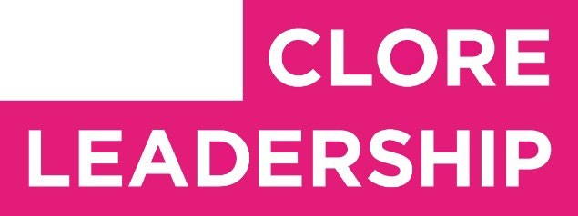

Clore Leadership-AHRC Online Research Library Paper
Growing Policy: Glass House, Art, Evidence
Author: Stephen Bennett Supervisor/s: Patrycja Kaszynska, University of the Arts London
Year paper completed: 2023

Leadership Content Theme/s: Climate Leadership, Sector Insights, Governance
AHRC Subject Area/s: Policy Arts Management and Creative Industries, Community Art (including Art and Health) A note on contents:
Since 2005 Clore Leadership and AHRC have partnered to offer a diverse range of cultural leaders the opportunity to produce a piece of extended research relating to leadership and to their specific cultural discipline. These papers, published from 2023 onward on the Clore Leadership-AHRC online research library, reflect an important contribution to the field and we are extremely pleased to make them available to practitioners, scholars, and other interested parties. We recognise that this research library contains a range of terminologies and outlooks: these are reflective of the significant and ongoing changes within the cultural sector over the past 20 years. As such we urge readers to recognise that the authors’ thinking and language may have shifted since completion of these papers, or may be in the process of shifting as consequence of their enquiries.
Unless otherwise stated, research papers included in the Clore Leadership-AHRC Online Research Library have not been formally peer reviewed or published in an academic journal.

GROWING POLICY: GLASS HOUSE, ART,
EVIDENCE
SRG BENNETT
February 2023
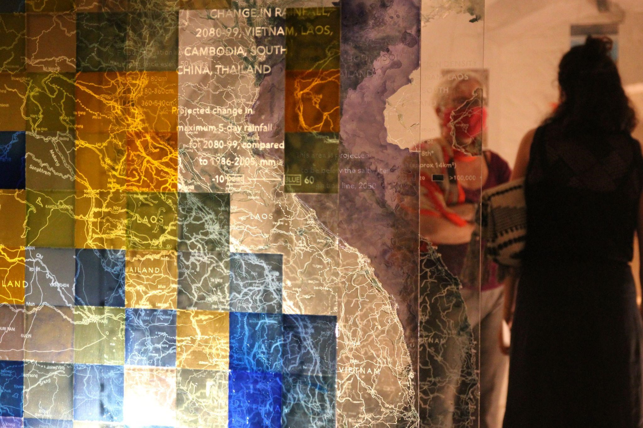
Figure 1: Participants in Glass House, with Layers of Southeast Asia in the foreground (image credit: the author)

EXECUTIVE SUMMARY
Many artists work on topics which relate to policy, from climate change to inequality, from biodiversity to artificial intelligence. This Clore Leadership/Arts and Humanities Research Council (AHRC) funded project interrogates the notion that such work can lead to transformation in policymaking. It reflects on the extent to which art can influence how policy is made by looking at one artwork by one artist in particular: the author’s Glass House which took place in 2021. The overarching finding is that experiencing art affects how policymakers approach the policymaking process in the aftermath of exposure. Whilst the longevity of these effects has not been verified as part of this project, and requires more longitudinal work, this paper can develop the main finding into the following more specific points:
- Artistic interventions such as Glass House can stimulate people and policymakers to generate new insight for policy from existing evidence. This promotes more sustained, reflective (self-aware) and reflexive (aware of one’s position in the world) engagement with what otherwise can be taken uncritically for granted.
- Glass House suggests that art can enable a diversity of perspectives to be brought to bear on a policy issue. This includes inputs from more diverse people, including from different demographic backgrounds and different disciplinary backgrounds. This also includes diversity in the types and forms of thinking and approaches to processing information.
- Initiatives such as Glass House provide interactive and dialogical spaces where diverse perspectives do not just co-exist in parallel, but are collectively developed in the ‘safe space’ provided. Time-based artworks in particular can create a forcing mechanism for listening, not just talking.
- Art can help people prioritise forms of agency when otherwise they may be paralysed by the complexity and enormity of policy challenges. This is a general point as there are many complicated policy areas, but it has particular pertinence to climate change given what is often cited as the overwhelming complexity of solving this existentialism threat.
- Art can provide a way for people to connect with emotions and to bring the affective and the cognitive aspects of information processing together, thereby resulting in more holistic approaches which may counteract the more ‘automated’, bureaucratised ways of thinking that might otherwise dominate policymaking.
Glass House had a strong participatory component which spawned new data to consider. This included a 30 minute discussion between participants, two completed artefacts per participant, an artwork which incorporated participants’ ideas as it grew through the duration of the exhibition and video interviews. These are analysed inductively as part of research for this report (Section 4. Key Themes from Participatory Component of Glass House and Accompanying Interviews). This report also takes a deductive approach to reflect upon the Art-Policy Matrix, the author’s previously developed conceptual model for considering the relationship between art and the process by which policy is made. This practical application of the Matrix brings out new insights (5. Analysis and Findings). The methodology used is described in the next section, before the context and details of Glass House are introduced. The two sections mentioned above follow before the concluding section brings the strands together.
This project was delivered through ‘practice research’. The production of Glass House was both a way of developing artistic practice and a way of conducting research. More precisely, it provided a way of testing concepts the author had developed in a previous AHRC/Clore Leadership-funded
research project. This report thus draws to a close the third act of a three-part arc of research-practice-research. It aims to describe the findings from the practice research in particular for the role that art may play in policy. It aims to reflect and learn about the process of practice research. It aims to demonstrate practice research as a legitimate and important mode of insight generation that should be supported for deployment by makers, artists, and practitioners. By cultivating a shared grammar and vocabulary for such practitioners, this report aims to nurture a fertile environment for the kind of artistic interventions which can be revelatory for policymaking.

METHODOLOGY
The central question for this report is the extent to which art can prompt and provoke new ideas, and new ways of thinking and acting, in policymaking, in particular in regards to how policymaking might take place. The report answers this primarily by analysing the outputs of the author’s Glass House which took place in September 2021. Glass House itself built on the findings of a research project entitled A Role for The Arts in Policy? led by the author between July 2020 and March 2021, also funded by the AHRC and Clore Leadership (Bennett 2021). The present report can thus be seen as a third act of a - to date - three-part series broadly following a research-practice-research parabola. Methodologically speaking, the notion of ‘practice research’ provides a key framing for the project; in terms of the analysis, inductive and deductive modes have been applied to the data collected from the exhibition staged as part of practice research for this project.
- Practice research
The research and the findings developed through this endeavour are grounded in the observations of Kaszynska et al. (2022) on practice research. Kaszynska et al. describe practice research as possessing three conditions. The first of these is that the research is sited in a real world situation from which insights and knowledge emerge. This most obviously is the Glass House exhibition space, where participants came into contact with Glass House’s artworks; but it also includes the studio space where artefacts were researched, planned, iterated, discarded and ultimately finalised. The second condition is that the research is situated in relation to a body (or bodies) of academic research, the main focal point of which in this case is the original A Role for The Arts in Policy? paper and evidence base. The third condition is that the research is situating in that it produces objects as well as knowledge, and results in ‘ontological transformation’ as well as epistemological. Glass House contained seven new artworks created specifically for the exhibition and the research it would enable. One of these artworks, Policy Ideas, grew as a result of the live feedback from participants (see next section). The premise is that works like Glass House can lead to actual changes to how policy gets made, albeit by presenting more 'statements of intent’ rather than conducting impact measurement evaluation. Indeed, the focus of this research is on articulating hypotheses about the mechanisms and pathways for how art impacts policymaking, rather than testing and showing that the impact happens in any scientific way.
- Inductive and deductive analysis
This research project uses both inductive and deductive modes of analysis, appealing to the categories well established in qualitative research (see for instance Denzin and Lincoln (2011)). Both modes were applied to the primary materials gathered for the purpose of the research. The data collection process involved two main types of information: 1) artefacts created by the 47 participants who came to Glass House; 2) short video interviews with a random selection of those participants directly after the show had finished. The participatory artefacts comprised two written cards per participants (see Figure 2), where participants were asked to write their answers and initials in relation to two separate questions:
Participant Question 1: “Which visual information is most striking - and why?”
Participant Question 2: “What policy needs to happen - and by whom?”
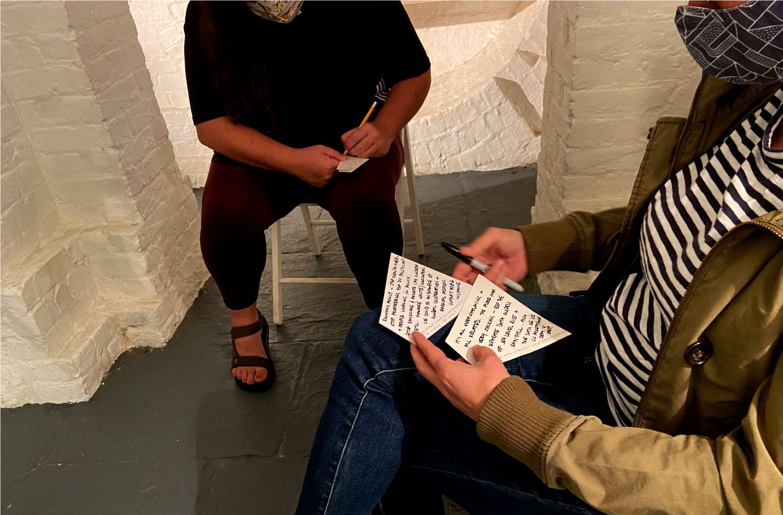

Figure 2: Attendees of Glass House writing answers to the two Participant Questions sat in the space where Climate Data Discovery was hung (image credit: the author)
Attendees were told in advance the cards would be collected; 48 cards answering the first question were obtained along with 46 cards answering the second. In 23 cases the participants did not write their initials. The next section describes how these cards played into the choreographed experience of Glass House. The video interviews included some or all of the following questions:
- “Can you tell me about what you have just seen?”
- “In Glass House, which visual information was most striking - and why?”
- “What do you think Glass House means for the possible links between art and policy?”
The video interviews were conducted by the author. Participant answers were typically between 30 seconds to 2 minutes in length. Very rarely were follow-up questions asked. There were 15 interviews asking the first question, 15 asking the second, and 16 asking the third.
Informed by Mortensen (2020), the subsequent thematic analysis of the five categories included the following stages: transcription; repeated review and familiarisation of the data; searching for and preliminary sorting of themes. Regarding the transcription phase, the materials were digitised using the Otter.ai artificial intelligence transcription service and stored using Google Sheets to enable easy user interface at the second stage of familiarisation. The template spreadsheets used for the analysis are provided in Appendix II, and include columns relating to the deductive analysis and the inductive analysis. At this point the analysis forked into two parallel processes. Again informed by Mortensen (Ibid), the inductive approach looked for emergent themes from the various responses and sought to cluster and amalgamate these themes. The deductive approach reviewed the information in the context of the Art-Policy Matrix, the conceptual tool for trying to understand the possible role for art in policymaking developed in the Role of Art in Policy report (Bennett 2021; also see Section 5 of this report). The Matrix is used to show the way Glass House may have different effects on policymaking at different stages of the policymaking process. The outcome is assessment of if/how Glass House relates to policy and a better assessment of the utility of the Art-Policy Matrix.

CONTEXT AND DETAILS OF GLASS HOUSE
Glass House took place between the 6th-11th September 2021 in Lumen Studios, a venue in the basement of St John of Bethnal Green church, London. The UK was not in a COVID-19 lockdown, though many people were still conscious about mixing and social distancing. The church requested visitors wear masks. The venue was relatively small. The circumstances of both the pandemic and the artworks, which included delicate, fragile and jagged glass panes, some hung at head height, urged an ‘invite only’ approach to attendance. The author reached out through various networks to invite thirteen groups of 1-5 people to attend hour-long sessions over the course of a week. In total 47 people attended, listed at Appendix I. Their contributions are anonymised in this report. With the exception of one or two instances, attendees did not know each other. Ex ante, the aim was to bring together people who had different professional, disciplinary and demographic backgrounds, as far as possible given the sample size. Ex post, and accounting for for practical contingencies, the following can be said of attendees:
- They were generally from the following professional/disciplinary backgrounds:
○ Policymakers
○ Artists
○ Arts professionals including curators, funders, theorists and critics
○ People working in the ‘knowledge sector’, for example universities, research institutes, science organisations
○ People who did not meet any of the above criteria and could be seen as bringing a non-specialist perspective;
- Neither demographic nor socioeconomic status data was collected from participants;
- Anecdotally many people were still reluctant to travel long distances given the pandemic, so the attendees likely had a London or London-periphery bias.
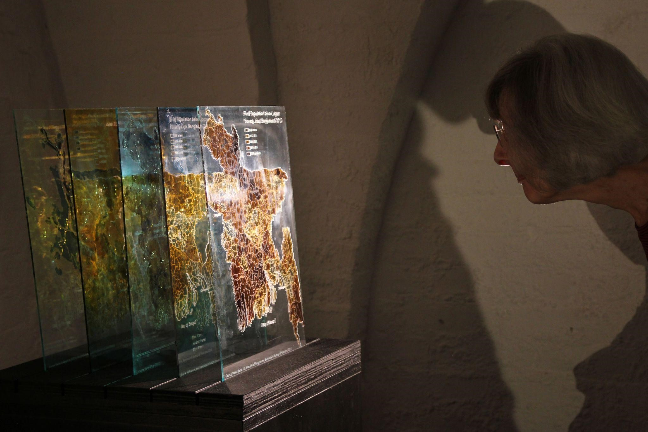

Figure 3: An individual examining Layers of Bangladesh (image credit: the author)
The exhibition included seven artworks. Spatially, the artwork closest to the entrance was Layers of Bangladesh (Figure 3). This piece presented five glass slides showing different types of information relating to the impacts of climate change including sea level, rainfall, economic and population data. Layers of Southeast Asia represented a human-sized counterpoint to this, and was referenced by many visitors as being the most prominent piece that first caught their notice, located as it was in the middle of the gallery (Figure 1). The three panels showed changes in rainfall, flooding and population in the region. Layers of East England (Figure 6) looked at the energy systems which are intrinsically linked with the environment in the region, including data relating to sources of energy and the carbon emissions associated with transportation, domestic and commercial energy use. As with Layers of Bangladesh, and indeed all of the artworks, the data is depicted on recycled greenhouse glass. In Layers of East England this is perhaps most apparent, with broken panes used, clearly showing a patina of grime and dirt. This theme continues with Greenhouse Panes, where images of the effects of climate change are rendered onto old window panels (Figure 9). The images are distorted, washed out and blistered, in some cases completely obliterating the evidence described on them. In a similar vein, Broken Arctic Map shows the reduction in the Arctic ice sheet between 1979 and 2020, engraved on scratched and broken 10mm glass. Climate Data Discovery arranged 40 pieces of climate evidence around a space which included 2-5 chairs facing inwards, towards each other (see Figures 7 and 8). The final exhibit, Policy Ideas, sat in a window alcove at the end of the space (Figures 4 and 5). A soundtrack with the sounds of drips, rain and water played throughout the experience.
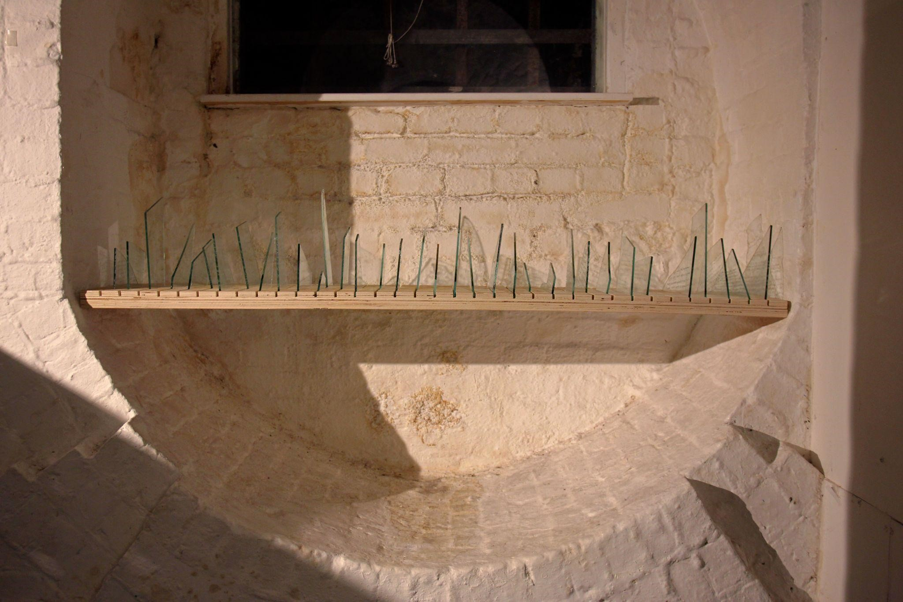

Figure 4: The finalised Policy Ideas. The engraved glass shards were added, right to left, through the duration of the week that Glass House ran (image credit: the author)
Glass House had an important temporal dimension. The groups of attendees were asked to arrive at a specific time and stay for an hour. Each participant was given two cards, a brief overview of the experience and a brief description of the overall research inquiry the exhibition related to. They were left for 30 minutes to explore the space and the artwork, and asked to handwrite answers to the Participant Question 1 card. After the 30 minutes, participants were asked to sit on the chairs, discuss their thoughts with each other and, only after the discussion, answer the Participant Question 2 card (see Figure 2). After the full 60 minutes finished, an announcement was made that the hour was nearly up and participants were informed of three further things:
- All panes of glass used in the exhibition were recycled greenhouse glass from allotments in Walthamstow;
- The sound recording was from Walthamstow, London, on 7th August 2021, the date of severe flooding across London and southern parts of the UK;
- The cards would be collected, and the handwriting transcribed by the artist engraving onto specifically made glass shards. These shards would be displayed in the final artwork Policy Ideas which, as a result, was a participatory piece which grew through the duration of the exhibition (see Figures 4 and 5).
A video showing excerpts from Glass House sessions is available here: https://vimeo.com/654259159
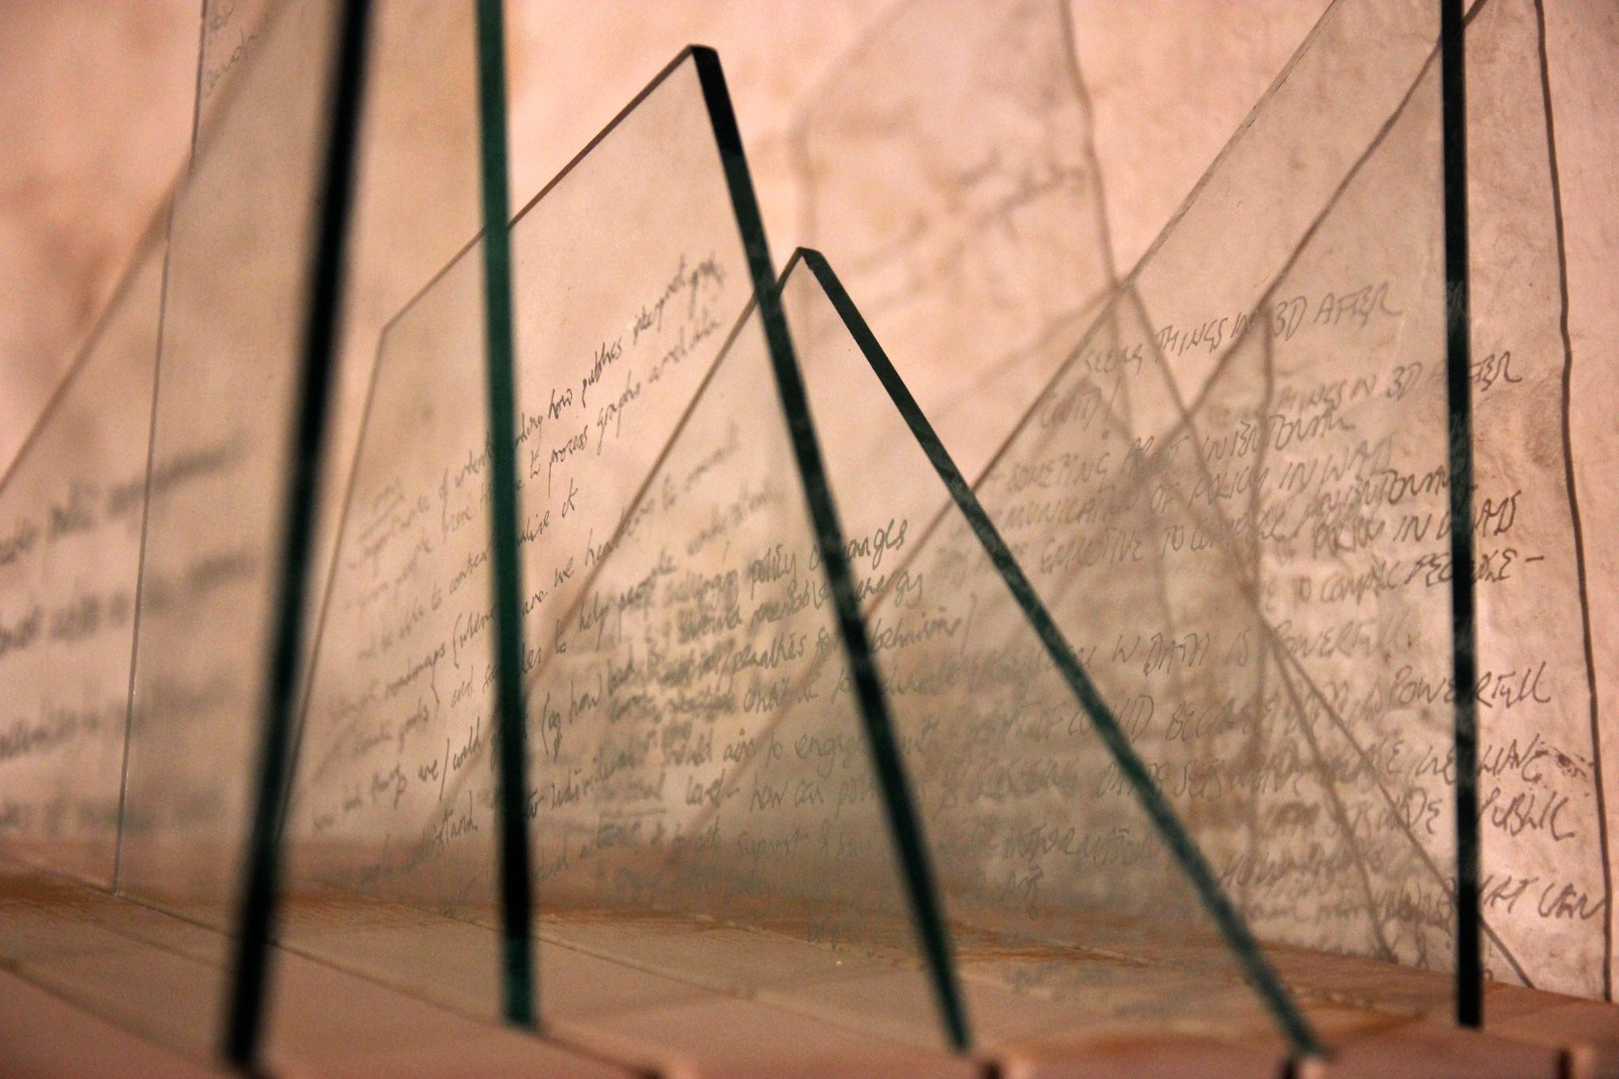

Figure 5: A close up the engraved glass shards towards the right hand side of Policy Ideas (image credit: the author)

KEY THEMES FROM PARTICIPATORY COMPONENT OF GLASSHOUSE AND ACCOMPANYING INTERVIEWS
This section provides an analysis of key themes emerging from the participatory component of Glass House. It adopts an inductive approach based on grounded theory where the qualitative evidence is considered on its own terms, without reference, at this stage, to prior frameworks or ways of structuring data. The text below presents, organically, central themes that emerged from the data familiarisation conducted by the author.
First considered are written responses to Participant Question 1: “Which visual information is most striking - and why?”. Almost all of the responses included references to the evidence in some shape or form, indicating that on a basic level artistic intervention can be an effective way of raising awareness of science/evidence/information relating to a topic such as climate change. Some participants explained how elements of the artistic depiction aided their engagement with data:
“Flood risk and population density maps together - really easy to see the correlation between the two and being able to see the piece from different angles. It's the kind of data I look at all the time but was much more engaging” (Policymaker 6)
“Potential Pinot Noir Growing areas. It is simple, clear and easy to understand. Also unexpected content as didn't imagine Pinot Noir would have such potential in the UK” (Arts Professional 3)
“Individual emissions - don't know if it was just broken while you made it but I found the broken pane really arresting in a way maps weren't” (Policymaker 8)
A selection of attendees including policymakers and knowledge workers said the artistic format allowed them to consider data they were quite familiar with in new, creative ways, allowing innovative thinking and the development of new ideas. As an example, participants saw the physical layering of the glass pieces as morphing with the cognitive layering of data types:
“Layered glass maps. Seeing multiple factors and how they can relate. See how population density might not always align with who is affected (Anonymous Participant 3)
“Cambodia layers of information; need to relook back to front; so clear how related people and water are (people need water) [...] (Knowledge Worker 1)
This novel, physical presentation of data allowed people to make new meaning. For Artist 1 this extended to literally seeing through the data-engraved glass to appreciate the physical, geographical, historical context in which we were observing and discussing climate change evidence:
“From the visual experience, what was most striking was the piece of work looking at London and the Southeast. I loved the layering, trying to figure out what that information was, and in a way how it was displayed. So it kind of bled through the light onto the space, which I'm really aware is a crypt. So it's not just anywhere, it's in a white gallery, it's a crypt in London”.
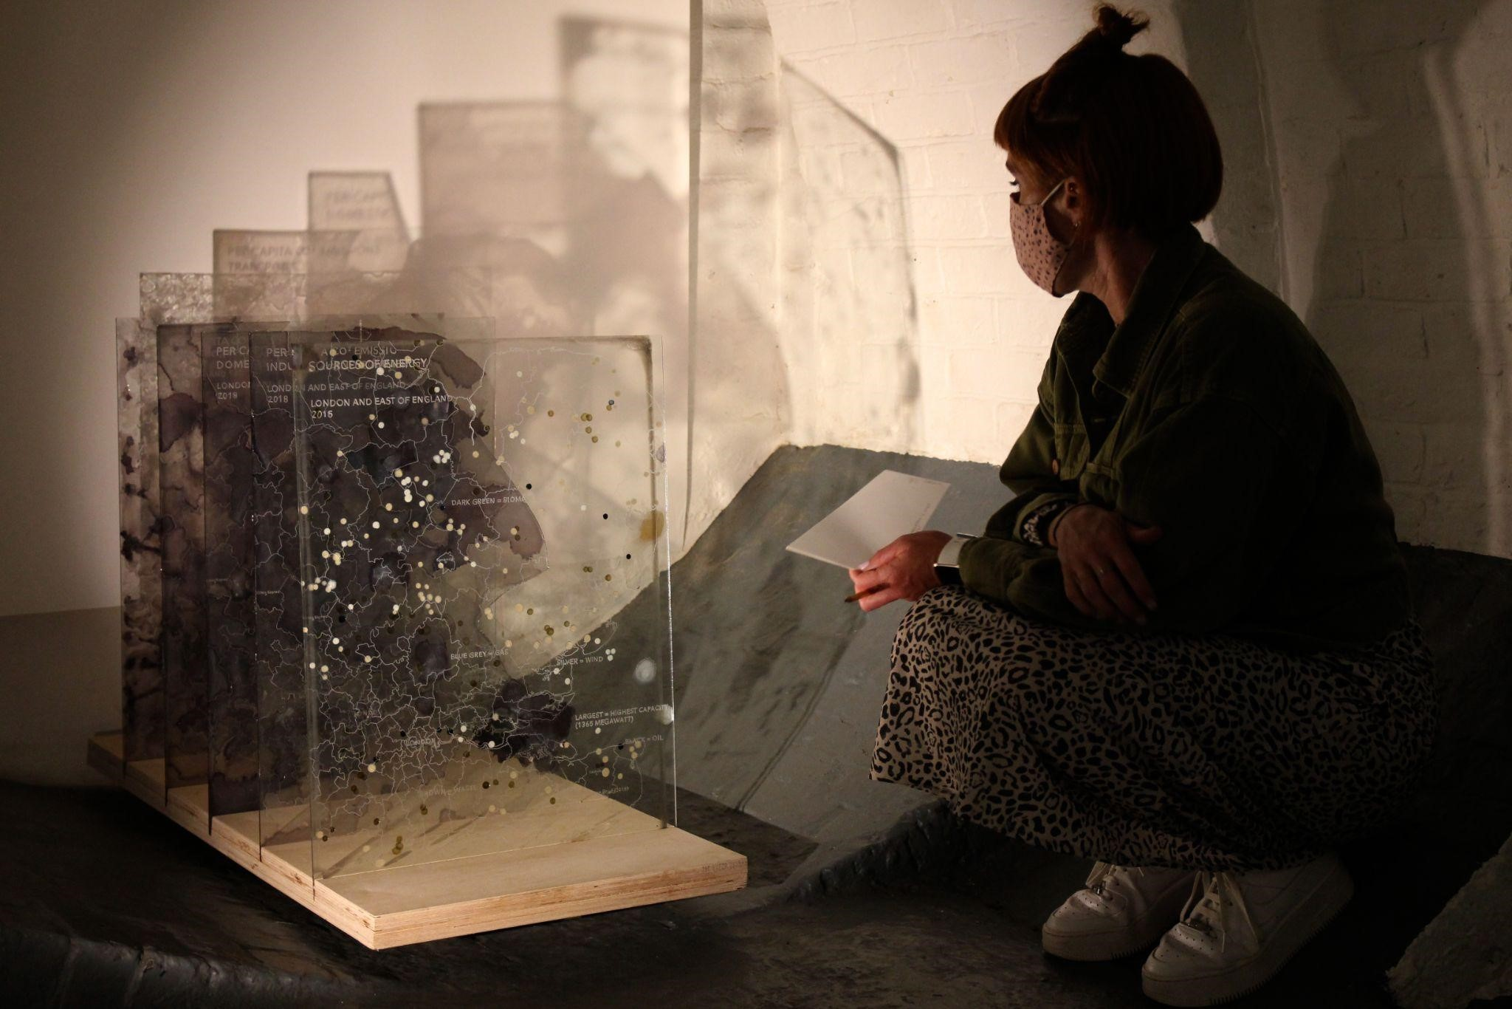

Figure 6: A participant with the note card in front of Layers of East England (image credit: the author)
Participants made metaphors in relation to the materiality of the artefacts which then allowed them to draw out new meaning and insights relating to climate change policy. For example, Arts Professional 9 perceived danger in the broken glass and Artist 1 reflected on his conflicted feelings as he wanted to pick up the sharp shards of glass which made up Policy Ideas (Figure 5):
“I had the experience of wanting to pick up the pieces of the glass to understand better, and then somehow when I got to the end, I actually found myself picking up the pieces, and then realised that it was broken glass. So I have a very physical response. So it wasn't about the visual. It was a kind of like, oh, danger. And somehow that resonated then with some of the themes and this idea of danger. That [climate change] is a threat too.”
Similarly Arts Professional 6 considered that “what this exhibition captures beautifully as well is it's not just about the information, it's about the fragility of our situation”. She made a link from the materiality to the imperative of appropriate policy response on climate change: “it really brings forth the idea that the action that is taken, the policy that is decided, needs to really be applicable and urgent”.
Others found meaning in the distressed and aged nature of the artefacts, “a sense of kind of entropy around the whole thing” in the words of one arts professional. In her written answer to the first participant question, an arts professional with extensive experience of curation reflected on how she was struck by “an archaeological effect” incorporating “History and future over time and space”. An anonymous participant wrote that the way the glass plates were disturbed or interrupted visually by drips in colour “took me to an imagined future looking back at relics from a (failed? Narrowly avoided?) past”. A participant who works in biomedical science made a striking finding based on some of the seemingly age-weathered material: “I find the distressed Our World in Data charts the most powerful. An admission that clear data has failed to catalyse action.” The participant builds on this point later to consider the importance of emotions (not just reason) in leading to action. In a similar vein, the physical presentation gave some participants a sense of poignancy, frustration and urgency in the need to act:
“When I examined the board, the base, there were watermarks. And it looked as if something had been lost [...] what I had absorbed through the narrative was we are losing precious time. And there's the history, the watermarks, the watermarks on the base was almost quite poignant for me [...] the way I saw it is time is precious, let's do something now” (Artist 3 in interview)
“It looked like possibly there's a lot of it's either melting or flooding, kinds of pieces of work, or age destroyed and it's a topic that we've been talking about, you know, I was introduced this topic as a child and, and it looks to me like pictures of things that were statements that could have been made back then. And they're just sitting there not having done anything about it” (Non-specialist 5 in interview)
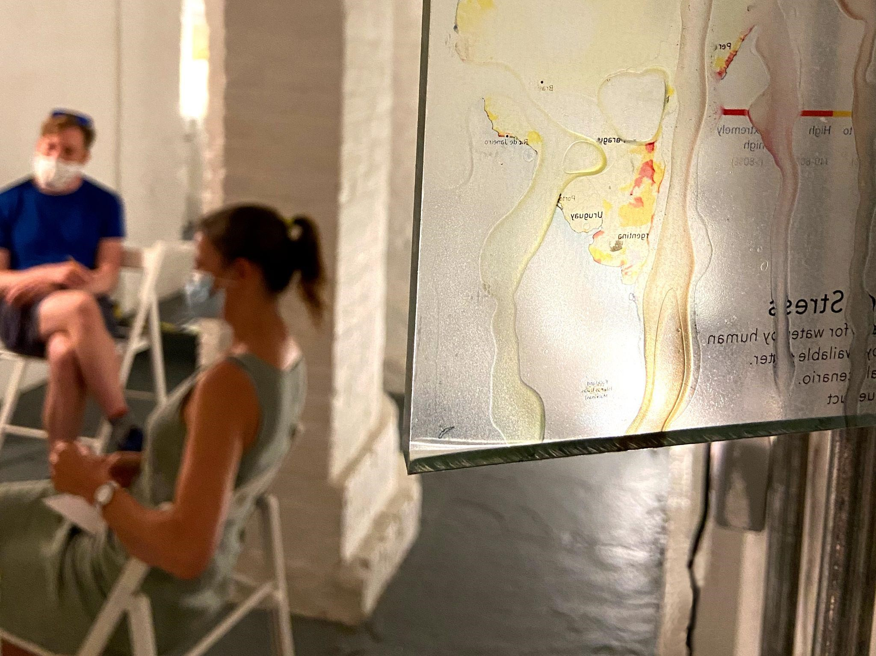

Figure 7: Participants discuss the artworks and Participant Questions with Climate Data Discovery visible in the foreground (image credit: the author)
Others took other meanings from the artefacts in Glass House. A number of attendees reflected on how the artworks helped them deal with the overwhelming complexity of the climate change challenge. For example, an arts professional who worked in arts funding said “I found the visuals that presented a lot of data really kind of contributed to that feeling of overwhelm that you get when you think about climate change, because you know, it's so important, but there's so much information and so many changes needed that you almost don't know where to start”. One artist described how a “poetic beauty in the way it has been put together” helped her deal with the overwhelming nature of the issue. One attendee who worked for an environmental foundation saw the artefacts as complex, but that this helped convey the very complexity and intractability of the climate change challenge. She observed that the artefacts also operated in a simple and powerful way, conveying a clear striking message despite the level of detail they contained. This complexity appears to be a driver of participants emphasising the imperative of interconnectedness when thinking about policy responses. For example, a participant who is an artist said in interview “we need joined up thinking, you know, we need a systemic approach, whereby policies are not just the big leaders meeting in Cornwall, policy has to be linked. So we're looking at health, education, economic policies”. A number of written responses on the second set of cards (where participants were asked “What policy needs to happen - by whom?”) brought out similar themes:
“Policies that embed accountability across governments. Stressing the need to consider impact beyond borders. It's the interconnectedness of issues that stands out in this exhibition.” (Arts Professional 3)
“Not one policy. Interconnection between policy areas / departments.” (Arts Professional 4)
“1) CONNECT! Interventions that acknowledge the multiple layers and realities of unequal facets of the climate change problem; [...]” (Arts Professional 5)
A range of attendees, including artists, policymakers, knowledge workers and arts professionals, all indicated that a reason why the information in Glass House may have landed in more compelling and unusual ways was that they had to work harder than usual to process the information. Much of the information was partially concealed, including by apparent drips or blisters; in places the glass panes were broken with elements missing; the layered pieces were extremely detailed, with time required to appreciate both what was on each pane and how it related to other panes; lighting highlighted and obscured elements. One artist described feeling like she needed “be like Da Vinci with a mirror” to decode her favourite piece in the exhibition, whilst an arts professional noted that “As I read, the images start to disintegrate, the information starts to disintegrate and I felt they're very much blistering, like something just burning up.” A professional who works in arts funding noted how the most impactful and cohesive pieces were not necessarily the most legible.
Many of these responses converge around the ostensibly counterintuitive conclusion that presenting data in unusual and aesthetically challenging formats can increase engagement with that data. A knowledge worker with a background in sociology and design drew a link between the physicality of the exhibition and the speed and nature of thinking it encouraged. She saw that Glass House encouraged something different to the quick, fact-based approach she has previously witnessed in policy spaces:
“these are extremely physical material things that as I walk around the space I have an embodied relationship with. And that changes over time as I pay attention, get distracted, listen, sense, notice others in the space. And so there's a sort of implication for the culture of policymaking based on quick evidence based... it slows it down. It invites you to think what what is here and what is not here, who is here and who is not here”
Similarly a policymaker who works in climate change noted that “for me, as somebody who's immersed in quite a lot of data day to day, actually having to stop and pause and think about the data presented in a slightly different way, engage with it, even struggle to see and read, it is actually quite a good way to reconnect with the information”. A senior civil servant working in education policy thought that “the rustic nature of some of them made you look much more closely and to check whether you understood, very different if you were flicking through The Economist or something”.
A former senior civil servant who has previously worked in climate policy and now works in science policy, compared the experience of Glass House with the typical policymaking experience. He reflected that he first operated in a “typical policymaker mode”, quickly appraising the entirety of the exhibition’s information. However, he then appreciated the “forcing mechanism” of having to spend longer sitting with the information, looking in more depth and allowing him to have thoughts he may not have otherwise had. The more dialogical second half of the exhibition appealed to this participant as a departure from the typical policy experience:
“The discussion with three people from quite different backgrounds and different professional lives was also thought-provoking. So the art as an experience, you've got the things that you see, you've got the way you engage with it. You've got the time spent doing it and you've got the people you can talk about with - it is not your everyday policymaking experience.”
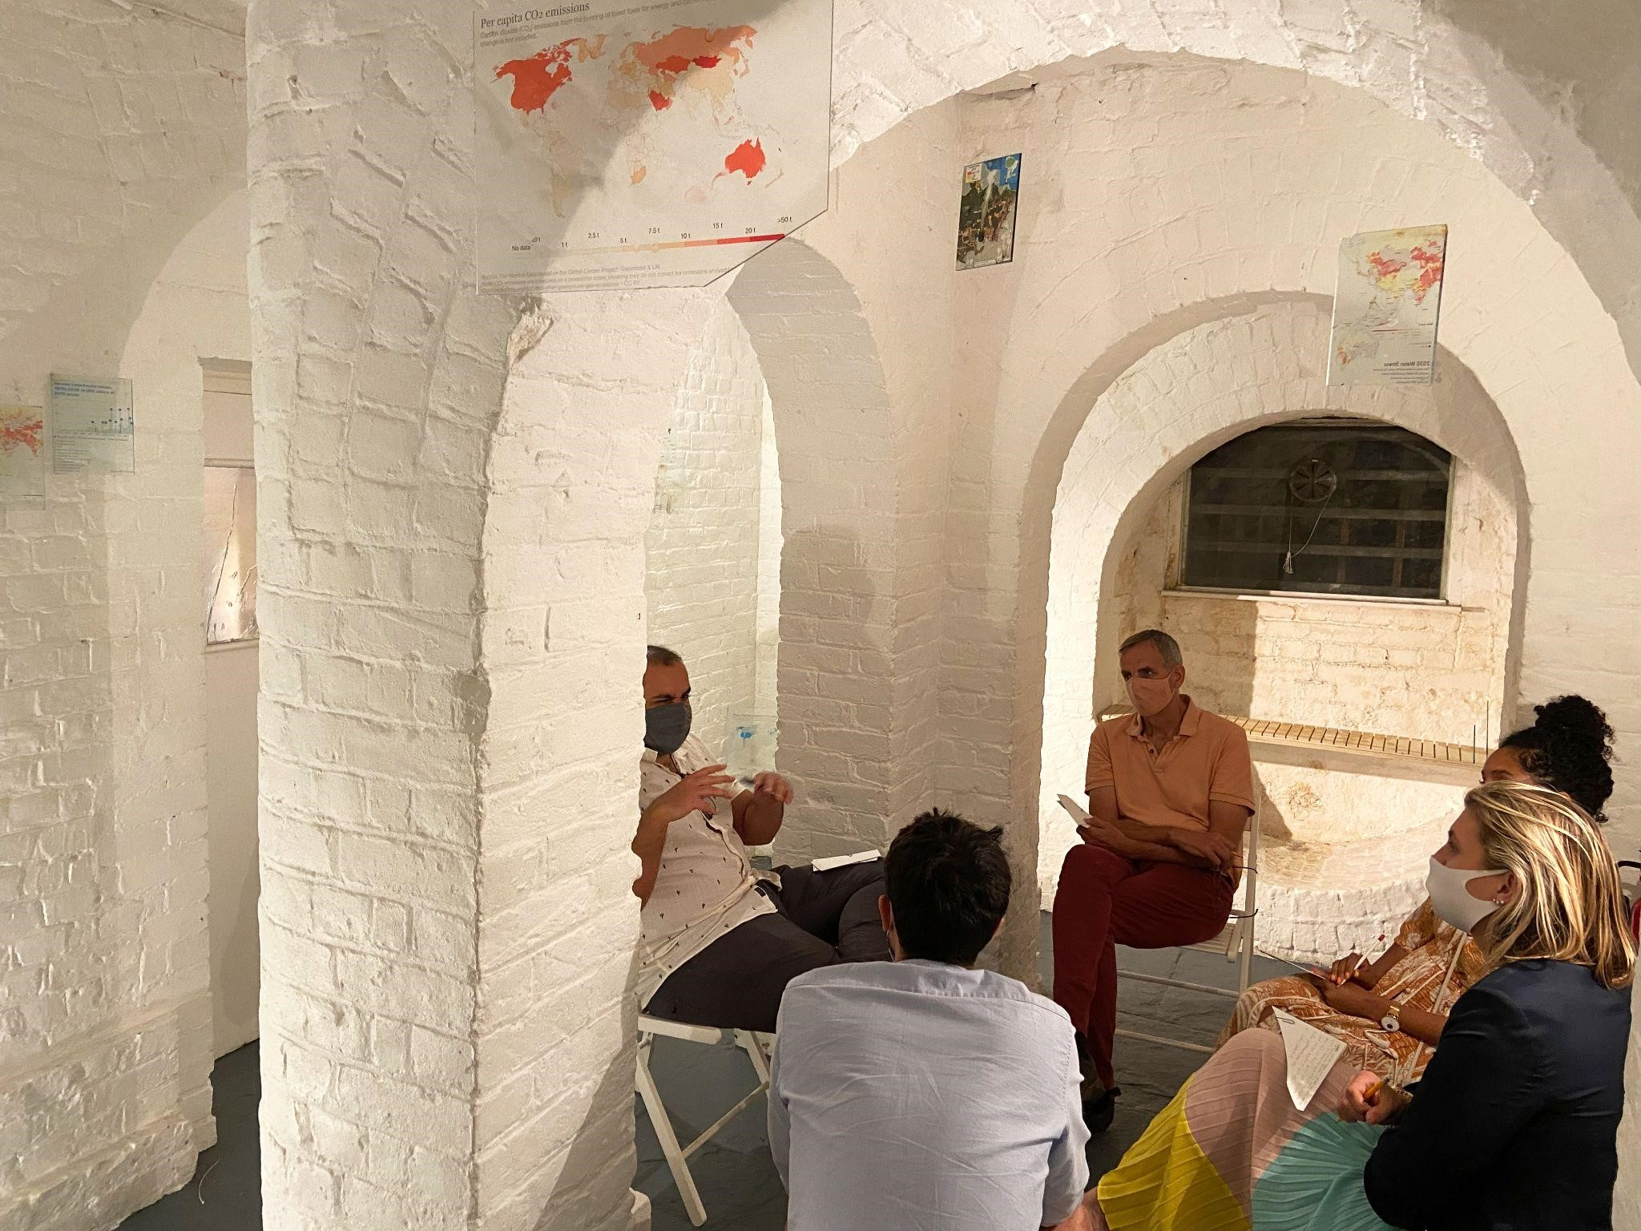

Figure 8: A group of participants discuss the artworks and Participant Questions surrounded by elements of Climate Data Discovery
One knowledge worker also saw an interesting connection between the artworks, the participants and the types of thinking this allowed for policymaking. She found that “by using different forms of art, and by having actually very diverse perspectives, so that very different people come and reflect on the same types of data and evidence - it made me think differently about the types of policies we might introduce.” For this individual, spaces like this and exhibitions like this ultimately “create innovation in the sense of new ideas and new ways of taking action on these really important issues”. Another knowledge worker, with a background in policy design and now working in food and farming, saw Glass House as a space to produce knowledge - in contrast to the more transactional nature of a typical policy environment where there are winners or losers depending on which approach is ultimately implemented.
A participant with experience in the creative industries described what he saw as a thread between the information, the physical environment, the social experience and policy positions people arrived at. According to this individual: “presenting the information in this kind of fluid space allows people to find ways through the data and maybe come to positions that they wouldn't ordinarily be able to arrive at if they were just experiencing the data through a book or a website”. A policymaker developed this further, seeing a relationship between the embodied experience of physically negotiating large glass panels and the social/political experience of negotiating policy positions with other participants:
“I really liked the fact that you had all of this information, you could look at it from one perspective, but also to really understand it, to really engage with it, you had to physically move yourself around it, move your position. Then looking later at things that were more about people's opinions and interpretations, it kind of joined the two together so you think about how you do actually have to move your position, change your position based on the data that you're seeing.”
For another participant, the presentation of climate change information in Glass House helped her draw meaning relating to the partiality of the policymaking process:
“I quite quickly noticed the drips, the splodges, the obscuring of the data. I found that it was hard to actually look to read to make sense. It became clear that you were trying to, I think, draw attention to the work of making sense and how what you choose to show or what you choose to pay attention to. Sometimes it's dismissing them as chunks of glass, dismissing them that you hadn't been able to print and overlay the data and analysis. It posed the question of what's in and what's out, what's included, what's excluded, and when does that matter?”.
A participant who is both an artist and an educator echoed this sense that Glass House created a reflective space for thinking about policy. He thought Glass House demonstrated how art can open up questions and shed light on di cult issues about how humans interface with the world, how governments are responding to that, and the role of the public. He concluded that the exhibition was “presenting a kind of oblique angle on it which encourages us in a critical frame to think about what's going on when we confront these things, rather than just passively consuming them as we so often do through normal media, like screen, mobile phone or a tablet or whatever”.
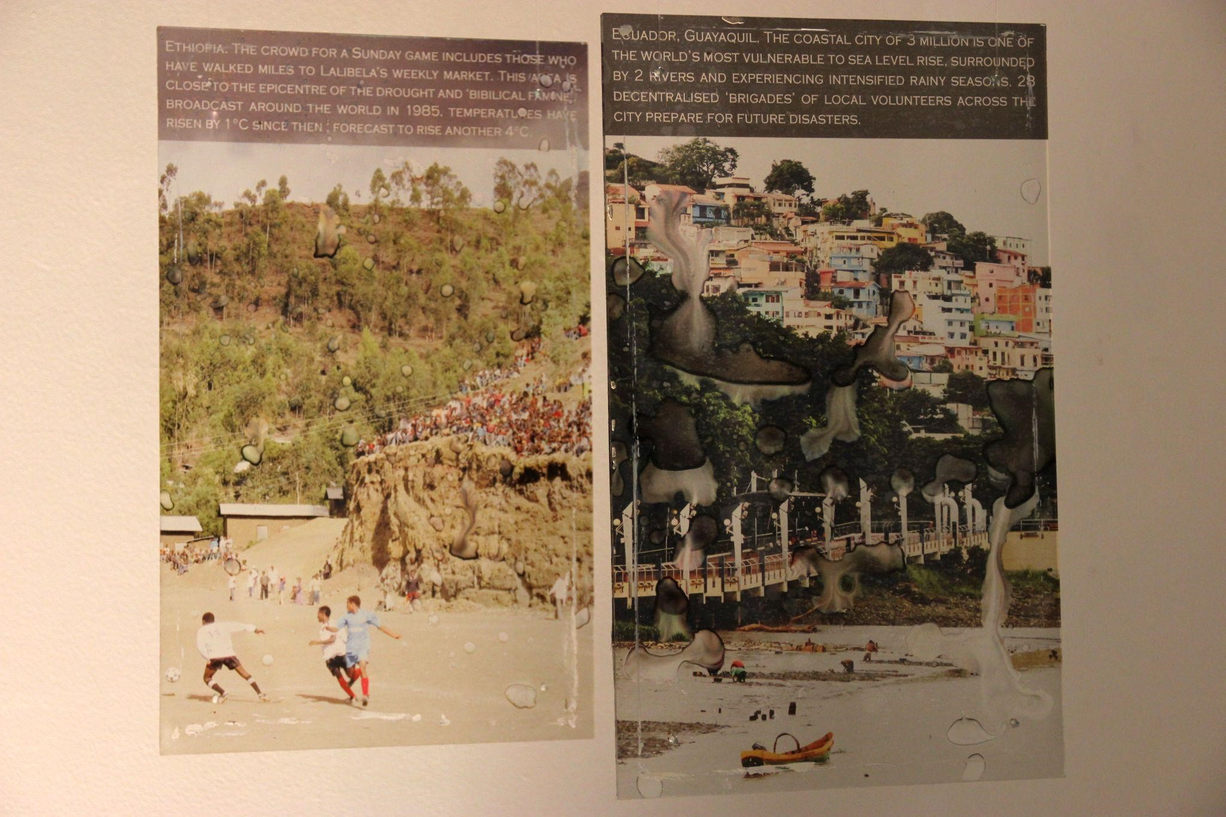

Figure 9: Greenhouse Panes (image credit: the author)
Many participants made a link between the information displayed, the artistic rendering of the information, and the emotional response which they felt. For example, two responses to the first participant card “Which visual information is most striking - and why?” were:
“The most striking and impactful for me was the installation with photos and stories about people and places being negatively impacted (very seriously) by climate change now - stark reminder that it is a life-threatening problem for many people now - and things will get worse. The narrative was strong and created a connection. It engaged my emotions and painted a strong, unusual picture.” (Knowledge Worker 10)
“The change in rainfall map. It combines "opposing" concepts - organised and analytical, but showing chaos and devastation. The play with light and colour makes it really sensory. The picture of the ERASED place is a close second! It's very emotional, you can't recognise the place, it feels raw.” (Arts Professional 5)
In interview, the participant who made the first statement elaborated, proposing that “Art can really engage people's emotions and interests in policy and kind of make it real for them”. In a similar vein, a senior policymaker saw that “it is the connection of data to the real world that I think the combination of art and policy has a lot to bring”. A participant working in arts funding agreed, noting that “from an arts policy perspective, it's really interesting because art has such an important role to play in making people really connect emotionally with policy ideas around climate change”. Two participants drew a strong response from their personal connections with locations described in certain artefacts, Bangladesh and Australia respectively. In their written responses, two other participants reflected that government policies may be more effective if they are attuned to how people may respond to the issues on an emotional level. A knowledge worker and a separate anonymous participant both saw art as enabling a connection with emotions relating to policy. Glass House helped the participant working in biomedical science draw a link between data, reason emotions and policy action:
“for me, as someone who thinks that if you show people data very clearly, it can elicit some sort of action, a rational action on the basis of that data […] it kind of hit home to me the way that many people might react when they're presented with a lot of data in a layered way, and that feeling of overwhelmed, being overwhelmed, and, and then a kind of emotional response of I want to do something [...] but not quite knowing what it is”.
Three participants described a sense of agency in wanting to find out more about the evidence base contained in Glass House. One who is not a specialist in climate change described how the exhibition “makes you question and want to know more”. An artist was particularly struck by the central large glass display showing rainfall; this “made me want to research and find out more about area density and industry, and what US/EU companies have production there... so much to think about.” The participant working in the environmental foundation spoke of the same piece “I still don't even know if I fully understood it. But that implies a good thing because I want to find out more”. A former civil servant found that the interactive, non-linear and detailed nature of the exhibition gave him a strong sense of agency:
“It's not like reading a book but it's like having a book - that you can get a sense of more the whole thing in one go, and then you can go where your interest takes you. So it's a lovely way of engaging with material.”

ANALYSIS AND FINDINGS
This section takes a deductive approach to consider the themes in Section 2 against the Art-Policy Matrix, the conceptual framework developed in the first ‘act’ of the three part research-practice-research process. The Matrix, as outlined in A Role for Art in Policy? (Bennett 2021), examines the effects of experiencing art on policymakers as well as, more broadly, how art can impact the policymaking system across the six stages of the ‘policy cycle’ developed by Cairney (2020) and shown in Figure 10.
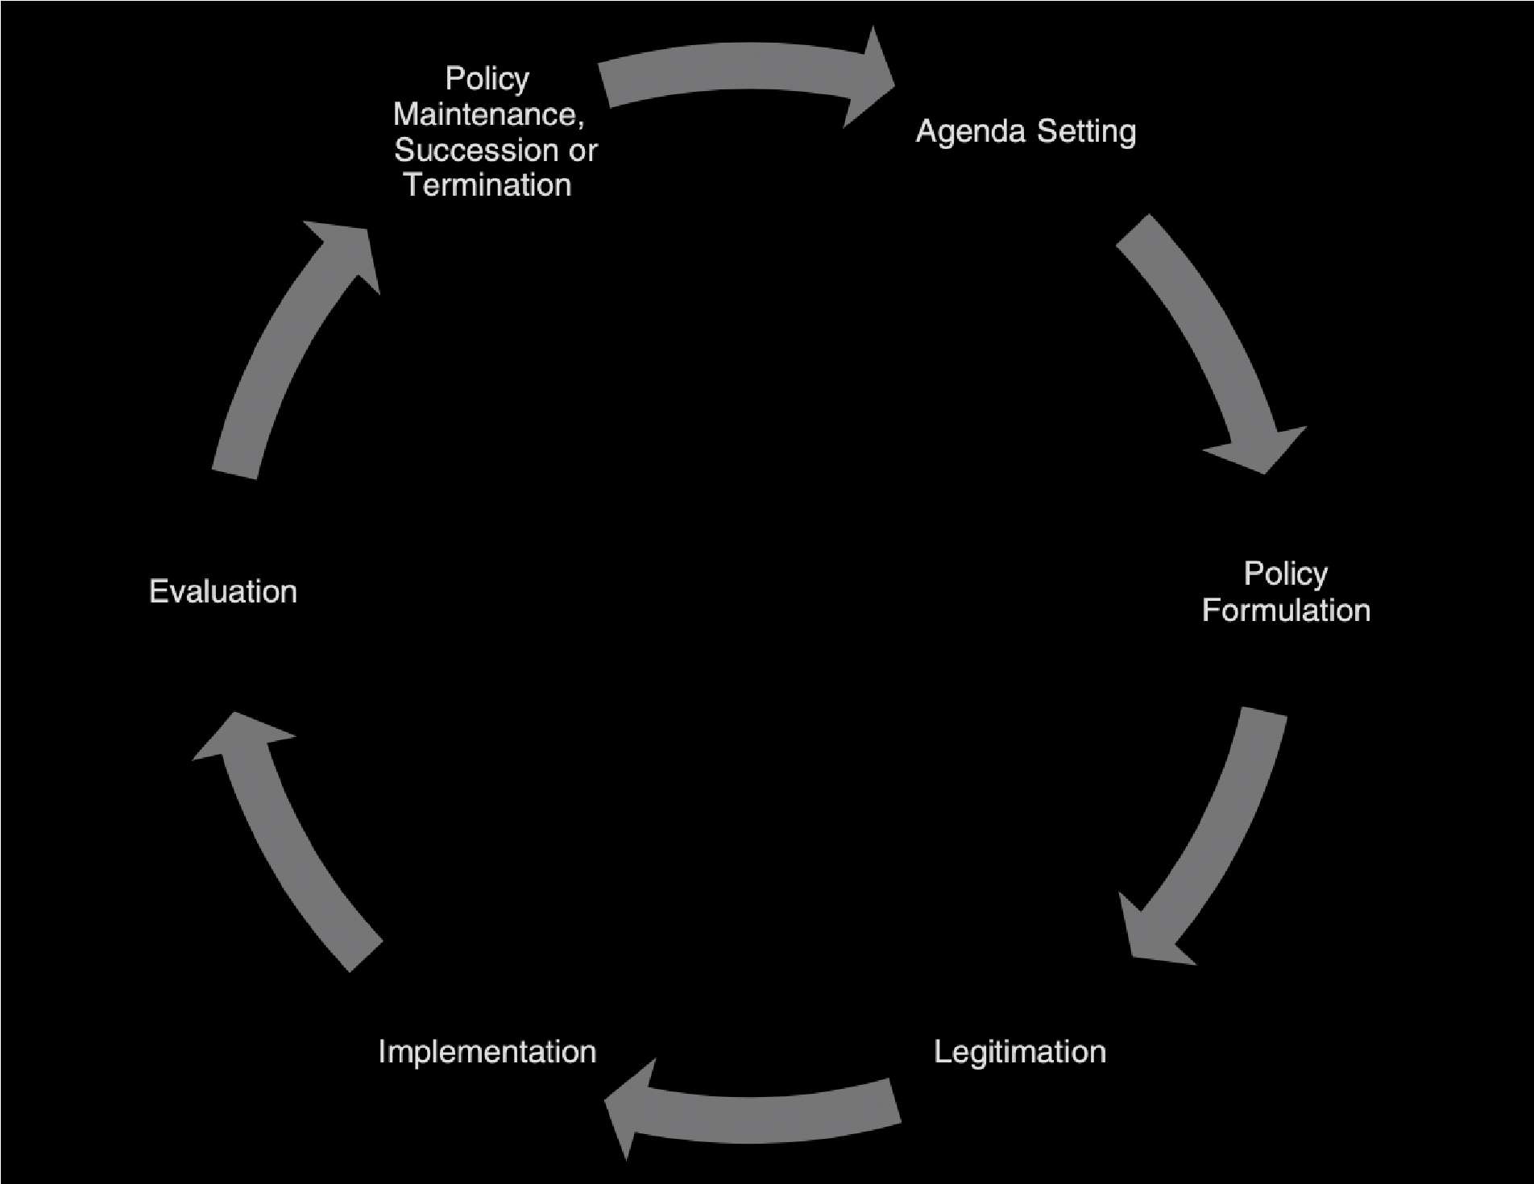

Figure 10: The ‘policy cycle’. Image credit: Cairney, P (2020)
Bennett (2021) establish a six category taxonomy for the effects on individual policymakers and the policymaking system, including:
- a multisensory experience of information;
- emotional impact;
- cognitive impact;
- ideas and alternatives to the status quo; ● providing dialogical space for policy issues; ● activating agency.
The six effects of art on policy and the six stages of the policy cycle are set against each other to create the Art-Policy Matrix which explores the roles that art can play at various points across the policy process. Bennett (Ibid. pp 13-14) situates twenty-one historic case studies into this matrix, arriving at Figure 11.
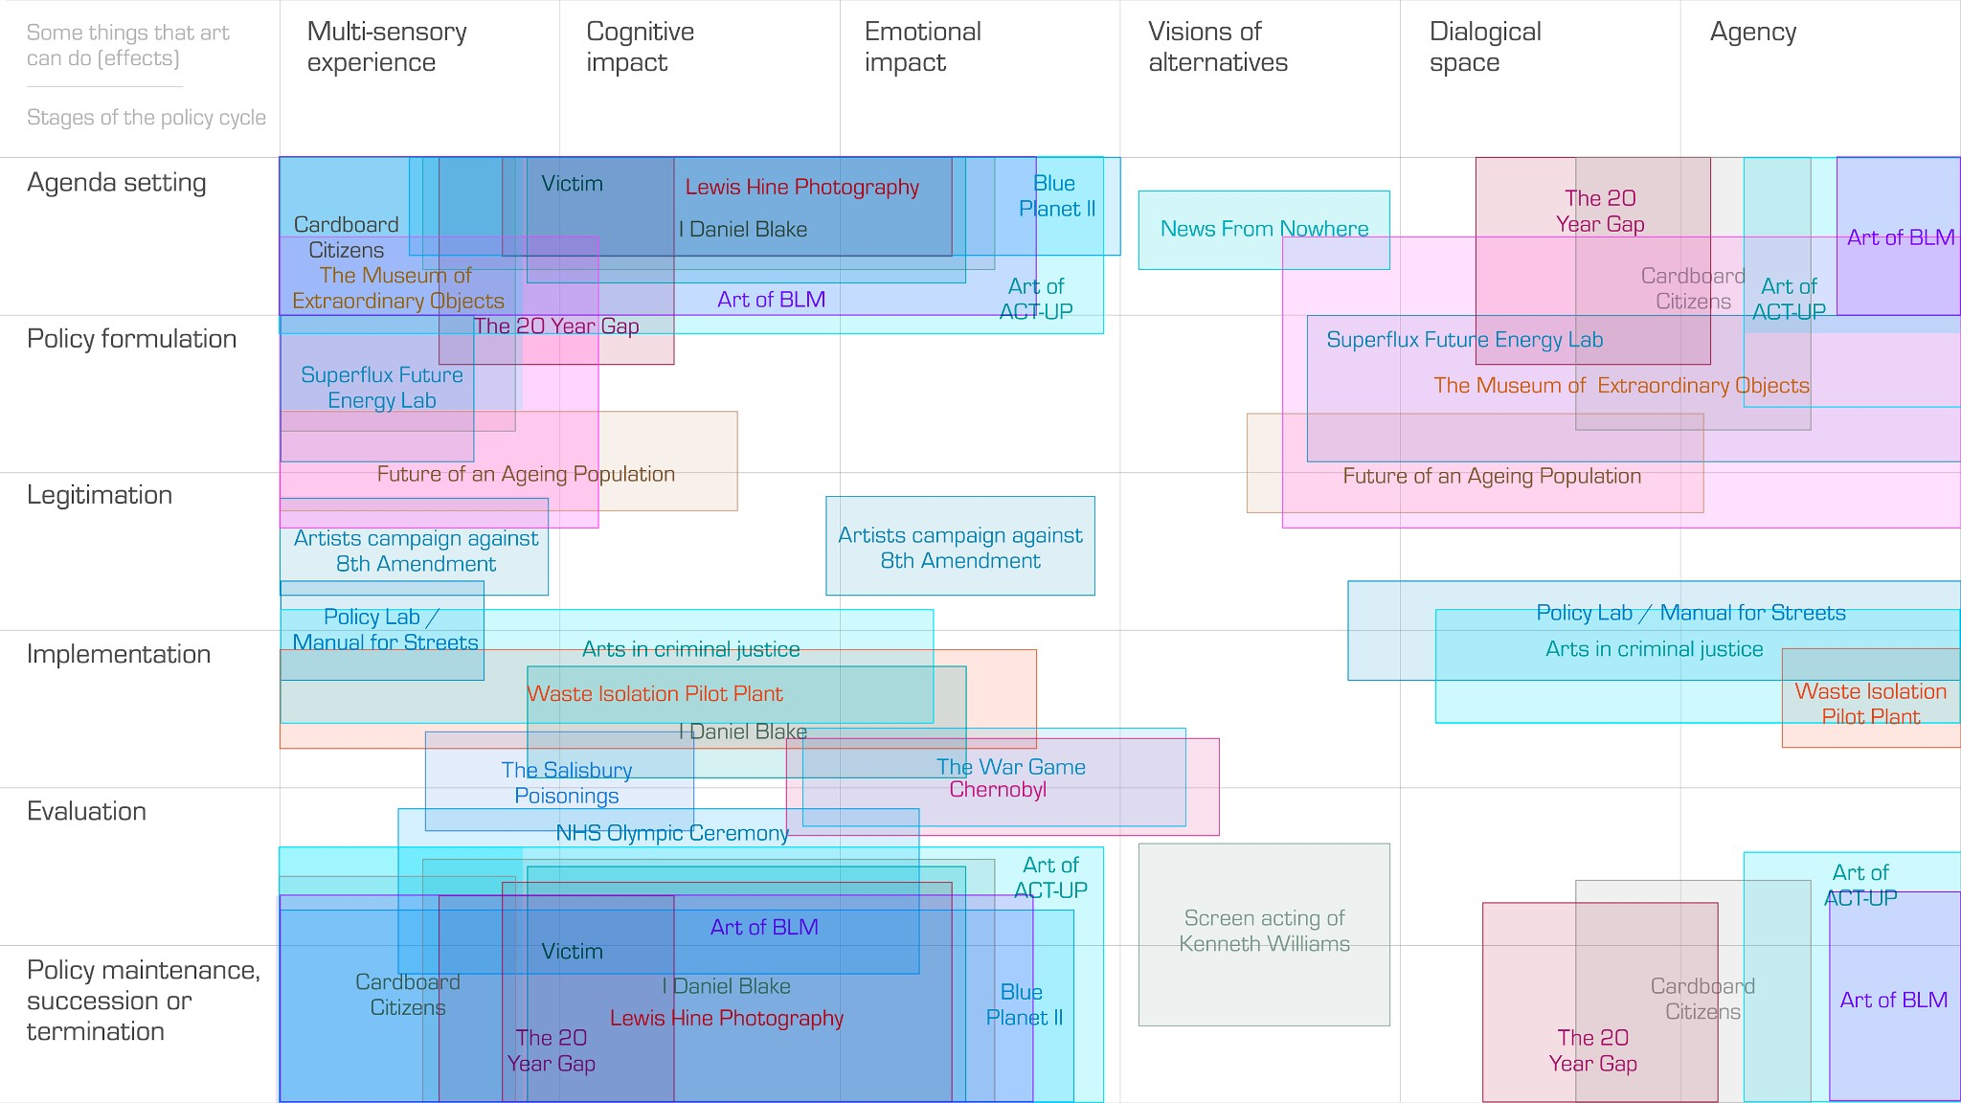

Figure 11: the Art-Policy Matrix including 21 case studies. Image credit: Bennett (2021)
This present report uses the Matrix differently and deductively for the evaluation of Glass House. Figure 12 shows how the relationship between the specific artistic intervention, Glass House, and climate change policy can be depicted based on the discursive materials gathered during the exhibition. Darker toned cells represent stronger evidence in the materials that art can have a certain effect at a certain stage of the policy process.
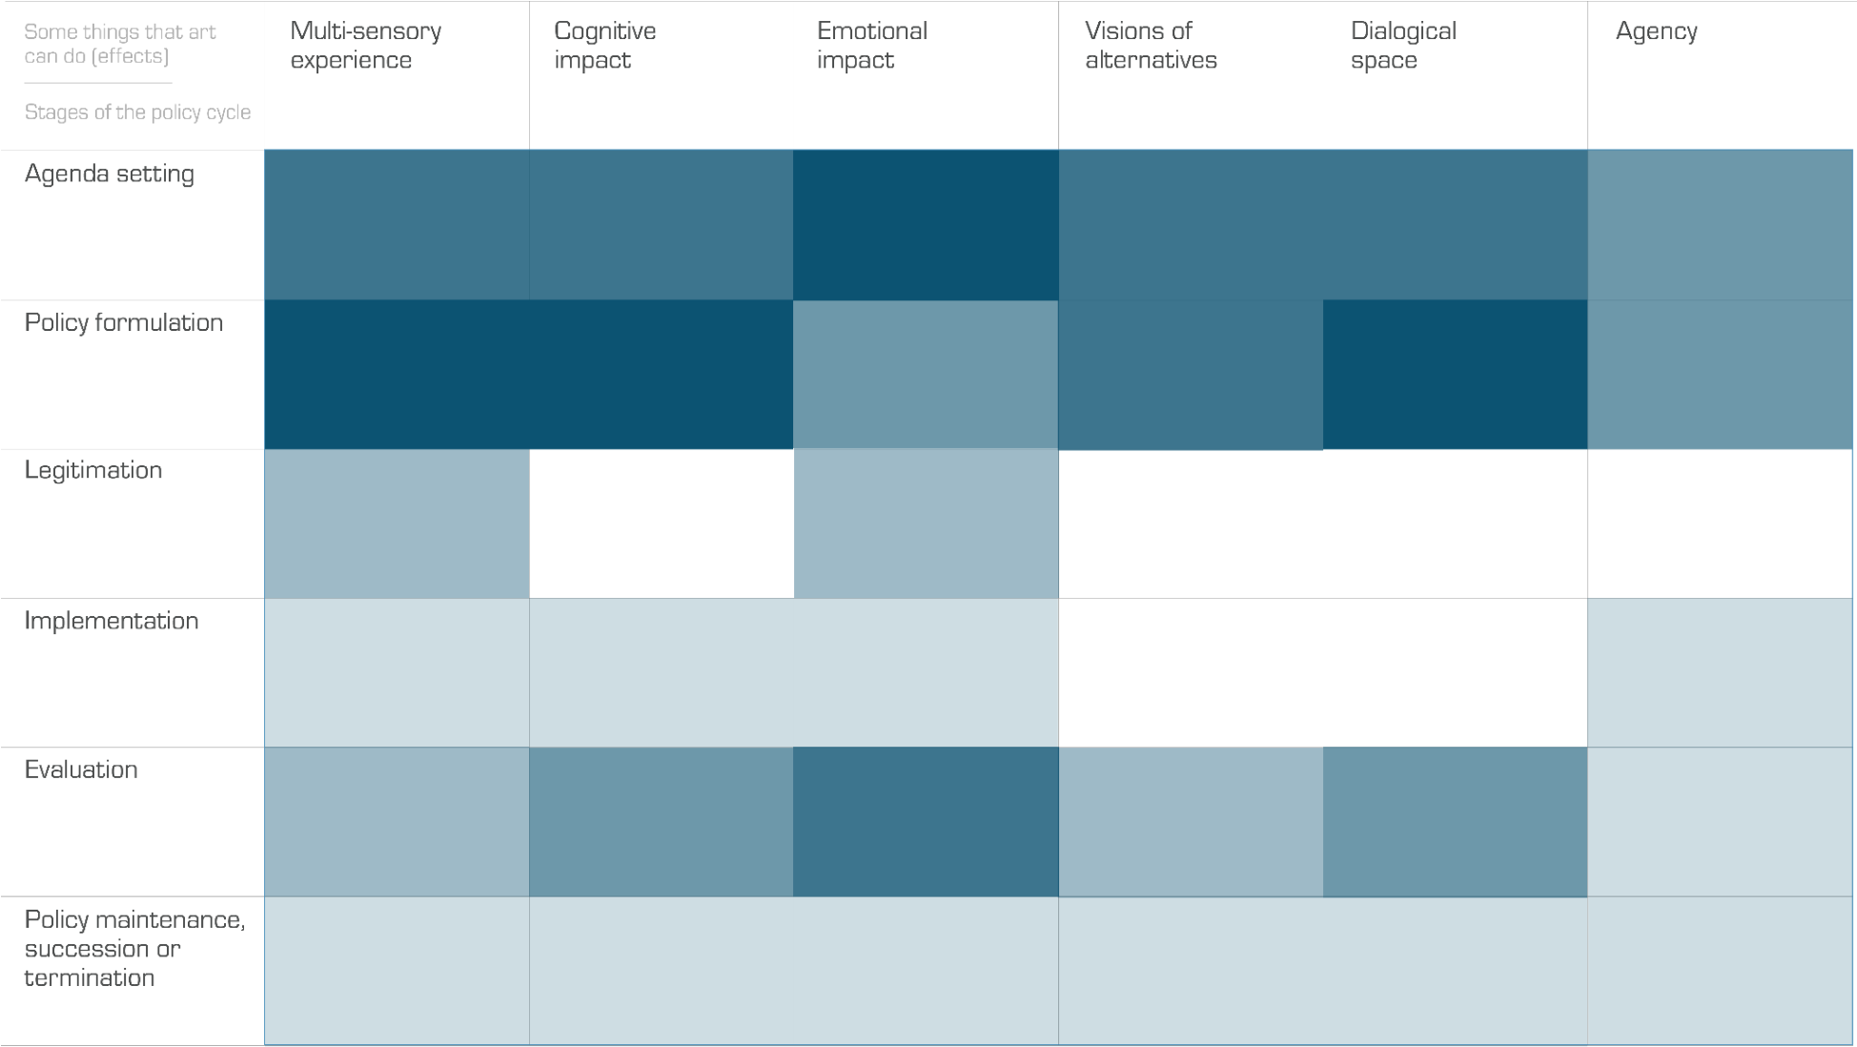

Figure 12: Mapping of Glass House to the Art-Policy Matrix
The Matrix, as used in this context, provides a heuristic, conceptual tool and it is important to acknowledge that there is an element of interpretative discretion on the part of the author involved in the mapping. In particular the analysis spreadsheet (shown in Appendix II) was used to code each participant contribution into appropriate columns relating to the different effects of art. As an example, as noted above Knowledge Worker 10 said in interview “the narrative was strong and created a connection. It engaged my emotions and painted a strong, unusual picture” - this would then be noted in the ‘Emotional impact’ column relating to this contribution. Other effects could also be noted alongside this - or indeed no effects, if appropriate. The mapping against the policy cycle (the rows in Figure 12) required more interpretation on part of the author as participants rarely referred to stages of the policy cycle, and indeed may not have been aware of this as a concept. The author used his knowledge of Cairney's work on the policy cycle to help situate the responses. The following paragraphs explain the decisions taken in the mapping in more detail.
Some of the strongest themes from participant feedback on Glass House relate to engaging with evidence in unexpected ways to arrive at new policy ideas for addressing climate change. This creates a dark cluster in the top left of the Glass House Art-Policy Matrix. It most obviously relates to the second ‘policy formulation’ row of the policy cycle, though there is also a strong sense from participants that the information contained in Glass House puts climate change, and its many consequences, firmly in people’s minds as an essential agenda item for policymakers (first row). The participant responses indicate cognitive impacts including seeing and considering previously unknown or underappreciated evidence, analysing what it might mean and applying it to identify better policies (second column). There also appear to be emotional effects (third column). In turn those may be driving people to make the case that climate change needs to be addressed urgently, that time is running out, and that the current global policy portfolio is not fit-for-purpose in terms of addressing the causes or impacts of climate change. This latter point is in effect an evaluation of policies. It highlights the fifth row of the Art-Policy Matrix, laying the ground for a new stage of policy agenda setting which would follow after the ‘Policy maintenance, succession or termination’ stage of the cycle.
Immanent in Glass House was a 25-30 minute discussion with randomly selected participants about the most striking information and policy ideas. Some attendees directly referenced this as one of the most satisfying and stimulating parts of the process. The fifth column ‘dialogical space’ thus comes forward at the agenda setting, policy formulation and evaluation stages of the policy cycle. The ‘visions of alternatives’ is also more resonant at these stages. Glass House did not ex ante contain speculative or visionary artworks that might directly evoke a new way of living, alternatives to current technology or policy states and so on. However, it did provide some ingredients with which attendees could, and did, use to concoct policy proposals which in some cases would create a radical alternative to the political and socio-economic status quo. Examples include:
“A universal global, per capita limit on carbon emission and incomes with the richest countries acting first to reduce the net zero global average quickly and no poorer country exceeding that average” (Anonymous Participant 2)
“Economic Policy - stop growth model [...] Stop emissions and private car ownership etc.” (Anonymous Participant 2)
“No single policy - needs to be more of a “war” [...] Must be biblical in scale - a new religion?!
[...] enabling rethinking & reimagining how we lead human life globally” (Policymaker 4)
It is more complex to ascertain the extent to which Glass House activated agency, as per the sixth column in the matrix. Given its circumstance as an input to a research project, Glass House lacks the immediate platform for action found in examples such as art in the criminal justice system, where organisations like the National Criminal Justice Arts Alliance advocate arts as supporting the process of desistance from crime, improving safety and wellbeing in prisons and communities NCJAA (2018), or legislative theatre, where policymakers are assembled to incorporate the outputs of co-created theatre into new policy proposals. On the other hand, a number of participant responses indicated a desire for action:
“There is an abundance of data (too much data - does it make it meaningless?). Lots of action needed by all. Consensus around what should happen in principle.” (Arts Professional 10)
“We demand a revolution!” (Arts Professional 8)
“Death to incrementalism! No more smallest possible steps to affect change” (Policymaker 8)
A readymade platform for policy action, incorporated into the artwork, is not a prerequisite for agency and action. Participants could be incentivised to act and make changes, whether that be personal actions relating to emissions, waste and diet, political acts like voting, or exerting influence in their professional capacities. This kind of action and agency would take place outside/after the exhibition, and could be ascertained by longitudinal interviews, outside the scope of this report.
There are two parts of the policy cycle where the impact of Glass House is most patchy and limited. The first is the legitimation stage which can be described as “ensuring that the chosen policy instruments have support. It can involve one or a combination of: legislative approval, executive approval, seeking consent through consultation with interest groups, and referenda” (Cairney 2020). An intervention such as Glass House could play a more obvious role in this space if, for example, it was attended by elected representatives such as MPs in a parliamentary democracy, by standing members of a politburo in a dictatorship, or by selected members of the public in a sortition arrangement or citizen assembly. This was not the case in September 2021. Nonetheless, Glass House still has relevance in this space, as a number of attendees suggested that artworks such as Glass House could build political legitimacy for climate policy by helping people engage with the evidence, connecting emotionally with people who are ultimately affected by policy and providing a forum for the public to demonstrate to politicians the importance of action. The other stage of the policy cycle apparently least relevant to Glass House is the implementation of policies, which includes tasking and resourcing an organisation to deliver the policy. However, some participants did muse about how interventions such as Glass House could help simplify complex and overwhelming sets of information into clear and simple ideas for personal action.
One of the main observations from this entire three-part process of practice-research-practice is that the different rows or columns in the Matrix can flex depending upon the artwork being considered. In particular certain cells may advance or recede depending upon the relevance and strength of a given artwork in relation to an intersection of artistic effect and stage of the policymaking cycle. Cells/intersections may advance where ex ante there is an intention to produce artwork to have a certain effect at that stage of the policy cycle, or ex post it was evaluated this outcome was had. Similarly cells/intersections may recede where there is an understanding that this combined effect and stage of the policy cycle is deprioritised or was not achieved in evaluation (ex post). This points to a wider utility of the Matrix. The framework is not implying every artwork can achieve every type of effect at every stage of the policy cycle - in other words to hit every cell in the Matrix. It is a more flexible linguistic device to enable knowledge sharing and collaboration between artists, commissioners, theorists, curators and policymakers. By opening the black box of policymaking, and by providing a shared grammar and vocabulary, it aims to empower those groups, and others, to be more germane and potent in relation to policy issues they want to explore.

CONCLUSIONS
This section incorporates the evidence and analysis from the previous two sections to make several conclusions. They are generalisable to policymaking in all domains; where there are specific points relating to climate change and science, the themes of Glass House, these are noted.
The first conclusion is that artistic interventions such as Glass House can enable people and policymakers to generate new insight from evidence. Participants said the artworks encouraged them to consider data they were quite familiar with in new, creative and compelling ways. Participants indicated that a reason for this is that they had to work harder than usual to process the information. Many explained that this was because the information was not in formats they expected and so they could not process it in an automated way. For policymakers this largely meant seeing powerful images of people, visceral marks, colour light and reflection; for one person involved in the artworld this actually meant looking at statistics and data rendered in unusual ways. In either case the artwork provided an interruption to what they were used to. This interruption caught their attention. There is an interesting echo of aesthetic theory. In his description of the origins of modern aesthetics, Paul Guyer (2004) relays the thoughts of the eighteenth century theorist Joseph Addison on the “pleasure of novelty”:
“Every thing that is new or uncommon raises a pleasure in the imagination, because it fills the soul with an agreeable surprise, gratifies its curiosity and gives it an idea of which before it was not possessed”. Spectator, 412(6): 127 cited in Guyer (2004:32)
There are also parallels with the alienation effect central to the work of Bertolt Brecht who used techniques like actors stepping out of character and revealing set designs to jolt the audience out of the artificiality of theatrical performance (Britannica 2020). There is a neat inversion of this where Glass House was cited by people involved in policy as disrupting an everyday routine which may be similarly removed from its consequences.
The second conclusion is that artistic interventions such as Glass House can diversify the types of human intelligence which informs policy development. This includes inputs from more diverse people, including from different demographic backgrounds and different disciplinary backgrounds. This also includes diversity in the types and forms of thinking. On a basic level, bringing artists in to think about policy and science creates an unusual confluence of disciplines which might not be traditionally associated. There are echoes of the Weimar Republic’s Bauhaus, where artists, craftspeople and technologists spliced together to create unexpected outputs unlike much else being produced in the society of the day. But more than this, participants reflected on how they had new ideas whilst at Glass House, partly putting this down to the various artefacts which held knowledge, partly down to the diversity of people brought together, and partly down to the format which created the space for new ideas to ferment. There is a thread between the diversity of people, diversity of ways knowledge was held, variety of senses stimulated, and diversity of thinking. This theme can be unfurled by considering the writing of Gardner (1983) on multiple intelligences which Fleming and Mills (1992) further developed into the notion that individuals lean variously towards “visual, auditory, reading/writing, kinaesthetic” learning styles. There is a fierce contemporary debate on the existence of learning styles, which Black (2016) partially attributes to inappropriately simplistic testing methods and partially to implicit scientific racism; but there is also a burgeoning literature on the benefits of object based learning which ranges from the psychoneurological processes at play when we are able to touch things (Gomez et al. 2017) to benefits of object handling in knowledge transfer for underrepresented groups (Samuels 2008, Lynch 2008).
The third conclusion is that fluid, interactive and dialogical spaces can enable a more innovative and holistic form of policy. Participants drew a clear link between the physical, three dimensional and multisensory nature of Glass House, the aforementioned diversity of thinking it allowed, but perhaps most crucially the outcomes in terms of policy development. The Merzbau-style space provided a different perspective whichever angle you looked, and some participants saw this spirit infuse the policy discussions. The embodied negotiation of large glass artworks translated into the social negotiation of delicate policy positions. The unexpected placement of artefacts encouraged a non-linearity in thinking. The artefacts, the inwards facing chairs, the physical structure of the space and the temporal structure of the hour experience all combined to open a cherished space for views to entangle and consensus to grow. Policymaking slowed down. This encouraged less developed ideas and perspectives to bubble to the surface. The process became more reflective. The broken and obliterated artefacts encouraged a consideration of what information is missing, whose perspectives are missing in policy discussions and the positionality of the ‘constructor’ of evidence. Surprising new policy proposals emerged. Multiple participants reflected on the importance of interconnectedness and systemic approaches.
Indeed a fourth finding is that art can create agency when people are paralysed by the complexity and enormity of policy challenges. This is a general point as there are many complicated policy areas, from technology to ageing populations to inequality to nuclear disarmament. It does have particular relevance to climate change given what is often cited as the apparent overwhelming complexity of solving this existentialism threat. One participant spoke of how Glass House manifested “that sense of the obscuring and the loss of meaning, and that sense that climate change is this hugely powerful, destructive force - so destructive, it's even destroying the ability to talk about it”. Simultaneously multiple attendees described how Glass House helped them translate the extensive complex evidence into clear messages and takeaway actions, including making the link between climate outcomes in far-off vulnerable countries and personal actions much closer to home. Participants also described how a combination of the interactive format and obscured evidence made them want to find out more about the evidence base. There is an interesting play at work with aesthetic theory relating to the sublime. Kant described natural phenomena such as bold overhanging threatening rocks, thunder clouds piled on each other and the boundless ocean as to ”make our power of resistance of trifling moment in comparison with their might” (Kant cited in Mothersill 2004). Can the same be said for the enormity of complex data humans have unearthed relating to how we are so profoundly altering these very same natural phenomena? Kant then writes of the threatening rocks, stacked thunder clouds and boundless oceans “but, provided that our own position is secure, their aspect is all the more attractive for its fearfulness” (Ibid). The aesthetics at play in Glass House somehow seem to have helped some participants look at, and make sense of, an otherwise unfathomably dreadful challenge.
The final conclusion is that art can provide a way for people - whether it be the public or policymakers or both - to connect with emotions which are likely to be important in a given policy area. Many participants described the artefacts in Glass House as having an emotional impact on them. This included artefacts portraying images of people or places affected by climate change, the visceral mark-making rendered onto artefacts, the brittle, sharp glass used, and the claustrophobic, low-lit space. Some participants were conscious that these emotional effects led them to be particularly animated and urgent in their calls for action. Others were more reflective in suggesting emotional images could be part of the policy process. In sum it indicates that art can provide a way for people to connect with the emotions which are often at play in policy, but are perhaps left under explored certainly by more policymakers towards the more technocratic end of the scale (for example bureaucrats). Global and national events of the last decade have perhaps taught us that ignoring and subjugating the emotions is a shortsighted and ultimately unsuccessful approach to policymaking.
These conclusions can be traced to the mapping in the Art-Policy Matrix, as shown above. This project thus not only formulated claims with regard to the mechanisms whereby art exposure impacts the how of policy making; it too applied and developed visual, heuristic means of analysis. This report builds on the previous Clore and AHRC funded project in a way which speaks to the author’s identity as an artist, a researcher and a policymaker. In totality this incorporates a methodology which weaves together desk based research, case study analysis, interviews, material research, artistic production, the experience of art, participatory creation and reflection, video interviews and qualitative analysis. The broad concept of practice research has been adopted, fleshed out and demonstrated in an art and policymaking context. The process has spliced together the ideas, thoughts and perspectives of artists, funders, academics, policymakers, curators, activists, company directors and allotment owners. The work has developed new insights as well as a means of conducting research in this important but under-investigated field. It seeks to inspire others to continue to produce artwork and practice relating to policy. Finally it aims to cultivate a vocabulary, grammar and transparent framework to increase the potency and cogency of that important work.

BIBLIOGRAPHY
Bennett, S.R.G. (2021) A Role for The Arts in Policy? Available at: https://www.srgbennett.com/art-in-policy-ahrc/ [accessed 28 February 2023]
Black, C. (2016) Science / Fiction. Available at: http://carolblack.org/science-fiction/ [accessed 28 February 2023]
Britannica (2020) Alienation Effect. Available at: https://www.britannica.com/art/alienation-effect [accessed 28 February 2023]
Cairney (2016) What is Policy? Available at: https://paulcairney.wordpress.com/2016/03/04/what-is-policy-3/ [accessed 28 February 2023] Cairney, P. (2020) Understanding Public Policy: Theories and Issue 2nd edn. London: Red Globe Press.
Candy, L. (2006). “Practice-Based Research: A Guide” in CCS report: 2006-V1.0. Available at: https://www.creativityandcognition.com/resources/PBR%20Guide-1.1-2006.pdf [accessed 28 February 2023]
Denzin, N. K., & Lincoln, Y. S. (2011). The SAGE Handbook of Qualitative Research. Thousand Oaks, CA: Sage.
Fleming, N.D. and Mills, C. (1992) “Not Another Inventory, Rather a Catalyst for Reflection. To Improve the Academy. 11, 137-155.
Gardner, R.C. (1983) Frames of Mind: The Theory of Multiple Intelligences. New York: Basic Books.
Gomez, M. A., Skiba, R. M., & Snow, J. C. (2018). Graspable Objects Grab Attention More Than Images Do. Psychological Science, 29(2), 206–218. https://doi.org/10.1177/0956797617730599 [accessed 28 February 2023]
Guyer, P. (2004) “The Origins of Modern Aesthetics: 1711-35” in Kivy, P. ed (2004) The Blackwell Guide to Aesthetics. Oxford: Blackwell.
Kaszynska, P., Kimbell, L. and Bailey, J. (2022) Practice research in design: Towards a novel definition. Social Design Institute Working Paper. London: University of the Arts London. Available at: https://www.arts.ac.uk/__data/assets/pdf_file/0018/360045/SDI_Working.Paper_6_Final_Tagged. pdf [accessed 28 February 2023]
Lynch, B. (2008) “The Amenable Object: Working with Diaspora Communities through a
Psychoanalysis of Touch” in Chatterjee, H. ed (2008) Touch in Museums Policy and Practice in Object Handling. London: Routledge.
Mortensen, D. H. (2020) How to Do a Thematic Analysis of User Interviews. Available at: https://www.interaction-design.org/literature/article/how-to-do-a-thematic-analysis-of-user-inte rviews [accessed 28 February 2023]
Mothersill, M. (2004) “Beauty and the Critic’s Judgement: Remapping Aesthetics” in Kivy, P. ed (2004) The Blackwell Guide to Aesthetics. Oxford: Blackwell.
NCJAA (2018) Why Do Arts In Criminal Justice Matter? Available at:
https://www.artsincriminaljustice.org.uk/wp-content/uploads/2018/11/NCJAA-Flyer_FINAL-1.pdf [accessed 28 February 2023
Samuels, J. (2008) “The British Museum in Pentonville Prison: Dismantling Barriers through Touch and Handling” in Chatterjee, H. ed (2008) Touch in Museums Policy and Practice in Object Handling. London: Routledge.

APPENDIX I: PARTICIPANTS IN GLASS HOUSE
Alia Alzougbi | Catherine Day | Jill Mueller
Phil Barton | Cat Drew | Ezra Neil
Lucy Bayliss | Jon Elliot | Jennifer Ngyou
Olivia Bellas | Catherine Fayers | Annie Norman
Bob Bennett | Ed Foale | Sofia Orellana
Emily Brennan | Deb Fox | Simon Parker
Lucy Brown | Clive Grinyer | Alison Perisic
Camilla Buchanan | Adrian Holme | Lisa Pettibone
Tom Cahill Jones | Rebecca Huxley | Marsha Quallo-Wright
Francesco Cagnola | Amy Jenkins | Sanjan Sabherwal
Eduardo Carvalho | Paul Kett | Miranda Schnitger
Hilary Carty | Lucy Kimbell | Caz Scott
Anita Chandra | Vanessa Lefton | Melissa Strauss
Vasant Chari | Rupert Lewis | Tom Wells
Fearghus ó Conchúir | Julie Light | Ksenia Zheltoukhova
Chantal Condron | Rebecca Lim
Thank you to all of you

APPENDIX II: QUALITATIVE ANALYSIS SPREADSHEET
The below shows two screenshots of templates used for the analysis of Participatory Questions (first image) and video interviews (second image).
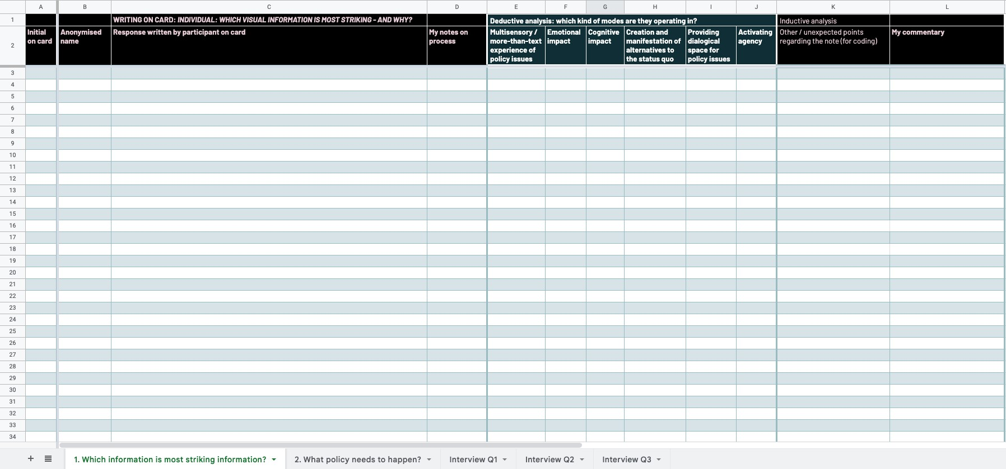
26
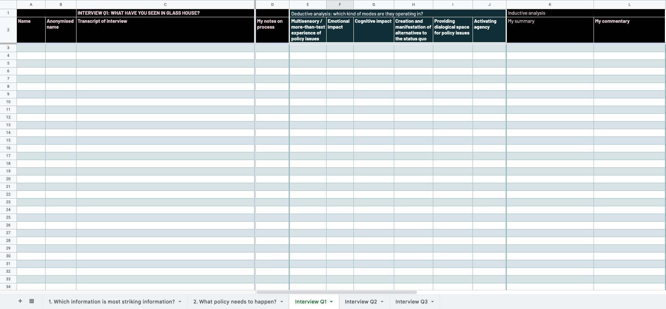

There is a parallel question which is what policy might need to happen in regards to the context of climate change, the topic at the heart of Glass House. This is outside of the scope of this paper. Parts of the project could provide an input to a discussion on the question of what, and this is noted where appropriate.
The process was less linear than this simplified model implies; for example, to meet deadlines the Glass House artefacts were being created whilst the first phase of research was being done.
Which in turn is embedded in a much wider body of literature and research, positioning it as state of the art for what is known about how art ‘operates’ in the world.
Kaszynska et al. delineate two other features of practice research useful for this project. The first is the relationship between practice research and networked knowledge production. As will become apparent through this report, the insights in it are heavily informed by the ideas, perspectives, writings and reflections of the people who participated in Glass House. The second relates to the distinction by Candy (2006) between practice-based research (which undertakes to gain new knowledge partly by means of practice and the outcomes of that practice) and practice-led research (undertaken to gain new knowledge about a practice). This project does both; it incorporates an artistic intervention to learn about what role, if any, art can play in policymaking.
It is likely that one participant took two cards
Where initials are not provided on the cards the responses are noted as Anonymous Participant 1, 2 and so on.

