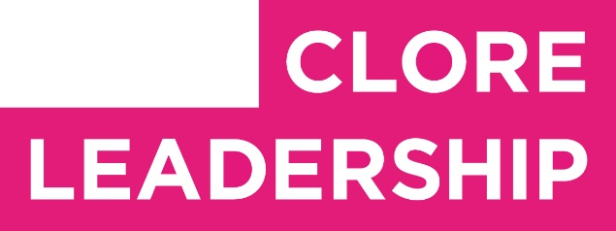

Clore Leadership-AHRC Online Research Library Paper
‘Embodiment’ in Autistic Cultural and Creative Leadership praxis. An exploration of method and insight.
Author: Hayley Williams Hindle
Supervisor/s: Jenny Mackewn,
Year paper completed: 2022
Leadership Content Theme/s: Qualities of Leadership, Inclusive Leadership Practice
AHRC Subject Area/s: Policy Arts Management and Creative Industries,
A note on contents:
Since 2005 Clore Leadership and AHRC have partnered to offer a diverse range of cultural leaders the opportunity to produce a piece of extended research relating to leadership and to their specific cultural discipline. These papers, published from 2023 onward on the Clore Leadership-AHRC online research library, reflect an important contribution to the field and we are extremely pleased to make them available to practitioners, scholars, and other interested parties. We recognise that this research library contains a range of terminologies and outlooks: these are reflective of the significant and ongoing changes within the cultural sector over the past 20 years. As such we urge readers to recognise that the authors’ thinking and language may have shifted since completion of these papers, or may be in the process of shifting as consequence of their enquiries.
Unless otherwise stated, research papers included in the Clore Leadership-AHRC Online Research Library have not been formally peer reviewed or published in an academic journal.

‘Embodiment’ in Autistic Cultural and Creative Leadership praxis. An exploration of method and insight.
Hayley Williams-Hindle 2022 - AHRC funded www.alittlebitdistracted.com

Abstract

This research expands on notions of Authentic Leadership, by exploring the usefulness of the practice of ‘TRE’ as an embodied methodology within Autistic cultural leadership praxis.

Tension and Trauma Release Exercises (TRE) assist the body in releasing deep muscular patterns of tension originating from stressful and traumatic experiences. Baseline measures of autism (AQ10), mindfulness (FFMQ15) and Authentic Leadership attributes (Authentic Leadership Self Assessment Questionnaire) were reported for 35 Cultural Sector practitioners. A series of online TRE workshops was then undertaken over a period of ﬁve months, and focus group data and reﬂections were collected from twelve identiﬁed neurodivergent members of the original sampled group, and subjected to a thematic analysis.

This initial exploration suggests that autistic and otherwise neurodivergent Cultural sector workers experienced TRE as a methodology which is easy to learn, and to self replicate. There are also positive indications that TRE may be considered a useful tool in supporting the development of self reported authentic leadership qualities in autistic cultural sector workers. Signiﬁcant trends in Mindfulness, and Authentic Leadership traits were also identiﬁed amongst the small sample of participants.
Implications for further research are considered.

Reﬂections from research participants, as recorded during the interviews following the TRE intervention, are woven throughout this narrative and statistical exploration.

Introduction

Autistic people are rarely identiﬁed in positions of leadership within the Cultural

sector, and consideration of nuanced pathways to leadership development for such populations are in their infancy. (Autistic Cultural sector workers aspiring to leadership will be referred to, for simplicity, as autistic workers throughout).

There is not scope within this examination to detail all of the literature that exists pertaining to these ideas. I start with an overview of the key themes of authentic leadership, autism and embodiment principles and aim to draw together a rationale for approaching the issue of underrepresentation of Autistic workers by examining the value of embodiment principles in development of greater coherence of autistic ‘self’ as a key attribute in authentic leadership development.

Understanding Cultural Leadership

‘Cultural Leadership’ means leading culture itself: making work, productions and projects which show different ways of thinking, feeling and experiencing the world, and bringing dynamism to the economy and wider society.

The particulars of leadership within the Cultural sector are revised here in some detail so that we can see the challenge of Neurodivergent framing in context. The British Council explains:

Describing value Leaders in the cultural sector must explain and communicate the value of what they do. This task is made harder because the ideas cultural organisations produce are non-replicable and they have to inspire conﬁdence in projects without precedent or known outcomes.

Working in networks Ideas thrive in loose networks rather than rigid structures, so cultural leaders have to too. They often need to simultaneously operate in small companies, production houses and as loan-agents while being connected to rich and diverse networks of supporters, funders and collaborators. There is a complicated balance for cultural leaders to maintain.

Living dangerously Cultural sector leaders often have to place themselves in danger. The best cultural organisations produce ideas that make new ways of seeing, thinking and feeling possible - their work is an expression of human freedom. This can be a benign, quiet act, but it can often threaten vested interests and powerful elites.
Cultural leaders have to maintain a moral conviction and the ability to route-around, confront and subvert authority.

Social work Complicated forms of communication and symbols are everywhere, used by individuals and organisations alike to deﬁne their politics, their values and their

attitudes. With cultural expression so prominent there are huge opportunities for cultural leaders to make a positive difference to things that matter, but the strategies and tactics which they can use remain unclear.

There is a challenge to leading within this domain of Culture as described above, within both ‘for proﬁt’ and ‘not for proﬁt’ cultural organisations. The particulars of that challenge as they pertain to the autistic self will be made apparent.

Autism as Neurodiversity and Cultural Difference

How can we understand ‘autism’? The psychological framing is slowly catching up to the narratives of those with lived experience. The preferred term of many - ‘neurodiversity’, with divergent conditions termed ‘neuro-minorities’ - was inﬂuenced by the social model of disability. The naming is based on ‘biodiversity’, being considered desirable and necessary for a thriving ecosystem.

The psychological deﬁnition of neurodiversity refers to the diversity within an individual’s cognitive ability, wherein there are large, statistically-signiﬁcant disparities between peaks and troughs of the proﬁle - known as a ‘spiky proﬁle’. (In contrast, a ‘neurotypical’ person’s cognitive scores fall within one or two standard deviations of each other, forming a relatively ‘ﬂat’ proﬁle. (Doyle, 2020).) A sample spiky proﬁle report is shown below.

Around one in three people in a general population are diagnosable with a neurodivergent condition; in psychological literature, ADHD, autism, developmental coordination disorder, and dyslexia are most frequently referred to under this banner, and are the conditions included in my references to neuro-minorities here.

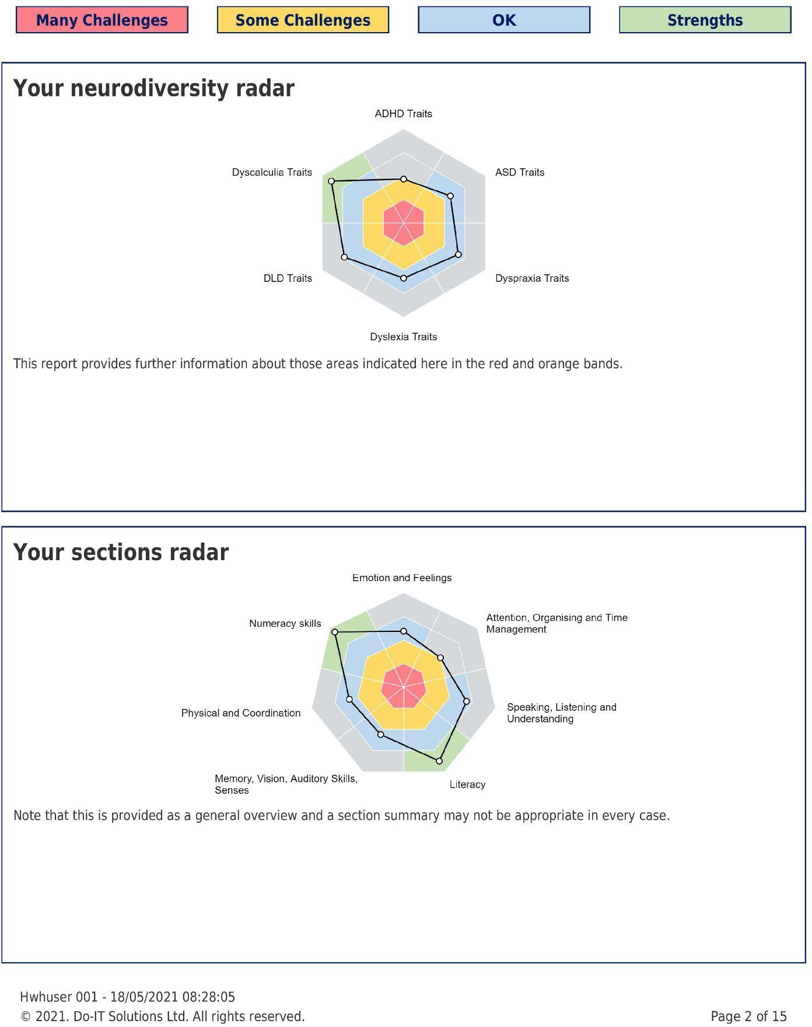

Representative examples of ‘spiky’ cognitive proﬁles - generated by Do It Solutions ltd.

Autism and the Double Empathy Problem - a Cultural mismatch

Damien Milton’s concept of a ‘double empathy problem describes a bi-directional cultural block in identifying, understanding and exploring a mutual experience which might otherwise lead to empathy and creative innovation. Perhaps the most clear

expression of such cultural mismatch is seen in Autism, where sensory proﬁle, social engagement, social hierarchy, and social/emotional relationality norms are not aligned with a neuro-typical majority. This concept is key to framing many of the social, emotional and relational difﬁculties experienced by autistic people in the workplace. And, crucially, it shifts the burden of understanding; we start with the assumption that neither the NT nor the ND communication style is superior.

Authentic Cultural Leadership?

(Kruse, 2013) deﬁnes Leadership as a process of social inﬂuence, which maximises the efforts of others, towards the achievement of a goal.

Leadership has been an evolving topic of interest and research across the ages. Even so, leadership failures are typical; recommendations for ‘ways to lead’ have often been descriptive, assumptive and prescriptive without considering various individual differences. We might compare prevailing methodologies to those recorded in Autism at Work intervention research (Scott & Milbourne 2018) in which individuals are overwhelmingly more likely to be trained to ‘act’ a behaviour rather than be supported to embody particular qualities as the foundation from which actions may be taken. This same trend is evident in Applied Behavioural Analysis approaches used with autistic children and adults - the consequences of which are equally overwhelmingly experienced as traumatic and counterproductive to wellbeing (McGill & Robinson).
What then might a different approach to learning to lead entail?

'How could we understand the dynamics of leadership from a holistic perspective that recognizes the emergence of leadership in the interplay between the biological, individual and social domains?' (Kaufman 2020)

The idea of “authentic leadership” was popularised by Bill George (2003), who described it as a style that is consistent with a leader's personality and core values, and that is honest, ethical, and practical (2003, 2007). In their (2015) study, Koya et al suggest a model that encompasses more than these metrics of authenticity which can be understood as ‘insular’, and instead posit ‘Embodiment’ as the desirable direction of travel in leadership development. Embodiment, as distinct from authenticity, requires the development of attributes that correlate with the state of being in the World. Koya et al identify 10 attributes they consider to be fundamental underlying qualities of primary importance in terms of leadership development. They are;
being non-judgemental, embracing uncertainty, active listening, congruence (morals and ethics), intuition, reﬂective practice, sense of meaning/purpose, holistic decision making, authentic presence and intention.

The same authors cite (Hede 2010) and point out that most of the attributes outlined as embodied leadership qualities can be acquired through mindfulness practices.
mindfulness
/ˈmʌɪn(d)f(ʊ)lnəs/ noun
- the quality or state of being conscious or aware of something. "their mindfulness of the wider cinematic tradition"
- a mental state achieved by focusing one's awareness on the present moment, while calmly acknowledging and accepting one's feelings, thoughts, and bodily sensations, used as a therapeutic technique.
This author is not aware of a currently validated measure for these 10 attributes of Embodied leadership. Consequently, a decision was made for this research to use the validated measures of authentic leadership, alongside a measure of mindfulness.
Koya and Anderson’s (2015) research in the ﬁeld of Human Systems Management encourages further investigation of methods that could inﬂuence embodied leadership attributes, with the intention that such an understanding could inform a framework to train individuals to become embodied leaders. Mindfulness practices are suggested as a useful starting point for exploring the development of authentic neurodivergent self expression within leadership.

‘Many people comment on the fact that TRE® has somehow helped them make rather quick and substantial progress in their meditation practice using the tremor mechanism in TRE®.’ David Berceli (creator of the TRE methodology)

Tension & Trauma Releasing Exercises (or TRE®) is a simple yet innovative series of exercises that assist the body in releasing deep muscular patterns of stress, tension and trauma. The process activates an autonomic shaking mechanism that exists in all mammals, and is postulated as being an adaptive response to completing a stress cycle and discharging excess survival energy which is otherwise held within the body.

This research situates Koya et al’s challenge within a culturally sensitive neuro divergent framework, and asks if TRE might be one ‘mindfulness’ method that can support the development of Embodied leadership attributes.

Methodology

Participants

The participants for this study were 35 adults (ages 21 - 65, mean age 30.2 , SD = 9.8), Of whom 17 were NT (ages 21-65, mean age 27.1 , SD= 5.3) and 18 who were ND (ages 22 - 41, mean age 33.3 , SD 12.0 ) working in the Cultural sector. Participants were all based in the UK. Some participants were foreign students studying in the UK but no information was gathered about the country of origin. Participants were recruited from my existing networks of neurodivergent cultural sector workers.
Sources included; ND artist collectives, individual connections, and one year MA creative practitioner students.

A total of 35 participants began the research cycle. 12 ND participants completed the full cycle through a minimum of 3 x TRE workshops and at least 1 reﬂective workshop.

Materials and Procedure

After reading information about the study and giving consent, participants were all asked to complete baseline measures. The measures consisted of: Population measures (age, gender); AQ10 as a measure of autistic traits; the (ALSAQ) Authentic Leadership Self Assessment Questionnaire; and (FFMQ15) Five Facets of Mindfulness Questionnaire.

Different modes of communication were offered to allow flexibility and cater for diverse communication preferences (Vincent, 2019). TRE sessions and reflective Interviews were arranged at a convenient time in the preferred mode – all 12 participants completed the interviews over Zoom. All interviews occurred in February 2022 and took on average 180 min to complete in small group format. Participants were reimbursed £100 each for completing the reflective feedback session following TRE workshops.

AQ10 - a 10 question Likert scale measure of autistic traits. The Autistic Spectrum Quotient Test (AQ) is a diagnostic questionnaire designed to measure the expression of autism spectrum traits in an individual, by his or her own subjective self assessment. A score of 6 or more is indicative of a ‘red ﬂag’ for clinicians to refer a person on for full screening for autism.

The 'Authentic Leadership Self Assessment Questionnaire' - a 16 items validated scale. This self-assessment questionnaire is designed to measure ‘authentic leadership’ by assessing four components of the process: self-awareness, internalised moral perspective, balanced processing, and relational transparency. By comparing scores on each of these components, one can determine which are stronger and which are weaker components in each category. Individual authentic leadership scores are interpreted using the following guideline: high = 16–20 and low = 15 and below. Scores

in the upper range indicate stronger authentic leadership, whereas scores in the lower range indicate weaker authentic leadership.
The 4 components of authentic leadership are described below;

- Self-Awareness Seeks feedback to improve interactions with others. Accurately describes how others view his or her capabilities.
- Relational Transparency . Says exactly what he or she means. Is willing to admit mistakes when they are made.
- Internalised Moral Perspective . Demonstrates beliefs that are consistent with actions. Makes decisions based on his/her core beliefs.
- Balanced Processing . Solicits views that challenge his or her deeply held positions.L istens carefully to different points of view before coming to conclusions.

15-item Five facets of Mindfulness Questionnaire (FFMQ)
The Five Facet Mindfulness Questionnaire (FFMQ-15) is a 15 question self-report scale that measures mindfulness with regards to thoughts, experiences, and actions in daily life (Baer, Carmody, & Hunsinger, 2012). The FFMQ-15 measures 5 subscales of mindfulness: Observing, Describing, Mindful Actions, Non-judgemental experience, non-reactivity.

Below is a brief description of the ﬁve factors that this test measures:
- Observing Observation entails the ways we use our sensory awareness. It involves how we see, feel, and perceive the internal and external world around us and select the stimuli that require our attention and focus.
- Describing The statements evaluating descriptive qualities study the way we label our experiences and express them in words to ourselves and others.
- Mindful actions Mindfulness is closely related to self-awareness and calculated actions. This facet of the test studies the movements we choose after attending to the information present at the moment. It delves deep into whether we can act out of quick judgement and get out of the autopilot mode before responding to a situation.
- Non-judgmental inner experience Non-judgmental experience is tied in with not letting the inner critic exert a toll on happiness and positive state of mind. It calls for self-acceptance and unconditional empathy for oneself and others.

5. Non-reactivity This aspect refers to active detachment from negative thoughts and emotions so that we can accept their existence and choose not to react to them. Non-reactivity makes way for emotional resilience and restores mental balance (McManus, Surawy, Muse, Vazquez-Montes, & Williams, 2012).

The scores of all ﬁve subscales of the FFMQ give a reliable measure of mindful
self-awareness and can also guide how effective a mindfulness intervention has been. TRE (Tension release Exercises)
‘TRE’ is the peer reviewed methodology of Dr David Bercelli. Based on a Polyvagal (Porges, 2009) understanding of the mammalian nervous system, the technique consists of a series of 7 stretches that isolate core muscle groups and work to stretch out in turn, starting from the feet and working up through the legs and into the psoas and torso. Following on, participants are guided into a prone position where they can safely activate an autonomic tremoring mechanism.
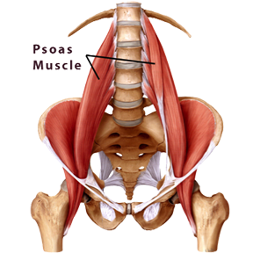

Image of group of participants lying prone with knees bent, activating autonomic tremors during the process of TRE. Second image shows the human pelvic structure and the psoas muscles involved in activating the autonomic tremor function in TRE.

- From the TRE for ALL website:
- The therapeutic muscle tremors evoked by the TRE exercise process is a

natural, internal, neuro-physiological response of the body to reduce its own stress and restore a sense of well-being.
- TRE is a body based (somatic) process which, when done properly, through a Certiﬁed TRE Provider can allow the individual to discharge tension from the body, which often does not require “revisiting the story” (ie: verbally describing or talking about the traumatic experience).
- TRE is designed to be a self-help tool that once learned, can be used as needed, throughout one’s life, thereby continuously supporting and promoting personal health and wholeness.
- TRE can be taught as either a simple self-help, tension reduction technique in a physical exercise program OR it can be used as an effective complementary practice when integrated with other treatment modalities by those in the healing professions, including the treatment of PTSD and anxiety disorder recovery.
- TRE can be taught in very large groups for communities that have experienced mass trauma. TRE promotes cohesiveness and openness between participants and can be a helpful tool for dispute resolution. (ie: interpersonal, corporate and political communication)
- TRE can cross culture and language barriers because it is based on natural physiological responses shared by all human beings.

Procedure

Participants were given the following introduction to this work:
I would be very grateful if you would consent to complete these baseline measures.

I am undertaking some research into ‘embodied leadership’ and somatic (of the body) methodology, particularly as it pertains to ‘Neuro-divergent’ leadership. The research is being funded by the AHRC (arts and humanities research council) With your agreement I would like to collect some information on your own experience of embodiment and to follow up with an offer to join a series of three online movement workshops before collecting some 'after' measures, and will use your email address provided below to do this. You are of course under no obligation to follow up with the movement workshops if you choose not to participate beyond this initial survey, and you are free to stop your engagement at any time.

You can contact me to ﬁnd out more about the research by email; hayley@alittlebitdistracted.com

Following completion of baseline measures, participants were invited to take part in a minimum of 3 x online TRE workshops over as many weeks, either individually or in small groups. Participants were not limited to 3 workshops, however, and a number of participants completed 18 workshops spaced out over a period of 6 months. TRE workshops were recorded and text transcribed using Otter.ai. Following the completion of these somatic TRE workshops, in the ﬁnal stage, a series of guided discussions were conducted in order to draw out recurring themes in insight.

Online discussions were prefaced with the following guidance sent by email 48 hours in advance;

- You might like to ﬁnd another 10 minutes to reﬂect using the following questions as prompts; There are no right or wrong answers, and you can respond or ignore the prompts any way you like!
- Q. How do I understand what 'leadership' is?
- Q. What does leadership mean in the context of me, as an individual? (thinking about my personal strengths and challenges / neurodivergent nature?) and do I consider myself to be a leader?
- Q. What has my experience of TRE (tension release exercises) been?
- Q. Do I notice any ways in which doing TRE has impacted on my personal reﬂections on leadership?
- Q. What do I notice about my personal Neurodivergent qualities and does TRE impact my understanding of myself?

A total of 3 guided discussions took place over zoom, in order to gather feedback from participants. Participants in each of the three groups ranged from 2 to 5 people. The workshops began with a TRE practice and followed with a loose reﬂective discussion about leadership in the context of their own identiﬁed neurodivergence. Open ended prompts were used as conversation starters.
Discussions were recorded in Zoom, and also via the Otter.ai application so that a transcript of conversations was made in real time.

Research Design and Analysis
This 6-month research project was undertaken with the intention of contributing to the ﬁeld of cultural leadership, and of exploring the impact of the particular practice of TRE for autistic workers within the framework of cultural leadership. I (as author) identify within the focus group represented here, since it is my own lived experience and growing appreciation of this autonomic Tremoring process and the facilitatory methodology of TRE, that was the impetus for the enquiry.
Leaning into ﬂexible design - from quantitative to qualitative and beyond

Recruitment of participants and engagement through TRE workshops was continuous over the ﬁrst 4 months of the research period. It quickly became apparent, however, that it was not going to be possible to conduct the quantitative analysis initially intended since we could not obtain ‘before TRE’ and ‘after TRE’ measures of authentic leadership attributes and mindfulness from all participants. A different approach was therefore adopted and the analysis instead considered between-participant measures. This approach meant considering any differences between NT and ND participants.

Qualitative research enables interpretation of autistic people’s experiences and can provide invaluable insight into lived experience. (Bölte, 2014; Braun & Clarke, 2019). Given the paucity of research examining autistic experiences of leadership and methodology for embodying leadership qualities, qualitative research can generate new possibilities for future research. Critically, an autistic researcher conducted this study, and designed the participatory approach which invites increasing agency and person-centred focus in research around autism more generally. (e.g. Chown, Robinson, et al., 2017). Baseline measures were also recorded, and signiﬁcant ﬁndings in self reported measures of mindfulness and authentic leadership were noted.
The research questions for this study are;
Are there signiﬁcant differences or interactions between measures of mindfulness, and authentic leadership attributes, in NT and ND participants?
Is TRE perceived to be a useful methodology for autistic and neurodivergent Cultural sector workers?

Can TRE facilitate the development of qualities of mindfulness as a catalyst to authentic leadership in autistic and otherwise Neurodivergent cultural sector workers?”’

Focus group interviews were undertaken using a semi-structured interview guide, to obtain insights into how autistic and otherwise neurodivergent Cultural sector

workers make sense of TRE in relation to their concept of leadership and self concept. Unstructured interviews typically produce results that cannot be generalised beyond the sample group, but they provide a more in-depth understanding of participants’ perceptions, motivations and emotions. Boud et al (1994) found that recording reactions and thoughts about experiences provides (students) with a structured process that can help them to get the most out of their examination of their activities.

The reﬂective material is drawn from the twelve participants who completed a minimum of 3 TRE workshops during the course of this research. A renewed understanding of the connections between biology and cognition, how the neural networks ﬁre together and wire together, can help us explain the relationship between bodily action, emotional experiences, and thinking in relation to stress and tension.
Questions were accordingly directed to the participants’ experiences, feelings, beliefs and convictions about Leadership and TRE.

Hypothesis

- We hypothesise that a continued and regular practice of TRE holds potential for facilitating an increasing sense of coherent ‘self’ as measured by the FFMQ, and higher relative scores on the Authentic Leadership scale. We also hypothesise that TRE may be a useful component of a wider exploration of culturally sensitive neurodivergent leadership development praxis as reported by participants in reﬂection of their experiences with TRE in the context of this research.

- Using measures of mindfulness (FMQQ), we anticipate that autistic workers will show signiﬁcantly lower scores on the measures of “4) Non judgemental inner experience” and “5) Non reactivity” than NT peers. However, it is expected that measures of “1) Observation”, “2) Description”, and “3) Mindful Action” will vary in response to individual neuro-divergent sensory proﬁles.

- Considering measures of Authentic Leadership, we hypothesise that scores of self-awareness, internalised moral perspective, balanced processing, and relational transparency will vary in autistic and otherwise Neurodivergent workers, as compared with Neurotypical workers, but that overall measures will be lower at baseline than those of NT workers. (We expect this variability as a function of masking, levels of cultural community and other variables, although causation is not part of the research design)

Results

12 Neuro-Divergent workers completed at least 3 TRE workshops and participated in reﬂective feedback discussion. A narrative account of the ﬁndings from these discussions follows ﬁrst. Statistical analysis of the Authentic Leadership and Mindfulness measures are given below.
Themes emerging from the participant discussions following TRE workshops
Theme: Reﬂecting on neurodivergent strengths and challenges

‘There is a lot of support in some ways in terms of people wanting to know what accommodations they can make and asking for your access rider and things like that. But I've personally found it very difﬁcult to know what I'm going to need, having just sort of muddled through for 20 years - to know what you're going to need when something's happening in the moment where you're like, oh, actually, this is too much or I can't be in this meeting. It's not possible to suddenly go, actually, can we just stop.’

‘I think there's a certain level of focus that balances my extreme distraction. … the frustrating thing is that people misplace that distraction as not being interested. …It's not because I'm not interested. Maybe overwhelmed. I may be dissociating, but it's deﬁnitely not lack of interest.’

This highlights another truism as reported by autistic people in particular - that lack of empathic understanding is not a default in autistic people, contrary to dominant current theory and interpretation of research. For some autistic people, emotional empathy, and compassionate empathy (a desire to feel, and to support the other) are in fact heightened.

‘There's a lot around getting to know myself with my own irregular skill sets and having an understanding of other people and that their skill sets are a particular way as well. And I know a lot of neurotypical people make an assumption that because somebody is good at one thing, and they're going to be good at all rounder; but i’m not. My skills are very speciﬁc. I have that understanding of other people. And I think that's helpful. That understanding of myself to be able to understand other people better.’

For autistic people the ability to positively appraise what it means to live on the spectrum may be adaptive for self-worth through recognizing personal strengths.

‘I've always been someone who steps in, in an emergency, like a manager walks out of a crazy

environment and everyone's losing their heads and I'm like, It's okay because I've been watching so, so I seem to sort of like have this. Maybe it's that autistic thing of just noticing everything - this overview.’

Instead of promoting neurotypical functioning, ‘neurodiversity’ encourages individuals to embrace their strengths and differences associated with autism in order to promote well-being and self-actualization (Ne’eman, 2010; Robertson, 2010).

Theme: TRE and physicality / perception of stress and tension

Reducing tension is about increasing the possibilities of being present with one’s own emotions. Encountering stressful situations can lead to the ﬁght, ﬂight or freeze or fawn response, activated by a reaction from the autonomic nervous system (ANS) also known as the acute stress response. This physiological reaction is triggered when we feel a strong emotion like fear or anxiety (Porges 2011). Muscle tension is part of this automatic, unconscious reaction to stress, and can lead to deep chronic tension lasting even long after the stressful situation is over.

‘I feel like both as a physical practice and intellectually I think TRE coming into my life was very timely. Like I've been doing talking therapy for quite a long time, and a lot of the talking for us it was to do with my body and accessing my body. ‘

‘From a trans experience and for a lot of trans people. I think there's a real piece missing in a lot of ways about how we can exist in our bodies because the bodies are being policed externally. And there’s dysphoria too’.

‘I was quite surprised (by the effect of TRE) - I've experienced a lot of pain and discomfort in my knee, and after that ﬁrst session I experienced an immediate comfort and no pain in my knee that I've not felt for ages.’

By inviting attention onto other aspects of intelligence, the salience of ‘different ways of knowing‘ is facilitated. This can be helpful because we might see the individual beneﬁt of increasing a physical ‘felt sense’ (of interoception) or of emotion (addressing the reliability or nuancing of emotional knowing which is implied in ‘Alexithymia’)

‘I'm sort of aware of this mixture of the kind of energy of the movement (of autonomic shaking) which in some ways feels like it's high energy, but at the same time, this very relaxed sensation. And I think I was aware of the idea of being grounded. It felt like there was something like - this is going to get you closer to the ground. And then I feel quite warm, which is good because it's freezing!’

‘TRE gives me focus time. Space to engage physically and without interruption. I felt it's very important to save space. And it's helped to release that tension. ‘

Theme: TRE and Self Awareness

‘I was thinking more about stress relief and relaxation would be the beneﬁt but the mind and body connection meant I could function better. (TRE) affected my mental capacity in a good way. ‘

FFMQ is a predictor for positive thinking, an overall uplifted mood, and subjective feelings of well-being (Baer et al., 2006; Bohlmeijer, Ten Klooster, Fledderus, Veehof, & Baer, 2011). The key aspects of mindfulness that the test measures act as the mediator of therapeutic change and mindful interventions (Carmody & Baer, 2008).

‘Finding these different things (like TRE) has sort of led me to have these bigger discoveries. And then it feels like a process of kind of undoing some of the trauma of those things that I didn't know - and I think that the idea of aiming for more ease is something that I'm always forgetting that it's a thing to aim for.’

Participants reﬂected a growing awareness of their own wellbeing over time as they participated in TRE, showing these elements of mindfulness that mediate therapeutic change, even as some acknowledged self doubt and reﬂected back a meta-awareness; a felt sense of not yet trusting their own instincts.

‘ I’ve learnt (through the process of TRE) that I don't feel like I can go ‘oh, this is a gut instinct. And that's the right thing to do’. Because often, those things that might be instincts (have been) taking me in the wrong way.’

‘I was surprised how quickly and easily things came out (in TRE) so I was wondering if there is a lot stored and I had to get over that initial thing of doubting you know, like, is this right? Am I making this up? I tend to doubt myself.’

Theme: TRE and Leadership development

‘TRE gave me a realisation - like how things feel is - I'm realising it's really important to me and in my way of thinking. It's the same as having a very academic idea around something for me. When I think of leadership, I don't know how to be the leader of myself at the moment. I sort of have a mistrust of my feelings as well.

Feelings are mental experiences of body states (Damasio 1999). This understanding explains how bodily reactions inﬂuence how we feel and how we think. We can see that muscle tension interferes with our thoughts, emotions and inner awareness. Since being tense is as much an emotional as a physical condition, likewise with relaxation.
Reducing tension is therefore about increasing the possibilities of being present with one’s own emotions and feelings so that a greater sense of cohesion of ‘self’ can be usefully accessed.

‘I deﬁnitely don't really see myself as an authority and more kind of just facilitate ….. (pause)
…. okay, leadership could just be kind of like facilitation, the person who's willing to just do that extra bit of work to make sure it keeps happening and to hold something together. ‘

‘(if) You're trying to lead for change, you need to change yourself ﬁrst. To force the change onto another person, I feel that’s really violent, and we're violent to ourselves as well. You know, we get impatient - I get impatient and frustrated with myself. And I wonder, let's see if we lead by self compassion. What would that look like? ‘

‘My difﬁculty with the connotations of leadership especially within professional or management or a hierarchical sense; It's just so overshadowed with very strong negative connotations. With not feeling like a leader or feeling like I want to be a leader.’

Reﬂecting on the necessary elements of meaningful, effective and sustainable leadership development structures, participants reported a sense of alienation from existing models - especially those that were perceived as hierarchical.

‘(i’m) just acknowledging how unhelpful and inappropriate structures and frameworks are for leading, or making work or doing work or functioning or ﬁtting in. They're just not helpful.’

‘It is hard to be yourself, when that ‘self’ is counter cultural .. ‘

‘I wonder if that's like a cultural thing; that understanding of what a good leader is, because I mean, a lot of good leadership I think is about being able to weigh up all of the information and make a good decision.’

Lack of consideration for leadership roles is clearly a challenge for this population. Research has demonstrated that the situation is partly driven by a focus on remediating impairments, with little regard for the strengths of autistic people; perpetuating low expectations and ultimately poor employment outcomes (Holwerda et al., 2012; Lorenz and Heinitz, 2014).

Self doubt may be seen as a natural consequence of a continuous pathological framing

of difference. Higher levels of self doubt predict lower self esteem (eg Hermann et al 2002). Being able to voice or frame an experience of self doubt within a neutral space, then, allows us to reckon with a judgemental interpretation and see the potential of other, more compassionate interpretations. Indeed, Marshall et al (2014) found that self-compassion protects against the negative effects of low self-esteem in a large sample of teenagers.

Theme: TRE and Balanced processing

‘It feels like I've been on quite a long journey of trying to ﬁnd the things that can help to unlock what's what's going on, and often the narrative of that is like, there's something wrong with me, and I don't know what it is. That's wrong with me, and how do I ﬁx it - kind of thing, which isn't always the most positive way of framing it.’

‘Knowing that not having a ﬁxed outcome is ok. That’s liberating. I’ve begun to understand more about those different areas of knowing.’

Participants reported experiential self focus in the reﬂective sessions following TRE. This kind of self focus tends to be more self compassionate and produces less self judgement and shame than more cognitive based self focus.

‘From a trans experience and for a lot of trans people. I think there's a real piece missing in a lot of ways about how we can exist in our bodies because the bodies are being policed. Both externally and there’s maybe dysphoria on board too. …there's a lack of integration for bodily (awareness). … sometimes if you're like, I've got these breasts and they just don't feel like part of me, but everyone's saying they should feel part of me.

I've started to do some volunteering with a youth group where everyone's trans - it's quite intense the wave of like, tension in their bodies because they can’t really trust their bodies or their bodies have become a sort of weapon against them. And it feels like something like TRE would be (useful)’

It is very conducive to having a good night's sleep. So having TRE and kind of treating it like a practice and really giving it time space every day.

Authenticity and self esteem, is key to positive life outcomes and resilience. A clear challenge to leadership development exists in understanding one’s individual needs around realising and asserting, neurodivergent, intersectional ‘self’ identity in the context of a culture which has traditionally pathologised or valued this expression as less-than.

‘There was an extreme perfectionism - my compensating mechanism was having to do things perfectly to compensate for these other things, so I can be accepted. And i’m trying to divest myself of these coping mechanisms which aren't healthy. Might be that they are great for other people, but they're not very healthy for my own emotional and physical well being.’

‘There's been a difﬁculty for me in not being able to see the big picture or not really knowing what discussions have been had. So that's a kind of tricky balance of knowing. I can't hold it all. But if there's certain things that - if I don't know what they are, I'm going to ﬁnd it hard to make decisions. ‘

‘I'm really not a conventional person. Gosh, I've got a lot of work to do to kind of reﬁgure out how I present myself as a more, kind of conventional person.’

Teaching normative body language or persuasive discourse models, for example, without reckoning with the culturally mediated nature of such rules can make it harder for neuro-divergent leaders to believe that an authentic expression of self might be accepted.

Theme: Masking and safety

Authenticity has been deﬁned, within the emerging ﬁeld of positive psychology, as “owning one’s personal experiences, be they thoughts, emotions, needs, preferences, or beliefs, processes captured by the injunction to know oneself” (Seligman, 2002) and behaving in accordance with the true self (S. Harter,2002: 382) The markers of authentic leadership, as we have seen, are self-awareness, internalised moral perspective, balanced processing, and relational transparency. Neurodivergent participants reﬂected on this lacuna of knowledge of self in context and the vulnerability that they frequently feel at work;

‘I tend not to disclose and I feel that I will get discriminated against, especially until they know me. And maybe the arts tends to be, probably, a lot safer, but it's still not safe.’

‘I think (the cultural sector) is structured on us having to mask basically’
I don't think everyone's in a safe place to be able to use TRE. I think that's the interesting thing - this question of safety or non safety, and feeling that out for yourself - ‘is this safe?’.

The aim in ‘TRE’ is that participants can learn to ﬁnd a ‘good enough’ felt sense of safety in order for them to be able to access the autonomic tremor mechanism. Because the autonomic tremor mechanism is a discharge of tension and survival energy, it stands to reason that a soma needs to perceive ‘safety’ to a level that allows this release. In other words - if someone does not feel safe at the level of the nervous system, their body will

not typically allow a voluntary, deliberate access to the shaking mechanism which is the aim of the TRE process.

‘I've been shaking for a couple of years. And it started after I had some Reiki energy. This was before I knew I was autistic. I don't have to do the exercises to induce it, but I feel like doing the exercises and going through it in that way gives it more of a controlled sort of space.’

This seemed particularly important to participants - knowing that a space existed where it felt ‘okay’ to be oneself, and to unmask. Both within the process of accessing TRE, and in the wider context of leadership work.

Because of the makeup of this cohort of Neuro-divergent workers and because the workshops were necessarily held in the wider temporal context of Covid, particular consideration was given to creating a framework of safety and ‘holding’ of participants.

The TRE workshops for this exploratory study were all conducted online; either individually or in small groups of a maximum of 6. Individuals typically lie down in order to activate the tremor mechanism, which means that they cannot really see each other on screen from that vantage point. This had the advantage of supporting a feeling of not being ‘observed’ or of feeling self conscious of being in a group. Being in one’s own home space is also an advantage in maintaining a visceral sense of safety. It is important for the workshop leader to be able to see and also hear all participants in order to guide the process safely and effectively, and to seek continuous verbal feedback as part of the protocol.

‘I tend to actively normally ﬁnd ways not to move because it's distracting and people ﬁnd it sometimes irritating. Like, zoom. I can sit on my hands. So I'm so used to trying to suppress the movement. That is interesting for me to allow (in TRE).

I was worried that the needs would be beyond our capacity. And that would be a real letdown... it turns out that we didn't need any other resources for support, we just needed time.

Theme: Self Concept as a limiting factor

Longitudinal studies tell us that global self-esteem is relatively stable across the human life course and that high self-esteem is predictive of positive outcomes in multiple life domains (e.g. better relationships, work, and health) (Crocker and Wolfe, 2001; Orth and Robins, 2014). (Di Paula and Campbell, 2002) suggest that this is because those with high levels of self-esteem tend to have greater persistence on challenging tasks

and have more effective self-regulation strategies.

Accordingly, autistic persons who report low self-esteem may experience greater difﬁculties in persisting with goals perceived as challenging (e.g. employment, social relationships). Carpenter, 1992 showed that autistic people reported feeling dejected at being under-employed relative to their capabilities. In another study, autistic adults said they often felt discouraged by previous attempts at managing social situations (e.g. “I didn’t try to interact with other students because I didn’t know how…It felt too complicated when I tried” Haertl et al. (2013) which may contribute to the experience of loneliness and perpetuate low self-esteem (Mazurek, 2014). Recorded reﬂections from participants in this research conﬁrm these observations about the impact of self esteem on leadership development.

There's a real tension there. In the arts, I think there is more acceptance of changing things but i’m noticing that at the moment i’m looking at other ways in which I can move my career, and I need to be more savvy with time and energy as things change. It’s been a real shock - I feel quite alienated from other worlds.’

Research examining factors related to self-concept in autistic participants has found that higher IQ and executive functions were associated with lower perceived social competence and global self-concept (Vickerstaff et al., 2007; Zimmerman et al., 2017). A potential explanation for these ﬁndings relates to the nature of self-appraisals, whereby heightened awareness of social difﬁculties and greater self-scrutiny (as supported by better reasoning, working memory and cognitive ﬂexibility) may contribute to poorer self-concept. Qualitative studies have identiﬁed that autistic adults often felt ‘different’ to their peers and experienced a sense of helplessness (Townson et al., 2007; Müller et al., 2008).

Theme: Perspective is key

‘My thing is, sometimes not being able to rely on consistent energy or mood. And, being overwhelmed and in chaos, and actually sometimes not being able to function. I don't see how the systems … support and accommodate that. It doesn’t allow for ﬂexibility and ﬂow’.

As we have identiﬁed, autism is viewed within a Neurodiversity framing as a way of being, rather than a health condition (Kapp et al., 2013). Even so, perceiving beneﬁts or ﬁnding positive meaning in living with a chronic health condition has been shown to have long-term positive effects on physical and psychological health (Afﬂeck et al., 1987; Evers et al., 2001).

‘When it comes to the actual function of what we're doing, we can function really well but I

think where the problems come in is the perception of those abilities. Perception of abilities and also perhaps the acceptance of having disability access needs to meet (in order to be) able to function.’

‘I’m acknowledging this holistic nature of leadership qualities and needing all sorts of capacity and energies to be functioning in order to lead and I think I'm really doing some work and putting some time into taking care of this best you know.’

Theme: the tension of authentic self expression

Autistic people frequently experience marginalisation on several fronts in ways that intersect with other aspects of their identity. The impact of marginalised status on identity has long been explored by Black scholars. “It is a peculiar sensation, this double-consciousness, this sense of always looking at one's self through the eyes of others.” Du Bois wrote of the “double consciousness” of being Black in America. The nature of masking, of having to suppress aspects of one's identity, means having to see oneself through the lens of another.

‘I tend not to disclose and I feel that I will get discriminated against, especially until they know me. And maybe the arts tends to be probably a lot safer (than other sectors), but it's still not safe.’

The damaging practice of Masking (conscious or unconscious suppression of natural / autistic responses) is a recognised phenomenon amongst neuro-minorities, as a result of this cultural pressure to conform. (Pearson & Rose 2021) It is harder, and more risky to be oneself when that self is counter cultural.

‘ I think we overcompensate just to try and navigate around the world or on social issues. We are so busy compensating or masking or trying to be wherever the expectations are. Because we're very well aware that we don't meet them.’

Autistic adults report masking across multiple contexts and higher levels of reported masking or switching between masking/not masking are correlated with higher reported higher levels of stress, which is consistent with the idea that disconnection from one's identity causes psychological distress.

‘I do ﬁnd myself quite often. Maybe like once a week at the very least, getting into a state where I feel myself being physically overwhelmed. I can feel anxiety bubbling up inside me.’

‘There’s something about movement. .. part of my exploration of my neuro divergence is an exploring kind of spins stimming and, and also being aware that my body wants to be moving

all of the time and whether that's like little twitches or waving my arms around or using a standing desk’.

This process of disconnection might be essential in understanding burnout, which has been described as the result of chronic life stress and a mismatch of expectations and abilities without adequate support.

‘I feel like i’ve ﬁne tuned the way of working and managing things that really suits my needs. It doesn't necessarily quite translate to personal things or professional situations, but I do know what I need. My self awareness is really strong because I've had to work out why, what or when I've not been able to function properly. In the past I've had to do a lot of work to work that out. But it's just kind of like turning that outwards [(to advocate for self] is a challenge.’

I'm always picking, ﬁddling and, like gnawing you know. And that's been quite bad. My hands have been quite bad - I just really just go in on them. They can really bleed and that tends to be my go to sort of action (to self regulate).

The relationship between masking and autistic burnout and suicidality means that it is important that masking is recognised as a self-protective mechanism rather than a necessarily conscious choice. Alexithymia (difﬁculty identifying one’s own emotional state and distinguishing it from bodily state) has a prevalence of 50% in the autistic population. |This interoceptive disconnection can make it difﬁcult to self-regulate - if one does not realise that stress is increasing until too late. Autistic people have also reported that the energy put into masking can further detract from the already impacted ability to self-regulate, placing strain on an already depleted system.

‘So much energy in having to present yourself differently. It can be exhausting’.

The term “unmasking” is common in community discussions, because it is the literal representation of autistic persons taking control and being more authentically themselves. Unmasking is a choice that is made after a long process of introspection, spending time among other autistic people and learning from sharing relatable experiences.

‘I think healing takes place both singularly and collectively. And there's something about collaborations that you know, other bodies even just moving and proximity, helping each other, learn and heal’.

Autistic community connectedness provides a buffer against the effects of minority stress and is related to an improved sense of well-being (Botha 2020). When we witness someone ‘like us’ leading authentically within a space, an embodied experience

is powerfully realised. Evidence is strong in this work around community connectedness, that opportunities for peer mentoring, coaching and aspirational modelling are critically important for neuro-minorities to access.

The above is a sample of responses collected, and fuller transcripts of the reﬂective discussions are available on request to interested parties. In summing up I have aimed to select a range of responses from across the participant group to illustrate some of the participant reﬂections related to qualities of embodiment within the context of cultural leadership development amongst neuro-divergent workers.

Statistical Analysis

35 participants completed the 3 screening measures described.

Each measure was scored and subjected to an analysis of correlation between each of the factors. Participants were separated into two groups titled, for ease, ‘ND’ or ‘Neurodivergent’ - this group included all participants who scored 6 or more on the AQ10, which indicates a ‘red ﬂag’ for referral for more formal autism screening. The sample included all those who scored 6 or more on the AQ10, as well as those who disclosed ND conditions.

The other group, termed ‘NT’ or neurotypical, included participants who scored between 0-5 on the AQ10, and excluded any additional participants who disclosed a neurodivergent condition.

A third party data analyst used spreadsheet software and the open-source data analysis software R to produce:
- a correlation matrix of the Spearman’s rank correlation coefﬁcient for each combination of pairs of the scores obtained,
- p-values for each correlation (using a two-tailed t-test),
- and a scatter plot for each combination of pairs of the scores obtained, for the dataset as a whole and for the two aforementioned groups separately.

This written analysis is prefaced with acknowledgement of the small sample size, so that any observations should be considered as offering guidance as to direction for further research.. Even so, there are some ﬁndings that indicate possible clues as to the nature of the systemic dynamics at play. The full output can be seen on the ﬁles in the appendix; however, some of the more illuminating ﬁndings are shown in the tables below.

Reﬂections recorded from ND participants following the intervention are woven through this narrative discussion in bolded green text.

The three correlation matrices below show the Spearman’s rank correlation coefﬁcient for each pair of measures for which p <= 0.05. Green indicates a positive correlation between factors, and red indicates a negative correlation.
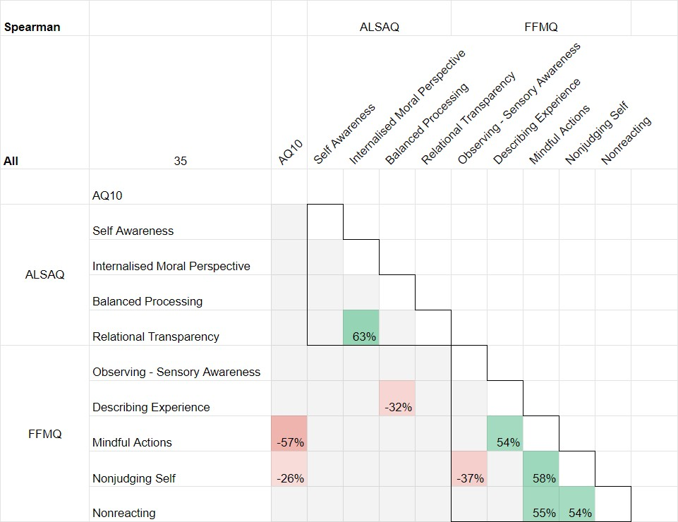
Correlation matrix for the group of all participants (n=35).

- There are signiﬁcant correlations between a number of the individual factors of these two measures, for both NT and ND participants.

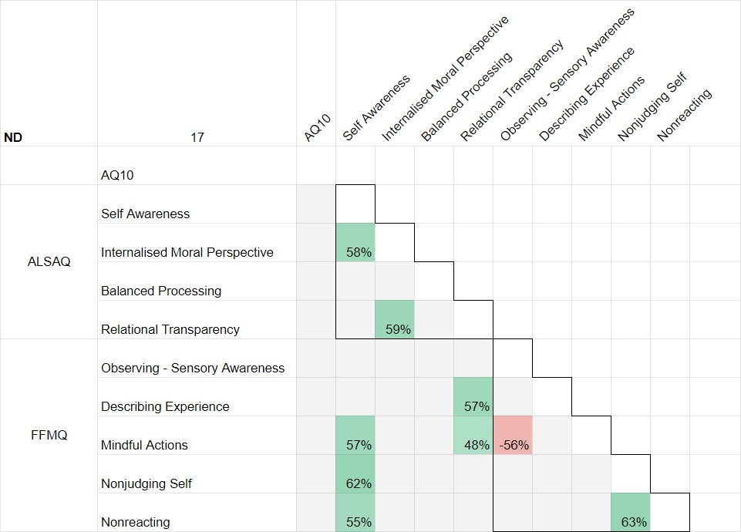
Correlation matrix for the sub-group of only neurodivergent participants. (n=17)

- There are no signiﬁcant correlations between the AQ10 score and any of the measures for the ND participants, although ‘Observing’ is approaching signiﬁcance.
- Self Awareness is positively correlated, in the ND group, with Mindful Actions, Nonjudging of self, and Non reacting (but not in the NT group).
- Relational Transparency is positively correlated with Describing experience
and Mindful action in the ND group (but not the NT group).

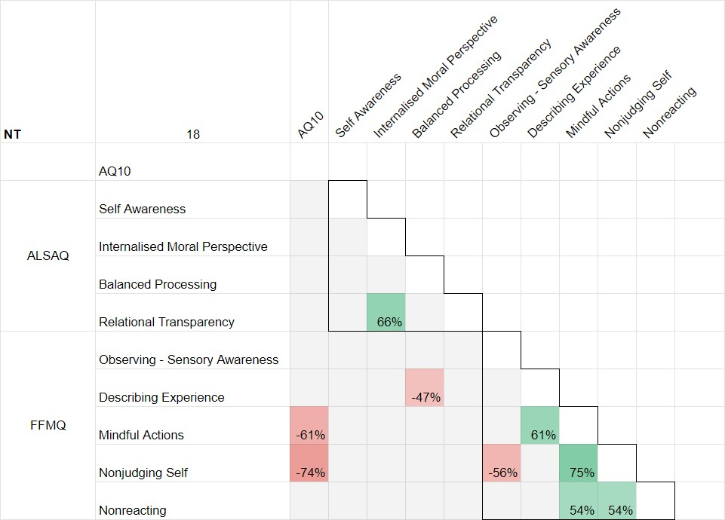

Correlation matrix for the sub-group of only neurotypical participants. (n=18)

- Of immediate note is that there is a signiﬁcant negative correlation between score on the AQ10 and measures of awareness and non judging of internal experience, for NT participants(but not for ND participants).
- There is a signiﬁcant negative correlation between Balanced processing, and
describing experience, in the NT group (but not in the ND group).

The following scatter plots offer a more detailed look at the relationships between the paired measures summarised in the above matrices.

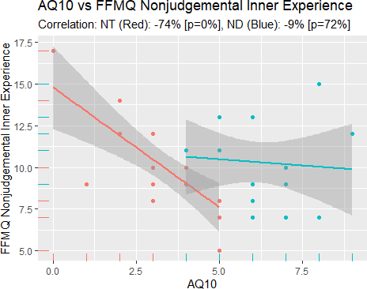

Scatter plot of individual responses, for the Mindfulness measure of ‘Non-judgemental inner experience’. Correlation strength and direction is indicated, alongside ‘p’ value, where a p value of 5% or less is statistically signiﬁcant.

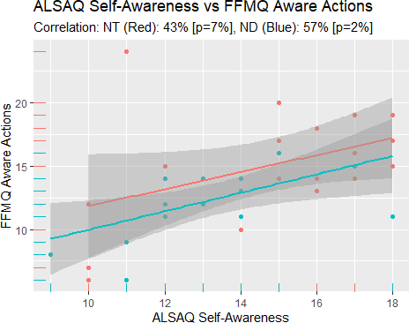

Self awareness as a correlation of Awareness of actions.

What Does This Mean? An Interpretation of statistical ﬁndings ..

The Authentic Leadership scale and the Mindfulness measures, perhaps unsurprisingly, show overlap in their construct factors. The differences in correlation between these small group samples of neurotypical and neurodivergent Cultural sector workers, as measured by the AQ10 and self report, suggest nuance that may guide further investigation.

Relating these measures to the literature discussion above, this small sample of a subset of Cultural sector workers broadly supports previous ﬁndings, and highlights some particulars for further exploration.

For neurodivergent Cultural sector workers, the quality of self awareness was found to be strongly correlated with awareness, non judging and non reacting. This might indicate a greater psychological need in ND to ‘know thyself’ - greater degree of awareness and non judging and non reacting to self might mean that a ND worker feels more secure / safer to seek external feedback without perceiving additional threat, because they are better able to describe how others view their capabilities.
This is in contrast to the current literature which suggests that heightened awareness of difﬁculties may contribute to poorer self-concept. This poorer self concept has been

attributed to a sense of helplessness however - and perhaps the nature of mindfulness, and TRE in particular, is that a growing self awareness is also balanced, ideally, by balanced processing and a more accurate (and compassionate) sense of self.

Similarly, relational transparency was positively correlated to mindfulness measures of describing and ‘awareness’. One explanation for this ﬁnding may be that for cultural minorities there is a benign expectation (and in some cases, non benign expectation) that the individual will ultimately be motivated - either by internal or externally driven mechanisms- to conform to a majority expression.

Research in the ﬁeld of social conformity gives a framework for understanding these behavioural drivers - as distinct from those driven by an ‘authentic’ expression of embodied reality. This correlation, from an admittedly low sample of participants, warrants further exploration as to the behavioural implications of the ‘authenticity’ factor of self awareness for Neuro-divergent minorities.

By contrast, the only signiﬁcant statistic with Neuro-typical cultural sector workers was that the authentic leadership quality of balanced processing was negatively correlated with the mindfulness quality of describing. This might suggest that NT balanced processing - or seeking others opinions on decision making - is not strengthened by an increased ability to label inner experience. In any case, it warrants further exploration and research.

> Mindfulness = > authentic leadership qualities? …

If it is the case, as current research suggests (Hede 2010) that increasing mindfulness can increase authentic leadership qualities, we would expect there to be a positive, rather than a negative correlation with each of these construct factors. It may be, however, that these ﬁndings are suggestive of particular nuance between ‘Authentic’ leadership, and ‘Embodied’ leadership qualities. In other words, increasing mindfulness is not necessarily going to impact on qualities of authentic leadership for NT workers.

There is no directional information in this analysis - it may equally be the case that in order to develop the quality of ‘balanced processing’ as a leader, NT workers must ignore their own inner convictions to a greater extent in order to allow for external voices to be considered. By contrast, this might be considered to be a particular strength of Neuro-divergent workers in the context of authentic leadership, where the ability to accurately describe inner experience has no signiﬁcant interaction in our results, with balanced processing. Further investigation is needed to replicate and tease out these various interactions.

It makes sense from what we have explored in the literature review, that the more one deviates from the majority in terms of Autistic expression, the more judgemental one becomes of internal experience - if we become aware that what we experience internally, is different from that reported or seemingly experienced by others. There are potentially interesting ﬁndings here that deserve further exploration so that the apparent merits of increasing qualities of mindfulness can be understood in context.

Discussion and Conclusion

Neurodivergence can be viewed as a minority cultural difference in the way that social structures of engagement are perceived and understood. Neurodiversity argues that society would beneﬁt from recognizing and developing the strengths of autism or dyslexia (for example) instead of pathologizing their challenges. The movement argues for equal rights for members, appreciation of the diversity of human cognition, and political power to break down structures of exclusion.

This is an important baseline to establish - the framing of the ‘issue’ is critical to how we individually and collectively approach addressing that issue. Neurodivergence as framing is humanising, without a value judgement of deﬁcit, and it is overwhelmingly the lens through which a lived experience is referred within the community.
Psychological research is slowly reckoning with this social framing and moving away from deﬁcit models - though not yet as readily as might be hoped.

Ethnographic research has focussed heavily, to date, on autistic-to-neurotypical interactions which take place against the cultural backdrop of neurotypical norms and expectations (Heasman and Gillespie, 2018; Kremer-Sadlik, 2004; Ochs, 2015). More recently (Heasman and Gillespie 2019) identiﬁed a generous assumption of common ground between autistic interactions leading to rapid rapport, and a low demand for coordination that ameliorated many challenges associated with disruptive turn taking in conversation. These ﬁndings suggest a truism that is often reported by autistic individuals, and is conﬁrmed in the reﬂective feedback here - that neurodivergent intersubjectivity is a form of social relating, albeit a minority one.
cognition
/kɒɡˈnɪʃ(ə)n/ noun

- the mental action or process of acquiring knowledge and understanding through thought, experience, and the senses. a perception, sensation, idea, or intuition resulting from the process of cognition.
- plural noun: cognitions

Safety and co-regulation - Future considerations

Where a TRE workshop is being conducted in a real space - with participants in the same room as the instructor - direct communication with individuals can happen much more discreetly by having the instructor move around the room. This isn’t possible online. The internet is a ﬁckle instrument, however, and even given the advantage it offered in this case, it’s still common for signal - sound and image - to be lost.

Establishing clear communication is paramount so online protocol forTRE is to maintain a more regular verbal or physical signal of acknowledgement. This was achieved by inviting reﬂection of felt sense and noticings, and by inviting regular ‘thumbs up’ from participants! Even so, we have recorded evidence that being ‘heard’ was clearly a concern for some. A full expression of nervous system discharge and regulation can involve sighing, or crying, or other verbalisation for some individuals, which are not ‘acceptable’ voluntary behaviours within a normative culture.
Overriding those culturally shaped norms is not simply a case of ‘will’. Perception of psychological safety is paramount.

This weighted focus of previous research effort as well as the reﬂective feedback from participants here illustrates the scale of the shift needed in conceptualising the challenge of nuanced and sensitive leadership praxis for autistic workers. The discussion below examines in brief some of these neuro-biological and cultural constraints to successful development within existing Leadership development models.

Intersectionality

Certain experiences of autism are under-represented. Consensus is growing that Autistic people are as diverse (in broad terms) as the rest of any wider population. Intersectional leadership has evolved from a deﬁnition to a burgeoning framework. Accordingly, intersectionality is an important consideration in a person centered approach to leadership development, that draws attention to the exclusion of marginalized subgroups of people with autism (e.g., by sex, gender, language, ethnicity, level of support needs, socio-economic status and age) as a major ethical concern.

Autistic experiences of racialization and other forms of ‘minoritization’ can create situations of “double vulnerability” or “double minority” status. Two pf the participants in this research cohort self identiﬁed as transgender (one of them male to female, and

one female to male). The reﬂections of these participants included reference to the additional challenge that came with their trans identity alongside their neurodivergence. None of the participants in the Neurodivergent group in this study were identiﬁed as non-white, but we know that there are particular compounding challenges for workers who are both neurodivergent and non-white that make avenues into Leadership even more potentially difﬁcult to access or navigate. This is a critically important area for further research.

Neurodiversity is not a synonym for disability, but even so, many ND employees ﬁnd themselves in need of disability accommodation at work. Autism intersects with other demographic characteristics of participants leading to sometimes unique needs and considerations. (Cascio, Weiss & Racine 2019). Irrespective of legal protection, social and occupational exclusion are endemic for ND workers. Long-term unemployment and failure to achieve career potential are signiﬁcantly more likely for this population.

Exclusion rates point to an economic, social and moral imperative to improve outcome-based research, from which we can advise practitioners and individuals on which adjustments improve inclusion, within a biopsychosocial model.

There is little doubt that autism exists worldwide, is biologically inﬂuenced, and crosses country and cultural boundaries. Notions of ‘typical’ often differ between cultures; we can begin to understand that the saliency of autistic ‘symptoms’ may be culturally shaped (Daley, 2004). Behaviours (as external indicators of state) that are seen as maladaptive and unusual in some cultures may not be particularly atypical in others due to differing cultural norms. In any case ‘atypical’ behaviour is a surface marker by which the drivers may be suspected, investigated and supported. Altering behaviour alone doesn't alter autism.

Autism is often, but not always, associated with speciﬁc cognitive strengths which have traditionally been conceptualised as dichotomous from speciﬁc autism related cognitive challenges. Russel and Kapp (2019) found that traits associated with autism could be experienced by autistic people either as advantageous or disadvantageous depending on moderating inﬂuences - which included the social context in which behaviours occurred, the ability to control behaviours, and the extent to which traits were expressed. The ability to hyperfocus, attention to detail, good memory, and creativity were the most frequently described strengths. Participants also described speciﬁc qualities relating to social interaction, such as honesty, loyalty, and empathy. A focus on the moderating inﬂuences of social context, on experiencing ones own traits as advantageous is clearly an important direction for future research.

Towards an Embodied Leadership framework

Consideration of an Embodied Leadership model has the potential to bypass the epistemological challenges of a patriarchal, white, hetero normative value hegemony and to allow an authentic autistic / Neuro-divergent understanding to ﬂourish.

Who can lead change when those with seniority and credibility are necessarily embedded in currently dominant mind-sets and power structures?

The notion of the tempered radical (Meyerson and Scully 1995) envisions people seeking to inﬂuence change through practices of action research and self reﬂective inquiry, adopting systemic thinking and paying attention to issues of power and diversity, acting both with and against the grain of their organisations and communities.

‘I need to lead myself. Trust and sharing then isn't that we have to trust ourselves to lead ourselves out of certain situations or go with certain situations or ﬂow through …. I wonder then if it's a sharing - saying okay, well, I was really down this week, and I had to lead myself out of this. So that's how you share - these are the tools that you used. This role can then be also passed on and go back and forth and that makes it much more rhizomatic, much more horizontal. And that process becomes almost like a ﬂow between all of us. But then we need to trust that we are digging deep inside ourselves to try and unfold certain things which we have to lead ourselves out of in the ﬁrst place.’

We might consider the practice of neurodivergent ‘un-masking’ to be an elemental and embryonic stage in the development of tempered radicalism, and an idea worthy of further exploration. It may prove to be a framing that allows an individual to adopt an authentic and directional position within a system without recourse to the other apparent choices of separation from, or surrender to, the dominant ideology.

‘Tempered radicals are individuals who identify with and are committed to their organisation and also to a cause, community or ideology that is fundamentally different from, and possibly at odds with, the dominant culture of their organisation. Their radicalism stimulates them to challenge the status quo. Their temperedness reﬂects the way they have been toughened by challenges, angered by what they see as injustices or ineffectiveness, and inclined to seek moderation in their interactions with members closer to the centre of organisational values and orientations’ (Frost - in the introduction to Meyerson and Scully’s longer paper).

Embodiment as the missing link in leadership development discourse and practice

Embodiment denotes ‘whole person’ living, experiencing, thinking, feeling and sensing and is a term widely used to represent, personify or express something in a tangible or visible form. It can be described as the presencing of a phenomena or a concept by transforming it from a mental idea into a physical experience and is theorised as a desirable quality for all leaders (Koya and Anderson 2015)

‘Embodiment is the missing link in creative innovation’ (Venucia 2021)

Pete Hamill - in his book of the same title, writes that Embodied Leadership is based on ‘the idea that the mind and body are inextricably linked: to develop one, you must cultivate the other’. Scharmer’s ‘Theory U’ gives structure to the proposed concept of embodied leadership, an approach built on the relationship between body, mind and social environment. Theory U is another model focussed on understanding leadership from a personal perspective asking ‘How can an individual pass through the thresholds to become a good leader?’

We are transformed, individually, collectively as we make radical creative space which afﬁrms and sustains our subjectivity, which gives us a new location from which to articulate our sense of the world (hooks 1990).

Authentic leadership models allow recognition of the value of autistic identity from a self- oriented perspective. Embodied awareness can be conceptualised as a foundation for development of high self-esteem from which neurodivergent workers can
co-create a more nuanced, sustainable, supportive and authentic leadership path. Utilising TRE in a Culturally sensitive Leadership development praxis
Whilst it is regrettable that conditions did not allow all research participants to feel safe enough to fully express themselves during the TRE workshops, it is also notable that the meta-reﬂections were possible; suggestive of a developing quality of non reactivity and describing own experience within the context of an increased mindfulness. Further research might examine the relative beneﬁts of in-person TRE workshops.

Simply by engaging in a TRE workshop we can understand that participants are undertaking a practice of mindfulness; observing sensory perception, and describing and labelling experiences. To the extent the participants reported a change in their perception having taken part in TRE, we can say that they are displaying a growing capacity for mindfulness. Further exploration of this phenomenon of self-led nervous

system regulation within a protocol of TRE might look at the importance of the element of autonomy as a key to therapeutic beneﬁt. (where therapeutic is understood to mean that which increases a personal sense of wellbeing/ personal development).

There is potential demonstrated here for further exploration of the value of using TRE in Embodied Leadership Development. All of the participants expressed interest in continuing with the TRE workshops beyond the terms of this study.

A comprehensive leadership development praxis must also prioritise attention to neuro-biological and cultural constraints that may make this metacognitive sensing and operationalising of self more challenging for ND people, as well as recognising the often unique strengths that a neuro-divergent perspective can offer. I personally look forward to seeing the global gains as Neuro-divergent strengths and perspectives are given equal consideration in Leadership research conversations.

Appendix - full transcripts and statistical breakdowns are available on request. References - these are linked throughout as referenced.

