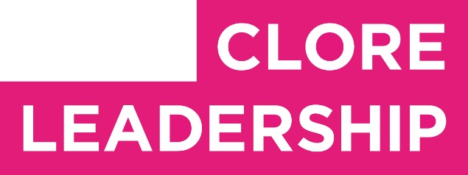

Clore Leadership-AHRC Online Research Library Paper
Cultural Leadership on the Peripheries of Scotland
Author: Lindsay Dunbar
Supervisor/s: Anthony Schrag,
Queen Margaret University
Year paper completed: 2021
Leadership Content Theme/s: Inclusive Leadership Practice, Sector Insights
AHRC Subject Area/s: Policy Arts Management and Creative Industries, Community Art (including Art and Health), Cultural Geography
A note on contents:
Since 2005 Clore Leadership and AHRC have partnered to offer a diverse range of cultural leaders the opportunity to produce a piece of extended research relating to leadership and to their specific cultural discipline. These papers, published from 2023 onward on the Clore Leadership-AHRC online research library, reflect an important contribution to the field and we are extremely pleased to make them available to practitioners, scholars, and other interested parties. We recognise that this research library contains a range of terminologies and outlooks: these are reflective of the significant and ongoing changes within the cultural sector over the past 20 years. As such we urge readers to recognise that the authors’ thinking and language may have shifted since completion of these papers, or may be in the process of shifting as consequence of their enquiries.
Unless otherwise stated, research papers included in the Clore Leadership-AHRC Online Research Library have not been formally peer reviewed or published in an academic journal.

Cultural Leadership on the Peripheries of Scotland

‘In many ways, the ultimate test of any economy is whether people are willing to live and work within that economy.’ (OHCPP) Economic Regeneration Strategy to 2020.

Abstract

This paper will explore the idea of cultural leadership when delivered on a periphery; examining the mindsets which guide leadership when living in rural and remote contexts, and identifying learnings from which the creative sector can learn.

While all culture leaders share similar skills and mindsets, there is a need to understand and communicate how rural and remote areas can encourage leadership to embed, ensuring a sustainable cultural landscape. This paper argues that cultural leaders alike should and can embed leadership to create a sustainable approach to the mindsets associated with place-leadership

By capturing a snapshot of leadership across the culture sector in Scotland and examining four diﬀerent cultural leaders operating in the very North, East, South and West of Scotland, it is possible to explore the mindset that enables leaders to develop their practice and how they overcome challenges that are universal to the cultural landscape, but with a diﬀerent perspective to address them.

Keywords: rural, remote, culture, Scotland, leadership

Introduction

The image of Cultural Leadership in rural Scotland is often romanticised: it is the visionary who tries to battle a close-minded community; they ﬁnd inspiration from the eagle ﬂying over barren landscapes as heather sweeps over the hills; tensions exist between groups, but as soon as they pour a dram and the ceilidh band strike-up a tune, the dancing brings everyone together. The reality, however, could not be further from the truth. Cultural leaders in rural and remote areas need to be experts in listening and diplomacy, engaging and embedding themselves in communities in ways that are neither romantic nor easy. The knowledge held by these cultural leaders enables them to use their expertise to support cultural development in what can be perceived by many as the harshest of terrains.

For the purpose of this research, it is crucial to understand what is meant by ‘remote’, ‘rural’ and ‘central’ in relation to leadership. In this context, ‘central’ refers to densely populated metropolitan areas, ‘rural’ refers to countryside(s), typically with an agricultural economy, and ‘remote’ refers to places out of the way or considerably secluded from larger metropolises, an extreme extension of rural areas. These areas are complex communities made up of individuals with wide-ranging social, political and economic needs. Any cultural leader operating in these contexts has to move around all these factors to deliver their core purpose. Similarly, ‘culture’ can refer to many human activities such as baking, sports and other localised activities. In the context of this paper, it is used to refer to

formalised and traditional cultural oﬀerings of arts including theatre, visual art, ﬁlm and crafts as explored later.

When exploring cultural leadership in relation to place and region, there is little information despite the strong evidence that ‘culture’ plays a signiﬁcant role in social and economic development (Scottish Government, 2018). It is also possible that economic or social leadership is a model that can be measured or monitored using ﬁeld theories or frameworks (Normann et al., 2017). This paper recognises that these forms of leadership help to shape the place in which they are based. What is less explored is how cultural leaders are shaped by place itself.

Tim Smit, the founder of the Lost Gardens of Heligan and the Eden Project, was a musician and entrepreneur when he settled in Cornwall, the south-east of England. There he was inspired to ﬁll a former China Clay pit that had left a scar on the landscape with something beautiful. This vision resulted in the iconic biomes of the Eden Project, an eco-destination for visitors to Cornwall. Such ambitious projects are a “Fitzcarraldo moment” referring to Fitzcarraldo by Werner Herzog (1982) – recommended by Smit himself in an interview with Joshua Spodek – about a man who wants to build an opera house at the end of the Amazon and the tribulations that such desires engender. So: what is the mindset that drives leaders to work on these peripheries, and how can they take such risks?
What can we learn from this way of thinking when applied to other locations?

Other questions to consider throughout this paper are how to embed leadership, how leaders perceive the support available to them, and the role of culture in a rural or remote community?

The Context of Rural and Remote Leadership

Understanding the role of cultural leadership on Scotland’s peripheries can be understood by comparing leadership in other peripheral areas. While the idea and deﬁnition of leadership itself can often be challenging to articulate, beneﬁts identiﬁed include “setting direction, taking responsibility for putting learning at the centre and keeping it there.” (OECD, 2013).

Within the literature, the idea of leadership speciﬁc to a region is still under-explored (Beer et al., 2013) with the idea that regional leadership is, “a broad label for leadership that takes place in regions.” (Normannet al., 2016). This vague expression often refers to political approaches or economic strategies. The need for a deﬁnition of regional leadership in itself indicates a need for diﬀerent forms of leadership in other regions, ensuring that leadership is place-based rather than “place-blind.” (Collinge et al., 2009) Further to this, Beer et al. (2017) conclude that “a fairly common popular reaction is to allege lack of local leadership or poor local leadership or to call for even ‘more leadership’.” Exploring to what extent leadership is being embedded at a local level rather than implemented from elsewhere is part of this paper’s purpose. In relation to the deﬁnitions used in this paper, there is some evidence relating to how these mindsets come about. As Quantz argues, “culture-based leaders must immerse themselves in social theory,” (2016) so these social skills and mindsets are shared by culture leaders; however they can be shaped by the place, as leadership can be informed by the culture of leadership, rather than cultural leadership.

Beer et al. (2013) suggests “good leadership depends on having suﬃcient uncommitted resources, especially high-quality individuals,” which assumes a cultural leader needs access to funders, networks, team members, volunteers, and artists to be “good.” Similarly, Kroehn et al (2010) suggests “eﬀective local leadership builds community resilience and can help secure an economic future for a region or community.” Therefore, the leader who can access the resources to enable their culture to become sustainable is indeed good, although it is easier for them than those that do not have access in the ﬁrst place: when there is a dense population, access to these things can be readily available.
This is less possible in peripheral locations. While Stimson et al. (2009) highlight collaboration, trust, the sharing of power, ﬂexibility, entrepreneurialism and a willingness to be proactive as central for eﬀective leadership in economic development, Beer suggests “these are characteristics not easily found within the community or business sector.” Perhaps then these skills and mindsets that can be found in a cultural leader instead?

Beer et al (2013) also highlights “places may have leadership deﬁcits as a consequence of a number of factors, including the absence of key decision-makers in the region or too few individuals with suﬃcient time to contribute to shaping the communities’ welfare.” In sparsely populated regions it could be argued that this is the case because – unlike urban populations - there are few who have formal training in leadership. However, he also notes “...especially rural communities – will potentially have two sets of leaders: one group that ‘leads by doing’ and is richer in bonding social capital; and a second group that ‘leads by talking’ and has strong skill sets in interpersonal communication and connecting with others.” Although there are examples of collective leadership approaches, cultural leadership in a peripheral context very often requires leaders to have the mindset to be able to do both.

These mindsets are embedded in our leadership culture: resourceful leadership or leadership deﬁcit interlink with the population they are operating within. There is a need to understand how these mindsets in rural and remote communities can encourage cultural leadership to develop a sustainable landscape.

Methodology
A case study methodology was undertaken to examine the particular contexts of peripheral leaders in-depth and provided generalisable insights into the ﬁeld (Silverman 2009). These case studies focused on leaders in speciﬁc communities on the peripheries of Scotland. Qualitative data was gathered via site visits which included North Uist, Lyth and Arbroath, with the ﬁnal case study conducted online due to Covid-19 travel restrictions. Case study data consisted of both
semi-structured and informal interviews, observations, and discussions.

In conjunction with the case studies, a broader survey aimed to capture perceptions from leaders across Scotland was also undertaken. Utilising a survey approach gained additional insights from a wider ﬁeld (Silverman 2009) and provided a snapshot of leadership perceptions based on various locations throughout Scotland. This survey reached 35 respondents across 12 of Scotland’s local authority areas. 17% of those surveys were based in Glasgow and Edinburgh, with the remaining 83% including the Shetland Isles, Dundee, Argyll & Bute to the Scottish borders. The complete data for the survey is available in Appendix 1.

Combined, the case studies and surveys inform both the depth and breadth of insight on this subject. The observation that runs through the case studies and survey responses relates to perceptions about what it means to be central or remote as well as the similarities and diﬀerences facing leaders in regards to diﬀerent approaches or attitudes. As a result, this research paper focuses on a cultural leader’s mindset; the attitudes that form their leadership and how they can adapt or adopt their perceptions to suit situations.

Surveys: A Snapshot of Cultural Leadership in Scotland

Within the survey, the distribution of responses indicates leadership experience in what could be perceived as rural, with the implication that location impacts leadership development and opportunities. What becomes clear through analysis is that perceptions of local culture can shape the mindset of leaders. While there is a clear division between the mindset of leaders who see themselves as central or rural leaders, where it becomes interesting, and explored below, is the consistency of remote leader mindsets, which raises questions about how to embed leadership in these contexts.

The response to the survey conﬁrms the perception of remoteness versus centrality is incredibly nuanced. In regards to their working location 51% perceived themselves to be central, 17% remote and 31% rural. These ﬁgures contrast with deﬁnitions understood by the Scottish Government, which indicated the rate should have been 25% central, 17% remote and 57% rural. The following analysis explores this mindset of locations as being ‘central’, ‘remote’ or ‘rural’.

The leader’s mindset is key to their behaviours, as can be seen in some responses: “While rural and remote issues do surround our region, we also consider ourselves to be central in many ways, particularly geographically and culturally” and “Remote is relative. I work in a geographically remote, or distant, location, but I don't feel that I am working remotely.” These remarks suggest that cultural leaders see themselves as central to their communities, art, and culture, and complicates geographic distinctions related to social, economic and political development.

For arts organisations based on the peripheries, what matters most to them is their centrality to their community and supporting cultural growth. As one respondent said: “Being out with a saturated city like London meant way more opportunities with an underserved community,” suggesting that a locality is a signiﬁcant lifestyle choice, as well as a professional consideration. Nevertheless, this comment exposes some of the challenges of cultural leadership and perception. Many rural communities do not see themselves as underserved. They feel they can access the same quality of cultural engagement as the capital cities; “If we were based in a city centre where competition is greater, I wonder if we – and the artists we nurture and whose work we promote – would receive the same coverage and recognition, both from peers and the wider arts community. Our ‘remote’ location enables us to punch above our weight, something we do consistently.” This theme repeats throughout the ﬁndings: that remote location enables leaders to excel, perhaps due to their locality’s unique positioning.

The responses also indicate the challenges of working outside of “saturated” cities. 70% of rural responders conﬁrmed sector networking was challenging and diﬃcult, compared to 74% of central responders who said sector networking was good and great. Accessing new work is more challenging, with 87% of rural leaders ﬁnding it diﬃcult and challenging in contrast to 73% of remote leaders who ﬁnd it both suﬃcient and great.

The complexities of working with local communities are highlighted in this research, with 27% of rural respondents saying that working locally was diﬃcult and challenging and 29% conﬁrming they would ﬁnd it “great” when working locally. In contrast, 90% of responders who identiﬁed as central indicated working locally was good or great. Leaders in remote areas seem greatly divided about this issue, with 27% ﬁnding it diﬃcult and challenging as “small-minded and arrogant people who do not respect others, their experience, their knowledge, their ﬁeld who bully. I think this experience of bullying and harassment, which some would say is worse when it occurs in a small community,” while 71% found it great; “Living here helped me understand how rural touring works in a way that living in the central belt couldn't.” There may be a more profound awareness within rural or remote leaders about the realities of working locally due to the very proximity of living with and alongside audiences and artists. Being a citizen within a small community blurs the line between professional and personal roles, and the toughest critic for the cultural leader on the periphery is their neighbour.

In the light of 2020 and the impact of COVID 19, unexpected ﬁndings include challenges generally associated with working rurally appear to have been reduced. The ability for networking and connecting internationally using video calls has increased opportunities for collaborative working and the chance to raise proﬁles. Additionally, travel restrictions have signiﬁcantly reduced travel time and environmental impact for many; “Meetings are diﬃcult for me because I live on an island and everyone I deal with doesn't live here. A 2-hour midday meeting in Edinburgh means two nights away for me. Luckily I have family on the East Coast, so it can be managed on a budget; it just takes an enormous amount of time.” This suggests that the logistics involved in time and travel for many rural leaders are barriers to development. Rural and remote leaders have often been campaigning for diﬀerent ways of working to address these barriers. The travel restrictions since 2020 have beneﬁted rural and their community’s future cultural life remote leaders rather than hinder them; “We are more connected now that everything has moved online; industry meetings and events (that we were previously, repeatedly told would be impossible to take online) are now online and accessible to us.”

COVID has changed the way arts organisations are engaging with their communities and each other. In 2021, the support of £5,891,553 million from Creative Scotland will actively engage people in shaping their community’s future cultural life through the Culture Collective Fund (Creative Scotland, 2021). “Central” organisations are leading only 30% of the projects, with the rest taken up by organisations in rural and remote contexts. With the focus on understanding collective leadership, the leaders from the peripheries involved with “central” leaders may ﬁnd new ways of approaching cross-regional culture.

The cultural leadership survey asked what advice leaders might oﬀer someone taking over their role, and much of the advice focused on networking and the need to listen. This is a skill invaluable to every leader, but there are subtle diﬀerences to networking advice from central leaders that can access the broader sector with greater ease. Leaders in rural and remote areas advise the beneﬁts of

the more expansive network agencies such as the Federation of Scottish Theatre or the Touring Network. These membership-led networks allow for a centralised access point to many other leaders, something invaluable to the leader facing networking’s logistical challenges. While much of the advice is similar, there are perceived mindsets around leadership in rural or remote areas in contrast to central: “Do not approach non-metropolitan/urban situations and practitioners with
pre-determined, metropolitan-centric terms and a ﬁxed mindset.”

As the following case studies demonstrate, this is not the case for leaders working on Scotland’s peripheries.

Case Studies: Living and Working on the Peripheries NORTH: Charlotte Mountford in Lyth, Caithness
Town Population: 7333 Regional Landmass: 712 sq mi
Industries: Fishing, Crofting, Tourism Distance from Edinburgh: 266 miles Distance from London: 493 miles
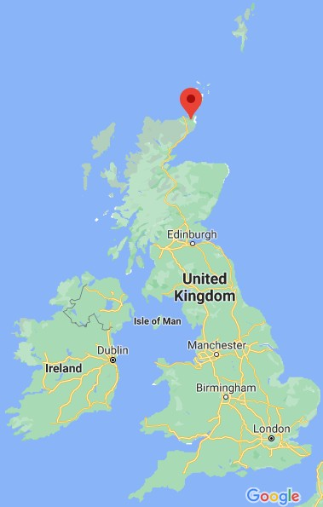
“What does it mean to be an arts organisation? Or, are we a community organisation?”

Lyth Arts Centre, located between Thurso and Wick’s towns, is the self-proclaimed “UK’s most Northerly mainland arts centre”. The venue plays a strategic role in Scotland’s touring network and supporting communities – as the crow ﬂies – closer to Norway than London. Charlotte Mountford and her partner Tom Barnes moved up to take over the centre’s direction after the founder William Wilson stood down after nearly 40 years. The centre began as a gallery that regularly – and intimately – spilled over into William’s home in the adjacent schoolhouse.

Originally from Manchester, Charlotte found her path into the creative sector after a serendipitous visit to Northern Stage in Newcastle. After attending the opening night of the reopening of Northern Stage at 16 years old her “mind was blown” by the performance as she had only had the
experience of watching a pantomime. Following an open day at the Royal Exchange Open Day, the theatre teams shared how they had all read English Literature. For Charlotte, studying English Literature to work in the theatre sector at Newcastle for the culture seemed the natural step. After graduation, she returned to Manchester. While working as a runner at Media City, she successfully joined the Foot in the Door Scheme working with the 24/7 Theatre Festival, which produced theatre in unusual spaces across the city. When the touring company Box of Tricks oﬀered Charlotte her ﬁrst paid producer job, her response was: “What’s a producer?” Evidence of her adaptability, something which would become key to her leadership mindset. In 2012, Arts Council England cuts meant the

company moved to Manchester. Traditionally, there had been pressure to move to London to succeed in the arts or media, but the cuts created work opportunities elsewhere. Charlotte took this opportunity to take an internship which allowed her to live aﬀordably, tour with the company, and support work by creatives in the North of England. This desire to support local artists continues through her work today.

Life started to change for Charlotte when she took her role with Action Transport Theatre. The Children’s Theatre company toured internationally, was well-respected, and for Charlotte, introduced her to the world of children and young people’s theatre. She stayed with them for three years, enjoying working across the North West, travelling around and supporting work in the North. Place was becoming an essential part of her work. She successfully applied for the BBC Performing Arts Fellowship (PAF), gaining access to a network of other PAFs for support which would be important later in her career. She used this opportunity to develop a Festival in The Lowry Studio, in a community theatre in Salford and a pub. In some ways, she feels she was replicating the experience of the 24/7 Festival; audiences entering the new, non-traditional spaces to experience theatre. After two years with The Lowry, gaining knowledge of working in a big venue, she took a new role as producer and programmer at Waterside Arts Centre. At the same venue, she had seen pantomime as a child, which proves the importance of cultural experiences to inspire future careers and support the local economy. During this time, she met Tom Barnes, a theatre producer, who became her partner and now co-CEO at Lyth Arts Centre.

By 2016, Charlotte realised the way she had been developing was reactionary. She had not invested in her professional development and began to “see the positive impact the work had on audiences and communities,” making her start to think about that process more deeply. While participating in the Clore Leadership Short Course, she started questioning her work: “What does it mean to put on this show and how do we respond? What can we do about the problems? What can I do to help?” She wanted to learn how to connect the work with the community in a more meaningful way.

In 2017 she saw a job advertised in the very North of Scotland which highlighted the organisational values, and they resonated with her – transparency, positive, pragmatism, innovation and authenticity. This ﬁnal value, both Charlotte and Tom agree, is their central touchstone, especially when things go wrong. Taking ownership, holding their hands up and being honest are all linked to authentic leadership, which matters a lot when living and working in a small community.

Applying for the most Northern Arts Centre on the mainland U.K was what they saw as a “total dream.” Charlotte recalls they asked themselves: “imagine what it would be like to run your own venue?” In framing their vision for Lyth Arts Centre they portrayed it as an “Internationally recognised, industry-leading, small arts centre in the heart of the community.” Despite this conﬁdent and ambitious pitch, it was not an easy decision when oﬀered the position. It felt “scary to move far away from friends and families, scary to run an organisation, a diﬀerent country with a diﬀerent funding body in the North of Scotland.” With all the focus on the scary diﬀerences, what did ﬁnally attract them to the role? Charlotte reached out to the networks of support from her previous Fellowships, asking about practicalities of working in non-urban contexts. When pressed about the remoteness of Lyth, a friend in Orkney recommended, “…don’t ever say that again. Nothing will feel remote to your audience. They don’t think they are.”

With this pivot in thinking, she realised life is quite similar in remote areas to everywhere else. They realised they needed to “hold your urban preconceptions.” With this shift in mindset, a growing awareness of the Scottish cultural sector, the welcoming, warm reputation of Lyth Arts Centre and positive changes in the relationship with funding body Creative Scotland, they agreed to move up. In November 2017, when the venue went dark at the end of the season, the nights grew longer. They arrived just in time for their ﬁrst Winter in Scotland.

By 2020 as Scotland went into lockdown along with the rest of the world, the dream of managing a venue could have become a nightmare: “Everyone thinks they want their own venue but it’s really hard. How tied to the bricks and mortar you can become, you want to engage with the community and the arts.” Yet, because they were small, they realised they could ﬂip quickly with their small team. They had no oﬃce and quickly tapped into the voluntary sector and oﬀered help. Charlotte said, “If we had shut our doors and waited until 2021, then no one would have come, they would have asked, “where were you when we needed you? We need to do something helpful, arts and creativity can be helpful. It was a natural response. I had felt disconnected from the national cultural sector and felt more connected in a Community meeting.”

By not thinking about the building’s conﬁnes, they used 2020 as an incredible moment for raising the venue’s proﬁle in the community. As a result, they paid out more to local artists than ever before. As their pursuit to be useful grew, they received a service agreement with Highland Council to work with care-experienced children providing CAIR: Caithness Artists in Residence. Over the next seven months, Lyth Arts Centre will match-make artists, six community artists, in residence, working with young people, older and care. Engaging with the community like this is something they had always wanted to do. As a result of adapting their programme away from the venue, it became the perfect opportunity. Whatever folk needed, they wanted to help. Charlotte believes in making the most of life in a rural place where you become connected and engaged with the community, especially as a practitioner or an organisation. However, there is an issue for some cultural institutions around the quality of arts organisations so embedded with their community, as Charlotte asks: “What does it mean to be an arts organisation? Or are we a community organisation?”

While Charlotte has a clear understanding of her role as a cultural leader in supporting the creative sector, she concludes, the culture of the area is strong: “an asset to the county, a shining light... still would be fantastic without us, the community is brilliant, there are thousands of creative people in the area. The area is responsive...I hope we bring more and add to the magic that’s already here.”

For Charlotte, working on a periphery has shifted her mindset, a mindset that was always looking outside of ‘central’ leadership. By embracing the risk of moving away from all the known support networks, it has enabled her to start to view her work through the eyes of the community, rather than the arts sector. The accountability to the community runs through the team, accepting the responsibility that comes with the art’s centre purpose. This ‘remote’ mindset is making the most of the creative assets found on this periphery; local artists working to support the creative needs of the community and demonstrating ways to engage with contemporary issues.

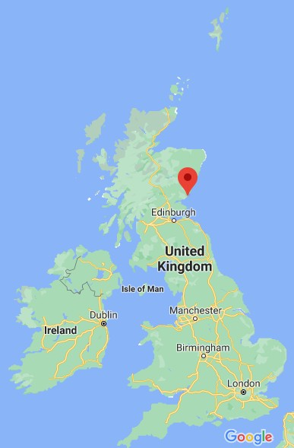
East: Lucy Byatt in Arbroath Town Population: 23,902 Regional Landmass: 842 sq mi
Industries: Public sector, Retail, Fishing Distance from Edinburgh: 79 miles Distance from London: 497 miles

“What you can do at the periphery because you are away from the centre, no one minds what you do. No one is saying you have to do anything.”

Arbroath is known as the location for signing the Declaration of Arbroath and delicious smoked ﬁsh, better known as Smokies. The town is perched on the East coast of Scotland, sandwiched between Aberdeen and Dundee, both which boast signiﬁcant cultural venues and a lively arts scene. While there is a receiving
theatre and art gallery in the town, Hospitalﬁeld House, believed to be "Scotland's ﬁrst school of ﬁne art." (Patience, 2011), is a beacon for artists and creatives. Lucy Byatt joined the organisation in 2012.

In the 1980s, Lucy Byatt, then a student of art, founded an artists’ collective in Brighton, which marked her leadership journey. As she acknowledges, her “radical left Brighton values” have always guided her. Although she observes, Brighton was a centre of culture, “on the edge of London but [still] a centre.” When she was in her mid-20s, she got involved with Brighton Festival, a festival to bring in local talent and raise awareness of creativity. She comments this was “a time of feeling included in something that was so much bigger than you - you were connected the artists were world-class.” She saw the grassroots creative community pushing up against the hierarchical approaches. However, being seen as, or perhaps because of being “the outspoken one” she was invited to join the Brighton Festival Arts panel for artists. She learned to embrace her
outspoken-ness, which continues to be central to her leadership approach.

After leaving Brighton and studying in Dundee, encouraged by artist Robert McGilvray, she moved to Glasgow to undertake a Master of Fine Arts at Glasgow School of Art. In Glasgow, she found “the same grassroots attitude” that had inspired her in Brighton. A pivotal moment was hearing from John Latham about the artist placement group, a programme to place artists in society, where they were “inﬂuential, to have ideas, sit on committees, to get people to think around corners and think in a diﬀerent way.” Inspired by this notion, she saw it was possible to unravel some of the diﬃculties of working in communities: “being outside the studio, being in a place outside my experience was brilliant learning.”

Glasgow was becoming an important artistic centre in the 1990s, with good money spent on public art for the city, including the Garden Festival, commissioning art in public spaces, artists working with architects such as the Tron Theatre development. She found work with housing associations and architects in Glasgow interesting. The relationship between community and art is a theme that continues to this day, as detailed later.

She was involved in public-space projects, including the Royston Road project, Govanhill Millenium Park and Red Road Flats. She observes of this time: “You build a massive centre, involving the community, artists working in these communities, and everyone understands what's going on.” The philosophy was that local communities would be making decisions with the artists but this
broke-down because of time and budget. As a result, artists said they could not see the art, but as Lucy observed: "the art is for the community, it's not for you".

In 2002 Lucy was headhunted for Spike Island, moving from Glasgow to Bristol and ﬁnding herself back into the 1980s. She said: “there was me coming from vibrant and powerful arts ecology (Glasgow) to Bristol which had the hierarchy, from Arnolﬁni down to Spike Island. There was a need to change the way artists worked in the city.” She developed the Spike Island Associate Programme to care for artists: this provided a space, a budget to travel, and this supported more artists in Bristol, resulting in “the interesting people staying.” She was working with a “very London-centric board” who wanted famous artists in the gallery, but she saw a need to focus on supporting artists in Bristol; energising the ecology, informing artists and acting as a catalyst.

After leaving Spike Island in 2008, she spent four years in London working with Tate National and the Contemporary Art Society before Scotland called her back. While the move back was scary, she admits she has never had the experience of feeling like being on the periphery, and she observes: “What you can do at the periphery because you are away from the centre, no one minds what you do. No one is saying you have to do anything.”

At the start of her tenure at Hospitalﬁeld, Lucy placed the art centre on the International map with the much-coveted Scotland + Venice 2015 commission. However, she maintains that getting an international reputation is easy, working with the local community is harder. By this, she explains partnerships are challenging, but community work has to emerge out of a partnership. For now, her priority is saving Hospitalﬁeld for the artists and the local community. The “local” is the hardest thing. She believes this is because people have thought: "we aren't allowed in here," and she is working to change this perception by working with schools, introducing walks around the site and food events. She encourages the team to join and sit on community panels, yet she has met some resistance.

The relationship with the community is one she continues to explore, particularly around complex issues. In a community where the primary economy is agriculture, one gently explores contemporary issues. The Beer and Berries Festival allows them to discuss issues around labour, pollination, the chemicals used in food produced, to overcome “That's not for me” perceptions by involving the Angus growers; “Beer and Berries is about more than stalls, it's about the debate. The Scottish Raspberry is Dead debate.” Hospitalﬁeld is beginning to feel part of the community by developing this way of working. However, Byatt notes, “you have to be careful. You have to live here”.

In the future, Lucy believes residencies for writers, dancers and artists will help embed leadership in the community, writing about experiences centred in the community, for the district to “live” with an artist for the month. Hence, both the artists and community get to know each other. She asked, "How this organisation can be meaningful in the community: Making it strong. "

Byatt is a cultural leader who has repeatedly moved from the periphery to the centre, and as a result her learning and the mindsets she adopts can be adapted. She is bold in her opinions and questions the attitudes associated with the wider sector. By taking the ‘central’ mindset into a ‘remote’ situation she has the ability to strike a careful balance, by thinking about the artist’s role and how this embeds with the community Her focus is people-led, whether they are artists or community; it is how they work together to make art.

South: Rachael Disbury, in Hawick
Town Population: 13740 Regional Landmass: 1,827 sq mi Industries: Textiles, agriculture
Distance from Edinburgh: 55 miles Distance from London: 359 miles

“Rural context means we can do certain things and can’t do certain things; we can’t just plonk art anywhere.”
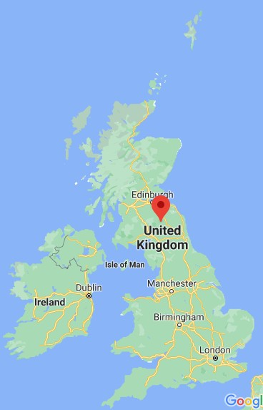
Based in the Scottish Borders, Hawick is synonymous with hunting and cashmere. This community with traditions in agriculture and textiles has faced high unemployment levels in the recent decade but the new Borders Railway has also brought tourism to the area again, along with a sports audience for rugby. In 2010 Filmmaker and artist Dr Richard Ashrowan established Alchemy Film & Arts, an artist-led collaborative project with Heart of Hawick and Creative Arts Business Network (CABN) with a vision to bring artists' moving image and experimental ﬁlm to the Scottish Borders.
Richard wanted an experimental ﬁlm festival, cultivating an international community that resulted in a Venice Biennale 2017. As a result of these achievements, in 2018, the organisation secured regular funding from Creative Scotland to expand into a year-round organisation when Rachael joined the team.

For Rachael, her leadership journey started when she was a student. Even throughout her academic career, she was leading: in 2015, as a Contemporary Art Theory
student at ECA, she was part of an artist-led collective, and although it was not a hierarchical approach, she found she was the one leading the vision. It was, however, the four years at Deveron Arts, Huntly that taught her how to lead an organisation, be a leader, and how not lead.

Rachael is a clear-thinking leader, as she admits, “I can register when I have got everything out of the situation...I can’t do anything without being fully invested.” She found herself interning, working on a large project – a project she acknowledges she would not give an intern the task now – but was

grateful for the responsibility. She learned to balance artistic integrity with community interest throughout her work as an art and community worker and sought out the next opportunity to
scale-up on budgets, management, organisational structure. Gaining these skills led her to apply for a position with Alchemy Film & Arts in Hawick. Her ability to balance artistic programming with community programming was perfectly suited to her role as the Programme Manager, organising exhibitions, residencies, a programme of events and community ﬁlm.

Alchemy founder Ashrowan decided to leave the organisation to focus on his artistic practice rather than running a regularly funded organisation (RFO). It was an abrupt departure, leaving the board, who had taken the lead from him and Rachael, who was managing six programmes to expand the festival as per the funding requirements, alongside Michael Patterson as the Festival director.

Rachael did not apply for the Creative Director position when advertised. She felt that experimental ﬁlm was not her expertise, and her age would be an issue. She admits she “felt secondary and not ready,” because of a perceived cultural management hierarchy. Colleague Michael Pattison was appointed Creative Director. However, it became apparent to the Board that while the artistic vision was strong, the organisational skills needed to manage an RFO were lacking. The Board suggested Rachael train him up, but Rachael conﬁrmed it was not appropriate. Instead, a creative working partnership formed, working together as a unit with a dual leadership approach. Rachael acknowledges that this form of leadership appears to be female-led and that “leadership” is a highly gendered issue. Despite progress in gender equality, a 2017 report by Creative Scotland conﬁrmed that 44% of women cited gender as a barrier to career progression, while only 12% of men saw it as a barrier.

As the only RFO in the Borders of Scotland, they have a sense of duty to provide multiple access points to culture to their population. In many ways, they face the same problems as any arts organisation in rural areas, including a perceived low uptake from audiences which cities can get away with as they have a larger catchment. For instance, the Lyceum Theatre has a capacity of 658, which is less than 1% of the Edinburgh population, while the same capacity in Hawick is 14% of the population. If Alchemy engages 1000 people equalling 10% of the population, an Edinburgh venue would need to attract 48 000 to be comparable. The perception of what is successful engagement seems determined by the locality. While Alchemy Film & Arts has an international reputation and audience, increasing the statistics for engagement, the Scottish Borders geography means fewer eyes are on them.

Alchemy has an experimental approach to activate the work and engage the community. Rachael admits that it is a struggle to get national recognition: “We aren’t recognised for this in the same way; we can get forgotten about. We are happier about local and international reputation.” Rachael is interested in creating the narrative around smaller, local audiences and what that means for quality, how to provide quantitative feedback. She cites the example of a workshop that may only have ﬁve children participating, but if one has improved conﬁdence as a result, it is hard to measure, especially in the short space of time of a workshop. It is the long-term impact that creates something meaningful. In an area such as the Borders, where 24% of children live in poverty, (Scottish Borders Council, 2017) there is a distinct lack of what Rachael sees as “formal cultural provision and talent retention”.

Rachael is excited to get people involved in the arts through historical research, walks and discussions in ways which activate audiences in a meaningful way. Rachael often asks herself: “Do people need to understand the process - what do they need, what are the results of participation?” By working in community partnerships for the last two years, Alchemy have become self-sustaining on a local level, meaning they are now less reliant on international partnerships. This move has enabled them to position themselves as more socially and locally relevant as has been essential during the pandemic challenges of 2020. Rachael believes this success is about being more integrated with the Hawick community, as Rachael and colleagues will attend the local pubs and council meetings. Previously Richard had “mystique, living outside the town, in the country.” Now when members of the community see Rachael, they always ask about Alchemy. As a leader, being connected and embedded with the community changes how the public perceives the organisation.

Rachael is helping support a feeling of community ownership over the organisation. At the start of 2020, a plan to celebrate ten years of Alchemy was launched to a packed cinema resulting in people then coming to the oﬃce with personal ﬁlm reels of life in town.

Indeed, during the lockdown of 2020, community groups turned to Alchemy for digital support and content. During this time, Rachael acknowledges that the support they were oﬀering “wasn’t art,” but what mattered was the community development. They made ﬁlms for charities to support others within the community. In this context, Rachael is prepared to take risks: for example, while exploring Hawick history concerning the Black Lives Matter movement, she became interested in Tom Jenkins, the ﬁrst black teacher in Scotland. She was initially worried that the Historical society might question the need to explore this part of local history; however, she admits this was her perception. Instead, they oﬀered to help because they see Alchemy as “friends” which Rachael believes is a rural thing and indicates her leadership value, making the organisation part of the community. This sort of work does raise the question of what purpose an organisation serves. In 2020 during the lockdown, the board asked Rachael if she thought Alchemy was a wellbeing organisation. Rachael stated they are artists but currently without arts as the method for engagement. The delivery of digitalised history is not art; however, the community partnership helps them engage creatively.

It is this certainty of purpose that enables Rachael to be the leader she is. They continue to attend area partnership meetings to strengthen those links. As a result, the local authority gave Alchemy
£10k to run events last year, based on a presentation that evidenced the festival’s economic input, which can typically be around £200k-300k each year. As a result of the pandemic in 2020, Rachael reported the investment and the impact without the festival. Instead, she shared the stories about digitising work for the community, providing culture at the same level and supporting the core issues which aﬀect the community. The authorities’ response was, “You always get more than what you pay for”, acknowledging the beneﬁt of culture helping people in 2020. The community perception is of Alchemy as digital and cultural leaders; “if people had a digital problem, they would come to us. The nursery wanted us to ﬁlm Santa - not what we had been known for!”

Rachael Disbury has beneﬁted from her ‘rural’ mindset, taking her understanding from Huntly to Hawick with the core focus on providing access to culture to the community. For Rachael her mindset is absolutely focused on the quality of their work, in some ways, this is a risk, to put the art ﬁrst and

foremost yet the impact of 2020 shifted the relationship with the community, gaining insight into how a ‘central’ mindset might work with the wider community. While age and experience might be considered a factor in her mindset, she demonstrates a clarity of purpose. Disbury is a leader who has learned that the best leadership comes from sharing experiences, not keeping things secret, staying rooted in the community, being experimental and getting work out there.

West: Simon Hart in North Uist
Island Population: 1271
Island Landmass: 74,885 acres Industries: Fishing, Crofting, Tourism Distance from Edinburgh: 283 miles Distance from London: 668 miles

“To be successful, you need to be ready to be taken out of your comfort zone. In the urban context, y can ﬁnd your niche, like-minded people - whereas, in a rural community, you need to be open to bein challenged by the very nature of living with your audience.“
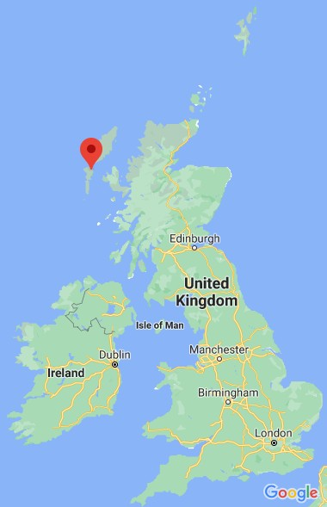
After more than 20 years working in Edinburgh, the Cultural Capital of Scotland (World Cities Forum, 2021), Simon Hart made a move to North Uist in 2020 to take on the role of Business & Development Director at Taigh Chearsabhagh Museum & Arts Centre, the only visual arts centre on the Uists and the most Westerly arts centre in Scotland. Since 1995, Taigh Chearsabhagh has evolved into a thriving museum and arts centre with an international reputation.

Before 2017, the organisation had “faced organisational challenges” (Comhairle nan Eilean Siar, 2017) with neighbouring island arts venue An Lanntair in Lewis oﬀering organisational frameworks to secure funding for a part-time CEO position. Since the organisation secured regular funding in 2018 from Creative Scotland, sustainability has been essential for future-prooﬁng the creative hub.

Simon Hart’s leadership journey started when he set up a theatre company as a teenager. From this he gained experience in leading ensembles, which he has continued to do throughout his career. Inspired by his mother, who ran a post-teen pregnancy young mums support group, he created a theatre show about teenage pregnancy for schools in Edinburgh, which included questions and answers with the pupils after each performance. Due to the nurturing cultural environment, there was support to set up a theatre company from the Arts Council of Great Britain. After a few years, Simon was beginning to look at other opportunities and in 1983 Donald Smith, Director of the Scottish Storytelling Centre, oﬀered him the chance to start a puppet festival which later grew to become Puppet Animation Scotland.

This new position gave him a lot of autonomy, ﬂexibility and he loved the community of puppeteers. In the early 1980’s it was not a craft recognised by the arts council. Many puppeteers were

“self-starters” creating work under the radar of institutions. To secure funding from the Arts Council, Simon called the puppeteers’ community to create a sector snapshot. Through his research, he discovered that these artists were engaging with audiences of 140 000. Simon was able to articulate the artists’ value and quantify the importance of the sector - numbers were the way to obtaining funding support. As a result, Simon found himself supporting a creative arts sector that had high return for low investment. This ﬁnancial investment led to productions where they could see a genuine return on value, supporting artists like Shona Reppe. At this point, Edinburgh City Council Arts Development oﬃcers were coordinating tours in venues and schools, raising the proﬁle of the Festival as well as the art form. Simon was aware that the company was very Edinburgh-based and decided to push on some doors with a mission to see how far it could spread. He discovered the Festival model was easy to sell, that adjacent local authorities would follow on from another, making it easier to expand logistically and ﬁnancially, with local authorities taking on a lot of the administration and promotion. The Festival was essentially an early model of supported touring with schools and community venues to and from a wide range of companies from across the U.K. They chose the work that would appeal to or have a meaningful impact on their audiences. This “ownership” was pragmatic for audiences, and the councils were active agents for promoting.
Between 1998 and 2020, Simon’s reputation as the leader of Puppet Animation Scotland and his expertise in the specialist area continued to develop, supporting home-grown talent as well as international links.

After 37 years with PAS, Simon sought a new challenge, despite or perhaps as a result of never managing a venue, Taigh Chearsabhagh appealed. He was aware that the national and international proﬁle of the organisation based on North Uist “wouldn’t be the same in a larger city.” Unlike his previous role with PAS which he had moulded to his own vision; this new role came with its own historical challenges.

In a small community like North Uist, Simon was aware that there would be a ﬁnite number of people available to serve on a board, to volunteer at events or join the team. Some people are less supportive and have strong opinions about what should happen and how it should happen. Without their support, they can potentially defeat leaders. Regarding Taigh Chearsabhagh, there is a perception on the Gaelic-speaking island that it is an “English” space. It is mainland, not island.
People feel it “not for the likes of us.”.

The challenge for Simon was how to bring people into “the English space”, a space that has to serve multiple purposes. The organisation runs the post oﬃce, which is a lot of work for the people involved. It does not make money, but the social value is priceless and as such, blurs the notion that it is just an arts centre: it has an essential use for the community at large. For Simon, the solution is to be aware of the many audiences rather than make everyone use the spaces.

Perhaps due to the island’s agricultural context, there is the perception that the context of heritage is easier to develop for local audiences. However, Simon points out it is not about engaging them through the arts. It is about a centre reaching out and meeting them on their terms, ﬁnding the vehicle to unlock their passion. He observes, “Most of the time, “if you liked this, then you’ll like this” doesn’t work. In a rural community, you need to ﬁnd ways with community politics.” Some of the ways developed these ideas include a Gaelic workshop about sheep fanks with young crofters, linking

the land with the art. The Stitch and Sing in Gaelic attracts people interested in knitting and weaving. Simon does wish he had learned Gaelic before arriving on the island. Although, as he notes, the language is in crisis, Gaelic is an intimate part of this island, with 61% of the population speaking it, he had not appreciated that. Even the Inner Hebrides (an archipelago of islands including Skye, Mull, Islay) do not have the same Gaelic identity. The Gaelic culture is unique in the Western Isles, and he questions how best he is to preserve it. If indigenous Gaelic speakers can use it as a living language, it enables the island’s culture to be accessible to more than just visitors.

As one of the only indoor visitor attractions on the island, Taigh Chearsabhagh elevates beyond a local cultural hub by securing international artists. The 2019 Lines (57° 59´N, 7° 16´W) artwork by Finnish artists Pekka Niittyvirta and Timo Aho was a simple yet powerful statement about climate change. As the installation drew international recognition, the local community felt a sense of pride that public art in the local landscape made international headlines. North Uist is an island made up of more water than land. It brought their awareness of the venue to another level. The community now has a local pride in sharing the island’s cultural wealth by challenging the perception of their ability to engage. Simon notes that young people see climate action, Black Lives Matter or #MeToo as pertinent to their lives, that it would be “better to be informed and respect the issues even if you don’t agree.”

Over the next two years, Simon is tasked to deliver a strategy to embed leadership within the Taigh Chearsabhagh team, supported by Highlands and Islands Enterprise to future-proof and address operational issues. Taigh Chearsabhagh has been through a lot of changes at a senior level over the years and while there is an experienced team in place, the leader must enable them to work together despite the proximity to their lives outside of work. The multiple hats of community members or the reduced options for social spaces on an Island are not the same as in an urban context when work can be left at the door of an evening.

Simon’s ambition is to leave an organisation that is internally clear about its purpose, and how to stay on that track. He is a leader that recognises it’s easy to burn out in a rural context and when the ‘good’ people burn out, it leaves even bigger gaps, making it challenging to future proof the organisation. There is a lot of knowledge retained by the team which is an important asset when a rural population means a smaller pool of essential skills. Their knowledge needs to be recognised and in turn, a clear purpose for the organisation, so the future becomes less challenging.

An experienced ‘central’ leader, Simon Hart demonstrates a willingness to move from the comfort of the ‘central’ mindset, being open to learning how to shift into the ‘remote’ mindset. He acknowledges the diﬀerences in leadership for a ‘remote’ community, the ways of working with less access to the same resources. This openness to learning will be key to the development of his ‘remote’ mindset. On an island, even a ‘remote’ mindset needs to connect with the wider sector, in order to embed that cultural awareness with the community which in turn will embed cultural leadership.

Conclusion

Cultural leaders working on the periphery of Scotland oﬀer us a macro insight into the mindset of leadership. While the theme for leadership across Scotland has many similarities, leaders operating on the very edge of geography must coexist within the most extreme of these conditions. Across the case studies, as well as the survey of the sector in Scotland some common themes, are running through leadership on the periphery:
- Living as a citizen within the community one serves makes one accountable to the community
- There is an element of ﬂying under the radar, to take risks, ﬂeet of foot
- “Local”, “community” and “rural” creativity are nuanced in the mindset of leaders

“Community” takes on a new meaning to cultural leaders on the periphery: they are living in close proximity to their audience, their artists and their greatest critics. There is an understanding of the cultural capital they bring to the region and the responsibility that comes with that, not only for their organisation but the reputation of the community. At the same time, leaders feel they can take risks because they are ﬂying under the radar of the central institutions and away from the major centres. They can be bold and engage internationally yet they are also very aware of the impact this might have on the relationship with the community. The risks they take beneﬁt the region, sometimes out of sight of the rest of the sector. If successful, they are seen to be a strategic cultural asset to Scotland, rather than a remote community arts leader.

Recommendations

The toughest critic for the cultural leader on the periphery is their neighbour: When leading in a peripheral context, leaders should see the work they do through the eyes of their community. Some cultural leaders are accountable to their board and their funders which is a very ‘central’ mindset.
This research has shown that considering how to be accountable to one’s neighbour who doesn’t support the arts can have productive outputs, as shown by cultural leaders pivoting their work to serve the community. What might previously be sense as audience development now places cultural leaders in an empathic position. Charlotte Mountford and Rachael Disbury responded to community needs because they knew that the relationship with the communities changes the way organisations can be seen, working with the community to support them, rather than channelling culture from other institutions.

“Do not approach non-metropolitan/urban situations and practitioners with pre-determined, metropolitan-centric terms and a ﬁxed mindset.” The cultural sector is responsible for maintaining a feudal-like approach to leadership. The perception that everyone must travel to central institutions for permissions, answers and opportunities is problematic and outdated. Technology has enabled cultural leaders on the peripheries to engage with support networks, partners and funders more than ever during 2020. The economic, environmental and logistical beneﬁts are already being felt as demonstrated in this work and yet if we are to move away from the feudal model we need to maintain this level of accessibility. If there is to be a challenge to the ﬁxed mindset of a
metropolitan-centric leader, the cultural sector as a whole needs to leave the comfort zone and

engage with the ‘remote’ mindset, to explore see how they engage and overcome challenges, and to gain the beneﬁts of taking risks when ﬂying under the radar.

Unravelling the problems: While there are a great deal of leadership programmes and mentoring schemes, rarely are rural or remote leaders placed at the centre. The wider networks of support can shift their own mindsets from seeing cultural leaders on the peripheries as strategy national cultural assets to valuable problem solvers. If a cultural leader can establish a meaningful relationship with their community, and can overcome local politics and generate work for local artists on a
macro-scale, what might happen if they were to advise on establishing meaningful relationships with audiences, overcoming policy diﬀerences and diversifying income streams in other contexts? The size of the institution does not reﬂect the knowledge of the leader: being ‘central’ does not mean quality. Cultural leaders on the peripheries should be represented on national boards, invited to speak on national platforms, and sought out when a unique perspective is needed, as this research has proved they have much to oﬀer the sector as a whole. The development of the Culture Collective programme and newly formed Rural Arts Network evidence there is a movement afoot of cultural leadership on the peripheries.

The triangle of mindsets, when working together, can strengthen the cultural landscape across Scotland. As leaders, we can move to and from the peripheries, adapt our mindsets to the location of our work. Yet community remains central to the peripheral leader, who responds creatively to the needs of the cultural landscape.

ACKNOWLEDGEMENTS

This research was guided by Dr Anthony Schrag of Queen Margaret University, who has acted as a critical friend throughout, and was supported by the Arts and Humanities Research Council and Clore Leadership.

REFERENCES
BEER, A. & CLOWER, T, 2013, Mobilizing leadership in cities and regions, Pages 5-20

BEER, A., & GIBNEY, J., 2016, Making sense of leadership in urban and regional development, Pages 187-193
COLLINGE, C., & GIBNEY, J., 2009, Connecting place, policy and leadership, Pages 379-391 COMHAIRLE NAN EILEAN SIAR, 2018, Sustainable Development Committee paper
CREATIVE SCOTLAND, 2021, Culture Collective Recipients Announcement
CREATIVE SCOTLAND, 2017, Understanding Diversity in the Arts Survey Summary Report GLASGOW ARCHITECTURE, Tron Theatre
KROEHN, M., MAUDE, A., & BEER, A., 2009, Leadership of place in the rural periphery: lessons from Australia's agricultural margins, Pages 491-504

NORMANN, R., JOHNSEN, H., KNUDSEN, J., VASSTROM, M., JOHNSEN, I., 2015, Emergence of
regional leadership – a ﬁeld approach, Pages 273-284
OECD, 2013, Leadership for 21st Century Learning, Educational Research and Innovation PATIENCE, J., 2011, Homes & Interiors Scotland
QUANTZ, R., CAMBRON-MCCABE, N., DANTLEY, M., & HACHEM, A., 2017, Culture-based leadership,
International Journal of Leadership in Education, 20:3, 376-392,

SCOTTISH BORDERS COUNCIL, 2017, Strategic Assessment of SIMD in the Borders

SCOTTISH GOVERNMENT, 2018, Investing in Cultural Infrastructure policy SILVERMAN, D., 2017, Doing Qualitative Research
SPODEK, J., 2018, Sir Tim Smit: Changing the World with No Special Skills

STIMSON, R., STOUGH, R., & SALAZAR, M., 2009, Leadership and institutions in regional endogenous development.

WORLD CITIES CULTURE FORUM, 2021, Edinburgh

APPENDIX - Survey responses Total of 35 responses
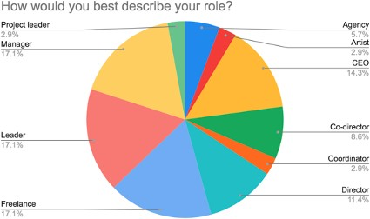
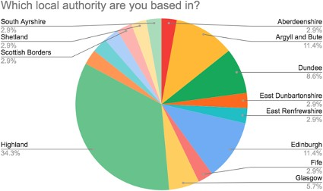
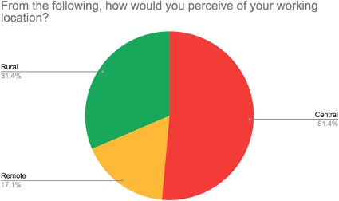

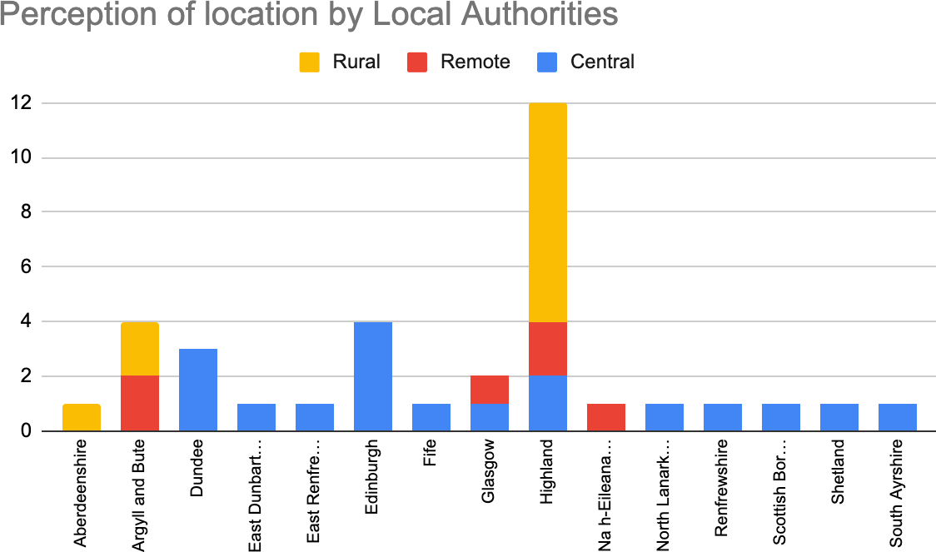

Thinking about where you are based, how would you rate the following?
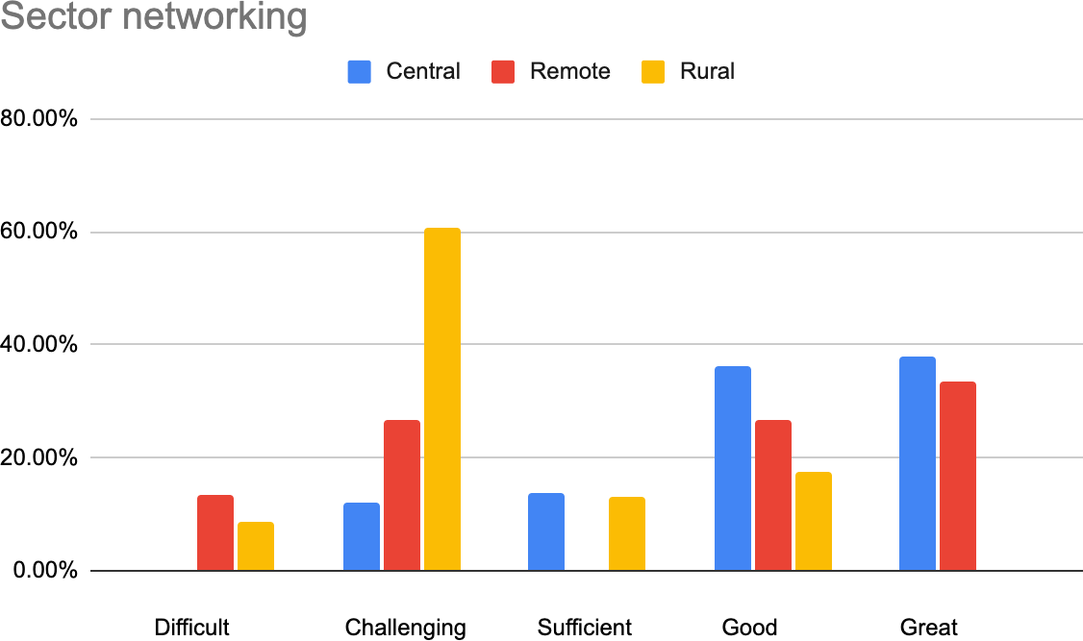

Advocacy

80.00%

- Central ■ Remote ■ Rural

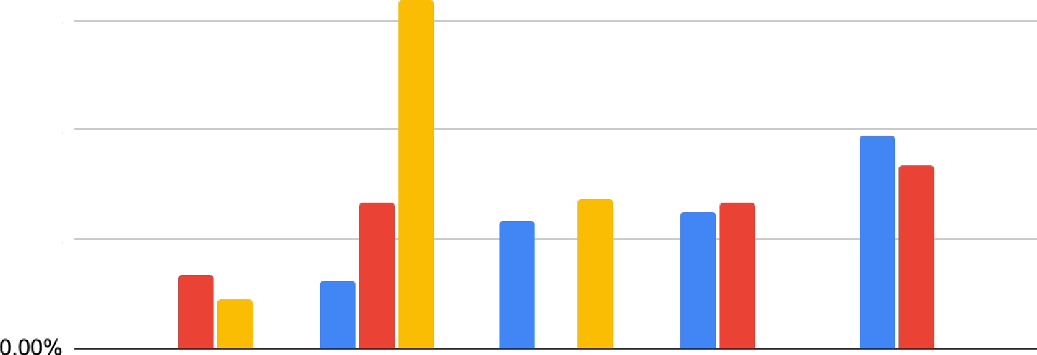
60.00%
40.00%
20.00%

Difficult Challenging Sufficient Good Great

Working locally

80.00%

- Central ■ Remote ■ Rural

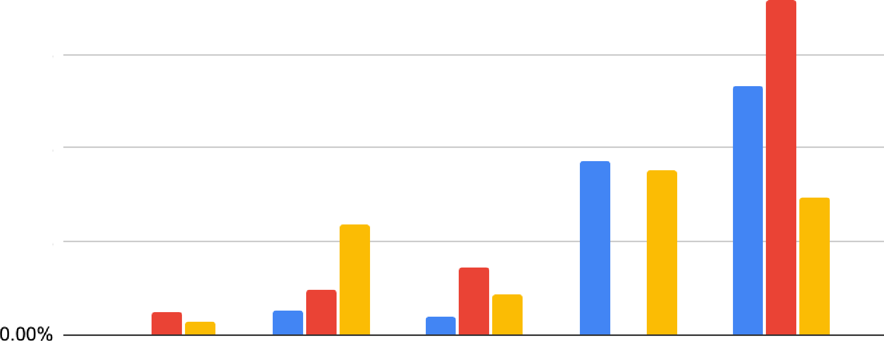
60.00%
40.00%
20.00%

Difficult Challenging Sufficient Good Great

Working nationally

60.00%

- Central ■ Remote ■ Rural

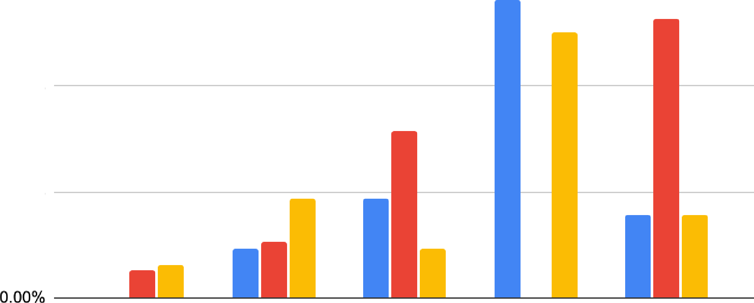
40.00%
20.00%

Difficult Challenging Sufficient Good Great

Influencing cultural policy
  - Central ■ Remote ■ Rural
50.00%
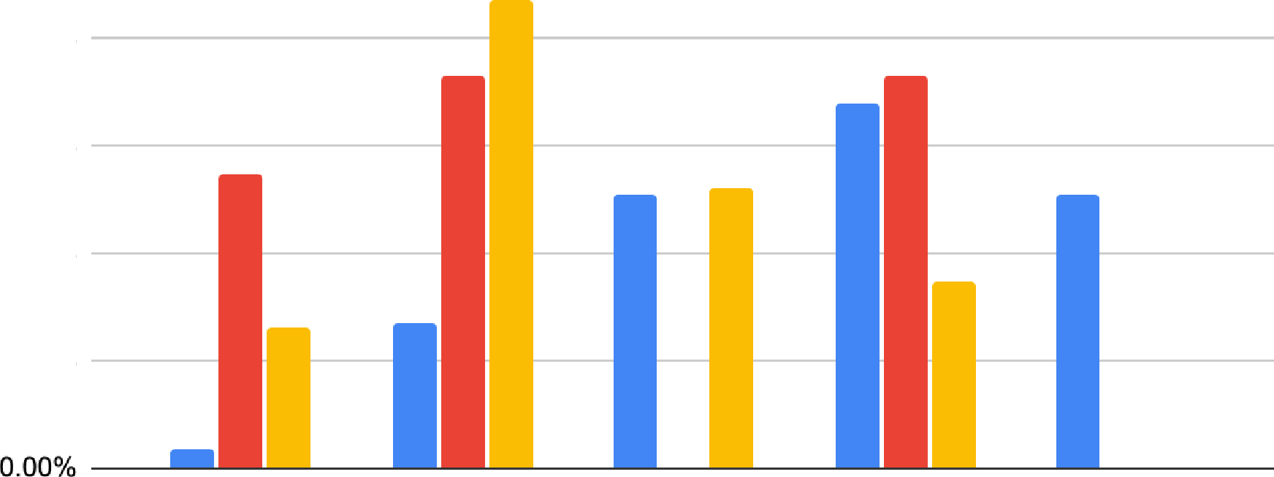
40.00%
30.00%
20.00%
10.00%

Difficult Challenging Sufficient Good Great

Getting support from local media
  - Central ■ Remote ■ Rural
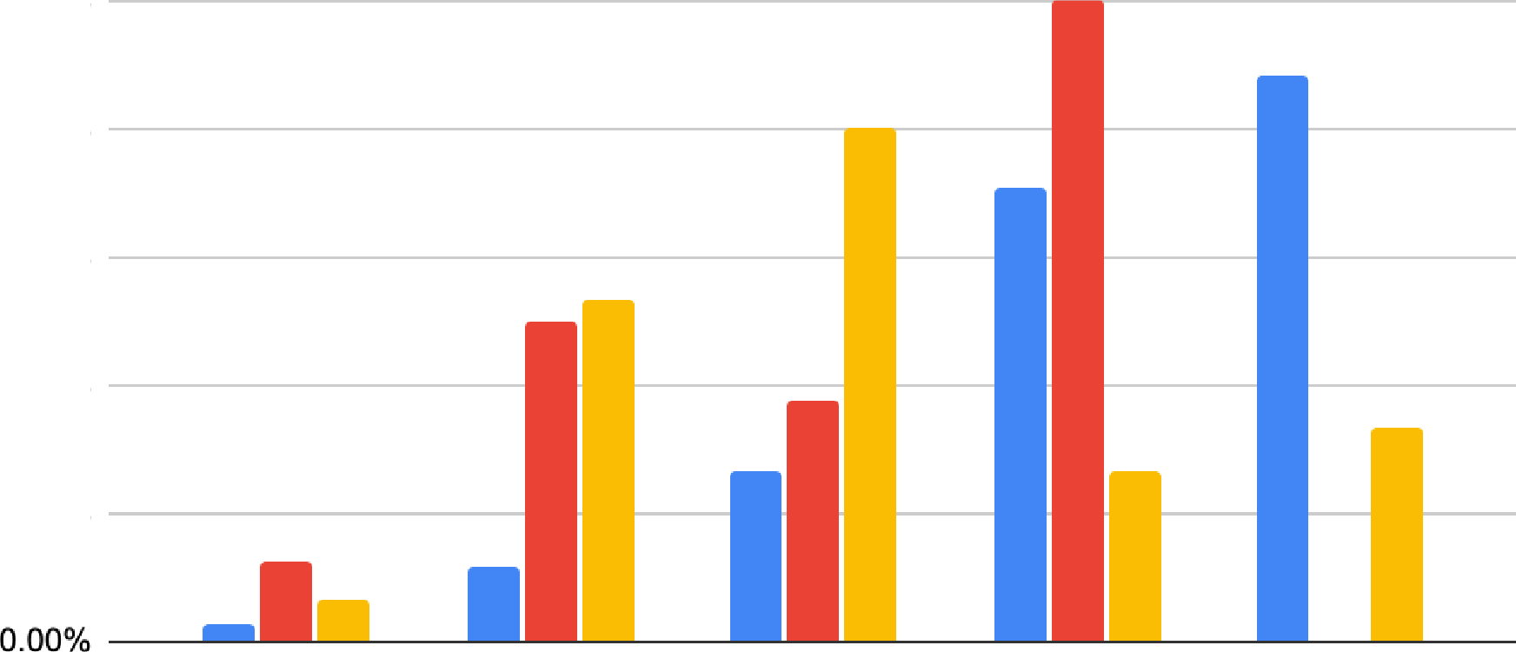
50.00%
40.00%
30.00%
20.00%
10.00%

Difficult Challenging Sufficient Good Great

Getting support from national media
  - Central ■ Remote ■ Rural
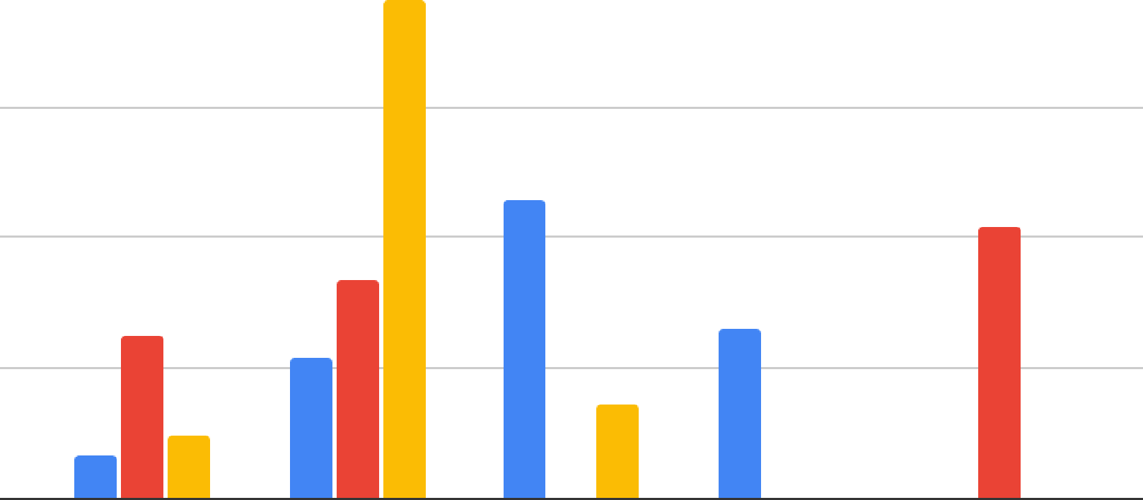
80.00%

60.00%

40.00%

20.00%

0.00%

Difficult Challenging Sufficient Good Great

Recognition from the wider sector
  - Central ■ Remote ■ Rural
80.00%
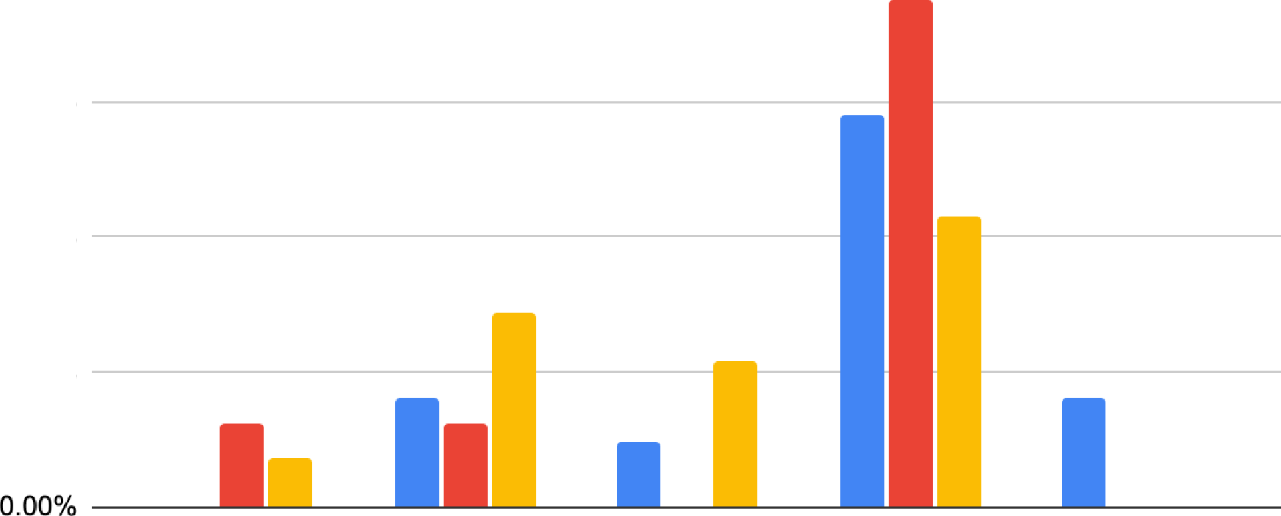
60.00%
40.00%
20.00%

Difficult Challenging Sufficient Good Great

Working internationally
  - Central ■ Remote ■ Rural
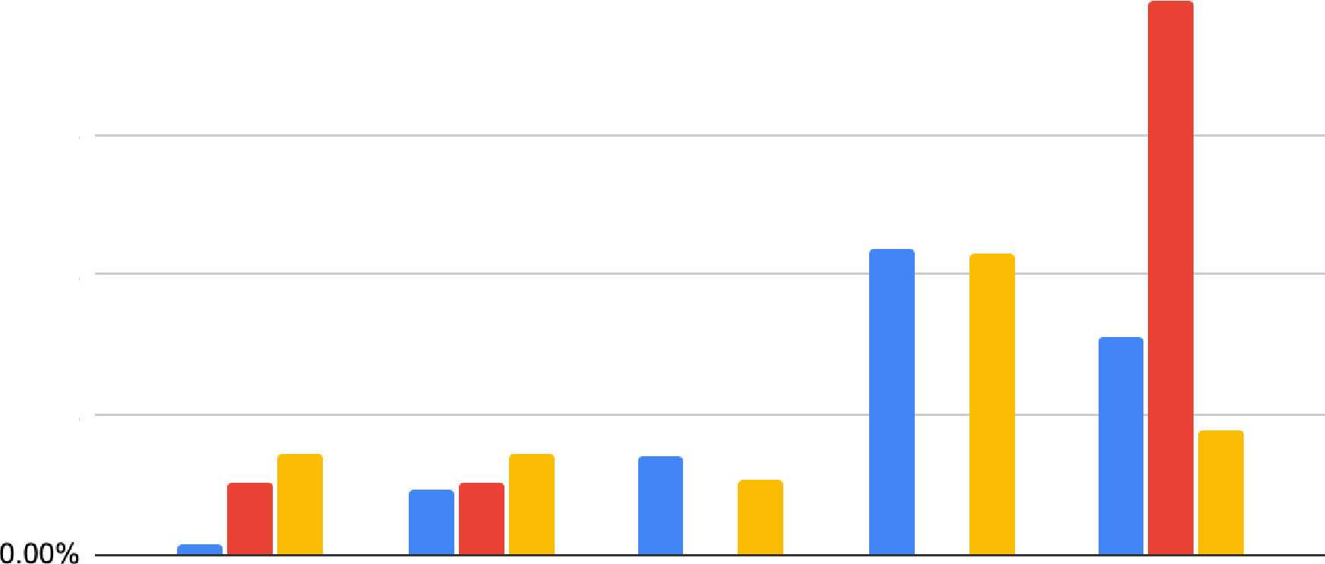
80.00%
60.00%
40.00%
20.00%

Difficult Challenging Sufficient Good Great

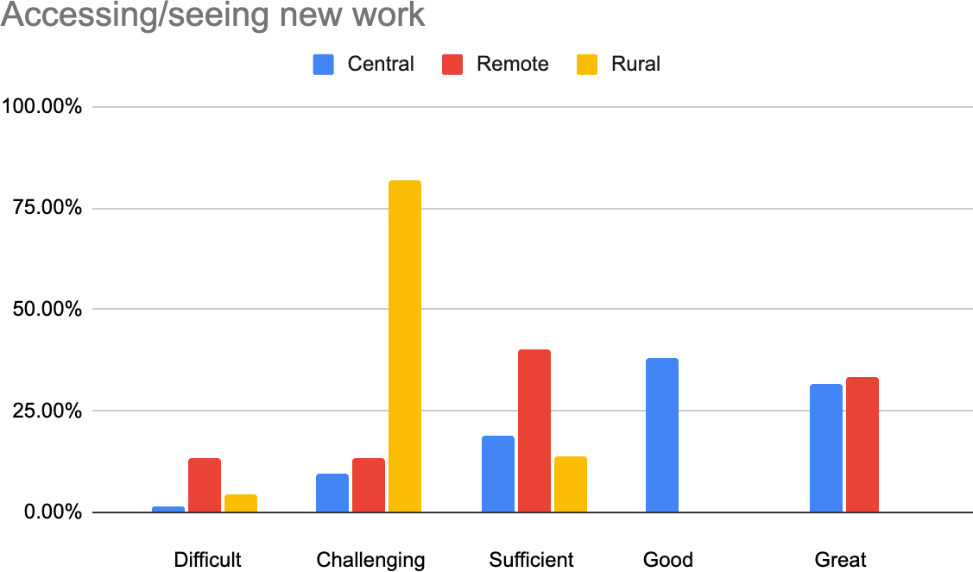

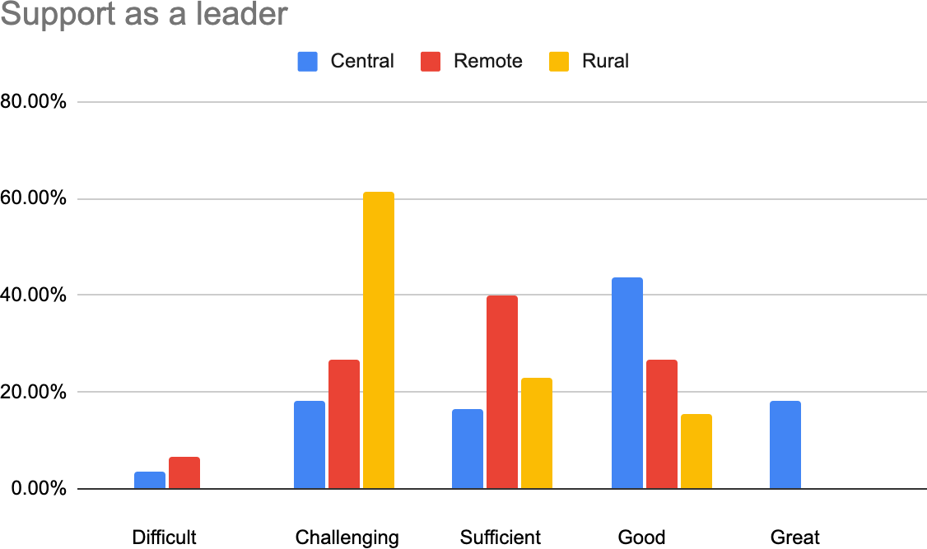

What attracts you to your working location?
- The heritage town in which we are based
- Flexibility as I work globally.
- The lifestyle; access to some of Scotland's best and quietest beaches and rural environment; the opportunity to engage directly with a whole community; more room to try things; one's work is more valued, and more directly critiqued; often artists in urban areas can choose not to hear views about their work and/or organisations which they do not want to hear - there

is so much "noise" around to drown out divergent views - in a rural community this is not possible!
- Nothing in particular, this is where I am based. It is the capital. It is well connected to other cities locally, nationally, and internationally. It is a cultural hub in many ways.
- Living in a vibrant city
- I have lived here since Uni, my husband grew up here. I grew up rurally and for this moment in time, we're enjoying city living (speciﬁcally Edinburgh city, not a fan of London living).
- Lifestyle
- A strong sense of place, a unique setting, a strong sense of community, tonnes of inspiration, new ways of seeing and being. There is also a lifestyle aspect to living and working rurally. I think with regards to arts and culture, there is also an interesting role to play when thinking about what culture looks outside an urban-centric world view
- We chose to live here to bring up our child. Work came later
- I love the Highlands and Islands. Each community has its own energy and character, and there's so much 'can do' and let's get on with things together.
- the organisation has an international reputation for projects it has initiated which was a big draw. communities are more distinct and active in future planning. It is nearer to my family.
- "Firstly, I don't consider my working location to be any of the above. Remote is relative. I work in a geographically remote, or distant, location, but I don't feel that I am working remotely, other than in the sense of working from home during lockdown and using the computer to connect with everyone with whom I work, no matter where they are based. I realise other people might think that I am remote, but I have never felt disconnected in Shetland because I am well networked with people all over the UK and other parts of the world, especially the northern and Arctic regions, and in some respects, North America. I have lived permanently in Shetland one month short of 20 years, and I've been involved in Shetland regularly since 1985. Rural doesn't quite feel accurate, either, as I live on an island. I live in a central location, relative to the rest of the Shetland community, in that where I live might be seen to be akin to the central belt of Scotland. I live close to the main town but on an island, where I am surrounded by water, people, sheep and ponies.
- I was attracted to move to my current location after more than 20 years in London because it is beautiful, I love its very strong community, and I am connected with a much wider range of people than in London, where most of my connections were part of the art world. I value its culture, which has links to Scandinavia through its Norse ancestry. I see Shetland as a hub in the North Atlantic. "
- Glasgow overs a rich mix of arts and culture, risk takers, creative entrepreneurs, entertainment and sound people. It’s everything you could want in a small city.
- It has been a good place for bringing up family and for community
- Best of all worlds - the beneﬁts of living in a city and all that it has to oﬀer, but small enough for a strong sense of community, knowing who to contact to make things happen, for cultural organisations to have power in the city, and to be super close to amazing countryside.
- Isolated living, community, proximity to nature,
- I grew up living in a rural place, familiar with the city/town/country dynamics. Visited this area over 8 - 9 years and was fascinated by 1. diversity of the programme and engagement activity 2. the building - location and architectural 3. across Scotland and the UK, it felt oﬀ people's radars. 2 children and they would need support to get through their childhood, grew up surrounded in country, to be free and wild in the country. We had to give up the school which had much more cultural diversity which isn't here. It's a brilliant place to live.
- I moved here when my husband got a job.. I like the scale of this place, we are a small walkable city, with plenty of things going on.
- Home Working so close to home
- its rurality

- Hawick is the largest town in the Borders, itself being a far-spreading region. While rural and remote issues do surround our region, we also consider ourselves to be central in many ways, particularly geographically and culturally. We are in close proximity to Edinburgh, Carlisle and Newcastle and have thriving histories and cultures. However, we are often positioned as rural or remote due to a lack of resources and infrastructure.
- This tension between urban and rural, post-industrial and in need of provision, is what makes this an attractive and relevant place to dedicate meaningful arts-based community-focused work.
- I work from home. I’m here out of necessity because I can’t aﬀord any other options.
- All the obvious things: the natural beauty and wild spaces, the skies, lochs, beaches...
- Majority of our stakeholders are based there/relatively close by
- It is my home
- Ended up here after 10 years in rural Aberdeenshire
- Seaside, historic buildings, good food
- Being in a city and the buzz that brings. Although in the last year that need to be close to people to connect more dots is less pertinent.
- Choose to be part of the community I live in despite work options being limited
- I live here
- Being in Inverness I get the best of urban comforts, and easy access to a massive range of outdoor places which suits my freelance work in location management for the creative industry.
- I chose to live in the countryside where I could take part in the community
- Family roots
- It is part of University of Dundee
- Can commute from South Queensferry where I live. We also have the ﬂexibility to work from home (and do so all of the time during the current pandemic).

Can you describe an example of a time when your working location became an asset, and why?
- We are in an empty shop unit, a retail shopping centre where we are able to oﬀer services (photocopying, printing, laminating etc) and the location gives us, literally, a 'shop window'
- I am able to work at diﬀerent times, diﬀerent days and I like being able to make those decisions.
- Our venue creates great programmes of work. If we were based in a city centre where competition is greater I wonder if we - and the artists we nurture and whose work we promote - would receive the same coverage and recognition, both from peers and the wider arts community. Our "remote" location enables us to punch above our weight, something we do consistently. It also enables us to contact artists and engage with them more easily than it might in a down-town city centre, because we can oﬀer so much access to the natural world on our doorstep.
- Pre-COVID19 during the summer festival season in August it is a particularly convenient time of year for arts and cultural business.
- The concentration of festival work makes it easier to get freelance opportunities
- We are part of the largest and greatest arts festival in the world. There is nowhere in the UK that manages to achieve the same chemical mix as Edinburgh in August. The location is an asset because it is close enough to greenery that it isn't hard to leave the city to breathe.
- Pandemic
- Throughout coronavirus our location has been a huge asset. We were able to quickly ﬂip our model and become a vital community asset supporting mutual-aid and mental health and well-being across the county. We are more connected now that everything has moved online; industry meetings and events (that we were previously, repeatedly told would be

impossible to take online) are now online and accessible to us. We ﬁnd international partnerships are highly attractive, connecting with international partners from the Highland diaspora and those in similar rural locations.
- Living here helped me understand how rural touring works in a way that living in the central belt couldn't. I have connections with village hall volunteers as well as paid arts centre staﬀ in the Highlands and Islands
- Lockdown has proved the huge beneﬁts of living outside major centres of population. It has minimised the negatives (long travel times, poor public transport) by making the need to travel so much less critical, and it has maximised the beneﬁts--a positive community, ready access to facilities and open country. Our service and its crucial community role has never been more evident.
- It's an asset in so many ways! Our organisation is all about the place, it's at the core of what we do, and it wouldn't work anywhere else. This can at times cause logistical challenges, but also means we think and respond to things very creatively. The location, and the communities that we work with, inform everything that we do. It is the starting point for projects, artists research, and conversations with communities.
- My working location is always an asset because I work in relation to the place where my work is located. Context is everything. It is also worth pointing out, perhaps, that I can work in many diﬀerent places, even when I'm living in one place. Sometimes others view Shetland as exotic and in this sense it can be an asset in terms of seeking collaborative partners.
- When I moved to glasgow I realised how much opportunity there was to connect, empower and upskill the creative population, initially in the city itself but then beyond its borders, across the country as there were clear gaps in the existing service oﬀer. Being out with a saturated city like London meant way more opportunities with an underserved community.
- You could make a diﬀerence in your community.
- The small size of Dundee is a huge asset, as it's easy and quick to galvanise key players and partners to make things happen - projects, events, advocacy, campaigns. We can be quick, responsive and agile, and are often used as a testbed for national projects.
- When working with other people in remote or rural scotland, it's an advantage to understand their perspective- also a sense of kindred spirits to the challenges and opportunities
- The building - it's such a gift - using the space outdoors, idyllic location, it was a blessing. The physical outdoor space, the riverside, the indoor space - there isn't much we can't receive artistically. We want to be an artist and audience centred organisation. Audience experience is very important and the quality of the welcome. I wanted touring companies to be leaving Inverness feeling like they had an amazing week, a jacobite cruise, a drink, a warm welcome, important to visiting artists. The experience of being an artist. To be their favourite. Everything is on our side - the building, the location etc
- Dundee's size means there is one of everything - a theatre, a museum, a contemporary art centre, a design museum -there is less competitiveness here than I've experienced elsewhere and organisations work very well together and partner regularly on activity.
- Being located close to Edinburgh is an advantage, it's possible to go and see work or have meetings easily.
- Most of my professional life I've lived in large cities - Paris, Glasgow, Copenhagen, London for many years, now central belt Scotland - chosen because of likelihood of easier access to employment opportunities
- Our location allows us to work with plural audiences and partners. We have a unique and
remote enough location to attract international guests; untapped stories and cultural quirks enough to attract artists to develop projects and research; and resilient and interested communities to access art projects in deinstitutionalized ways, through access points beyond gallery visitation or cinema-going.

- I can get quite dramatic pictures for social media and products using the scenery around me as a backdrop.
- Our location always acts as the perfect headspace after work, or during work if you need a wee half hour. Our team is also scattered across Highlands and Islands and has always worked as a dispersed team, used to working using collaborative digital tools, so our familiarity with this type of working has really helped during the pandemic.
- As above.
- I can work during lockdown!
- My job is to activate place as an asset - always. It's central to my practice and the ﬁeld I work in.
- This one: if I need to go to Edinburgh, it's day-trippable, but I get to live in a small town by the sea, with all the advantages of that.
- Being able to attend an event and see possibilities through bumping into people and organic networking. Also needing (pre-pandemic) to drive across the country - being fairly in the middle makes that easier.
- On occasion being geographically remote or perceived as disadvantaged has helped with sourcing temporary funding
- I don't have to compete against many.
- Literally every time I do a job because that's why people come to ﬁlm here.
- In the current pandemic because it's possible to control infection here and there is space to be outside
- Community spirit
- Connecting people and opportunity through landscape and place with culture of food and through exploring and supporting nature based solutions to designing future resilient landscapes together
- The oﬃce is in central Edinburgh near my favourite theatres and friends' workplaces to meet on lunch breaks. Could meet friends in town after work on days I didn't need to collect my child. Pop to Princes Street on my lunch break for errands.

Can you describe a time when your working location became a challenge, and why?
- It's very public and sometimes diﬃcult to concentrate
- Working in the city has been a challenge as time is wasted moving around, and the challenge of lack of ﬂexibility.
- So far, apart from the weekly trek to the only half-decent supermarket on the islands, I see our location completely in positive terms. It is what it is and every potential challenge is also an opportunity. Covid has shown us how easily we can engage with an international audience through online connections. It has almost forced us to do it and get comfortable with the technology etc. As a result, even when we return to more normal times and open exhibitions with invited people physically in the gallery, we will continue to create these online links and retain these new audiences.
- During the summer festivals, it is incredibly diﬃcult to navigate the city as a local due to transport delays, traﬃc, and the pure volume of people in the city. Business as usual becomes diﬃcult especially as local arts work is inundated with international work and work from other parts of the country.
- It can be an insular viewpoint
- It is a challenge to manage the density of action. It can be hard to take a step back and see the bigger picture when in the midst of it.
- Isolation
- We face a unique set of challenges and it is incredibly unhelpful when these challenges are lumped together as 'rural' challenges. One 'rural' place is not the same as another. Our community faces multiple-deprivations, challenges and barriers to access and getting

centrally based funders or industry bodies to understand takes time. Access for us to attend industry events, training and networking is limited as a trip to Edinburgh for a 3 hour meeting could mean 3 days out of the oﬃce and be extremely costly.
- (Pre-Covid) Meetings are diﬃcult for me because I live on an island and everyone I deal with doesn't live here. A 2 hour midday meeting in Edinburgh means 2 nights away for me. Luckily I have family on the East Coast so it can be managed on a budget, it just takes an enormous amount of time. Because of ferry restrictions I can't even drive to Inverness and back in a day (8-9 hour round trip). What works well for me are full-day or multi-day events where accommodation and/or travel are covered. They allow enough time to share info and network and are worth the time, eﬀort & money. Meetings have been a vital connection for me as I would never bump into anyone in my normal life, and networking is how I ﬁnd work and get a feel for what's happening in my sector.
- (Post-Covid) Zoom meetings are the norm so it doesn't matter where I live but there aren't the same connections, informal chats, information sharing. More limiting for me.
- Moving a huge articulated truck around the Highlands and Islands on a tight schedule is always a challenge, and these practical issues (cancelled ferries, blocked roads, etc) can sometimes get in the way of the wider purposes of the service.
- Our geographical remit is very large for a small team. It can be challenging to reach such a wide area, not like we are working in one location but we move around a lot. This is positive for me, but it can be challenging at times to cover such a wide area.
- There are two occasions, one is a reason, and that is to do with the high cost of travel to and from the islands. The second is to do with small minded and arrogant people who do not respect others, their experience, their knowledge, their ﬁeld who bully. I think this experience of bullying and harassment, which some would say is worse when it occurs in a small community, can in fact be found in all kinds of working locations. I experienced a similar challenge in my working location in a big city as well as in my small community.
- The culture in Scotland is entirely diﬀerent and expectations, work ethic and quality of staﬀ diﬀer wildly here making it a learning curve for me, not being Scottish to deliver to, but also making hiring sometimes challenging.
- I would have said that at one time there were quieter roads and that was a lovely way to live. But not now. Huge Tourism and poorly kept roads. But it used to be a joy. tourism as one of few routes to employment have kept our communities on low wages plus house sales to "second homes and airBnB's are damaging our lives here.
- Some UK wide programmes we are involved in sometimes culminate in sessions in London which can be expensive and impractical for some staﬀ to get to.
- The usual - travel and access to resources. But also I wonder whether perceptions of someone working in a rural location as somehow lesser ?
- The way in which the airlines have stopped ﬂying, larger touring companies aren't touring - transport infrastructure needs to be addressed. Companies can't get from London at the moment, we have never been more disconnected. Producers were starting to see us as a viable tour venue but less so now in 2021. Alternatives (sleeper) are too expensive.
- Late night inte-city transport is diﬃcult, so getting ﬁnished for the last train home can be a challenge, particularly for travel to Glasgow.
- In Devon it felt like a cultural desert - not exactly true but opportunities hard to come by in order to earn a decent living
- it is always a challenge - we work in the non-proﬁt sector and mindsets are so intensely ﬁxed that everything we do requires a process of unravelling assumptions before we can start to work towards building commonality. We do our work because these challenges continue to persist
- The lack of basic provisions such as a train station or bookshop takes its toll on travel, relationships and project delivery.

- Hugely reduced access to varied choices. Poor public transport. High rent and rates for businesses and local residents.
- Challenges mostly include centralisation of the workforce - the way in which Scotland seems to operate from Glasgow and Edinburgh. For those of us living and working in remote and rural locations, this impacts on our access to support/opportunities/networks etc. Covid 19 has had a weirdly positive eﬀect on this as now everyone is considering how to deliver services at distance and all are thus working more inclusively.
- Our remit as a national organisation is challenging to fulﬁl when based in the central belt. Sometimes this is perception as much as reality. We have to literally point out that our programmes are open Scotland-wide and that we have a travel and access budget yet there is still a view that we will favour those in Edinburgh and Glasgow. Artists based outside the central belt often want to be supported in the central belt and not in their local communities. Pre-pandemic, space was becoming less available or aﬀordable.
- Lack of ﬁbre internet
- It is always a challenge. Mostly I'm working in contexts where others have 'ownership' either literally as inhabitants or metaphorically as service owners...
- I lived in a city that had no cultural or historical depth, and hated it. It meant I wasn't inspired to do good creative and curatorial work.
- The aesthetics of my immediate environment can be less inspiring than more rural vistas. Travelling in heavy traﬃc increases stress and produces less art.
- It frequently is, as so much networking, income generation and sustainability is impacted negatively by a rural location
- It is always a trek, expensive in time and in money to go to meetings in the Central Belt. Since Covid we are on an equal footing.
- Incoming shoots bringing in all their own crew and not hiring any locals.
- Meetings in the central belt (in non-Covid times) require 2 nights on the mainland. Expensive and time-consuming
- Lack of services
- The funding is challenging in a city and university where V and A and a few other chosen project take 80% of available resource
- Commuting - I use the bus as it is cheaper but they can be unreliable/get stuck in traﬃc so I would sometimes be late for work or late to collect my child from the childminder. Trains are very expensive and busy at peak time. For the business the oﬃce is expensive and also not accessible (stairs/no lift), which is problematic.

You are handing over to the next person to take on your role, what advice would you give them?
- Stay true to your vision and values.
- Do not stress about the things you cannot control, structures and pace in the creative sector do not work well together and much is decided in vacuums. Make sure you know who and what you are here to serve and be the best version of that you can be.
- Time ﬂows diﬀerently in remote places, go with it and be patient. Things will get done, maybe just not as speedily! See the remoteness as one of your greatest strengths and immediately the world starts to look diﬀerent and more easy to manage successfully.
- Make sure the board undergoes unconscious bias training, surround yourself with allies, and build your network of support. The arts in Scotland and the UK is an incredibly hostile environment for young people, women, people of colour - the white supremacy is insidious and it is not your responsibility to be the token disruptor to bring progressive change to the sector. Look after yourself and your mental health ﬁrst because this sector will not adequately support nor look after you.
- Progress will be slow

- The best thing I was asked to do when I started was to write an annual report (ﬁrst time the org had ever), it felt near impossible, arduous and onerous. But since then I have referred back to it many times, and it meant I got to grips with the scale and detail of what we do quickly. Which during a global pandemic has rather helped with the funding bids!
- Network!
- Listen carefully, lead slowly and dig where you stand
- Meet/speak to as many people as possible, through organisations such as FST and The Touring Network. Try to keep in touch by phone as well as email and chat about everyone's situation.
- have a team you can trust; and trust in the communities you work with
- collaboration and partnership are vital!
- Communicate well with everyone with whom you have contact in your working position, that means promptly, clearly and concisely. Remember the constituency for whom you are working and get to know them well, build relationships with them, keep learning about them. Be open and generous with your colleagues and peers. Build and nurture networks, starting from your core community and move outwards, ensure national and international reach. Be kind, caring and generous. Keep abreast of your ﬁeld, learn, refresh your knowledge.
- Maintain a sense of humour and listen to the community.
- Know your worth. You can be ﬂexible but always know your worth.
- To be proud of where you are - people are interested in who we are and what we do, and never to lose sight that the same thing makes locally and internationally relevant - great work.
- Be well connected before you work /live rurally
- Spend time listening, not talking, the next person should run the organisation diﬀerently. You have to settle (staﬀ turnover and retention) people stay in their jobs for decades which is a strength and a weakness of the organisation. That is speciﬁc to the geography - you need to take the time to reconcile that is the case. I would hope the organisation I hand over is a place anyone would want to work here. There is a question around how culture is valued.
- Go to the meetings, meet everyone, it won't take long to get to know everyone and what their objectives are. Play nicely, encourage partnerships for your team but also be generous in your contacts and introductions so you encourage others to collaborate.
- Networking is key, virtual meetings make this possible but there is a loss of organic conversation / blue sky thinking / brainstorming and idea sharing, that said, in one day I currently digitally travel which is a delight
- do not approach non-metropolitan/urban situations and practitioners with pre-determined, metropolitan-centric terms and a ﬁxed mindset
- Talk to people here, listen to them, and build projects from that rather than inviting projects ﬁrst and expecting interest.
- Get everything online. You’ll never survive otherwise.
- Make the very most of digital and be bold, creative and excited in your approach to the use of collaborative digital tools.
- Be bold.
- Start young...
- Get to know the place - there are lots of ways to do this through art practice... use them.
- Make the eﬀort to get out and about: don't narrow your horizons to just this place, no matter how lovely it is.
- Be a pirate. Forget all the "should"s of how you think you're supposed to do things and carve your own path.
- Keep working on central belt connections but stay true to local needs
- Be true to yourself.

- Know your territory and make yourself known nationally.
- Network as often as possible by joining FST/Touring Network and go to as many meetings as possible, especially the larger events. There are lots of people in a similar situation and it's good to meet with them too.
- Build partnerships as much as you can but don’t waste time on those not interested.
- Breath deeply, take stock of the opportunities, build deep and meaningful local and regional relationship and learn the spirit of place
- I would encourage the ﬂexibility to work at home or in the oﬃce. They should assess whether the charity still needs an oﬃce of this size, could we hot-desk and work alongside other charities instead? Covid-19 has changed the world for now, but there will be some changes that live on after restrictions ease. I think everyone in our charity would choose to continue home working, possibly for at least half of their working hours.

