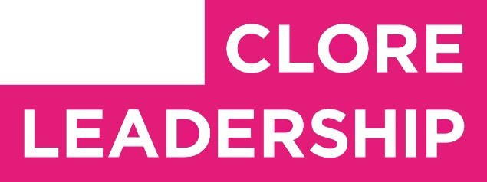

Clore Leadership-AHRC Online Research Library Paper
A role for the arts in policy?
Author: Stephen Bennett
Supervisor/s: Patrycja Kaszynska,
University of the Arts London
Year paper completed: 2021
Leadership Content Theme/s: Sector Insights, Governance
AHRC Subject Area/s: Policy Arts Management and Creative
Industries,
A note on contents:
Since 2005 Clore Leadership and AHRC have partnered to offer a diverse range of cultural leaders the opportunity to produce a piece of extended research relating to leadership and to their specific cultural discipline. These papers, published from 2023 onward on the Clore Leadership-AHRC online research library, reflect an important contribution to the field and we are extremely pleased to make them available to practitioners, scholars, and other interested parties. We recognise that this research library contains a range of terminologies and outlooks: these are reflective of the significant and ongoing changes within the cultural sector over the past 20 years. As such we urge readers to recognise that the authors’ thinking and language may have shifted since completion of these papers, or may be in the process of shifting as consequence of their enquiries.
Unless otherwise stated, research papers included in the Clore Leadership – AHRC Online Research Library have not been formally peer reviewed or published in an academic journal.

A ROLE FOR THE ARTS IN POLICY?

Full research report

SRG BENNETT
March 2021 ______________

CONTENTS
- Executive summary
- Why research the possible role for art in policy? A personal perspective
- How policies are made
  - Policymaker perspective and bounded rationality
  - System perspective
- What do the arts do (that is relevant to policy)?
- Six effects of the arts on policy
  - Multisensory experiences of information
  - Cognitive impact
  - Emotional impact
  - Ideas and alternatives to the status quo
  - Dialogical space
  - Agency
- Considering case studies in an art-policy matrix
- Findings
  - The problems of causality, intention and magic
  - Transference and activation energy
  - The six ways art can play a role in policymaking 8. Where next for this research?
  - Integrating the experience of artwork into this research
  - Considering other theories of policymaking
  - Broader and deeper qualitative analysis
9. Methodology

1. EXECUTIVE SUMMARY
Governments around the world are experimenting with opening up bureaucracies and bringing in "outside perspectives" and "creative approaches" to policymaking, whether that be design thinking, agile delivery or ethnographic methods. This research project, and resultant report, enquires into a possible role for the arts in policy. It does that by looking at the effects of experiencing art on policymakers as well as, more broadly, how art can impact the policymaking system across the stages of: agenda setting, policy formulation, legitimation, implementation, evaluation, policy maintenance, succession or termination.
The main findings and conclusions are that:
- Art has a number of different effects which can be claimed to have varying impacts across the policy cycle on the level of individual policymakers and the policymaking system. These effects are categorised under the headings of: a multisensory experience of information, emotional impact, cognitive impact, developing ideas and alternatives to the status quo, providing dialogical space for policy issues and activating agency.
- The causal impact of art on policy is hard to trace in general, but harder still at the "agenda setting" stage of policy development, which is where more policy-relevant artworks tend to cluster. However, there are notable "smoking gun" examples where there is reasonable evidence that an artwork did have a significant impact policy, for example Blue Planet II. ● Artworks can play important roles in the "policy formulation", "legitimation" and "implementation" stages of the policy cycle. While the problem of causal attribution remains, the contribution pathways are easier to trace for these stages as they are more focused on the "how" of policy delivery (as opposed to the "what" of policy agenda setting).
- This project raises questions about evidence construction, research and analysis methods and the conceptual framing suitable to account for the complexities of how art and policy interact. Its early conclusion is that while it may be futile to aspire for the "holy grail" of scientific demonstration, there is nevertheless still a lot we can do to improve our understanding of these complex interactions.
The project has conducted eight interviews, comprising policymakers and those involved in the arts, science engagement and policy theory; examined twenty-one contemporary and historical case studies where art has related to policy; and reviewed some of the extensive relevant literature, especially that which looks at theories of policymaking and the value of the arts. The analysis was conducted using a bespoke matrix matching the effects of art across the policy cycle, and situating various case studies within that matrix. There are examples of artworks providing a significant role at all stages of the policy cycle.

2. WHY RESEARCH THE POSSIBLE ROLE FOR ART IN POLICY? A PERSONAL PERSPECTIVE
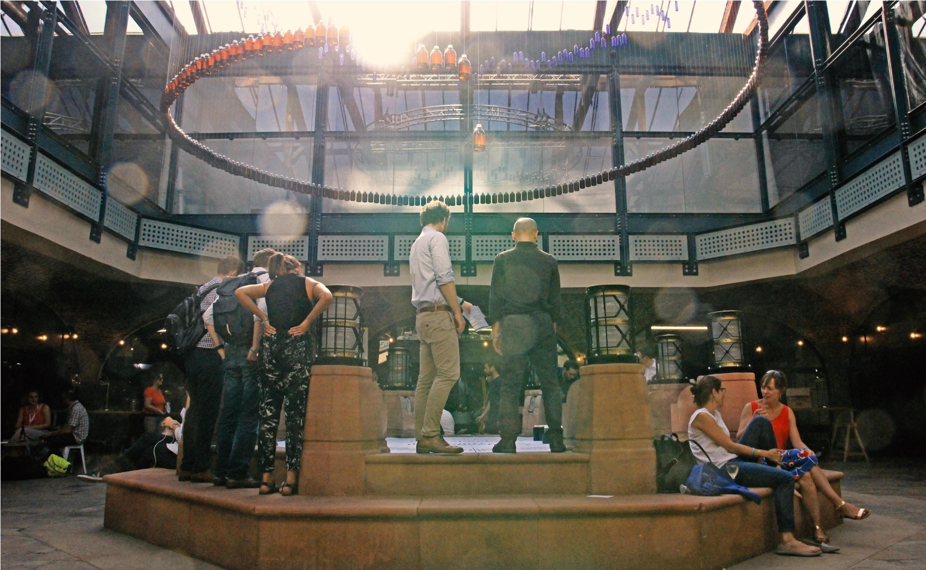
Figure 2.1: Bennett, S. and Sleeman, C.The 20 year Gap, installation showing data relating to disability-free life expectancy in the UK,
displayed at Nesta’s FutureFest in 2018 (image credit:the author)
Successful policymaking closes holes in the Ozone, reduces infant mortality and leads to the creation of the national health systems. Bad policymaking hurts individual citizens, exchequers and states. The author brings three perspectives on this: 1) as co-Head of Policy Lab; 2) as a practicing visual artist; 3) as policymaker who has worked at the intersection of evidence and policy in the UK Civil Service over 15 years.
Policy Lab was set up in 2014 as part of the Civil Service Reform plan. Its mission is to transform policymaking in the UK by pioneering new methods to show how policy can be designed with the people it affects (Policy Lab 2021:2). Kimbell (2015:77) describes it as demonstrating “hybrid new ways of working... in the ongoing mediation between politics, evidence and delivery”. The author’s part in this explores the role of art in policy (e.g. see Bennett 2018), combining a practice as a visual artist with 15 years experience of policymaking (see Figure 2.1). The enquiry to date has been practitioner-led, working with artists, designers and policymakers on experimental projects where there is appetite and funding. The ambition of this research project has been to juxtapose the resultant learnings with both more theoretical approaches to policy and case studies from other areas in the arts.
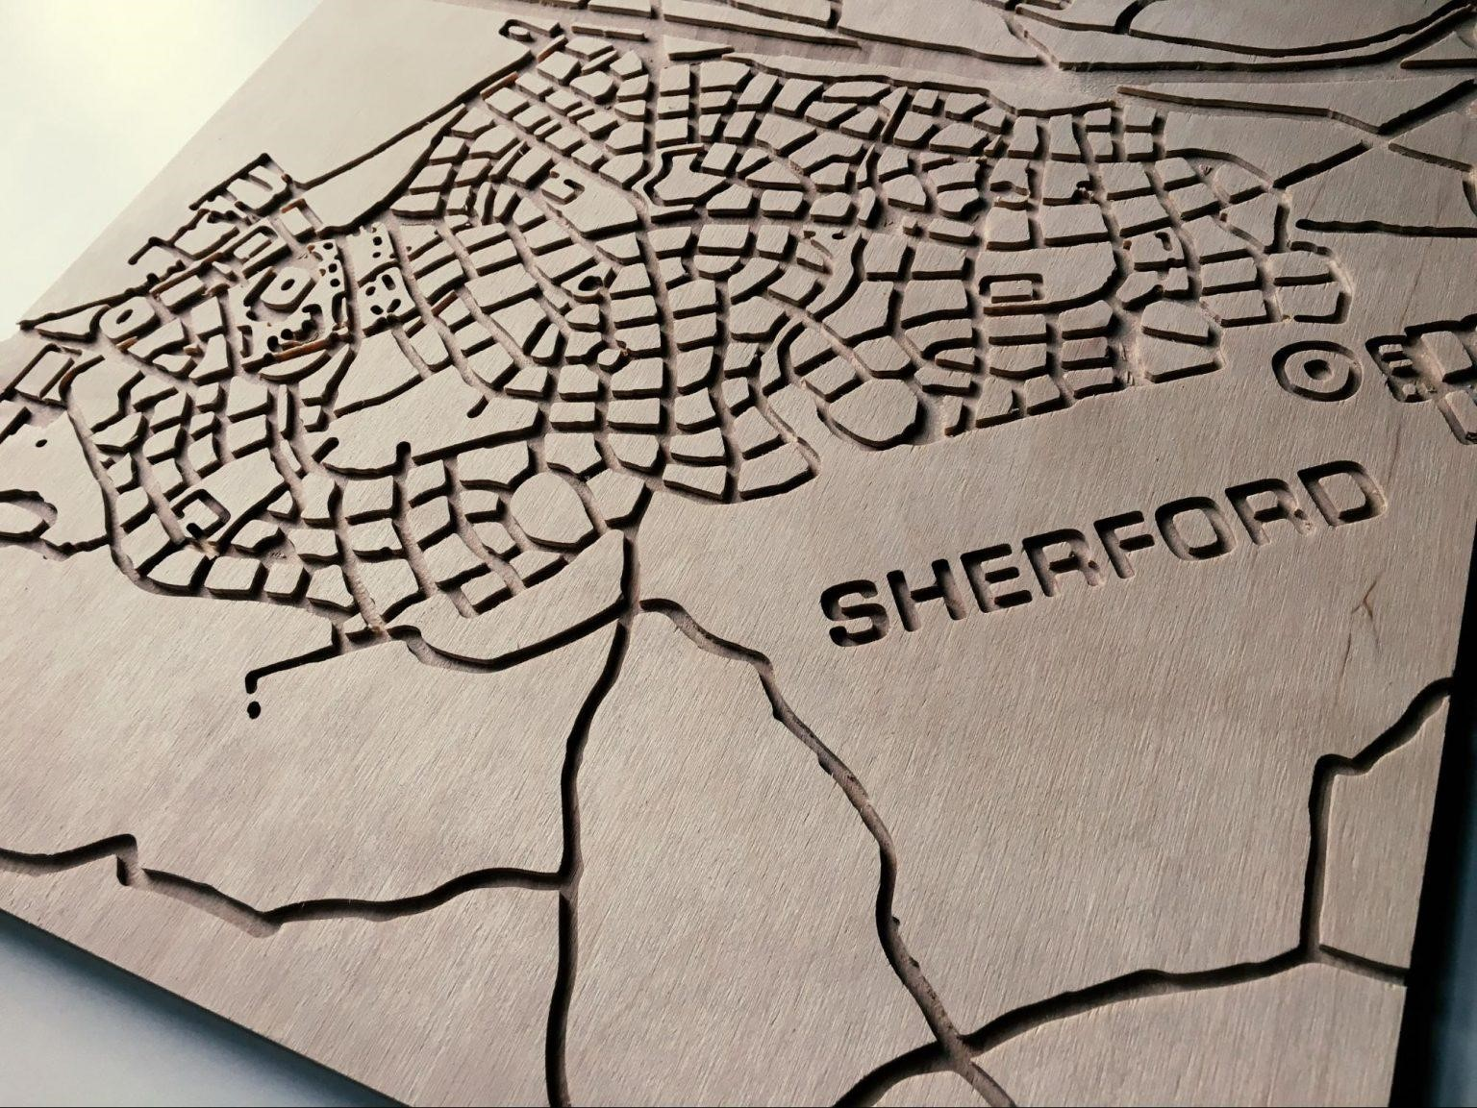
Figure 2.3: A tactile street map, designed for people involved in Policy Lab’s Manual for Streets project with the Department for
Transport, to enable a multisensory exploration of policy issues relating to street design (image credit: Policy Lab)

3. HOW POLICIES ARE MADE

3.1 POLICYMAKER PERSPECTIVE AND BOUNDED RATIONALITY
In 1820 the French positivist philosopher Henri de Saint-Simon said of his proposed new political order based on scientific reason:
All the questions which have to be debated in such a political system... are eminently positive and answerable; the correct decisions can only be the result of scientific demonstrations, absolutely independent of all human will de Saint-Simon 1975, quoted in Hallsworth (2011:80)
Nearly two hundred years later Kimbell (2015:8), after interviewing people involved in the production of policies, produced an assessment of how policy might be made today, viscerally illustrated by Holly MacDonald (see Figure 3.1). The image shows the influences on policymakers: parliament, business, experts, academia, the media, and so on. The pressure is amplified by the single message on the computer screen: HURRY UP!
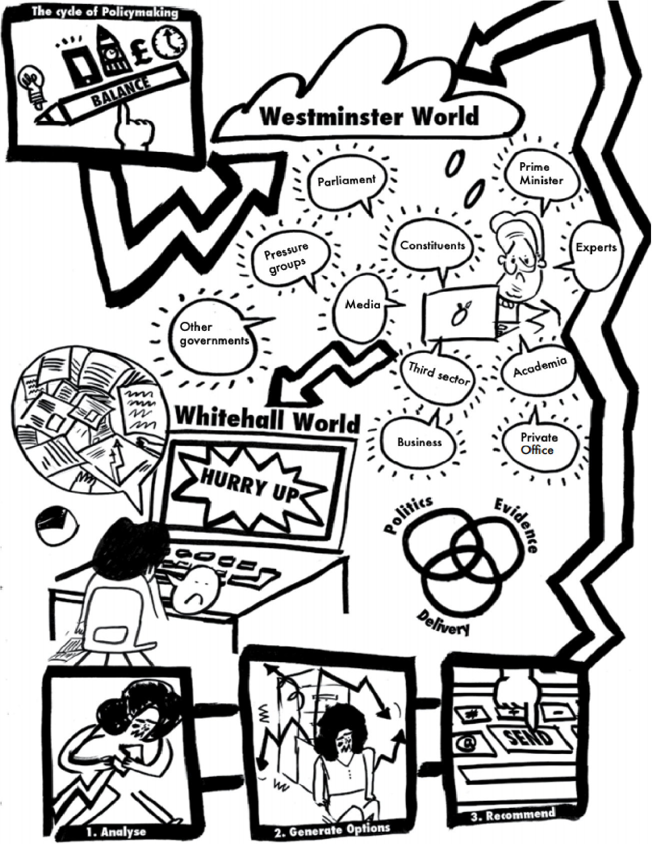
Figure 3.1 How policies are made, especially considered from the perspective of the policymaker (image credit: Kimbell/Macdonald
from Kimbell 2015:8)
This illustration appears to correlate closely with the concept of "bounded rationality" that Cairney and Kwiatkowski (2017:1) use in their analysis of policymaking. The term describes the limits on what information policymakers can realistically process and incorporate into a policy decision especially given the "unusually strong and constant pressures on [policymakers’] cognition and emotion". As a result policymakers, just like everyone else, use "short cuts" to gather information to make decisions, including:
The "rational", by pursuing clear goals and prioritising certain kinds of information, and the "irrational", by drawing on emotions, gut feelings, values, beliefs, habits and the familiar, to make decisions quickly - Cairney and Kwiatkowski (2017:1)

3.2 SYSTEM PERSPECTIVE
The bottom of Figure 3.1 shows three stages of activity: 1) analyse, 2) generate options, 3) recommend. This nods to a system or process of policymaking. Consideration of the policymaking process is helpful for two reasons:
- It provides a more nuanced and less monolithic view of policymaking, allowing greater insight into the multiple ways that the arts may play a role;
- It broadens the focus from beyond the potentially narrowly defined "policymaker" to other actors in the system.
The "policy cycle" is a well-established model for describing how policy on a given topic goes through different stages, appearing in HM Treasury’s Green Book on the appraisal and evaluation of policies (2020:15). Cairney (2020:27) provides a slightly more intuitive version shown in Figure 3.2.
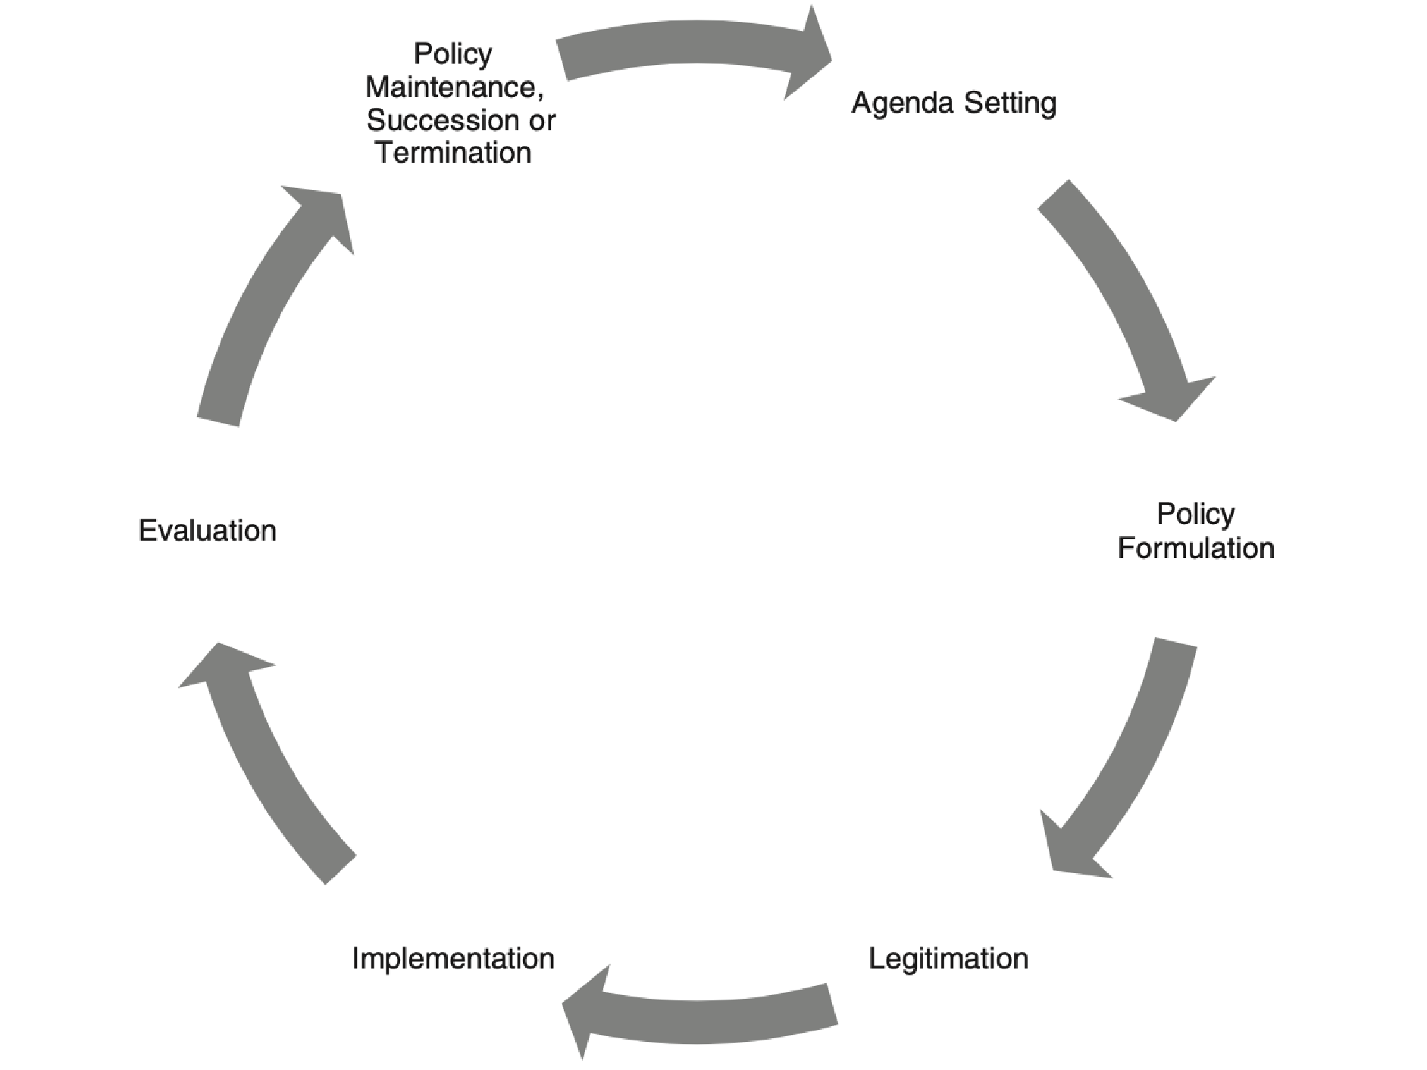

Figure 3.2: How policies are made; the policy cycle (image credit: Cairney (2020:27))
The figure indicates that the policy process is circular and continuous. If there is a starting point, it is likely to be towards the top, where either an existing policy is judged unsuccessful (including the absence of measures), or a problem is identified as requiring government attention. The next stages include:
- Policy formulation, such as setting objectives, assessing options, costing;
- Legitimation, i.e. ensuring the chosen policy instruments have support (whether legislative, executive, popular...);
- Implementation, including tasking and resourcing an organisation to deliver the policy.
The cycle then loops back onto itself, with further evaluation and decisions about policy maintenance, succession or termination in turn giving rise to a new agenda for policy.

4. WHAT DO THE ARTS DO (THAT IS RELEVANT TO POLICY)?
Matarasso (2013:4) differentiates "art" and "culture" by explaining that “art is a toolbox that enables human beings to interfere with their culture”, whilst culture “add[s] meaning (value) to what needs to be done”. This research project focuses on the role that the arts play in policymaking, and only indirectly on culture. Belfiore and Bennett (2008:17) describe how the millenia-old debate over "what is art" partly coalesced, since the 1960s, around "functionalism" which tries to identify the functional properties possessed by artworks, i.e. what art does. In this light, another passage from Matarasso is helpful:
[Art] uses sophisticated techniques [...] to produce intellectual and emotional effects through which it aims to communicate values, ideas and feelings [...] Perhaps most importantly art can question, re-imagine, undermine, critique and dream about existing values and meanings - Matarasso (2013:4)
A logic chain can be drawn between this articulation of the functions or effects of art and the earlier quoted passage by Cairney and Kwiatkowsksi (2017:1) regarding how policies are made, including the role of values and emotions:
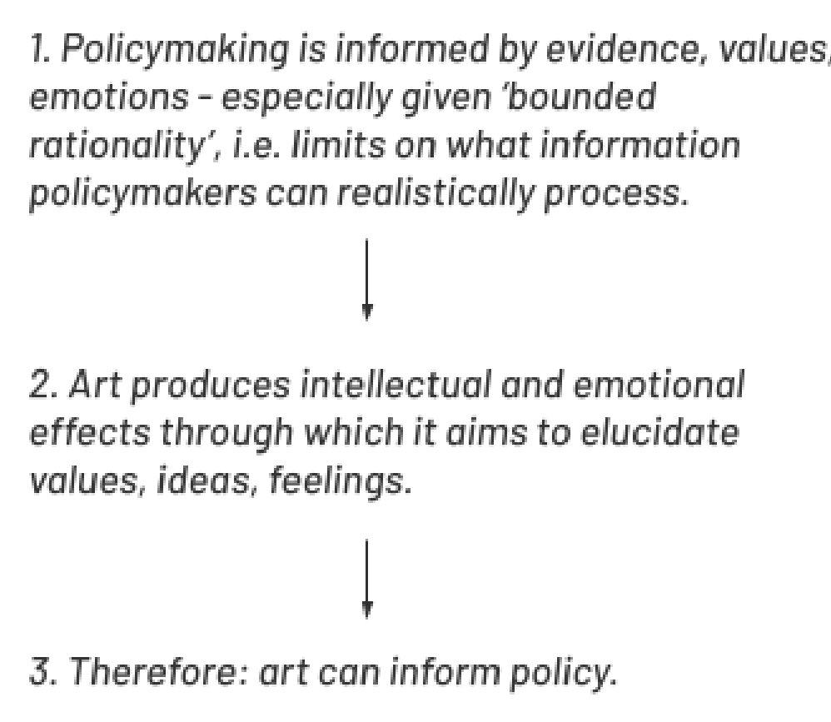
An exhaustive, definitive list of the effects may be impossible partly because of the subjective nature of what constitutes "art" and then partly because of the infinite ways its effects can be carved up. Instead, this research project has considered some effects of art relevant for the specific context of policymaking, informed by the literature reviewed for this project, the interviews conducted and the author’s 15 years experience working in British policy whilst practicing as an artist. It has been benefited from a cross-check against a compendium of lists developed by the Centre for Art Activism (2018:24) for how art can foster social change, a closely related, though slightly broader, relationship. The resultant “six effects of the arts on policy" are proposed as follows and are developed further in the next section:
- Multisensory experiences of information
- Cognitive impact
- Emotional impact
- Ideas: visualising alternatives to the status quo
- Dialogical space
- Agency to act

5. SIX EFFECTS OF THE ARTS ON POLICY

5.1 MULTISENSORY EXPERIENCES OF INFORMATION
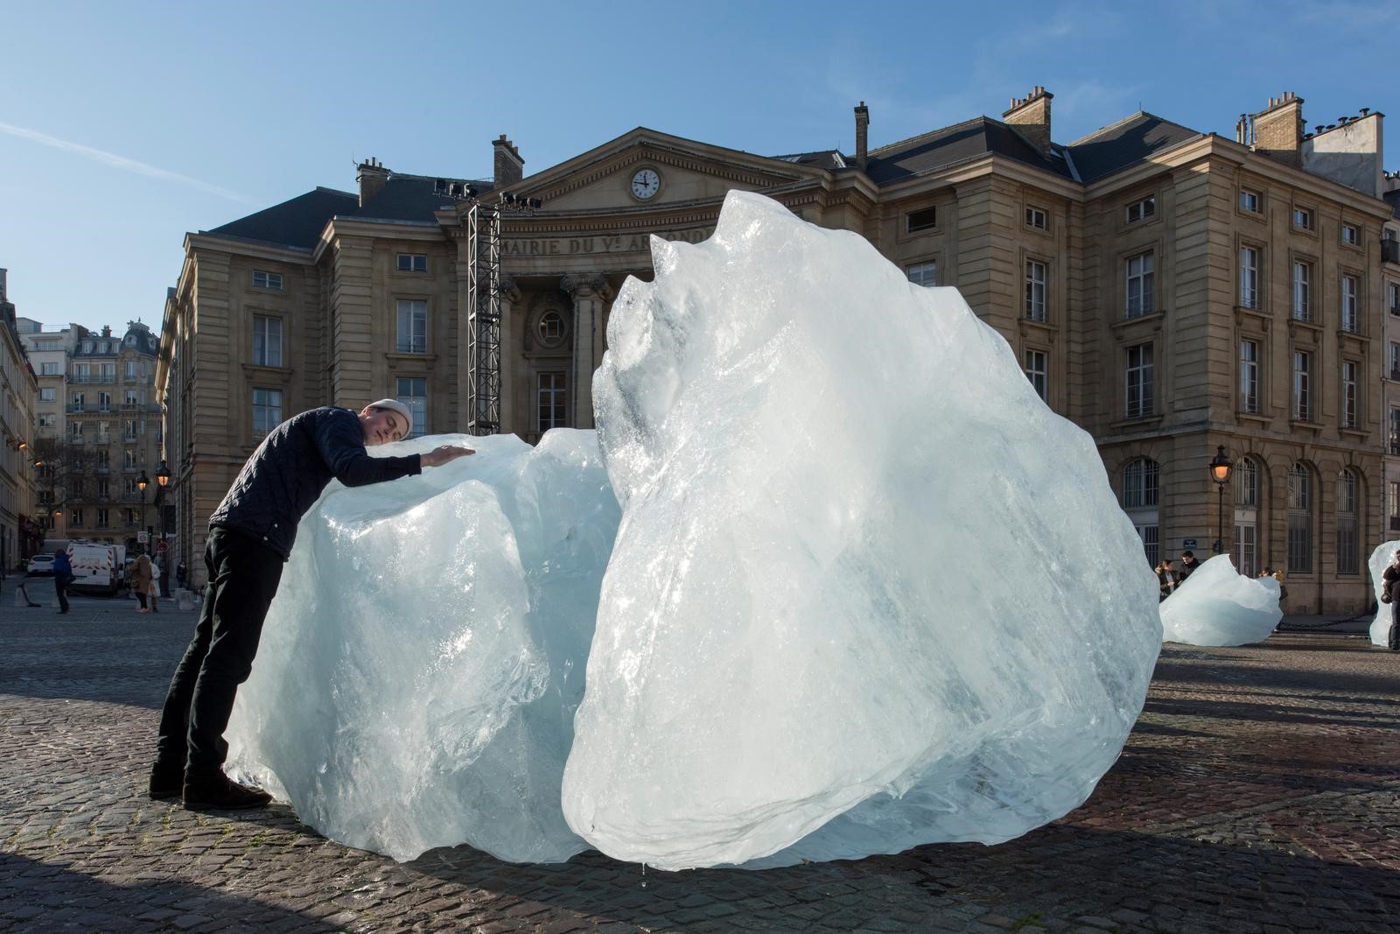
Figure 5.1: Ice Watch, Olafur Eliasson (2015-20) an artwork which brough arctic glaciers onto the streets of Copenhagen, Paris and
London for people to see, touch, hear and even taste (image credit: Martin Argyroglo)
Artworks, almost by definition, provide visual, physical, kinaesthetic, aural, haptic (and so on) interpretations of an idea or issue. Barnett (interview, 2020) explains how “If you see an image, you engage with the idea more fully and more personally than seeing a bullet point of text; if you feel an object, if you can pick something up and manipulate it, it opens up different parts of your brain.” The notion that individuals acquire information through different senses is both self-evident and surprisingly controversial. Black (2016) summarises the current controversy, whilst Chatterjee et al (2015:1-6) provide a compendium of case studies and arguments for object-based learning and multisensory engagement, including reference to John Dewey’s findings on learning from experience (1899), David Kolb’s experiential learning cycle (1984), Gardner’s theory of multiple intelligences (1985) and Fleming and Mills (1992) tweak of Gardner’s theory to include the “visual, auditory, reading/writing, kinaesthetic” learning styles. In their analysis of art and socio-political activism, the Centre for Art Activism (2018:53-54) find that art forms are
a more effective means for ideas than more traditional vehicles such as manifestos, reports, and words on a page or screen… ideas are understood as things to be viscerally felt rather than just intellectually thought
Matthew Syed (2019) has recently written on the importance of diverse thinking for organisations to deal with increasingly complex challenges. By expressing policy-relevant concepts in different sensorial forms, the arts can enable more diverse forms of engagement with policy.
5.2 COGNITIVE IMPACT
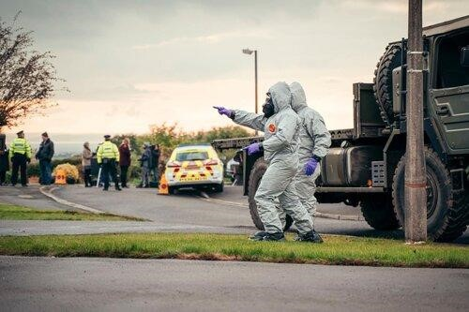
Figure 5.2: Still from The Salisbury Poisonings (2020), an artwork which brought considerable amounts of information about this event
both to a board public, and also policymakers in government departments working on the policy issue (Civil Servant A interview, 2020)
(image credit: BBC/Dancing Ledge/James Pardon)
From TV dramatisations to reportage photography, from data art to portraits of rulers, the arts can increase understanding of policy-relevant issues in both a wider public and a narrower group of policymakers. Cynthia Freeland explains that “artworks stimulate cognitive activity that might teach us about the world [...] we learn from artworks: we acquire fresh knowledge, our beliefs are refined, and our understanding is deepened” (quoted in Belfiore and Bennett 2008:121). There is a long and contentious history of the notion that art can provide some form of truth about the world, from Plato’s concern in Republic that “an image-maker, a representer, understands only appearance, while reality is beyond him"" to Baudelaire (“Truth and song have nothing to do with one another; this is because an artist depends on no one other than himself”) to John Hospers who saw truths as “belonging to other fields” than the arts (Ibid:42-47). What seems unquestionable in these critiques is an acceptance that people do receive information through art forms. Matarasso (2013:9) suggests that for millions of people questions relating to climate change “exist imaginatively through works such as Cormack McCarthy’s The Road, Roland Emmerich’s film, The Day After Tomorrow or perhaps even Planet of the Apes”. Khan (interview, 2020) believes that “one of the things that arts and culture can do is not necessarily change what facts or what information that people have about climate change, but can change the weighting they give to those facts relative to other issues politically”. Here we see the cognitive impact of art as providing a fundamental role in policymaking given "bounded rationality".
5.3 EMOTIONAL IMPACT
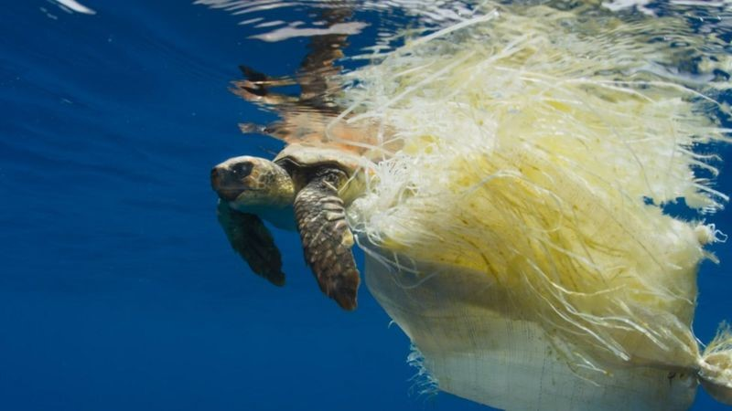
5.4 Blue Planet II (2017), which both quantitative evidence (Waitrose 2020:4) and qualitative evidence (Civil Servant C interview, 2020)
suggests were influential in the UK’s plastics policy, especially 2019 legislation to ban, in England, the supply of plastic straws, stirrers
and cotton buds (image credit: BBC)
From Medea to The Scream to Blue Planet II, artworks have long been cited as enacting strong emotional forces upon those who engage with them. Plato was so worried about the emotional impact of poetry and drama on "non-philosophers'' that, in Republic, he envisioned using such art only for the good of the state (Belfiore and Bennett 2008:54); Aristotle similarly thought that the arts evoked emotions, but saw this as a positive force (Ibid:79). Robinson (2004:187) proposes that a good artwork “invites and encourages us to reflect upon the emotions of the characters and our own emotional experiences of them”. Fafard (2020:209) argues that policymaking requires a “normative if not an emotional engagement with the issues at hand”. It follows that “to the extent that an art exhibit, a piece of music, a novel, or a play elicits an emotional reaction from those who engage with it, this same reaction creates the possibility of galvanizing individual and/or mass opinion”. The Centre for Art Activism (2018:7) suggests that “people don't just soberly decide to change their mind and act accordingly, they are moved to do so by emotionally powerful stimuli”. The policymakers interviewed for this project agree, with one specifically citing powerful scenes from the BBC documentary Blue Planet II as influential in changing public policy on plastics in the UK (Civil Servant C interview, 2020). There are clear linkages between the cognitive and emotional effects of art.
Daniello argued in the sixteenth century that poets were more effective teachers than philosophers "because of their power to delight" (Belfiore and Bennett 2008:113), and this finding reverberates from Plato to twentieth century experiences of propaganda.
5.4 IDEAS AND ALTERNATIVES TO THE STATUS QUO
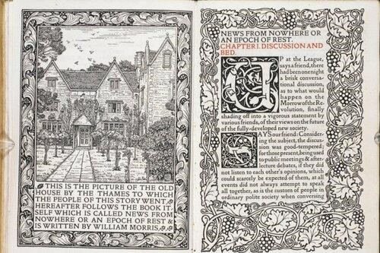
5.5 A manuscript of William Morris’ proto-science fiction novel from 1890 News from Nowhere (image credit: British Library)
In News from Nowhere (1890) William Morris wrote of an imaginary, "utopian" London, 100 years in the future, where salmon swam in the River Thames, money was redundant and women were still subservient to men. Wright (2011:37) argues that the ideals embodied in such "utopian" visions "might still figure in the real-world institutions and social transformations'' and that in the right circumstances such visions can become "powerful collective ideas in political movements''. Fafard (2020:206) describes the importance of ideas in policymaking, suggesting that politics informs policymaking partly in "the power of a small number of simple ideas to galvanize and animate the policy-making process". Katherine Smith (2013:110) argues that policy-relevant ideas can be catagorised as "institutionalised", "critical", "charismatic" and "chameleonic". Art can play a role here, not just as a source of ideas, but as a compelling, cognitively stimulating, emotionally resonant and multisensory source of ideas - wherever those ideas feature in Smith’s typology.
5.5 DIALOGICAL SPACE
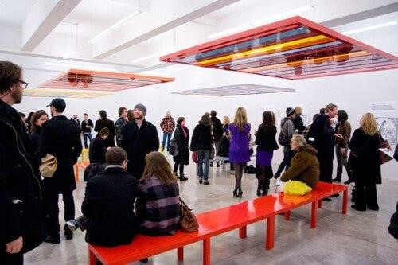
Figure 5.6: Nicholas Bourriaud saw the work of Liam Gillick, such as Discussion Bench Platform (2010), as part of the "relational
aesthetics" movements where artists adopt the role of facilitators as much as makers (image credit: Art Observed 2010)
Many artworks provide a framing for dialogue and discussion, but it is particularly integral to some traditions. Barnett (interview, 2020) describes her practice as “dialogical and open ended - it’s an invitation to communicate”. Artworks in the "relational aesthetics" movement described by Bourriaud (2000), tend to create space and time for people to engage and interact (see Figure 5.6). In their analysis of the trends underpinning the "post-expert age", Luers and Kroodsma (2014:203) state that the biggest challenge of the digital age for communicating science is “the shift from the ‘broadcast’ model, where a network or magazine broadcasts information, to a ‘conversation’ model, whereby someone generates information and others comment, share, and add to it”. This is a microcosm of a broader trend in society, commerce and politics, whereby "old power" models of broadcasting, deference, compliance and consumption are being replaced by "new power" behaviours such as shaping, producing, adapting and a liating (Heimans and Timms 2018:62-63). There is a possible role for artistic interventions in creating space and time for dialogical stages of policy development like "policy formulation" and "consultation", stages too often perceived as dry, linear, antagonistic, inaccessible and uninspiring.

5.6 AGENCY
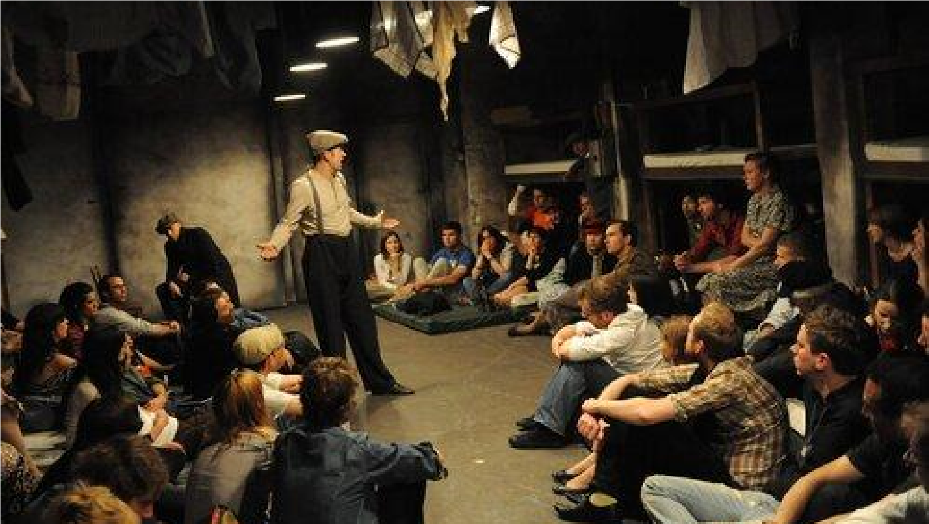
Figure 5.7:the work of Cardboard Citizens, made in the tradition of Theatre of the Oppressed, and aiming to "activate change" (image
credit: With One Voice)
Robinson (2004:186) notes that a major difference in the audience’s emotional response to an artwork compared to real life is the absence of "appropriate action": “despite my compassion for Anna Karenina, I cannot act to promote her welfare”. If a viewer cannot act to help a fictional character, can artwork activate people to take relevant action in the real world? Robinson argues that novels offer "not just sentimental education but experiential education” (Ibid:188). Matarrasso (2013:9) writes: “People act also as a result of their conscious and unconscious feelings, beliefs, and values, their past experiences and not least their physical being”. Alongside Dewey's "experiential learning" is the educational theory of "constructivism" first developed by Piaget which proposes that "knowledge and meaning are generated through an interaction between experiences and ideas constructed in the mind" (Chatterjee et al 2015:3). The implication is that individuals can take experiences from fictional scenarios and translate them into real world change. Related to this are artforms like immersive theatre, participatory arts, interactive TV, video games etc where audience members can actually step in to help fictional characters, an artistic device with antecedents in Baol, Brecht and Benjamin. Is there then a translation from being an agent in creative production of an artwork to being an agent in policymaking? Brecht devised "defamiliarising" theatrical techniques to "create a critical distance for the audience so that they might reflect and act on their own" (Centre for Art Activism 2018:19-20). Cardboard Citizens’ participatory theatre is made with and for homeless people in the tradition of the Theatre of the Oppressed and aims to "activate change". Stern and Seifert (2009:17) argue that "the arts can be seen as provocateur, challenging people as a means of provoking discussion, or animateur, motivating people to collective action".

6. CONSIDERING CASE STUDIES IN AN ART-POLICY MATRIX
The last Section described six effects of the arts on policy, whilst the Section before described policymaking as proceeding through various stages of a "policy cycle". This Section sets these two typologies against each other to arrive at a 6 x 6 matrix which explores the roles that art can play at various points across the policy process. Twenty-one case study artworks, all which somehow link to policy, are then situated in the matrix which provides grist for analysis in Section 7.

13
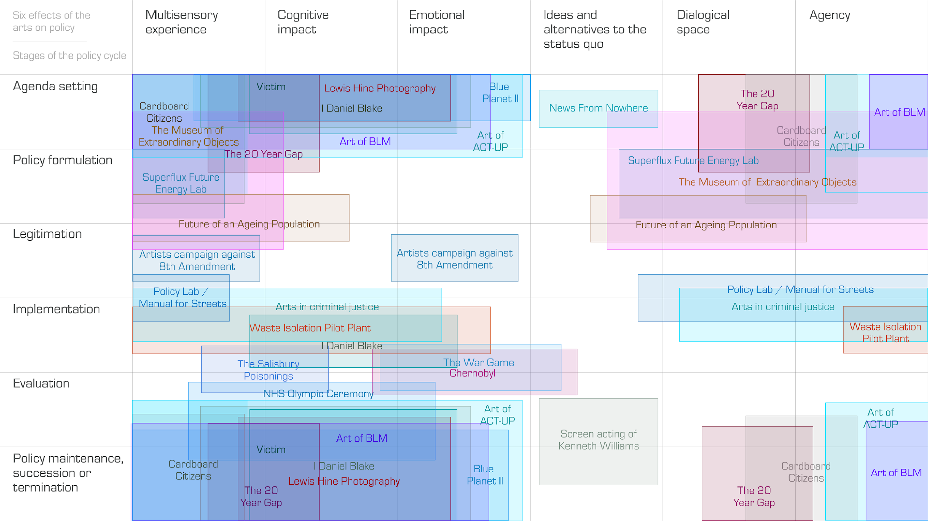

Figure 6.1: twenty-one case studies artworks where there is some kind of link with policy (or the intention of so). Further detail provided in Box 6.1 (image credit: the author)
14
Box: 6.1: Description of case studies by location on the chart (some artworks have multiple effects in different parts of the matrix; they are only listed once)
Case studies toward the upper and lower left generally provide a multisensory experience of a policy issue, having a cognitive and/or emotional impact, aiming to get a policy issue on the public policy agenda - with the implication being that the existing policy is failing. The examples include:
- Lewis Hine’s photography of child labour, cited as helping bring about labour laws in the US, most prominently the 1937 Fair Labor Standards (The Guardian 2018);
- I Daniel Blake, Ken Loach’s 2016 film about the eponymous craftsman struggling to navigate England’s benefit and welfare system in a time of austerity;
- The 20 Year Gap by SRG Bennett and Cath Sleeman, an immersive data installation showing the 20 year gap in disability-free life expectancy across the UK (see FIgure 2.1);
- Blue Planet II, described in Section 5.3;
- Artwork relating to ACT-UP, the AIDS Coalition to Unleash Power, helped raise the importance of addressing AIDS in US public policy (Aizenman 2019, Hoffman et al 2020);
- The 1961 film Victim about the suicide of a man being blackmailed because of an affair he had with another man. The film has been widely cited, including by politicians at the time, as creating a climate of public opinion in the UK receptive to the decriminlisation of "homosexual relations", with the law changed in 1967 (Earl of Arran 1968);
- Black Lives Matter is a vast movement, and art relating to it naturally varies in its aesthetic, form and intention. However, much of it appears to evaluate current policy as inappropriate and sets the agenda for a new set of actively anti-rascist policies.
There are a collection of artworks which aim to create a dialogical space around policy issues, found at the top right of the image, and including:
- Speculative design imagery produced by Strange Telemetry to enable GO-Science to consider the future of ageing population with policymakers and the public (Voss et al 2015);
- Superflux’s Future Energy Lab which synthesised air pollution vapour from a 2050 energy scenario to help the UAE energy ministry develop policy (Superflux 2017);
- Central Saint Martins’ Museum of Extraordinary Objects to support the Royal Society in its co-creation of a policy for a positive future research culture (Bennett et al 2017); ● Cardboard Citizens, as described in Section 5.6.
In the middle of the diagram are a collection of projects which focus on the more practical elements of policymaking around implementation; these include:
- The 1966 BBC documentary The War Game which addresses the fallout, in multiple senses, of nuclear war and is seen as a possible model for engaging the public on national security issues today (Civil Servant A interview, 2020);
- Arts in criminal justice, argued by the National Criminal Justice Arts Alliance as supporting the process of desistance from crime, improving safety and wellbeing in prisons and communities, and supporting the professional development of criminal justice practitioners (NCJAA 2018:3);
- The 2019 HBO/Sky drama Chernobyl which explores the causes of, and emergency responses to, the eponymous nuclear disaster;
- The Waste Isolation Pilot Plant, a US Department of Energy (DOE) commissioned project to warn future beings of the existence of nuclear waste buried below Texas, delivering a policy taken by the DOE in the 1970s to store nuclear waste in a way that would prove least harmful to humans deep into the future (Langione 2015);
- Policy Lab’s collaboration with the Department for Transport and Chartered Institute of Highways and Transportation to use multisensory artistic media to enquire into the uptake and use of the Manual for Streets street design guidance in England (Bennett 2020); ● The Salisbury Poisonings, described in Section 5.2.
There are four other artworks which sit slightly separate from these clusters:
- Artists’ Campaign to Repeal the Eighth Amendment, a collection of artworks/activities by artists in Ireland in support of the 2018 referendum on the Eighth Amendment (Saner 2018);
- William Morris’ 1890 novel News From Nowhere, described in Section 5.4;
- The performances of figures such as Kenneth Williams, a popular post-war British actor, cited by Matarasso (interview, 2020) as being influential in creating the conditions for a change in public attitudes towards the legalisation of homosexuality, which was later reflected in a change in the law (although Matarasso does not suggest a direct causal link);
- The NHS sequence in Danny Boyle’s opening ceremony for the 2012 Olympics, argued to be influential in making the case for policy "status quo" (e.g. Birrell (2012) writing in the Mail on Sunday that the opening ceremony will set back reform and privatisation by years).

7. FINDINGS

7.1 THE PROBLEMS OF CAUSALITY, INTENTION AND MAGIC
A theme from the interviews, case studies and literature is the complex non-linear relationship between intention and outcome when considering the link between art and policymaking. Matarasso (interview, 2020) argues that the search for causality or a controllable connection is fruitless because “outside of a totalitarian society, the great strength of art and culture is that it is not controllable. It is beyond anyone's attention”. Artists and artworks, as well as policymakers and policy, all operate in complex systems where the outcomes are di cult to predict and even harder to control. As a practical example, Civil Servant B (2020) describes how they were unclear whether Loach was using I Daniel Blake deliberately to pursue a policy agenda or it was adopted by politicians whose agenda it aligned with, and asks “what is the anti-poverty policy that happened as a result?”.
The Centre for Art Activism (2018:25) makes similar points about art aimed at social change, but cautions that “to acknowledge complexity, however, does not mean that we abandon the field and retreat into mysticism, repeating some mumbo jumbo about art’s magical powers that resist all such attempts”. Whilst some literature and interviews emphasise the di culty of finding causality, other statements and observations from the case study analysis suggest evidence can be found in some situations. It appears easier to evidence impact on more specific, practical examples such as arts in criminal justice, Policy Lab’s Manual for Streets, the future of ageing speculative design and the Museum of Extraordinary Objects (See Box 6.1 for more information on these case studies). These examples tend to be orientated towards the "how" of policymaking, including policy formulation, legitimation and especially implementation, rather than the "what" of policy-agenda setting. The outcomes are in many cases "intermediate" rather than "long-term"
- for example there is evidence that the Museum of Extraordinary Objects did lead to a development of better policy ideas, but it is tougher to evaluate if the artwork led to better research culture, or whether research culture was even worth focusing on at all.
In contrast, examples such as Black Lives Matter, ACT-UP, Lewis Hine, News from Nowhere and Blue Planet II (see Box 6.1) have a bigger audience and potential impact, but are harder to evidence (though possible). These case studies tend to be towards the "what" of policymaking, including agenda setting, evaluation, policy maintenance/ succession/ termination, where there is a larger window for impact than after this phase has been settled. Based on the case studies considered, one can suggest that there is a possible inverse relationship between magnitude of impact and ease of tracing impact with stages of the policy cycle mapped out along the slope as shown in Figure 7.1.
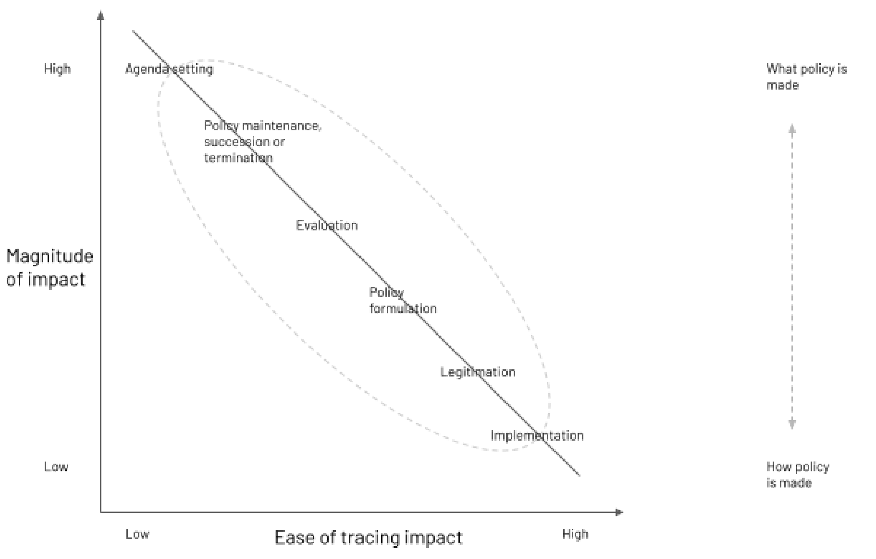
Figure 7.1: a hypothesised inverse relationship between the magnitude of impact of art on policymaking and the ease of tracing
that impact - overlaid with stages of the policy cycle (image credit: the author)
Timing is important. According to Civil Servant B an artwork “would need to land at a moment where policy is labile” in other words “there are moments when [policy] is more open or not”. Lability is a term used in chemistry to describe compounds in which atoms are loosely bound together, and so more easily removed or exchanged. Speculatively, "policy lability" can be mapped onto Cairney’s policy cycle as per Figure 7.2, thereby replicating the pattern between magnitude of impact and ease of tracing impact.
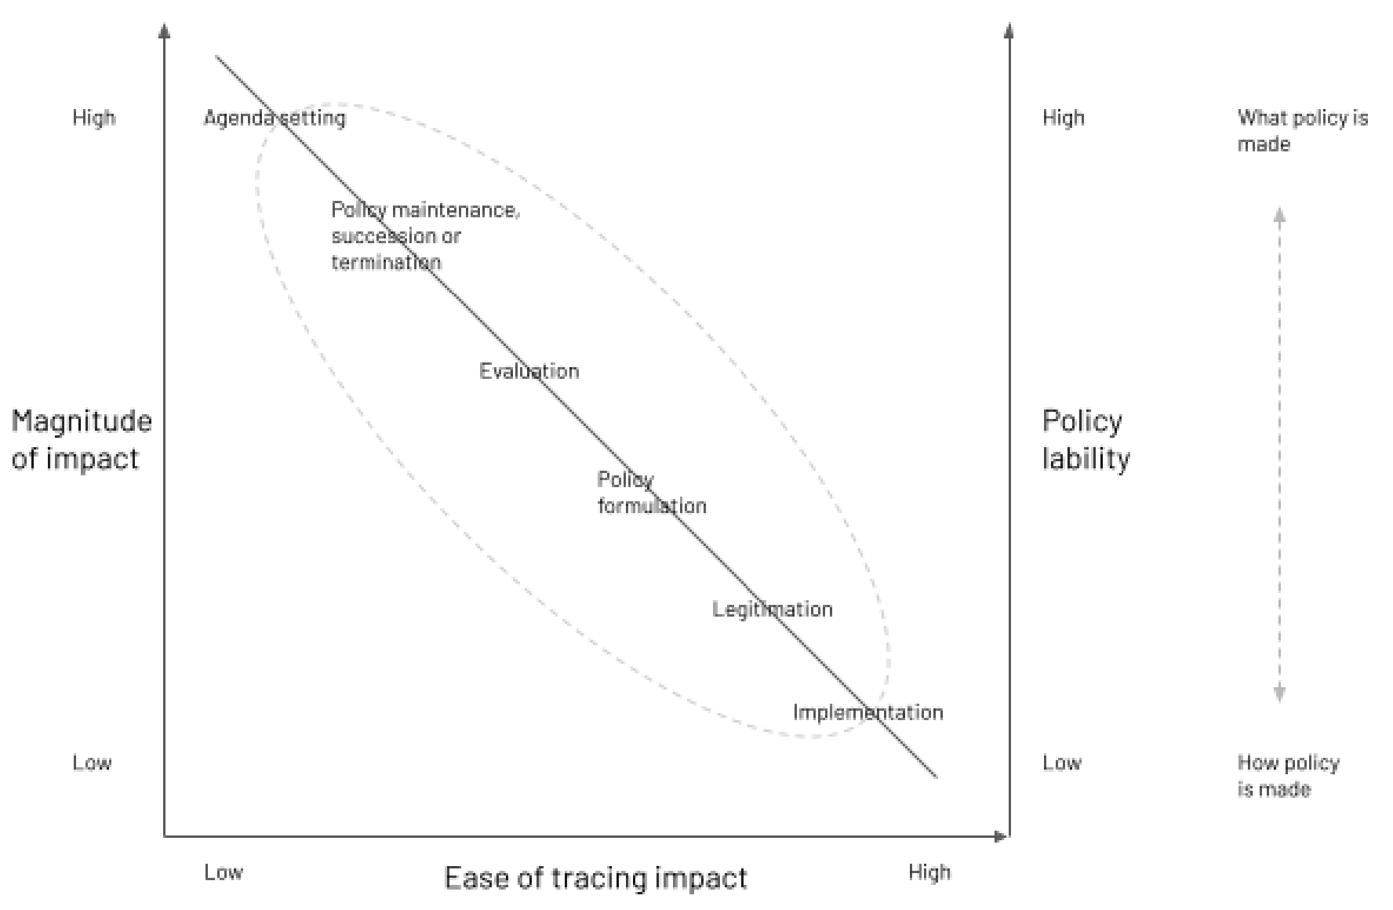

Figure 7.2: the magnitude/ease of tracing impact relationship with "policy lability" (image credit: the author)
The correlations suggested are hypothetical but supported by the analysis of the case studies; they offer a partial answer for why "proving" the impact of art on policy is and is likely to remain challenging.

7.2 TRANSFERENCE AND ACTIVATION ENERGY
Barnett (interview, 2020) picks up the question of causality and develops it with reference to the concept of transference, "those convergence points of where an idea in one realm gets picked up in another in a different way, or one kind of knowledge generation within one realm enables a different interpretation or different direction, in another"". She cites several examples of transference between artistic, technological, societal and political domains, including the microscope, representation and cell theory; gender fluidity and Ursula La Guin’s The Left Hand of Darkness; and the promise and concern relating to AI in today’s world. This is a powerful way of thinking about artworks such as William Morris’ News From Nowhere and Lewis Hine’s photography: it jolts us away from tracing causality across days and weeks, and towards thinking about paradigm shifts in society over decades.
Khan (interview, 2020) also deploys a chemistry term, “activation energy”, to think about how art may have an impact in a longer time frame. Activation energy is the energy level that two chemicals require to react with each other (e.g. para n and oxygen will react at high temperatures, but not if they are both cold). As an example, he notes that much artistic output that goes alongside the Black Lives Matter movement may or may not have specific short term policy objectives now, which may or may not be achieved, but will "lower the activation energy required" for many other, currently unknown, policies in years to come, meaning they are more likely to succeed. Looking back in recent history, Civil Servant D (interview, 2020) identifies such a possible relationship between the cumulative work of artists such as Dirk Bogarde, Keith Vaughan and Derek Jarman and half a century’s equalities policy - from the 1967 decriminalisation of "homosexual relations", to the 2003 overturn of Section 28, to the 2010 Equality Act which enshrined certain protected characteristics.
The concepts of transference and activation energy help us understand the entwined, non-linear and profound interaction between art, science and policy over an epochal period in a way which is more nuanced than a more scientifically familiar causal evaluation.

7.3 THE SIX WAYS ART CAN PLAY A ROLE IN POLICYMAKING
The Centre for Arts Activism (2018:56) takes a different approach to the usual evaluation toolkit approach for tracing the impact of art on social change, which they describe as both relatively abundant in the field, and generally ignored. Their "query-based approach" is deceptively simple, and involves asking artistic activist themselves a set of questions:
1) What do you want your piece to do? 2) How will you know if it has worked?
And then, after the intervention has been done and assessed, 3) What do you want to do next?
Matarasso describes a similarly streamlined recent framework for considering the link between health and the arts (2020, interview). Instead of wading through complex questions of causality, he advocated a simpler approach which was to show how relevant art practice fit with the existing Five Ways to Wellbeing developed by the New Economics Foundation (2008:5) for Foresight based upon a comprehensive evidence base (see Figure 7.3) .
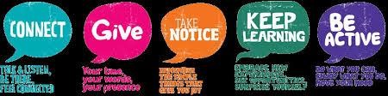
Figure 7.3: one of the many remixes of the Five Ways to Wellebing originally produced by Foresight / New Economics Foundation.
(image credit: Mental Health Foundation of New Zealand)
Inspired by both these approaches, Figure 7.4 shows the six ways art can play a role in policy.
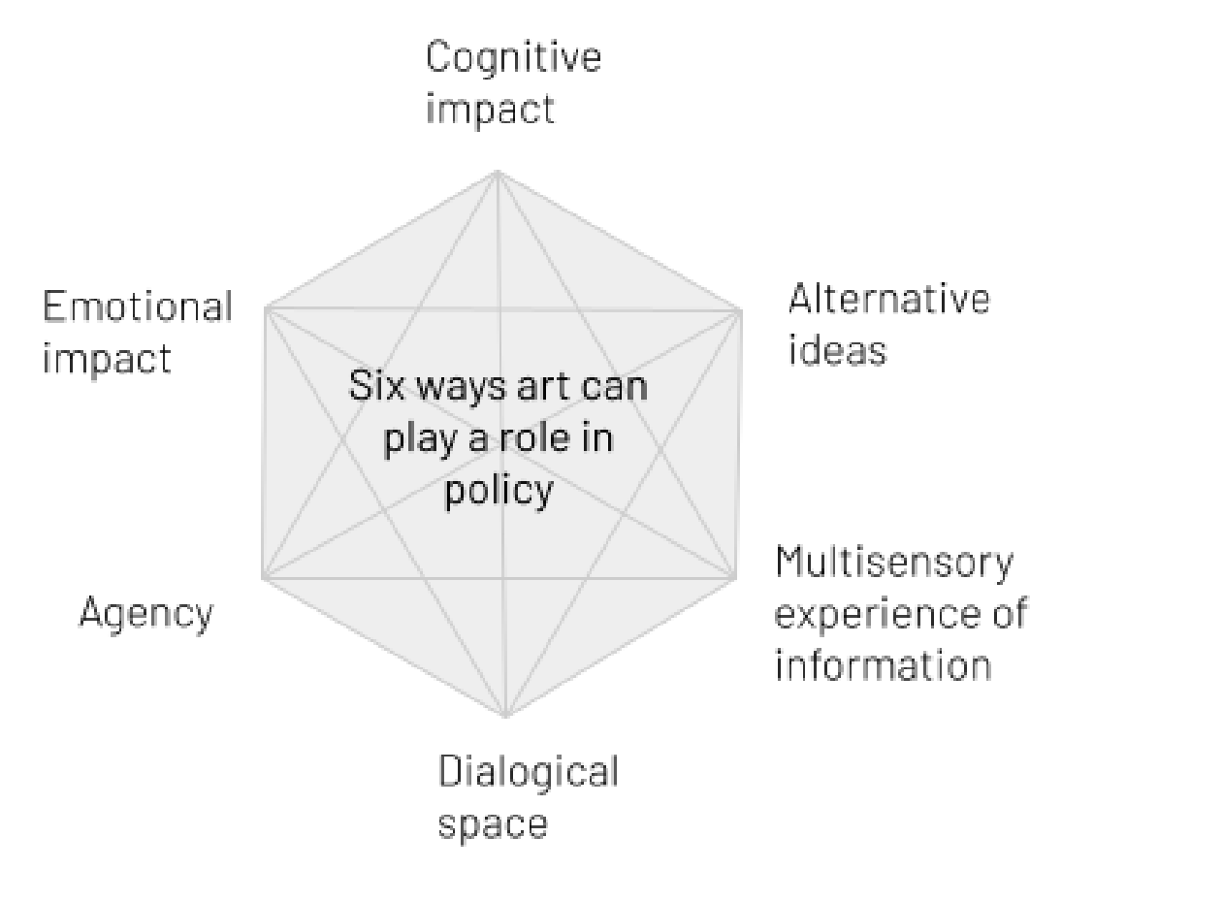

FIgure 7.4: Six ways art can play a role in policy (image credit: the author)
The schematic illustrates that if art presents policy information in a multisensory way, has a cognitive and/or emotional impact with that policy information, creates dialogical space for discussing policy issues, creates agency or provides a stimulus for policy relevant alternatives to the status quo - then it meets the conditions of having policy impact. This can be a useful guide for artists, funders, commissioners and policymakers alike. However, it is unfeasible to expect this policy impact to occur in a linear, demonstrable, time bound manner, and this is shown in Figure 7.5. In some cases the impact may occur over years or decades, as the “activation energy” is lowered by an artistic intervention, potentially acting in concert with others - or a broader process of transference between cultural, political, technological and other domains. Impact is likely to be easier to trace when the artwork is orientated towards the "how" of policymaking, including practical phases like policy formulation, legitimation and implementation, though the window for influence is also likely to be smaller at this stage as policy is less “labile”.
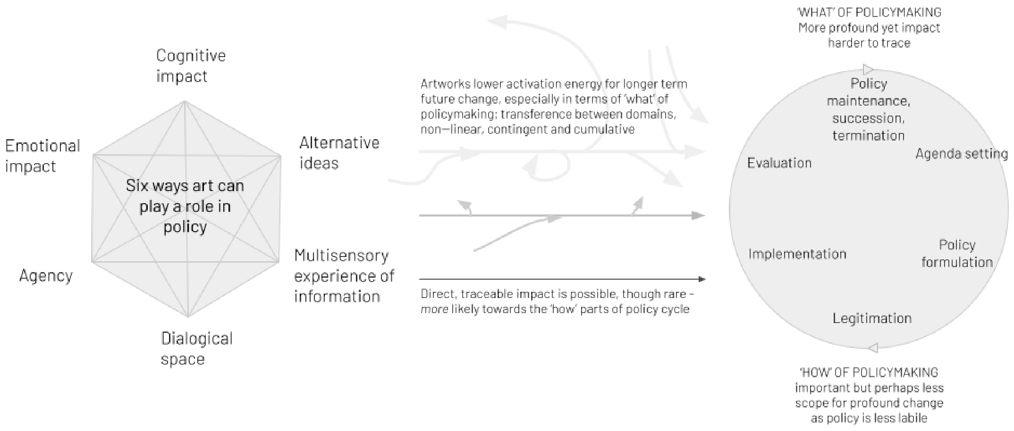
FIgure 7.5: Six ways art can play a role in policy
with considerations relating to timing and impact
(
image credit: the author
)
8. WHERE NEXT FOR THIS RESEARCH?
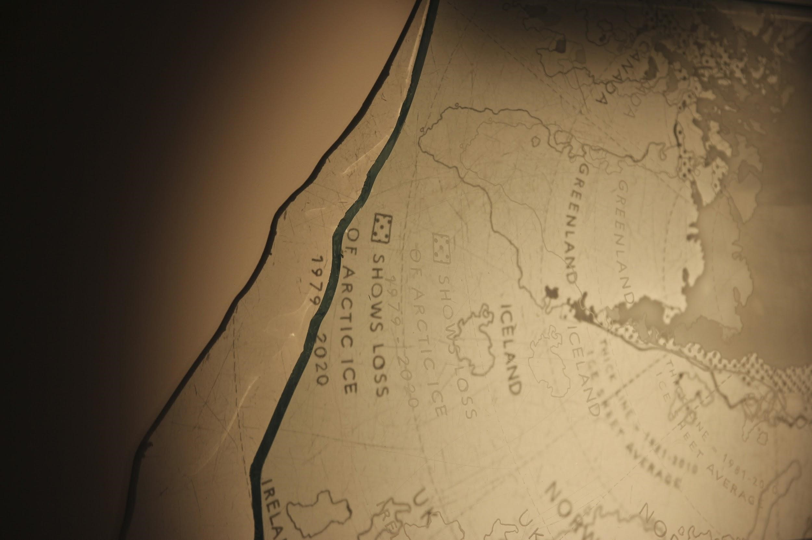
Figure 8.1: An artwork developed by the author in response to the research from the first half of the project; to be considered with people involved in art and policy in June, lockdown restrictions notwithstanding (image credit: the author)
There are three complementary future directions for this research: 1) fully integrating the experience of artwork into this research; 2) moving beyond the policy cycle to consider other theories of policymaking; 3) a deeper qualitative analysis relating to the case studies cited in this report alongside a broader literature review to bring more theoretical concepts to bear on the analysis.

8.1.INTEGRATING THE EXPERIENCE OF ARTWORK INTO THIS RESEARCH
Crossick and Kaszynska (2016:21) describe how they foregrounded the experience of the arts in their report on cultural value because “value begins there, with something fundamental and irreducible, and all the other components in the framework might be seen, to a greater or lesser extent, to cascade from it”. This project originally included practice-based research alongside the interviews, case study analysis and literature review, to investigate how people experience artworks and what that means for the impact on policy. This phase included the creation of artworks by the author in light of the analysis and findings of this report, and this work has largely taken place (see Figure 8.1). However, COVID-19 lockdowns have disrupted the exhibition and experience of these artworks, including by policymakers, and planned interviews of participants to provide further insight for the research. The exhibition is now planned for June 2021, subject to the Government’s plan for lockdown easing.

8.2. CONSIDERING OTHER THEORIES OF POLICYMAKING
The second direction recognises limitations of the policy cycle model and would juxtapose the policy-relevant effects of artwork with other theories of policymaking. For example, an alternative conceptual frame to use for understanding policy could be that of "policy images''. Cairney (2020:149) explains how policy issues are multifaceted and can command different policy images which can be highly influential in how policies are framed. In this model, rather than as a cycle, policymaking is considered as competition between different sets of interpretative frames. According to True et al. (2007:161) policy images are “a mixture of empirical information and emotive appeals”. Figure 8.2 attempts to demonstrate some of the spectrum of competing images of nuclear power, a case cited by True et al which leads the authors to consider that “when there is disagreement over the proper way to describe or understand a policy, proponents may focus on one set of images while their opponents refer to a different set of images” (Ibid:162). Allocation of government/state resources is likely to follow a dominant policy image. A successful challenge to a hegemonic policy image is likely to result in a shift of government attention, a change in policy, and a reallocation of resources. A productive research question might be: how do the arts relate to policy images?
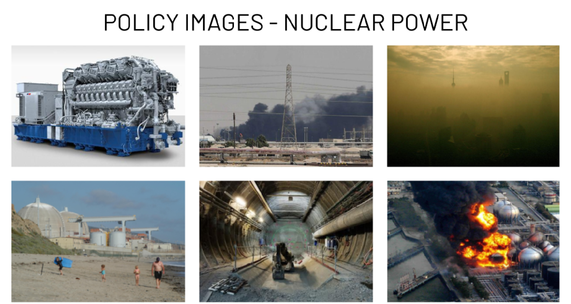
FIgure 8.2: "policy images" relating to nuclear power; clockwise from top left: nuclear power as emblematic of scientific
progress; nuclear power as reducing oil dependency; nuclear power as cleaner than air polluting fuels; a nuclear disaster;
problems with storing nuclear waste; the impact of nuclear infrastructure on the local environment (image credit: the author)
An alternative would be to turn to the "multiple streams analysis" which provides a framework for how some of the elements in the policy cycle may interact, but in a more fluid and contingent way. Instead of there being a rigid cycle, Cairney (2020:12) describes how there are three "streams" which need to come together at the same time for a policy solution to be adopted, including “[1] a problem is high on the agenda and "framed" in a particular way, [2] a technically and politically feasible solution already exists, and [3] policymakers have the motive and opportunity to adopt that solution and translate it into policy”. The arts may relate to those streams in different ways and it would be productive to map those streams against the effects of art and situate case studies accordingly.
Yet a different approach is offered by the Social Construction of Target Populations (SCTP) theory of policymaking which echoes notions related to "bounded rationality" especially that people have a "fast thinking" element to policymaking underpinned by quick, biased and emotional judgments which are then integrated with selective facts and rationale in slower time
(Cairney 2016). Policymakers - Cairney specifically describes elected public o cials - use this "fast thinking" to make fundamental choices about which social groups should be treated differently by different government bodies, especially support (for "good" groups) and sanctions (for "bad" groups). Cairney (interview, 2020) emphasises the importance of "representations" of population groups in the SCTP theory - either literal visual representations, or representations in a way that people can easily visualise. Case studies such as Cardboard Citizens, I Daniel Blake, and the screen activity of Kenneth Williams, would be interesting to analyse through this lens.
8.3. DEEPER QUALITATIVE ANALYSIS
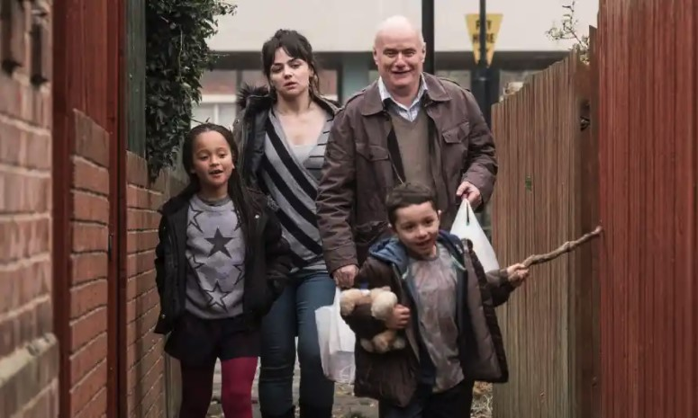

Figure 8.3: Still from I Daniel Blake, Ken Loach (2016) (image Credit: Entertainment One UK / Guardian)
There is further publicly available information for most of the case studies cited in Figure 6.1, bountiful in some cases. The final direction for further research would be to conduct more and deeper interviews with protagonists involved in the artworks and their possible policy impact, and to contextualise this with a broader literature review. As an example, Yvonne Roberts (2016) interviewed the artist Gavin Turk, the social campaigner Jack Monroe, the director general of the Institute of Economic Affairs Mark Littlewood and the chief executive of the Child Poverty Action Group Alison Garnham in relation to I Daniel Blake. An insightful addition to this would be to interview senior or junior Civil Servants working in the Department for Work and Pensions or HM Treasury (probably the two most relevant Departments) over the period, ministers, special advisors or even other parliamentarians not part of the Government. For case studies like I Daniel Blake, Blue Planet II, Danny Boyle’s NHS sequence, the Museum of Extraordinary Objects, Foresight’s The Ageing Population, The Salisbury Poisonings and Manual for Streets, such policymakers are still identifiable, and the information they could provide would take forward our collective understanding of the possible role of art in policy.
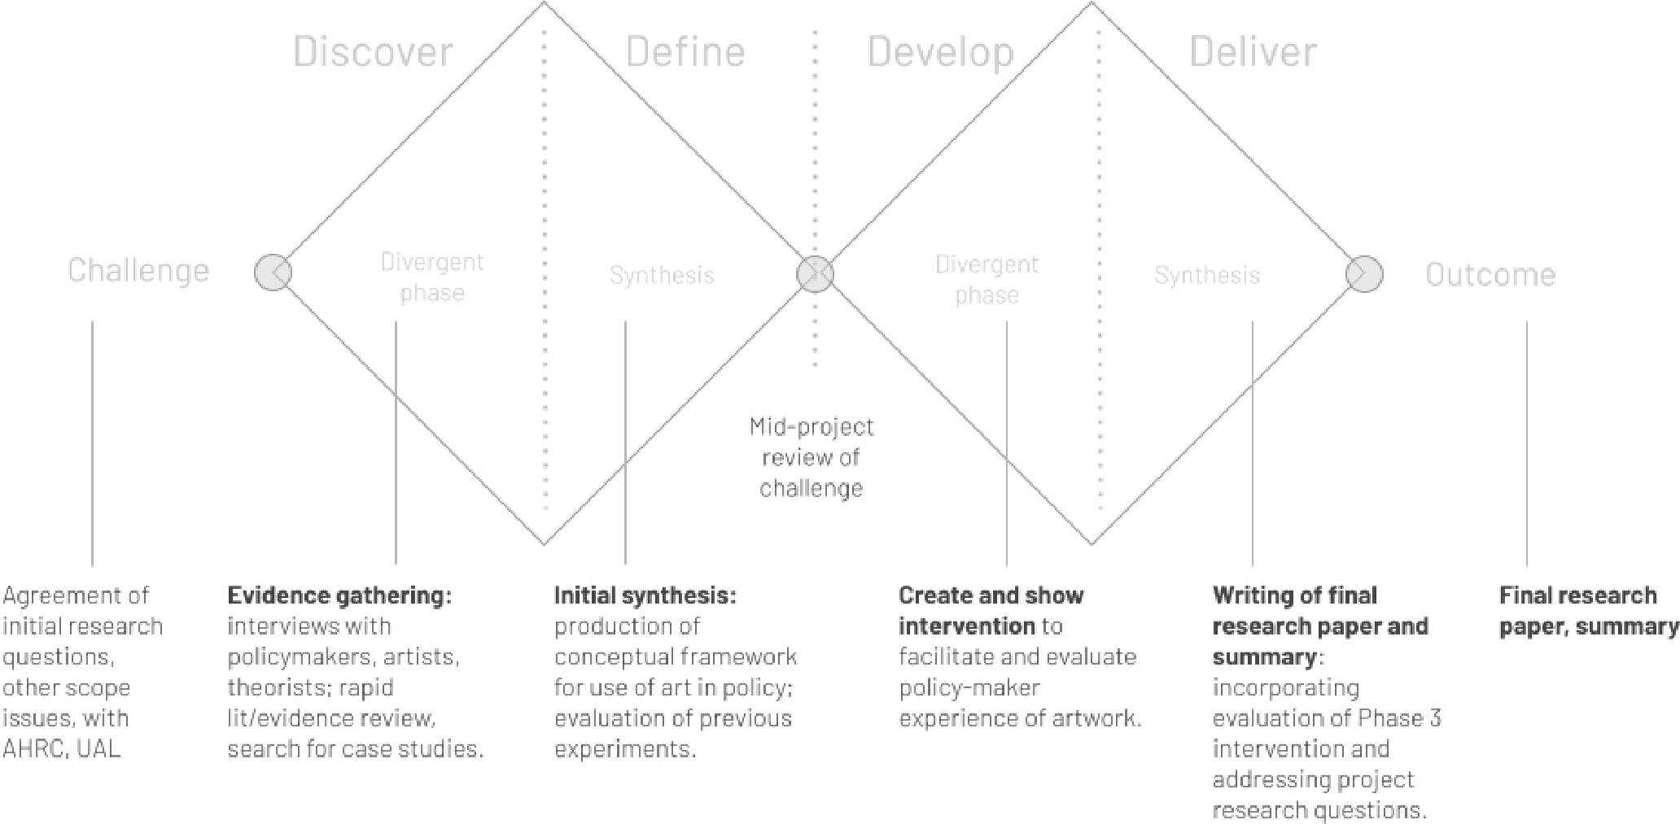
9.
METHODOLOGY

Figure 9.1: the double diamond approach taken in this research project (image credit: the author)
The project’s research methodology has been based on the Design Council’s “Double Diamond”, emphasising alternating phases of divergence and synthesis to address questions in an iterative and non-linear way (see Figure 9.1). The planned methodology comprised four distinct phases:
- Discover: the first diamond starts with traditional research methods, including a literature review, case studies and interviews, employed so as to access and appraise a broad range of evidence on the use of art in policy;
- Define: that information is then synthesised into a framework for how art and culture can play a role in policy, including references to the policy theories where appropriate;
- Develop: the second diamond incorporates practice-based research, where findings from the conceptual framework are materialised in a real-world prototype by the author for example an artwork, an exhibition or an intervention - and people (including policymakers) invited to experience this prototype and provide feedback. This practice-based component was intended to incorporate learnings from the AHRC Cultural Value Project (Crossick and Kaszynska 2016:21) regarding the centrality of experience when considering the value of art and culture.
- Deliver: learnings and responses to the intervention are combined with insights in earlier phases, and the final research findings are produced.
The project commenced in August 2020 with a completion date of March 2021. The first "Discovery" phase and second "Define" stages proceeded as intended. A range of literature was considered, spanning policy theory, art philosophy, art history, contemporary and historical case studies and practical policy guidance. Eight interviews were conducted, comprising four anonymised Civil Servants with experience working on science, resilience, oceans and cultural policy, and four individuals with interesting non-governmental perspectives on art, science and policy (the art writer François Matarasso, the policy academic Paul Cairney, the artist Heather Barnett and the ex-Head of Engagement at the Wellcome Trust, Imran Khan). Examples of artworks for case studies were identified; the case studies were written up in an extended form and then condensed for the purposes of the present report. This information has then been synthesised into a conceptual framework which was critiqued at an event run by the University of Arts London’s Social Design Institute. Each phase has been underpinned by dissemination of interim findings via blogs on the webpage https://www.srgbennett.com/#/art-in-policy-ahrc/ and this has allowed the findings to be reviewed and discussed through social media channels and personal correspondence. The practice-based research of Phase III has proceeded satisfactorily in some respects, as the author has been exploring the findings from the first two phases in a series of physical artworks (see Figures 9.1 and 9.2). However, COVID lockdowns in London have made it impossible to display work and enable people to experience and provide feedback on these interventions. A revised exhibition date has been pencilled in for early June. Pending the situation regarding lockdowns, the plan is to invite a selection of people involved in art and policy (including the eight interviewees) to experience the artworks, and generate further feedback which can be used to interrogate and iterate the framework developed in this report.
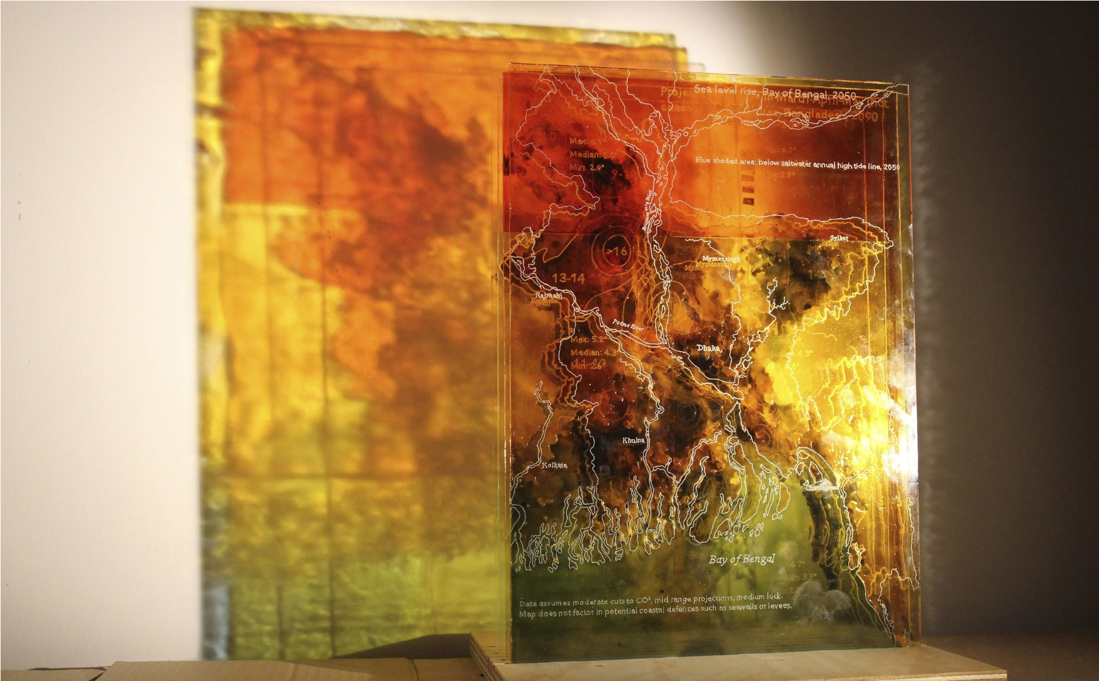
Figure 9.2: An artwork developed by the author in response to the research from the first half of the project; to be considered
with people involved in art and policy in June, lockdown restrictions notwithstanding (image credit: the author)

BIBLIOGRAPHY
Aizenman, N. (2019) “How To Demand A Medical Breakthrough: Lessons From The AIDS Fight” NPR, 9 February. Available at:
https://www.npr.org/sections/health-shots/2019/02/09/689924838/how-to-demand-a-medical -breakthrough-lessons-from-the-aids-fight?t=1613389700861 [accessed: 29 March 2021]
Belfiore, E. & Bennett, O. (2008) The Social Impact of the Arts: An Intellectual History. London: Palgrave Macmillan.
Bennett, S. (2018) A Role for Art in Policymaking? Available at:
https://openpolicy.blog.gov.uk/2018/10/10/a-role-for-art-in-policy-making/ [accessed: 29 March 2021]
Bennett, S. (2020) Seeing it, feeling it, video-conferencing it: what policy can learn from participatory art and design in a time of social distancing. Available at: https://openpolicy.blog.gov.uk/2020/05/13/seeing-it-feeling-it-video-conferencing-it-what-poli cy-can-learn-from-participatory-art-and-design-social-distancing/ [accessed: 29 March 2021]
Bennett, S., Downey, F. and Light, J. (2017) “The Museum of Extraordinary Objects: How a
Museum from the future is shaping science policy today”, SciArt Magazine, Oct 2017. Available at: https://www.sciartmagazine.com/the-museum-of-extraordinary-objects.html [accessed: 29 March 2021]
Birrell, I. (2012) “The London 2012 opening ceremony, and a night that set NHS reform back years”, Mail on Sunday, 3 Aug. Available at:
https://www.dailymail.co.uk/debate/article-2183440/London-2012-opening-ceremony-The-nigh t-set-NHS-reform-years.html [accessed: 29 March 2021]
Black, C. (2016 ) Science / Fiction. Available at: http://carolblack.org/science-fiction/ [accessed:
29 March 2021]
Bourriaud, N. (2000) Relational Aesthetics. Translated by Pleasance, S. and Woods, F. D on: Les Presses du Réel.
Cairney, P. (2016) Policy Concepts in 1000 Words: the Social Construction of Target Populations.
Available at:
https://paulcairney.wordpress.com/2016/01/08/policy-concepts-in-1000-words-the-social-con struction-of-target-populations/ [accessed: 29 March 2021]
Cairney, P. (2020) Understanding Public Policy: Theories and Issue 2nd edn. London: Red Globe Press.
Cairney, P. and Kwiatkowski, R. (2017) “How to communicate effectively with policymakers: combine insights from psychology and policy studies”. Palgrave Communications 3, 37 (2017). https://doi.org/10.1057/s41599-017-0046-8 [accessed: 29 March 2021]
Center for Artistic Activism (2018) Assessing the Impact of Artistic Activism. Available at: https://c4aa.org/2018/02/report-assessing-the-impact-of-artistic-activism [accessed: 29 March 2021]
Chatterjee, H., Hannan, L. and Thomson, L. (2015) “An Introduction to Object-Based Learning and Multisensory Engagement” in Chatterjee, H. and Hannan, L. eds. (2015) Engaging the Senses: Object-based Learning in Higher Education. London: Routledge.
Crossick, G. & Kaszynska, P. (2016) Understanding the value of arts & culture: The AHRC Cultural Value Project. Swindon: Arts and Humanities Research Council. Available at:
https://ahrc.ukri.org/documents/publications/cultural-value-project-final-report/ [accessed:
29 March 2021]
Earl of Arran (1968) Letter to Dirk Bogarde, 5 June. Available at:
https://dirkbogarde.co.uk/icon/victim-discreet-reformer/ [accessed: 29 March 2021]
Fafard, P. (2020) “Can Art Influence Global Health Policy?” in Imaginations: Journal of
Cross-Cultural Image Studies, vol. 11, no. 2, Aug. 2020, pp. 193–216,
doi:10.17742/IMAGE.IN.11.2.11.Available at: http://imaginations.glendon.yorku.ca/?p=13324 [accessed: 29 March 2021]
Hallsworth, M., Parker, S. and Rutter, J. (2011) Policy Making in the Real World: Evidence and Analysis. Available at:
https://www.instituteforgovernment.org.uk/sites/default/files/publications/Policy%20making %20in%20the%20real%20world.pdf [accessed: 29 March 2021]
Heimans, J. and Timms, H. (2018) New Power: How Power Works in Our Hyperconnected World – and How to Make it Work for You. New York: Doubleday.
Hoffman, S. et al. “Learning from the Role of Art in Political Advocacy on HIV/AIDS.” Imaginations: Journal of Cross-Cultural Image Studies, vol. 11, no. 2, Aug. 2020, pp. 233–258, doi:10.17742/IMAGE.IN.11.2.13. Available at:
http://imaginations.glendon.yorku.ca/wp-content/uploads/13-hoffman.pdf [accessed: 29 March 2021]
HM Treasury (2020) The Green Book: Central Government Guidance on Appraisal and Evaluation.
Available at:
https://assets.publishing.service.gov.uk/government/uploads/system/uploads/attachment_dat a/file/938046/The_Green_Book_2020.pdf [accessed: 29 March 2021]
Kimbell, L. (2015) Applying Design Approaches to Policy Making: Discovering Policy Lab. Brighton:
University of Brighton. Available at: https://researchingdesignforpolicy.files.wordpress.com/2015/10/kimbell_policylab_report.pdf [accessed: 29 March 2021]
Langione, M. (2015) "Will Art Save Our Descendants from Radioactive Waste?" in JSTOR Daily May
13, 2015
https://daily.jstor.org/can-we-use-art-to-warn-future-humans-about-radioactive-waste/ [accessed: 29 March 2021]
Luers, A. and Kroodsma, D. (2014) "Science Communication in the Post-Expert Digital Age" Eos, Vol. 95 (No. 24, 17 June 2014), pp203-204. Available at: http://onlinelibrary.wiley.com/doi/10.1002/2014EO240003/epdf [accessed: 29 March 2021]
Matarasso, F. (2013) The Parliament of Dreams: Why everything depends on culture. Available at: https://parliamentofdreams.files.wordpress.com/2013/02/the-parliament-of-dreams-2013.pdf [accessed: 29 March 2021]
Morris, W. (1890) News from nowhere, or, An epoch of rest. Kelmscott: Kelmscott Press.
New Economics Foundation (2008) Five Ways to Wellbeing. Available at: https://neweconomics.org/2008/10/five-ways-to-wellbeing [accessed: 29 March 2021]
NCJAA (2018) Why Do Arts In Criminal Justice Matter? Available at: https://www.artsincriminaljustice.org.uk/wp-content/uploads/2018/11/NCJAA-Flyer_FINAL-1.p df [accessed: 29 March 2021]
Policy Lab (2021) Introduction to Policy Lab. Available at:
https://www2.slideshare.net/Openpolicymaking/introduction-to-policy-lab-jan-2021-241087221 [accessed: 29 March 2021]
Roberts, Y. et al (2016) “I, Daniel Blake: Ken Loach and the scandal of Britain’s benefits system”, The Guardian, 11 Sept. Available at: https://www.theguardian.com/film/2016/sep/11/i-daniel-blake-ken-loach-director-film-movie-b enefits-system [accessed: 29 March 2021]
Robinson, J. (2004) “The Emotions in Art” in Kivy, P. ed (2004) The Blackwell Guide to Aesthetics. Oxford: Blackwell.
Saner, E. (2018) “The hateful Eighth: artists at the frontline of Ireland’s abortion rights battle”, The Guardian, 12 Apr. Available at:
https://www.theguardian.com/artanddesign/2018/apr/12/the-hateful-eighth-artists-frontline-ir eland-abortion-rights-battle-eighth-amendment [accessed: 29 March 2021]
Smith, K. (2013) Beyond Evidence Based Policy in Public Health: The Interplay of Ideas. London: Palgrave Macmillan.
Stern, M., & Seifert, S. (2009). Civic Engagement and the Arts: Issues of Conceptualization and Measurement. Philadelphia: Arts and Civic Engagement Impact Initiative of Americans for the Arts/ Animating Democracy. Available at: https://animatingdemocracy.org/sites/default/files/CE_Arts_SternSeifert.pdf [accessed: 29 March 2021]
Superflux (2017) The Future Energy Lab. Available at: https://superflux.in/index.php/work/futureenergylab/# [accessed: 29 March 2021]
Syed, M. (2019) Rebel Ideas: The Power of Diverse Thinking. London: John Murray Press.
The Guardian (2018) “The photos that changed America: celebrating the work of Lewis Hine”, The Guardian, 15 March. Available at:
https://www.theguardian.com/artanddesign/gallery/2018/feb/15/lewis-hine-photographs-childlabor-ellis-island [accessed: 29 March 2021]
True, J., Jones, B. and Baumgartner, F. (2007) ”Punctuated-Equilibrium Theory: Explaining Stability and Change in Public Policymaking” in Sabatier, P. (ed.) Theories of the Policy Process. Boulder: Westview Press, pp. 155-188.
Voss, G. Revell, T. and Pickard, J. (2015) Speculative Design and the Future of an Ageing Population: Report 1: Outcomes. Available at:
https://assets.publishing.service.gov.uk/government/uploads/system/uploads/attachment_dat a/file/441883/speculative-design-workshop-outcomes.pdf [accessed: 29 March 2021]
Waitrose (2019) Food and Drink Report 2018-19. Available at:
https://www.waitrose.com/content/dam/waitrose/Inspiration/Waitrose%20&%20Partners%20 Food%20and%20Drink%20Report%202018.pdf [accessed: 29 March 2021]
Wright, E. “Real Utopias” Contexts, vol. 10, no. 2, 2011, pp. 36–42. JSTOR, www.jstor.org/stable/41960206 [accessed: 29 March 2021]

