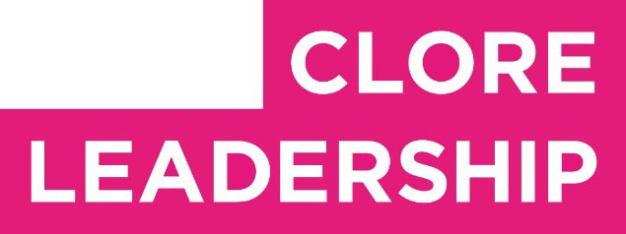

Clore Leadership-AHRC Online Research Library Paper

Where arts and nature meet are fertile ground for both

Author: Sarah Bird

Supervisor/s: Ian Convery, University of Cumbria
Year paper completed: 2020
Leadership Content Theme/s: Climate Leadership, Inclusive
Leadership Practice, Sector Insights
AHRC Subject Area/s: Policy Arts Management and Creative
Industries, Community Art (including Art and Health)
A note on contents:
Since 2005 Clore Leadership and AHRC have partnered to offer a diverse range of cultural leaders the opportunity to produce a piece of extended research relating to leadership and to their specific cultural discipline. These papers, published from 2023 onward on the Clore Leadership-AHRC online research library, reflect an important contribution to the field and we are extremely pleased to make them available to practitioners, scholars, and other interested parties. We recognise that this research library contains a range of terminologies and outlooks: these are reflective of the significant and ongoing changes within the cultural sector over the past 20 years. As such we urge readers to recognise that the authors’ thinking and language may have shifted since completion of these papers, or may be in the process of shifting as consequence of their enquiries.

Unless otherwise stated, research papers included in the Clore Leadership-AHRC Online Research Library have not been formally peer reviewed or published in an academic journal.

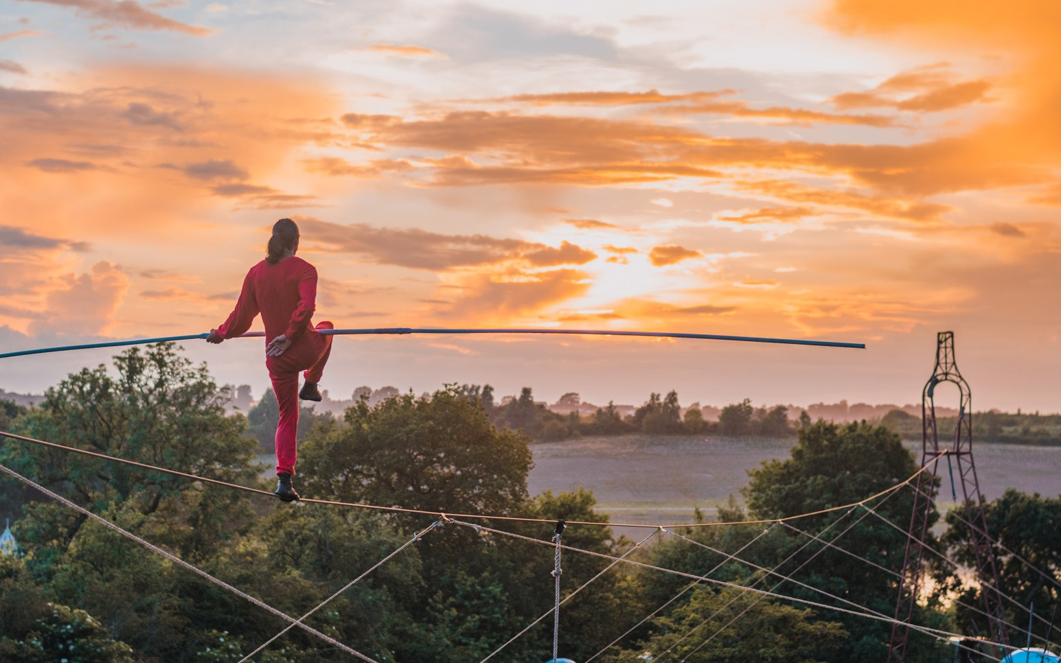
Sarah Bird

Where Arts and Nature meet are fertile ground for both

Introduction

This research project considers the relationship between arts and nature conservation organisations, investigating the current opportunities and different approaches to collaboration between the two and exploring different models for future work- ing. It explores the conditions required for the creative sector to inspire transformative change in the attitudes, behaviours and policies associated with society and nature.
It investigates how the arts sector can respond to the urgent need to act on biodiversity loss, addressing the bleak pic- ture as outlined in the 2019 State of Nature Report and the Bio- diversity Intactness Index which reports the UK to be one of the world’s most nature-depleted countries - in the bottom 10% glob- ally and last among the G7 group of nations, with an average of about half its biodiversity left, far below the global average of 75% (Royal Society for the Protection of Birds, 2019). A figure of 90% is considered the “safe limit” to prevent the world from tipping into an “ecological meltdown” (Natural History Museum, n.d.).
Given the severity of the biodiversity crisis, how can the arts contribute? The potential benefits from collaborations are significant; arts research and practices can reframe issues, reveal values and facilitate conversations that otherwise would not exist. Arts and conservation collaborations can create knowledge and understanding that goes beyond data collection and into
meaningful community and individual engagement (Saratsi et al., 2019).
As a wealth of research demonstrates, the arts profoundly influence the ways in which we connect to the world around
us, stimulate positive community actions, and inform effective decision making with regards to our environment (Charles et al., 2018, Richardson et al, 2018, Soga et al., 2016).
The project responds to my own experience working at the intersection of arts and nature, and the practice of delivering arts activities focused on creating a nature-connection for audiences, as well as supporting artists to create work that meets this objec- tive. Through my personal experience I recognise the benefits that place-based strategic interventions can make to this work - Timber Festival, for example, is a weekend camping festival held in the National Forest which celebrates the transformative impact of trees and forests on our lives through a wide variety of artis- tic forms. This event has its roots in and is a response to the still unfolding story of regeneration and landscape transformation of the National Forest.

1

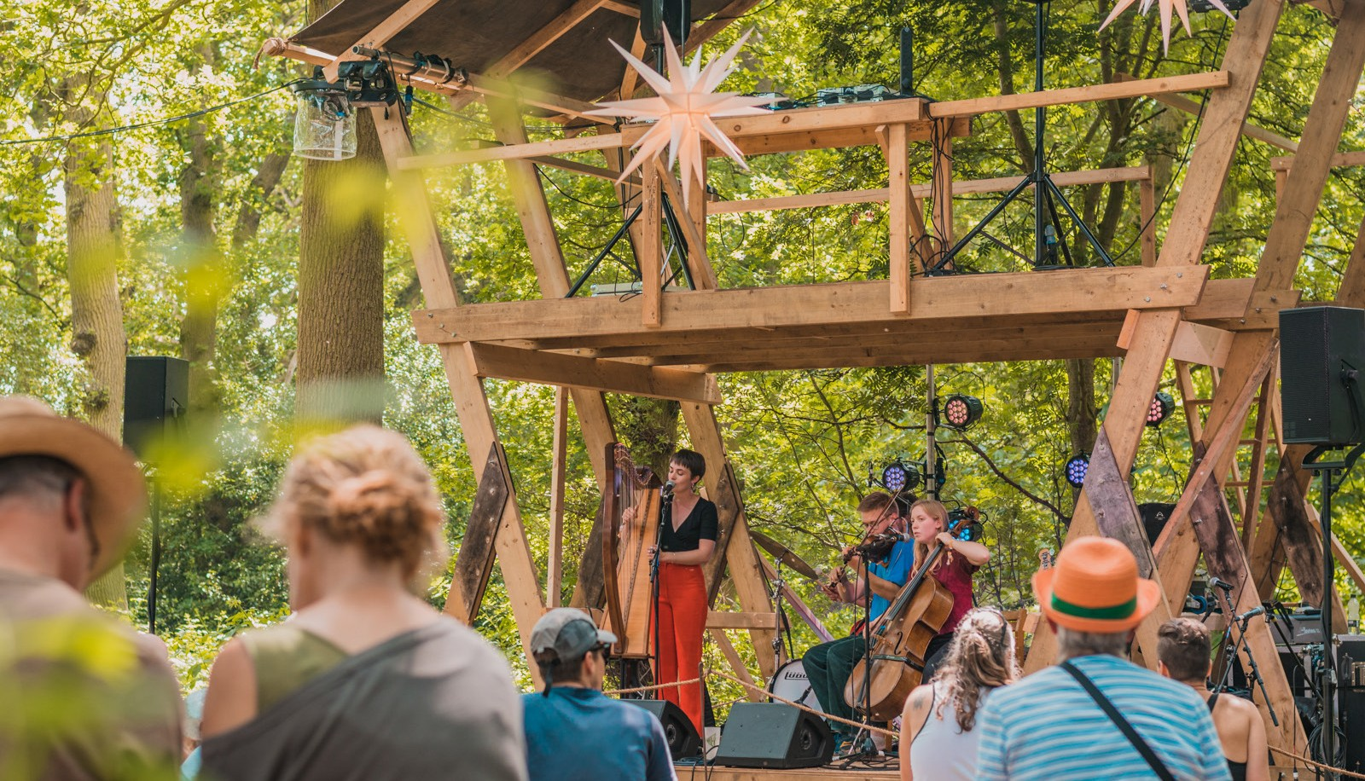

Above Timber Festival 2021. Photo by Wild Rumpus
Wild Rumpus (the organisation I co-direct) have also worked closely with a range of other conservation and natural heritage organisations on individual projects, from the National Trust and Wildlife Trust to Forestry England and Chester Zoo, but we have often felt that there is a need for more strategic, longer-term (i.e. longer than typical 2-3 year project funding) co-ordinated thinking and approaches that seek to connect and consolidate arts and cultural organisations with environment and nature organisations. We see the need for innovative part-
nership working and meaningful collaborations that co-develop knowledge and understanding in this vital space. A range of cross disciplinary approaches could develop solutions to respond to critical biodiversity problems.
In this report I investigate a range of current initiatives, awards, networks and projects to identify current good practice alongside barriers, challenges and opportunities. I will explore the need for more local place based partnerships, perhaps using the Local Cultural Education Partnerships (that bridge the gap between education and the arts) as a model, and in the process consider whether existing Local Nature Partnerships could be expanded to also include cultural organisations.
I recognise that the arts are an incredibly wide ranging area, spanning everything from architecture to fashion to poetry. Indeed, many individual disciplines have their own prizes that encourage a focus on nature and environment, from the Wild- life Photographer of the Year to the Laurel Prize for nature poetry and Coal Prize for contemporary artists. These individual awards

2

help elevate this work, shine a light on it and create momentum in terms of connecting large numbers of people to nature through direct engagement with creative work.
It is therefore important to state at the outset that whilst these areas overlap and intersect in a variety of ways, this report focuses more on the performing arts and outdoor arts – where Wild Rumpus predominantly locate ourselves. It will look at the various motivations, barriers and relationships that underpin and contribute to collaboration and cross sector working that helps people develop a stronger nature connection and imagine more sustainable futures.
There is cause for optimism in this area right now, one of the largest cultural investment programmes of recent years Fes- tival 2022/Unboxed, which developed ideas from a cross sector R&D process, has a number of projects with an active focus on nature connection; Green Space, Dark Skies, celebrating nature through light installations; Dandelion, a celebration of growing, music and community; Polinations a city-centre forest garden.
In the following sections I will look at the drivers com- pelling closer collaboration between arts and culture and nature conservation organisations, as well as the policy arena in which these organisations operate. I will then discuss the various impacts of policy and strategy on those working at the intersec- tion of arts and nature, based on semi-structured interviews with a range of artists and environmentalists.
Throughout the report I have included a number of case studies that highlight specific issues and/or challenges, whilst
also demonstrating arts activity nature connection ‘in action’. They include examples of European partnerships, projects that are the culmination of cross sector R&D processes, academic research inspired activities, projects instigated by arts organisa- tions as well as projects instigated by environmental conserva- tion organisations, multi year funded landscape programmes and grass roots artist led projects, they demonstrate the breadth of inspiring good practice already underway within our sector and the diversity of approaches taken.

3

Case study #1 LAND

LAND (Land stewards AND Artists) created a network of arts and environmental organisations across Europe. Initially a Creative Europe funded cooperation project and now funded as part of an Erasmus+ programme it brought arts and rural land- scapes together to:

» Produce stronger inter-connected relationships
» Engage audiences with artistic work in the rural landscape
» Exchange knowledge, skills and learnings in this specialist field of work

It has built the foundations for a long term commit- ment to working collaboratively as a European network. They are promoting projects that develop collaboration between arts,
environment, place and science, as well as strengthening the rela- tionships between partners, artists and land stewards through the creation and production of artistic work in the landscape.
LAND are partnered with four festivals, host a range of artistic residencies, delivered 10 landscape arts presentations, and have reached an overall audience of 34,202 who have experienced LAND’s artworks over 85 days of installations and performances. One of the projects, entitled Wayfaring involved a journey of exploration through a series of artworks within the landscapes of
Norfolk, Berkshire, Dorset and the Dutch island of Terschelling. Through using local and found materials, artists crafted installa- tions for audiences to move through, investigate and contribute to, culminating in a final event with music, performance and fire.

https://landartists.eu/produce https://landartists.eu/project/wayfaring

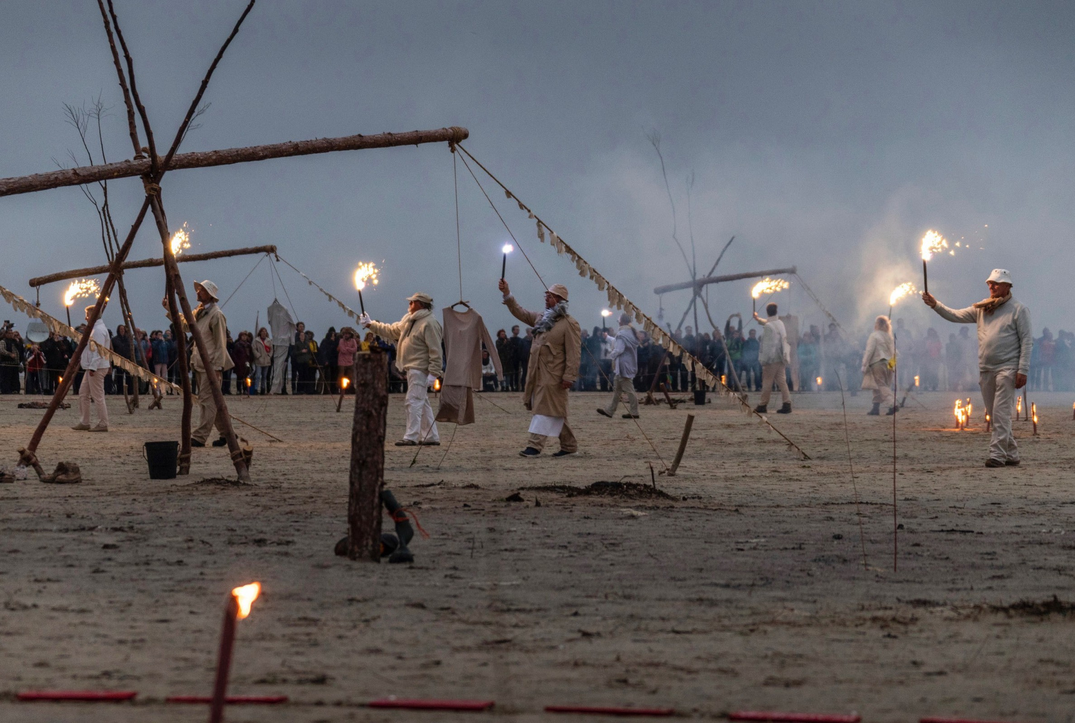

4 Above Wayfaring, 2018. Photo by Moon Saris

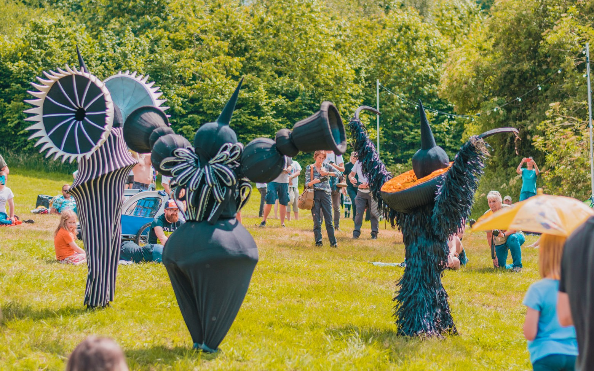

5

Why should conservation and arts organisations collaborate?

The plethora of benefits that can arise when people form positive connections to nature through the arts has been well documented within academic research. Researchers from The Nature Connections Department at Derby University have demonstrating the role arts could play in creating meaningful connections between individuals, communities and nature. For example, Lumber et al. (2017) highlight how connections with nature leads to pro-environmental behaviour, as well as bene- ficially impacting personal and community wellbeing. Nature
connectedness was found to ‘be beneficial to wider nature’, as ‘A connection with nature creates a sense of belonging to the wider natural world as part of a larger community’, therefore facilitat- ing appreciation of the environment which has been found to lead to concrete, direct action on the part of individuals, who describe the desire to protect nature from human threats as a result of their personal connectedness with nature (Lumber et al., 2017, p.54). By focussing on fostering human connectedness with nature in policies and practices in a cross sector fashion, the research group found that we have the potential to ‘Improve the human condition and that of the Earth itself.’ (Charles et al., 2018, p.4).
If increased nature connectedness can lead to such bene- ficial conservation actions, it is clearly important to understand
how deep, meaningful connections to nature are formed, and, in turn, how can we, as individuals, organisations, and policy mak- ers, facilitate these connections? Understanding the factors that facilitate increased connections, as highlighted by the Nature Connections research group,, will inform moves to increase nature connection for both natural and human well-being (Lum- ber et al., 2017).
Through exploring a variety of influencing factors, the research group from Derby University has demonstrated that there are five key nature connection pathways; contact (sensory), emotion, meaning, compassion and beauty (Lumber et al., 2017). These pathways provide alternative values and frames to tradi- tional knowledge and identification routes often used by organ- isations when engaging the public with nature, and therefore provide an interesting and fruitful starting point for answering the questions this research paper poses.
The Nature Connection Indicator Working Group was convened between 2009 and 2019 in an effort to undertake the Monitor of Engagement with the Natural Environment survey (MENE). The MENE attempted to understand better how people, use, enjoy and are motivated to protect the natural environment; to monitor changes in the use of the environment over time; to link more closely delivery initiatives to people’s needs; and to evaluate the impact and effectiveness of related policy initiatives (Natural England, 2020). Their findings corresponded to those of the Derby University research group, with ‘Positive relationships between people’s nature connectedness and their wellbeing and

6

pro-environmental behaviours’ being discovered (Natural Eng- land, 2020, p.5). In fact, these positive relationships were found to last even after accounting for a wide range of socio-demographic and other variables. With regards to statistics, individuals with high nature connectedness were twice as likely to enact ‘house- hold pro-environmental behaviours’, and 1.8 times more likely
to report ‘conservation pro-environmental behaviours.’ (Natural England, 2020, p.5) The report defines nature connectedness as ‘A measurable psychological construct that describes a person’s relationship with the natural world. It includes aspects related to a person’s affective (emotional) and cognitive relationship to
nature and their sense of place in nature.’ (Natural England, 2020, p.5) In particular regards to this research paper, Natural England also state that a person’s nature connectedness can change over time and in response to different experiences.
Understanding how more structural, strategic and tar- geted efforts could amplify current practices, alongside a better understanding of the the conditions required for greater use of the arts in conservation strategies, would seem to offer much promise in terms of enhancing nature connections.
Valuable research in this area includes the Valuing Arts & Arts Research Report, Saratsi 2019, which looks at this from the perspective of arts and academia and how to foster greater links around environmental research and the arts “Valuing nature bet- ter requires the creation of new discourses that disrupt prevail- ing wisdoms and re-think the ways different disciplines work together.” (Saratsi et al., 2019)
The 2020 report from the International Network for Con- temporary Performing Arts (IETM) on Arts in Rural Areas inter- rogates opportunities for work that is taking place in natural landscapes “Contemporary performing arts in a rural context are an integral part of that exercise of imagining a different future.
Moreover, contemporary art in rural areas have been nurturing and shaping local narratives for ages. However, contemporary artistic practices have gone almost unnoticed in many funding schemes
– both cultural programmes and rural development funds, which tend to focus on economic assets of only a few sectors” it goes on to say “ We realised it is urgent to find unconventional approaches to the arts in rural areas. We need to identify innovative solutions to support the rural arts in their endeavour of working transversally with other sectors. We have to seize the momentum and potential of rural arts to help reinvent the system. Today, when our planet needs it the most” (Garcia-Dory et al., 2020).
The Arts are also briefly referenced in Julian Glover’s 2019 Landscapes Review, with the Wye Valley River Festival highlighted as an example of how our landscapes can work together to be happier, healthier and more open to everyone “with inspiring art focused on the special qualities of the landscape, nurturing emo- tional connections with the natural environment” (Glover, 2019).
The scale of the biodiversity crisis necessitates immediate (though well considered) action, and in the following sections I want to explore opportunities fordeveloping a more ‘joined-up’ cross-sectoral collaborative approach. To quote Aldo Leopold (1966), it is time to ‘think [holistically] like a mountain’.

7

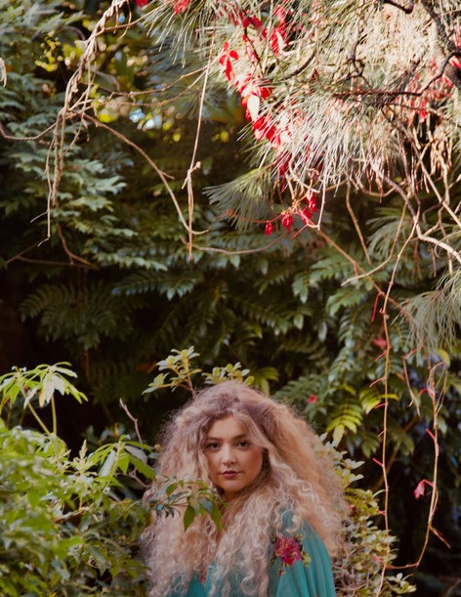

Case study #2 The Oak Project

The Oak Project works directly with the nature connected- ness researchers at the University of Derby to build a pioneering art programme that harnesses the power of cultural moments
to connect audiences to the natural world. The project is based at the Yorkshire Sculpture Park, with projects including a pavil- ion-style sculpture in the Park, the Tune into Nature Music Prize
- a national music competition for those aged 16-29, and the Great Oaks from Little Acorns Grow instillation at the RHS Chelsea Flower Show. The Oak Project base their work on the psychologi- cal research described earlier from the University of Derby, and so really puts into action the notion that actions around protecting the environment can be built through artistic events; ‘We believe art can save us from extinction. Art can open minds and inspire us. Art can reconnect us to the natural world, helping to heal
the rift between us and the planet. Art can create space for real change.’

https://oakproject.org.uk/

Right LYDIAH, winner of the 2020 Tune Into Nature Music Prize

8

Approach

In order to better understand the impact of current policy and strategy on those working across arts and nature I conducted a series of semi-structured, one-to-one interviews with a repre- sentative range of stakeholders, including policy makers, funders, and individuals from arts and nature organisations of various sizes and orientations. The group of interviewees presented below is as representative as possible within the parameters of the time and access of this project, as always, however, there is scope for further research to expand on this work.
All interviews were transcribed and analysed for key words and themes (using a modified constant comparison approach), and the following section is organised around the key themes emerging from the research. At the end of this section I also present a number of (unanswered) questions raised during the interviews (and which could provide the basis for the further research mentioned above).

Interviewees

To understand the impact that policies and strategies are having on those working across arts and nature I conducted a range of one-to-one interviews with the following policy makers, funders and individuals from arts and nature organisations:
» Jason Singh, Artist
» Sarah Sawyer ,AONB’s
» Helen Meech, Oak Project
» Annette Macdonald, Chair of Cheshire Local Nature Partnership
» Kate Wood, Activate
» Julie Attard, Charnwood Landscape Project
» Becky Hazlewood, Julie’s Bicycle
» Claire Elbourne, AONB’s
» Simon Hough, Forestry England
» Rob & Harriet Fraser, Somewhere Nowhere
As well as campfire conversations with Jennifer Tegg, (The Good Project); Caroline Sanger Davies (Experience Marketing Ltd, ex marketing Director Chester Zoo) ; Rowan Cannon, (Direc- tor Wild Rumpus).

The primary research questions asked were:

» What are the greatest opportunities/challenges to arts/ nature collaborations?
» Do arts/nature organisations understand each other’s motivations, ambitions, strategies and needs?
» What are the conditions required to encourage cross sec- tor collaboration?
» How do we develop better understanding to inform solu- tions to achieve common goals?
» What platforms/networks currently encourage collabora- tive working for arts and nature?

9

What are the greatest opportunities/ challenges to arts/nature collaborations?

The barriers that need to be overcome and the challenges individuals and their organisations have faced in the area of cross sector collaboration can provide valuable information when look- ing at how projects can work differently, and more effectively, in the future. A variety of problems had been encountered by the interviewees, some more specific to their own organisation or project, and some that seemed sector wide, which occurred in almost every conversation. Accessibility, funding, public policy, and time and capacity were the main, stand out problems which were repeatedly raised. As Rob and Harriet Fraser from The Place Collective stated in their interview, there is no one size fits all framework or structure, however it is interesting to see how often these problems can carry across sectors and demonstrate the universality of certain issues.

Accessibility

One of the key problems raised by numerous interview- ees was the problem of accessibility to the organisations and events in question. Rob and Harriet stated that conservation organisations can be silos, and so really placed the emphasis on how important it is for them to work more collaboratively and
coherently with others. Helen Meech also raised awareness of the problem of the perception of the arts as being a very middle class area, and therefore the arts organisations and events that are being produced can often seem inaccessible for much of the general public. Kate Wood similarly said that there is a level of intimidation surrounding much of the arts world which desper- ately needs to be broken down, as well as making the point that often scientific language is inaccessible, and so there needs to be
an accessible language created to facilitate engagement. This also relates to a point made by Julie Attard around the power struc- tures within the governance of organisations, and how a more diverse range of voices can be heard. Both internally and exter- nally, then, arts organisations need to ensure that they are being as inclusive as possible. Simon Hough stated in his interview that the project he was involved in, Forest Live, faced challenges in programming the diversity of artists they would wish for, with 60% of programming being white, straight males. The most sig- nificant obstacle to greater diversity is the need achieve commer- cial outcomes, which in turn probably affects audience diversity. Here, the intersection of accessibility, diversity, and money as problems faced within the artistic and environmental sectors becomes clear.

Funding

Another major barrier, perhaps the most obvious bar- rier, again, raised by almost all the interviewees, is the issue of

10

funding. Sarah Sawyer stated that cross-sector collaborations are incredibly capacity draining, and without the money to sup- port these projects they will continue to be limited. Julie Attard raised the challenge of how projects can be sustained once that funding ends, saying that a longer term legacy is difficult to follow through on. As well as the problem of legacy, she men- tioned that on a local level it is difficult to reproduce larger scale ideas and events without a huge funding pot, which is of course harder to access at the local level. Claire Elbourne similarly said that without money, the capacity for momentum, enthusiasm, as well as the more practical capacities of training, the oppor- tunity to write further funding proposals, and the time that can be bought for projects and salaries are all, of course, much more
impractical to access. Kate Wood noted a lack of capacity withing smaller organisations for effective production, which would also be solved if access to funding was more significant. Simon Hough also stated that capacity was the largest challenge within For- estry England’s events production team. It goes without saying that this lack of money creates further problems with the accessi- bility of the arts - the issue raised earlier - as the lack of capacity to pay people results in fewer projects, or projects involving only people who can already afford to spend their time on the organ- isation, which is obviously a more exclusive group of individuals than the general public represents.
Time

A problem very much related to that of funding and capacity is that of time. As Kate Wood stated, many people have network fatigue, and are too busy with the many existing rela- tionships, collaborations, and projects going on to deal with anything further. She also highlighted that relationships take
a long time to build, and due to the busy nature of the sched- ules of many of the people involved in this world, alongside the lack of money, time could be hard to find. Simon Hough also said that in the wake of the pandemic NGO’s are facing unprece- dented demand for existing services and facilities, and that time is a large inhibitor. Within the science, environmental side of the sector, the arts seems nice to have, however the amount of time spent on dealing with each new crisis each day prevents a real focus on the relationships being built to the creative sector. Longer term planning is also tricky when the short term prob- lems are so time consuming. Sarah Sawyer reiterated the busi- ness of people within the arts and environmental sectors, and emphasised that the work necessary is very labour intensive and needs a significant amount of time and focus.

Public Policy

Public policy often presents other challenges around pro- viding cross sector arts and nature collaboration. Helen Meech stated that from her perspective there has been a lack of support

11

for policy reform, and the systemic and structural changes she views as necessary are being held back by this lack of motivation in the policy sector. Sarah Sawyer added that Brexit has posed additional issues in terms of international collaboration, which is of course intrinsically tied to the policy being made in this area.

Collaboration

Cross sector collaboration between the arts and environ- mental sectors in and of itself can pose a number of challenges. Jason Singh spoke of the problem with a project he was involved with, wherein there was initial resistance from the horticultural team because they perceived the project not to be based on sci- entific evidence. This problem of the arts not being taken seri- ously was also raised by Rob and Harriet Fraser who said that integration of artists into certain projects can be difficult if they are not directly affiliated with academic institutions. Sarah Saw- yer similarly stated that there is often a problem in communicat- ing the aim of arts events and organisations to stakeholders, and this pitching requires confidence and a deep level of knowledge. Simon Hough raised the challenge between prioritising either the arts or science, stating that scientific expertise often drives deci- sion making, rather than people and engagement, which can be frustrating. This can often be a problem for the arts sector, which is more difficult to quantify in a tangible way.

COVID-19 Pandemic
COVID-19 was a less present part of problems presented in the interviews than expected, however Claire Elbourne did mention that the pandemic has derailed a lot of the momentum within her networks. She also raised the problem of online train-
ing, which has led to a lack of personal connections being created, which she sees as vital. Helen Meech similarly raised the prob- lem of ‘Zoom fatigue’ having emerged from the pandemic, which reflects some of the problems with the network fatigue men- tioned earlier.

Other

Finally, the other problems raised which seem significant, but not necessarily repeated throughout the interviews including the feeling of powerlessness, the lack of agency, and the sense of
eco-anxiety raised by Helen Meech. She stated that culture can bring hope and possibility through the telling of different kinds of stories and changing the narrative, however this sense of anxiety and pow- erlessness is a real problem that is hard to overcome. Kate Wood also raised the problem of policies actually trickling down; one thing is having a strategy embedded on the surface, another is it actually being implemented. She also mentioned the problems around sup- porting smaller organisations who often don’t feel as comfortable to commission larger projects, as well as the problem of brokering rela- tionships between organisations and individual artists.

Reasons for positivity

12

The barriers and challenges to cross sector collaboration can tend to eclipse the plethora of reasons to be hopeful, joyful and positive about the opportunities ahead of us. One of the most inspiring parts of conducting these interviews was witnessing the passion and excitement of those involved in this line of work, and it is this enthusiasm that should be shared and celebrated.
Jason Singh and Sarah Sawyer both spoke about the momentum that passion drives, as well as the amazing levels of enthusiasm from communities, organisations and individuals that they have worked with. Sarah also spoke of the power of live events to not only bring people together, but to also communicate vital mes- sages in an incredibly large impactful way which traditional communications can’t. This can offer an opportunity for the pub- lic to participate with their local environment, meet different people, take them out of their comfort zones perhaps, and in turn really strengthens the heart of communities. Other reasons for hope and joy come from the significant shift in attitudes towards the natural world seen by those within the creative and environ- mental industry, including Helen Meech. Simon Hough reflects that whilst NGOs are often caught up in the day to day crises that seem to form so much of our working world, collaboration has been able to provide a route to encouraging passion and enthusi- asm in future projects. It is these achievements which really need to be celebrated to create further motivation for future action.

Opportunities
There were a range of potential opportunities mentioned throughout the various interviews which it is important to take note of. Concrete structures that are already in place that could form prospective future opportunities for promoting, organising and funding nature connection projects through the arts were listed by numerous interviewees. Cultural institutions in their broadest form were cited as having a vitally important role to play, for example TV programmes, literature, magazines... Jason Singh spoke about his direct experience of the positive influence publicity such as that of Countryfile can have, as it gave him the possibility to reach such an incredibly broad audience that other- wise would not, perhaps, be accessible for arts and environmen- tal organisations. Other shows such as Blue Peter, BBC Breakfast, Newsround, and Spring Watch were mentioned by a range of interviewees as potential channels for broadening the conversa- tion around arts and nature connections. Outside of mainstream media, opportunities could also be provided through institutions such as the British Council, the Climate Convening Conversa- tions and COP, alongside a higher profile being achieved through the creation of new awards and prizes being cited as a possible opportunity.

13

What are the conditions required to sustain cross sector collaboration?

The question of sustainability and legacy were commented upon earlier, having been raised by numerous interviewees in
the conversations. Looking, then, at how good practice can be sustained when it is able to occur is a vital part of the evaluative process. Julie Attard cited the need for having quantitative and qualitative evidence as proof that cross-sector collaboration over arts and the environment can be effective. Rob and Harriet Fraser also listed research-led projects and evidence and case studies
as part of the answer to how good practice could be sustained, alongside the building of relationships based on trust, freedom, and boldness. Sarah Sawyer similarly said that projects had often been able to be sustained where positive personal relationships have been created.
Reaching and effectively connecting to audiences was raised by both Simon Hough and Becky Hazlewood as important in sustaining practices; Becky stated that grassroots projects, over policy led initiatives, were perhaps more likely to be sus- tained due to the fluctuating nature of public policy, and Simon said that reaching a diverse and empowered audience would allow projects to continue. Other participants also promoted the local, grassroots side of participation as a key method of sustain- ing projects; Rob and Harriet Fraser, for example, said that by bringing in wider, more diverse perspectives projects were more
likely to have a future, rather than organisations staying within the bubbles or silos that are often created. Annette Macdonald also stated that systemic change has to happen from the grass- roots up, with smaller, local, sustainable solutions working better in terms of sustaining projects. The need for longer term plan- ning, as well as mixing the community and social aspects of pro- jects, was also raised by Annette.
Becky Hazlewood cited sector specific sustainability, for example looking at the work of Music Declares Emergency or IMPALA as examples of how within certain sectors organisations and projects can support each other. On the topic of organisa- tions supporting each other, Kate Wood proposed different sized organisations having different roles within cross-sector collabo- ration, with larger organisations potentially being able to broker relationships with or for smaller organisations.
Julie Attard cited the need to break out of our silos to forge productive and effective connections, but also acknowledged
the power imbalances apparent when organisations of differ- ent sizes and different levels of governance come together. Helen Meech stated that bringing in community voices could help cre- ate a national conversation around nature and creativity. Rob and Harriet Fraser also mentioned that working with the same organisations and artists repeatedly can lead to really amazing relationships being formed over longer periods of time, which creates a trust and level of support that may not be there oth- erwise. Brokering relationships with landowners, as sources of knowledge, rather than solely as funders, was mentioned as an

14

idea by Kate Wood, as well as her mentioning the opportunities provided by potential joint bids with Areas of Outstanding Natu- ral Beauty. Sarah Sawyer stated the importance of organisations being adaptive, having a variety of skill sets, and a large source of motivation when looking to work cross-sector. Becky Hazlewood spoke about how important sharing successes can be when work- ing in partnerships, as well as sharing a clearly articulated vision, and having a robust approach to problems and solutions. Helen Meech referenced the need to have a shared language when working collaboratively, as this can help create a shared under- standing of the project and goals in hand. Rob and Harriet men- tioned a similar idea in their interview, of specialists finding new voices to speak with to create a more innovative approach and potentially a broader public appeal.

Do arts/nature organisations understand each other’s motivations, ambitions, strategies and needs?

Developing a better understanding of how nature connec- tion can occur through engagement with the arts is at the core of this research proposal. Some answers provided by interview- ees include training those within the arts around conservation,
testing out interventions, collecting evidence from projects, and providing tangible examples to potential funders. Online training workshops could be provided for conservationists and environ- mentalists, as well as conversely for artists and creatives. Sarah Sawyer stated in her interview that this training could be given with regards to a greater understanding and confidence sur- rounding who to talk to, how to build relationships within and outside of your sector, or how to access funding pots. This type
of training could also try and breach the barriers between the arts and environmental worlds, as they could demonstrate that there is no need to be afraid of engaging with science, and could potentially motivate creatives to get involved. Another opportu- nity could come in the form of potentially creating a new, more accessible language around science - Julie Attard referred to this as creating ‘a language of scientific desire’. Outside of data and science, exploring with environmentalists how the arts connect to audiences, providing a more human based approach, was cited as another method that would allow cross sector collaboration
to become more effective. As well as this training within organ- isations, creating the position of community representatives at workshops, training and events would provide a space for organi- sations to learn from the grassroots up.

15

What platforms/networks currently encourage collaborative working for arts and nature?

Many of the examples of collaborative working discussed have been included in this report as case studies to help show the variety of work already happening in this area. After exploring a variety of problems, benefits and practicalities surrounding exist- ing cross-sector partnerships with regards to nature and arts col- laboration, the idea to create Local Creative Nature Partnerships (LCNPs) as a means of facilitating this collaboration further was proposed to each of the interviewees. Many of the interviewees seemed to have a positive response to the idea, with the further idea of cross sector collaboration being seen as a productive and worthwhile endeavour. However, the general feeling was that this type of project can become incredibly difficult to sustain without a significant amount of funding, as well as a motivating factor
to ensure that individuals and organisations come to the table. The problems described earlier were raised with regards to the LCNPs, primarily the issues of capacity, time, and funding pots. Annette Macdonald from the Local Nature Partnership encap- sulated these concerns in her interview, stating that individuals within creative and environmental organisations are already in a plethora of networks. Perhaps, then, she wondered whether it would be better for individuals within the arts sector to have a
seat at the table within an already existing nature partnership, rather than creating a brand new organisation. This idea was reflected across the interviews, with numerous interviewees stat- ing that existing networks could perhaps be cross-pollinated, therefore utilising the structures which are already in place.

Questions raised during the course of the conversations by the interviewees:

» Whilst the conversations were focussed on interviewees’ answers, inevitably a number of prescient questions were raised during the process which could form the basis of future research.
» How can the results of creative projects be better captured when attempting to demonstrate the impact of the arts?
» How can extractive elements of creative projects be miti- gated? (i.e. working in tech)
» How can diversity be increased? (institutions, audiences, performers)
» What role could a new, more accessible language play in reshaping and inspiring future conversations?

A number of organisations and artists were mentioned over the course of the interviews. See Appendices 1 for links to their work.

16

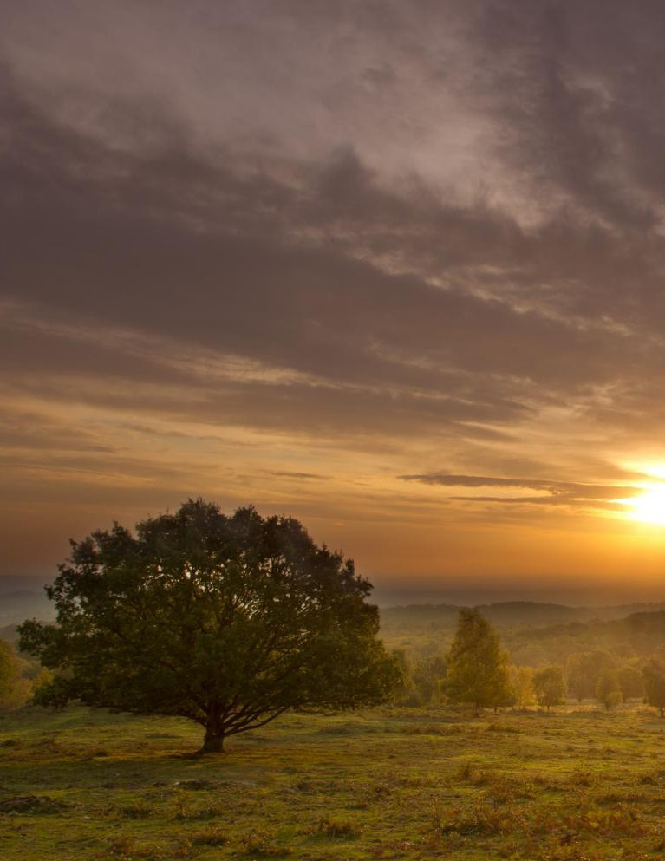

Case study #3 Charnwood Forest

Charnwood Forest is an upland tract in North Western Leicestershire, having been created in a volcanic eruption 600 million years ago it has developed rich layers of heritage. But, despite being on the doorstep of cities, towns and villages, its value and beauty are hidden from most communities and have been overlooked for protected status. This puts it at risk “if people are not passionate about Charnwood Forest, they will not under- stand its importance and, ultimately, the features that make it special risk being forgotten and lost”. Through HLF funding as part of a Landscape Partnership scheme this is being addressed as the story of Charnwood is being told: celebrating its interna- tionally important geology, connecting people to its history and securing its sustainable future. Excitingly culture and creativity are at the heart of telling this story.

https://www.nationalforest.org/about/projects/charnwood-forest

Right Charnwood Forest. Photo by the National Forest Company

17

Policy and Strategy

There are a wide range of policies and strategies that cur- rently influence the ability of arts and nature conservation organ- isations to collaborate, and alongside this, a long history of missed opportunities and lack of understanding/awareness at various levels of governance. In the following section I highlight impor- tant areas of policy, including some examples of strategies and approaches (e.g. MOUs) that go some way to ‘bridging the gap.’ Everyone – artists, professionals and audiences, especially young people – needs policy to facilitate the journey toward sustaina- bility, and unleash the potential of culture as an agent for change’ (Julie’s Bicycle, 2021). Whilst the policies and strategies mentioned beow are by no means an exhaustive list, hope-fully they will go some way to indicating examples that currently exist.

Relevant Policies & Strategy

A Green Future: Our 25 Year Plan to Improve the Environ- ment, The Department for Environment, Food and Rural Affairs (DEFRA), 2018, sets out ambitious targets to help the natural world regain and retain good health. A section entitled ‘Connecting peo- ple with the environment to improve health and wellbeing.’ dove- tails with the research done by Derby University, described above, which advocates for the public to become connected to nature in
order to facilitate action around conservation and preservation of our environment. The government states here that they are looking to help people improve their health and wellbeing through using green spaces, encouraging children to be close to nature, making cities more green, and creating the 2019 Year of Action for the Envi- ronment. Having a full chapter focussed upon the connection to nature demonstrates its importance, and represents a significant step within this field of research. However, whilst this focus on the importance of connecting the public to nature is positive, the arts are not included as a potential means through which this could occur. The only mention of the arts within the document, in fact, comes with a description of the work done by The Canal & River Trust, who successfully implemented a ‘Community Roots’ part- nership project in Huddersfield and Rochdale, wherein local people took part in creating art trails, paddle boarding, walks, alongside canal clean-ups and dredging. This project is an excellent example of how linking the arts to nature can create a deep nature connec- tion, as the canals were found to be ‘cleaner and more attractive’ afterwards, as well as inspiring 1,200 new volunteers to join the project, many of whom had not been to the canals previously.
Despite the clearly positive impact the arts can have, they were not included more significantly within the DEFRA 25 Year Plan.

Alison Tickell founded Julie’s Bicycle in 2006, and she has commented regularly on the need to link arts and environmental policies, arguing that the government are ‘missing a trick’ by not doing so. There are opportunities on the horizon with ELMs and

18

Landscape/Nature Recovery planning (e.g. the Nature Recovery Green Paper) to do things differently…something like, is there the political will to think outside the box/silos, be more creative…
Alison Tickell stated that the government has ‘missed a massive trick’ by failing to link arts policy with environmental pol- icy and has restricted the cultural sector’s ability to make wide- spread change.

Local Nature Partnerships (LNPs), the 47 LNPs across Eng- land provide an example of cross-sector, place based, collaboration with regards to conservation.
Beginning in 2010 as an initiative to facilitate the effective management of the rural environment through partnering up a broad range of local organisations, businesses and people, LNPs attempt to help the local area manage the natural environment as a system, and to ‘Embed its value in local decisions for the bene- fit of nature, people and the economy.’ The government has rec- ognised and declared their support for LNPs, signalling that they view the project as a credible partnership with real potential for local economic growth and the wellbeing of local people. 47 LNPs are currently listed on the government’s website, with each work- ing differently depending on the context of their local community. Effective LNPs are able to drive positive change in their local nat- ural environments, develop strategic visions for restoration, and facilitate cross sector collaboration through the active involvement of economic, health and environmental interests within a single organisation. LNPs also raise awareness of the value of the natural
environment, as well as having an overview of the range of activi- ties and partnerships concerned with the sustainable management of the natural environment with the hopes that this will provide integrated and effective outcomes for local communities. DEFRA’s role is to help in building up an evidence-based picture of the local natural environment through the sharing of their wealth of infor- mation, alongside their contribution in terms of implementing the LNP’s visions by considering the LNP’s priorities and ideas when undertaking strategic planning. Whilst each LNP works differently depending on the local context, making it difficult to assess on a large scale the significance of their work, the government’s sup- port of LNPs can be seen as a positive step towards encouraging cross-sector, place based, collaborative action.
Cheshire Local Nature Partnership states its ambition to offer Cheshire: “A healthy, connected, productive landscape richer in biodiversity, where the natural environment is embedded in decision making, managed for wildlife, supports healthier lifestyles and farming, creates attractive places and delivers sustainable eco- nomic growth.”
However few, if any, LNP’s appear to include any cultural/ arts organisation representation.

Sustainable Development Goals (SDG’s): The United Nations fifteenth SDG, is entitled Life on Land, and is focused on the issues of deforestation, desertification, species extinction, zoonotic dis- eases, and a variety of other destructive forces surrounding the cli- mate crisis (though the SDG approach has been widely criticised

19

and is unlikely to deliver significant biodiversity benefits (Zeng et al., 2020)). As part of the attempt to prevent, halt and reverse the worldwide degradation of the earth’s ecosystems, the UN has launched the Decade on Ecosystem Restoration programme.
This project is aimed at the restoration of 350 million hectares of degraded terrestrial and aquatic ecosystems, in an attempt to remove 13 to 26 gigatons of greenhouse gases from the earth’s
atmosphere. Whilst financing, incentives, leadership, and research are all listed as essential parts of the strategy for the implemen- tation of this project, the very first point in the UN’s plan is to ‘Empower a global movement.’ The UN Decade is looking to con- nect and empower groups and individuals to become informed and inspired to act, which - this paper posits - can be realised through connecting the environmental sector to the arts, so that people can form the motivating nature connection.

The Noticing Nature Report from the National Trust, 2020, provides an analysis of the research conducted by the University of Derby discussed earlier, expanding upon the growing body of evi- dence which points to the positive impacts on people when they engage with nature. They looked at the question of why certain people take climate action whilst others do not, and how notic- ing nature in small, everyday ways could lead to radical results
in terms of conservation action. For many people, unfortunately, nature is not an integral part of their life, despite research which proves that connecting to nature on a regular basis enhances well- being. Within the National Trust’s action plan, they are looking
to promote activities which facilitate an appreciation of the sim- ple pleasures of nature, for example through larger programmes or creative installations in public spaces. Alongside this, they hope to ensure everyone is able to connect with nature on a local, daily basis, and to this end they have established UK-wide targets for ‘nature connectedness.’ Some of their projects include a new weekly guide to everyday nature connection as well as a public awareness campaign, including billboards by roads and in railway stations. Through publishing the Noticing Nature report, digging
deeper into the findings of Derby University and analysing further the subject of nature connectedness, the National Trust have made an important step in highlighting that those with an active nature engagement are more likely to help tackle the nature crisis, as well as increase their own personal sense of wellbeing.

The Nature North Steering Group established in early 2020 is a collaboration between some of the largest environmental organisations which have come together to drive climate resil- ience and green growth through nature recovery in the North of England. They have been working with the NP11 which brings together the 11 Local Enterprise Partnerships LEP’s to look at Green Recovery.
Their vision is for ‘A thriving environment across Northern England, with nature acknowledged by policymakes, the public and businesses as key to the prosperity, wellbeing and resilience of communities in the North’.

20

There is clearly potential here for crossover and collaboration with the Northern Cultural Network convened to focus on the cultural recovery for the North of England.

Arts Council England (ACE) arguably enact the most signif- icant crossover between the arts and environment within govern- ment policy. A non-departmental public body of the Department for Digital, Culture, Media and Sport.
Until recently much of the strategy from ACE had been more focused on organisational carbon footprints, mitigating emis- sions and addressing climate change (via projects like Julie’s Bicycle Creative Green Tools) rather than thematic focussed interventions.
However their new 10 year strategy published in 2020 enti- tled Let’s Create, encourages a more holistic approach to environ- mental action from the organisations and individuals they fund (Arts Council England, n.d.). One of the Art Council’s four key Investment Principles, which are used to filter and choose appli- cants for funding projects, is Environmental Responsibility. Here is a clear intersection between the arts and nature conservation, with the Arts Council highlighting right at the core of their 10 year
plan that cultural organisations will lead the way in their approach to environmental responsibility. The plan states that they expect organisations ACE invests in to develop clear pathways towards net zero carbon, as well as wanting cultural organisations to embody the principles of environmental responsibility throughout the work they create.
“The climate crisis and environmental degradation will be
the most significant challenge facing all of us over the next dec- ade and beyond. The cultural sector has already taken major steps to reduce its carbon footprint, partly as a result of a range of ini- tiatives supported by the Arts Council. Alongside this, more and more artists and organisations are engaging with the subjects of climate, biodiversity, waste and energy in the work they create, programme and support. Research using natural history collec- tions, meanwhile, helps people better understand these issues and suggests ways in which policy and behaviour might be adapted to address them. This creative and scientific dialogue is shaping a cul- tural response to the climate crisis that provides new insights and reflects the demands of audiences.”
ACE state that they are ‘Aware of the cultural sector’s role in helping to lead change… innovate and be responsive.’ (Arts Council England, n.d.)
Alongside this, ACE’s Memorandums of Understanding (MOU’s), with land steward organisations are another significant way in which they are working to bring culture into the conversa- tion around nature and landscape.

Forestry England will work with ACE’s Lets Create strategy to creatively implement and connect audiences with its ‘Grow-
ing the Future’ strategy. ‘Growing the Future’ focuses on Wildlife, People’s Connection to Nature and Climate. Forestry England sees its contemporary arts programme as an integral way to creatively explore and connect audiences with these priorities, and a mech- anism though which the organisation can lead the conversation

21

at the intersection of art, design and environmental issues (Arts Council England, n.d.).
The Canal & River Trust MOU of 2021 marked a five year agreement based on a shared belief that arts, culture, and our country’s vibrant canals and rivers have an inspirational and trans- formational effect on communities, as well as having the potential to boost people’s wellbeing.The primary objective of this agree- ment was to bring a new wave of arts and culture events along England’s waterways (Arts Council England, n.d.).

The National Trust renewed their MOU with ACE in 2018 with a joint ambition stating “This renewed partnership will allow an increased level of high-quality and innovative contemporary arts and cultural experiences across National Trust sites – inspired by National Trust places, both indoors but also in gardens, coun- tryside and on the coast. With the renewed MoU, the two organ- isations want to increase the diversity of commissioned artists from a wider range of backgrounds, and to diversify audiences and participants reaching more people in areas of low cultural engage- ment” (Arts Council England, n.d.)

There are in addition to these MOU’s a number of conser- vation organisations who have adopted Arts Strategies or Grant Funding programmes including the Areas of Outstanding Natu- ral Beauty AONB’s National Art In the Landscape Strategy (Land- scapes for Life, 2019) and the National Forest with their Forest Arts Grants designed to support the National Forest creative
community to develop and pilot new projects inspired by the National Forest and in response to one or more of the following themes - Nature, Health & Wellbeing, Sense of Place, Sustainability and Climate Action (National Forest, 2022).

Arts Council Wales state their objective to specifically help cultivate the relationship between the arts and the natural environ- ment with their 2020 MOU with Natural Resources Wales (NRW). This MOU solidifies a shared understanding around the improve- ment of the environmental and cultural well–being of Wales, and demonstrates the importance of looking at these two areas of the arts and climate in conjunction. The Creative Nature partnership, aims to bring communities across Wales together, ‘To help build a more sus- tainable future by encouraging people to value nature and Wales’ out- door spaces through creative activity’ (Natural Resource Wales, 2020). This entails delivering projects to increase economic activity in cer- tain under-resourced areas of Wales, establishing environmental, cul- tural, and social public bodies, as well as ensuring public land is made available to the cultural sector as a venue, a resource for research and development wherever possible. As the Chief Executive of Natural resources Wales Clare Pillman stated, ‘From our earliest poets to the most contemporary sculptures, nature has been an inspiration for art- ists everywhere. Wales’ landscapes and the culture shaped by them have inspired artists for generations.’ (Natural Resource Wales, 2020) This powerful call demonstrates that artistic engagement with the natural environment is nothing new, rather, it draws upon a long and inspiring tradition of creativity within our landscapes.

22

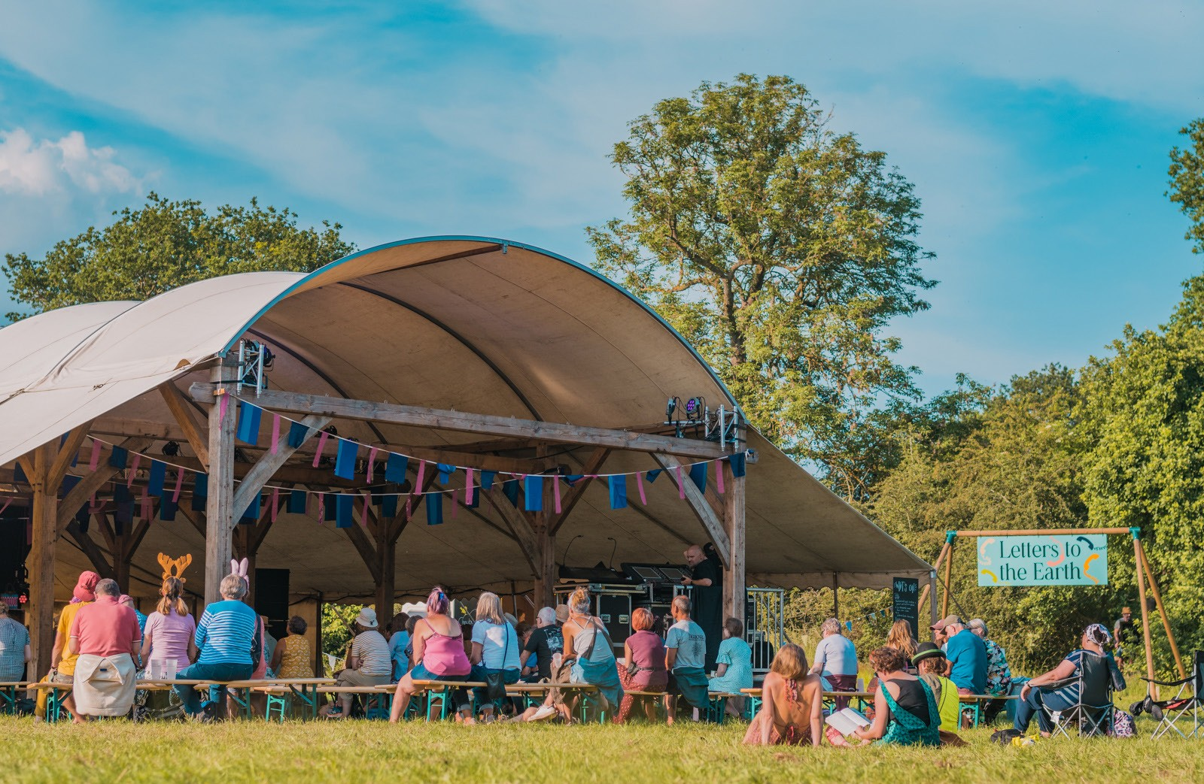
Case study #4 Timber Festival

For the last 5 years Timber Festival has invited an audi- ence of 5000 people to a woodland in the heart of the National Forest to re-examine our relationship with nature and sustain- ability through workshops, performances and discussions with activists, musicians, artists, and writers, helping us understand the economic, social, cultural and environmental impacts of trees & forests. The festival tells the unfolding story of landscape transformation that has seen this post industrial landscape be reclaimed and reforested. It is a particularly collaborative event with a wide range of community groups, schools, commissioning
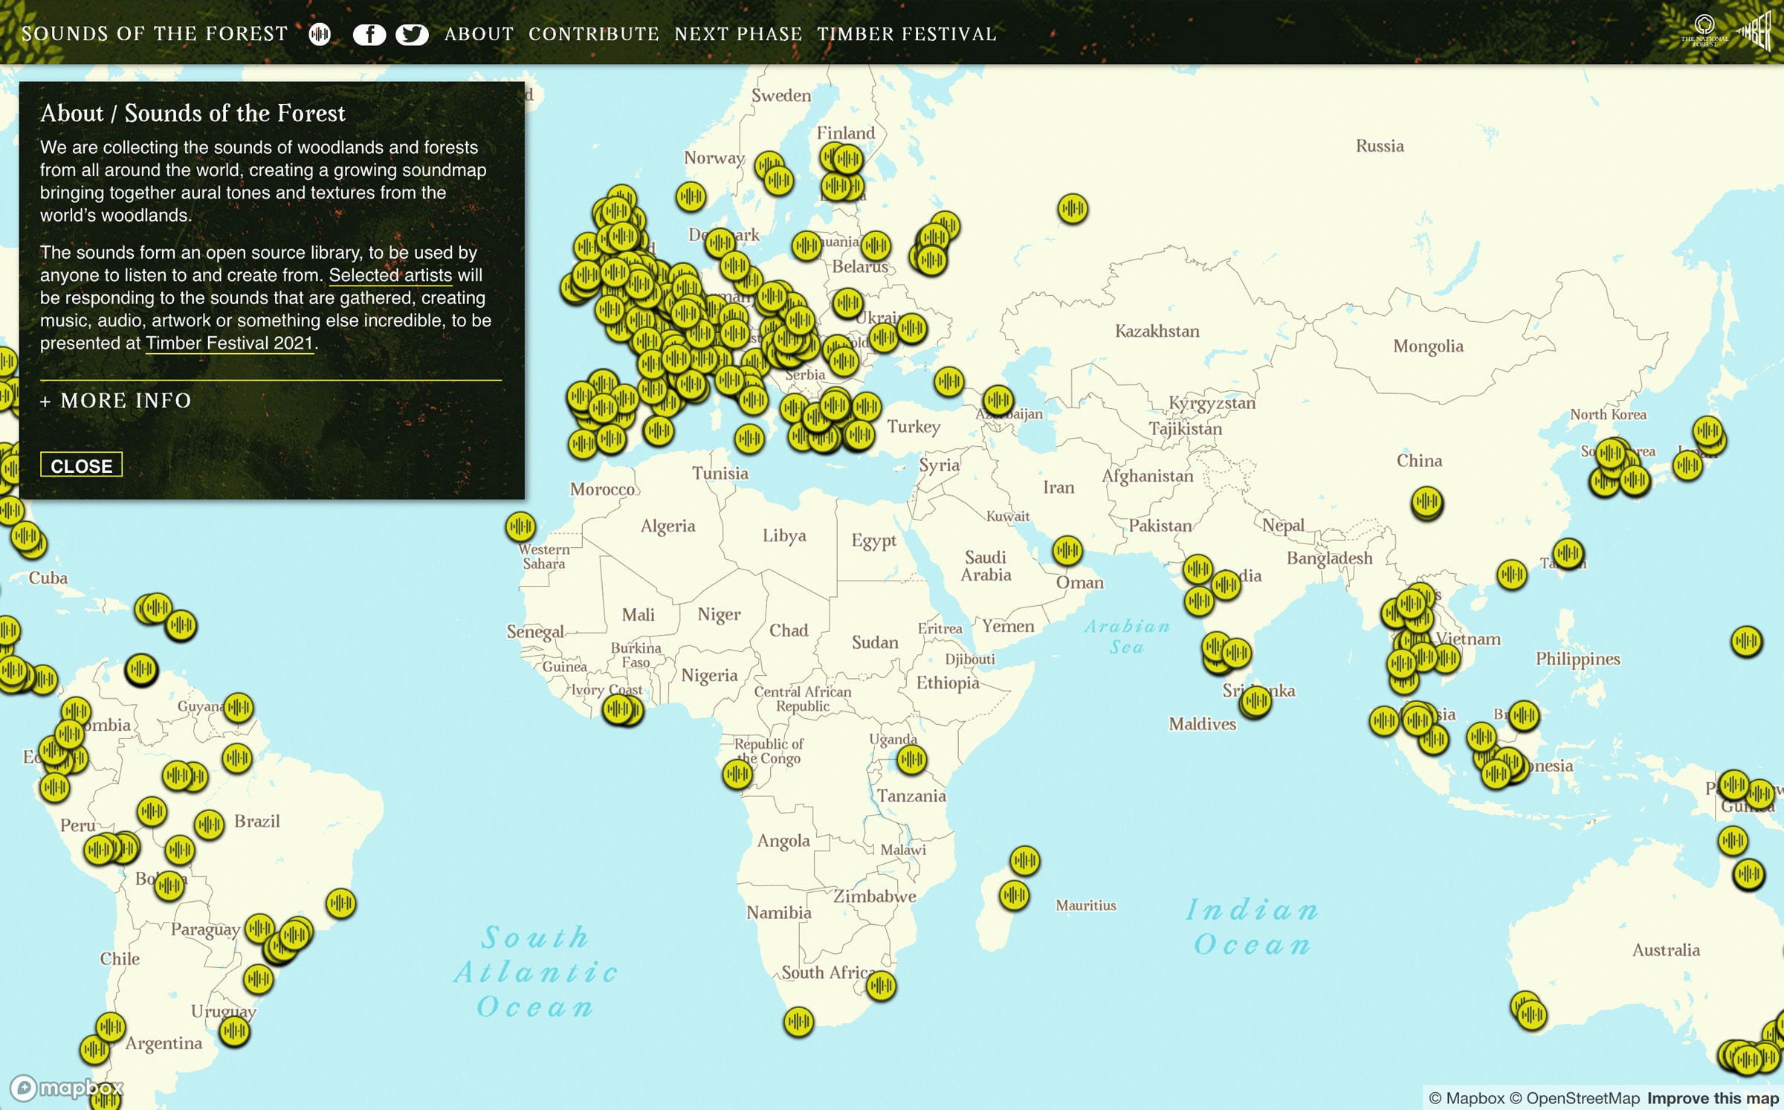
partners, researchers, conservation specialists and NGO’s involved as well as artists, helping to reimagine our relationship in nature.
It was also the inspiration for the global forest soundmap Sounds of the Forest which has engaged thousands of peo-
ple around the world in the art of recording nature sounds and uploading them to a digital map which has then been listened to millions of times and itself inspired musical responses. Cyclically these musical interpretations have then been performed at Tim- ber Festival.

www.timberfestival.org.uk

Top Timber Festival 2021. Photo by Wild Rumpus Above Sounds of the Forest soundmap, webpage
23

Most notable for working across the cultural and environ- mental sectors over the last 15 years has been the work of Julie’s Bicycle. A pioneering not-for-profit, founded in 2006, providing high-impact programmes and policy change in an attempt to meet the climate crisis head-on. Their values reflect the importance of integrating environmental action with the arts; they view the cli- mate crisis as a cultural crisis, stress the power of culture in shifting hearts and minds and creating different ways of living and work- ing, are guided by science, data and expertise, and highlight the importance of engaging with as wide a variety of people as possible (Julie’s Bicycle, n.d.). The project entitled Season for Change exem- plified these commitments. Season for Change was a UK-wide cul- tural festival and campaign which occurred in the lead up to COP26 which inspired urgent and inclusive action on climate change. 16 artistic commissions combined with an open programme gave art- ists and arts organisations the possibility to host events, artworks and actions across the UK aimed to mobilise creative and cultural organisations to put climate action at the heart of their practice and programming (Julie’s Bicycle, n.d.). Their focus on inclusivity is also vital, as Julie’s Bicycle attempts through all their projects to platform voices that have historically been excluded from the climate conver- sation, and Season for Change was no exception. Without actively promoting inclusivity and diversity within our discussion around
how nature connectedness can increase climate action, all outcomes will be severely limited. In fact, Julie’s Bicycle have just launched a new resource platform entitled Creative Climate Justice Hub for art- ists and cultural practitioners who want to understand the systemic
causes of the climate crisis, how it intersects with issues of social, economic and environmental injustice and how arts and culture is responding creatively (Julie’s Bicycle, n.d.). The themes through
which one can search include decolonisation, health and wellbeing, natural resources, land and nature, racial justice, and regenerative systems. This platform is yet another example of how Julie’s Bicycle has been at the forefront of cross sector collaboration, making posi- tive, impactful change for years, and set an amazing example of how arts and culture can mobilise the public to take action on the climate and ecological crisis.
There are also some good examples of strategic funding and awards from other organisations working in the cultural sec- tor including The Culture Health and Wellbeing Alliance with their collaboration with Culture Declares Emergency and the Happy Museum Project on their Climate Award celebrating the culture, health and wellbeing sector’s progressive work to address climate change and inspire future action – the award aims to recognise the innovation and impact of a project or programme that is leading by
example in caring for people, place and planet and responding to the threat of environmental and ecological emergency (Culture, Health & Wellbeing Alliance, 2022).
And The Space a digital agency established by Arts Council England and the BBC to help promote digital engagement across the arts and cultural sector, who recently launched a specific Environ- mentally themed commissioning round in association with Julie’s Bicycle to benefit digital initiatives with environmental responsibil- ity at their heart.

24

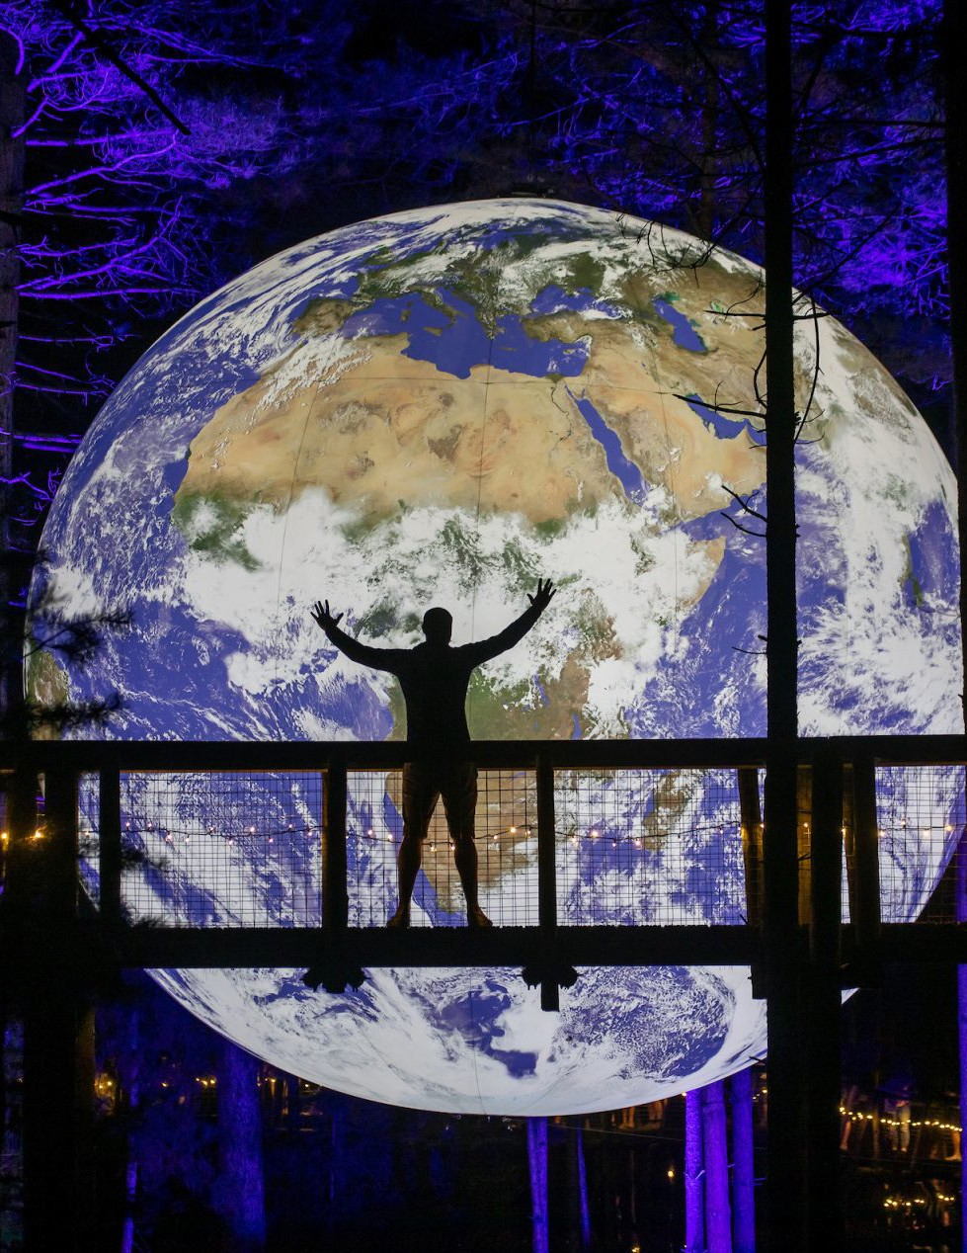

Case study #5
Activate Performing Arts

Activate a partner in LAND are an inspiring example of collaborative efforts across the nature and arts sector. For over thirty years, they’ve produced events across the UK in an attempt to bring performing arts to as large an audience as possible. In their mission statement, they write that live performance has the power to ‘Fire the imagination uplift and connect us. It creates moments that touch the hearts and minds like nothing else.’ If artistic and creative events are really able to produce this reaction within as large and diverse an audience as possible, a powerful and lasting connection to nature could be formed. Activate have made their climate emergency declaration clear, and attempt to break down barriers, celebrate nature, and connect communi- ties to the landscape (particularly of Dorset) through their arts events. One of the events connected to Activate is the Inside Out festival, which takes place across five urban and rural locations around Dorset. Their events are produced in natural landscapes to raise awareness of environmental importance and sense of place through the accessible arts programmes. They place a high importance on ensuring accessibility to their events for as wide an audience as possible.

https://activateperformingarts.org.uk/

25 Right Photo by and from Inside Out Dorset 2021

From a research perspective prominent interdisciplinary funding programmes have included:

Valuing Nature Programme which aimed to better under- stand and represent the complexities of the natural environment in valuation analyses and decision making. Considering the eco- nomic, societal and cultural value of ecosystem services. The Valuing Arts & Arts Research Report, Saratsi 2019, formed part of this project which look at making links with policymakers, busi- nesses and practitioners through the Valuing Nature Network.

Future of UK Treescapes, this programme aims to under- stand the environmental and societal benefits of landscapes in which trees play a significant role. It brings together environmen- tal scientists, social scientists, economists, and arts and human- ities researchers to form large research collaborations. Its aim to encourage a holistic, whole-systems approach to significantly improve the environmental, socio-economic and cultural under- standing of the functions and services provided by UK trees- capes, in order to inform decision making on the expansion of future treescapes for the benefits of the environment and society.

The Arts and Humanities Research Council (AHRC) recently announced 12 research projects that will unleash inno- vative ways of using culture and nature to tackle health dispar- ities. From wild swimming to creative activities with young
people, 12 new research projects explore how culture and nature can level up health and wellbeing across the UK.

The British Council launched its Creative Commissions in 2021 which form part of the British Council’s global platform the Climate Connection. The Creative Commissions are bring- ing together indigenous communities, people from rural areas and city dwellers to understand each other’s perspectives and collaborate on creative responses and solutions towards climate change. Projects tackle difficult issues head-on, push boundaries and become a catalyst for real change to challenge issues such as climate migration, plastic pollution, coastal erosion, deforest- ation, biodiversity and the effects of climate change on our environment.

And projects from specific academic institutions like the Entangled Festival from the Ensemble team at Lancaster Univer- sity which looked at “the insights we gained around the role of arts and creativity in not just conveying often complex scientific concepts and messages, but also enabling deeper engagement with a range of audiences including the general public, children and those responsible for decision-making in the crucial area of environmental change.” (Blair, 2021)

26

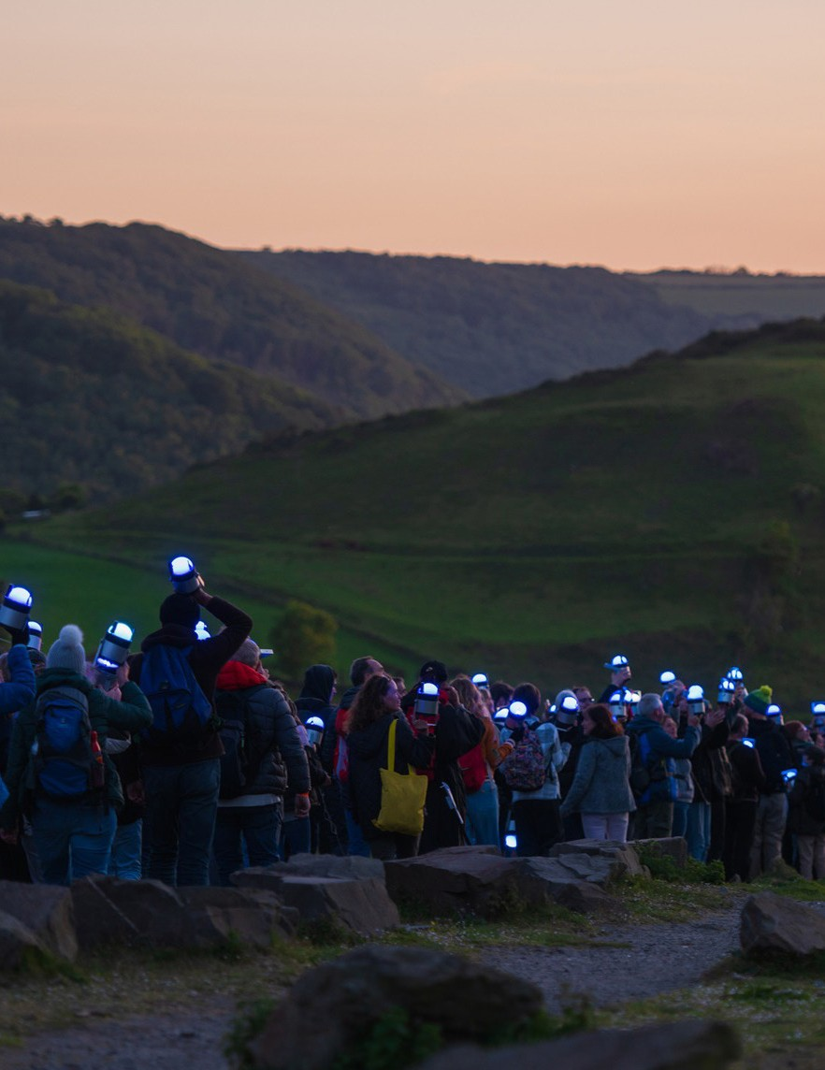

Case study #6
Green Space Dark Skies

Green Space Dark Skies from outdoor arts company Walk the Plank, is a series of 20 events taking place from April to Sep- tember 2022 which focuses on the intersection between land- scape and the arts, and is an inspiring example of a project which allows audiences to forge new relationships with nature through creative events. Walk the Plank invites sections of the public
that are usually not accessing or experiencing the countryside to take part in their events, therefore placing a much needed focus on inclusivity, diversity, and ensuring that these types of pro- jects are reaching as large an audience as possible. Part of this comes with ensuring that the spaces in which the 20 events take place are accessible geographically, are available at any time, and are free. 20,000 people will be involved in the project, and will become ‘Lumenators’, each carrying a low impact light into their local landscapes. In addition the final closing ceremony will be broadcast to millions across the UK, and will hopefully encourage thousands of Lumenators to become caretakers of nature for the future. Green Space Dark Skies is a major national participatory event as part of Festival UK*2022 and was developed in collabo- ration with Siemens, the technology corporation

https://greenspacedarkskies.uk/

27 Right Photo by and from Walk the Plank

Areas of further study

After reviewing current governmental policies, academic research, and existing examples of good practice, I would now like to offer some suggestions for further research. An obvious starting point is to highlight the need to continue the amazing work being carried out by the various organisations mentioned in this report. To this end, it is important to celebrate and pub- licise their endeavours, with the aim of maintaining, and hope- fully increasing, the reach of their work. Increasing visibility will hopefully create more opportunities for potential funding
streams and, as a consequence, further opportunities to connect with the public. Alongside recognising the existing work, it is also important to help understand the ways in which these projects can be refined and enhanced. As each of the interviewees stated, there are significant areas which could be improved upon within existing cross-sector collaboration. Research into how the bar- riers mentioned in the interview section of this proposal can be mitigated and overcome would be welcome in ensuring the con- tinuation, facilitation and improvement of nature and arts part- nerships in the future.
Further research might focus on the pathways and mecha- nisms need to increase the visibility of this work. Despite despite the amount of work already being done, there is still unfortu- nately a lack of visibility and a corresponding need to raise the public profile. The question of creating visibility is a complex and
difficult area that I am sure all of the organisations and individu- als involved in this report have grappled with. One suggestion for ensuring that awareness is raised, as well as ensuring that pres- tige and aspiration are associated with the cultural facilitation
of nature connections, is a potential new award to be given for work in this area. Here, inspiring examples include the Gulben- kian Prize, which recognises the contributions of those who work to mitigate the effects of and facilitate adaptation with regards to the climate crisis (Calouste Gulbenkian Foundation, n.d.). On a smaller scale the Ginkgo Prize for ecopoetry awards poets who explore the themes of the environment, ecology, and the rela- tionship between human culture and the natural world (Ginkgo Prize, n.d.). Ginkgo gives prize money, provides writers’ residen- cies and supports the development of ecopoetry through a pro- gramme of free workshops. Creating an award such as Ginkgo or Gulbenkian for arts and nature collaborations would be an excit- ing step forward, and would help to raise awareness for the sig- nificant contribution that cross-sector collaboration can have on facilitating widespread climate action.
Another potential model for future working that has already been considered within this proposal is that of the Local Creative Nature Partnerships. LCNP’s are an area which could benefit from a future action research project. Having discussed the various barriers to cross-sector collaboration within the interviews, hopefully some of the critiques and potential pitfalls can be taken into account during any following investigations of how LCNPs could function. Inspiration and advice can also be

28

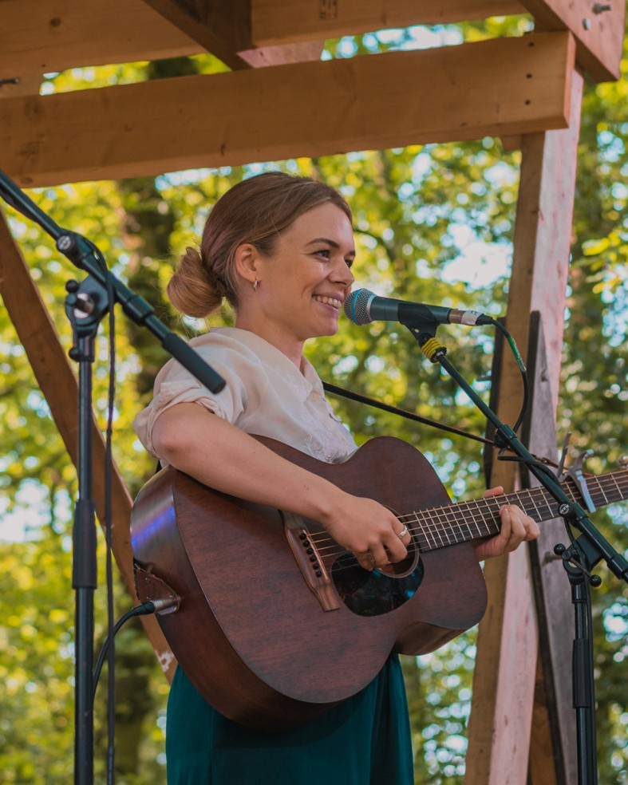

taken from looking further into the workings of the Local Nature Partnerships, described in more detail in the ‘Government Pol- icy’ section of this report, which currently provide strategic local forums for climate action. Rather than sidelining the collabora- tion between the creative and environmental sectors, and having disjointed and uncoordinated efforts through a multiplicity of individuals and organisations, LCNPs could potentially central- ise and make cohesive arts and nature partnerships. This would help with the visibility, ease of collaboration, and broaden public access to nature connections.

29

Case study #7
The PLACE Collective

The PLACE Collective (People Land Art Culture Ecology) uses arts to enrich research and connection within communities to nature and the environment, ‘Working together to fuel crea- tive action and meaningful change.’ Artists have come together to engage with nature, environment, and rural landscapes, recog- nising the critical need for more sustainable ways of living, and viewing the arts as a crucial means through which conversation, research and action can be enacted. The Place Collective recog- nises that Art and artists are able to ask difficult and exciting questions, engage and inspire, celebrate and embrace the wonder of the natural world, and can therefore form a positive journey towards preserving our landscape.
The PLACE Collective views art as a catalyst, able to create links between artists, rural communities, academics, and organ- isations. An event which really exemplifies their mission state- ment is the Moss of Many Layers project, which can serve as an inspiration to other organisations who wish to combine arts and nature in this way. Moss of Many Layers is a science-art-commu- nity project taking place at Bolton Fell Moss in northern Cumbria, which is a lowland bog being transformed from a site of indus- trial peat extraction into a National Nature Reserve. The project
is led by the PLACE Collective, in partnership with the Univer- sity of Cumbria and Natural England, and combines information
around peat restoration, earth science, ecology research, and local residents’ reflections through photography, film, poetry and par- ticipatory art created by local communities. Scientists, reserve managers, local residents, artists and ecologists have been involved in the co-creation of the events, which include guided walks, presentations, film screenings, installation art and an exhibition. It is these types of collaborative, participatory, crea- tive events that can truly help forge new nature connections with a wide variety of the public.

https://theplacecollective.org

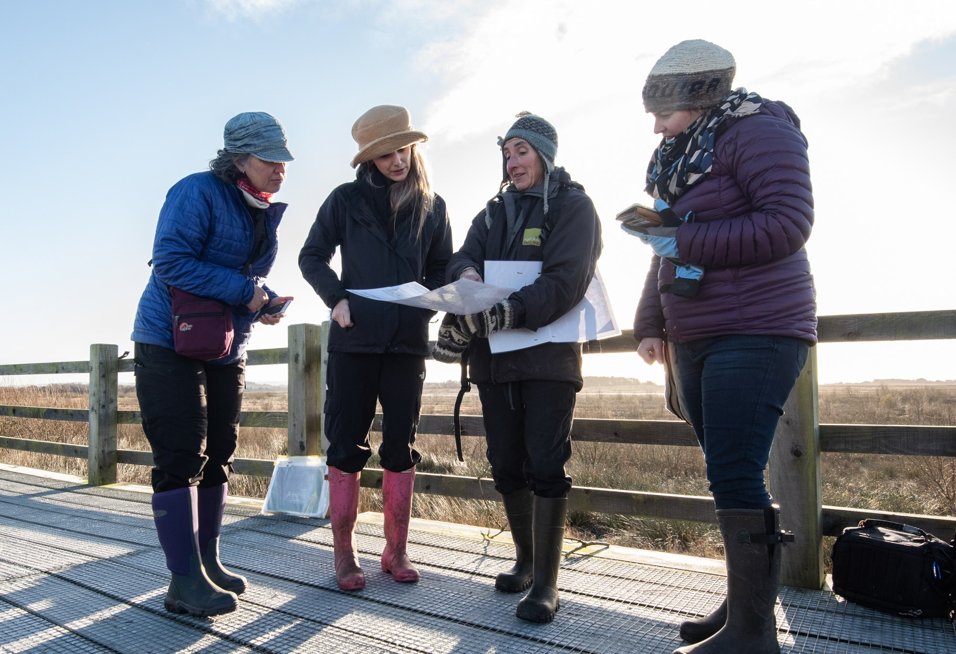

30 Above Photo by and from PLACE

Case study #8
Yorkshire Sculpture Park

The Yorkshire Sculpture Park (YSP) are an incredibly inspiring example of how the arts and natural environment work together. They offer an amazing range of opportunities for the public, creative sector, and educational institutions to become involved in the landscape through their sculptures, exhibitions, and events. Since the YSP’s inception they have offered artists a unique space to work and think, with artist residencies, gradu- ate awards, open studios and laboratories for experimental and risk-taking practice.
Their Art for the Environment Residency Programme pro- vides students and postgraduates the opportunity to explore the relationship between new forms and concepts of contemporary sculpture, landscape and nature. The artistic programme fea- tures major indoor and open-air exhibitions and ambitious inter- ventions in the landscape. These residencies provide the means through which artists can become involved with and inspire others regarding the natural landscape. Alongside this, the pub- lic experience of the Yorkshire Sculpture Park allows audiences to boost their wellbeing, as spending time there outdoors and
having meaningful experiences with nature improves health and happiness; the YSP reference the five pathways of nature connect- edness on their website, as researched by Derby University.

31

https://ysp.org.uk/learning/artandwellbeing https://ysp.org.uk/media/press-releases/yorkshire-sculpture-park-announc- es-2019-artistic-programme
https://ysp.org.uk/exhibitions/visiting

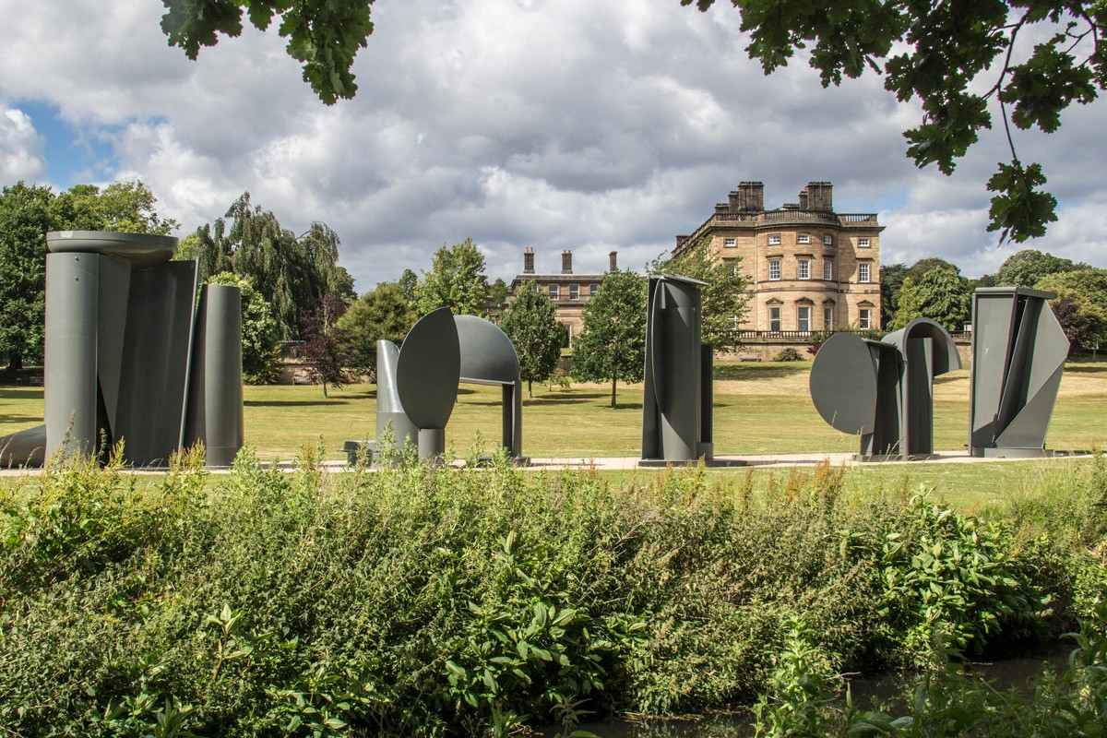

Above Photo by and from Yorkshire Sculpture Park

Conclusion

This report contributes to ongoing debates around how the arts sector can help facilitate vital nature connections. The importance of this work cannot be overstated. There is compel- ling evidence that increased nature connections can improve individual health and wellbeing (with corresponding implica- tions for public health policy and budgets) and also provide inspi- ration for environmental activism. The need for greater nature connectivity has been well documented, and in this report I
have linked research from our partners at Derby University (e.g. 5 Nature Connections pathways) with a wide range of national and international policy initiatives, strategies and agreements. Cross-sector collaboration between cultural and environmental organisations has the potentialto co-create new knowledge and understanding that goes beyond data collection, and into mate- rial and consequential community and individual engagement. This would represent a paradigm shift. Through tracing the aca- demic research, governmental policy, existing examples of good practice, and conducting interviews, this report has attempted to consider the subject of cross sector artistic and environmental collaboration from an interdisciplinary, multi dimensional per- spective. Having worked at the intersection of arts and nature, delivering a multitude of events focused on creating nature con-
nection for audiences in the face of a lack of coordinated, strategic
interventions, it felt important to try to collate both existing information and resources with potential possibilities for the future in a single, concise report. There is so much being done within our sector already, but ensuring that the already occurring conversations and action are easily accessible and being high- lighted to an appropriate extent is of vital importance. Through highlighting existing good practice I also hope to shine a light on the many opportunities for further innovative practice, with the arts and culture sector taking a genuinely collaborate role (rather than merely an ‘add on’ or an ‘after thought’) in tackling the bio- diversity crisis.
The outcomes of this research are intended to be practi- cal and useful for advocacy for policy makers, funders, arts and nature conservation organisations, with evaluation and data informing future working and potentially the pilot of a LCNP. I hope it provides discourse between arts, conservation, policy and funders, enhancing recognition of the critical importance of arts and cultural policy in developing environmental interventions, as well as the need for environment strategies to reference culture and cultural strategies to reference the environment.
This project will hopefully go some way in furthering the conversations and action already occurring, increasing ambitions and confidence in collaboration and I look forward to following future developments which will hopefully arise from the publica- tion of this report.

32

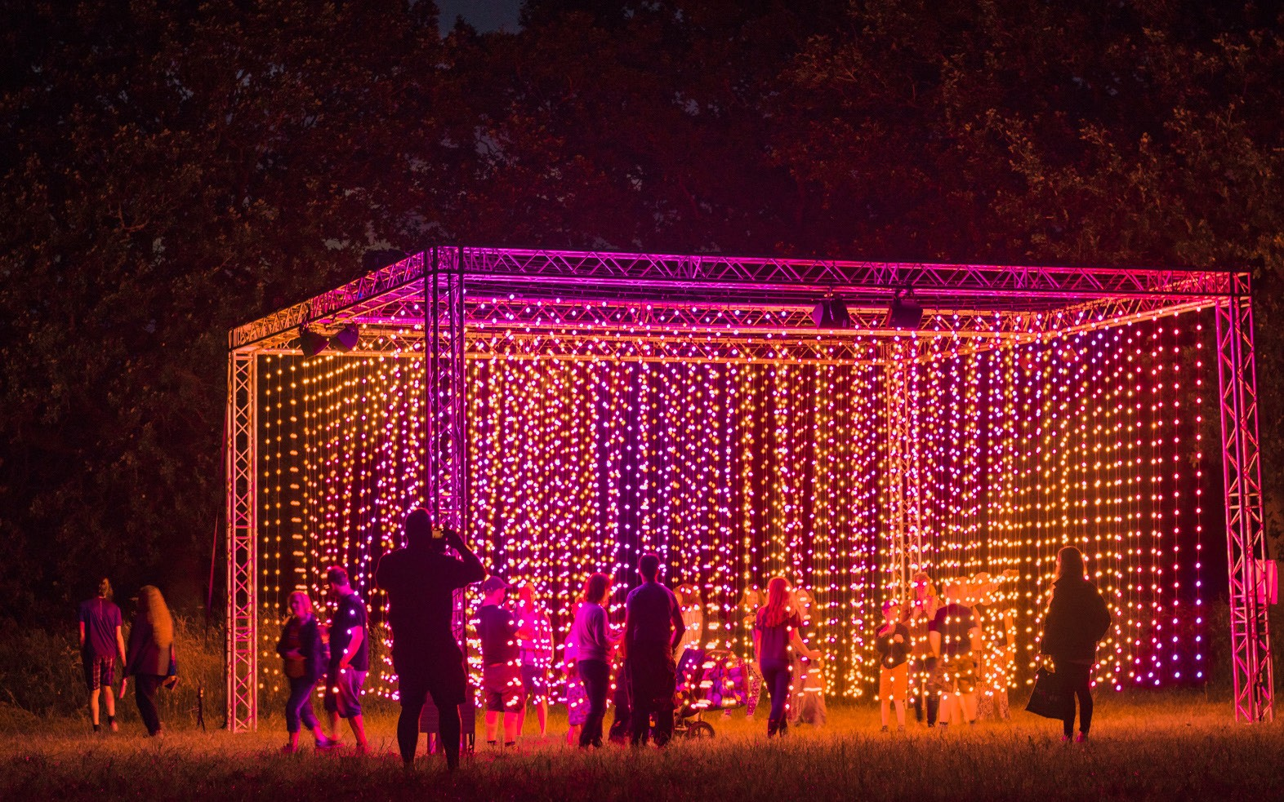

33

Bibliography

Arts Council England. (2020) Let’s Create, <https://www.artscouncil.org.uk/ letscreate>

British Council. (2022) A better world: Creative Commissions for the cli- mate, <https://www.britishcouncil.org/arts/culture-development/our-stories/ creative-commissions>

Charles, C., Keenleyside, K., Chapple, R., Kilburn, B., Salah van der Leest, P., Allen, D.,
... & Camargo, L. (2018). Home to us all: how connecting with nature helps us care for ourselves and the Earth.

Climate Change Committee. (2018) 25 Year Environment Plan, <https://www.theccc. org.uk/2018/01/12/25-year-environment-plan-climate-change-perspective/>

Department for Environment, Food and Rural Affairs. (2018) A Green Future: Our 25 Year Plan to Improve the Environment, <https://www.gov.uk/government/ publications/25-year-environment-plan>

England, N. (2020). A summary report on nature connectedness among adults and children in England. Monitor of Engagement with the Natural Environment.

García-Dory, Fernando, Piotr Michałowski, Laura H Drane. (2020). Arts in Rural Areas. IETM Publication.

Glover, Julian. (2019). Landscapes Review. Department for Environment, Food and Rural Affairs.

Hughes, J., Richardson, M., & Lumber, R. (2018). Evaluating connection to nature and the relationship with conservation behaviour in children. Journal for Nature Conser- vation, 45, 11-19.

Julie’s Bicycle. (2022) Julie’s Bicycle, <https://juliesbicycle.com/>

Julie’s Bicycle Briefing Note (2021) Connecting Culture and Nature, the Creative Cli- mate Convening. Rebecca Hazlewood; Lucy Latham; Chiara Badiali; Alison Tickell

Landscapes for Life. (2022) Art in the Landscape, <https://landscapesforlife.org.uk/ about-aonbs/art-landscape/art-landscape>

Leopold, A. (1966) Thinking like a mountain. A Sand County Almanac with Other Essays From Round River, Oxford University Press, New York (1966)

Lumber, R., Richardson, M., & Sheffield, D. (2017). Beyond knowing nature: Contact, emotion, compassion, meaning, and beauty are pathways to nature connection. PLoS one, 12(5), e0177186.
National Forest. (2022) National Forest Arts Grants, <https://www.nationalforest. org/about/grant-opportunities/arts-grants>

National Trust. (2020) Noticing Nature, <https://www.nationaltrust.org.uk/features/ noticing-nature-from-dawn-to-dusk>

Natural History Museum. (2022) Biodiversity Indicators, <https://www.nhm.ac.uk/ our-science/data/biodiversity-indicators.html>

Royal Society for the Protection of Birds. (2019) State of Nature Report, <https://nbn. org.uk/stateofnature2019>

Soga, M., & Gaston, K. J. (2016) Extinction of experience: the loss of human–nature interactions. Frontiers in Ecology and the Environment, 14(2), 94-101.

Saratsi, E., Acott, T., Allinson, E., Edwards, D., Fremantle, C., & Fish, R. (2019). Valuing arts and arts research.

Sustainable Development Goals Knowledge Hub. (2019) On the Road to the 2020 UN Biodiversity Conference <http://sdg.iisd.org/commentary/policy-briefs/
on-the-road-to-the-2020-un-biodiversity-conference-imagining-the-post-2020-glob- al-biodiversity-framework/>

United Nations. (2021) Decade on Restoration, <https://www.decadeonrestoration. org/what-ecosystem-restoration>

United Nations. (2021) Sustainable Development Goals, <https://iraq.un.org/en/ sdgs/15>

Zeng, Y., Maxwell, S., Runting, R.K. et al. (2020) Environmental destruction not avoided with the Sustainable Development Goals. Nat Sustain 3, 795–798. https://doi. org/10.1038/s41893-020-0555-0

HEI Partner: University of Cumbria Supervisor: Prof Ian Convery

34

Appendices 1.

PLACE Collective https://theplacecollective.org
Centre for National Park and Pro- tected Areas
https://www.cumbria.ac.uk/ research/centres/centre-for-nation-
Green Space Dark Skies https://greenspacedarkskies.uk
Wellcome Trust https://wellcome.org
Wildlife Trust https://www.wildlifetrusts.org
Kew Gardens https://www.kew.org/
National Forest https://www.nationalforest.org/
Jan Van Eyck’s Nature Research Programme & Future Materials
Serpentine Galleries https://www.serpentinegalleries. org/
Anne Marie Culhane https://www.amculhane.co.uk/
Ackroyd & Harvey
Jason Singh http://jasonsinghthing.com/

Music Declares Emergency https://www.musicdeclares.net/

IMPALA
https://www.impalamusic.org/

al-parks-and-protected-areas/
Bank
https://www.ackroydandharvey.

Forestry England https://www.forestryengland.uk
Valuing Nature https://www.valuingnature.ch
Art.earth
https://art-earth.org.uk
InsideOut Dorset https://activateperformingarts.org. uk/whats-on/inside-out-dorset/
Activate https://activateperformingarts.org. uk
Oerol Festival https://www.oerol.nl/en/ wat-is-oerol/
Rewilding Britain https://www.rewildingbritain.org. uk
Oak Project https://oakproject.org.uk
May Project https://www.mayproject.org
The LAND Project https://thelandproject.org
National Trust https://www.nationaltrust.org.uk
Nature North https://www.naturenorth.org.uk/
RSPB
https://rspb.org.uk
In Situ
https://www.in-situ.info
Shift https://www.shiftliverpool.com
Sail https://wearesail.org
Unboxed 2022 https://unboxed2022.uk
MAST
https://www.g-mast. org/10-years-of-mast
Wild Rumpus www.wildrumpus.org.uk
Timber Festival www.timberfestival.org.uk
Hinterlands Festival www.hinterlandsfestival.org.uk
Chester Zoo https://www.chesterzoo.org/
https://www.janvaneyck.nl/ postacademy/nature-research
Julies Bicycle https://juliesbicycle.com/
Culture Declares Emergency https://www.culturedeclares.org/
Nature North https://www.naturenorth.rg.uk/
Common Ground NNF https://nnfestival.org.uk/ common-ground/
The Nest Collective https://thenestcollective.co.uk/
Instar
https://www.we-are-instar.co.uk/ aboutus
Eden Project https://www.edenproject.com/
Dartington Trust https://www.dartington.org/
Wye Valley River Festival https://wyevalleyriverfest.com/
WWT
https://www.wwt.org.uk/
com/

Orchestra for the Earth https://www.orchestrafortheearth. co.uk/

Slung Low https://www.slunglow.org/

National School of Forestry https://www.cumbria.ac.uk/study/ academic-departments/insti-
tute-of-science-and-environment/ the-national-school-of-forestry/

International Union for Conservation of Nature https://www.iucn.org/

Somewhere Nowhere https://www.somewhere-nowhere. com/

Manchester Museum https://www.museum.manchester. ac.uk/

Katie Patterson http://katiepaterson.org/

Natural England https://naturalengland.blog.gov.uk/

35 Interviews

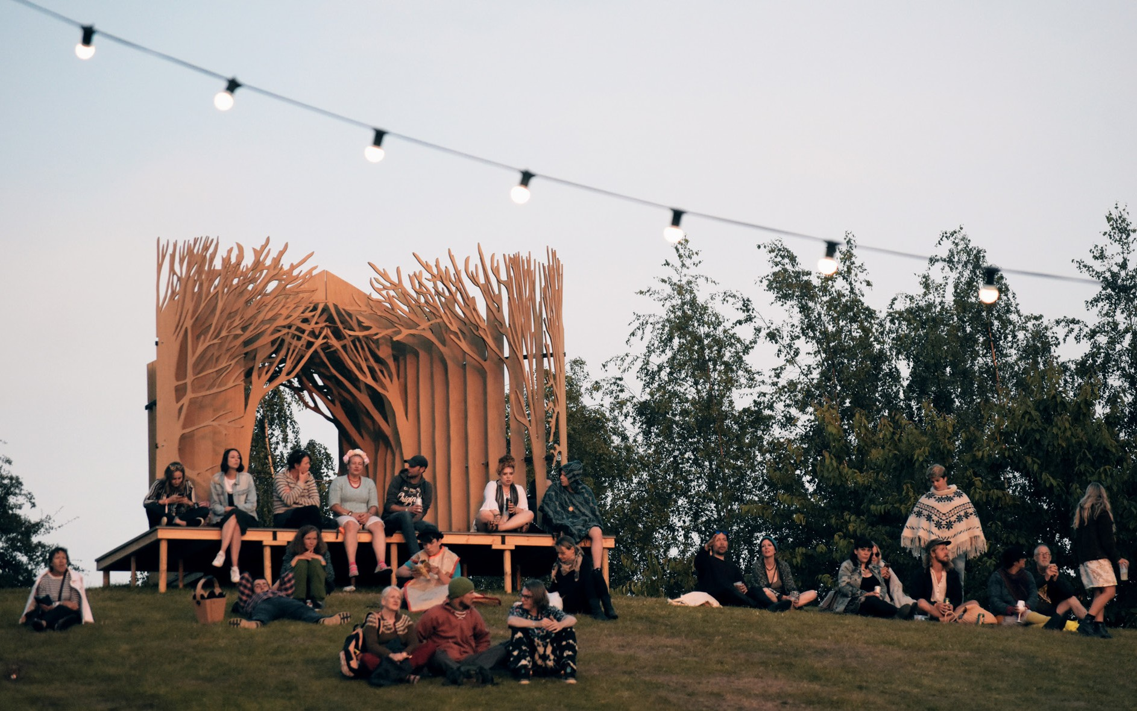

36

