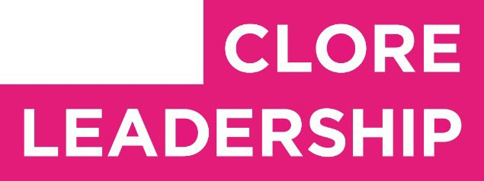

Clore Leadership-AHRC Online Research Library Paper

Let’s Create: Do we know how to?
Author: Naomi Alexander
Supervisor/s: Leila Jancovich, University of Leeds

Year paper completed: 2020
Leadership Content Theme/s: Inclusive Leadership Practice, Leadership Styles

AHRC Subject Area/s: Policy Arts Management and Creative Industries, Community Art (including Art and Health)

A note on contents:

Since 2005 Clore Leadership and AHRC have partnered to offer a diverse range of cultural leaders the opportunity to produce a piece of extended research relating to leadership and to their specific cultural discipline. These papers, published from 2023 onward on the Clore Leadership-AHRC online research library, reflect an important contribution to the field and we are extremely pleased to make them available to practitioners, scholars, and other interested parties. We recognise that this research library contains a range of terminologies and outlooks: these are reflective of the significant and ongoing changes within the cultural sector over the past 20 years. As such we urge readers to recognise that the authors’ thinking and language may have shifted since completion of these papers, or may be in the process of shifting as consequence of their enquiries.

Unless otherwise stated, research papers included in the Clore Leadership-AHRC Online Research Library have not been formally peer reviewed or published in an academic journal.

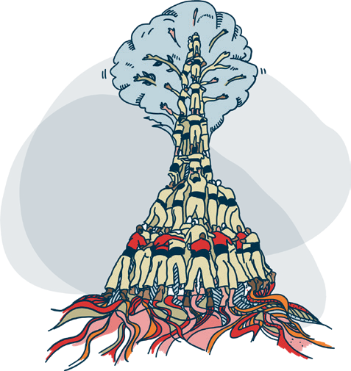
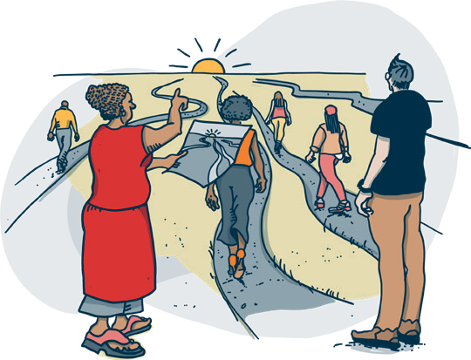
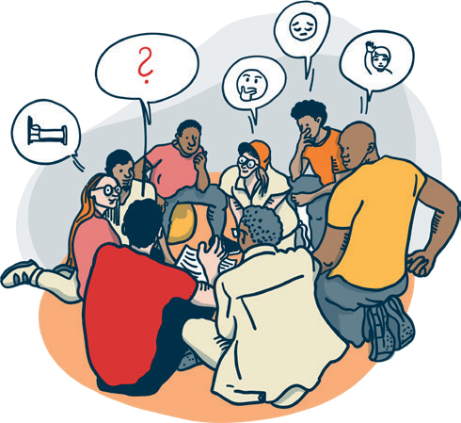
Let’s Create:
Do we know
how to?
Arts and Humanities Research Council/ Clore Leadership funded research by Naomi Alexander, Clore Fellow 2019/20

Let’s Create:
Do we know how to?
Arts and Humanities Research Council/Clore Leadership funded research by Naomi Alexander, Clore Fellow 2019/20

Table of Contents
Research Findings 6
Qualities 7
Skills 15
Responsibilities 22
Conclusion 32
Thanks 33

Introduction

Why is this research needed?
Above my desk, I have this written on a post-it note:

The Creative Process

This is awesome.

This is tricky.

This is shit.

I am shit.

This might be ok.

This is awesome.
I saw it on Twitter a few years ago and wrote it down because it made me laugh with recognition of just how challenging the creative process can be. I keep it on my wall because in those moments where everything feels lost and I doubt my own abilities, it reminds me how normal and inevitable these feelings are when creating.

Creative processes can be hard work. They can also be joyous.
While potentially even more rewarding, creating with others can be even harder work. The music industry is awash with stories of bands who break up over creative differences. In the theatre industry, what you are like to work with, how you co-create is as important as what you create.

Implicit within the upbeat vernacular of the Arts Council’s new 10-year strategy, Let’s Create, is an assumption that co-creation is a joyful process, and that we know how to do it. But is this the reality?

When co-creation takes place between professional artists and non-professional artists there are a myriad of tensions and power imbalances at play. So my research set out to explore how people involved navigate these tensions and power imbalances in order to co-create and asks how does leadership work in this context?

There has been a resurgence of interest in co-creation in the arts in recent years. Particular initiatives of relevance to this research are:

- Arts Council England’s Let’s Create strategy 2020-
2030 with its emphasis on participatory and
co-created arts
- Creative People and Places (CPP) Network and the emphasis on co-created work with communities the initiatives are there to serve
- Battersea Arts Centre’s
Co-Creating Change (CCC) Network enabling people in the field to share practice

But there is a lack of evidence-based research into leadership practice in co-creation that is striving for greater cultural democracy.

I hope my research helps fill that gap.

What I did
Working with my supervisor, Dr Leila Jancovich in the School of Performance and Cultural Industries at the University of Leeds, I began the research process by undertaking a desk-based review of literature related to theories on leadership and current leadership models. I also looked specifically at literature on cultural and community development leadership approaches which seemed most
relevant to co-creation and cultural democracy.

I then ran 3 workshops on zoom for professional and non-professional artists who had experience of co-created artistic practice. These were advertised on Twitter, and through the CPP and CCC Networks. They were attended by a total of 3 non-professional and 23 professional artists. I asked
participants at each of these workshops to explore the ideal skills professional artists need to acquire, the qualities they need to embody and the responsibilities they need to hold.

Following these workshops, in dialogue with my supervisor, I decided to focus fully on professional artists. I took this decision because I have been unable to find any existing research about the skills, qualities and responsibilities needed by artists to lead co-creative practice effectively. Alongside this, at the first 2 workshops, there was very positive feedback from artists saying that they had not thought about this before, nor articulated it. People said they found the process of participating in the research really beneficial.

This is not to ignore the fact that non-professional artists also play a role in leading co-creative processes at different times and in different ways. They do. And this is an important and under- recognised part of the co-created process. However, due to the limited scope of this research process and the complexity of what I was already looking at, I decided to focus purely on leadership by professional artists in order to generate real value for artists leading co-creative practice.

Alongside the workshops I asked CPP and CCC Networks, Twitter and my own professional networks to identify professional artists who have an outstanding track record of co-created work who I could interview in more depth. I carried out 8 in depth interviews with artists practising co-created work in a variety of different art forms: theatre, music, opera, film, photography, visual art and dance.

During the interviews I modelled a co-created approach to generating new knowledge production with my interviewees. Together we explored the ideal leadership qualities, skills and responsibilities necessary for effective co-creation and gained new insights during the conversations.

Artists involved in both the workshops and interviews were drawn from across the UK, most of whom were working freelance. All artists who contributed are credited at the end of this report, but the detail of their contribution has been anonymised to encourage more open and critical examination of the

topic. It was frequent that workshop participants or interviewees would comment that they had never thought about or articulated their work in this way before.

Once the interviews and workshops were complete, I undertook thematic analysis to produce this report for AHRC. This involved looking for recurring themes, coding these together and reflecting on how to interpret the data with my supervisor. Within this report I have attempted to show where I noticed high levels of consensus amongst research participants and where fewer artists talked about a particular idea.

I have subsequently secured funding from Arts Council England to work with a visual artist,
Sandra Staufer, to turn the findings in this report into an accessible resource for other artists that can be freely available online. This funding also enabled me to record 20 podcast episodes exploring each of the 20 research findings with artists working in the field. These are available on my website www.naomi-alexander.com.

What this research is and isn’t

This research is a starting point into a rapidly evolving field of practice. It is not attempting to be a definitive work that maps out the whole territory of leadership in co-created practice.

This report represents the findings of a piece of research which in total has lasted for 20 days only.
There is much more to be explored and discovered.

My hope is that by undertaking the research that it will kick-start a conversation that recognises the extremely skilled, complex and nuanced leadership that artists already demonstrate when leading co-created practice with non-professional artists.

More detailed research needs to be undertaken to explore how these qualities, skills and responsibilities might be developed in those new to the work.

Inherent within the research findings are a wide range of contradictions. Artists are individuals with their own unique way of working. Very few, if any, have had any formal training in how to lead co-created practice. So, a wide range of styles, approaches and methodologies have evolved from artist to artist and from art form to art form. Artists learn on the job and occasionally, by watching other artists at work.
I have attempted to capture these differences alongside the similarities which clearly emerged as I
analysed the research findings.

Definitions
Just as there are many different approaches to leading co-created work, there are many different
ways of defining the boundaries around the work. The process of
co-creating is highly complex and variable from one artist to another. For the purposes of this research, I have defined things in the following way, drawn from sources like this from The Arts Council (Heart of Glass and Battersea Arts Centre) and this from Francois Mattarrasso.

Co-created art
A range of processes that stretch along a continuum of shared influence, power and control between professional and non-professional artists; leadership and control can ebb and flow between professional and non-professionals during a session and over the lifetime of a project. It is not a creative process where an artist has a vision for a work of art and involves people in realising it but they have limited or no creative input into the creation of the piece.

Leadership
Where paid responsibility for leading an artistic process sits with an artist to instigate, frame, facilitate, reflect, synthesise and produce a work of art and where responsibility for some or all of these activities will be shared with non-professional artists. While leadership can come from anywhere, my focus in this research is on leadership by professional artists.

Professional Artist
A person who is paid to take a creative lead in the production of a work of art.

Non-professional artist
A person who is voluntarily contributing their time to contribute creatively to the production of a work of art.

Research findings
The research enquired into three areas of leadership in co-created arts practice: qualities, skills and responsibilities. Throughout the research process I framed these three areas to people in the workshops and interviews in this way:

- qualities as ways of being that an artist leader embodies
- skills as ways of doing things that an artist can acquire
- responsibilities as things an artist holds ethically, contractually, or artistically.

What has been interesting about the research process is the ways in which there were both high levels of consensus amongst research participants in their responses to the research questions alongside real differences in the nuance of their individual approach.

The research findings are presented here as a series of verbatim quotes from research participants to fully reflect the diversity and the consensus of their perspectives.

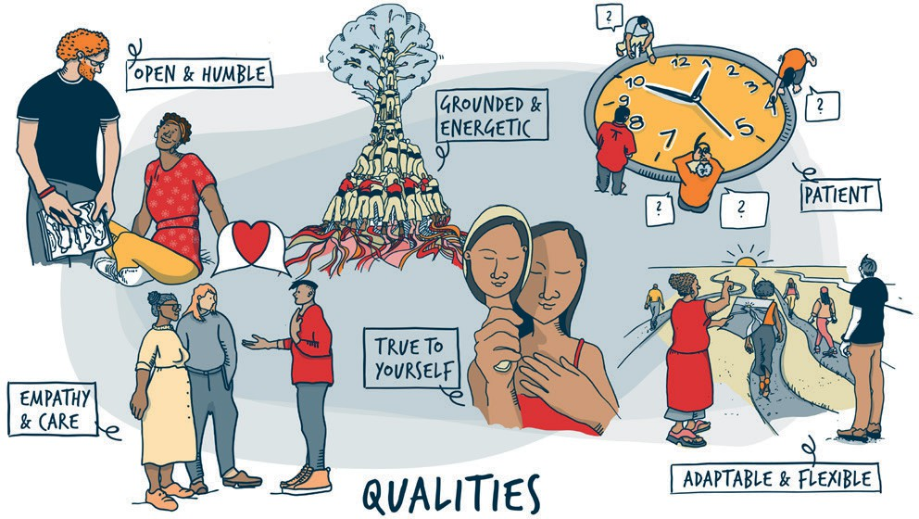

Qualities

These are the main qualities that artists who took part in the research identified as being of most importance to the effective leadership of

co-creative processes. We define qualities as ways of being that an artist embodies whilst leading.

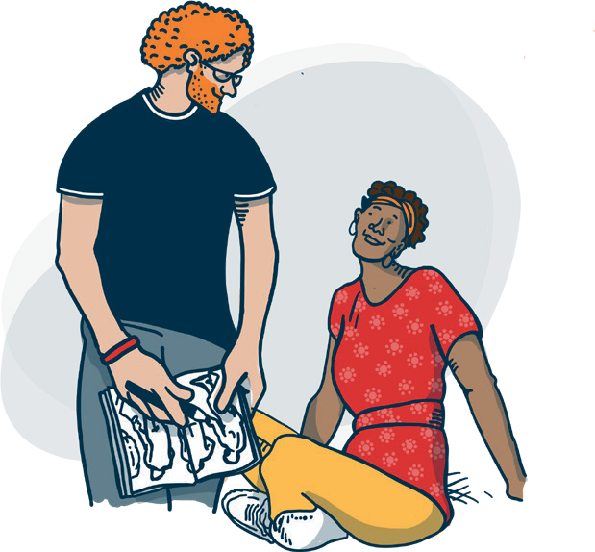
Open and humble
Almost every person involved in the research process talked about the importance of being both open and humble whilst leading co-creative processes. These qualities were deemed to be absolutely essential to effective leadership, in order to give space for non-professional artists to develop their own creative ideas. The professional artist leading the co-creative process has to be open to creative influences from everyone in the room.

Quotes from research participants

“You have to be open hearted, open minded, open spirited and have an open physicality. If you’re anything but open, it’s not going to work.”

“So someone who is humble when leading a co-creative process won’t have the expectation or feeling that their work is
somehow worthier than the other people in the space. They won’t be arrogant, or domineering with a top down approach.”

“Totally role modelling humility. Yes. That you as an artist are on your journey as a human being. It’s about saying, ‘I’m moving too and I can be moved by you.’”
“It’s also important to have a sense of humility and to be humble because I think I find the differentiation between a professional and non-professional artist problematic within the idea of leadership and the power imbalance of that.”

“I suppose it’s a humility thing, at least, an embodied understanding that you’re actually beneath rather than above. You need to reign in your artistic creative voice and bring that right back so that you allow other people
to space. Unless you do that, people aren’t going to come forward and be leaders in their own right. So I think that humility is a really important aspect to this work.
A really important quality.”

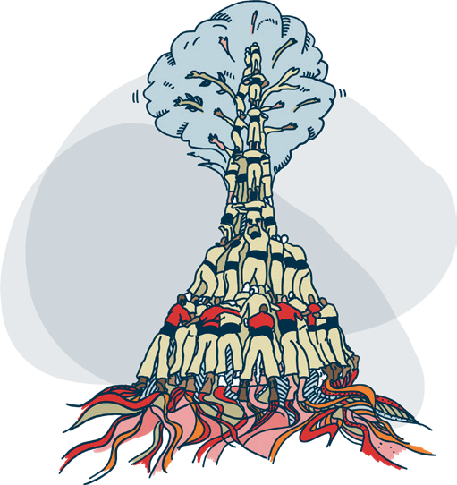
Grounded and energetic
Many research participants talked about the significance of the energy that artists use when leading a co-creative practice. This varied across art forms with people working in performing arts placing more emphasis on this than those working in visual arts. Artists talked about the need for energy to be both grounded and expansive. People are aware of the energy in the room and in their own bodies and the relationship between the two.

Quotes from research participants

“The energy comes from my chest, a little bit from the eyes, that’s where I mobilise from in a workshop. It’s a very emotional feeling. It’s love. It’s definitely love. Yeah, like it’s from the heart. And there’s something about an invitation happening. Energetically in the body.”

“You’re deciding how much you lead because if you can cultivate and inspire leadership in everyone, then hopefully you can create a space where everyone feels their own agency to navigate that themselves. I think the energy moves through and with people rather than over them.”

“There’s something about being grounded in a space. You need to find that ground and be rooted in the present.”
“You need to be modelling the energy you want to see in the room. And creating that energy and making space for energy. You’re a superconductor, in so many ways. In
both meanings of the word. Like your super conductive energy that you take it in and give it out, right, like you’re mercury. Like, you know, you can really absorb the heat in the room and hold it. Yeah. But you can also then disperse
it. Yes, you can cool the room down and you can heat the room up. I think knowing when to dispense and take that energy is also really important because sometimes that room is
giddy and you want it to be giddy, you know you really want that kind of giddiness. And other times that’s not helpful.”

“There’s a kind of animalistic, hyper aware, hyper alert kind of energy, where your radars are on in a really big way. And you’re just totally there and you’re totally in it.”

Grounded and energetic continued

“I think sometimes you are balancing energetically between really shooting for something and also being restrained and sitting back to let other people
come forward.”

“Having a passion for what you’re doing, I think really helps to draw people in. But not the kind of passionate energy where everyone else
is being all sort of subsumed, and you’re the centre of attention. Not that kind of passion. Just that you’re really passionate about your art form with a sense that ‘we can do this together’.”
“It is about creating energy. It’s about creating an energy with everybody and then sustaining that and knowing it’s exactly the same as if you’re working with 100 people or 5 people. You know, it’s like there’s a string from you to every single person and you’re holding it. You’re never going to lose the room. It’s always that energy. And I think whether you’re dealing with a massive group of 1000s or a smaller group.
You have to keep that energy on, like on the up and everybody feeling positive.”

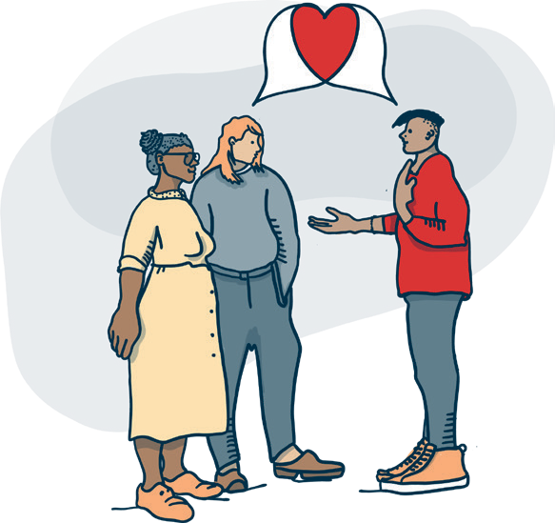
Empathy and care for others
Almost all of the artists talked about the need for care and empathy with the non-professional artists in the creative process as fundamental qualities that artistic leaders need to embody. Particularly for artists leading group processes in the
performing arts there was a sense of taking great care of everyone in the room and being aware of connecting with them in a careful way.

Quotes from research participants

“I’m running an internal dialogue constantly. And part of my brain is doing a constant scan of the room, to the best of my ability, travelling through the heads of everyone in the room constantly. I’m like, ‘You okay, how
are you? What’s that? What’s going on? What’s happening for you? Are you alright?’ That’s obviously the biggest thing. Doing empathy.
For me it’s constantly like a generator running.”
“You’ve got to make an effort to connect with every single person. You have to make
everybody feel seen and everybody feel heard very quickly. You have to make everybody feel seen, which is about using your physicality, your eyes, your voice in the way that you’re talking to everybody. So it’s about the physicality. It’s about eye contact. It’s about vocalisation all of those things in terms of how you connect with every single individual in
the room.”

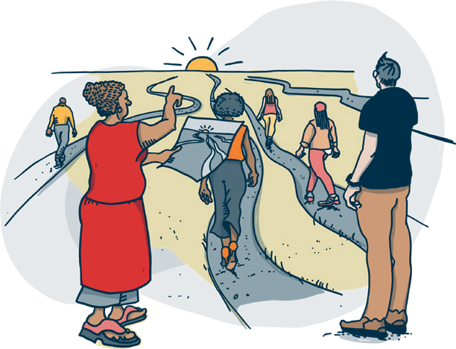
Adaptable and
flexible
All the artists talked about the importance of being adaptable and flexible in the work. We know that for any co-creative process it’s not possible to predict the artistic product, but all the artists talked about the importance of adapting and flexing the artistic process around the people who are on the journey with you. These qualities also draw on high levels of art form skill and competence to enable people to be held effectively on that journey.

Quotes from research participants

“It’s not sticking to the plan that you’ve created. You make the plan but then it’s about having the competence and the quick thinking in the moment to be able to follow what is happening in the room. Something happens that is really magic, and then quickly building things around that. It’s not just going off on a big tangent
for no reason. You’re holding the goal for the session that you had in mind, whilst we’re going in this new direction. You have to shift what you were previously planning to ensure we still achieve what we were aiming to achieve in that session.”

“So whilst you’re delivering the workshop, you’re also evaluating and revising, to get back to the goal. You’re communicating, you’re still holding the space and you’re replanning
in your head at the same time. Yeah, while everyone’s watching you.”
“You need to be able to see the end and to have a sense of this emergent thing of multiple possibilities. It’s like parallel universes, isn’t it? But it’s being able to scan the horizon and say, we might be going there or we might be going there or we might be going there. And I think in the first part of any co-creative process, if you don’t do that you’re really shutting down that horizon and those emergent possibilities.”

“I think all the time you need to be really aware when you’re delivering anything or speaking to the room. You have to be aware of how
it’s landing, and then be able to adapt what you’re doing, adapt the pace, adapt absolutely everything through an awareness of how it’s being received by every single person in
that room.”

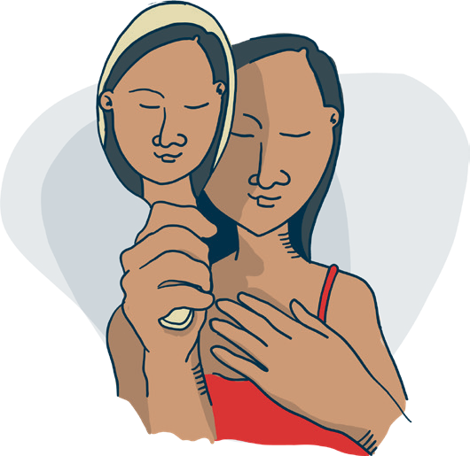
True to yourself
Many artists talked about the importance of being authentic, or true to who you are. Because there is a lack of training and support for artists in co-creative practice, people talked about a draw that can exist to deliver the work in the way that you have seen someone else deliver it. This doesn’t work. Artists need time to discover who they are when leading co-creative practice so that the way they lead is congruent with who they are.

Quotes from research participants

“You can’t ape somebody else’s way of facilitating co creativity. I think you have to draw on your own style. You know, if you’re a bit more of a shy person, use that, don’t pretend to be something that you’re not.”
“People can smell bullshit from a mile off whatever age they are. So actually, just being true to yourself, don’t try and push being passionate and you know, wildly gesture.
Everybody works in different ways. And actually somebody with a very quiet energy can probably pull the threads of creativity out of a quiet person beautifully.”

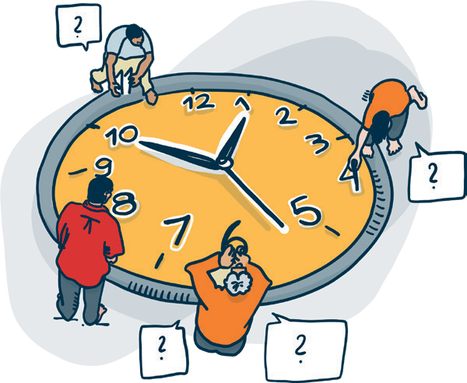
Patient
A couple of artists mentioned the importance of patience as an underrated quality that is especially important in a co-creative process. People work at different speeds and it’s important not to rush the process or non-professional artists who may have many competing demands on their time and less training/understanding of the art form.

Quotes from research participants

“It’s quite a dry quality, but there’s something about patience, something about sort of quietly making sure that there is space for somebody to come forward and sometimes that does
just take time and you need patience within yourself. If you imagine being in a room with an impatient leader you can see the importance of that quality. It would shut down creative possibilities quite quickly.”

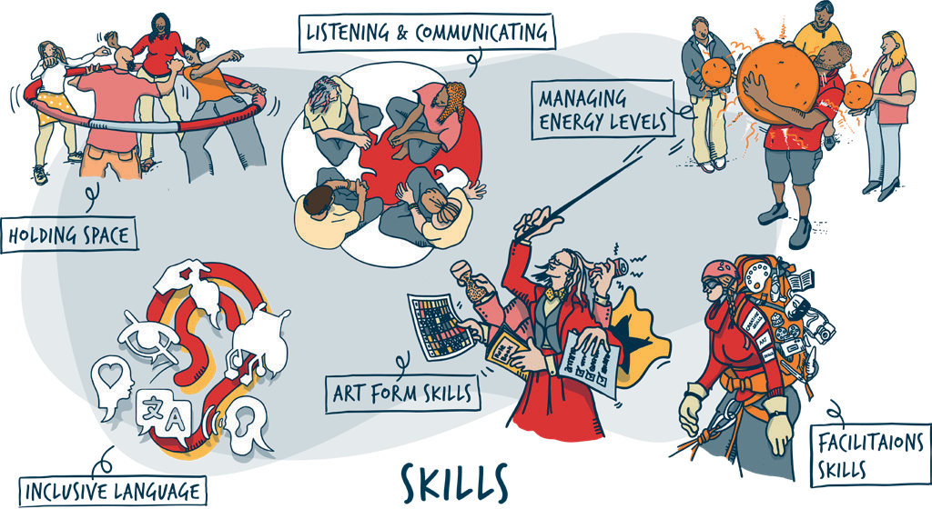

Skills

These are the main skills that artists who took part in the research identified as being of most importance to the effective leadership of co-creative processes. We define skills as being ways of doing things that an artist can acquire or learn to practise whilst leading.

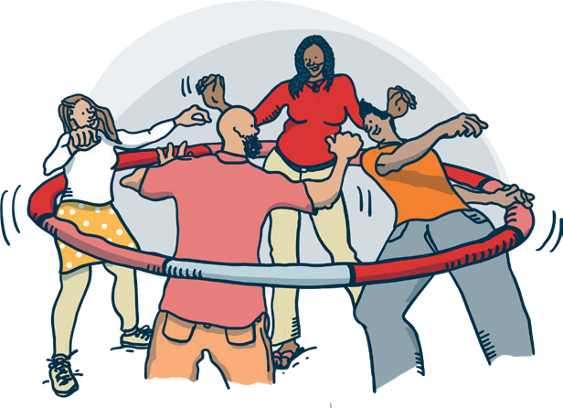
Holding Space
A key skill identified by all the artists was that of being able to hold space effectively for the expression of multiple ideas and opinions. This is a challenging thing to do well, ensuring that people feel safe to express themselves. The idea of holding space as a skill has been drawn from all of the artists talking about the need to be generous and share power between everyone in the room.

Quotes from research participants

“There’s something around debate and different thoughts and ideas. So being able to hold and encourage that. I think that’s a major skill. People come with differences of thoughts, opinions, politics, and so to be able to make sure that it’s a safe and inclusive
space, the skill to be able to hold that well feels important; to hold the difference of opinions, the difference of thoughts in the room. ”

“You need to sometimes gently close someone down in order to create space for someone else and that’s where the ‘yes and’ comes in. If you’re improvising or if you’re in a group discussion.
Because you can say ‘yes, Malcolm thank you and Derek what do you think?’, you know, you can sort of pass it on to the quiet person. So that skill is your ability to manage different personalities within a group so that everybody has an equal capacity to input ideas.”
“If you picture the room, there’s a kind of centrality to the leader, right. There’s a lot going on. And I think people are orbiting in really different ways, but I think you are almost always the centre of that orbit whether you like it or not. Now your positionality in that can be really problematic. So if we accept it and are aware of it, then there’s something about the generosity of that place and the way you share power and hold the space.”

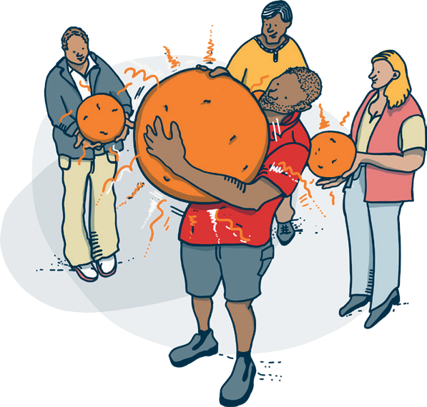
Managing energy levels
The skill of managing your own energy levels as an artist was raised by many of the artists during the research. This is clearly connected to the qualities
of being grounded and energetic, but I have listed it separately as so many people talked about this as being an important skill. In part it is a skill of self-
awareness, in part it is a skill of learning how to generate and manage the energy in the room.

Quotes from research participants

“Like this kind of work can be really exhausting and draining, especially to do it really well. So how can you make sure that you’re fuelling yourself as well? All the time.”

“I think you need to be able to read yourself. You need to be aware of yourself. You might be suddenly aware that you’re feeling really, really, really, tired. And sometimes that’s because you’re travelling too far. You’re pushing in the wrong direction or you’re pushing against the people in the room. And maybe you’re not even aware that you’re pushing against it until you become aware of yourself because you’re so kind of like ‘we can do this’. Maybe it takes you longer to be aware of yourself because you’re so focused on everybody else.”
“You need to be self-aware and alert. A really high energy but it’s contained. And it’s careful. It’s cautious.”

“So without getting too heavy about it, I think it’s like, literally you are holding a ball of energy but with your whole body, and with your face. And it has to have a certain charge within it. And if any part of it starts draining, if it starts being drained, then you start losing it, and other people will lose their energy and the energy will change and have a different
quality, a quite negative quality. So it’s learning how to manage that.”

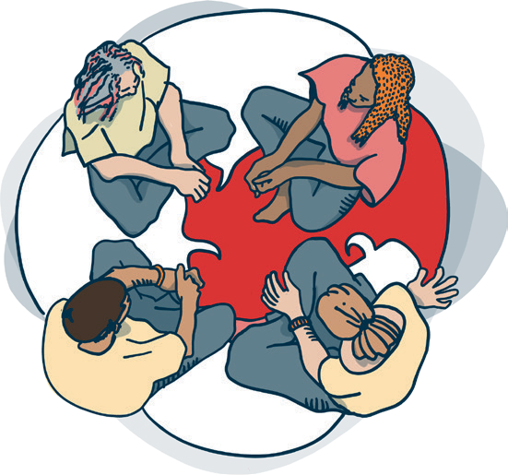
Listening and Communicating
Every artist talked about the importance of excellent listening and communication skills. I could have named this more broadly as ‘facilitation skills’, but there is something specific about the skills of deep listening and careful communication that is not captured in such a broad title. These skills are connected to the qualities of being open and humble, which create an environment where deep listening skills can be utilised most effectively.

Quotes from research participants

“In order to really listen, you have to not know what the outcome is.”

“There’s a whole load of skills in terms of the way you capture and refine material. It’s the way that you ask questions that are both open enough and not too open.”
“Something I do a lot is frame. So I provide frameworks for the work. And I make sure we’re all in the same place. I might say, ‘Okay, so what we’ve just been talking about is this, and I think, from what you said, that we’re interested in that. Do you agree? Yes. Okay.
Could everyone just get into pairs and have a chat about it?’”

“So mirroring, validating and reflecting back creative ideas.”


Inclusive language
Alongside the skills of listening and communicating clearly, was the skill of ensuring that the language you use is inclusive. This could be around the art form itself, through avoiding jargon that might exclude people, to ensuring that language is inclusive to people with different abilities.

Quotes from research participants

“We choreographed steps to the side, and steps to the other side. And there were some people in wheelchairs in that group. And I remember just thinking normally my language was like ‘step to the side’ and I realised Oh, no, that doesn’t work. It has to be move to the side. So now I use that language for all sessions, my language has become more inclusive.”

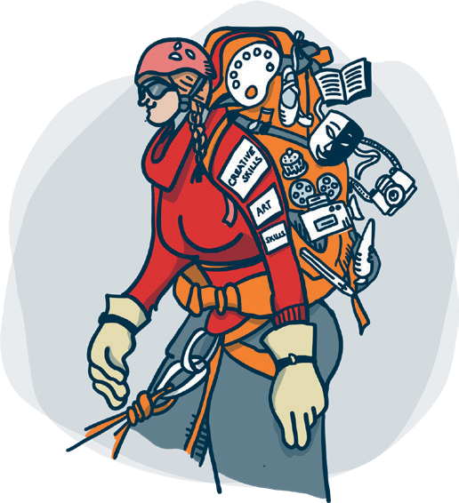
Art form skills
Most of the artists emphasised the importance of the skills they have acquired in their specific art form. People talked about the need for art form expertise and competence in order to be able to lead co-created practice effectively. Some favoured a depth of skills in a particular art form, while others believed that having access to cross art form skills at less depth was preferable as it generated more possibilities to support the creativity of non-professional artists in multiple art forms.

Quotes from research participants

“You need to have real competence in your art form and yet not let that dominate the space. You need to know your shit whatever that is. To be trained and knowledgeable in the art form at depth.”

“Cross art form creative skills can just unlock creativity in many different ways. How can you bring a platter of different ways of unlocking all of that with people? Because people respond in different ways to different offers.”
“We have things to teach, that we are in there as experts in what we do. Everyone’s in there as an expert of what they do, right. But the thing you bring is the skill in your art form.”

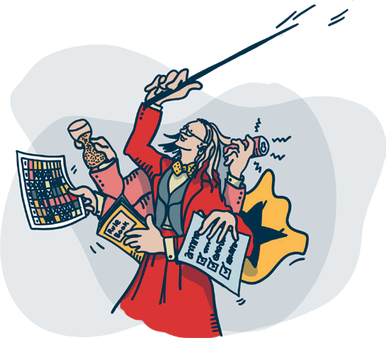
Facilitation Skills
There was consensus amongst all of the artists involved in the research that high quality facilitation skills were an absolute necessity for effective leadership of co-created arts practice.
For some they preferred to be seen as a facilitator than as a leader, finding more congruence with their values through the label of facilitator.

Quotes from research participants

“If you look at the root of the word facilitation, it means to make life easy. So, for me, the idea of facilitation, the idea of leading co creation is about making it easy for other people.”

“Do not underestimate the depth of skill needed to shape questions, shape lines of inquiry, pick something up and develop it. Filter. Reflect. Encourage and challenge. We don’t say this enough. It’s really important.”
“When you are facilitating, you’re holding this space and you’re not centering yourself at the core of it. That is a really integral skill.”

“I think one of the key skills that we have as artists is the ability to create space for people to prioritise. Instead of saying, ‘What are you interested in?’, say, ‘Here’s six things, put them in order. Why is that your number one?’ The biggest thing is asking ‘why?’ ‘Why?’ is my sharpest tool of all.”

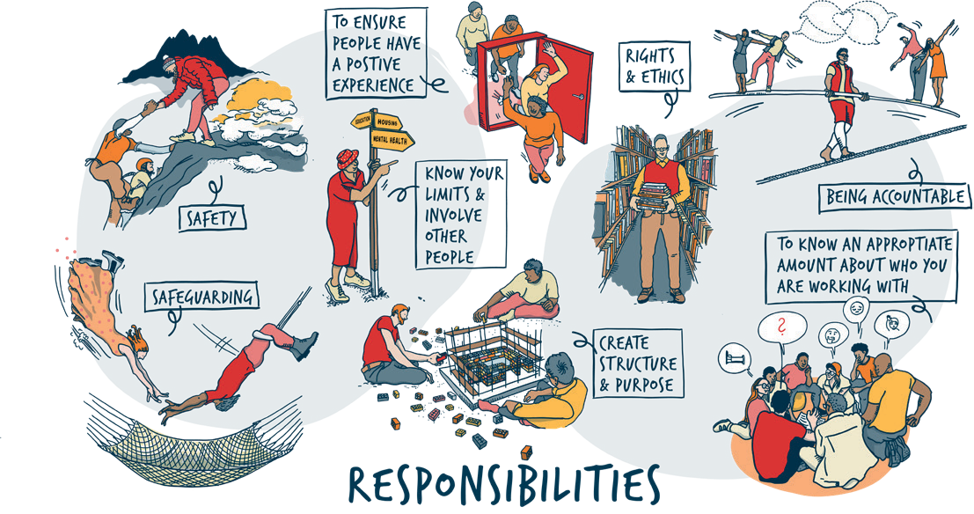

Responsibilities

These are the main responsibilities that artists involved in the research identified as being most important in leading co-creative practice effectively. We define responsibilities as things an artist holds ethically, contractually, or artistically.

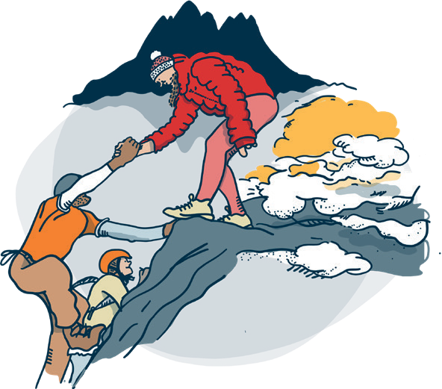
Safety
The first responsibility that almost everyone involved in the research identified was the responsibility to create a safe space for the creative process to happen. If people don’t feel safe, it’s much more challenging to be creative in a group setting. There was a difference of opinion about whether it was actually possible to ever truly
create a safe space. However, all artists involved talked about the importance of building trust in a group and between the group and the artist in order to generate feelings of safety.

Quotes from research participants

“When I started this kind of work, I would let stuff go because I was scared of conflict. I was scared of not being liked. I’m not scared anymore in any way. I’m pretty strict. I hold the space. And I hope I hold boundaries really tightly, especially with new groups. And I think the sooner we equate physical safety with
emotional safety, like if we treat those the same,
then that’s a good start.”

“You have to make sure this is safe for everyone. Safe, inclusive and accessible.”
“People come to trust in that space and to know that they are being held and looked after. And to know what kind of systems and protocols exist should things go wrong in that space.”

“If you feel safe you can celebrate your whole self and you can take risks and be brave. I think in some ways your responsibility is just to people’s safety and you know, the more you build a soft play area for everyone to play and
the more they can fling themselves at the walls and jump from very high and do cartwheels that they never thought they could do.”

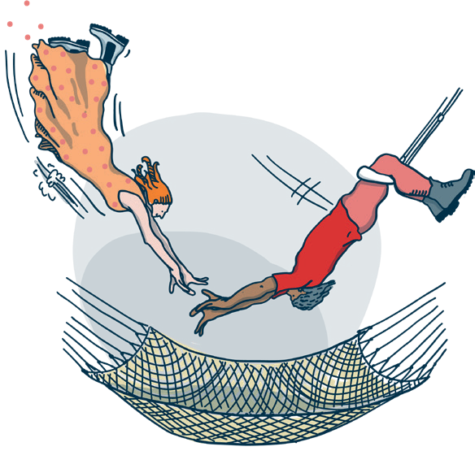
Safeguarding
Many of the artists specifically mentioned safeguarding as a particular responsibility which they felt artists leading co-creative practice need to be aware of. If contracted by an arts organisation they should ensure they are familiar with the policies in place. If they are operating as a freelancer they need to seek guidance and ensure they know what steps to take if someone shares something of concern.

Quotes from research participants

“Particularly if you’re working with vulnerable groups, I think it is really important that you know what to do about safeguarding. You need to know about mental health issues that people might be facing for example. It’s important to understand the context in which you’re working.”
“If you’re freelance, research into safeguarding and have something in place so that if somebody does divulge something that could put another person at risk you know what to do. There are very clear processes for reporting that. I think that’s a real responsibility.”

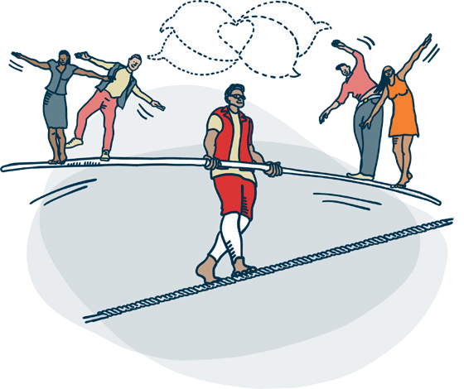
Being accountable
Many artists contemplated and interrogated the notion of accountability as a responsibility and the myriad of people and institutions that the artist is responsible to when leading this work.
Some felt that artists need to have their own sense of to whom they are accountable when juggling potentially competing demands or priorities.
“Have you been commissioned to do this work? Who are you reporting back to? What notes are you required to take? Are you clear on what outcomes and indicators you’re reporting against?”

Quotes from research participants

“You have to be clear about your motivations and intentions for doing the work. Do you genuinely want to co-create or are you just after the latest bit of funding in order to support you to do your own practice? Do you actually have the depth of skills to do this work? One of the issues is that there is often no-one monitoring the quality of this work and whether or not artists have appropriate track record and skills in co-creation as it’s such a relatively new field. So who are you accountable to when you decide to do it?”
“I think the responsibility is to hold the voices and the hearts of the people you are working with in your head. Okay, that’s quite poetic. But I think that’s the responsibility of who you are accountable to.”


Rights and ethics
Many of the artists involved in the research talked about the responsibility of being aware of the ethics involved in co-created work. The ethical landscape is complex, with many factors at play. Artists discussed the issue of who holds the rights to
co-created work and how much ownership professionals and non-professionals have over the work. There are also complex ethical responsibilities around the use of people’s personal stories and the need to ensure that these are not being used for the artist’s benefit.

Quotes from research participants

“Who owns co-created work? I mean, I have never made money out of any of the co- created work that I have been involved with. But the purpose of the work is to showcase the creativity of other people, not yourself. And that’s a key distinction, isn’t it?”

“I think there’s a habit in our work, people deny themselves in it, they say ‘oh it’s all their own work.’ And there’s loads of problems with that. One, it’s a lie. Two, it’s often used as an abdication of responsibility when things don’t go well.”

“If you’re using their material to make something larger you need to set up very clearly how you’re going to use material generated with them. Be clear how you’re going to come back to them to get the feedback.”
“You have to hold the responsibility of always asking, whose stories are being told and in whose hands are they being held? Often artists will come and go. They work with
this group, work with that group, and then they’re off again to the next thing. I think there’s a responsibility for organisations probably, but also for artists to think about what’s the legacy of the work? Even if the legacy isn’t with the artist? Because so many times groups feel like you’ve just taken off
at the end of the project having used our lived experience or expertise, and you’ve just used it for your shiny project, and there was nothing left for me. There’s no ownership for me in my life, or legacy.”

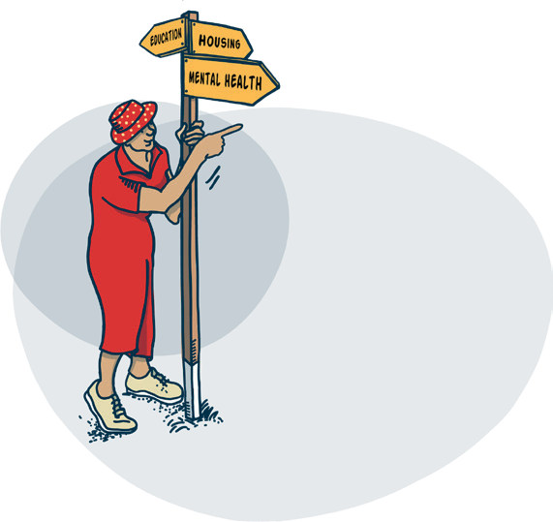
Know your limits and involve other people
Many of the artists talked about the importance of knowing the limits of your responsibilities and where you need to bring other people into the process to support it. Co-created work can involve asking people to share something of themselves and often this will need additional resources to support this happening effectively.

Quotes from research participants

“I’m not a counsellor, and I’m not a therapist. People often want to share a lot with you that could be about their own personal trauma or their own personal circumstances that they’re going through and that’s a lot for us to take on. And it’s really important to be able to hold the space so you need to ensure that you’ve got people in there who can do that or that you’ve got the systems and mechanisms outside of that space to support people.”
“Being aware all the time of what you are asking people to give. They don’t need to give too much of themselves, or that you are
enabling them to do that in a way where they are not being too vulnerable in the space.
Some commissioners are very afraid of that. I don’t think there is anything to be afraid of, people opening up. You just need to be really clear about what your responsibilities are and what the routes are to take action, or give people additional support if something happens.”

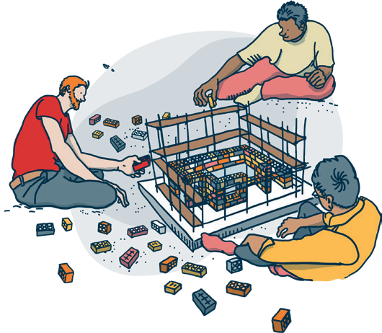
To create a structure/purpose
A key challenge in leading co-created work is that if you’re doing it properly, you don’t know what the artistic outcome is going to be. While the landscape is shifting, many artists talked about tension with funders wanting to know what the product was going to be before work had started. Others talked about the need
to co-create what the project was before the creative work started. There is then the responsibility of keeping the work focused, to
a structure in which people feel held and with a clear purpose. Some artists talked about the need for this leadership from the professional to stop projects going off at wild tangents.

Quotes from research participants

“The responsibility starts in a co-created collaborative process in designing the project WITH participants before you even start to
do the creative process. Ideally this happens before you apply for funding but that’s not always possible, especially if you’re freelance. It means artists are yet again put under pressure to work for free.”

“You need to know where you’re going. It’s about the purposefulness of what this session is and that’s where the leadership comes in. And you’ve got to facilitate that and have everybody signed up to the purpose. The shared purpose needs to be in the space in the room. Your responsibility as a leader is to make the workflow in that direction.”
“I found I struggled because I couldn’t give commissioners the artistic vision they wanted for their marketing department to sell the show. It was too early in the process, and they wanted to know what it’s going to be. I don’t know! I haven’t been in workshops with people, but they needed the info. I wanted it to be co- created and not my vision. I realised I could have put in an overarching shape early on that would have directed the co-creation, rather than it just being so open. That’s what the commissioners needed.”

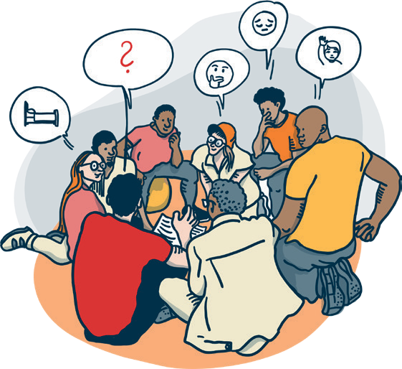
To know an appropriate amount about who you are working with
Context is key for this responsibility in which some artists felt that it is important to know an appropriate amount about who you are working with. Many co-created projects
are open access, others are working with a discreet community of people. All will have differing levels of ability and needs that the artist needs to sensitively accommodate without shaming or exposing anyone.

Quotes from research participants

“There is a responsibility to understand something about the people that you’re working with. And again, there are layers to that. Like sometimes there are things that you don’t need to know because knowing it wouldn’t make a difference to the co-creative process. But you might need to know how somebody’s ability to process things visually might impact on their ability to take and play a small percussion instrument or their ability to process sound.”

“Something that really annoys me about how lots of supposed community organisations operate is that they don’t know the names and faces of the people that they’re working with. And they use the word community when they don’t mean community they mean ‘other’.”
“I think it’s about immediately being able to know your room. To know who’s in the space, and very quickly work out what makes people tick, and the kind of energy that they’ve got and how you’re going to harness everybody’s energy and make something really exciting and enable everybody to feel really comfortable and safe and inspired and then use that. Use all of that to enable everybody to be their most creative selves. Most musical
selves, most connected with everybody else in the room and then fully see where it goes.”

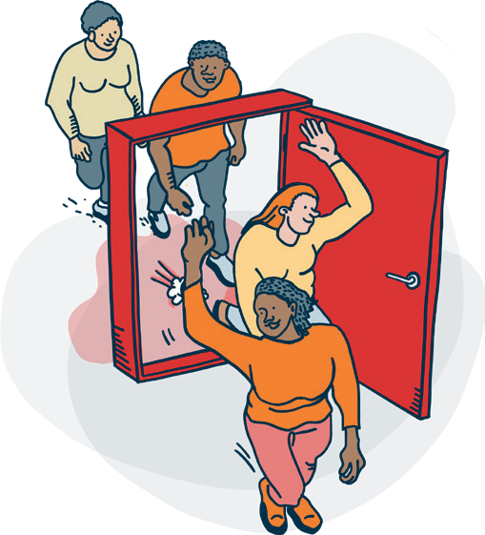
To ensure people have a positive experience
Some artists felt that they have a responsibility to ensure that people have a positive experience. For them, this is even true in the parts of a creative process
that might touch on the sharing of more challenging emotions. Artists need to hold this responsibly, name difficulties and close sessions properly. It’s possible for people to leave having had a positive, even cathartic experience of co-creating.

Quotes from research participants

“My responsibility to those people in that room is that whilst they’re working with me, they have a positive experience. And they go away feeling like something good has happened, even if part of the process has been difficult or a struggle.”

“I think you’ve got a responsibility to be with people who have walked into the room. People are in all sorts of states and you’ve no idea what is going on in people’s lives. And they don’t know everything that’s going on in your life as well. At its basic level you don’t want people to walk out in a worse state than they were when they walked in. Ideally you want people to walk out better. Yeah, maybe just having learned something new about themselves or you know, having felt enriched in some way.”
“Being a responsible host, being kind and friendly, as if you’re kind of welcoming people into your own home. How do you ensure they don’t feel uncomfortable in your space? I think as a professional artist, understanding that you have ownership of that space, especially at the beginning of the process, you have ownership of that space, and you have to welcome people into it to make them feel at home in it. So that’s kindness and friendliness and cake. Cake is always the way to do it!”

“When things get difficult you need to name it immediately, as soon as it’s happening. To
actually talk about the fact that it’s happening
or talk about the fact that it might feel a bit awkward rather than just sort of trying to push your way through it. You need to give everyone permission to feel that it’s okay. A normal part of the process. You know, it’s hard work. It’s not easy. Sometimes things don’t come easy.”

To ensure people have a positive experience continued

“Make sure you leave enough space to bring people together at the end and make sure people feel good before they leave you, a bit like doing a counselling session – you don’t want to let people leave if they haven’t fully processed or closed down the experience.”

Conclusion
The work of professional artists leading co-created practice is challenging, complex and highly skilled. During the research it was interesting to note the frequency with which almost everyone
involved talked about how they hadn’t necessarily even thought about any of the questions they were exploring before, and most had never articulated or shared the insights that were generated with others. Most people reported that the process of participating in the research was valuable to them for this reason as together we were generating new knowledge and understanding of the qualities, skills and responsibilities needed for effective leadership of co-created practice.

My interpretation of this is that the work of artists as leaders of co-created practice is under-valued and under-resourced. My experience of working in this field alongside this research leads me to conclude that there are a myriad of assumptions made by commissioners, funders and artists themselves about what it takes to lead co-created practice effectively. Amongst the artists involved in this small research project there was a great deal of consensus on some areas and also differences of opinion and approach in others.

Further research and conversations with artists exploring these differences further and to enquire more deeply into this would be valuable. My conclusion is that there is a definite need for further, deeper conversations about the qualities, skills and responsibilities utilised by artists when leading co-creative processes. I also believe that there is a need for further research to understand how artists come to embody the ideal qualities, acquire the skills and hold the responsibilities and to
develop training programmes to assist in this process. With the Arts Council’s continued investment in co-created practice for the next 10 years, investing in the development of artists as leaders is
long overdue.

Thanks to the research contributors:

Gemma Alldred Georgia Attlesey Daniel Bernstien Jess Blackledge Louise Brown Kate Clark Hannah Conway Maddy Costa
Claire French Charley Genever Ned Glasier Kane Husbands Pragya Kumar Elizabeth Lynch Skylar Mabry
Cristina Mackerron
Holly Marland Alison McIntyre Seth Pimlott David Slater Colin Stevens Sita Thomas Dan Thompson

Thanks to supporters of the research project:
Leila Jancovich Clore Leadership
Arts and Humanities Research Council Arts Council England
Battersea Arts Centre’s Co-Creating Change Network Creative People and Places Network
All the artists who responded offering to be involved, most of whom I did not have time within the scope of this research to talk to


