


Clore Leadership-AHRC Online Research Library Paper
Small Society: Arts, Craft, Culture and Community on Fair Isle
Author: Mai Lin Li
Supervisor/s: John Burnside,
University of St. Andrews
Year paper completed: 2012
Leadership Content Theme/s: Inclusive Leadership Practice, Hard Skills, Sector Insights
AHRC Subject Area/s: Policy Arts Management and Creative Industries, Cultural Geography, Community Art (including Art and Health)
A note on contents:
Since 2005 Clore Leadership and AHRC have partnered to offer a diverse range of cultural leaders the opportunity to produce a piece of extended research relating to leadership and to their specific cultural discipline. These papers, published from 2023 onward on the Clore Leadership-AHRC online research library, reflect an important contribution to the field and we are extremely pleased to make them available to practitioners, scholars, and other interested parties. We recognise that this research library contains a range of terminologies and outlooks: these are reflective of the significant and ongoing changes within the cultural sector over the past 20 years. As such we urge readers to recognise that the authors’ thinking and language may have shifted since completion of these papers, or may be in the process of shifting as consequence of their enquiries.
Unless otherwise stated, research papers included in the Clore Leadership-AHRC Online Research Library have not been formally peer reviewed or published in an academic journal.

SMALL SOCIETY: ARTS, CRAFTS, CULTURE
AND COMMUNITY ON FAIR ISLE

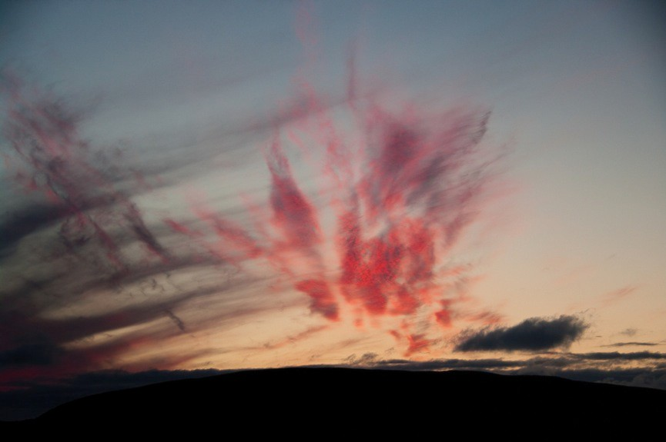
Cirrus by Dave Wheeler

Mai Lin Li Clore Fellow
Clore Leadership Programme

Supervisor: Professor John Burnside
School of English The University of St Andrews

CONTENTS
INTRODUCTION 1
Context of Research 2
Methodology 3
Research Methods 5
FINDINGS 6
On Natural and Institutional Contexts 6
- Arrival… 7
Fair Isle Bird Observatory Trust 11
The National Trust for Scotland 14
Crafts 17
On Spinning 18
On Knitting 22
- Fair Isle Crafts 26
- Knitting Skills and Knowledge 28
- The Tall Ships Kep Barter 30
- Traditional and Contemporary Textile Practices 34
Cultural Narratives 40
The George Waterston Memorial Centre 40
On Writing 44
On Photography 50
On Filmmaking and Visual Arts 55
CONCLUSION 61
APPENDICES
Bibliography 69
Acknowledgements 73

INTRODUCTION

The purpose of this study is to develop an understanding of the cultural ecology of Fair Isle, in order to identify and describe elements in a model of adaptive, intelligent, community-led creative living. It is hoped that the findings will be useful and relevant to individuals, communities and cultural organisations interested in the relationship between arts, crafts, culture and community; in models of engaged cultural citizenship and self-organisation; and in alternative approaches to cultural commerce.

As well as considering how Fair Isle’s arts, crafts and culture may have been shaped and influenced by its physical environment, I also want to explore the responses of the community and individuals to influences outwith the island, and how these could be understood as positive interventions, which refresh island culture, creating opportunities for development and building resilience, rather than posing a threat to tradition and continuity.

I want to understand why particular forms of cultural expression have developed on Fair Isle, and how they are perceived, practiced and organised. More broadly, how has life on Fair Isle remained viable, productive and creative? Is the existing model of culture and community likely to remain sustainable and resilient? Are there tensions, problems and challenges attendant to this model of culture and community, and how do the islanders respond to them? And, is it possible to identify and document some models of good practice and learning from Fair Isle, which could be usefully applied to other contexts?

Context of the research

This topic seems particularly relevant and compelling in the current political and economic climate, in that it proposes in part to examine a model of community mobilisation, self-organisation and local leadership, with particular reference to culture and cultural identity. These qualities are gestured at by the controversial, much-discussed ‘Big Society’ concept that was the flagship policy of the Conservative party manifesto and continues to inform the discourse of the coalition government.

The research is also contiguous with current thinking on cultural strategy and policy-making, in relation to building resilience and sustainability into organisations and communities, as demonstrated by the Arts Council England commissioned report Making Adaptive Resilience Real.1

The traditional and locally distinctive nature of several of Fair Isle’s key forms of cultural expression have been acknowledged in Edinburgh Napier University’s project to inventory the Intangible Cultural Heritage of Scotland, as defined by UNESCO’s Convention on Intangible Heritage. The definition includes cultural practices, skills and knowledge that are ‘traditional, contemporary and living at the same time’, ‘inclusive’, ‘representative’ and ‘community-based’. The Edinburgh Napier ICH project also seeks to reflect ‘the Scottish Government's commitment to respecting diversity and creating community cohesion’.2

This study is carried out against the background of renewed popular interest and

1 Mark Robinson, Making Adaptive Resilience Real (London: Arts Council England, 2007).
<www.artscouncil.org.uk/media/uploads/making_adaptive_resilience_real.pdf > [accessed 7 September, 2011].
2 ‘Edinburgh Napier University, Intangible Cultural Heritage’, Edinburgh Napier University,
<www.napier.ac.uk/randkt/rktcentres/scob/Projects/Current%20Projects/Pages/IntangibleCulturalHerit age.aspx> [accessed January 2012].

engagement in craft and making, and in handmade crafts in particular. The exhortation to ‘buy handmade’ or ‘make your own’ has penetrated the spheres of culture, commerce and politics (see the recent V&A/Crafts Council ‘Power of Making’ exhibition).3 A new concept has been created, ‘craftivism’, that has associations that reach beyond aesthetics to a brand of political activism and community mobilisation that is often anti-capitalist (or at least ethically motivated) in outlook, and facilitated and mobilised by social media technology. Craftivism has some intellectual footing in earlier feminist and subversive readings of the culture of textile arts and needlecrafts, offered by critics such as Roszika Parker.4

Methodology

Embarking on this study, I realised that what interests me about Fair Isle can be plotted across a number of theoretical territories. This, then, is an interdisciplinary study, a documentation of the culture of arts, crafts and heritage activity within a specific community, which also takes in theories of:

- Craft, and the culture of craft – with particular reference to the commerce and transactions of craft, diversity of practice and product, and the transfer of skills and knowledge, through making, teaching, use and repair.

- Resilience, as originally expressed in the ecological study of living systems, and understood to have wider social applications to organisational and community development. It recognises that systems (organisations and communities) are

3 Daniel Charny, The Power of Making (London: V&A, 2011).
4 Roszika Parker, The Subversive Stitch: Embroidery and the Making of The Feminine (London: Women’s Press, 1984).

complex, interrelated and subject to variable, adaptive cycles. Resilience rests on the ability to integrate and adapt to change, challenge and innovation.

- Social capital, and the conditions under which social capital is likely to flourish, enabling group mobilisation and co-operation towards shared objectives and interests. Recently, theories of social capital have been adopted and applied to thinking on social media, described as a tool for social connection and change, most influentially by Clay Shirky in Here Comes Everybody.5 Shirky’s ideas are related to and informed by the concept of emergence theory, which suggests that meaningful systems and organisations develop ‘from below’, and are largely self- regulating, rather than externally controlled or prescribed.

- Alternative economic models, that seek to remodel definitions and measures of prosperity, away from those based on market expansion and profit.

All of these approaches have profound implications for our understanding of leadership; where leadership is reconfigured to imply self-organisation, co- operation and mobilisation. As described by Peter Block in his book Community, this departs from more hierarchical, charismatic or directive conceptions of leadership:
In communal transformation, leadership is about intention, convening, valuing relatedness, and presenting choices. It is not a personality characteristic or a matter of style, and therefore it requires nothing more than what all of us already have.6

5 Clay Shirky, Here Comes Everybody: How Change Happens When People Come Together (London: Penguin, 2008).
6 Peter Block, Community: the Structure of Belonging (San Francisco, CA: Berrett-Koehler Publishers, 2008).

Research methods

I have undertaken a review of relevant literature, documentation and research, to help identify some appropriate theoretical approaches and to develop my background knowledge of Fair Isle, its history and culture. During a ten day study visit to Fair Isle and to Lerwick on mainland Shetland, I interviewed ten members of the Fair Isle community, visited the George Waterston Memorial Centre on Fair Isle, and visited the Lerwick Museum and Archives where I met Dr Carol Christiansen, Curator and Community Museums Office for Lerwick Museum and Archives, whom I later interviewed by telephone. I also interviewed representatives of the National Trust for Scotland, and Ann Cleeves, who is an author and former Fair Isle Bird Observatory employee and resident. It was Ann who first introduced me to Fair Isle and its community.

The interviews were conducted either face-to-face or by telephone and followed up by email correspondence. The face-to-face interviews were recorded and then transcribed. They were quite informal and conversational, covering common themes but without a set list or order of questions. Where appropriate and as much as possible, I have used direct quotations from these interviews in my findings, as I feel it is important to let the people, who kindly agreed to participate in this study, speak for themselves.

FINDINGS

On Natural and Institutional Contexts
Let no one think that because a community is small, it contains less nuance than a larger one; the reverse is so. There is no end to it; the place never stops.7

Fair Isle had been in my thoughts since my first visit to the island two years ago. It was late spring when I came for a friend’s book launch, and this brief visit of only four or five days, left an unusually strong and enduring impression on me. As well as the sheer beauty and mutability of the island and its physical environment, I was quite simply struck by the people. I came away with a strong sense of individual personalities, and of the general friendliness and openness that seemed to characterise the community’s attitude towards visitors. Moreover, the community possessed an unusual diversity of skills and knowledge, ranging through arts, crafts, heritage, manual trades, administration and various scientific, academic and professional disciplines.

The creative industries seemed particularly significant, and prominent in the island economy; among a population of seventy people, there were writers, musicians, spinners, knitters and painters; there were craftsmen who made boats (clinker built yoals), spinning wheels, straw-backed chairs and stained glass; there was a photographer, a local historian, and an archaeologist. Individuals often fulfilled multiple roles on the island, both paid and voluntary, moving between tasks as required, perhaps suggesting a soft conceptual edge between creative work and practical, functional work, with much of it requiring what Richard Sennett refers to as ‘the triad of ‘the intelligent hand’ –coordination of hand, eye and brain’.8

7 Candia McWilliam, What to Look for in Winter: a Memoir in Blindness (London: Jonathan Cape, 2010), 147.
8 Richard Sennett, The Craftsman (London: Penguin, 2009, originally published 2008), 174.

Initial inquiries suggested that life on Fair Isle was agreed to be rewarding, but not easy in the sense of leisurely; in order to keep the island functioning and viable even at the most basic level, there was much work to do, and few people to do it.
It was physically and mentally demanding, and lived at a pitch and pace that could easily be seen as inimical to the personal ‘space’ that is often thought important to an individual’s creativity and cultural development. Yet the creative and cultural industries were visibly present and flourishing on Fair Isle.

Arrival
Fair Isle is part of Shetland, the archipelago that, along with Orkney, forms the Northern Isles of Scotland. It is twenty-five miles from Fair Isle to the next landfall: the island lies halfway between the Shetland mainland and the most northerly part of Orkney (North Ronaldsay). Fair Isle is roughly three miles long and one and a half miles wide; it is small and remote enough that it is effectively left off many maps, or framed in a discrete, enlarged inset, appearing strangely uncoupled from its precise geographical context.9
Fair Isle experiences kaleidoscopic effects of weather and light. On a clear day, the island is coloured by intense, prismatic blues and greens, and, if you are arriving by plane, the land is laid out like a treasure map, or a piece of draped velvet, with the nap of grass worn through to pale golds and darker bronzes. On a high day, the air is soft and bright. On a stormy day, the sky can be as dark as ink. Then, surrounded by churning, milky seas, and wind and rain cracking and slapping at the windows, the horizon itself seems to heave and buck, while the island hunkers, and waits. When people think of Fair Isle, they often think of the weather (and of the shipping forecast in particular), or of birds, or of knitting.

9 Ordnance Survey, Shetland – Mainland South: Lerwick, Sumburgh & Fair Isle, 1:25,000, OS Explorer Map (Southampton: Ordnance Survey, 2007).

Travelling between Fair Isle and the Shetland mainland (having arrived in Lerwick via Aberdeen, by plane or overnight ferry), involves an exhilarating twenty-minute ride in a seven-seater Islander plane, or a longer sea journey on the ferry/mail boat Good Shepherd IV, which is owned by Shetland Islands Council, but based on the island and crewed by islanders. Both services operate summer and winter timetables, and all flights and sailings are subject to weather conditions; it is not so uncommon for the island to be cut off for a week or more. Travel requires patience, flexibility, and forethought, for islanders and visitors alike. If you live outwith Shetland, Fair Isle is not a place visited casually, simply due to the length, expense and complexity of the journey. A visit to Fair Isle is an adventure, a commitment, for many, something of a pilgrimage.

Visit the Fair Isle community website and you will see a welcome message that describes Fair Isle as ‘Britain's most remote - though far from isolated - inhabited island’.10 It is an important and meaningful distinction; the island and its culture can be defined and understood as much by its many and far-reaching connections, as by its indisputable geographical remoteness. In his book The Northern Isles Alexander Fenton observes that ‘isolation and remoteness are relative concepts’.11 To this I would add that the status of ‘remoteness’ (or even ‘marginality’) is generally conferred on a place or community by an individual or institution outside of and far removed from that community. Fair Isle is not only at the confluence of the North Sea and Atlantic Ocean, but is also a calling point for a rich diversity of migrant birdlife, which attracts hundreds of human visitors to the island every year. Furthermore, Fair Isle has historically stood as an important crossroads (and trading place) for many international sea routes:

10 ‘Fair Isle: in Reality Virtually Unforgettable!’, Fair Isle community website, <www.fairisle.org.uk> [accessed September 2011].
11 Alexander Fenton, The Northern Isles (East Linton, E. Lothian: Tuckwell Press, 1978), 1.

In the days of sail, Fair Isle stood at the centre of a busy shipping lane. If you went anywhere you went past Fair Isle, from the Mediterranean to the Baltic, from Europe to the Americas, from Dundee to the Carolinas, there was a constant stream of ships passing the island.
Anne Sinclair12

To this day, Fair Isle expects and welcomes visitors from passing craft, including regular planned visits from cruise ships, whose passengers are welcomed at the community hall. This provides an important opportunity for the island’s artists and craftspeople to display and sell their products.

Fair Isle is home to approximately seventy people, (this figure has remained relatively stable over recent decades), mostly living in eighteen crofts clustered at the more fertile and sheltered southerly end of the island. Crofting on Fair Isle consists of small-scale landholding and farming of livestock (mostly sheep, with some cattle and poultry) and crops (mostly oats, turnips, and potatoes). Fishing, historically vital to the island economy, is now done primarily for personal consumption and recreational purposes. The size, types of farming activity, and levels of mechanisation vary considerably from croft to croft, but the crofting way of life on Fair Isle is often characterised by co-operative effort; for the observer, this finds its clearest expression in the shared ownership of Shetland sheep that live on the rough pasture to the north of the island. The flock is cooperatively reared by the community, with the summer ‘caaing’ (driving) and clipping of the sheep being a central event to both the agricultural and social calendars of the community.

Crofting supplies produce for both the household table and the market, but most crofters supplement their income by other means. Moreover, there are few full- time salaried posts on the island, so an income is often drawn together from a

12 Interview with Anne Sinclair, 22nd October 2011, Fair Isle. All of the interviews cited in this study were conducted by Mai Lin Li.

variety of activities and enterprises. Some are explicitly linked to supporting the island’s infrastructure, such as social care for the elderly, road maintenance, crewing the ferry and teaching at school. Other areas of work and expertise engaged in by the islanders have a wider application, creating products and services for a market that extends beyond the island and its community, but are often informed by and expressive of the immediate environs. This type of activity includes such services as environmental or meteorological consultancy, and also the arts, crafts and heritage work that is undertaken on the island.

The creative industries on Fair Isle are also part of a larger community tradition of making things by hand, often using local or salvaged materials. It is costly and time-consuming to bring goods and materials (and people) on and off a remote island, so it simply makes sense to learn how to do and make things yourself, to use what is to hand, and to extend the useful life of whatever you have by repairing, repurposing and conserving.

Fair Isle is off-grid and has supplied its own electricity since 1982 via ‘the first commercially operated wind energy scheme in Europe’.13 The scheme was initiated in response to the escalating cost (and environmental impact) of running diesel-fuelled generators. The community was instrumental in establishing and upgrading the project with guidance and support from various agencies (The National Trust for Scotland, Shetland Islands Council, Shetland Enterprise, the European Regional Development Fund). In 1999 the scheme became constituted as the Fair Isle Electricity Company, which is community owned and managed.

Other important elements in the fabric of island life are: a small primary school, a community hall, a museum, a resident nurse and a village shop and post office.

13 Fair Isle Electricity Company Ltd, ‘Leading the Way With Community Wind Power’, Fair Isle community website, < www.fairisle.org.uk/FIECo/index.htm> [accessed January 2012].

There are two churches serving the population on Fair Isle, a Church of Scotland kirk and a Methodist chapel. Services are held at each church on alternative Sundays, and are well attended by both residents and visitors to the island.

The population of Fair Isle has experienced considerable fluctuations over the years, falling to 45 people by 1954, the year in which owner and ornithologist George Waterston sold the island to the National Trust for Scotland (NTS).14 Waterston had purchased Fair Isle in 1947, establishing a bird observatory on the island the following year. While recognising and wishing to conserve the rich natural environment of Fair Isle and its environs, both Waterston and the NTS were also consciously concerned with the welfare of the community, and acted to stimulate the economy and improve the island’s infrastructure and transport links. The significant contribution of the Fair Isle Bird Observatory Trust (FIBOT) and NTS to the economy and culture of Fair Isle continues to this day, and should not be underestimated. The relationships are synergetic, with members of the community and representatives from the partner organisations sitting on each other’s boards and participating in meetings of the Fair Isle Committee and Community Association where, supported by a system of subcommittees, local issues are discussed and decisions made.

Fair Isle Bird Observatory Trust

A brand new observatory and lodge was opened by FIBOT in 2010, replacing the former building that had been built in 1969 and renovated in 1989. From April to October (covering the spring and autumn bird migrations), the Bird Observatory is by far the largest provider of accommodation on the island,

14 ‘On this day - 3 September 1954: National Trust buys remote island’, BBC News,
<http://news.bbc.co.uk/onthisday/hi/dates/stories/september/3/newsid_3020000/3020298.stm> [accessed January 2012].

receiving around 400 visitors each year. Observatory staff, volunteers and visitors are a substantial presence on the island; interestingly, several observatory wardens and administrators have chosen to remain living on Fair Isle for many years after leaving their posts at the observatory, often taking up crofting and other work.
FIBOT Administrator Susannah Parnaby is quick to point out that, while the observatory has undoubtedly been important to the island economy and community, it is very much a relationship of mutual dependence and co-operation:
Certainly from the observatory point of view we regard it as a very symbiotic relationship: you can’t maintain a building of this size with this number of guests on an island like this without everybody in the community helping you out.
Susannah Parnaby15

Susannah explains how the observatory contributes to the island’s economy and infrastructure in various practical ways, including a deliberate policy of ordering all of their food supplies from the island shop, and also providing some work opportunities ‘through jobs that need doing at the observatory’. The observatory also has a direct relationship with many of the musicians, artists, craftspeople and cultural practitioners on the island. The observatory shop, as well as selling FIBOT and ornithology-related souvenirs, books and clothing, also displays and sells a range of locally produced books and pamphlets, prints, and a range of garments knitted on the island. The observatory staff are an initial point of contact between some of the island’s craftspeople and observatory guests who are interested in craft demonstrations, workshops and viewings of work for sale. They also help to organise guided walks with islanders who have specialist knowledge of Fair Isle’s history, archaeology, weather and wildlife. During the spring and summer, the observatory hosts highly popular ‘Fair Isle Thursdays’, when the island band, Fridarey, play for guests at the observatory.

15 Interview with Susannah Parnaby, 21st October 2011, Fair Isle.

FIBOT raises a considerable proportion of its revenue from visitors other than birdwatchers, particularly so during quieter periods in the ornithological calendar. Staff at the observatory are currently considering ways of extending their offer to cultural tourists:
Because August is traditionally quite a quiet month, because the seabirds have gone and the rare migrants haven’t started coming in – one of the things I’d really like to do is to focus on writing or photography or art courses, in the summer, and promote it as a destination […] I think that’s potentially something for the future, to start advertising in arts or photography magazines, because the scenery is fantastic – we do get a number of independent artists coming and staying at the Observatory anyway, but to make it a much more formal thing, and to be able to put on activities so that folk can come and have someone do stuff with them, I think would be great.
Susannah Parnaby

FIBOT is also hoping to extend and develop its research activities at the observatory, while continuing to serve a mixed economy of ornithologists, conservationists, tourists and other visitors to the island.

The remarkable birdlife of Fair Isle has been crucial to the development of the island’s culture and economy, and it is an important element in the interdependent richness and diversity of the island’s marine environment. The islanders are highly conscious that the vitality of the natural environment and that of the community (its economy and culture) are contingent on the protection and promotion of the island’s natural assets, including those of the surrounding seas.16 For several years the islanders, through the Fair Isle Community Association, with FIBOT and NTS, have been working together on the Fair Isle Marine and Tourism Initiative

16 Fair Isle has received a number of special designations relating to its natural and cultural environment: see Nick Riddiford, ‘Future Fair Isle: retaining, maintaining and enhancing its maritime values’, Safeguarding Our Heritage, FIMETI, <www.fairisle.org.uk/FIMETI/Reports/Safeguarding_Our_Heritage/future.htm> [accessed February 2012].

(FIMETI)17, to develop a practical approach to the sustainable management of the island’s resources. At the end of 2011, FIMETI lodged a detailed proposal with the Scottish Government, for the creation of a Marine Protected Area in the waters around Fair Isle. FIMETI is another example of community leadership from the ground up, requiring decisive action and great amounts of discretionary effort from all involved, co-ordinated by leading individuals (in this case naturalist and FIMETI Coordinator Nick Riddiford) and well supported by the community and partner organisations invested in the future of Fair Isle.

The National Trust for Scotland

The National Trust for Scotland’s relationship to Fair Isle and the community is described as one of ‘shared stewardship’, implying a co-operative relationship, with strong ethical dimensions, of negotiated joint responsibility for the sustainable management and conservation of the island and its resources. As landowner, the Trust has an unusual relationship with Fair Isle, in that it owns the croft houses as well as the crofting land; since taking ownership in 1954, it has focused considerable energy and resources on substantially improving the quality of housing on the island. Much of the early work was done using volunteer work camps and very limited budgets, but over the last two decades the Trust has embarked on a major programme to improve all of the housing stock on the island. The Trust developed good working relationships with and gained crucial support from other agencies during this process, including Shetland Islands Council, Community Shetland, the Shetland Development Trust, and Shetland Enterprise. Substantial housing improvement is not a quick process, or an easy one, as indicated by Angus Jack, the Trust’s Regional Surveyor:

17 FIMETI’s website: www.fimeti.org.uk

I’ve got to work with the Trust’s conservation principles, but at the same time work with the island, and produce housing that I think is fit for purpose in a Northern clime, that actually gets as much natural light in as possible.
Angus Jack18

The Trust’s building programme works to reconcile conservation and heritage requirements with the need to provide comfortable, functional housing for the community; a practical approach that not only accounts for the exacting environmental conditions on Fair Isle, but also the fact that many islanders work from home, particularly the artists and craftspeople. Providing houses that could also function as flexible workspaces is described by Angus as ‘absolutely integral in my thinking the whole way through’.

The Trust maintains rents on Fair Isle at affordable levels, and in partnership with the community’s housing forum, manages the application and interview process when a house becomes available for new tenants. With the sustainability of the community and island economy in mind, tenancies are generally advertised as being particularly suitable for those who are willing to engage in crofting, to turn their hands to some of the work available on the island, or to bring with them an occupation or business that can be transferred successfully to an island setting.

The provision and management of affordable, good quality housing stock by the Trust perhaps allows the community to invest its energy in other directions, from crofting to other cooperative projects and individual enterprises, which in turn can help to strengthen the community and develop island culture. Moreover, there are further benefits to be gained from the leverage possessed by a large, national organisation in terms of lobbying and advocacy, and the fact that the Trust brings with it its own constituency of heritage enthusiasts, tourists and volunteers. There is a great deal of voluntary activity to be seen on Fair Isle. As well as volunteering

18 Interview with Angus Jack, 15th October 2011, Inverness.

opportunities for visitors,19 to work for the observatory or on the crofts, a huge amount of unpaid or discretionary effort is generated by the community itself:

It’s not easy: although people appear to be busy, it’s not a busyness earning a lot of money […] and a lot of it is busyness that’s just to keep the place ticking over – working.
Jimmy Stout (crofter and former skipper of the Good Shepherd)20

It should be noted that voluntary effort on Fair Isle is not a means of simply passing one’s time; many of the unpaid tasks that people regularly undertake are crucial to the sound functioning of the island and to the fabric and wellbeing of the community. As well as making life better, these efforts make life on Fair Isle viable in the most basic sense, and are an ongoing and steady commitment.

19 Fair Isle Lodge and Bird Observatory, ‘How You Can Help’, Fair Isle Lodge and Bird Observatory,
<www.fairislebirdobs.co.uk/help.htm> [accessed February 2012].
20 Interview with Jimmy Stout, 19th October 2011, Fair Isle.

Crafts

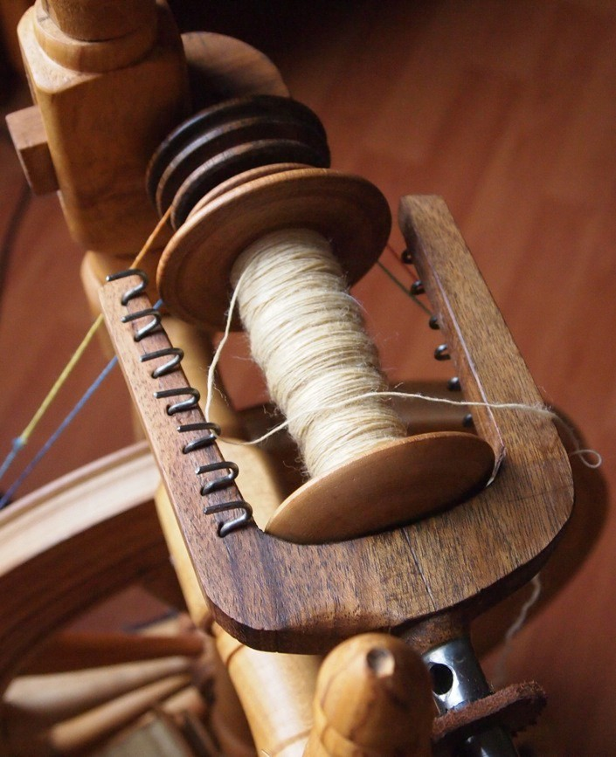
Spinning Wheel by Stewart Thomson, Yarn by Kathy Coull.
Photograph by Mai Lin Li, 2011.

On Spinning Wheels

The carpenter, lab technician, and conductor are all craftsmen because they're dedicated to good work for its own sake. Theirs is practical activity, but the labour is not simply a means to another end. The carpenter might sell more furniture if he worked faster; the technician might make do by passing the problem back to her boss; the visiting conductor might be more likely to be rehired if he watched the clock. It's certainly possible to get by in life without dedication. The craftsman represents the special human condition of being engaged.
Richard Sennett, The Craftsman21

Stewart Thomson is a crofter who has been hand-crafting spinning wheels for forty years. Stewart intended to retire from making when he reached his 100th wheel; he is now in his 88th year, and while officially retired, has to date produced 114 wheels. He is also a musician and founding member of island band Fridarey, along with several generations of his family.

Stewart bases his wheels on a local design called the Shetland Spinney, which he has modified to create extra stability. Everything on the wheel is handcrafted, including all of the metalwork. There are very few trees on Fair Isle; the degree of skill in working with wood that is demonstrated by several of Fair Isle’s craftsmen therefore seems all the more remarkable. Historically, islanders carefully conserved and re-used any resources of wood available to them, including wreckwood and driftwood; to this day Stewart incorporates driftwood into his wheels where he can, though this is becoming increasingly hard to come by.
Leftover and reclaimed timber from building work on the island is also used; Stewart used wood taken from the old Observatory to make a wheel that was then auctioned to support the new observatory building.22

21 See Sennett, The Craftsman, 20.
22 Louise Thomason, ‘Special spinning wheel auctioned’, The Shetland Times, 19th March 2010,
<www.shetlandtimes.co.uk/2010/03/19/special-spinning-wheel-auctioned> [accessed January 2012].

Stewart inherited an interest and skill in working with wood from his father, but his practice in making spinning wheels is self-taught, in the most literal sense:

Well I started making spinning wheels when I found an old one – an old spinning wheel, in the loft, when I was doing up this house, so I repaired it – and from then on people wanted spinning wheels, they wanted them repaired, and they wanted new ones, so I had to start making them!
Stewart Thomson23
Stewart’s first experience of the craft of spinning wheel making was to repair an old and broken one; repair, though often overlooked, can be understood as a core competency and learning experience for the committed craftsman. According to Sennett, ‘repair is a neglected, poorly understood, but all-important aspect of technical craftsmanship. […] Put simply, it is by fixing things that we often get to understand how they work’.24

As a self-taught maker, Stewart relied on his existing skills with wood in order to copy the original wheel that he found and repaired, but in order to improve and develop the functionality of the wheel, he sought the advice of a fellow craftsperson, who could actually use and test the wheel, and give him detailed constructive feedback:

To begin with […] I didn’t know the wherewithal, the different sizes of the spindles and the grooves and that, but what I did do, I made a spinning wheel and I sent it out to a spinner in Shetland, and asked her to try it out and tell me what was wrong with it, if anything. So I got a great long letter from her, with all the faults and the good parts! […] And I’ve never looked back since then, I’ve been making them ever since, so I can make a spinning wheel down the workshop, and bring it up and spin on it straight away.
Stewart Thomson

To further improve his own technical understanding, Stewart set about learning to spin, testing each wheel before sending it to the buyer. A huge amount of work

23 Interview with Stewart Thomson, 25th October 2010, Fair Isle.
24 See Sennett, The Craftsman, 199.

goes into each wheel: it takes about a fortnight to make one, and Stewart charges upwards of £300 for his work. He has an international base of customers (from Japan, Finland, Norway, France, Canada and the US, as well as the UK), many of whom have visited Fair Isle and attended his workshops and demonstrations; as well as teaching people to spin, he has also taught people to make their own spinning wheels. When I visited Stewart in the room that he uses for his workshops and demonstrations, he showed me letters and cards, as well gifts of fibre, yarn and knitting, that are regularly sent to him by past customers and students. This suggests that an unusual type of transaction occurs between Stewart and those who buy his wheels or benefit from his knowledge, one guided by understanding, individuality, and connection. This transaction appears to runs counter to the sterility and detachment that characterises many commercial transactions. The qualitative as well as quantitative values of the exchange are manifest, for both maker and buyer.

If anybody’s wanting a wheel for just ornament, I won’t make them. Because it’s too much work goes into making a wheel that’s going to be standing at the side and not being used.
Stewart Thomson

According to prevailing consumer ideology, Stewart need not care very much about how people use his wheels after they buy them, as long as they agree an acceptable price, and his customers are pleased with their purchase. But as an individual and a craftsman he clearly does care, establishing a mutual understanding and a sense of respect and responsibility on both sides of the contract. As Bruce Weber has observed, transactions like these are made possible because ‘craft has a human face’.25

25 Bruce Weber, ‘Craft and Art, Culture and Biology’, in Peter Dormer, ed., Peter Dormer, ed., The Culture of Craft (Manchester: Manchester University Press, 1997), 67-82.

Although he is officially retired from making wheels, Stewart still spins most days (he was spinning throughout my interview with him, and encouraged me to try it too), for both pleasure and purpose; he enjoys the work (he told me that he loves it, and finds it relaxing) and the yarn that he produces is used by his family. He expresses as much enthusiasm when talking about the work and craftsmanship of others, as about his own ongoing practice. Stewart seems to typify Sennett’s concept of the ‘engaged’ craftsman.
I remember one time, I was home on holiday, and my father had been repairing a spinning wheel for a lady who spins the very fine stuff, so we went down with the wheel and she took the wheel and she went away and then she came back, and she says ‘Stewart, you’ll not guess what’s in my hand?’ and I could see nothing, she’d a smaller hand than I had! And she opened up her hand and she had a six-foot stole, eighteen inches, wide!
That’s craftsmanship for you!
Stewart Thomson

On Knitting

This is not a study about knitting as such. It is about the wider cultural ecology of which it is part, but knitting is the activity (and artefact) most closely associated with Fair Isle in many people’s minds. What is meant by Fair Isle knitting? In this study, it refers to a distinctive type of knitting that is produced on Fair Isle, and which has a long and intimate association with that place. It is ‘two-coloured’ (no more than two colours are used per row), and geometrically patterned, in non- repeating horizontal bands.26 Patterns are selected from a working inventory of commonly used motifs, with further variation added by the use of colour. Fair Isle knitting is often described as brightly coloured, though the characteristic blues, reds and yellows are complimented by a range of natural colours available from the wool of native Shetland sheep. This undyed wool has many subtle gradations, from black and brown (‘moorit’) through fauns and greys, to natural white.27 Sensitivity to fashion and the increased availability of commercially produced coloured yarns have stimulated knitters to experiment and extend their colour palettes further to reflect contemporary tastes.

In Fair Isle knitting, unused colours are carried across the reverse of the garment, creating a double thickness. This increases the insulation and durability of the garment. Knitters traditionally use very fine circular needles (called ‘wires’), secured by a padded belt worn around the knitter’s waist. Methods diversified during the 1970s with the introduction of hand-operated knitting frames capable of producing two-coloured patterned knitwear (though this still requires finishing by hand). Both hand knitting and hand-frame knitting methods are used to produce garments on Fair Isle to this day. Historically, all knitted garments are
26 ‘Arts and Crafts on Fair Isle’, Fair Isle community website,
<www.fairisle.org.uk/Crafts/arts_crafts.htm> [accessed January 2012].
27 See Elizabeth Riddiford, ‘A Fair Isle Handknitter’s Diary’, Exclusively Fair Isle,
<www.spanglefish.com/exclusivelyfairisle/blog.asp> [accessed February 2012].

collectively referred to as ‘hosiery’, including jumpers and cardigans, and smaller items such as hats, scarves and mittens.

The term ‘Fair Isle’ is also used to describe this type of knitting when it is produced in other parts of Shetland. Moreover, the name has become loosely applied to a diverse range of pattered, knitted garments that are quite generic, global in origin and often mass-produced, bearing little resemblance to ‘genuine’ Fair Isle knitting. It is interesting to note that, once you leave the parameters of the island, the name also appears as ‘fair isle’ and even ‘fairisle’, as if the whole concept of Fair Isle as a place becomes notional and abstract. On Fair Isle, opinions vary on the appropriation of the name ‘Fair Isle’ to describe knitwear that is produced outwith the island, but most of the islanders that I interviewed were quite philosophical about this phenomenon. It seems that for most islanders, serious objections would only arise if producers from outwith the island claimed that their garments were actually made on Fair Isle. They were also conscious of the advantage that is afforded to them by being from the island that gives its name to the knitting:
But we live on Fair Isle, and there’s only one small place that is Fair Isle, that does Fair Isle knitting, you know? And that’s it! I guess that must make it sellable. […] It’s up to you, who live here, to take advantage of your situation. It’s here that has the opportunity.
Jimmy Stout

‘Fair Isle’ knitting is often conflated and slightly confused with Norwegian, Faroese and Icelandic patterned knitwear. This makes sense when one considers the similarities and likely commerce of knitwear and designs between Fair Isle and the various Nordic and eastern Baltic countries to which the island is historically connected by the sea road. Patterns seem to travel easily, and patterned knitting is a tangible, domestic artefact that can be traded, studied, copied and adapted.
While it has proved impossible to pinpoint the exact origin of the knitting on Fair Isle, the importance of knitting to Fair Isle (and Fair Isle to knitting) cannot be

overestimated. It has always made a vital, at times decisive, contribution to the island’s economy and culture.

Evidence shows that hand-knitted hosiery was being produced in Shetland by the sixteenth century, and soon became central to the economy.28 Following plain knitting, patterned hosiery was being produced and traded on Fair Isle by the nineteenth century. Island historian Anne Sinclair points out that there were simple economic reasons as well as aesthetic ones for favouring patterned over plain knitting; though it was slower and more complicated to produce, it had a higher status and value as barter and trade goods (knitters continued to produce plain knitting for domestic use). The islanders had a long history of barter with passing ships; that is, the exchange of goods for goods, rather than money:

Bartering was a constant, and an activity of choice for most of the men on the Isle. The only shop was run and controlled by the laird. The yoals would put to sea and exchange goods such as knitwear and fresh produce for whatever they could trade with passing ships.
We went out with fresh produce, and as I said, hosiery, and we brought back – well, they always talk about tobacco and spirits and there would have been some for sure, but also things like spoons and knives and items you couldn’t get, like sailcloth. To enable the continuation of traditionally patterned and coloured knitwear, indigo must have been traded for.
Anne Sinclair

Barter is tightly and manifestly woven into the history, culture and economy of Fair Isle. Barter is materially evident in the evolution of the knitting (hence the bartered indigo) and also in the development of a type of commerce that is not wholly predicated on money, but rather on the exchange of goods and services. It created an alternative economy; the lineaments of which I believe can still be seen on the island today, albeit in an adapted form. This type of transaction is

28 Alice Starmore, Alice Starmore’s Book of Fair Isle Knitting (New York: Dover, 2009), 7.

expressed through the creative industries and through the community at large, and it is characterised by enterprise, co-operation, direct dealing and autonomy. To this day, the knitters on Fair Isle generally choose to deal directly with their customers, mostly selling to visitors to the island, but also filling orders for individual international buyers, offering a mixture of ready-made and bespoke garments. The spirit of barter lives on in Fair Isle, and it is a subject I will return to later in this study.

The circular relationship on Fair Isle between knitting and barter, and more broadly between crafts and commerce, can be clearly seen. The knitting was a craft-based activity, informed at every stage by a strong sense of utility and economics. Using the island’s natural resources of fine, high-quality wool, and what dyes were available to them, the women used their skills to produce warm, durable and attractive garments that could be traded for commodities, and eventually for money. The development of this, and many other forms of craft, is inextricably linked with practical and economic considerations. As observed by commentator Gloria Hickey, ‘made for sale or commission, craft has usually been subject to the influence of its purchaser. This is true in situations of barter, a craft co-operative or a department store.’29

As the practice of barter died away, so knitting was increasingly produced as sale goods, and by the 1920s Fair Isle knitting became highly fashionable, followed by what Shetland Museum curator Dr Carol Christiansen30 refers to as an ‘explosion in design’ in the patterned knitwear that was being produced across Shetland, responding to increased demand and reflecting changing tastes. For many Shetland women, knitting was the primary means of supplementing household income, and remained so for several decades. Increased prosperity in Shetland

29 Gloria Hickey, ‘Craft within a consuming society’, in Peter Dormer, ed., The Culture of Craft (Manchester: Manchester University Press, 1997), 83-100.
30 Telephone interview with Dr Carol Christiansen, 8th October 2010.

during the 1970s, due to the booming oil industry, enabled many women to choose not to knit, or at least not for commercial purposes. Yet the accompanying increase in funding for infrastructure, amenities and community projects also supported a renewed interest in the cultural identity and heritage of Shetland.31

Fair Isle Crafts

Fair Isle Crafts, a workers’ knitting co-operative, was established on Fair Isle in 1980. Over the next thirty years, the co-operative produced a steady stream of hand-frame knitted and hand-finished Fair Isle garments for sale. At its height, the co-operative employed a workforce of a dozen knitters (which has included both men and women over the years). Paid at an hourly rate, knitters worked through the winter to prepare an inventory of garments for sale during spring and summer. To give some indication of the amount of work involved, it is estimated that it takes roughly 100 hours to produce one jumper. The work included the knitting, finishing and checking of garments, and the handling of sales, often to visiting cruise ship passengers up at the community hall, or by mail order to overseas (often international) customers. Marketing was minimal, as demand consistently outstripped supply. Fair Isle Crafts sold directly to individual customers, and the lack of intermediaries gave the knitters an unusual degree of autonomy; it meant that, beyond the capacity of the workforce and the requirements of their individual customers, they were not contractually held to producing a certain quantity of stock or type of product. Having this within their control, the members could focus on matters such as design, quality and pricing.32 I spoke to Florrie Stout, who worked as a finisher for the co-operative, was Treasurer for twenty years and also arranged the cruise ship and mail order sales:

31 Lynn Abrams, Myth and Materiality in a Woman’s World: Shetland 1800-2000) (Manchester: Manchester University Press, 2005), pp7-8.
32 Tommy Hyndman, Fair Isle Crafts Knitwear & Knitting table display for cruiseship visitors’, Fair Isle BlogSpot, 5th May 2011, <http://fair-isle.blogspot.com/2011/05/fair-isle-crafts-knitwear-knitting.html> [accessed January 2012].

The main thing that it involved was the quality control of the garments, that’s quite important, because we do sell our garments pricier than they do on Shetland […]. Because this is where the patterned knitwear originated, we think, so we feel that’s quite okay. On the other hand, it’s not okay to sell stuff that’s not really top class, so we have this quality control, so if somebody knitted and finished the garment then two other people would check it, and that was quite an integral part of our business, all these years, to produce high quality knitwear.
..we tried to sell it at a price that people could still buy it.
Florrie Stout33
The acknowledgement that pricing may be higher (for items knitted on Fair Isle) than elsewhere on Shetland is qualified by the suggestion (put forward by several of my interviewees, both on and off the island) that many producers on Shetland, particularly those of the older generation, were not charging enough for their work, and that this situation may have been exacerbated where intermediaries were used:
History will show you that people who work with their hands are never paid for the skill that they have, and if you’re going to divide it again, you’re going to be paid even less.
Anne Sinclair

And while conscious of the cache and added value of the Fair Isle name, the islanders are also quick to acknowledge the quality of work and skill involved in the knitting produced in other parts of Shetland. The recognition and appreciation of the craftsmanship of others, and the value of other people’s work (both within and outwith the community) was a recurring theme during this research, and seems deeply ingrained in the attitude of many of Fair Isle’s makers and artists.

The number of knitters and finishers working for the co-operative dwindled to very small numbers (as little as two or three) over recent years, with its capacity gradually reduced to producing maybe 30 jumpers per year, plus greater numbers

33 Interview with Florrie Stout, 19th October 2011, Fair Isle.

of smaller items, such as hats and scarves. Fair Isle Crafts finally ceased trading in 2011, with some members wishing to retire, and others choosing to continue knitting independently. There is great sadness about the closure of Fair Isle Crafts after so many years of productivity. A more optimistic perspective may be gained from a ‘socio-ecological’ interpretation of these events, viewing the whole culture and economy of knitting on Fair Isle as a wider system that is inevitably subject to a continuous cycle of change:

Social-ecologicial systems are always changing. A useful way to think about this is to conceive of the system moving through four phases: rapid growth, conservation, release and reorganization - usually but not always in sequence.34
‘Creative destruction’ is a term now used to describe the disturbances that periodically punctuate the adaptive cycle. It breaks down stability and predictability but releases resources for innovation and reorganization.35

Understood on this basis, the assets needed for knitting are still very much in place on Fair Isle (the shared skill and knowledge of how to knit, the materials and equipment to support it, and the ‘Fair Isle’ name), but it may come to be organised and practiced differently, operating on different scales, and entering into a phase of development through individual entrepreneurs who are able to innovate and extend their practice and product lines as they wish.36

Knitting Skills and Knowledge

When I embarked on this study I made an assumption that the main ‘threats’ to the knitting culture on Fair Isle would be a dwindling of skills and knowledge, and perhaps the availability of cheaper, mass-produced ‘fairisle’ garments for the

34 Brian Walker and David Salt, Resilience Thinking: Sustaining Ecosystems and People in a Changing World
(Washington DC: Island Press, 2006), 12.
35 Ibid,.,75.
36 For example, see Mati Ventrillon’s Fair Isle Knitwear: www.fairisleknitwear.co.uk

average consumer. I found myself wrong on both counts. The market for Fair Isle knitting from Fair Isle may be a niche one, but it is loyal, well-informed and enthusiastic enough to still outstrip supply. Moreover, I was struck by just how much knitting is still done on Fair Isle. Some islanders, who have often learned their knitting skills at an early age from their mothers and grandmothers, continue to knit, but for friends, family and themselves. It is a recreational, cultural and often social activity, but not a commercial one. The time when knitting was an economic necessity is still within the living memory of the community on Fair Isle, when it was the primary way that girls and women could make a contribution to household income. That situation no longer exists; women are making different choices, and that has altered the status of knitting on Fair Isle and the way that women choose to engage with it:

I do love it and I - the thing about it here is it’s a gift: it’s like having a croft, that you can turn into something better. We live on the island that gave its name to two-coloured knitting, so, if you needed to, if I needed to for income, […] then I could sell it directly, so it’s a gift in that sense that it’s there, as something that you can do, it’s another thing that’s an asset, we’re very lucky to have that.
I’m a good knitter, but […] I’m better at writing poetry and music and I really want to do that.
Lise Sinclair37

Lise, who comes from a long line of skilled and prolific Fair Isle knitters, chooses writing as her professional creative practice, and reserves knitting as a non- commercial activity, the corollary to this being that the knowledge and ability to produce Fair Isle knitting is an asset, and one that she (and others) could choose to utilise for commercial purposes if they wished or needed to.

37 Interview with Lise Sinclair, 18th October 2010, Fair Isle.

The Tall Ships Kep Barter

Lise was instrumental to a fascinating cultural project that took place on Fair Isle last year: the barter of traditional hand-knitted fisherman’s hats (called keps) during the 2011 Tall Ships Races:

Last year, my daughter Lise, and Liz from Haa, arrived for coffee and obviously with something on their minds! [laughs] They’d come up with the idea that we should do some bartering, just for fun, purely and simply to take something from the past, to put into the whole Tall Ships thing, which was getting really exciting.
Anne Sinclair

The summer visit of the Tall Ships was a significant event in Fair Isle’s social and cultural calendar. The ships came during the non-competitive ‘cruise in company’ leg of the races. Inviting and hosting the Tall Ships and their crews on Fair Isle was an ambitious enterprise, organised and co-ordinated by Jimmy Stout and requiring the community to formally invite the ships to berth at the island, and then to mobilise and organise support, funding and resources for a programme of entertainment and provisions for the visiting crew.38 The community set about this task with characteristic brio and co-operation:

And you also, like the Tall Ships this year, set up things that are going to be outside your general experience otherwise, asking if we could invite the ships to come as part of the events in Shetland and then going through the whole process of the folk here making it happen, funding it and everyone working hard to make things ready, even re-roofing buildings, putting up the tent, cooking, singing in the shanty choir — everything. Because of the way it is here, it’s not like being in a big town where the ships would be the other side of these barriers, and going to cruise dinners and things. You’re just all in among it; in a sense you’re exhausted because you’re the only people who are here so you’re the people doing everything, but that also makes your experience very rich. Lise Sinclair

38 ‘The Tall Ships Races 2011: Cruise In Company’, Sail Training International,
<www.sailtraininginternational.org/_uploads/documents/CaptainsPage/CruiseInCompanyBrochure.pdf
> [accessed January 2012].

The idea of bartering grew out of the Tall Ships project, and Anne Sinclair agreed to oversee the making of the goods for barter:

They thought it would be a very good idea to make traditional fisherman’s keps, which are very specific to Fair Isle, and to one area of Holland called Marken. They’re long and brightly coloured, with a tassel on the end.
They asked if I would give some lessons on the construction, design, pattern and colour use in the making of a Fair Isle Fisherman’s kep. We planned that after Christmas we’d set aside an evening and everybody would come here, and they would knit.

It was really good fun, just everybody getting together, and it’s amazing how many different permutations of the few colours you can get - no two hats were the same. I was very keen that we should keep the hats traditional as the project was to barter as in the old days. I put together some basic instructions, including pictures of keps from the 19th century.
Anne Sinclair From January 2011 onwards, Anne held a weekly knitting group at her home.
These meetings proved incredibly popular, attended by upwards of twenty women. Lise also secured some vital in-kind support: plentiful amounts of free wool from Jamiesons’ Spinning. Significantly, not all of the women who attended were experienced knitters, and several had never knitted before, so Anne’s expertise and guidance was invaluable. About fifty keps were produced, and were displayed at the island museum in advance of the barter. The skipper of every visiting ship received a kep, and the crew specifically invited to barter was that of the Sørlandet, which was built in Norway in 1927, and is the oldest working full rigged ship in the world. It was hoped that, in true keeping with tradition, the island men would go off in their yoals and barter directly with the ships, but this was prevented by the weather on the day, so instead the crew came ashore to barter.
The keps were bartered for a variety of goods (books, clothing, food), with the crew. On the open market, the keps could have commanded extremely high prices; after the barter, seven of the remaining keps were auctioned on the internet

(with their individual makers clearly identified), to raise funds for an extension to the island museum. One kep alone raised £755.39 While the original culture of barter on Fair Isle was doubtless concerned with securing a good price (in terms of commodities) for one’s goods, the Tall Ships barter was not motivated by money or profit. It was a revival of tradition, and also a reassertion, not only of the activities of barter and hand-knitting, but of the particular way in which Fair Isle organises and positions itself, which is defined by sociability, creativity and co- operation within the community and, historically, habitually extended to visitors to the island:

We all got together and had great fun – that was far more important in the end. One or two people said ‘ these hats are really valuable’ and they are actually really valuable – but that wasn’t what we were doing it for, it was not about the monetary value of the keps, it was about the getting together and being a community and the company and the custom, and that’s how we worked it in the end
Anne Sinclair
Perhaps the modern-day spirit of barter endures more easily in craft-based, co- operative cultures and communities, as suggested by craftsman and commentator Matthew Crawford:

I barter services with machinists and metal fabricators, which has a very different feel than transactions with money, and further increases my sense of community.40

In terms of cultural legacy, the Tall Ships barter was more than a one-off heritage activity or historical reconstruction. It has had something of a revitalising effect on the island’s hand-knitting culture. With Anne acting as what Richard Sennett describes as a ‘sociable expert’ who is ‘good at explaining and giving advice’ and

39 Tommy Hyndman, ‘Traditional Hand Knit Fair Isle Fisherman’s Keps (6 Hats for Auction) Museum Fund Raiser’, Fair Isle BlogSpot, 11th October, 2011, <http://fair-isle.blogspot.com/2011/10/traditional- hand-knit-fair-isle.html> [accessed October 2011].
40 Matthew Crawford, The Case for Working with Your Hands (London: Penguin, 2011), 27.

also ‘comfortable with mentoring’,41 it has resulted in more people learning how to knit, or extending their knitting skills, with established knitters adding an unusual traditional garment to their repertoire. Moreover, the value and sheer sociability of learning and making together has been reasserted in a positive and enduring way; six months after the barter, keps are still being knitted on the island, (more for friends and family than for commercial purposes), suggesting that the genuine enthusiasm generated by the barter project has not abated.

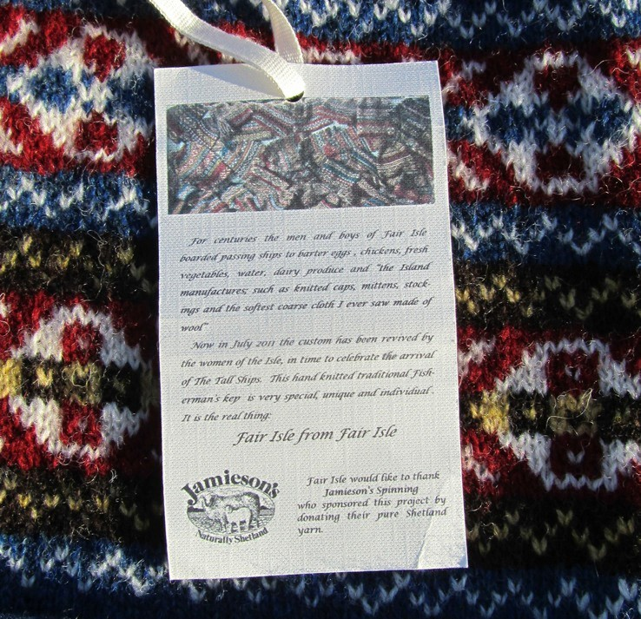
Label on a Fisherman’s Kep, text by Anne Sinclair with Tommy Hyndman.
Photograph by Tommy Hyndman, 2011.

41 See Sennett, The Craftsman, 248.

Traditional and Contemporary Textile Practices

This is not to suggest that hand-knitting was rarely happening on Fair Isle before the barter project; while the garments produced under the Fair Isle Crafts label were hand-frame knitted, a number of knitters had continued to produce hand- knitted garments. Hand-knitters use both commercially-produced and hand-spun wool; hand-spinning yarn adds many hours of labour to the process, but it also adds layers of value and meaning for particularly well-informed customers. For this type of garment, people are willing to pay considerably more, and to wait longer.

My own practice covers knitting, weaving, hand-spinning, felting – in fact most textile crafts that have got to do with wool, because wool is the raw material that I’ve got to hand; my sheep are in that field over there!
Kathy Coull42

When Kathy describes her creative process it seems a model of the intelligent use of resources. Kathy rears her own Shetland sheep, breeding them for the fineness and natural colour of the wool, which she then clips, cards, washes and then hand spins into yarn (it would be prohibitively time-consuming for Kathy to hand-spin all of her own wool, so some is sent away for custom mill-spinning.) Using her yarn, Kathy produces one-off hand-knitted garments on a commission basis.
Within the given parameters of her practice, she is happy to produce a garment specific to her customer’s requirements in terms of colour, pattern, and style, though they often leave at least some of these choices to her. Furthermore, they are under no obligation to buy the garment at the end of the commission if they are not happy with it; demand is such that Kathy can be confident that every garment she produces will find a buyer. £900 for a hand-spun, hand-knitted jumper may sound prohibitively expensive, but they are keenly sought by knitting, textile and fashion enthusiasts from all over the world (at the time of her interview, Kathy was working on a commission for a Japanese customer).

42 Interview with Kathy Coull, 21st October 2010, Fair Isle.

Kathy acknowledges that the price she asks for her work sounds high, but she places it in the context of the number of hours, sheer effort and skill that goes into their production:

It sounds huge, but at an hourly rate, it’s not that huge! But you can imagine the hours that go into not only hand spinning and knitting, but raising sheep, and clipping sheep, and preparing the wool, and then hand spinning it, and then knitting it, and then finishing the jumper.
Kathy Coull

Kathy is aware that this lengthy, skilful and intelligible process is partly what attracts people to her work; they are not simply buying an attractive, exclusive garment, but a garment that has a clear provenance, and the mark of an individual maker working within a living tradition.
It’s a very, very small, limited market. If people just want a nice jumper, they can go to Marks and Spencer’s and buy one! But they really have to want the authenticity and to know that this garment has come not just from Fair Isle, but that Fair Isle is embodied in it, because the sheep have been eating the environment, and it’s been made on the island, from beginning to end.
It’s amazing, once people see what goes into it, there are lots of people who just want to have them.
Kathy Coull

Authenticity is often a vexed concept for craft practitioners and theorists, but here it suggests the coherence and integrity of Kathy’s creative practice, her complete involvement in the material construction and design of her work, her direct negotiation with individual buyers, and her explicit connection to a distinctive knitting culture and tradition. It creates a soundness of process and a traceability to the garment that seems to satisfy the most ethically engaged and demanding customer. In Kathy’s words, it is as much about ‘what goes into it’, as about the finished product.

I would suggest that there is something else interesting at work here; in purchasing a piece of knitwear, people are affiliating themselves, albeit indirectly, to the culture and way of life on Fair Isle. For some owners, a genuine Fair Isle sweater has an almost talismanic value, infused with a sense of lineage, connection, community, and tradition:

When I was cooking [at the Bird Observatory] a family came, and the woman was wearing a hand knit jumper and I think she’d been there as a child, in, I don’t know, late fifties, early sixties, and because it had got holes in the elbows, she’d had to cut the sleeves off and re-roll them, but she was so proud to be wearing this jersey back to the island, where it had been originally made.
Ann Cleeves43

This type of cultural affiliation could be applied to any of the arts and crafts produced on Fair Isle, but it holds particularly true for the knitting and its enthusiasts; as Carol Christiansen observes, Fair Isle is ‘the ultimate destination for knitters’.

While Kathy may sometimes quietly marvel at the willingness of buyers to pay these prices for her work, it is not because the knitting does not hold value for her, but because it is within her capability to produce it. On the matter of other people’s artistry and craftsmanship, she is happy to take the role of appreciative, knowledgeable customer:

I’m trying to think, what was the last expensive thing that I bought, where I thought “why am I paying so much money for this?” and I thought, “I can’t make one myself” […] it was a spinning wheel actually! But the craftsmanship in it is fantastic; it’s a work of art in itself. So I don’t mind paying quite a lot of money for that, because I can’t do it, and I appreciate the skill that goes into doing it. It’s also useful, and I hope the jumpers are useful as well!
Kathy Coull

43 Interview with Ann Cleeves, 20th October 2011, Whitley Bay.

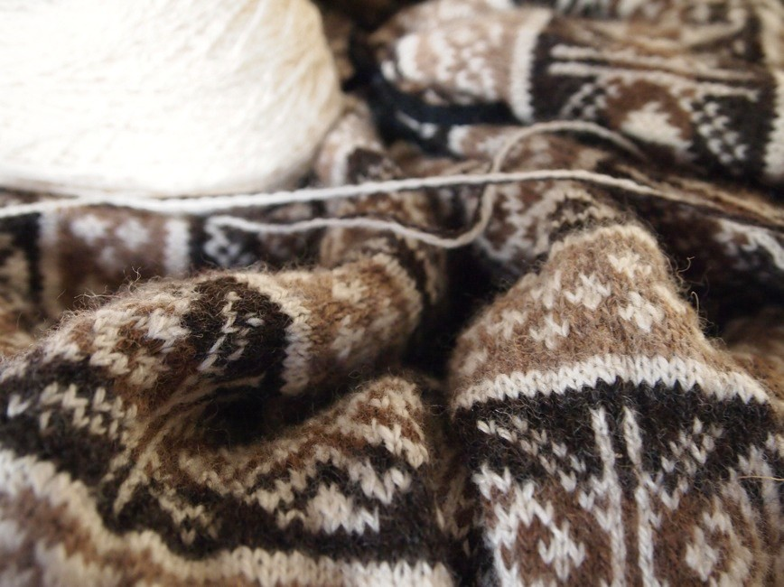
Hand-Spun Yarn and Hand-Knitting by Kathy Coull.
Photograph by Mai Lin Li, 2011.

Kathy describes her work (and that of other individual entrepreneurs on Fair Isle) as a ‘micro-business’. Such is the work involved that Kathy’s marketing for her bespoke garments is minimal (most orders arrive via word-of-mouth), but Kathy also offers tuition, workshops and demonstrations on a variety of traditional textile practices.44 She sells a limited amount of her yarn directly to the public, and has received a Scottish Crofting Produce Mark (as has Elizabeth Riddiford, another skilled Fair Isle hand-spinner and hand-knitter) in recognition of the crofting provenance of her products.45

44 Kathy Coull, ‘Fair Isle Textile Workshop’,
<www.spanglefish.com/FairIsleTextiles/index.asp?pageid=25534> [accessed October 2011].
45 ‘SCP Producers’, Scottish Crofting Federation: www.crofting.org/index.php/scpbrandproducers> [accessed November 2011].

There is another significant dimension to Kathy’s creative work, which has a more explicit footing in contemporary practice: she is currently studying for a BA in Contemporary Textiles at Shetland College in Lerwick. When I first met Kathy, she described herself as having two textile practices: the traditional on Fair Isle, and the contemporary on the Shetland mainland. In fact, her explnantion of the relationship between the two areas of work seems much more symbiotic:

The whole knowledge of how the contemporary textile world works is of value, because although we may not enter into that sort of commercial realm, to know what’s happening is of value, because then you know why: why is your product different? If it’s not hugely commercial, it’s very unique and very crafted, then you’ve got a different marketplace, and you have to pitch your product differently.
Kathy Coull

And while partly motivated by personal professional development, Kathy is also conscious that her learning could in the future be applied to the wider benefit of the knitting culture and community on Fair Isle:

There is such a textile heritage attached to Fair Isle, that you can’t not get involved in that, and admire it for exactly what it is, […] where else can you find such authenticity and ongoing traditions? It’s quite unique, I think.
And my whole idea of going into contemporary textiles is really to try and evolve something that’s more contemporary and commercial, that can support all the traditional skills at the same time, because without support I can see things dwindling severely.
Kathy Coull

Kathy, while circumspect about imposing her ideas or interests on others, is exploring ways to build resilience into traditional practices, and in encouraging the best use of Fair Isle’s natural assets. To this end, she is conducting an informal feasibility study on the possible introduction of a mini-mill on Fair Isle:

I think it could be a very valuable thing in the future for Fair Isle, to utilise all of its own resources of wool, in various different ways, because there are lots of different grades of wool; even from one Shetland sheep, you get lots

of different grades of fibre. It’s using each one to its best advantage that’s important, and also ending up with a product that is a valuable commodity to sell; to keep the provenance of the wool absolutely Fair Isle grown, and not mixed with anything else.
Kathy Coull
Kathy’s ideas illustrate how concepts of tradition and innovation, and commerce and craft, so often contested and held in opposition in the discourse of craft theory, are not necessarily implacably set against each other in the real-life thinking and working of crafting communities.

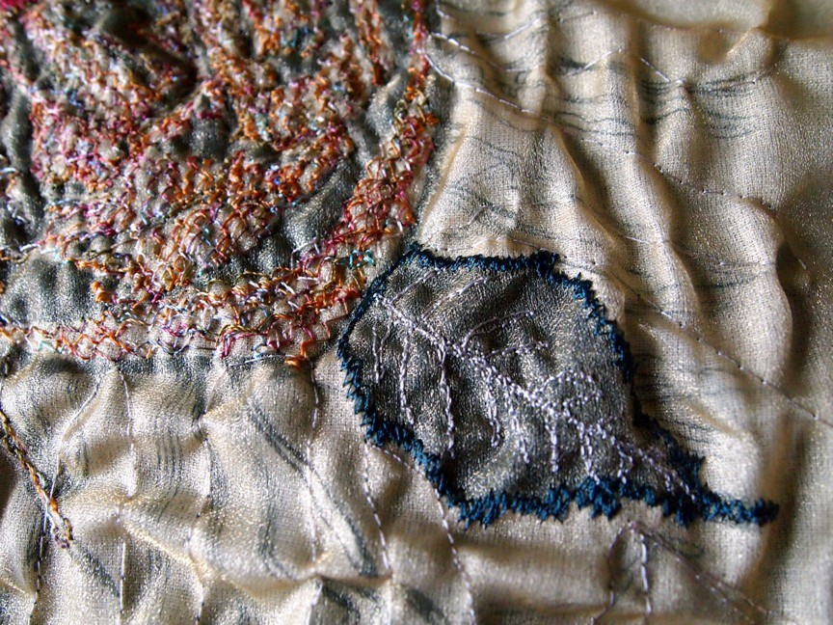
Contemporary Textile Piece by Kathy Coull. Photograph by Mai Lin Li, 2011.

Cultural Narratives

On the George Waterston Memorial Centre

The George Waterston Memorial Centre and Museum occupies a prime, elevated position on Fair Isle, overlooking the southeast of the island. The museum opens for three days a week during the summer months, and then by appointment. The museum has a single large room, and this is packed with objects, photographs and documents from and about Fair Isle. It has a significant island-specific textiles collection, which complements that held by the Shetland Museum. It is a registered museum and accredited as part of the national Museum Accreditation Scheme.46

The building that houses the museum was originally built as a schoolhouse, and subsequently served as the community hall for over a century. When a new hall was built in 1980, the islanders were faced with a decision as to what to do with the now-vacant building. At a Fair Isle community meeting it was decided that the building should become a museum. With her extensive knowledge of local history and a particular interest in textiles and social history, Anne Sinclair was asked to form a museum committee and to start looking at ways to raise funds. It was a timely decision:

We were very fortunate, because it was just at the start of the period in Shetland when people became very interested in having small community museums and oil money was enabling the formation of several charities, including Shetland Amenity Trust.
Anne Sinclair

The situation was dramatically brought to a head when a storm took the back roof off the building. Anne and her brother were galvanised to act quickly; they
46 MLA, ‘Accreditation Scheme for museums in the UK’, Museums Libraries Archives (archive website),
<www.mla.gov.uk/what/raising_standards/accreditation> [accessed January 2012].

personally stood surety for cost of repairs, which were then covered by Shetland Islands Council. The museum opened in 1986, having received crucial support and financial assistance from a number of development agencies, including the National Trust for Scotland, the Countryside Commission and the Shetland Amenity Trust, while momentum behind this process and what was achieved came very much from the community itself. Indeed, establishing the museum at a time when there was a vacant building and a groundswell of interest in and financial support for community-based cultural projects may seem deftly pragmatic. In fact, it was the formal culmination of a process that had been happening, quite instinctively and proactively since the 1960’s. Islanders Perry and Gordon Barnes had been carefully collecting and preserving artefacts, photographs and documents, and they operated a small, informal museum service from their home.

These early efforts created a rich and solid foundation for the establishment of the museum, which still retains this spirit; the museum is run by volunteers from the community, and is all the more distinctive for it: as noted by Carol Christiansen, it embodies ‘a stronger sense of the personalities that make up that community’. In this way, the museum memorialises not only George Waterston, after whom it is named, but also individual members of the community. Carol, as well as being a Curator at the Shetland Museum in Lerwick, is a Community Museums Officer, acting as curatorial advisor to the Fair Isle Museum. Working with people like Carol, and also with the overarching organisation of Museums Galleries Scotland, helps the museum to develop a consistent approach in terms of acquisition, conservation and interpretation; it was the first museum in Shetland to have a formal constitution and a collection policy.

Our collection policy basically is to retain only artefacts which have historical value and import to Fair Isle. We’re too small to go any wider than that, and it makes no sense to do so. Anything coming into the collection has to be relevant to Fair Isle. So far we have only made one purchase (of hats from Fair Isle Crafts); so far we’ve been very lucky with

items gifted to the collection. Since the museum opened lot of things that might have been thrown away, or might have left Fair Isle, have stayed.
Anne Sinclair

When Anne showed me around the museum, she demonstrated a detailed and animated knowledge of many of the artefacts’ exact histories, provenance and individual makers. Her commentary and interpretation gave coherence and meaning to the collection; a consummate storyteller, she made the museum a narrative environment and experience. The smallness of the community and the museum could be seen as an advantage in this context; it places the meaningful curation and interpretation of the collection on a manageable scale for what is undeniably a very small team of volunteers. Having said this, the museum is a small and nimble part of a much larger museums network and infrastructure, which Anne feels is not always calibrated to take into account these differences in scale and capacity.

I rant and rave at Museums Galleries Scotland quite frequently, because of the amount of paperwork that they come with […] we did get Registration, and then we had to face the requirements for Accreditation. I’m not sure if the people who set down what is required realise that one size doesn’t fit all.
Anne Sinclair
Despite this, Anne is very positive about the assistance offered by MGS staff in navigating these requirements:
The staff at Museums Galleries Scotland are brilliant. We can contact them at any time for help, support and grant aid. They give you a gentle prod if you stray from the required path, but they are definitely on our side
- there’s no doubt about that.
Anne Sinclair
While working in accordance with their collection policy and the national accreditation scheme, the museum volunteers are effectively shaping the collection and its interpretation; the artefacts come from the community, and, according to Carol, the intellectual content of the interpretation is also very much left to the community, while she advises on technical standards for legibility and accessibility.

Fair Isle as a community features high levels of what commentator Clay Shirky refers to as ‘social density’ and ‘social continuity’; put most simply, the community is small and closely knit, and people who are born or move to the island tend to stay for long periods.47 This creates favourable conditions for co-operative, community-minded behaviour to become a social norm, a concept that it popularly referred to as ‘social capital’.48 For Fair Isle, factors of social density and continuity have also fostered a long, detailed and coherent set of memories and histories: a type of institutional memory for the community. This can be presented as a cultural narrative, which is communal but punctuated by a strong sense of individual personalities, and nuanced by individual perspectives. Fair Isle’s cultural narrative finds an institutional form of expression through the museum.
Moreover, having a formally constituted museum can also offer a degree of protection for the community and its cultural identity. It is an interface with the interested public, and when it is run by members of the community, they can lay down the terms of engagement, and directly resist and challenge questions or assumptions that they may find intrusive, patronising or voyeuristic.

The museum has a forward plan that will take them to 2014, which includes the digital cataloguing of the collection’s artefacts, and then of the documents, and the building of a new extension, which will create a workspace for the volunteers. This plan is felt to be achievable and is currently on target. The George Waterston Memorial Centre is a museum built from the ground up, strongly rooted in the community, and owned by them in a very palpable sense.

47 Clay Shirky, Here Comes Everybody, (London: Penguin, 2008), 313.
48 The term ‘social capital’ was popularised by the American sociologist Robert Putnam, who suggested that this quality was declining in increasingly homogenised post-industrial American society. Robert Putnam, Bowling Alone: the Collapse and Revival of American Community (New York: Simon and Schuster, 2000).

On Writing

Cultural narrative finds many forms of expression on Fair Isle. Lise Sinclair is a poet and musician (a singer, composer, lyricist, and instrumentalist). Her first poetry collection Here was published in 200649, and her writing has appeared in a variety of anthologies, literary journals and magazines. She performs her poetry and music at festivals such as StAnza, Celtic Connections and Edinburgh Book Festival, and at venues including the National Storytelling Centre in Scotland. Her poem ‘Juist laek Maunna’ was selected for the Scottish Poetry Library’s Best Scottish Poems 2010. Lise writes in English and Shetlan (Shetland dialect), and her work has been translated into Estonian, Icelandic, Finnish, Latvian and Norwegian. She composed and recorded Ivver Entrancin Wis, a suite of music inspired by Shetland poems, and she is a member of Fridarey, Fair Isle’s folk music group.

I write music and poetry mainly, but I sometimes feel like my creative practice is more... as someone once said, “more agricultural than cultural”, because it’s inseparable from the rest of life, living on an island, growing things, having four children, and I really only started writing when my youngest started school.
Lise Sinclair
Lise sees her creativity as inextricably linked to and informed by her wider life as a crofter, islander and mother. Both the content and practice of her work is directly and explicitly influenced by the rhythms and requirements of island life, community and family. It is shaped by the crofting calendar (the summer months are particularly busy and much time is spent outdoors working on physical tasks) and by the wider cycle of activities that bring the community together. Among many other things, Lise teaches music at the school, plays the organ at chapel and leads the island choir.

49 Lise Sinclair, Here, North Idea, 2006.

Elements of Lise’s creative practice developed at an early age, stimulated by the musical environment provided by her family and community:
I grew up singing with my family, and playing the fiddle, in a crofting community, and have just gradually developed those skills. I had enough piano lessons to be able to realise that, to recognise that I could write music, because it was more or less when I started hearing it that I was needing to write it down, I was wanting to write more songs, to sing basically, but I could easily hear the music and arrange, and write and compose. That was something I found that I could, not easily do but it was something that I really, really wanted to do, and was finding myself doing.
Lise Sinclair
From its early foundations within a family and community tradition, Lise’s musical practice has continued to develop gradually and organically. By contrast, her work as a writer began in adulthood, and this newer, elective practice has benefited greatly from mentoring and peer support from individuals and development agencies from outwith the island and community. Lise also acknowledges a particular debt to people such as writer and broadcaster Mary Blance, and writer and former Literature Development Officer, Alex Cluness:
At the point when I was starting writing, I had a lot of encouragement from the Literature Development Officer at the time, that was just beginning in Shetland at that time, Alex Cluness, and the realisation at the time that it was […] normal, and that it’s okay to write, and being introduced to the literature of my community in Shetland, which I hadn’t had at school, at all, I hadn’t realised that in terms of Shetland language that existed properly. I had been introduced to that at home through singing and in terms of home life, obviously, but not in terms of literature and the very rich literature tradition that’s in Shetland.
Lise Sinclair

Lise places her writing as quite a recent development in her wider creative practice. Chronologically at least, Lise’s writing is more ‘contemporary’ in process, form and content, than her music. Yet by writing in both Shetlan and English, and on a diverse range of subjects, she takes a pluralistic approach, applying her emerging practice to transmit (and sometimes refract) her strong affiliations to

tradition and her sense of cultural identity. Lise explains how she can put her writing to use in this way, when describing her poem ‘Juist laek Maunna’:

Jen Hadfield put a poem that I wrote into the Scottish Poetry Library's best poems of 2010, that’s based on a snippet that my grandfather told me. It was for a writing project on fishing in Shetland, and I’d gone and asked him about it, and it’s just this snippet of a thing, that’s him remembering something that he was told as a child once, by an old man at the time, about his childhood. It just comes through as this snippet, and to write that in a poem, has fixed it somehow, it’s also fixed it in my mind. It’s not a big story but it is a poem […] and to write it as a poem is also functional, it’s not art or it is art - I’ve no idea, but it’s also functional and I understand that that’s a luxury because I don’t have to worry about it in that sense.
Lise Sinclair
On the SPL website the poem is accompanied by a commentary, where Lise describes the true story at its source and her desire to ‘to set it down as clearly as I received it, for what it shows’.50 This is poem as social document, a lyrical capture and arrangement of memory, language and culture. Once made, it can be both given back to the community, and communicated to a wider audience. Lise also points to the lack of (or perhaps the lack of consensus on) a ‘definable language and orthography’ for Shetlan as creating additional reason and urgency for capturing and preserving the living language through poetry and music, with the latter being a particularly effective way of ‘breaking language barriers’. To this day, Shetlan as spoken in Shetland contains vivid dimensions of Norn (a variant or descendant of Old Norse), Scots and English, indicating something of the historical and political significance of these isles over the centuries, set as they are at the confluence of several cultures.

Just as it is difficult for Lise to separate her creativity in any meaningful way from the other elements of her life, it is also difficult to distinguish between the intrinsic

50 Lise Sinclair, ‘Juist lack Maunna’, Scottish Poetry Library
<www.scottishpoetrylibrary.org.uk/poetry/poems/juist-laek-maunna> [accessed October 2012]

artistic and instrumental values and motives operating in her work. Instead, she suggests that having elements of her work that are of clear practical and tangible benefit to her family and community, can be creatively freeing rather than inhibiting. Beyond making competing claims on her time, these values and impulses are not set against each other; they are balanced and complimentary elements in a larger system of creativity.

I clearly know that I am expressing myself when I write, but I also know that, if I was feeling it was only about that, that I would then struggle with what on earth was that for […] maybe it’s a crutch that I use as well to say that allows me not to be too self-absorbed, the fact that I’m also doing it for a reason - I do garden flowers because I think they’re just beautiful and I love to look at them and wrestle them out of the gales in the summer and see what I can do, and that’s different from growing vegetables […] I like to do both, and I would feel unbalanced, you know I don’t want to grow just vegetables that are just functional, I do also want to grow flowers because they’re lovely, there’s room for all of that, and one exists better because of the other almost, they’re both important.
Lise Sinclair

Lise is currently working on a collaborative music and literature project with Icelandic composer Ástvaldur Traustasson and Icelandic poet and translator Aðalsteinn Ásberg Sigurðsson, inspired by A Time to Keep, a collection of short stories by the Orcadian writer George Mackay Brown.51 The project is supported by Creative Scotland and by Scotland’s Islands (a year long celebration of Scottish island culture), and will culminate in a series of performances (with musicians including Bryan Cromarty, Inge Thomson and Ewen Thomson) in Orkney, Fair Isle, Shetland, Edinburgh and Iceland, and the publication of a CD and songbook. The creative process for this project has involved what Lise describes as ‘remote practice’; a long-distance collaboration facilitated by social media and the internet. Having said this, the value of some face-to-face time between the collaborating

51 ‘ 'A Time to Keep' songs by Lise Sinclair based on the short stories by George Mackay Brown’, Tommy Hyndman’s Fair Isle BlogSpot, 16th February 2012, http://fair-isle.blogspot.com/2012/02/time-to-keep- songs-by-lise-sinclair.html [accessed February 2012].

artists, particularly at the beginning and end of the creative process, is not abated by technology, and the limits of technology (i.e. broadband capacity on Fair Isle) can bring its own frustrations and challenges:

For the music, Ástvaldur came to Fair Isle for one week and we laid down most of the music, since then we’ve been trying to use Skype and Dropbox which is amazing because you can send and receive files of recorded music and work on them, but there seem to be a lot of things to go wrong, even Skype is just – we don’t have a great broadband connection, so I’m really running up against that here, sometimes the connection is so poor we can’t really get anywhere.
Lise Sinclair
Technical constraints aside, Lise sees and describes Fair Isle with a kind of radiant perception that places it at the centre of an expansive circle of connections, bridging Shetland and Orkney as one continuous archipelago, gradually widening to other places, and signalling a common Northern Island affinity. This renders political and national boundaries temporarily arbitrary, or at least secondary to the identification of shared perspectives and similarities of experience.
I’d been thinking about writing songs inspired by those stories for a couple of years, and the idea of the circle between the Northern Isles and Iceland kept growing. It’s there in George’s work, his work has such a big background in time, of time being not particularly solid and it all being present, from Viking times, through the whole Scottish history as well, and everything was all present, and then I was working with the Icelandic poet who translated his work, I thought well, maybe this is a really good circle to draw in this work again.
[…]
Because you have these geographic parameters, it somehow frees you, in another sense, of having parameters at all.
Lise Sinclair
In this way of thinking, cultural identity is perhaps made stronger by being a permeable rather than a sealed construct. Highly distinctive forms of cultural expression are reached as the result of a delicate and ongoing negotiation of remoteness and connectedness.

It’s not just you’re taking the voice out of the songs out of the stories and putting them into some new songs, but you’re also drawing together the Orkney and Shetland community, and the fact that A Time to Keep is from this landscape, that's really important to me, as a reader, that there is work from this landscape in among the many voices and landscapes of 'English', that's important for people grown up or visiting here, or whatever it is, that there continue bodies of work that discuss this place.
Lise Sinclair
Through her writing Lise is both defining and lobbying for cultural identity, an identity that includes a culturally distinctive voice and narrative. She is speaking and writing from a position of remoteness that is perhaps as much defined by an audience external to that culture, as felt or experienced by the writer herself (echoing an earlier observation that remoteness or marginality is a relative concept). Lise’s assertion could in fact be used to argue democratically for the cultural representation and individuality of all communities, whatever context or place they are writing from. That is, to have a voice, one among many, that is present and available in the pluralistic landscape of literature.

On Photography

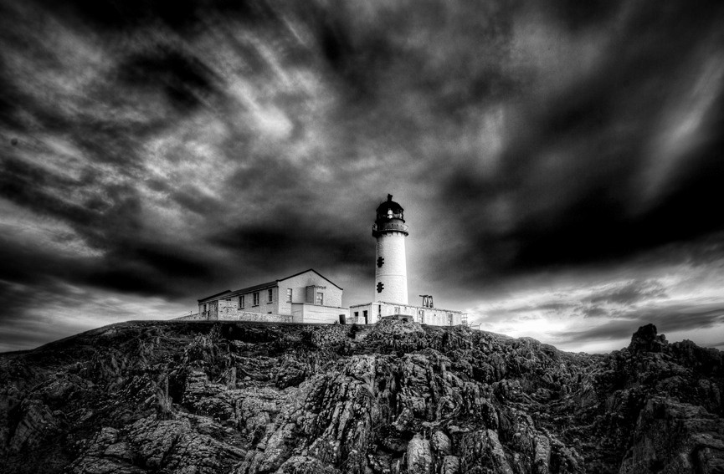
South Light, Fair Isle. Photograph by Dave Wheeler.

Dave Wheeler and his wife Jane moved to Fair Isle in 1972. They already had an interest in and experience of living in a small and remote community, having spent several years in South Georgia, where Dave worked as a meteorologist. Dave brought his meteorological expertise to Fair Isle, setting up a weather station and taking over and developing the existing service (originally provided by Stewart Thomson, who had been making weather observations three times a day). I was aware from previous interviewees that, as well as island meteorologist, Dave has filled quite a quite a number of roles over the years. I asked him to tell me about this:
Well there’s not as many jobs now as I used to do, I’m tending to have retired from some of them. What I’m actually still doing: I run the weather

station on Fair Isle, I’m a professional meteorologist. So jobs at the moment – running the weather station, the grand-sounding title Airport Manager, but that’s just being responsible for the running of the airfield here, and I’m also the radio operator as well. I’m an IT instructor at the primary school, and Registrar of Births, Deaths and Marriages, and also a photographer. I don’t know if I’ve missed anything out, I might’ve done! But in the time here I was also on the fire team, and the coast guard, I’ve retired from both those. I also worked as lighthouse keeper, as well, and of course I’m a crofter, so there’s the 35 acres with a couple of cows […] and Shetland sheep on the croft, and then there’s the Shetland sheep on the hill as well. So yes, that’s one of the things, the variety of the jobs that you do, it just makes life interesting. I mean quite honestly, there’s never a boring day! Because if you’re not happy doing whatever you’re doing, it’s not likely to be going on for very long, and you’ll do something else. And anyway I think that you wouldn’t be doing things, you wouldn’t be living here, if you weren’t happy in the lifestyle.
Dave Wheeler52

As well as bringing a number of specialist skills and interests that could be usefully applied or transferred to Fair Isle, Dave also communicates a general willingness to learn and try new tasks, and to do several tasks at once. This dovetails with Lise’s observations about the balance to be struck between community and personal interests, and between capabilities and preferences. In a very small community such as Fair Isle, the adaptability and capability of each individual benefits not only them, but increases the capacity of the community as a whole, making it more resilient and sustainable. A degree of pragmatism helps; as Dave comments, ‘the thing is that you have to modify your plans, you have to adapt as things develop.’

One of Dave’s most significant roles is as island photographer. It was an interest that he brought with him to the island, which has continued to evolve:

Right from the very first, coming to Fair Isle, I would have a camera around my neck, and when I was actually working with [the community], I was just taking pictures.
Dave Wheeler

52 Interview with Dave Wheeler, 22nd October 2010, Fair Isle.

Over forty years he has amassed a substantial body of work, which he estimates as including around 17,000 images. It forms a detailed chronicle of the island, capturing nuances of landscape, weather and wildlife, as well as many aspects of community life. Dave’s position as a longstanding and trusted member of the community has enabled him to record, celebrate and memorialise events that are profound and personal:
It’s expected, oh yes. I mean just taking funerals, for example. I was certainly the first to be taking photographs at the funerals, and I think people thought this a little bit strange at first, but as I pointed out, not everybody’s here, that would like to be here. The photographs are taken, and they’re kept, they’re a record, but some people want copies, and it’s expected now! […] it’s an aspect of island life. I just like to take pictures whenever. I don’t take pictures of everything, because I can’t because I’m not always there at the right moment, but sometimes I’m told about happenings and they say “make a good picture, Dave!”
Dave Wheeler

In terms of audience, there is a dual significance to Dave’s work. It is a vital social document for the community, helping to form and perpetuate memory, registering both change and continuity and creating a visual cultural narrative. In turn, selected elements of this narrative are shared with a wider audience. Being part of such a tightly woven community, Dave’s photography is self-governed by a strong ethical code; he is mindful as to what and whom he photographs, and how and where those images will be seen. The images that Dave chooses to make publically available are a significant part of Fair Isle’s ‘face to the world’, disseminated primarily through the internet, but also in books, magazines, newspapers and brochures. These images form the first impression of Fair Isle in many people’s minds.53

53 See Dave Wheeler Photography: www.davewheelerphotography.com/galleryindex.php

Dave is characteristically modest and diffident when discussing the intrinsic artistic value of his photography, but he speaks with great verve and knowledge about subject, composition and the different effects that can be achieved with post- camera processing treatments. He is currently experimenting with High Dynamic Range Imaging (HDRI or HDR), which allows for the adjustment and expansion of the dynamic range of light and dark in both black and white and colour images, to produce effects that are closer to how the human eye (and brain) naturally processes what it sees.

As a commercial practice, Dave’s photography is perfectly adapted to remote island life (as is the bespoke weather forecasting service that he provides for the local media plus yachtsmen and private pilots). It is a model of remote commerce. In the age of digital photography, once the photograph is taken, all processing can be done on a computer, rather than in a darkroom. Dave can then transact his business via the internet: he displays his images in an online gallery and sells them through his online shop. Buyers can download digital files, or place orders for prints and print products, which are received by a business on the UK mainland, that fabricates the orders and sends them directly to customers. Dave does not make large amounts of income from this business, but operations are crisp, efficient and of consistent quality.

Dave acknowledges the many advantages brought to the island by developments in technology and communication. He draws a parallel with the gains in efficiency brought to crofting practices by increased mechanisation:
Mechanisation has made it a lot easier to farm and croft, which means that we can do things more speedily, which helps actually if people are doing so many other different jobs.
Dave Wheeler

He has also noticed a more ambivalent corollary to improvements in technology: that is, a raised expectation about the increased availability and the speed of delivery of goods. This is a general trend in consumer attitudes rather than one specific to Fair Isle, but is particularly problematic in the context of a remote island community:
Technologically, things like the internet are a huge improvement – I hesitate when I said improvement; it is, but it’s brought difficulties with it, because of course we’re now in an age when we want something to happen now; you get on the internet, […] you can order something immediately, you get an email back to say it’s been dispatched after about twelve hours, if you work with Amazon it’s even sooner than that! But of course you have to sit and wait, and it can be a week, it can be ten days before anything arrives here. Of course sometimes it’ll arrive in two or three days, but you still have to have the patience to be able to wait for mail deliveries and other deliveries to the island.
Dave Wheeler

Within the creative industries on Fair Isle, Dave is conscious of his privileged position in having a creative product that is not subject to the logistical constraints and overheads that affect other producers; as with livestock, it is unavoidably more expensive and time-consuming to send products off the island to their buyers, even more so if you work with materials that also have to be brought onto the island. It is one of several considerations for people who come to Fair Isle with an established creative practice. The context of living and working on a small, remote island simply creates more favourable material and social conditions for some practices, rather than others.

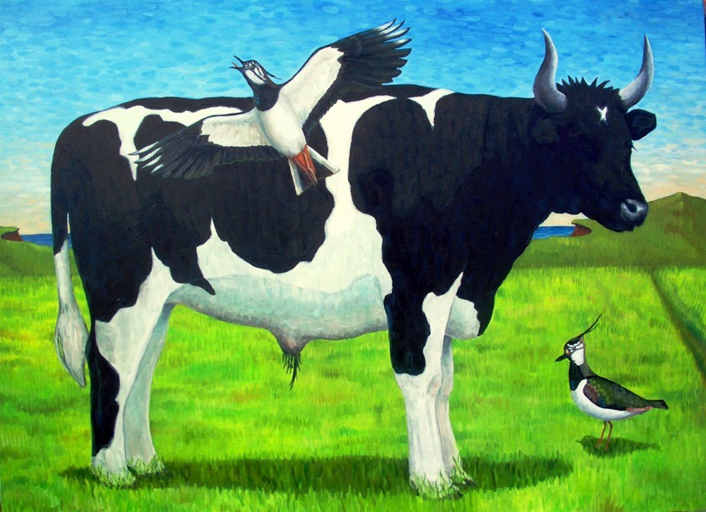
Shetland Ox and the Cry of the Lapwings, by Tommy Hyndman. Oil on wood panel, photography by Tommy Hyndman.

On Filmmaking and Visual Arts

Tommy Hyndman, his wife Liz Musser and their son Henry moved to Fair Isle from New York State, America, in 2006. Tommy is a visual artist, working primarily in painting and sculpture, while Liz is a documentary filmmaker. Liz first heard of Fair Isle, and the search for new tenants for the Auld Haa, when she was listening to the radio while driving home in rush-hour traffic through Saratoga Springs:

I think because I worked in journalism and storytelling, I’m always really keyed into good stories and it just so happened that there was a story about Fair Isle. It was a little three-minute radio story feature, and the hook was that the island had a couple of empty houses, and this, the Auld Haa, was the old laird’s house, and it was available, so I thought ‘Oh! How interesting!’ and they were looking for tenants, so we just kind of followed

up on it, looked at it on the web, then looked at Dave Wheeler’s photos […] I’d never actually heard of Fair Isle, and I hadn’t heard of Fair Isle sweaters […] because I grew up in Southern California, not wearing wool! So it was a place I’d never heard of before, but I was intrigued by hearing Anne Sinclair, who is island historian and was interviewed, and she talked about the place, and its sense of place, and Fair Isle knitting. It just intrigued us, initially, and then as we read more, we got more and more interested.
Liz Musser54

Liz’s personal passion for storytelling, and for true stories in particular, finds many rich sources of inspiration on Fair Isle, with its manifest sense of history, tradition and community. However, for both logistical and ethical reasons, Liz’s filmmaking practice was not immediately or directly transferable to the environs of Fair Isle. Instead, considerations of community and integration came first, as well as the requirement of drawing together an income. Liz’s interest in story and narrative found expression through her work as a carer, where she listened to and shared stories on an informal, unrecorded basis, while building relationships with members of the community. Her professional practice went through a period of necessary dormancy, but her interest and sensibilities as a collector of stories remained engaged:

It’s interesting for me – I was always employed, I always had a definite job, I never was out on my own, self-employed […] So I wasn’t able to come here and start doing documentaries type work right away – the community wasn’t really open to that for one thing, so that my love of storytelling found its place doing social care work with older folks, so that was just really hearing stories, but not really telling stories, and it’s really only been in the last year or so that I’ve been asked to tell stories, and collect stories and tell them through the Promote Shetland folk.
Liz Musser
Working under a similarly strong sense of ethical responsibility and sensitivity to that described by Dave Wheeler, Liz gradually started to film again, taking a soft approach by first capturing some of the more public events of community life, such

54 Interview with Liz Musser, 20th October 2010, Fair Isle.

as the summer sheep caaing. She has also worked with some of the island’s other creative practitioners, including Lise on her ‘A Time to Keep’ project.

You’re so exposed here, so if someone’s gathering stories on you, that feels almost – it’s a way more voyeuristic feeling! And at both ends, feeling that somebody’s looking at your life, so closely examining it, and also feeling like a voyeur, if you’re the person that’s gathering the stories or collecting the stories. […] it’s taken a long time to get to that point where I’m even competent enough to tell some of the stories.
Liz Musser
By her own definition, Liz has been able to achieve competency as a filmmaker on (and for) Fair Isle by first consolidating her own position within the community, and by developing a fuller and more nuanced understanding of the island’s existing cultural narrative, to which she can now contribute with her own work. Equally subject to a new set of parameters for his creativity, Tommy has also found his practice to be influenced by the environs of Fair Isle. These influences are evident in the material, aesthetic and commercial dimensions of his work. As Tommy comments, ‘Fair Isle inspires you to want to make items that are relative to the island and its history and its environment’. Added to this is the practical difficulty and expense of transporting art materials and finished works on and off the island, particularly large, delicate pieces (such as Tommy’s large-scale paintings).
Considerations such as these have stimulated Tommy to work with the island’s resources, taking them as both inspiration and material, and in doing so, building sustainability into his practice. Tommy takes the landscape and wildlife of Fair Isle as the subject for many of his paintings, and he also creates sculptures using recycled, repurposed and salvaged materials:

These wire sculptures I do of birds and other things, are made out of wire that I’ve reclaimed from the dumpsters at the lighthouse, at the North Lighthouse […] this is wire that was used for strength around the copper wires, it doesn’t rust and it has a lot of strength to it, so it’s really good for the wire sculptures and holds its shape. For a base I use Russian trawler net floats that still come ashore – the nets have been snagged on the sea bottom probably at some time in the 60’s, and they still break up, and they pop up

off the nets and come floating ashore - I’m told not as many as they used to, and they’re getting harder and harder to find, but they’re a nice bit of Fair Isle found-object reconstruction, into a small work of art.
Tommy Hyndman55
Tommy’s practice is interdisciplinary, playful, and extends beyond the paintings and sculptures for which he is known. Liz and Tommy believe that one of the factors that helped their tenancy application was that Tommy also designs and produces a line of colourful, wildlife-themed hats that seemed particularly apposite to Fair Isle. They even included a sample (a puffin hat) with their application:
I make hats with a number of different bird shapes like puffins and gannets out of polarfleece, which are quite unique – I did that professionally in the states before we moved here, but there I made thousands and thousands of them, and licensed my company to larger companies and they made hundreds of thousands of them and sold to department stores – here I sew them myself and just show them at the hall! […] So I’ve just done these things for the cruise ship sales at the Hall, and to be part of the community, mostly.
Tommy Hyndman
Tommy’s business relationship with the larger company to whom he licensed his designs in the U.S. had ended shortly before the move to Fair Isle, so that by the time the family arrived on Fair Isle, operations had been substantially scaled down. Tommy has now returned to designing and producing a small number of hats by hand, using the wind-powered industrial sewing machine that he keeps at his converted studio/gallery space at the South Light.

While the logistical challenges of transporting materials and pieces of work are considerable, they are not insurmountable. What has had an inescapable impact on the work that Tommy makes and sells is the market for that work on Fair Isle. Tommy is conscious that as an artist and entrepreneur he is operating under very different market conditions to those he was accustomed to in the U.S., where he

55 Interview with Tommy Hyndman, 20th October 2010, Fair Isle.

showed and sold his work through commercial galleries and large companies, to an established art-buying clientele. By contrast, Tommy’s immediate market on Fair Isle is comprised of relatively small numbers of wildlife enthusiasts, tourists and visitors to the island. He suggests that, for many cultural tourists and potential buyers, if they do choose to buy a piece of art or craft during their visit, they will often choose something they see as more quintessentially and traditionally ‘Fair Isle’, usually meaning a piece of Fair Isle knitwear.

Tommy maintains a wider constituency interested in his work, and in his personal experience of living on Fair Isle, through the regular upkeep of his blog. It has received in excess of 134,000 hits to date.56 Tommy describes it as ‘a calling card to the world’ for Fair Isle, and views it as a community-oriented enterprise as much as a personal one. As well as publicising his own creative and entrepreneurial activities, Tommy promotes the work of the island’s other artists and craftspeople, and offers travel advice and information for visitors, as well as personal accounts of birding activity on the island, all accompanied by plenty of photographs, mostly taken by Tommy. Tommy used his blog to great effect in the management the online auction of the keps for museum funds.

Tommy has recently reinstated an idiosyncratic piece of Fair Isle’s heritage; namely, the adventurous six-hole lighthouse keeper’s golf course at the South Light. (In a pleasing piece of cultural symmetry, it was HRH the Prince of Wales’ donning of a Fair Isle sweater to play golf in 1921, which originally popularised it as a high-fashion garment.57) While he may sometimes feel frustrated by the challenges to his established creative practice that arise from the parameters of island life, Tommy remains an expansive and open generator of ideas, constantly seeking to produce new creative and entrepreneurial responses to his environment.

56 Tommy Hyndman’s Fair Isle BlogSpot: http://fair-isle.blogspot.com
57 Alice Starmore, Alice Starmore’s Book of Fair Isle Knitting (New York: Dover, 2009), 22.

Tommy sees both his blog and the revival of the golf course as ‘infrastructural’, and linked to the possible creation of a ‘Fair Isle’ cultural brand or offer of island- specific products and experiences.

I have a couple of books I hope to write, I’ve got some art to make, and I’ve got proposals about developing Fair Isle –I’ve started in my own small way to develop a Fair Isle product company, a Fair Isle collection, making things that are specific to Fair Isle and its history and its heritage. And I’ve got some paintings that I hope to do, that are still Fair Isle specific – most of them are these days, all of them are!
Tommy Hyndman

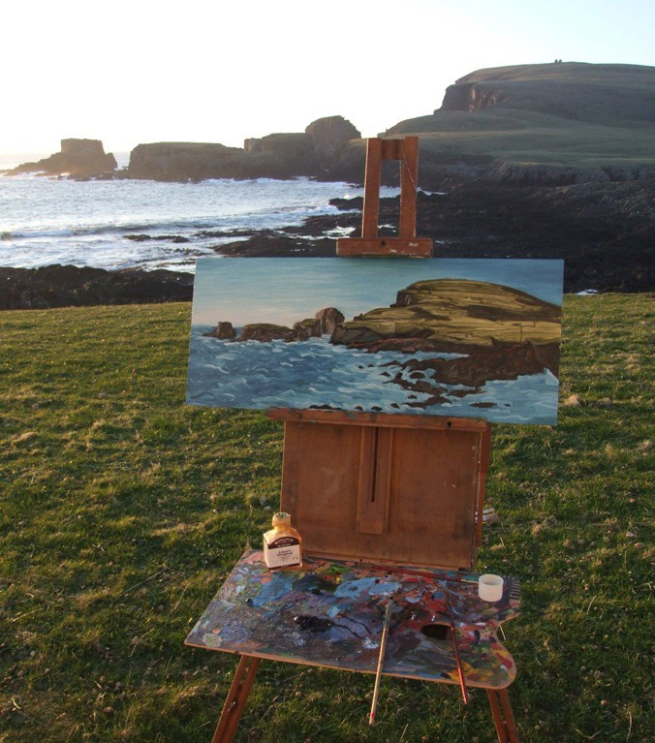
Work in progress: Studio View, The Holms & Malcolm’s Head, Fair Isle. Oil on wood panel. Painting and photograph by Tommy Hyndman, 2011.

CONCLUSION

A resilient world would place an emphasis on learning, experimentation, locally developed rules, and embracing change.
Brian Walker and David Salt58

I think that, generally speaking, the Isle is quite forward-looking, we are not afraid of new things. It’s difficult to put us in boxes. I think we don’t dwell on the past and that quite probably has to do with the fact that we have had so many influences from the outside. But that’s just my opinion.
Anne Sinclair

It is worth revisiting the most salient features that have emerged during this study, to consider what conclusions may be drawn from these findings, and to identify questions and lines of enquiry that may reward further investigation. I make these general observations with some hesitancy and the proviso that, while many interviewees expressed similar views and attitudes to one another, they also stressed that they could speak only for themselves, and moreover that they would not wish to impose their views or ideas on the rest of the community, or suggest that they held the prevailing view.

That’s not my way, to impose my vision of what I think is maybe appropriate, because I can do that on my own, to a certain extent. But if I’ve got any sort of knowledge or network that’s valuable on a community level, then that’s good.
Kathy Coull
Ironically, this indicates something of the restraint, diplomacy and self-moderation that is required to live and work successfully in a community such as Fair Isle’s.
This approach depends on the integration and ongoing negotiation of the needs and wants of the individual, and those of the community:

58 See Walker and Salt, Resilience Thinking, 14.

There’s that interdependence - that people need each other. There’s a certain restraint, I think, that people need – and you can let your hair down, certainly, at parties and dances, but to keep [the community] firm and whole, you have to be quite careful.
Ann Cleeves
In the course of this study, one can discern a similar awareness of the interdependence of natural and human environments and systems, and the need therefore for the sustainable management of the island’s assets; this encourages the sensitive, intelligent use of materials, and a practical, co-ordinated and creative response to the constraints and opportunities arising from this context.

It is important not to romanticise life on Fair Isle. There is no denying that being part of a very small, remote and close-knit community has attendant difficulties and tensions, as well as great dividends. The island is remote, but it is not a secluded, leisurely idyll, nor is it much suited to those seeking complete personal isolation; there is much to do and few to do it, which immediately throws one back onto one’s own resources, and more importantly, onto those of the community.
Remoteness creates not only a greater need for self-sufficiency, but also a greater dependency on your neighbour and community. Moreover, it is surprisingly difficult to remain anonymous; in a small community each individual plays a larger and more visible role. In a culture of craft this visibility is further amplified, where it is a vivid consequence of the aforementioned ‘human face’ of craftsmanship.

Fair Islanders have to contend with dark winters, the extreme variability of the weather, the demanding logistics (and occasional impossibility) of getting people and goods on and off the island, and the challenge of finding or creating remunerative work that can be successfully discharged from the island; or of piecing together an income from multiple activities. Yet the words ‘luxury’, ‘asset’ and ‘opportunity’ came up repeatedly in the interviews for this study, suggesting there is a richness and reward to life on Fair Isle that offsets these challenges and

constraints. It is even possible to see these factors as having a beneficial, equalising effect on the community, in that everybody is subject to the same fundamental constraints and parameters. This is supported by structures of governance that were created by the community, with the intention of facilitating democratic decision-making at a local level.59 Furthermore, the sharing and rotation of various roles and tasks is conducive to cooperation, adaptability and a sense of shared purpose and experience.

In areas that involve a greater specialisation of skills and knowledge, including the arts and crafts, there may be less rotation and adaptability. This may amplify issues around the succession and continuity of those practices. These concerns will further come to bear on the community as a whole as the population (and therefore the workforce) ages. Having said this, individuals on Fair Isle engage in various types of work (with crofting and community work central to this), until well beyond conventional retirement age. Furthermore, while the straightforward rotation of roles may not proliferate in the creative industries, a set of symbiotic relationships exists, manifesting high levels of co-operation and mutual support between practitioners; people regularly film, photograph, paint, write about and play music on each others’ projects, and they are quick to acknowledge and promote each others’ work. There is encouraging evidence of skills transfer and sociable expertise (rather than expertise passed down through a sealed, guild-like system). This was demonstrated during the kep barter project, which is of even wider cultural value given the withdrawal of knitting lessons from the school curriculum in Shetland.60

A creative economy, however small, that is composed of a mixture of individual enterprises and co-operative ventures, diversely practiced across a variety of arts,

59 The Fair Isle Committee and Community Association.
60 John Robertson, ‘Era of knitting in schools to come to an end as cash saving is agreed’, The Shetland Times, 6th May, 2010, <www.shetlandtimes.co.uk/2010/05/06/era-of-knitting-lessons-in-schools-to-come- to-an-end-as-cash-saving-is-agreed> [accessed October 2011].

crafts and cultural activities, indicates an adaptable, pluralistic approach that is likely to foster resilience in the system as a whole. Some tension can actually be beneficial in maintaining the structural integrity of the system, so that it is mobile, permeable, and coherent. The ability to withstand and absorb small stresses (which could be anything from differences in opinion, or diversification of practices, to the fluctuating availability of natural resources) can prevent complacency and over- homogeneity. The theory of adaptive resilience put forward by Brian Walker and David Salt, suggests that points of weakness can develop in a system that is characterised by over-connectedness and uniformity:

Overconnected systems are susceptible to shocks and they are rapidly transmitted through the system. A resilient system opposes such a trend; it would maintain or create a degree of modularity.61
While over-connectedness can create vulnerability, co-operation and collaboration between diverse elements (or modules) builds resilience, and increases the capacity of the system as a whole. Moreover, being open and adaptable to new ideas and external influences can stimulate creativity, innovation and progress.
I don’t think it’s an ideology, you know, this business of being open and accepting of new things, I think it’s a geographic necessity, which is always a good thing, because then it doesn’t mean you have to be disposed to be that way. I think human beings tend to respond better to things that make their lives easier. We’re not ideologically predisposed; we’re more predisposed to doing things that make life easier. And in a very remote community, being open and accepting is fundamentally just better; there are not a lot of us, and there a certain things that you just have to - you have to just get on and do, or get on and set things aside that are not so important, and you just have to keep going, and so accepting new things makes things better, really.
Lise Sinclair

If it is not an ideological openness, then it is a habitual, attitudinal openness, built on direct experience and a constant proximity to purpose. How the community makes art, crafts and culture, is inextricably linked to how the community works to
61 See Walker and Salt, Resilience Thinking, 146.

make life better in general. This is not to suggest a model that is wholly self- sufficient; when an artist or craftsperson develops a practice or project that has requirements beyond the immediate resources of Fair Isle; external support can be sought, via a network of regional and national development agencies such as Shetland Arts, The Shetland Amenity Trust and Creative Scotland.62 Support for Fair Isle from outwith the island is fundamental to the future and prosperity of the community; Fair Isle is as much defined by its many and fruitful connections, as by its singular remoteness. As well as the resident community, the island’s relationships and transactions with the rest of the world have created another type of community, that of the community of interest. Communities of interest are comprised of individuals and organisations that are in some way invested in one or more aspect of Fair Isle. This could be knitting, traditional crafts, ornithology, conservation, marine environments, remote communities, Northern Isles literature, island hopping, to name but a few. These communities may vary greatly in size, focus and also in the degree to which their interest in Fair Isle is actively pursued or latent, but maintaining a wider constituency of support, that cares about the wellbeing of Fair Isle and its community, continues to be a crucial element in the island’s social-ecological system.

Tourism (including cultural tourism) is increasingly important to the island’s economy, but capacity is limited by the environment, infrastructure and size of the resident community. The unlimited growth and expansion of the tourist industry is not an option, and any development requires careful management and that close attention be paid to sustainability, and to qualitative as well as quantitative impacts. In such a carefully regulated environment, small things can make a big difference:

62 See Shetland Arts: www.shetlandarts.org, The Shetland Amenity Trust: www.shetland-heritage.co.uk, Creative Scotland: www.creativescotland.com.

It’s very fragile. It doesn’t take much to upset the balance. It’s quite a fragile community, it has to work together, and if it doesn’t, the community would be even more fragile.
Jimmy Stout
The culture and community of Fair Isle is predicated on delicate calibrations such as these, striking a functional balance between: remoteness and connection, tradition and innovation, consolidation and change, openness and restraint, consensus and pluralism, and the individual and the community. Yet despite the small scale and intricacy of these considerations, there is an astonishing sense of increase, and a sense of the potential for further increase, in the pattern of living and making on Fair Isle.

It would be inaccurate and somewhat naive to surmise that people living in communities such as Fair Isle don’t need and want to achieve an equitable income and standard of living. Fair Isle is undergoing changes to social attitudes, behaviours and expectations commensurate with those found in wider society, and these may be difficult to reconcile with the particular demands of a remote island context:
The concept of island life has changed completely. And now you need money, otherwise you get left behind in the system, and getting left behind in this system is not good for people’s mental attitude either – you have to be able to live in the same ethos as you neighbour. […] And that is perhaps the problem, now, of living on a small island.
Jimmy Stout

Despite this, definitions of productivity and value still seem to be differently constituted on Fair Isle, and for now remain relatively uncoupled from purely financial metrics. This is clearly reflected in the arts and crafts industries.
Possessing a sharpened sense of the assets and parameters of their context, the artists and makers of Fair Isle are conscious that they are differentiated, and even privileged by this acute perspective:

On the mainland, especially in the cities, you’re a step removed from your raw materials, so you don’t have to do anything with them – why would you? You can go to a supermarket and buy a leg of lamb, you can go to Marks and Spencer’s and buy a jumper – so you don’t actually have to look at your raw materials and think ‘I could do something creative with that!’
Kathy Coull

When Kathy looks out of her window, she can see the sheep whose wool she will clip, spin and knit, and the skies and landscape that inspire her work (she also sometimes sees that rain and wind that will keep her indoors, and focused on making). A habitual awareness of necessity lends a logical integrity and coherence to life; when you live so closely to the parameters of your natural resources, the weather, and the physical boundaries of your environment, it makes sense to reserve and direct your energies towards that which is purposeful, and enriching, and which allows you to use the materials and skills you have to hand. As E.F. Schumacher observed,

It is moreover obvious that men organised in small units will take better care of their bit of land or other natural resources than anonymous companies or megalomaniac governments which pretend that the whole universe is their legitimate quarry.63

If companies and governments are taking an increasingly unrestricted view of what is their ‘legitimate quarry’ then we, as consumers and citizens, experience a similar deregulation of our expectations, rights and responsibilities. Any expansion of our sense of entitlement can make it much harder to see what is really to hand, and what is logical and ethically appropriate to use and draw upon.

Is it therefore realistic to encourage or expect a similar level of awareness, co- operation and mobilisation in other contexts, particularly where a community’s

63 E.F. Schumacher, Small is Beautiful: a Study of Economics as if People Mattered (London: Vintage, 2011, original work published in 1973), 23.

assets, and even the parameters and constituency of that community, are not so clearly delineated? Is it always possible to be so alert to the resources and opportunities afforded to you by living in a specific place? Are these qualities scalable upwards, to apply to larger communities? Ultimately, beyond the capabilities of the individual, is it practicable to legislate for this model of living and making?

This study, and any conclusions that may be drawn from it, are not intended as an exhortation to move to Fair Isle, or to model one’s own practices or approach to community directly on those of Fair Isle. Nor is it necessarily encouraging the further study of Fair Isle and its creative model of community; it is a small place, whose fragility and capacity may not benefit from the weight of further attention. Fair Isle is in many ways simply prismatic of wider social and cultural concerns, about how to live well and make well, as both an individual and a community. I hope that this study gives the reader pause for thought, and gestures towards something that is interesting, illuminating and potentially useful.

APPENDICES

Bibliography

Abrams, Lynn, Myth and Materiality in a Woman’s World: Shetland 1800-2000)
(Manchester: Manchester University Press, 2005).
Adamson, Glenn, ed., The Craft Reader (Oxford: Berg, 2010). ‘Arts and Crafts on Fair Isle’, Fair Isle community website,
<www.fairisle.org.uk/Crafts/arts_crafts.htm> [accessed January 2012].

Block, Peter, Community: the Structure of Belonging (San Francisco, CA: Berrett-Koehler Publishers, 2008).
Charny, Daniel, The Power of Making (London: V&A, 2011). Christiansen, Carol Guide to Shetland Museum Textile Collection (Shetland:
Shetland Amenity Trust, 2010).
Coull, Kathy, ‘Fair Isle Textile Workshop’, Fair Isle Textiles
<www.spanglefish.com/FairIsleTextiles/index.asp?pageid=25534> [accessed October 2011].
Crawford, Matthew, The Case for Working with Your Hands (London: Penguin, 2011). Dormer, Peter, ed., The Culture of Craft (Manchester: Manchester University
Press, 1997).
Fair Isle Electricity Company Ltd, ‘Leading the Way With Community Wind Power’, Fair Isle community website,
<www.fairisle.org.uk/FIECo/index.htm> [accessed January 2012].
‘Fair Isle: in Reality Virtually Unforgettable!’, Fair Isle community website,
<www.fairisle.org.uk> [accessed September 2011].
Fair Isle Lodge and Bird Observatory, ‘How You Can Help’, Fair Isle Lodge and Bird Observatory, <www.fairislebirdobs.co.uk/help.htm> [accessed February 2012].
Feitelson, Ann The Art of Fair Isle Knitting: History, Technique, Colour and Patterns.
(Loveland, Colorado: Interweave Press, 1995).

Fenton, Alexander The Northern Isles: Orkney and Shetland (East Linton, East Lothian: Tuckwell Press, 1978).
Gauntlett, David, Making is Connecting. (Cambridge: Polity Press, 2011). Gunderson, L.H., and Holling, C., eds., Panarchy: Understanding Transformations in
Human and Natural Systems (Washington, D.C: Island Press, 2002).
Halpern, David, Social Capital (Cambridge: Polity Press, 2005).
Hickey, Gloria, ‘Craft within a consuming society’, in Peter Dormer, ed., The Culture of Craft (Manchester: Manchester University Press, 1997), 83-100.

Hyndman, Tommy, ‘Fair Isle Crafts Knitwear & Knitting table display for cruiseship visitors’, Fair Isle BlogSpot, 5th May 2011, <http://fair- isle.blogspot.com/2011/05/fair-isle-crafts-knitwear-knitting.html> [accessed January 2012].
Hyndman, Tommy, ‘Traditional Hand Knit Fair Isle Fisherman’s Keps (6 Hats for Auction) Museum Fund Raiser’, Fair Isle BlogSpot, 11th October, 2011,
<http://fair-isle.blogspot.com/2011/10/traditional-hand-knit-fair-isle.html> [accessed October 2011].
Jackson, Tim, Prosperity Without Growth: Economics for a Finite Planet (London: Earthscan, 2009).
Johnson, Steven, Emergence (London: Penguin, 2001).
MLA, ‘Accreditation Scheme for museums in the UK’, Museums Libraries Archives (archive website), <www.mla.gov.uk/what/raising_standards/ accreditation> [accessed January 2012].
McGregor, Sheila, Traditional Fair Isle Knitting (New York: Dover, 1982, reprinted 2003).

McWilliam, Candia, What to Look for in Winter: a Memoir in Blindness (London: Jonathan Cape, 2010).

Norman, Jesse, The Big Society (Buckingham: University of Buckingham Press, 2010).

‘On this day - 3 September 1954: National Trust buys remote island’, BBC News,
<http://news.bbc.co.uk/onthisday/hi/dates/stories/september/3/newsid_ 3020000/3020298.stm> [accessed January 2012].
Putnam, Robert, Bowling Alone: the Collapse and Revival of American Community
(New York: Simon and Schuster, 2000).

Pye, David, The Nature and Art of Workmanship (London: The Herbert Press, 1995, original work published in 1968).
Riddiford, Elizabeth, ‘A Fair Isle Handknitter’s Diary’, Exclusively Fair Isle,
<www.spanglefish.com/exclusivelyfairisle/blog.asp> [accessed February 2012].

Riddiford, N.J., and Riddiford, E.A., eds., Proposal for a Marine Protected Area for the Waters around Fair Isle (Fair Isle: FICA, FIBOT & NTS. FIMETI, 2011).
Riddiford, N.J., ‘Future Fair Isle: retaining, maintaining and enhancing its maritime values’, Safeguarding Our Heritage, FIMETI, <www.fairisle.org.uk/ FIMETI/Reports/Safeguarding_Our_Heritage/future.htm>
[accessed February 2012].
Robinson, Mark, Making Adaptive Resilience Real. [pdf] (London: Arts Council England, 2007).
<www.artscouncil.org.uk/media/uploads/making_adaptive_resilience_ real.pdf > [accessed 7 September, 2011].
Schumacher, E.F., Small is Beautiful: a Study of Economics as if People Mattered
(London: Vintage, 2011, original work published in 1973).
Scottish Crofting Federation, ‘SCP Producers’, Scottish Crofting Federation:
<www.crofting.org/index.php/scpbrandproducers> [accessed November 2011].
Sennett, Richard, The Craftsman (London: Penguin, 2009, originally published 2008).
Shirky, Clay, Here Comes Everybody: How Change Happens When People Come Together
(London: Penguin, 2008).
Sinclair, Anne, ed., Handwork. [booklet] (The SafeinHerit Network, 2004).
Sinclair, Lise, ‘Juist lack Maunna’, White Below (Stromness: Hansel Cooperative, 2010)

Starmore, Alice, Alice Starmore’s Book of Fair Isle Knitting (New York: Dover, 2009).
‘The Tall Ships Races 2011: Cruise In Company’, Sail Training International,
<www.sailtraininginternational.org/_uploads/documents/CaptainsPage/ CruiseInCompanyBrochure.pdf > [accessed January 2012].
Thomason, Louise, ‘Special spinning wheel auctioned’, The Shetland Times, 19th March 2010, <www.shetlandtimes.co.uk/2010/03/19/special-spinning- wheel-auctioned> [accessed January 2012].
‘ 'A Time to Keep' songs by Lise Sinclair based on the short stories by George Mackay Brown’, Tommy Hyndman’s Fair Isle BlogSpot, 16th February 2012,
<http://fair-isle.blogspot.com/2012/02/time-to-keep-songs-by-lise- sinclair.html> [accessed February 2012].
Walker, Brian and Salt, David, Resilience Thinking: Sustaining Ecosystems and People in a Changing World (Washington DC: Island Press, 2006).
Weber, Bruce, ‘Craft and Art, Culture and Biology’, in Peter Dormer, ed., Peter Dormer, ed., The Culture of Craft (Manchester: Manchester University Press, 1997), 67-82.

Acknowledgements
I would like to thank all of the people who agreed to appear in this study: Dr Carol Christiansen, Ann Cleeves, Kathy Coull, Tommy Hyndman, Angus Jack, Liz Musser, Susannah Parnaby, Anne Sinclair, Lise Sinclair, Florrie Stout, Jimmy Stout, Stewart Thomson, and Dave Wheeler.
With particular thanks to Anne Sinclair and Carol Christiansen, for telling me much of what I know about the history of Fair Isle knitting, and everything I know about the George Waterston Memorial Centre.
I would also like to acknowledge the other talented artists and craftspeople who live on Fair Isle, whom I did not manage to interview during the course of this study, and of course the community of Fair Isle, for their abundant generosity, patience and humour. It is much appreciated, and will be long remembered.
I am grateful to my academic supervisor Professor John Burnside, for his support, guidance and enthusiasm, and to Katrina Thomson and Heather Doherty, for providing me with useful contacts and information.
Thanks also to the Clore Leadership Programme (Sue, John and Sharon) and the Arts and Humanities Research Council for giving me the opportunity to undertake this research.
With special thanks to Jacob Polley, for his conscientious reading, thoughtful feedback and constant encouragement.

