


Clore Leadership-AHRC Online Research Library Paper
Thinking about theatre: The space where professional and non-professional practice meets
Author: Annie Rigby
Supervisor/s: Peter Reynolds,
School of English, Newcastle University
Year paper completed: 2008
Leadership Content Theme/s: Inclusive Leadership Practice, Sector Insights
AHRC Subject Area/s: Theatre and Society
A note on contents:
Since 2005 Clore Leadership and AHRC have partnered to offer a diverse range of cultural leaders the opportunity to produce a piece of extended research relating to leadership and to their specific cultural discipline. These papers, published from 2023 onward on the Clore Leadership-AHRC online research library, reflect an important contribution to the field and we are extremely pleased to make them available to practitioners, scholars, and other interested parties. We recognise that this research library contains a range of terminologies and outlooks: these are reflective of the significant and ongoing changes within the cultural sector over the past 20 years. As such we urge readers to recognise that the authors’ thinking and language may have shifted since completion of these papers, or may be in the process of shifting as consequence of their enquiries.
Unless otherwise stated, research papers included in the Clore Leadership-AHRC Online Research Library have not been formally peer reviewed or published in an academic journal.

Thinking about
theatre:
The space where professional and non-professional practice meets

Annie Rigby July 2009

Contents

Introduction 3-4

Case Study 1: How do Quarantine make theatre? 5-18

Case Study 2: Theatre making in the Eastern Cape 19-31
of South Africa
Postscript 32-36

Thinking about theatre: the space where professional and non-professional practice meets

Introduction
This piece of research was carried out between Spring 2008 and Summer 2009 as part of my Northern Rock Foundation fellowship on the Clore Leadership Programme.
I set out with the intention of investigating theatre made with non-professional performers. This interest came from my own personal experiences and practice as a professional director. I regularly make work with non-professional casts and therefore I was interested in taking the opportunity to explore other theatre makers’ work in this area.
I carried out my research by writing two case studies. The first focuses on the work of Quarantine, a theatre company based in Manchester, and the second explores theatre making in the Eastern Cape of South Africa. Writing the two case studies gave me the chance first to consider work that is well known to me, then to explore theatre made in a completely unfamiliar context.

As my research progressed, I realised I was less interested in focusing simply on the question of professionalism and non-professionalism and more interested in considering what I saw in a broader context: what were the ambitions of these theatre makers, what did they make work about, and how did they go about it? I hope my case studies go some way to answering these questions.

Process
I researched my case studies by interviewing theatre makers and observing their rehearsals and performances. I recorded and transcribed each of the interviews and, where I could, I photographed the work I saw.

I explained the scope and context of my research to all of the theatre practitioners I met as part of the process. For each interview I gave the interviewees the option of giving their thoughts, comments and feedback anonymously. I also sent interviewees a draft of the case study to which they had contributed to give them an opportunity to check, veto or comment on what had been written. A few of the South African interviewees were difficult to contact once I had returned to the UK, and in those cases I have quoted individuals anonymously.

Impact
I wrote this research predominantly to inform and develop my own practice as a director, and I have written about the impact it has had on my own work in the postscript to the case studies.

Additionally, each of the case studies has had an impact in its specific area of focus. The Quarantine case study has mainly impacted on the people directly involved in the project I observed, Old People, Children and Animals. In particular, it has given the non-professional performers an opportunity to capture and reflect upon their journey through the project. One performer expressed her pleasure in having a copy of the case study as a good record of their experiences and achievements. I also sent copies of an early and final draft to director, Richard Gregory, who was actively involved in supporting my research through arranging interviews with the performers and creative team.
The Eastern Cape case study has had a wider impact in terms of articulating the experience of a number of UK theatre makers involved in the Swallows Partnership delegations to South Africa. The Swallows Partnership circulated the case study to a range of artists and arts organisations that have been involved in their exchange programmes, and it was also posted on their ‘ning’ networking site, Swallows’ Nest. Furthermore, it was used as an introductory paper for UK artists at Northern Stage to help inform their development of a theatre training programme in the Eastern Cape for Autumn 2009.

Acknowledgements
I would like to thank all the theatre makers I met, interviewed and observed for their time, generosity and openness in contributing to my research. I would also like to thank Peter Reynolds (Professor of Theatre Studies and Deputy Head of School of English Studies at Newcastle University) for supervising my research and for pushing me further in my thinking and writing, thereby opening up my field of vision in developing this research.
Finally I would like to thank Northern Rock Foundation and the Clore Leadership Programme for making my research possible, and the Arts Council of England and Swallows Partnership for funding my first trip to South Africa.

How do Quarantine make theatre?
I have seen five theatre productions made by Quarantine since they were founded in 1998. I always enjoy the experience of being an audience member of a Quarantine show. I enjoy the connections they build between performer and audience and the particular and personal stories they uncover in their work.

The strength of the connection they build is, in a way, summed up by an experience I had when my boyfriend and I saw Susan and Darren in 2006 at Contact Theatre, Manchester. The show was made with Darren, a young dancer and choreographer, and his mum Susan, a cleaner who had never performed before. It was a great night, full of dancing, one of Susan’s “famous buffets” and interspersed with their stories; sometimes sad, sometimes funny, sometimes both. The next day I had a meeting at Contact and as we arrived my boyfriend spotted Darren walking through the foyer. “Oh look, it’s Darren”, he said, and called out “Alright Darren!” A split-second later he turned to me laughing and said, “I don’t know him!” When I told director Richard Gregory this story he replied, “Well he did. Probably knows him better than he knows some of his friends.”
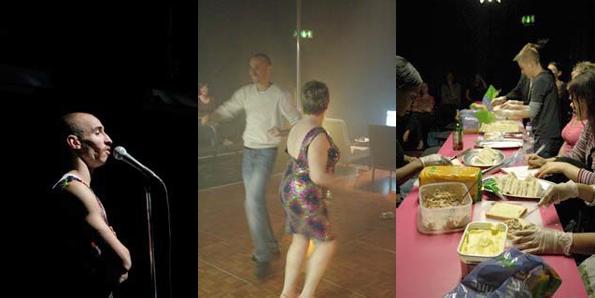
Darren on mic; Susan and Darren dance; the audience help Susan make the buffet

Quarantine’s ability to build strong connections between audience members and the performers onstage is part of what makes them distinctive as a theatre company. Their work is not about acting in the sense of performers presenting invented characters, but about finding effective frames and techniques to present and share the lived experiences of the people onstage. Because Quarantine take this approach it means that they work with people who have never made theatre before as often as they work with professional performers.

The act of making theatre with ‘non-professional’ performers is not in itself unusual. However, what makes Quarantine’s approach distinctive is how they refuse to allow themselves to be described as making community, amateur or participatory theatre. It is an

artistic ambition that drives their theatre making process, rather than a desire to deliver benefit to the people they have chosen as performers.

As a director interested in the creative potential of making theatre with people who have never performed before, I was curious to look at their performed work more closely and to find out about the process they go through to create a new piece. I began this exploration in January 2008 by interviewing director, Richard Gregory. Throughout May and June I observed rehearsals and a performance of Old People, Children and Animals. In early 2009 I interviewed four of the performers to reflect on their experiences.

I would like to thank Richard, the performers, the creative team of Old People, Children and Animals and everyone at Quarantine for their generosity in allowing me into rehearsals, for their time, and for the many cups of tea I had along the way.

Introduction to Quarantine
Quarantine was set up in Manchester in 1998 by directors Richard Gregory, Renny O’Shea and designer Simon Banham. They describe what they do by saying simply “Quarantine makes and researches new theatre”∗. They have produced twelve pieces of theatre over the
last eleven years, ranging from shared meals, EatEat and Rantsoen, to a piece centred around men playing pool, White Trash, to work made with families, Butterfly and Susan and Darren.
They tour work nationally and internationally, as well as making geographically specific work, such as See-Saw (2000) which was made with a cast of 75 people who live in Glasgow.

Based in Salford, Quarantine currently have a core team of four who run and manage the company on a day to day basis. They also have a team of regular creative collaborators, including writer Sonia Hughes, choreographer Jane Mason and lighting designer, Mike Brookes. Although they are not based in a theatre building, they have strong working relationships with Contact Theatre in Manchester and Tramway in Glasgow, who have co- produced and commissioned a number of their productions. They are a registered charity, and are regularly funded by Arts Council North West. They raise funds for their projects through trusts, foundations, arts initiatives and local authorities.

Old People, Children and Animals: Recruitment and preparation
I began my research by asking Richard Gregory why he makes theatre. He replied by saying he often feels “inarticulate” as a speaker, but has “a lot to say”; “Theatre is my means of talking to people about how I see the world”.

There is great simplicity in Richard’s statement, and it makes sense that he then goes on to choose his cast from people who can best articulate that world that he sees. He borrows a phrase from Berlin based theatre company, Rimini Protokoll, in describing who he works with as “experts in everyday life”. He asks “Why should you work with an actor to pretend to be part of someone’s family… when you can work with a family who are experts in being a family?”

∗ www.qtine.com

The title Old People, Children and Animals pretty much laid out the description of the cast for which Quarantine were looking. More specifically Richard was looking for people over 65 who had a background in dance, people under 18 who were in a band, a young child, a parrot and some rabbits. Adverts went out on their website, through their mailing lists and they targeted potential cast members by advertising in a selection of publications and websites.

Brenda, one of the older performers, saw the advert in her local advertiser and phoned up to ask for an application form for herself and her sister, Maureen. Norma saw the advert in the Valuing Older People newsletter published by Manchester City Council. Chloe, drummer in the rock band Ripswitched, got in touch with Quarantine through the website MySpace. On the other hand, Kay met Richard in person when he came to visit the over 50s dance group that she attends.

Kay summed up what attracted her to the project, saying “I looked on it as an opportunity to do something new”, while Maureen said of herself and Brenda, “Anything that looks as if it’d be interesting, we go for”. Norma had more specific thoughts about why she wanted to get involved, saying “As I want to be a director I thought I could learn a lot from knowing what its like to be directed by a professional”.
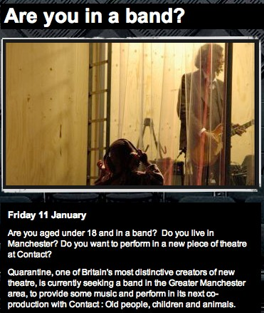
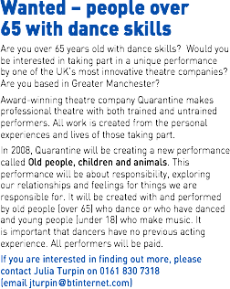
Recruitment advert for Old People, Children and Animals on Contact Theatre's website; advert in Manchester City Council's Valuing Older People newsletter (Dec 2008)

Quarantine phoned up the prospective performers for what Brenda described as a “casual chat”, which was followed by a face-to-face meeting and a series of workshops. It was at the face-to-face meeting where Maureen first understood that there was a fee on offer for the work, “and obviously being pensioners, we got quite excited about earning some money.” For the seventeen-year-old members of Ripswitched, it was the first time they had ever

earned a full time wage. Chloe’s first pay packet was spent straight away on a brand new drum kit.

Quarantine are unusual in paying their ‘non-professional’ performers. I had always imagined that this grew out of an ethos of professional respect and while I don’t doubt this is true, there is a much more pragmatic reason. As Richard explains, “I prefer working more intensely, which is… one of the reasons why we pay everyone”. It enables them to rehearse full time, for periods typically ranging from five to nine weeks, thereby creating the space for “continuous engagement”.

Rehearsing full time is rare in theatre made with non-professional performers, where meetings of a few hours each week are much more common. It is obviously cheaper to work with communities when you do not commit to paying them, but what Quarantine have recognised is the limitation of working with unpaid performers in terms of the time and commitment they are able to give. It is not an easy choice financially, which is almost certainly why very few theatre companies follow the same model. However, I think this practical decision has a direct impact on the quality of theatre they are able to attain.

Rehearsals: Early stages and exploration
The first day I observed rehearsals there were four members of the creative team present working with the performers; Richard, the director, Jane Mason, the choreographer, Sonia Hughes, the writer, and Gareth Nicholls, the assistant director. There was an atmosphere of real freedom in how they worked together, with Sonia, Jane and Gareth given the space to pursue whatever had caught their imagination throughout the day.
Sonia instigated a discussion with the older women about how they had felt when their children left home. As Sonia has a teenage son, there was a real personal curiosity that sparked off the conversation. She talked to me about her work as a writer on Quarantine’s productions, saying “My role is really listening and watching and seeing what is happening.” However she also described a more active contribution, saying of both Susan and Darren and Old People, Children and Animals, “I tried to generate provocations”.

Gareth told me about a session they had had earlier in the week where the whole creative team, Richard, Sonia, Jane and Simon Banham (designer) had sat as a panel to give the performers the opportunity to ask anything they wanted about the show they were embarking on making together. This simple exercise is something I have never seen before in other people’s rehearsal processes and it laid out a freedom open to all to ask questions, respond to each other and to explore particular avenues of thought.

What struck me as that day’s rehearsal progressed was the space given for conversation. There was no sense of rush, and a real patience in letting conversations run out of steam to then pick up again with a new idea. That day they discussed the morality of having animals onstage. After a while the conversation dipped then suddenly Emma, one of the teenage performers noted, “A goldfish in the show would be different than a dog, because it’d still be in its own environment”. Suddenly the conversation had a new impetus. The question of

an animal’s consciousness of performing is exactly what Richard wanted to explore, and Emma had found a particular and personal way of looking at the issue.

Later on that day, Richard set up an exercise asking the performers to imagine three people who had been significant influences over their lives sitting in three chairs in front of them. He ran through an example himself imagining his father in one of the chairs. He mentioned how important the motto “Do unto others as you would have done unto you” was to his dad and to himself. He echoed the same thought later on saying, “Most people are pretty articulate if you take the time”. It is not difficult to see this philosophy in his way of working through the space he carves out not only for himself as an artist, but also for those he works with.
The exercise began and the performers took their turns to go up to the three chairs whenever it felt right to them. It got to the point where there was a long pause. No one got up, and it was clear that while all of the older women had had a turn, none of the younger girls had. Everyone waited, and a few of the older women encouraged the younger girls to try. They stayed where they were and Emma said “We’re only 17, so we don’t know yet what has made an impact on us”.
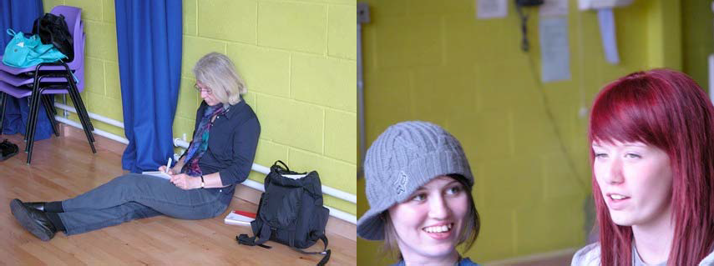
Kay makes notes; Chloe and Emma talk

I have no doubt that Richard or Sonia could have got the girls to do the exercise, but what they did instead was to consider how the girls had reacted to the given structure. This was what had revealed how the girls felt about the landmarks in their own lives, as yet impossible to distinguish. It would have been easy to miss this by being focused only on content, but by being attentive to the interplay between frame and performer new material was uncovered.
During the next rehearsal I visited, Richard set the older women the task of writing questions for a range of situations; questions you could ask a complete stranger, questions you have always wanted to ask someone but never have; questions you’d like to ask the audience at the beginning of the show, and so on. He then asked Maureen to ask her questions in a random order on the microphone and to intersperse them with a story she’d told earlier in the week about doing a reading at a wedding. It was a “yes moment”, as Richard described it later.

After she’d presented her questions and story Richard asked her if she’d mind repeating it. Maureen was happy to do so, and the second time was just as funny and seemingly spontaneous as the first. He asked her to do it a third time, playing around with the intervals between the story and the questions, creating unexpected twists and turns.
Seeing how Richard suggested and developed the structure was interesting, but what interested me more was what he didn’t do. He didn’t ask the other women to have a go using their questions. When your priority is delivering benefit to your performers or project participants, you would be concerned to give each person an equal turn. However, the priority here was an artistic one, so when a theatrical moment was found it was pursued and explored, rather than commended then passed over so the next person could have a go.

The performers I interviewed talked about having enjoyed the exploratory part of the rehearsal period. As one person said, “It was like living in another world for a few weeks – exciting and stimulating.” Another person agreed; “There were no restrictions. It was fantastic.” The focus on their personal stories was also something important to the performers. As one said, “You don’t get many chances to tell your story, and that’s what they [Quarantine] were interested in”. She described how “it made you feel special”.

However, there were nerves that set in alongside the enjoyment. “Not knowing what was expected” was a worry, even though it was accompanied by “realising that perhaps nothing was necessarily expected and the canvas was blank for us.” Equally, the pressure of doing a public, professional show was taken on board from the start. As one performer described, “I was always really aware that, for me, it was a really serious, serious thing we were doing. And I said to myself “Whatever I’m asked to do, I will do”. And that’s what I did.”
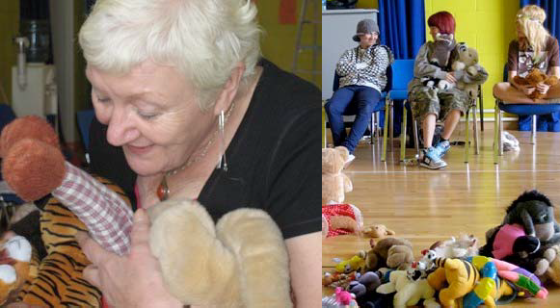
Maureen puts out teddy bears; Chloe, Emma and Sarah and the teddy bears

The biggest challenge, however, was the schedule; “it was like 10 weeks Monday to Friday, you know, solid. And everything else in my life stopped, because you were too tired to do a great much of anything”. Even though the working schedule is designed to provide “continuous engagement” a side effect was that it radically altered the performers’ usual routines and day-to-day lives.

Rehearsals: Later stages and preparing for performance
As rehearsals went on, I found it fascinating observing Richard’s search to find the frames that most clearly expressed the performers’ stories, experiences and personalities. While the first half of the rehearsal process had been focused on the gathering of personal stories, the second half shifted into reordering and reframing this material. He continually played with order, made cuts and additions, and most importantly, questioned why the audience was experiencing each moment of performance.
When I had interviewed Richard he had talked about working “in opposite directions” to that of Quarantine director, Renny O’Shea. While she accumulates material over a long period of time and builds detail and the structure from that, he said of himself “I start with a fairly concrete concept about what the show will look like, feel like and how it might operate, and then I kind of dismantle that in the process”.

There was an additional search going on, however, in this particular process of shifting and reworking material. As Sonia described “They [the performers] had lots of stories but we couldn’t find the thread that held them together.” Whereas Susan and Darren’s relationship as mother and son provided a “heart” to their piece, here Sonia worried “Is it enough that some of them are old and some of them are young?”
The continual reordering that followed threw up some interesting discoveries. In one session Kay was asked to tell her story of hitch-hiking to Israel in 1968 straight after a section where she danced to rock music played by the younger girls. As she began speaking she was obviously out of breath, and this stood out to Richard. It captured something of Kay’s energy. When someone suggested her story could be moved later on so she could have the opportunity to get her breath back, he said he didn’t want to disguise the moment because “these things show who we are as much as the stories we tell”.

Such discoveries were often accidental. Richard had suggested Maureen should prompt Brenda to begin the show. We as the audience sat and waited. Brenda and Maureen looked at each other and got the giggles. Maureen managed to settle herself again and then said bluntly to Brenda “Are you going to start?” which set them both off again. Like Kay’s breathlessness, this moment was important to Richard’s development of the piece, saying “Maureen and Brenda’s laughter reveals more about their relationship than 1000 words we can write about it”.

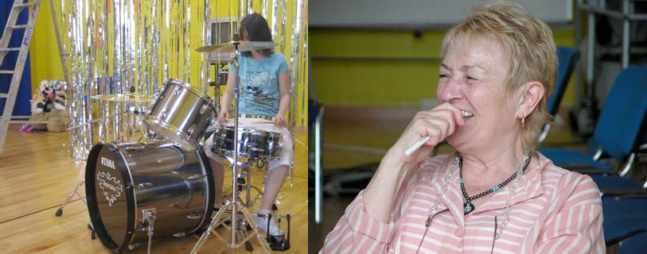
Chloe plays the drums in rehearsals; Brenda laughs

Despite new discoveries, the reworking and reordering of material put a strain on the performers. “It was never set in stone, and we didn’t know right up until the day [of performance], what we were going to do, not do”, said one. It also didn’t reflect how they had imagined rehearsals would progress; “I had expected everything to be more or less in place after 5 weeks so that the last 2 weeks would be mainly rehearsing.”
The constant changes had a different impact on each of the performers individually. While one voiced frustration that “we spent a lot of time on dance routines that were never used”, another said, “I accepted everything because I just found Richard, from day one, to be supportive, I think. I trusted him. I absolutely, absolutely trusted whatever he said.”
Certain obstacles that the creative team faced generated some of the most interesting material for the show. Bill, a saxophonist in his seventies, had been diagnosed with cancer before he got involved with the project and as rehearsals went on it became clear that he wasn’t going to be well enough to perform live. Instead he was filmed playing his saxophone and telling stories, one of which described his experience of looking after birds in his aviary. Sarah, one of the younger girls, introduced Bill’s recording in the show and explained why he couldn’t perform in person. For me this ‘included absence’ broadened the spectrum of the thoughts provoked by Old People, Children and Animals. In the live cast it brought together different generations at different points on their journeys through life. However, Bill’s recordings, conveying both his presence and absence, offered a moment of reflection on the inevitable end of these journeys. This in turn held real poignancy when we returned to the live performance of the older women and of the young girls.

Another obstacle that emerged as rehearsals progressed was that Chloe, who had been at the forefront of getting Ripswitched involved with the project, became less open in her participation. Richard, Sonia, Gareth and Jane tried to find ways to encourage her to open up, but she resisted in a valiantly teenage way. They undoubtedly found her stance frustrating, but they never attempted to invent material that would conceal this aspect of who Chloe is. Instead Gareth worked with her on a scene where she played the drums, even as the kit was being dismantled around her, and refused to answer questions that other performers threw at her.

Right up until the end of rehearsals, and even during the run of performances, Richard wasn’t afraid of cutting material. This left some performers with more lines in the show than others. While it seems obvious that performers having an equal share of the limelight shouldn’t be a primary concern in making a piece of theatre, it so often is when making work with people who have never performed before. The refusal to compromise artistically is fundamental to Quarantine’s ability to make good theatre, but it was difficult to accept for some of the performers.

One performer described how she felt when one of her stories was cut at the last minute; “I felt I had been cheated of a ‘part’ which I had understood had been considered more than acceptable for some time.” She recognised that “the director has every right to do whatever he considers relevant to his production”. However, she also felt, “This is perhaps one of the main problems of using real people and real stories. If you are acting in a normal play it is far less damaging to the ego to be asked to act this way or that than it is to have your personal life stories manipulated.”

Old People, Children and Animals in performance:
In the run up to the opening of Old People, Children and Animals Richard was interviewed in the Guardian, where he said, “The hope… is to pose questions and leave sufficient gaps in the performance so that they can be answered. I like the idea of silence, of waiting for something to happen and extending an invitation to the audience to have a real dialogue with the performers.”

The performance of Old People, Children and Animals took place inside a marquee, with the audience sitting on three sides and a small stage at the end decorated with a glitter curtain. A parrot was stood on a perch at the opening of the show, with a microphone placed in front of it. It was an extraordinary sight and set the scene for something unusual and special. In contrast, many aspects of the set and props were very familiar to a marquee setting. A festoon lit the space and wooden bench seating ran behind rows of plastic chairs.
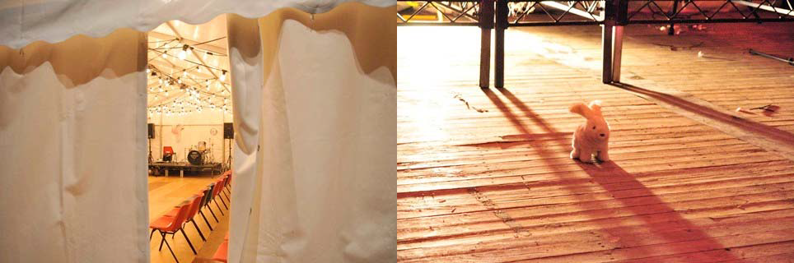
Looking in to the marquee; one of the toy rabbits from the beginning of the show

The juxtaposition of the ordinary and the extraordinary was a conscious choice in the design. In the article Cooking with my daughters, Simon Banham said of his designs for Quarantine “However familiar and ‘real’ these environments might be, they are performance

environments and do not pretend otherwise. It is in that contradiction that the design situates itself, tinkering with the reality of the familiar and positioned at its edges”.

After the parrot had had its time in the spotlight, occasionally squawking into the microphone, the (human) performers appeared along with a bag full of toy rabbits that were placed on the floor by Chloe. Maureen asked the audience her mixture of questions, and the dialogue between audience and performer that Richard desired began. At the show I attended people answered Maureen questions readily, laughing at the funnier ones, quietly pondering the serious ones. When she had finished asking questions and telling her story about the wedding reading, she asked, “What are you going to do with my story?” Almost straight away a woman replied, “Remember it”, followed by a man who called out, “Pass it on”.
Richard had talked to me about his fascination in “what occurs in that gap between what I’ve made, what I’ve constructed… and [the] uncontrolled moment of performance”. An example he gave was a section in Butterfly, made with a 3 generations of a Glaswegian family in 2004. The adults in the show asked each other questions, with the rule that they had to answer honestly or ask a question in return. As Richard described, “it resulted in some incredibly banal conversations most of the time… but it also, when things were more electric… would release questions that were incredibly difficult and powerful.”

Old People, Children and Animals also occupied this theatrical territory. Later on in the show Brenda sat on one side of the audience and told Maureen what various people on the other side were thinking. Some of them nodded in agreement and some laughed and shook their heads. Maureen kept telling Brenda that she couldn’t mind-read but Brenda continued nevertheless. The line between audience and performer existed but it was continually crossed, played with and then put back again.

The presence of relatives and friends of the performers in the audience further enhanced the blurring of the line. Maureen had acknowledged their presence early on when she asked, “Did you come because of something you read or saw, or are you here to support a cast member?” By acknowledging and welcoming their friends and family they encouraged the possibility of their dialogue. For example, when Emma told a story about how much she hated it when her father caught and skinned rabbits, her dad felt comfortable enough to throw in a few comments in his defense.

Richard talked in our interview about the mixed demographics of their audience, which tends to be “split between regular attenders of experimental performance, and people who’ve not really ever been to the theatre before, who might have some… direct connection or relationship with the people in it”. This has resulted in many “fabulous moments” over the years, as some people obey the unwritten rules of being an anonymous audience member, while others instinctively react and respond to whatever their friend or relative is talking about.

Xyla, the four-year-old member of the cast, had the most active, open dialogue with her family in the audience. Her mum was sat in the front row and Xyla didn’t think twice about running back to hide behind her mum’s legs when she felt a bit shy. She also had a tent to

hide in, but when the rest of the performers brought out sacks and sacks of teddy bears and arranged them on tables, it was something that inevitably tempted her out to play.

The show ended with a series of short sections that gave space for the audience to reflect on the images and ideas of Old People, Children and Animals. Norma gave the audience a tantalising list of all the stories she could tell; “Missing tooth: Part 1”; “The man I should have married” and “The white polka dot shoes” amongst others. She then announced that she didn’t want to tell any of them. She wanted to talk about now.
Chloe then brought out nine real rabbits and placed them in an open-topped pen, carpeted with Astroturf. ‘Gold’ by Spandau Ballet played and the performers appeared from behind the glitter curtain dressed in full body rabbit costumes. It was impossible to tell who was who, and who was what age, as they danced to the music. When the song finished they took their costume heads off and sat and watched the rabbits. The rabbits hopped around and nibbled at the Astroturf. After several minutes had passed Chloe gave us the nod that the performance was over by speaking her first words of the show, “Thank you”.

I saw the show at the end of its run at Contact Theatre, before it went to Tramway in Glasgow. Richard had made changes throughout the run up to that point, and continued to when it went to Glasgow. The uncertainty this created for the cast meant that some had less of a positive experience of performing than might have otherwise been the case. One member of the cast said of performing, “this was less important to me than the process itself… coloured for me by the fact that the day before the first performance my ‘… story’ was taken out.”

Despite the disappointment she still described the experience of performing as a “buzz”, which was a feeling shared by all the performers that I interviewed. Another cast member said it was “so exciting! Never experienced anything like it before and I don’t think I ever will, you know, in the future.”

Perhaps the most rewarding experience for the performers was the feedback they got from the audience. One of the cast described how, “I’ve never felt I was really any good at anything. And when people came up to us, strangers, after the performance and were just overwhelmed with what we did, and spoke to me as an individual, I couldn’t get over it.” This experience was mirrored by the response they got from their friends and family. As one said, “they couldn’t tell me enough how much they enjoyed it, and how surprised they were at the performance that I gave. Because obviously they’d never seen me in that situation or that environment before.”

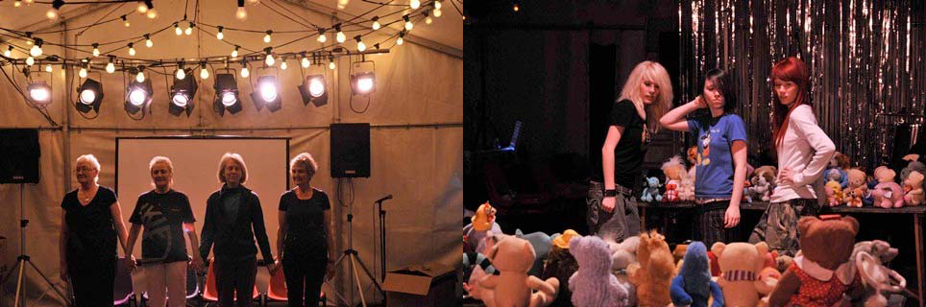
The older women dance; Ripswitched and the teddy bears

The positive experience of performing was, for most of the cast, a great ending to the project: “It was just a wonderful experience, you know, as a whole. It was fantastic.” However, Richard described it as “the hardest piece I’ve ever made.” He, Sonia, Jane and Gareth were never convinced that they had found the elusive thread that held the different stories, individuals and sections of the piece together.

He talked of the struggle in The Guardian, where he said of the performers “They are tremendously polite to each other. An image flits through my mind of first world war soldiers crossing no man's land on Christmas Day to shake hands. Their relationship is based on an endless metaphorical shaking of hands that never moves on. It is harder to make theatre out of politeness than out of confrontation.”
Despite his frustrations the piece was pretty unanimously well received and well reviewed, with Joyce McMillan saying "This is… one of those memorable shows that stop us in our rush through the days". I found it touching, thought provoking and enjoyable. However, Quarantine spare no criticism of themselves, and are as open about what they see as their shortcomings as they are about their successes.

Legacy:
The experience of being part of Old People, Children and Animals has had a significant impact on all the performers who I interviewed. Maureen told a story about having been stopped in Tesco six months after the show by a woman she didn’t know. “She said “Can I ask you something? Do you mind?” and I honestly thought it was going to be to do with my performance. But she didn’t, she wanted to know if porridge oats was ok for making flapjacks.”

This story shows the extent to which Maureen feels like she was seen and recognised publicly. Being part of the project was deeply self-affirming for a number of the performers. As one person said, “I think it was life changing. I know it was.”

All of the performers had regularly participated in courses or group activities before the project and have continued to do so since. However, the sense of achievement has had an impact in pushing some of them to take on new challenges: “It’s given me so much more confidence. I just feel as if I could take on the world.” One of the performers also said “I

keep looking in the papers to see if there’s anything familiar that we could probably take part in again, but I don’t think anything will match the way that made us feel.”

For some members of the cast the experience defined their area of interest within theatre more clearly. Norma who had gone into the project to learn about directing, felt afterwards that it “made me realise I’d rather direct than perform, although performing was interesting and fun and demanding.” She has since gone on to explore and initiate other inter- generational projects.
The cast have kept in touch since the project ended. The older women went to see the girls perform in a Ripswitched gig, and also attended Emma and Sarah’s eighteenth birthday party. Another time they met for lunch in the Gemini Café, where they had often eaten during rehearsals. They decided to pop into Contact Theatre afterwards, where one of the staff recognised them and started a conversation. They asked him if they could go up to the rehearsal room where they had worked, so he got the key for them. Maureen described how “we were an hour and a half in there, doing the Gold dance routine” and reliving memories.

While the cast have stayed in regular touch, the contact with Quarantine since the show has been less frequent. One performer said “the blank left at the end was quite difficult”, even though “We’d done a job and been paid – so perhaps we shouldn’t have expected more.” Even though the contact hasn’t been as frequent as they perhaps expected, the cast and the creative team are still in touch. Ripswitched and Quarantine have sent each other messages on MySpace. Maureen and Norma did an interview with Richard for Front Row on Radio 4. Some of the performers also went to see Sonia Hughes’s next show at Contact Theatre, Song of Songs, for which Maureen also sat in on a few rehearsals.

Conclusion:
Joyce McMillian said in The Scotsman of Quarantine’s first show See-saw, “it makes us see others afresh, with a new intensity, humanity and respect; and you can’t ask much more from theatre than that.” For me, this sentiment holds true for Quarantine’s work in general. However, Quarantine have been criticised for being voyeuristic in the work that they make, and audience members have sometimes asked ‘Why should I be interested in this person’s life?’
It is true that the performers of Old People, Children and Animals had mixed feelings about the way their stories were used or not used, and tensions developed out of the artistic choices that led the process. While some members of the cast found it easy to trust Richard’s direction and were happy with cuts and changes he made, others felt disappointed and even betrayed when their stories were left out of the final production.

My conversations with the performers left me with questions about the ethics of this method of making theatre in a community context. It is difficult to come to any singular conclusion, because while some of the performers had reservations about the process, others found it to be a completely positive experience.

When I think about Quarantine’s process in a professional context, however, their way of working provokes far fewer ethical questions. Material is always cut and rearranged in any devising process, and generally it is accepted that the director gets the final say on what is used or not. It is important to remember at this point that Quarantine refuse to describe their work as community theatre or participation. They don’t even like to use the term ‘non- professional’ to describe their performers. They pay performers, rehearse full time and market their productions as pieces of high quality, experimental, contemporary theatre.

I believe it is through Quarantine’s refusal to inhabit a non-professional working space that they are able to achieve such distinctive, engaging and surprising theatre. They unlock artistic potential in their performers through reclaiming and redefining theatrical expertise. This is achieved first and foremost by their choice to make theatre with the people whose stories they want to tell, rather than actors who can convey a story on their behalf. They are bold in their approach and in the practical and creative choices they have made, and this is what makes them interesting to consider in the broader context of current theatre practice.

Joyce Macmillan described Old People, Children and Animals as “a unique and delightful form of theatre”. By making theatre that challenges the dividing line between professional and non-professional, and between audience and performer, Quarantine help us see our world and its possibilities a little bit differently.

All photographs used courtesy of Quarantine

Theatre making in the Eastern Cape of South Africa
I visited the Eastern Cape of South Africa in Sept 2008 and in May 2009 as part of Swallows Partnership delegations, an organisation that partners artists, venues and arts companies from the North East of England with those in the Eastern Cape. During my visits I travelled across the region, met and interviewed theatre makers, visited arts centres, ran workshops with drama groups and worked with South African theatre practitioners. It was an incredible, eye-opening experience and it gave me the opportunity to think about making theatre in a context completely new to me.
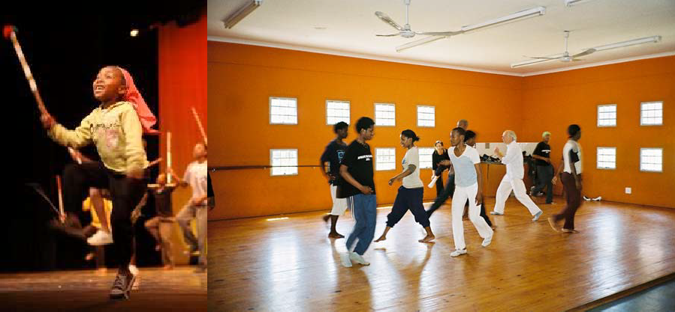
Rehearsals at the Port Elizabeth Dance and Drama Festival, 2007; a workshop run by dancer Tim Rubidge in Gompo Arts Centre, Duncan Village, Sept 2008

An introduction to the Eastern Cape
The Eastern Cape, home to the Xhosa people, is roughly the same size as England, Wales and Northern Ireland put together, with a scattered population of less than 7 million. This in combination with a limited transport infrastructure means that the province feels vast, with many hours by car between cities, townships, and villages.
The region has exceptionally diverse landscapes. The western interior is dry and arid, while the eastern coast is green and wet, with a wild, rugged coastline. The far north, bordering on Lesotho, has snowy mountains in winter.

The Eastern Cape is one of the poorest provinces of South Africa. Subsistence agriculture is the way of life for most of the rural population. The larger cities, such as Port Elizabeth and East London, have significant industrial economies that have been based largely on car manufacturing. Although this has created employment, extreme poverty and high unemployment is still visible across the urban townships.

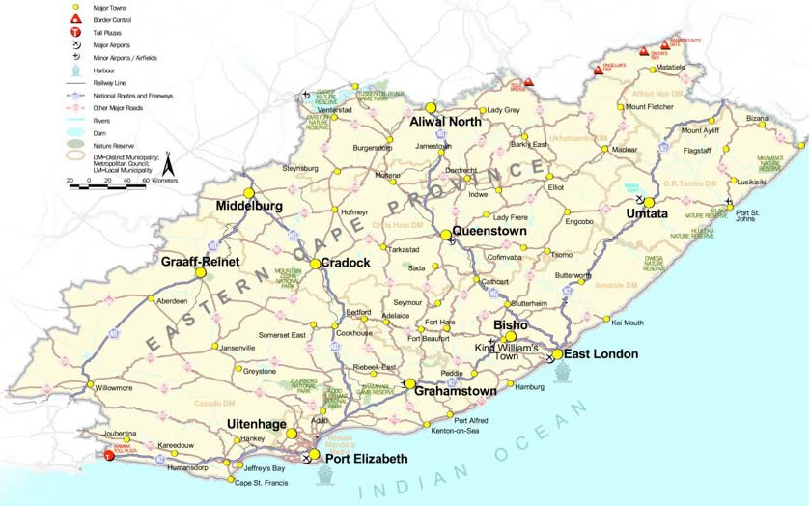
Map of the Eastern Cape

Despite its poverty, the Eastern Cape has produced some of the countries most important political and cultural figures. Nelson Mandela grew up in Qunu, a village south of Mthatha (colonial spelling, Umtata, as on the above map) and former president Thabo Mbeki is from the small town of Idutywa, which is on the road south of Mthatha on the way to Butterworth.

Theatre makers from the Eastern Cape include actor and playwright John Kani, who was born in the New Brighton township of Port Elizabeth, Winston Ntshona, also from Port Elizabeth and Athol Fugard was born in Middelburg. The Eastern Cape is also home to South Africa’s National Arts Festival held in Grahamstown each June.
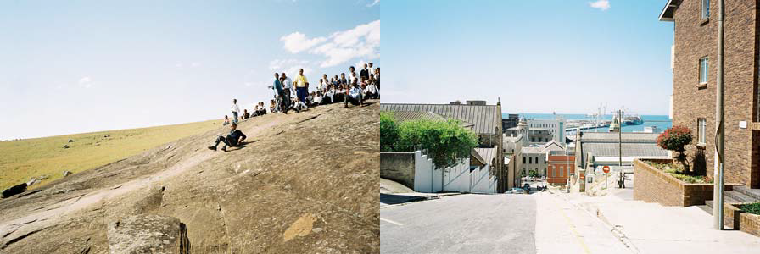
A boy plays Mandela's favourite childhood game in Qunu; central Port Elizabeth looking to the port

The role of theatre and theatre making in the Eastern Cape
The theatre I saw from across the Eastern Cape does not reflect much of the province’s diversity in the form it takes and the stories it chooses to tell. For example, six of the seven drama groups performing at the 2008 Dance and Drama Festival, run by Port Elizabeth Opera House, presented work that dealt with multiple harsh social issues including rape, HIV, murder, prostitution, child abuse and drug addiction.

After the festival I asked Monde Wani, artistic director of Kula Productions, based in Port Elizabeth, about the consistent choice of Eastern Cape playwrights and directors to make issues based theatre. His reply was, “When you ask, why is all South African theatre issues based, the only reply I can make is, why isn’t yours?”
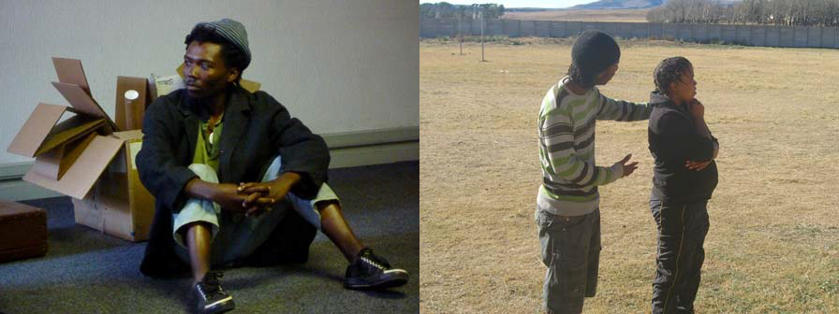
Mfundo Zono of Magenge Productions in 'Where the Heart is', a play about homelessness; Melikhaya and Thombi from The Butterflies rehearse a play about HIV

Monde’s reply was one of the most thought-provoking questions put to me during my time in South Africa. It made me think about the political and social role that Eastern Cape theatre makers see for their work, and how conscious this role is when they are writing, rehearsing and performing.

All the theatre makers I interviewed talked of their desire to raise social issues and to educate and empower audiences through their work. Zwai Mgijima of Three Brighton Players asked “What can we write about if our society is in disarray? ... Yes I can talk about love, but there is something that lies underneath love.” So it is this, the issue that lies underneath “like a volcano”, that Three Brighton Players choose for their focus.
Theatre has a strong heritage of protest in South Africa, with plays like The Island and Sizwe Banzi is Dead standing out as cultural landmarks in the struggle against apartheid. From the conversations I had with theatre practitioners I could see it is still seen as a powerful vehicle to give a voice to the oppressed. However, Eastern Cape theatre makers have perhaps moved their focus from the Political (with a capital P) to the social. Xolani Ngesi from Three Brighton Players commented, “Our big brothers, like John [Kani] and others in Johannesburg, they like to go to the politics, and that thing for me is becoming annoying… Everyone rushes for the politics. They don’t look at our society, what really kills us.”

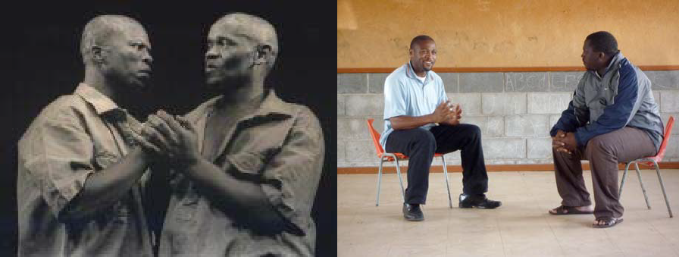
Kani and Ntshona in 'The Island' in 1973; Three Brighton Players rehearsing 'It's Not Me' in 2009

The choice of focus for Three Brighton Players, and many theatre groups like them, perhaps reflects that in post-apartheid South Africa there are new things to protest about. 1 in 9 black people are living with HIV, many people live in extreme poverty, and rape affects far too many of the lives of women and girls.

Cultural and creative influences
Alongside the relatively consistent choice of content, I was interested in finding out what shapes the sense of theatrical form for Eastern Cape theatre practitioners. Most pieces I saw used similar theatrical techniques, with linear narratives following the events in a character’s life. Scenes were mostly made up of dialogue with an occasional monologue. The scenes were sometimes interspersed with a song or dance but other than these self-contained sections, there was little variation in form.
To give a context to this, it is worth saying there is almost no infrastructure of rural arts touring in the Eastern Cape. Communities outside of the urban centres have little opportunity to see theatre other than that they make themselves. Furthermore, the drama groups that do exist, both in rural and urban areas, repeatedly talked about how rare it was for them to perform to each other. Simphiwe Mzimba of Fire Theatre from Port Elizabeth summed up the creative challenge this set for theatre practitioners when he said, “We… have not discovered the secret of working together, helping one another, giving one another skills, collaborating so we can come up with something.” Monde Wani pondered the situation further, asking “How does one group become a resource for another? I think if we were to win that battle, our theatre would go somewhere.”

The presence in the Eastern Cape of one of South Africa’s largest annual theatre festivals, the National Arts Festival which takes place every June in Grahamstown, feels almost contradictory to this description of the region’s lack of opportunities for creative exchange between theatre makers. Groups come from across South Africa and beyond to perform there, and the festival also has a strong connection to the drama department of Rhodes

University, also based in Grahamstown. Therefore, one finds a hub of interesting new work that is made, seen and developed in Grahamstown, but with most Eastern Cape communities lacking the resources to travel, the festival’s impact beyond Grahamstown and out into the wider province is severely limited.
Theatre is not an art form with a long cultural heritage for amaXhosa people. Black people were denied access to theatres during apartheid, and the experience of watching work in their own language on a professional stage is still something new and treasured. Additionally, the rich amaXhosa culture of song, dance, and storytelling is often held quite separate from the making of contemporary theatre. Therefore, creative influences are limited to what is seen on television and perhaps also the educational pieces that are produced by schools and health initiatives, warning of the dangers of HIV.
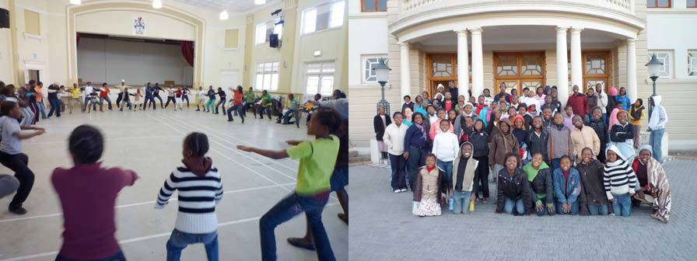
Groups from Alfred Nzo working together for the first time (Swallows Partnership workshop 09)

The meeting point between sensationalist South African ‘soapies’ (soap operas) and didactic educational drama could be seen in a piece by the group from Alfred Nzo district at the 2008 Dance and Drama Festival. The story told of an unhappy young girl who had lost her virginity, fallen pregnant, and become ostracised from the community. Meanwhile a city- living friend had also lost her virginity and as a result had fallen into drug abuse. This moral piece, showing the dangers for young women of losing their virginity, fitted in to the bracket of shows that educate and warn of contemporary social dangers. However, there were other influences at play in the piece.

Alfred Nzo is the most rural district of the province, and cultural and traditional practices are much stronger here than in the other areas I visited. These traditions were clearly a creative influence on their piece, which included a demonstration of a virginity testing ritual. While the older women sang, they stripped a younger girl naked: one of the most shocking moments for me at the festival. Not understanding the text of the play, I presumed they were aiming to show the vulnerability of the young girls who go through this ritual. What was interesting to discover later on was that this wasn’t their intention at all. They were showing the ritual to celebrate their culture and their pride in their traditions.
This is quite an extreme example of the meeting of traditional culture and theatre’s contemporary purpose in the Eastern Cape. However, in several of the other pieces performed at the festival I saw church services fairly accurately reproduced, and school

lessons shown in extensive detail. The rituals of life are replicated and recognised, with the audience joining in with hymns and prayers unprompted.

When I spoke to Monde Wani he recognised this audience reaction, saying of black South Africans “naturally we like to connect, talk, and do all of that thing. So when someone, say, performs something onstage, if it’s a song, quickly… we join in.” This desire for an “active relationship” between performer and audience not only influences the actor onstage, but also the writer and director choosing subjects for their work. Mark Lloyd, a British actor and director who has worked a lot in the Eastern Cape reflected “That might be why so much of it is driven by issues based stuff, because you’re in a way guaranteeing that [audience] reaction”.
Of course, the way the audience reacts significantly shapes the way theatre is performed and made. What might be a monologue in the UK becomes a dialogue in South Africa, with comments, encouragements and responses frequently thrown in from the audience. This gives performances a vibrant, live atmosphere and a real sense of event, with the audience constantly acknowledged and accepted into the action.

Economic influences
The poor economic situation in the Eastern Cape undoubtedly has a massive impact on how and why its theatre is made. What struck me immediately was how different the sense of professionalism and non-professionalism is compared to that of the UK theatre sector. Peter Stark, director of The Swallows Partnership, talked about “people’s need to define themselves as professional” so that they can enable themselves to earn money from their theatre work; “Whatever skills base they’ve got is a currency”.

Turning their theatre skills into a currency would logically define theatre makers as professional. However, much of their work is more comparable, through western eyes, to amateur theatre practice in the UK. Many of the actors and directors are untrained and meet in local arts centre to develop work without being paid. They take shows to local competitions and perform in community settings.
Even the more recognised, high quality groups in the Eastern Cape struggle to operate professionally. When I met the Three Brighton Players, who have performed across South Africa and internationally, the funding for their current piece was still unconfirmed. They had brought in a team of female performers in spite of their financial uncertainty, but they knew their ability to pay them was at risk. “We’ve lost so many artists because we can’t pay the actors, we don’t have the money, so they go and work somewhere else, in the factories.”

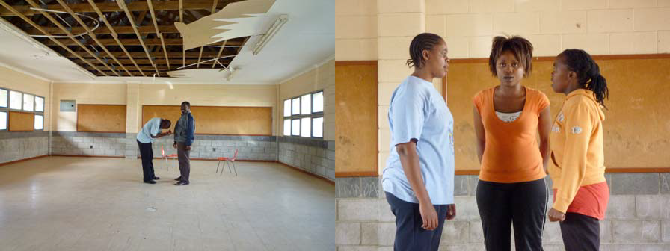
The long-established Three Brighton Players rehearsing in an abandoned school classroom

Unemployment in the province stands at 32%, so the need to be earning and working is a critical factor for many aspiring theatre makers. However, because there are only a small number of professional theatre companies in the Eastern Cape, there are few opportunities for actors, directors or writers. The pressure to find paid work leads many people to give up on making a career out of their art. As Xolani said, the challenges of making a viable business out of theatre are “mountains that we have to, not even climb, but crawl.”

However, there are markets to make money from theatre outside of arts spaces and some Eastern Cape theatre practitioners earn their money through ‘industrial theatre’. This is theatre paid for by commercial companies to educate their staff about health issues, legal rights, or to help communicate issues or new initiatives that face the company. Monde Wani, who has been successful in selling his productions to arts venues in South Africa and internationally still considers industrial theatre his “bread and butter”.

These market forces have a significant influence over the artistic direction taken by Eastern Cape theatre practitioners. Fire Theatre’s piece, Meneer, told the story of a foolish teacher who holds many misconceptions about HIV and the clever student who teaches him the truth. It has a serious educational message, but it is also an entertaining piece, with tricks played on the teacher and an actor in drag playing Beauty, the object of the teacher’s desire. Meneer was not made specifically for an industrial theatre setting, but it has still been made in that mould. Simphiwe talked about his previous work, “I did [industrial theatre] shows on crime, I did shows on HIV, I did shows on safety at work… that’s how I was making money.” Watching Meneer it is hard to say how much Simphiwe’s creative choices are down to his entrepreneurialism in targeting a potential market, or the way his working experience has shaped his sense of theatre.

I also spent time with three theatre makers in the early stages of their careers. Mfundo Zono, Mojalefa ‘Liefe’ Koyane and Siyabulela ‘Socx’ Seya, who set up their company, Magenge Productions, in late 2008. So far they have found it difficult to successfully put their case forward for funding. Socx talked about the generation gap that he felt hindered them, saying “what you find is that most offices, whether government or private, [they] are occupied by 55 and above. And then I’m 28 years old trying to present something to a 60 year old. He doesn’t see it.” Furthermore, he talked about officials who often come from outside the arts

causing an additional barrier; “They wouldn’t normally think about having a fund for upcoming artists, because they’ve never been upcoming artists.”
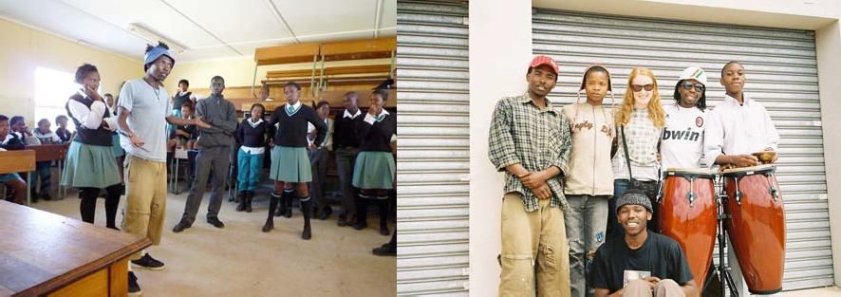
Mfundo Zono (Magenge Productions) leading a school workshop; Mfundo and Liefe with other young artists at MACO, an arts centre in Motherwell

Magenge Productions have looked to schools to provide an income from their skills. They have managed to get a few paid jobs, but even here there are limited opportunities open to them. “Basically schools can’t afford to pay us” explained Liefe. But they are continuing to deliver work in schools because “it’s not about money now. Just for now it’s to enlighten them, educate them, build the profile, you know, get that working relationship and progress.”

Pragmatics
The majority of groups I met worked out of an infrastructure of arts centres that exist in most townships and larger villages across the Eastern Cape. They are central to the way the provision for culture is delivered, however, their funding is often limited to covering one manager’s wages. Unsurprisingly, given the poverty of the province, there is very little resource for theatre equipment available. None of the groups I worked with had any experience of working with theatre lighting, and only one group used recorded music in their work. Theatre design, likewise, was restricted to a small number of props and costumes, rather than any set or stage dressing.
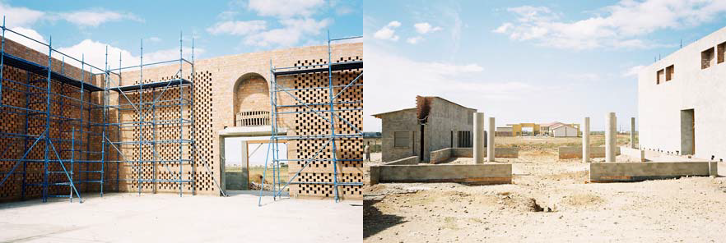
Long-awaited building development at MACO arts centre in Motherwell

Of course, one can only make work with the materials that are available. Easily found objects, such as chairs, books and bags, appeared as props time and time again in the work I saw. However, more obscure objects, like a watering can, rows of spinach and a spade were all mimed. There didn’t seem to be an artistic approach to choices of whether to use a prop or to mime it. If it was there it would be used, if not, never mind.

Alongside the paucity of physical resources, there is a wealth of what each individual brings to a creative process. My experience in the UK is that people often define themselves as one thing, whether that is an actor, or a director, or a writer, and can be nervous of claiming expertise in multiple areas. However, there isn’t the luxury of bringing only some of your skills to a process when you work in the Eastern Cape. Whether you can sing, dance, act, direct, or write, you bring it all.
Working in this context was one of the most liberating experiences for me. Just as Mfundo and Liefe wanted to talk about my experiences as a director and facilitator, they also wanted me to teach them a traditional English song and tune. The openness of Mfundo and Liefe’s creativity was refreshing to work with, and similar manifestations of their approach were visible in all the groups I met.

The multiple roles of theatre makers in the Eastern Cape maximises creative resources, but it can also cause problems. Often the director and/or the writer will perform in the play, so the benefit of an external perspective can be limited. Monde Wani also talked about how “strong actors will take the director and want to direct him”. In the end the strongest voice usually wins, and this is compounded by a strong cultural respect of status, whether that is because of age, gender, experience or talent.

I experienced this cultural respect in practice during an evaluation session that I ran at the Dance and Drama Festival. I wanted the groups to have the space to reflect on their experiences and begin thinking about what they wanted to do in their next piece. I put a question to the groups, which were made up of mixed ages and genders and got a long response from a few of the older women and one of the male district officials. I couldn’t get a word out of any of the younger performers. Respecting your elders is important in Xhosa culture and Monde explained,“[even] if you find a way to get them to speak, [they] will agree with what the others have spoken”.

Challenges: A focus on The Butterflies
During my first visit to South Africa I saw a piece by The Butterflies, a drama group from the small town of Dordrecht. On my second visit I, along with three other artists (Amy Golding from Live Theatre, Newcastle, and Zamuxolo and Noluto Mgoduka from Uphondo Lwe Afrika, Port Elizabeth), spent 4 days working with them in Dordrecht where I found out more about their experience as a young theatre group.

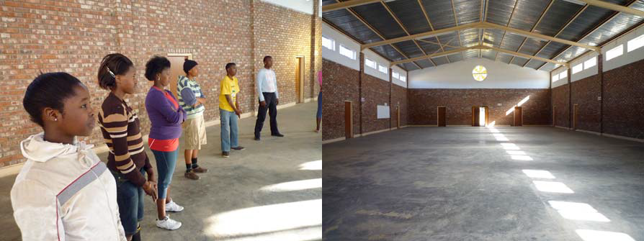
Members of The Butterflies; the hall where The Butterflies rehearse

There are around 15 members of The Butterflies, mostly in their early 20s. Some are still at school, while others have finished their education. They rehearse seven days a week, two hours a day, in the hall of a nearby youth centre. The director who founded the group died under two years ago, but the group have continued to make work, and perform at festivals despite having no older or more experienced leader.

The theatre they make is similar in content and style to work I have described previously. They describe their work by saying “We are making [theatre] about the things that are happening… true stories… the challenges of youth, living in our communities”. The piece they were working on when we visited Dordrecht followed the story of a young man diagnosed with HIV and desperate for a cure, so desperate that he believes the advice of man who tells him to rape his own baby daughter.

Portraying such a shocking storyline isn’t new to The Butterflies. They presented a piece at the 2008 Dance and Drama Festival about the abuse and ultimate murder of a disabled boy, and the year before had presented a piece about child abuse. I asked them how they choose the subjects for their work and they explained “We go through the competition. Sometimes they tell us, ‘This is a competition and all the stories must be based on domestic violence, or be based on HIV and AIDS.’” However, when no theme is set they still maintain their interest in hard-hitting social issues.
The Butterflies have been recognised for some time as an outstanding young drama group in the district of Chris Hani. They have been selected twice to go to the Dance and Drama Festival in Port Elizabeth and took a piece to the National Arts Festival in Grahamstown in 2006. When we met them they were preparing for the competition that would decide which local group would go to the 2009 Port Elizabeth Dance and Drama Festival. They were confident in the quality of their work, but they were nervous about the competition. They had heard a rumour that they weren’t going to be selected no matter how good their piece, so that another group could have the opportunity of going to the festival.
Herein lies the challenge for The Butterflies. They have had some success, but there is almost no infrastructure for their further development. The Arts and Culture Department have a responsibility to share existing opportunities amongst other groups, but there is no support for The Butterflies to make new opportunities and to replace what they may lose.

When I spoke to the group about the possibility of applying for funding Clement Noka explained a major problem: “When you want to be funded, you’re supposed to have a certificate. We did have that certificate, but… I think we didn’t renew it. Then they are asking for the reference number. I don’t know.” He went on to say “since our director passed away they [Arts and Culture officials] didn’t tell us how to do this, how to submit this, how to write this.”

Without their lost documentation, held by the previous director and unlikely to be found, they are stuck, unable to apply for future funding. There are ways they could get past this obstacle but they are not yet at the stage where they have the confidence and experience to do so. As they said, “We are all young. There is no one older than us who is looking after the group” and furthermore, “We are not good at paperwork.”

When I asked the group about their aspirations and where they’d like to be in five years time Nonceba replied “Maybe we are going to Jo’burg. We are making our own shows there so that people can see us. We are the group that is existing.” In looking to Johannesburg the group are right to see that Dordrecht cannot sustain them financially or in terms of creative opportunities. The group said their community like watching their performances, but are unwilling to pay a ticket price. Dordrecht doesn’t have the scale of businesses that could offer industrial theatre work or enough schools to support a significant market in paid drama work.
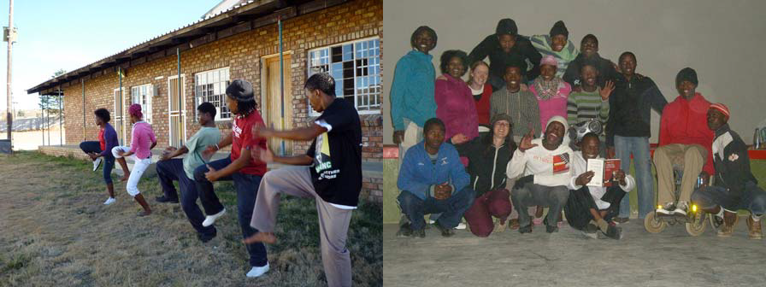
Zamuxolo and Noluto run a dance workshop with The Butterflies; The Butterflies together

Some members of the group are pursuing their ambitions beyond Dordrecht already. Melikhaya has spent time in Cape Town while Clement and Babalwa are currently studying performing arts in the small, nearby town, Queenstown. However, the ambition of individuals versus the ambition of the group has created tension. Clement and Babalwa feel committed to The Butterflies and want to bring the new skills they are learning back to the other members. However, the group is suspicious and upset that Clement and Babalwa have been performing as part of another group while in Queenstown. Queenstown is only a 45 minute drive away, but the taxi fare is more than Clement can regularly afford, so his visits back to The Butterflies are also limited.

We helped the group discuss how they can make the most out of Clement and Babalwa’s time studying in Queenstown, and also made suggestions about how to move forward with their Arts and Culture office beyond the issue of lost documentation. However, it was hard not to feel like the odds are stacked against The Butterflies. They are talented and committed, but their existence seems fragile in an environment that offers them little support. It is hard not to be moved by their commitment: “We are the same age. We are making art ourselves. There is no teacher now. But we try, we try.”

Opportunities: A focus on Monde Wani, Kula Productions
Having written about the challenges The Butterflies face, I am now going to write about opportunities for theatre practitioners in the Eastern Cape by focusing on the work of Monde Wani and his company, Kula Productions. This is not meant as a comparison to the work and approach of The Butterflies. They are at completely different stages in their careers and in their geographical locations, and it would be unfair to consider them as peers.
However, Monde’s outlook on the opportunities that exist reveal another perspective and reality for theatre makers working in the Eastern Cape.
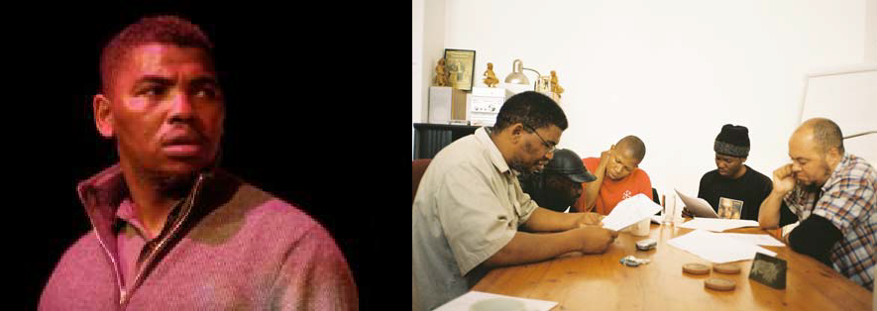
Monde Wani in performance; working on an early draft of Simphiwe Vikilahle's play 'The Journey'

Monde describes himself as “a mature artist”, and he has worked nationally and internationally as an actor, writer, director and drama facilitator. He has been successful in developing a business that delivers industrial theatre as well as working in educational settings. In May 2009 he was beginning a yearlong programme of drama work in schools across Port Elizabeth. He also tours theatre productions, the most recent being Ours was the dawn, which told the story of the struggle against apartheid and people’s hopes for democracy through the eyes of an old couple who had lived through it all.

Despite his success he agrees that the Eastern Cape is a hard place for a theatre maker to live and work. “Everyone is surrendered to the fact that we don’t have anything”, he notes.
However, this vacuum is the very place where Monde sees opportunity. “The first one [opportunity] is that nothing is happening… Whatever we put on the table we might be the first ones. So there’s opportunity for us to be trendsetters. There is an opportunity for us to change people’s lives. There is an opportunity for us to play a big role.”

He and his wife Nomsa, a singer and actress, drive their work forward with this motivation and sense of purpose. For example, they are currently working on a film and also plan to develop a project telling township women’s stories. They don’t receive funding for this work, and indeed Kula Productions is a close corporation, meaning that as a for-profit company it cannot apply for public funds. Monde is clear when he says, “I don’t believe funding should take authority or power away from me to be able to create.” Instead, they put income generated from industrial theatre into developing their new work, and Monde feels the freedom that this gives them has been fundamental to their success; “We’ve been able to succeed, to continue, because we don’t wait for funding to come.”

It is refreshing to hear Monde talk. He challenges the status quo and is confident about making change happen through his work as an artist. He engages with work on a strategic level in his role as an adviser at Swallows Partnership, right through to working in a ‘hands on’ role helping develop young artists in his community. His energy and entrepreneurialism is inspiring, even when the landscape looks bleak, and it opens up a new perspective on the potential that exists for theatre makers in the Eastern Cape.

Final thoughts
I returned home from my trips to the Eastern Cape with a mixture of emotions. There had been a great deal to take in while I was there and much to process when I got back. On the most immediate level, it had been extremely moving to spend time working with people who have so little. It is humbling to see how theatre practitioners who can’t find money for food or transport for their groups can make things happen through commitment and energy alone.

It is easy to look at the situation in the Eastern Cape and become despondent about how things could possibly improve. However, South Africa is a country looking to the future. Unlike the UK, where relatively little changes in the grand scheme of things, South Africa has seen radical change in its living history. This means South Africans often talk and work with a belief in the possibility of major future change and development.

It felt to me, in the people I met and worked with, that a sense of possibility does exist for them. Many people echoed Monde Wani’s optimism when I spoke to them, and many people work tirelessly to make theatre, reach audiences and survive financially. The words of Simphiwe Mzimba stick in my head, when he described the future for theatre makers in the Eastern Cape. He said with a smile, “Wherever there is a place with no shoes, for instance, that means if you can start doing shoes there will be big business for you.”

Postscript: The impact on my creative practice
The experience of researching both case studies has given me much food for thought about theatre practice. In this postscript I now want to reflect back upon my own practice as a theatre director and consider what I have learnt and the impact it will have on my future approach to making work.
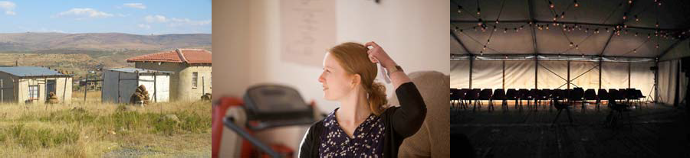
A view of the rural Eastern Cape; me; the set of Old People, Children and Animals

I have always enjoyed working with non-professional performers. I am excited by the journey that each new project takes; the starting point of not knowing what we will find and the end point of having created and performed a new piece of theatre. I enjoy the sense of achievement that comes from the performers’ experience of doing something they did not know they could. Ultimately, working in a context where untold stories are unearthed and presented theatrically for the first time is a process that fascinates me.
My fascination in seeing stories presented for the first time is what has always attracted me to Quarantine’s work. Their performances have a really particular and personal quality. We get to know the people onstage, alongside our awareness that we’re unlikely to see them or hear their stories in a theatrical context again.

What I have taken from observing Quarantine’s work in more detail is the choices they make to emphasize the extraordinary nature of what they present to their audience. ‘Ordinary’ people get to tell ‘ordinary’ stories but that is set alongside, for example, a parrot at a microphone. The ordinary no longer feels ordinary. The audience is left in no doubt that they are witnessing something special, and the event reinforces the feeling of being a ‘one off’.
I have been inspired by how Quarantine combine the ordinary and the extraordinary, the professional and the non-professional, to draw the audience’s attention to the fact that they are at a live event. Of course, all theatre is live, but when we watch trained actors we trust them to be relatively consistent from one performance to the next. Through this trust we become less conscious of the fact that the performance will be different, even if only in a small way, for every audience, every night. Quarantine continually explore structures that provide their performers with security, but offer up completely different results to the audience from one night to the next. The Q&A halfway through Susan and Darren cannot rely on learnt lines and stock responses from the performers. And at the same the audience cannot forget that they are present at a live event.

The opportunity of seeing how Quarantine achieve and explore the live space has pushed me to see new possibilities in my own work. Embedding uncertainty in a performance within something constructed, for example a game or a set of rules, is a brave way to make theatre. As Richard himself admits, sometimes it results in electric moments and sometimes it falls flat. However, for me it is such boldness that enables the creation of a truly vibrant theatrical space.

I have also been inspired, both in Quarantine’s work and in the theatre of the Eastern Cape, by the strong connection they build between audience and performer. A significant part of this comes from the audience recognising the people on stage as being ‘close to home’, both in the stories they tell and in how they tell them. In the Eastern Cape, simply hearing Xhosa spoken onstage has a powerful impact on audiences because it is so rare and new. Audience members laugh at hearing colloquial phrases, and throw back responses and encouragement. Although the culture of British audiences is quieter and more passive, Quarantine regularly find and play with a more active dialogue. For example, I am reminded of Emma’s dad feeling welcome to throw in comments from the audience defending his rabbit hunting during Emma’s speech.

Inviting the possibility of dialogue, response and even heckling from the audience, is a riskier space in which to present work. Performers onstage, as well as the writer and director, must relinquish an element of their control. However, it can be exciting for an audience in a different way to the passive, quiet experience of witnessing performance. They can comment, respond and affect the progression of the piece. The performers, in turn, must engage with the audience more actively. The instincts and personalities of both parties are brought into focus, and a relationship is built.
By observing these theatre makers, I have been encouraged in my own work to think more broadly about the type of relationship between audience and performer that best serves each piece. Of course, there are times when a distinct fourth wall is required, but by spending time exploring the other end of the spectrum I feel more able to be brave and clear about choosing where on that spectrum to place each piece I make.
My time with Quarantine and in the Eastern Cape has also forced me to acknowledge more fully the inter-relationship between pragmatics and creativity. One can only make theatre with the resources to which one has access. Witnessing theatre groups working in the Eastern Cape is a stark reminder of this fact. And while I like to believe our imaginations are limitless, my research has revealed the extent to which working structures and environments define the creative space we are able to inhabit.

On the most basic level, my experiences in South Africa have informed my practice by making me grateful for the resources I often take for granted in the UK; technical expertise and equipment, budgets for design, access to training, regular opportunities to see other theatre companies’ work. Moving beyond gratitude, it has made me value more consciously the creative contribution of these resources. Although it has hard to measure the impact this will have, I hope that by being more conscious of the value of these resources I utilise them more fully and thoughtfully.

In contrast to the poverty of theatre practice in the Eastern Cape, Quarantine are relatively resource rich. However, I saw in their process thoughtful and definite choices about the structures within which they choose to work. The most obvious example is that they have recognised that to achieve the quality of performance they desire they need to rehearse full time, therefore they have chosen to pay their non-professional performers.

I know from my experience of working in community contexts that often a lack of rehearsal time hampers artistic ambition. Having seen the artistic difference a full-time approach can make has had a big impact on my practice. Of course, paying community performers and working full-time is not always possible or appropriate, but it is now an approach that I have seen in practice and will consider in the future. Equally, when working with community groups who rehearse only at weekly sessions of a few hours, I will be more realistic about what can be achieved. That realism is not about a lack of ambition but more about choosing where to focus during shorter rehearsal time, and measuring the success of the project in those terms.
The interviews I did with the cast of Quarantine’s Old People, Children and Animals, six months after the production, has informed my practice in terms of how I think about supporting non-professional performers beyond their performance. What I saw was that just because a non-professional performer has been paid and treated as a professional, it doesn’t necessarily mean that they are professional in their outlook and perspective on the project. For many of the performers I spoke to, the experience of working with Quarantine was life changing and massively self-affirming. However, once the project was over there was a sense of being bereft, which hit some of them harder than others.
It is also fair to note that rehearsing full-time and paying non-professionals lifts them out of their regular routine. How that return to ‘normal life’ is managed is something for which I, as a director, now feel more responsibility. Several of the Quarantine performers expressed a desire just to have a few more informal get-togethers after the project had come to an end, but for Quarantine’s incredibly busy staff, they were working on their next project and more meetings had not occurred.

Post-project support and continuity was something that I also had to consider carefully while I was in South Africa. Artists there are so desperate for opportunities that a visit from a UK artist sets up a whole series of expectations. Perhaps, they expressed to me, I could create an opportunity for them to visit the UK, or I could help them get funding, or I could (in one case) give them money myself. When meeting and working with people in this environment, I found I had to be extremely careful and clear in communicating realistic aims and limitations for our work together. I was also aware that with a few of the drama groups I worked with, there were no firm plans for continued drama work beyond my return to the UK. The question of what would happen for those groups after our workshops were over was something that troubled me.

Communicating the purpose of projects clearly is something I have taken back to my work in the UK, as is more detailed planning for legacy and setting up expectations. However, I recognise achieving total clarity is not as easy as it sounds. I sometimes saw in Quarantine’s performers a misunderstanding of where their project might lead, despite the fact that Richard and Quarantine’s staff went to great lengths to be clear and open throughout the

process. For example, one performer thought that the show had not gone on to tour more widely because it was not judged to be good enough. I understood it had never been made with a wider tour in mind, and was saddened to hear her disappointment. I hope that my experience of conversations in South Africa, where one has to be so careful not to give false hope or empty promises, will help me communicate more thoroughly and fully with the non- professional performers I work with.

Finally, working on these case studies have given me an opportunity to consider the role of the theatre maker in more depth. I remain challenged and excited by Monde Wani’s question, “When you ask, why is all South African theatre issues based, the only reply I can make is, why isn’t yours?”
Monde’s question forced me to realise how easy it is to make theatre in the UK without thinking about one’s political or social motivations. Of course, theatre often inhabits different social spaces in the UK compared with its place and function in South Africa. For example, it can simply be a leisure activity, a night out, or a chance to be entertained. As a result, not all theatre in the UK feels a responsibility to question the state of our society, to actively empower its audience, or to suggest ways to implement political change.

The luxury of being a director in the UK is that there are many different roles and avenues of work available to us. There are audiences for West End musicals, just as there are audiences for community theatre. The work may be of a different scale, but the professional spectrum is broad. In reflecting on my case studies I don’t seek to define the role of theatre makers in an all encompassing, theoretical way. Instead, I have chosen to attempt to define my own role as a theatre maker. In reflecting upon the ambition and purpose of my own work, I also attempt to seek more clarity in how I approach making theatre in the future.

I was impressed by the clarity of Quarantine and the Eastern Cape theatre makers’ motivation to make theatre that says something about the world. For Quarantine, their drive is rooted in changing how we see, judge and treat each other. This is also true for the writers, directors and actors of the Eastern Cape, but they are also committed to the urgent mission of reducing levels of HIV infection, empowering victims of rape and abuse and building a stronger, safer society within what is still a new country.

In thinking about my own work, I see my role in three different, but connected, ways. As a creative practitioner and initiator of projects I see my role as bringing together people with something to share to create a new piece of performance. The way different artists and non- professional theatre makers respond to each other consistently inspires me, as does exploring where the ideas of individuals lead. I relish and take seriously the role of giving artists, and those making theatre for the first time, a creative space where they can achieve something imaginative, distinctive and artistically successful.
In a social context, I see my role as a director as finding and unearthing stories that aren’t being heard. Through telling these stories I hope to challenge people’s assumptions and opinions and help them see their world with a fresh perspective. I am fascinated when somebody’s experience of the world challenges what I thought to be true, and I believe my role as an artist is to communicate and explore those discoveries with others.

Finally, I see my role as being a creator of events. My work brings audiences and artists together in a shared space for a limited period of time, and this always excites me. I believe opportunities for shared celebration are fundamental to being human. I therefore see my role as a theatre maker as providing opportunities for this activity. Celebration sometimes sits within the content of the work I present, or sometimes it occurs as a simple celebration of the talent of the performers and the experience that has been shared. Wherever it manifests itself, it is fundamental to how and why I make theatre.

