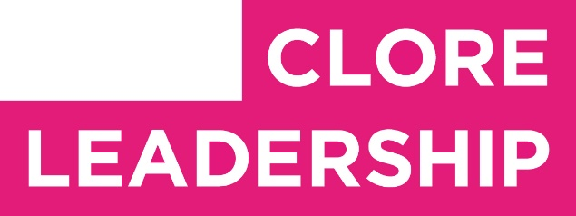


Clore Leadership-AHRC Online Research Library Paper
Can culture be used to build sustainable rural communities?
Author: Anthony Butler
Supervisor/s: Owain Jones,
University of Gloucestershire
Year paper completed: 2008
Leadership Content Theme/s: Inclusive Leadership Practice, Leadership Styles, Hard Skills, Sector Insights
AHRC Subject Area/s: Museum and Gallery Studies, Cultural Geography, Community Art (Inc. Art and Health)
A note on contents:
Since 2005 Clore Leadership and AHRC have partnered to offer a diverse range of cultural leaders the opportunity to produce a piece of extended research relating to leadership and to their specific cultural discipline. These papers, published from 2023 onward on the Clore Leadership-AHRC online research library, reflect an important contribution to the field and we are extremely pleased to make them available to practitioners, scholars, and other interested parties. We recognise that this research library contains a range of terminologies and outlooks: these are reflective of the significant and ongoing changes within the cultural sector over the past 20 years. As such we urge readers to recognise that the authors’ thinking and language may have shifted since completion of these papers, or may be in the process of shifting as consequence of their enquiries.
Unless otherwise stated, research papers included in the Clore Leadership-AHRC Online Research Library have not been formally peer reviewed or published in an academic journal.

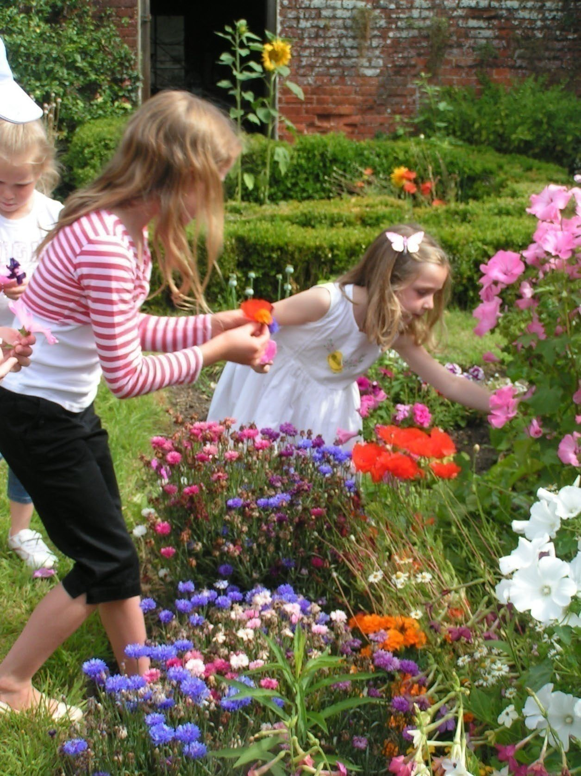
An examination of an asset-based approach to developing cultural amenities in rural areas
Grow Your Own
Tony Butler –Clore Fellow for Museums support by MLA 2007-08
Supervised by Dr Owain Jones, Research Fellow, Countryside & Community Research Institute, University of Gloucestershire, Cheltenham

Contents

Acknowledgements Section 1 - Introduction
Section 2 - The countryside and its cultural facilities

  - Emerging social and economic trends in the countryside
  - Cultural places for rural people
  - Extraordinary places for the arts in the countryside
  - The Country and the City

Section 3 – Asset Based Development and local distinctiveness

  - Defining Asset based development
  - Common Ground and Local Distinctiveness

Section 4 – Case Studies from Wales, Kenya and the Shetland Islands

  - Case Study One: The National Trust Wales, Llanerchaeron, Ceredigion, Wales
  - Case Study Two: Meru Museum, the courthouse at Nchîrû and Gituune Sacred Forest, Meru, Kenya
  - Case Study Three: Shetland Museum and Archives and Shetland Arts
  - Common principles of the case studies

Section 5 - Conclusion Bibliography

Acknowledgements

My thanks go to all the people who have helped me develop my thoughts and have spared their time to be interviewed.
- Owain Jones, Countryside & Community Research Institute at the University of Gloucestershire
- Ben Cowell, Olivia Morris and Paul Boland at The National Trust
- Ian Tait, Shetland Museum and Archives
- Gwilym Gibbons, Shetland Arts
- Kiprop Lagat, Mwanaima Salim and Muthoni Thangwa at National Museums Kenya
- Rev. Stephen Mugambe of Njûrincheke at Meru
- Julie Hudson at the British Museum
- Sue Clifford at Common Ground
- Bridget Yates, a Trustee and friend
- Michael Day, Historic Royal Palaces
- Ian Tuckett at Coin Street Community Builders, Southwark
- Chris Smith, Sue Hoyle and Prue Skene at the Clore Leadership Programme
- Grateful thanks to trustees and colleagues of the Museum of East Anglian Life who have supported me all through my Clore Fellowship.
- My partner Rachel, the brains behind the operation

Section 1 Introduction

The purpose of this paper is to asses the characteristics of cultural amenities such as theatres, arts centres museums and galleries in the countryside and to suggest that an asset based approach to development can improve their quality and the range of activities they host. By using the assets of the countryside; the strong and active communities, the landscape and a respect for custom and tradition, improved or new, inspirational cultural amenities can be created in the same way that cultural regeneration has transformed the artistic life of many British towns and cities.
I begin by demonstrating that the cultural amenities servicing rural areas are poorer and less accessible than those in towns and cities because of a combination of a number of factors. Firstly, whilst new cultural facilities have been integral to urban regeneration, this has not been matched by investment in facilities in the countryside. This means it is far harder in terms of cost and time for rural dwellers to access high quality cultural activities than their urban counterparts. Secondly, there has been an over-concentration on developing existing small-scale amenities such village or church halls by rural development agencies and the arts community. Whilst this has enabled the improvement of the most important of community facilities and the development of vibrant a rural touring network, it has been at the expense of considering larger, more ambitious projects (the Eden Project in Cornwall is a notable exception) . Thirdly, the preoccupation with ‘localness’, whilst strengthening community ties and uncovering hidden or unappreciated facets within a locality, has fragmented any sense of cultural commonality within the countryside. All these factors combine to hinder arguments for strategic case for culture in the countryside to funders and developers.

Rather than repeat the arguments made so convincingly by those leading urban regeneration, who saw culture as a handmaiden of economic development, I suggest that an asset led approach is a more suitable means to deliver improved cultural facilities in the countryside. Asset based development is defined as employing beneficially, the facets of a whole community, be they physical built or natural environment or the human resources of a community through their skills, networks or relationships with one another. The Ford Foundation describes assets as, ‘wealth more broadly than savings, stock or property. We see wealth as a series of asset resources that enable people to take control of their lives and participate in society in meaningful ways.’

Using three case studies in Wales, Kenya and the Shetland Islands I describe an emerging ‘asset- based’ approach in developing facilities, all of which had a positive effect on the community and

cultural amenity itself. Whilst the objectives of the projects had much in common, their approaches varied. National Trust Wales in Llanerchaeron drove a restoration project of a minor gentry estate ‘from above’, which engaged a legion of volunteers and local businesses but were firmly in control of its management. In Kenya, partnerships between community leaders, local museum professionals and African development agencies have helped reclaim a sacred forest from degradation and will help to broaden the activities of a traditional courthouse to improve the lives of vulnerable people. On the Shetland Islands the creation of a new museum was achieved through a mixture of strong leadership by the Shetland Amenities Trust, and a well-tuned antenna to the importance the cultural heritage and the engagement of the Islands disparate communities in managing historic sites. Running parallel is the work of Shetland Arts which formalised community participation through the LEAP (Learning, Evaluation and Participation) model of strategic development. Both organisations have contributed to shape Shetland as ‘one of the most creative island groups in the world’. All three projects show the benefits of community and cultural organisations working in concert to create remarkable facilities and that an asset based approach can be applied in different cultural settings.

To conclude, I look at the emerging trend of asset transfer and suggest that this presents opportunities for cultural organisations in rural Britain. Moreover drawing upon the social enterprise model, which facilitates more democratic ownership as well as improved prospect for external investment, organisations will be better placed serve their communities. Citing as examples the Museum of East Anglian Life (MEAL) which has the only social enterprise based in a UK museum and Cogges Manor Farm museum in Oxfordshire, which has recently been taken a over by a community trust, I suggest that particularly in the face of pressure on public finances and the current financial recession an asset based approach will perhaps be the most sustainable model for culture.

Section 2 the countryside and its cultural facilities
  - Emerging social and economic trends in the Countryside
Over the last 30 years a body of literature concerning the countryside has appeared which in the words of Roger Scruton has reflected a ‘culture of lamentation’. ¹ Notions of loss and disconnection with the past have characterised attempts to articulate the implications of a decline in agriculture and the notion of the ‘working countryside’. Polemics like Alun Howkins’ The Death of Rural England and Graham Harvey’s Killing of the Countryside, portray the countryside in irreversible decline.
Farming is in crisis, villages are blighted by second homes and the landscape is under threat from encroaching towns or former urban dwellers who have moved to the countryside, wishing to preserve the rural idyll at all cost of economic development. In part, rural dwellers may have a right to feel chippy. On average services and facilities are poorer. Connectivity, be it virtual through broadband access or real, through public transport, is worse that in urban areas. Rural areas face a demographic challenge of having a greater proportion of elderly people per head requiring more services than the, on average, younger urban population. Local authorities in the industrial North West receive more funding per head than their counterparts in rural East Anglia.

However a range of other indicators show that life in the countryside is good. Standards of health and life expectancy are higher, as is the quality of the environment². Community life is strong with villagers far more likely to meet their neighbours than people living in urban tower blocks or commuter towns. Inconveniently the measures of prosperity and deprivation are contradictory in rural communities; the very wealthy may live very close to the poor. This is not a situation common in towns and cities. The fact of the existence of large communities living in poverty in former industrial regions like Merseyside or Tyneside has made it easier to for the case for economic and cultural regeneration to be made to a sympathetic Labour government.

This study suggests that by using the assets of the countryside, the strong and active communities, the landscape and a respect for custom and tradition, improved or new, inspirational cultural amenities can be created. Thus emulating the way in which cultural regeneration has transformed the artistic life of Britain’s towns and cities.

In 2005, superseding the Rural Development Commission, the Commission for Rural Communities (CRC), was established as an independent body whose purpose was to provide advice to government

¹ England: An Elegy, Roger Scruton 2006 p235
² State of the Countryside 2008, Commission for Rural Communities

and ensure that policies reflect the needs of people living and working in rural England. It had a particular focus on tackling disadvantage. Each year since 1999 the CRC and its predecessor body has produced a State of the Countryside report outlining rural social and economic trends. Over 10 years consistent findings were:

- An ageing rural population.
- A desire to live in the countryside and the consequent migration of people to rural areas, coupled with a trend of young people leaving rural areas for work and for study.
- Concern about the quality of the countryside.
- The relative similarity in the make-up of urban and rural employment, with agriculture employing a relatively small number of people.
- A growing rural economy with many small businesses and self-employed people, but with lower wages than in urban England.
- Rural areas have, on average, better health outcomes (which are related to the higher average incomes of rural areas, with professionals who have moved to the country and retirees).
- Housing affordability issues, fed by increasing demand for housing, and the presence of second homes.
- Fewer service outlets for many service types in rural areas.
- Poor access to services for those without cars.

The most telling finding is the increasing polarity of rural affluence and disadvantage.

While rural disadvantage is generally found to a lesser extent than in urban areas, the actual volume is not picked up in most area-based analysis, because it is not concentrated in specific geographic areas but dispersed across rural settlements. Our latest analysis seems to show increasing inequality within rural areas.³
Disadvantage is demonstrated not merely in incomes but in terms of access to services and amenities. These findings are further borne out by sub regional studies carried out over the last few years. For example a study of amenities in Derbyshire found that the city of Derby and town of Chesterfield scored well above the national average for amenities per head of population. Five of the remaining 7 rural districts were found to be in the bottom 15% in terms of Amenities Scores.

3 State of the countryside, 2008 Summary report, Commission for Rural Communities p11

Derbyshire as a whole came 45th out of 49 in terms of providing good amenities.⁴ Another survey The State of Suffolk carried out by the consultants the Local Future Group described the county as having:
Levels of deprivation and crime correspondingly low by national standards and health conditions which were very good. The county has produced an enviable labour market position. Growth in jobs is also very good in Suffolk. The quality of local public services is good while the quality of local amenities is poor.⁵
In 2008 Suffolk ACRE (Action with Communities in Rural England) conducted a survey into rural services, comparing facilities with a similar study carried out in 1997. It discovered that despite rising prosperity in the UK as a whole, the level of facilities within communities in rural Suffolk had actually declined 5%.

Parishes without a Village Hall / other meeting place: ⁶
1991-2008 trend in Suffolk
 | 1991 | 1994 | 1997 | 2000 | 2008
Village Halls/ Community Centres | 25% | 26% | 23% | 23% | 29%
Church Halls | 74% | 74% | 72% | 73% | 79%

However, some improvements in transport had been made which enabled people to access services, just not necessarily where they lived.
Parishes in Suffolk without community transport provision:
1991 – 2008
 | 1991 | 1994 | 1997 | 2000 | 2008
Dial a Ride Schemes | 99% | 98% | 85% | 76% | 63%
Community Minibus Services, Social Car Schemes &  Car Sharing Schemes | 89% | 88% | 85% | 83% | 73%

The statistics describe a very mixed picture. Whilst communities appear strong and people’s health fine, services are not as good as in the towns and access to them is poor. Cultural amenities are good in large towns and the expectation is that they act as hubs to the rural hinterland. However

⁴ An Amenities Profile of Derby City Local futures 2009
⁵ An Economic, Social and Environmental Audit of Suffolk, Local Futures 2006 p 34-3
⁶ Suffolk Rural Services Survey, Suffolk ACRE, 2008 p 39-40

connectivity has declined, which especially hits the elderly or young who do not have their own transport. The rural poor have little chance to access urban based cultural activities whilst their middle class counterparts have the option to go there in their cars, this divides the community experience.

  - Cultural places for rural people
Communities, be they urban or rural, and interest groups to which they give birth, have a problem if they have nowhere to meet.⁷ The Village or Church hall is often the only secular public space to be found in small communities. They are not just a venue for parish meeting or the local chapter of the Scouts, Guides or Women’s Institute, but multi-purpose buildings many of which are well equipped as venues for film, theatre and music performances. They are an obvious starting point for development of a physical cultural infrastructure within rural areas. A 1989 discussion document Rural Arts suggested that, ‘The development of rural arts spaces should concentrate on the improvement and adaptation of multipurpose halls, their shared use in fact enhancing the presentation of arts events.’⁸

In 1991 ACRE, with funding from the Arts Council and Carnegie Trust published a guide to Bringing Arts to Village Halls. Aimed at community councils and village hall committees, the publication offered a practical guide to presenting a range of art forms, from theatre, to music, and the visual arts ‘as more often that not, only the imagination, enthusiasm and confidence of local people, and hall committees in particular will be the main constraints on what actually take place.’⁹ ACRE tempered its advice by stating that in the Rural Development Commission’s (RDC) funding streams, there was no budget for the arts and funds available for improving facilities in halls were only available in a few disadvantaged areas¹⁰.

In the late 1990s the Millennium Commission allocated £10m towards the cost of renovation and rebuilding of village halls falling into decrepitude and disrepair. The programme enabled over 400 village halls to be upgraded. These improved community facilities have enabled the development of a very healthy rural touring scene in the UK. The National Rural Touring Forum, a body representing over 40 touring organisations, not only provides a useful network of promoters to bring

⁷ Landscapes of Poverty, Michael Simmons 1997 p 145
⁸ Rural Arts p12
⁹ Entertainment, Events and Exhibitions, Bringing Arts to Village Halls, Sheila Rowley and Stephen Woollett, ACRE 1991 p5
¹⁰ Ibid p 6

performances to villages and small communities but training and advice for village hall managers to put on challenging and innovative work. Occasionally, successful touring schemes have led to improvements to village halls, Terrington (N.Yorks) village hall committee used surpluses from touring promotions to improve facilities. As Francois Matarasso points out, ‘Village Halls were not designed for the performing arts. That being so, it is remarkable how successfully [they] are adapted to arts performances¹¹.’

As well as the upgrading of many village halls to accommodate a growing breadth of cultural activity, since the 1980s there has been a growing trend of artists performing site specific work. Site specific programmers of the highest quality are thriving in the UK, from Knee High theatre in the South West to the Kendal International Festival in the Lake District. Inspired by landscape, unusual buildings or distinctive traditions within a community there are countless examples of visual arts installations or theatre or music performances occurring in the most unusual of places. Audiences can see great art borne out of a rural setting; opportunities not readily available to urban dwellers. In Cornwall, Wildworks is a theatre company specialising in landscape-based works that involve communities in performance. They develop work in places that have great historical resonance for the communities, but are currently seen as without use. Their most recent performance set in a disused tin mine was based on the epic story of Orpheus and Eurydice it was a ‘tale of love and adventure in the underworld so the theme resonates with this ex-mining community. Indeed the content of the drama comes from the lives and memories of those who live there.’

However concentrating efforts on temporary site specific work or developing high quality touring shows in well equipped village halls has some limitations. Whilst halls are run by the community and compliment the scale of place, their functionality is often depressingly utilitarian. There are very few cultural buildings in the British countryside which are not only unique and unexpected but are developed with a local place and people in mind. Occasionally extraordinary buildings and facilities are found, such as Aldeburgh Music’s complex at Snape Maltings where a redundant industrial building was transformed into a world renowned concert venue. Glyndebourne Opera House in the Sussex downs or Compton Verney art gallery in Warwickshire all offer the highest standards of activity in remarkable locations. However the output of these facilities could hardly be described as a response to or for the local community. The programming is often aimed established audience.
Moreover, these organisations were founded either by individuals of vision such as Benjamin Brittan

¹¹ Only Connect, Arts touring and Rural Communities, Commedia 2004

or by philanthropists such as John Moores. To develop a policy for the development of arts in rural areas cannot rely on this kind of beneficent serendipity.

2.4 The Country and the City
The experience of the regeneration of the physical cultural infrastructure in rural Britain compares poorly to urban areas. In the last 15 years virtually every major town and city in the UK has enjoyed some form of rejuvenation. New commercial quarters have been supported by development of new museums, galleries and theatres. Successful artists like Tracey Emin in Margate or Banksy in Bristol have given something back to their home towns by promoting new art galleries or providing work for ‘homecoming’ shows . Free admission to museums has meant that more and more people have access to their cultural heritage. In contrast until very recently there was little appetite nor encouragement to create new facilities in the countryside. In 1995 Jonathan Brown of the National Council for Voluntary Organisations analysed how successful rural groups had been in bids for Lottery support. Of the 15,000 bids received only 1,824 were for projects in rural areas and of those only 306 were successful. ¹²

Twelve years on the priorities of public lottery funding has changed little. Regional Development Agencies offer grants to turn redundant farm buildings into businesses facilities but the Arts Council through their lottery funded capital programme, very rarely support big projects in rural areas. A community led project in Halesworth, a market town in Suffolk transformed an old grain warehouse into The Cut, a multi use arts centre with fully equipped Dance studio, theatre, art gallery and business units. The Cut hosts the feted High Tide festival for new writing and is endorsed by acting luminaries like Sinead Cusack and Diana Quick. No capital funding came from the Arts Council.
Indeed that the Arts Council England (ACE) East do not hide the fact that they have little interest in the arts in rural areas citing priority areas of the urban centres of Peterborough, Norwich, Luton, Colchester, Cambridge and the Thames Gateway. Yet over two thirds of the population living in East Anglia, the bread basket of England, do so in a village or settlement of fewer than 20,000. ¹³ ACE East’s preoccupation with urban centres may not be mirrored by other regions, both the South West and North West regional bodies have a tradition of supporting artistic activity in the countryside.
However the absence of a countrywide strategy or even a common approach means that people’s access to cultural activity may continue to depend on where they live.

¹² Landscapes of Poverty, Michael Simmons 1997 p 163
¹³ During the research for this study no one from Arts Council England East was prepared to talk to me. I was informed by e-mail in early November 2008 that research into rural arts was not a priority for them and that no-one would be available to speak to me by telephone until Spring 2009.

Extraordinary cultural experiences can be found in rural areas and are inspired by its greatest asset, the landscape. In Cumbria the FRED festival brings the work of artists out of the confines of the gallery and into the landscape. FRED events are found ‘on buses, up the fells, under the lakes, in the woods, at the service station, down the pub and around a mountain. Over the past four years, over 350 artists have created 164 projects in over 250 locations.’ The FRED event is strongly linked to cultural tourism (it is supported by National Parks authority, Cumbria Tourism and the Youth Hostels Association), encouraging visitors to experience not only the art but the countryside as a leisure facility. Visitors, many of whom are from cities in the North West , get a good deal. They get to see great art in the most beautiful of ‘galleries’ – for free, benefiting from the countryside’s natural assets. Some rural businesses benefit from more tourism and welcome though these rural arts events are, there is no lasting cultural legacy for the rural community. This compares poorly to cultural activity in town or cities. New museums and performance spaces go hand in glove with economic regeneration and institutions work hard to build links with the local community. Both David Lam at the Young Vic and Kevin Spacey at the Old Vic pride themselves in the discounted tickets they make available for Lambeth residents.

Rural dwellers are entitled to feel aggrieved. Firstly because of an over concentration on temporary, place-based activities, there has been little appetite to create a legacy of new cultural amenities in the countryside. In some cases the policy of public funders has also conspired against it. Secondly, whereas urban dwellers who visit the countryside get to see great art in the landscape for free (as in the FRED programme) rural people who visit a gallery or theatre in a city, would invariably pay.
Whilst visitors may benefit local rural businesses with their secondary spend, they are not paying for the upkeep of a creative programme or the building of a new cultural infrastructure. Thirdly because of expensive transport costs and being unable to enjoy the discounts available to residents, they are effectively paying double for performances or temporary exhibitions of high calibre in the city.

This study aims to show that, by using an asset based development, opportunities are being created to ensure that rural communities can benefit from high quality cultural facilities. Through new approaches combining the unique assets of custom, landscape and community and trends towards collaborative management and independent or social ownership, under-used assets can be transformed into centres of excellence. This practice can also be used as new institutions are established; by exploiting the mores of a locality and a sense of place which allows both continuity and impermanence, which in turn contributes to their long term sustainability.

Section 3 Asset based development and local distinctiveness

  - Defining Asset Based Development
Whereas much of the regeneration in towns and cities has been led by private investors, corporations and large local authorities, I suggest that due to scale, cost and political interest this ‘top down’ approach is not suitable for rural areas. Mathie & Cunningham (2003) point out that, ‘Asset-Based Community Development takes as its starting point the existing assets and strengths of community, particularly the strengths inherent in community based associations and other social networks.’ ¹⁴It defines assets not just as physical capital assets such as buildings but the distinctive qualities of the environment and the skills of people within the community. Broadly speaking assets are defined as having social, cultural, spiritual, physical and economic elements, in effect in a rural context making necessity a virtue.

The Ford Foundation, which has developed practice in asset development for many years, describes its approach as viewing wealth more broadly than savings, stock or property. ‘We see wealth as a series of asset resources that enable people to take control of their lives and participate in society in meaningful ways.’¹⁵

For the purpose of this study I define assets as:

    - Financial assets such as savings, investments, and equity in a home or business
    - Natural resources that sustain livelihoods in rural communities
    - Physical assets which contribute to a collective sense of place such as the landscape and built environment
    - Marketable skills that enable people to improve their earning power
    - Public assets such as community philanthropic endowments, civic organizations, cultural spaces and public transportation systems
    - Social assets that strengthen inclusion and collaborative problem solving in communities

¹⁴ Mathie, A., & Cunningham, G. ( 2003), ‘From clients to citizens: Asset-based community development as a strategy for community-driven development. ‘ Development in Practice, 13 (5),pp474-86.
¹⁵ http://www.fordfound.org/about/mission

    - Effective community services and institutions to meet the reproductive health needs of women, men and youth, as well as to promote gender equity and participation in community life.

The combination of assets and community vitality builds resilience by providing a base of resources for weathering crises and establishing long-term cohesion and well-being.

The European Union initiated Budapest Declaration of Community Development of 2004 stated the need to:
‘strengthen the capacity of people as active citizens through their community groups, organisations and networks; and the capacity of institutions and agencies (public, private and non-governmental) to work in dialogue with citizens to shape and determine change in their communities.’¹⁶

Some practitioners separate development which is physical and social. At least one American writer, Randal Pinkett, distinguishes between ‘community development’, which is seen as restricted to the development and regeneration of physical infrastructure and ‘community building’ which is related to capacity building processes in communities¹⁷. As far as ‘top down’ UK public policy is concerned, regeneration is squarely about the development of physical assets. Virtually every town and city in the UK which has undergone ‘regeneration’ in the past 15 years and has seen new public buildings constructed alongside the ubiquitous shopping malls and hotels. Only very rarely, as in the case of the New Art Gallery in Walsall, where groups of local people helped choose the architects to design the building, has the community been engaged to participate in the shaping of new infrastructure.

Most of the UK’s community organisations consider neighborhood development in its broadest sense. One of the Country’s most successful social enterprises, Coin Street Community Builders in Southwark, embodies both physical and social assets in its name. Apart from being the largest social landlord on the South Bank of the Thames, Coin Street also runs learning and enterprise support activities, childcare facilities and a sports centre. In its early years it recognised the power of arts and culture to bring diverse communities together. Long before London’s Southbank had aspirations of becoming a cultural quarter for the capital, with Tate Modern, the National Theatre and the South

¹⁶ Budapest Declaration
¹⁷ Pinkett, Randal D. (2000), ‘Bridging the Digital Divide: Sociocultural Constructionism and an Asset-Based Approach to Community Technology and CommunityBuilding’, paper given at 81st Annual Meeting of the American Educational Research AssociationNew Orleans, April 24-28.

Bank Centre leading the renaissance of UK arts, Coin Street organised the Thames Festival and free exhibitions in the Oxo Tower. It encouraged the community to participate in culture, meet their neighbours and celebrate the panoply of difference within the neighbourhood.

Coin Street were exemplars in an urban setting and in rural areas in Britain and Ireland the Carnegie Commission for Rural Community Development (CCRCD) has been influential in shaping a similar asset based approach. In its Charter for Rural Communities it identified the essential ingredients of a thriving rural community as:

      - Community ownership and management of local assets
      - Stronger local governance and effective community action planning
      - Strong social networks founded on high levels of volunteering and skilled support

Carnegie also recognises the importance of using culture to build the capacity of a community based on its peculiarity and distinctiveness.

‘Rural cultures have evolved over a long period, but they are not static. There is a dynamic new strand in folk music and community-based arts. New local food and drink products are being produced. There is an appreciation of vernacular buildings and a growing interest in contemporary eco-friendly construction in the countryside.’¹⁸

There are clearly plenty of assets to develop!

  - Common Ground and Local Distinctiveness

The Carnegie Trust cites the notion of local distinctiveness as a major influence.

‘ Every rural area is different, with a unique package of attributes derived from its physical geography, landscape, natural flora and fauna and people’s interaction with these factors over a very long period of time. In a world in which urban places appear increasingly homogenous, the distinctive characteristics and cultures of rural places are highly valued.’¹⁹

¹⁸ The Carnegie Commission for Rural Community Development, 2007 p61
¹⁹ Ibid p62

Long before asset based development was labelled as a methodology; Common Ground espoused the benefits of celebrating the distinctive and peculiar within a community. Founded in 1982 by Angela King and Sue Clifford ,who had met whilst working for Friends of the Earth, Common Ground was a response to a burgeoning environmentalism which was in their view “technocratic and paid little attention to people.” Interviewed, King noted that “unless a place had special and rare things, it wasn’t of importance, or worth fighting for, and the people who cared about it were left bereft.”

Sue Clifford describes Common Ground’s work as “letting people define for themselves what’s special about a place, and what matters about it. That’s the key. Government agencies and large bodies can’t stand this. They want to define things, they want to keep tabs... only ordinary people can make ordinary places matter.”

Over thirty years Common Ground’s work has been highly influential to those working in both the arts and community development. One of their first projects – Parish Maps was a practical way for local communities to express what mattered to them about their locality. Parishes are the administrative unit and communities were encouraged to map the people and places with which they were most familiar. Sue Clifford wrote ‘Making a Parish Map is about creating a community expression of values, and about beginning to assert ideas for involvement, it is about taking the place into your own hands’²⁰. The results were impressive with over 2000 communities producing maps. These included an eight foot-long painting from Eltham in Kent, a vast, knitted map produced by children from 21 schools in Sunderland, and a map produced by a multi-ethnic community in Easton, who held a double-decker bus tour to get everyone involved in their map.

The interest in Parish Maps helped shaped the thinking of the then Countryside Agency in the implementation of the policy of Village Design Statements (VDS). Their purpose was to encourage communities to own the process of development within their localities. Planning guidance from the then Office of the Deputy Prime Minister noted that the aim of a VDS was to,

‘Manage change, whether that change is major new development or just cumulative, small- scale additions and alterations. Rather, it is about how planned development should be carried out, so that it is in harmony with its setting and contributes to the conservation and enhancement of the local environment.’

²⁰ From Place to PLACE, maps and parish maps “Places, People and Parish Maps” Sue Clifford 1996 p4

Just as members of the community engaged in parish maps, the uptake in participation of local people in the production of VDSs and later Village Plans was noticeable. Local people participated not just to stave off unwanted development in their back gardens, but to celebrate the unique qualities of their community. The uniqueness of a locality is explicitly referred to in these plans.
Many Village Design Statements are beautiful documents; the cover of the Kirkby Malzeard (N.Yorks) VDS featured embroideries of various buildings in the village by the local Highside Stichers.

Paul Kingsnorth pays tribute to Common Ground thus, ‘its tools of the trade are not direct action, letter-writing or hard-hitting reports, but art, poetry, sculpture, and the creative impulse in all of our lives.’²¹ This approach is further exemplified in Common Ground’s use of the apple as a means to convey the notion of a fragile English miscellany. The apple ‘a symbol of the physical, cultural and genetic diversity that we should not let slip away.’ Their publication The Apple Source Book was a ‘celebration of nearly 3,000 varieties of apple we can grow in these islands, with their distinctive flavours, uses, places of origin, stories and associated customs.’ Inspired by their work Apple Day events take place in most English counties and the preservation of old and cultivation of new orchards has become noticeably more visible.

Most importantly, Common Ground proved that a richness of these assets still exists. As their magnum opus England in Particular (2007) opines, ‘Mass production, fashion, increased mobility and the forceful promotion of corporate identity have brought with them standardised shop fronts, farm buildings, factories, forests and front doors.’ Common Ground is a counterblast against loss and uniformity and a celebration of the distinctive details of England. From a development perspective, Common Ground has been exemplary in encouraging communities to indentify their own assets and their work has been at its most successful when they have driven projects from the back seat.

The modus operandi of Common Ground encourages the community to participate by lauding what is distinct but also what is familiar and certain. Whilst much of Common Grounds work is powerful, inspiring and unifying, it frequently champions the enduring over the unpredictable, tradition and custom over the muddle of contemporary life, the small over a bit bigger. This occasionally has the effect of making past seems like a comforting certainty. This approach can be limiting. The notion of place is static; development should always be ‘in keeping’. Limited by scale and resources, cultural work in rural areas especially if it is site specific is in the main ephemeral. It is necessary to ensure that pride in what is distinct about a place is complimented by physical permanency. This is best

²¹ Local Heroes: Sue Clifford & Angela King The Ecologist Paul Kingsnorth 01/12/2006

manifest in the creation of assets which are intellectually owned by and able fulfil the aspirations of the community.

In the following case studies from Wales, Kenya and the Shetlands Islands I aim to demonstrate that there are a variety of models which can be used to help develop cultural assets in the countryside by building on the strengths of a place. The examples vary in size, and they have either become or, are evolving into unique and highly valued assets. All have involved a degree of public participation and relied on the development of effective partnerships to create them. Some have built capacity from above, others from below. One placed consultation at the core, another left it to the judgement of professionals who themselves were rooted within the community. Common to all the projects was desire to celebrate the distinct culture of a locality and all have influenced the building of new capacities and capabilities within their locality.

Section 4 Case studies from Wales, Kenya and the Shetland Islands

  - The National Trust Wales, Llanerchaeron, Ceredigion, Wales

The majority of examples of cultural activity projects cited so far have emerged either directly from the community or from small enterprises. However a large number of the cultural assets in rural Britain are managed by large and sometimes remote organisations such as the National Trust and English Heritage.Fo these organisations to celebrate the local and encourage the community to participate whilst maintaining the brand and conformity so cherished by their members and customers, is a test. The National Trust is in a tricky position of being at once one of the UK’s largest landowners, whilst performing the role of community and environmental activist as well as being custodian of historic buildings and collections.

In recent years the National Trust has addressed this challenge by considering the social and economic impact of its work upon the local community. It has began to measure how far its physical assets benefit the locality in a range of areas such as developing skills, building social capital and stimulating the local economy by supporting networks of suppliers.

One such case is Llanerchaeron a typical small Welsh gentry Estate situated in rural Ceredigion. The county of Ceredigion stretches from Borth in the north to Cardigan in the south. Its fairly sparse population stands at around 74,000. There is a large proportion of elderly or retired people, many of whom are attracted to the resorts and villages on Cardigan Bay coast. Until the 1970s agriculture was the mainstay of the economy, but with the expansion in higher education, the university towns of Lampeter and Aberystwyth now exert an important influence on social and economic life. Plant breeding and agricultural technologies are growing industries and local farmers and producers supply niche food markets. An example is Ty Nant in Llanon 7 miles from Llanerchaeron, who produce mineral water in the blue glass bottles much desired by city restaurants . Probably due to the influence of the universities, the area has a reputation as a centre for environmentalism. The UK’s most renowned organic dairy, Rachel’s began life in Brynllys Farm near Aberystwyth. With the Ceredigion coast a popular tourist destination and an existing market for high quality food products, it was not surprising that a key aspect of the National Trust’s restoration programme for Llanerchaeron was to have it operate as an organic farm.

The Llanerchaeron Estate was designed by John Nash in 1790 for Sir William Lewis. According to the National Trust it was ‘important for its landscape setting, architecture, natural history, social history and surviving completeness and integrity as a representation of rural life in Wales’. Acquired in a dilapidated state by the Trust in 1989, the business case for its sustainability was not promising. It came with no endowments, would clearly cost millions to open and restore to the public and was situated in an area away from a significant catchment of visitors.

Twenty years and nearly £3.5 m of public funding later, the estate is a popular visitor attraction and influences the local community in a way not dissimilar from when it was a gentry farm a century ago. Local people are employed to run its farm sustainably with garden produce available both to visitors and wholesalers. Produce from the farm has the Llanerchaeron brand tand is found in many grocery stores across Ceredigion.

After the property opened in 2004, National Trust Wales (NTW) engaged KPMG and Neil Caldwell Associates to carry out an economic and social impact assessment of the site’s development programme. This study examined how development guaranteed the long term sustainability of the property, the significant impacts on the local economy through tourism and use of local businesses and the increase in community participation in heritage. The economic impacts were measured by determining the increased volume of trade within the area and interviewing businesses who had worked on the restoration. Social impacts were measured by talking to local people, visitors and the Trust’s staff and volunteers. Apart from coming up with robust data the Trust hoped to replicate the process elsewhere. It hoped that the…

‘…Development of a socio-economic impact methodology capable of capturing and measuring the distinctive and diverse impacts of the Trust’s activities represent a valuable output from the study. It gives the Trust a bespoke method to measure the impacts of its other properties.’²²
The findings were striking. By the end of the project the Trust could put its contribution to the local economy at £3.552m. Llanerchaeron directly created 16 full-time jobs and the report also noted that

22 Socio-Economic Impact Assessment for the Llanerchaeron Estate, executive summary p 3 KPMG 2004

without the Trust many businesses would be worse off today. Significantly, some local businesses attributed subsequent contract opportunities to their involvement with Llanerchaeron.
The initial grant based investment has been replaced by a substantial increase in the volume of visitors spending in the area, which is likely to entail wider social and economic impacts than has hitherto been the case. The challenge for the Trust is to keep the momentum going; carefully managed then it should succeed particularly where the integration with the community is reinforced.’

Llanerchaeron’s social impact is also tangible. KPMG identified a sense of ownership felt by the local community which was really praiseworthy of the management of the estate, especially since this was hitherto ‘an inaccessible and undervalued estate’ which has now become a ‘precious economic and community asset.’ The report singled out the volunteer programme for particular praise

‘A cynic could judge it [volunteering] as ‘work on the cheap’; but not one of those consulted suggested this – quite the contrary. Such is the integration of the community that it has created a strong sustainable bond with the project. This may point the way to an important future strategy for the Trust. To avoid accusations that it is simply ‘conserving in aspic’ it should extend the practice adopted at Llanerchaeron of restoring an estate as a form of living, working heritage resource that makes a meaningful long-term contribution to the socio-economic regeneration of the area. Llanerchaeron is a superb illustration of the way that the objectives of heritage conservation can work together with modern sustainable community regeneration’

Some volunteers were encouraged to join the Llanerchaeron project by the local GP practice who viewed the property as a ‘green gym’.

It is undeniable that restoration of Llanerchaeron had a positive impact on the community and many people felt immense pride in what has been seen as a ‘local’ effort. However without the National Trust to lead the project it is questionable that the level of public investment required to renovate the estate would have been made available. Crucially, KPMG report noted the significance of...

‘…the unanimous response from everyone contacted that no body other than the National Trust could have achieved the beneficial outcomes associated with Llanerchaeron. Had a

private developer acquired the property, most feel its historic integrity would have been damaged and its accessibility to the public would have been limited or non-existent. Neither was acquisition by a public authority seen as a viable alternative.’
Although the estate was essentially restored ‘from above’ it was done so by building on the assets of labour and skills from within the community. The volunteering programme was especially beneficial in building local social capital with over 40 new volunteers recruited by the Trust.

It is through its remarkable volunteering programmes that the National Trust gains ‘admission’ into a community. In England and Wales it has over 42,000 registered individuals who give their time freely and in recent years the trust has worked hard to reposition the notion of the ‘National Trust volunteer’. From a glance at its website it would appear that its volunteer body is diverse, in age, gender and ethnicity. Moreover, inspired by impact study at Llanerchaeron and its sister site in Nantgwynant the Trust is now measuring the impact of cultural volunteering on the communities in the vicinity of its properties.

Further attempts to re-engineer the relationships between communities and the Trusts landscape and properties have begun with management of its sites. Property managers now have far more autonomy to develop links with the community beyond volunteering. Jennifer Forrest, Policy Director for the National Trust Eastern Region, described how properties like Wimpole Hall in Cambridgeshire encouraged parishioners to use flowers from its gardens to decorate the village church. The Trust seems to be trying to normalise the experience of using its historic properties. At Polesden Lacy in Surrey the house’s drawing room is furnished with daily papers and visitors are encouraged to use it as ‘home from home’. Further evidence that the Trust has moved towards an asset based approach is shown in their adoption of the Triple Bottom Line (TBL) accounting model. Ben Cowell, Assistant Director for External Affairs told me that by focussing on the economic, human and environmental consequences for its activities ‘we will now take a more rounded approach to assessing how we should earn and invest our precious resources’

The direction of travel of the National Trust is inspiring. Far from being an archetype of middle class Britain it is now recognisable as a pluralistic, diverse body, comfortable in its role as custodian, conservationist, and environmental and social activist.

  - Case Study two: Meru Museum, the courthouse at Nchîrû and Gituune Sacred Forest Meru, Kenya

In the UK, development trusts and bodies like the National Trust have sought to encourage the community to become more involved with the running of cultural assets. Likewise in Africa, projects are afoot to bring previously neglected, culturally significant sites into greater public use through partnerships with national government, development agencies and community groups. The following case study based in Meru in Kenya, shows that an asset based approach to building cultural capacity is as important in developing countries as in the developed world. There are however, a range of very different challenges to overcome. Issues such as poverty, debt and aid dependency, bureaucratic complexity and corruption make it difficult for developing countries to build community capacity from above (as in the case of the National Trust). However qualities such as strong family ties, a thriving traditional civic culture and widespread respect for institutions such as schools, churches and museums, provide a strong foundation to follow an asset based approach

Although in Nairobi, Kenya has the largest city in sub Saharan Africa, its population of nearly 30 million is overwhelmingly rural. Often described as one of Africa’s success stories, Kenya is a democracy, has an independent judiciary and a thriving free press. As a counterpoint, corruption is endemic, social and political stability is punctuated by bouts of intercommunal violence (there are 44 ‘communities’ within the country) and despite a growing middle class its economy is typical of developing nations with the average wage less than 2 dollars a day – in 2008 Kenya’s GDP per capita was $640 compared to $1,180 in India and $46,740 in the UK²³

Meru is a market town situated in the Central Highland region, on the windward slopes of Mount Kenya. It is a particularly fertile part of the country, and a centre for tea and coffee production. It is also the major trading centre of miraa a mildly hallucogenic plant whose leaves are chewed widely in East Africa. It has a population of around 40,000 of whom the majority belong to the Ameru community. I visited Meru in January 2009 both as research for this paper and preparation for a partnership project between, The Museum of East Anglian Life and National Museums Kenya. The work will focus on using the social enterprise model to exploit the cultural and environmental assets on both sites to encourage greater community participation in cultural heritage.

²³ http://www.economist.com/theworldin/forecasts/COUNTRY_PAGES_2008.pdf

Meru museum is a branch of the National Museums of Kenya. Located in the former District Commissioner’s House (1917), the oldest stone building in the Town. The museum houses displays of natural history, paleontology and ethnography of the Ameru people. As one of the town’s few public buildings it is well used by local people, most of whom, according to the curator, are attracted by the live animals specimens; crocodile, Sykes monkeys, snakes and lizards. The museum has a lecture room which is used as a film theatre at weekends.

The museum has strong links with the community. In its grounds are specimens of over 50 trees and shrubs with medicinal properties. These plants are used by a group of local herbalists to pass on knowledge to local people of traditional medicines for ailments where pharmaceuticals are too costly. The museum is also used widely by elders who meet there each week, to chat and play games. Several of the elders have been involved with collecting the oral testimony of local people which will be used in the displays and publications.

In some ways, regional museums in developing countries are better placed to build community capacity than their counterparts in the North. Often they are one of the few public spaces in the locality; as in Meru’s case they provide a variety of additional services from theatre to film, from music venue to medical centre. Virtually every school in the locality will visit the museum at least once a year. However its management and governance remains centralized and bureaucratic. As part of the state run National Museums, management is controlled by the centre with budgets and appointments set in Nairobi. There is no tradition of volunteering. Two projects involving Meru museum seek to redress this centralizing tendency by engaging community groups to manage cultural assets for the wider benefit of the community.

    - The Courthouse of the Njûrincheke at Nchîrû

10km south of Meru lies the courthouse of the Njûrincheke, a group of elders who are the custodians of traditional laws and customs of the Ameru people. The Njûrincheke has its origins in pre-colonial times dating back to at least 1800 about the Ameru first arrived in the region. It describes itself thus:

‘The tenets of Njûrincheke are honesty, justice, compassion, mercy and accountability and consensus. These principles provide the kind of indigenous dynamics which influenced Ameru

leadership. Traditional cultural values can be applied today to enforce Anti-corruption laws effectively to rid society of social injustices and economic crimes’.²⁴

Prior to the 1960s the Njûrincheke met in the open air before a courthouse was built. This building and its surrounding land are considered by both Meru museum and the Njûrincheke as underused assets and ripe for development as cultural facilities for local people. The driving force for the development is clearly the elders and it is a challenge for NMK to contend with their impatience.

‘We are concerned that the Ameru cultural values, which should be accommodated and assimilated and emulated by modern Kenyans, may be lost completely. We have a duty therefore to protect our past treasures. Our indigenous seeds and genetic resources are at the brink of indiscriminate destruction’.²⁵

The courthouse at Nchîrû sits within about 20 acres of land donated by the Njûrincheke to the National Museums of Kenya in 1989. The building was ‘gazetted’ (listed) in 1994 and is owned by the Njûrincheke who still use it as a sacred meeting place. The land surrounding the courthouse is partially exploited by growing specimen plants for resale at a subsidized rate to the community.
Planting schemes have been developed with a group of herbalists who run the specimen gardens in Meru. (two herbalists are also members of the Njûrincheke supreme council). The aspiration of the elders is to utilise “this Land Parcel as a sanctuary for cultural heritage of the Ameru people. There is also a dire need to maintain, conserve, preserve, perpetuate and propagate the Ameru genetic biodiversity.” The long-term aspiration is to build a visitor centre on the site to host temporary exhibitions centre focusing on traditional governance, citizenship and the rights of vulnerable people.

Having previously received support from Afripad (African Initiative for Alternative Peace and Development Programme) and the United Nations Development Programme, the Museum and Njûrincheke have identified and documented and conserved many Ameru sites and traditions within the locality. A notable success was the rehabilitation of the Giitune Sacred forest (see below). A programme to document the indigenous knowledge of the Ameru resulted in the publication of a book whose purpose was to form the basis of new displays in Meru museum.

²⁴ National Supreme Council of Njûrincheke Ya Meru strategic plan
²⁵ Op cit Njûrincheke Ya Meru strategic plan p5

Aside from its use as a cultural resource centre, there are aspirations that Nchîrû site will practically contribute to the well-being of the community. Both Meru Museum and the Njûrincheke have been attracted to the social enterprise model for the use of the land surrounding the Courthouse. In a country where land ownership is hotly contested, the site has potential to not only preserve and strengthen the indigenous biology of the region but to provide training and skills development for vulnerable people. Rev. Stephen Mugambi, spiritual leader of the Njûrincheke Ya Meru told me that “Poverty coupled with HIV/AIDS pandemic, TB and Malaria have gripped the economically active stratum of the community which has resulted to increased numbers of widows, Orphans and Vulnerable Children (OVC) and People Living with HIV and AIDS (PLWHIV/AIDS)” .This has resulted in a trend to either import more food or use hybrid seeds which grow more easily but are less resistant to drought or heavy rains. By linking the indigenous traditions represented by the Njûrincheke to modern horticulture skills the cultural value of both land and courts are elevated within the community. Furthermore by developing sought after produce Nchîrû will generate additional income to maintain the site without reliance on public subsidy.

On the ground the partnership between NMK and the Njûrincheke has been harmonious. But where there are mutual benefits, there is mutual expectation. Meru museum clearly does all it can to facilitate the development at Nchîrû, but its influence is limited. Funding cuts in January 2009 within NMK has meant that the likelihood of immediate investment is slim, further provoked irritation from Njûrincheke over the site’s ownership and management which had festered for several years. In 2005 a visiting journalist Bertha Kang’ong’oi noted tensions over the ownership of the site The museums caretaker, Charles Mbera, says the elders handed over running of the site to them, "We then put it under the Meru museum." The elders deny this, saying they want total control of the house.²⁶ Well hidden though not extinguished are the tensions between a government department on the one hand, and traditional Court on the other, whose stated aim is to combat the corruption it believes is endemic within the Kenyan state.

There are clearly limitations to developing an asset based approach when an unwieldy and underfunded government department does so by trying to lead the community. Whilst Meru museum staff on the ground work closely with local elders on a variety of small projects, they are remote from the crucial decisions which have to be made regarding ownership and investment. In

²⁶ Visit to Holy House of the Meru elders Story by BERTHA KANG'ONG'OI /Inside Story ref http://jukwaa.proboards.com/index.cgi?board=general&action=display&thread=282

the end it took the intervention of the Minister of State for Cultural Heritage who to pledged a aillion Kenyan shillings (£100,000) for the development of the site in April 2009, to get the project moving.

    - The Gituune Sacred Forest and Meru museum partnership
If the development of the site at Nchîrû bears its fair share of frustrations, both Meru museum and the Njûrincheke can take heart from the success of another site which is of considerable cultural value to the Ameru. Gituune Sacred Forest lies 5 km to the south of Meru town and is one of the few remaining catchment forests in Kenya. It has been used as place where rites of passage were conducted and as meeting place for the local branch of the Njûrincheke. Its position on a hill overlooking the Mikindure valley has made it a prominent meeting place for the Ameru ever since they first settled in the region in around 1800. The current elders talk of the forest as the ‘church of their ancestors’ as there were countless shrines under its canopy of trees.

In the years following independence the forest was neglected. Non-native species of trees overwhelmed the site and illicit breweries sprang up in parts of the forest. For the elders of Ameru who had coexisted with their natural environment for many centuries the degradation of the Sacred Forest was painful. Then in the mid 1980s they took direct control of the management of the forest and working with the United Nations Development Programme initiated partnerships with African based NGO’s involved in community and sustainability projects. One such was the Porini trust, (Porini translates as ‘natural wilderness’ in Kiswahili.) an organisation focusing on ecological and cultural regeneration projects in rural communities. Porini leads programmes for the protection of critical areas, based on knowledge of the local ecological and traditional cultural practices. In this respect it bears similarities with Common Ground’s approach in galvanising communities in the UK to pay notice of and protect assets which are distinct to the locality. Working with NGO’s fully sensitive to the cultural value of the forest, meant that outside encouragement was essentially ‘light touch’. The Elders made the key decisions and took control of the process, with Porini raising funds and offering training and support.

After 20 years or so years the results of a traditional approach to the management of an asset are palpable. Saplings of indigenous trees planted in the 1980s are bearing fruit. Traditional management has brought swift benefits to the micro climate. The richer canopy of native trees has led to an increased pattern of rainfall enabling the forest to better perform its role as a catchment, trapping the moisture in the soil and feeding local springs. There have been also been benefits to wildlife. Local farmers had often complained that their crops were raided for food by the Sykes

monkeys who lived in the forest. With native trees and shrubs reintroduced fruits and nuts are far more abundant and the monkeys now eat at home without resorting to rustling.

The Elders have worked in partnership with staff from Meru museum in promoting the cultural significance of the forest to local people. Along with the collections of Ameru objects in the museum and Courthouse at Nchîrû, the Sacred Forest represents the cultural, built and natural heritage of the Ameru people. A publication regarding the process of ‘reclaiming’ the forest is in progress and the elders wish to develop a nature trail around the forest for visitors, highlighting the significant native plants. Most importantly the cultural and spiritual properties of the forest have been re-established. Local Elders meet weekly (on Saturday mornings), in a clearing at the top of Gituune Hill to discuss community business.

The elders are fully aware of their status as exemplars to other community groups and development agencies within Kenya. A lodge has been constructed as accommodation for ecologists wishing to learn from the elders experiences. There are plans to install an electricity and water supply so that the forest can better support seminars and courses. The elders are clearly savvy enough to understand the opportunities which arise from such as remarkable asset. Yet rather than allow the forest to be exploited by unscrupulous farmers (or indeed development agencies) the Elders have control of place, legitimised by their traditional management methods and exaltation of its cultural value.

Julius Gikundi, a Gituune Elder notes

“Our traditional methods have been very successful in the protection of natural resources as has been shown by Giitune forest community. Our traditional ways have systems of governance that are more in concert with nature as opposed to the imposed systems of management being promoted by the powerful today. We have shown that they can work!”²⁷

In Kenya, as in the UK, traditional cultural values have been drawn upon to influence the development of community assets. Much of the impetus to develop these assets stems from a sense of loss. Steadily, over the last 100 years due to outside influences such as British colonial rule, a

²⁷ Sustainable Cultures Cultures of Sustainability, Dialogues on the Future of Low Ecological Footprint Communities NAIROBI DIALOGUES Wara Safari Lodge, Nairobi, Kenya, 67August 2008

newly independent centralising Kenyan state and globalization, Ameru cultural and social traditions have been considered ‘at risk’. The cultural significance of their special places had shrunk and the traditional means of resolving conflict, whilst not expunged, had diminished a sense of place in the consciousness of local people. Similarly in West Wales, where patterns of land ownership and social hierarchies had changed (for better or for worse), and the old purpose of the Llanerchaeron estate had diminished, there was a need to connect with past in order to realise the full potential of the asset for the community.

The Njûrincheke recognize that for their cultural values to have a place in modern Kenya they must reflect contemporary concerns such as fighting corruption and campaigning social justice for the vulnerable. Many of these elders have adapted to a new language of community development – it is fascinating hearing men in their eighties speak of ‘partnerships’ ‘stakeholders’ and ‘outcomes’.

The experience at Meru points to the complexities of asset based development in a post-colonial society. The contrast of the success of the rehabilitation of Gituune Forest and the more tortuous progression of the Courthouse at Nchîrû is instructive. At Gituune, the community is in control. It is their knowledge of the biodiversity which enabled the native species to flourish and the cultural values to be re-established. Crucial to the success of the projects was the Kenyan Government’s attitude to ownership. At Gituune the Kenyan government through NMK was comfortable in the role of broker, matching the elders with a respectful African run development agency which facilitated a ‘bottom-up’ approach. At Nchîrû the picture is complicated precisely because whilst the community intellectually and spiritually owns the site, actual ownership lies with a state department, who were both unwilling to relinquish ownership and unable to do anything with the site because of lack of funds. This both disappoints local people and stymies the efforts of museum staff to forge valuable links with community elders. This lays bare the limitations of a centralised the state to manage local, community assets.

  - Case Study Three - Shetland Museum and Archives and Shetland Arts

Few communities in the UK are more apparently isolated and homogenous than the Shetland Islands and few communities have a cultural life which is as rich and rooted within people and place. The islands are situated 180 miles north of the Scottish mainland. It is closer to the Arctic Circle than to London and equidistant between Bergen and Aberdeen. It has a population of around 25,000 around third of which live in the capital, Lerwick with the remainder scattered across villages and isolated communities on Mainland and fifteen other inhabited islands.

Despite being an Island group, Shetland history has been anything but insular. Culturally the heritage is as Nordic as it is Scots. Turn a map of northern Europe ninety degrees and Shetland is in the middle of a network of Nordic trading routes from Norway, to the north of Scotland and on to Iceland.

‘Shetland is blessed with a rich and diverse culture which has grown and evolved out of the geographical remoteness, and the industries and communities of fishing and agriculture. Shetlanders have embraced and responded to many new influences which when integrated with existing traditions results in a strong and dynamic culture. This cultural legacy is one which many other areas of Scotland envy.’²⁸

Prior to the 1970s, Islanders were mainly engaged in the farming or fishing industries. However the discovery of North Sea oil and gas and the subsequent building of the Sullom Voe Oil terminal in 1978 (the largest oil Shipping terminal in Europe) arrested a decline in population and brought good fortune to Shetland. According to Shetland Museum curator Ian Tait, the ‘discovery of oil was Shetland’s 1066.

By permitting the building of Sullom Voe, the Island’s Council established the Shetland Charitable Trust (SCT), a body which received income from the oil industry as ‘disturbance receipts’. In 2007 its funds amounted to £250m. The purpose of the Shetland Charitable Trust is to improve the quality of life for people living in Shetland, especially in the areas of Social Need, Leisure the Environment and Education. Over the last twenty years the Trust has funded capital projects ranging from rural leisure centres to new care homes for the elderly. Ian Tait echoes the view that most Islanders

²⁸ Shetland Islands Cultural Strategy A vision for cultural life in Shetland 2004 – 2008. P2, 2004

recognise, “in fairness, Shetland is almost unique in having such funds, no other local authority possesses reserves on this scale”.

Rather than centralise services Shetland leaders have remained committed to the way of life based on a culture of local co-operation and self reliance, making virtue out of necessity. The oil dividend has enabled Shetland’s leaders to keep its services local and accessible and has halted a decline in population and the hollowing out of communities. It is striking that even in the smallest of settlements there are community halls, museums or swimming pools (or even all three – perhaps in the same building). A key to the success has been the use of third party charitable trusts to deliver the benefits of the oil dividend.

Writing in the Shetland Times recently, Gavin Morgan explained

Through third party charitable bodies such as Shetland Recreational Trust (SRT), Shetland Amenity Trust (SAT), Shetland Arts (SA) , an admirable level of success has been achieved over the years.

The isles have eight top-class leisure centres and sporting facilities, including the outer isles of Yell, Unst and Whalsay. These have all been provided through the Shetland Recreational Trust, set up on 1st June 1982, with the Isles’ flagship leisure centre The Clickimin opening in Lerwick on 30 March 1985. This has contributed to the growing number of Shetlanders who are reaching top levels in various sports including athletics, swimming and shooting.

The achievements of Shetland Amenity Trust are also wide-reaching. Among its most high profile successes is Da Voar Redd Up, the isles annual clean up of beaches and roadsides, which has been given royal approval by Prince Charles. Recently, the spanking new museum and archives at Hay’s Dock in Lerwick has exceeded all expectations, breaking attendance forecasts and generally being praised across the board.

Shetland Arts in its various forms has contributed immensely to the international name of Shetland’s creative industries through the hugely respected and popular festivals, Wordplay, Screenplay and Fiddle Frenzy, all of which attract big names, showcase local talent and provide various artistic learning opportunities through workshops, seminars and lectures.²⁹

²⁹ Politics: What is the Shetland Charitable Trust? Gavin Morgan, Shetland Times April 9 2009

The capital receipts from the oil industry are absolutely critical to the building of a cultural infrastructure on the islands. But it is an asset-led approach of independent ownership, management in partnership with the community, and a commitment to ensure that local people are able to participate in planning and programming, which brought a powerful sense of ‘Shetlandness’ to the facilities. The following examples show what can be achieved if an asset based approach is combined with high levels of capital funding. Extraordinary facilities can be created which resonate with local people. The Island’s heritage and arts services display precisely this approach both in the development of Shetland Museum and the creation of Shetland Arts.

    - The Shetland Amenity Trust and Shetland Museum and Archives
Founded in 1983, The Shetland Amenity Trust (SAT) exists ‘to protect and enhance buildings and artefacts of architectural and historical importance and to provide facilities for the enjoyment of the Shetland countryside and its flora and fauna’. Originally an archaeological and conservation charity, the Trust has long been involved with a number of community heritage projects, such as a ten year archaeology programme to plot the Viking Heritage of Unst and a project to create Shetland Place Names Database. Today they own a range of heritage assets which includes three lighthouses available as holiday lets. In the late 1990s Shetland Islands Council asked the SAT to lead a project to create a new museum and archives for the islands. The new building, owned and managed by the Trust, was to be a first class visitor attraction and central hub for a number of community heritage projects in the outlying islands.

In 2007 the new Shetland Museum and Archives was opened to critical and popular acclaim. It was nominated by the Art Fund as Museum of the Year 2008 and won the popular vote on 24 Hour Museum’s on-line poll. Situated of Hay’s Dock, Shetland’ s first purpose built harbour, the complex consists of museums and archives storage and research room , boatbuilding sheds, an excellent cafe and a number of public art installations. The museum and archives was immediately popular with audiences, Museums Journal proclaiming in April 2007 ‘This is a fantastic museum that deserves, and is already winning, an international audience.’ In its first year of opening visitor figures were around 70,000. Museums Journal noted, ‘There are only 21,000 people living in the Shetland Islands, so what will keep the locals coming back? The programme of events, lectures and films, all free and covering everything from story telling to creative writing will help’.

The total project cost was around £12m most of which came from Shetland Charitable Trust and the Heritage Lottery Fund. From its inception the complex was intended to be not only a landmark but

an important cultural hub for the people of Shetland and starting point for visitors exploring other archaeological sites and visitor centres on the islands. Crucially, Shetland Amenity Trust nurtured the community through the development. Current curator Ian Tait told me:

“Although we didn’t do a lot of direct consultation with the community, there was always a lot of support for the project. It was a gamble as without a lot of consultation there was a danger the public might not like what they saw- but they were not disappointed. Ever since the 1980s people wanted a new museum and we had to carefully manage their expectations. The Trust ran a really good PR campaign, keeping people informed with snippets of news. They encouraged people to become volunteers and more and more people got involved offering stories and objects. It was a bit like a termite mound with more heritage coming to light.”

Rather than encouraging participation by engineering a consultative process, community buy-in to the new museum was due to something more profound. The displays reflect a sensitivity to place and the traditions cherished by local people. They are filled with photographs and testimony from local people and set amid sounds of fiddle music, which is extremely important to Shetland’s cultural identity, and is heard throughout the space. An on-line photographic resource managed by the adjacent archives is testimony to the involvement of the local people. There are over 60,000 images, most of which have been donated by locals.

A further example of the importance of tradition, place and community to the islands was exhibited at the 2008 Johnsmas Foy or Midsummer festival. A replica sixareen, a six oared fishing boat built by Shetland Museum volunteers was launched. (Fig. 7) The boat was named after 16 year old Vaila May Harvey who had recently died of cancer. Museum curator Tommy Watt noted that there was a long heritage of naming new vessels as tributes, “The sixareen played a huge part in Shetland’s economic history in the past and it is also one of those boats that has an emotive connection because of the many disasters there have been”³⁰. Miriam Brett a friend of Vaila launched the boat and told the Shetland Times, “One reason for the name is that it reflects the associations with the sixareen and Vaila Sound. But the main reason for our suggestion is that it is also the very lovely name of our dear friend, Vaila Mae”.

³⁰ http://www.shetlandtimes.co.uk/2008/06/27/fond-memories-of-vaila-mae-as-sixareen-enjoys-her-first- outing/

The nature and role of the Shetland Amenity Trust is critical to how the heritage facilities on the islands have developed. As an independent body it has a Board comprised of local people including a local author and an air force officer and can concentrate solely on amenities without other services competing for resources. Some facilities owned by SAT, such as the small heritage centre on the island of Yell, are managed locally. In the summer months museum is a popular attraction for visitors, but throughout the year doubles up as a neighbourhood health and social centre and plays host to music evenings. On Fetlar the Interpretation Centre is run by:

“A group of people working voluntarily to preserve, record, interpret and display the social and natural heritage of the island for the benefit of both local people and visitors. We are a charitable trust, whose running costs are partly covered by Shetland Amenity Trust. In the Winter we are dependent on finding our own funding for projects, and we are proud of the fact that, so far, we have managed to secure funding for projects every winter, which have employed a number of local people. Our other income is derived from visitor donations and from the sale of our publications.” ³¹

Local control, and independent ownership result in better quality of amenities, more inventive services and greater support from the community.

The positive experience of building a new museum affirmed that, in the words of Ian Tait “culture within the islands was healthy, not a dying culture. Shetland has a tradition of ‘pass-in-on’ learning which the new museum has embodied”. When this is combined with significant investment in infrastructure the results were impressive. Ian Tait concludes, “Non-islanders are surprised to see something of this quality, perhaps its something they don’t think is proportionate for somewhere like Shetland.”

    - Shetland Arts
The new Shetland Museum and Archives is well embedded within the community and has raised the bar for future cultural development on the Islands. The challenge is being met by Shetland Arts, another arms length organisation charged with making the Islands one of the most creative places in the UK. Created in 2006 Shetland Arts runs the Garrison Theatre in Lerwick as well as the Bonhoga Gallery in Weisdale Mill and promotes a year round programme of music, theatre, film, literature and visual arts and crafts events. It provides development activity across a range of art forms,

³¹ http://www.fetlar.com/what.htm

including film, drama, music, literature, dance, visual arts and crafts though a team of specialists arts officers. By far its most contentious task is the delivery and management of the Mareel music venue and cinema due to open in 2010 (see below). Echoing the values of the Shetland Amenity Trust, Shetland Arts inspire and involve the community in arts activity with a desire to see first class facilities built in Shetland.

In 2006 Shetland Arts published a Hansel for Arts (2006) - a vision for a creative future for the Islands. (‘Hansel’ means a commemorative gift in the Shetland dialect), Gwilym Gibbons, Shetland Arts Director presents the islands as a contemporary place.

“I think Shetland has a real opportunity right now to develop itself as a centre for the creative industries. It already has a very strong international profile to build on, in terms of music and crafts particularly, and as we become more digitally connected, I think creative industries could play an increasingly important role in the islands' economic diversification as fishing and oil revenues continues to decline. But for that to happen, you need some of the core ingredients that professionals in this sector look for, be it in terms of a decent social life, proper facilities to work with, or conducive spaces to meet with other practitioners."³²

In order to encourage greater participation in its activities Shetland Arts adopted the LEAP (Learning Evaluation and Planning) methodology. Developed in 1998 by the Scottish Community Development Centre, the framework is based on the premise that participatory planning and evaluation are integral elements of good practice. Stakeholders share power, build relationships, and negotiate their different perspectives. In practice this means working with the community to develop their own ideas to influence programming. Gwylim Gibbons who had previously worked in the Health service and feels that “changing peoples lives always comes first”. Local people were encouraged to look at the strengths of their locality (be they people, buildings or landscape) and then discern how these assets supported creativity. Gibbons admits that at first his organisation struggled with the approach, “I think many people felt that they would be inundated with ideas from the public and that it would be impossible to please everybody. There was a shift from turning staff in Shetland Arts from gatekeeper to empowerer. By way of using origin sheets to define the idea and echo sheets to evaluate the outcome, the LEAP methodology not only allowed people to participate in planning but ensured that Shetland Arts would learn what was out there in terms of skills and interests of local

³² http://heritage.scotsman.com/culture/Developing-discord-in-Shetland.4075201.jp

people. Participants became an important part of the local cultural infrastructure, Shetland may be cash rich but money cannot buy volunteers.

A Hansel for Art lifted further aspirations within the creative community which had already used culture as a means to improve learning, skills and cohesion in isolated communities. Global Yell runs a Centre for Creative Industries on the island of Yell. It aims to nurture, train and educate in art and crafts, combining traditional skills with new technologies and ways of working to enhance existing businesses and create a vibrant community in the North Isles. In January 2009 Global Yell was awarded £25,000 by the Shetland Development Trust as part of a £130,000 project to redevelop its premises. Yell has a population of 954. Shetland Islands Council was also inspired. A revision of its cultural strategy in 2008 included the ambition to make Shetland “the most creative island community in the world.”

Gwilym Gibbons believes that Shetland Arts has brought a new impetus to developing the creative economy,

“The scale of the place is important. It’s relatively easy to get appropriate people round the table talking but the size of the population means that there is critical mass to get things done. There are now community clusters around the island and Shetland Arts brought all the players needed to nurture the Creative Industries which the Shetland Island Council economic development team could not get their heads round before.”

Shetland has always been a place of fluidity with people passing through, a pivot in a northern arc, but the islands are now cosmopolitan in outlook. Shetland Artists live at home and abroad and are exhibiting abroad. Depopulation is no longer marked, younger people are returning at 30 rather than 50. The oil boom has given Shetland confidence, a pride in the sense of place and its uniqueness. Other island groups like, say the Western Isles, don’t have this mentality.”

Shetland Arts desire to create a hub for the revitalised cultural communities on the Islands is manifest in the development of Mareel . This new arts complex will be a multi-purpose music, cinema, arts and education space will include a performance auditorium, cinema, recording studio, rehearsal rooms, multi media production suite, lecture theatre, education facilities and a cafe bar. Mareel is to be situated on the Hays Dock waterfront near to the Museum and Archive and is due to

open in 2011 at a cost of £10m, £5m of which is to come direct from Shetland Island Council. It is also one of four major projects supported by Scottish Arts Council Funding. The development is controversial. A decision to commit funds to the project was only granted on the casting vote of Shetland Islands Council Convener in June 2008. Disquiet is further evident of the local forums of debate (Letters page of the Shetland Times, on line at Sheplopedia and on Mareel’s own Bebo site) where there are are the familiar arguments over value for money, design and need. It is striking that whilst there was almost a universal yearning for the new museum opinion is divided over a new cinema and music venue. One of the most telling complaints was, “if they build Mareel, any buses visiting the museum no longer have anywhere to park.”³³

To many Shetlanders, cultural life is at its most vibrant in the outlying islands and villages. Precisely because so much effort has been put into a community led approach for the arts there is less appetite for the grand project like Mareel. There are unique factors which assist an asset based approach in the islands. The nest egg provided by the oil dividend has permitted infrastructural investment unseen in other parts of the UK, whilst the geographical separateness of the islands both from themselves and the UK mainland fosters a spirit of self-sufficiency and co-operation. However the economic downturn, coupled with the inevitable decline in oil industry has polarised views for the need for thrift and moderation on one hand and increased investment for the future on the other. A Shetland Times editorial in November 2008 remarked

‘The amount of money that was available has spoilt the people of Shetland to some extent and now new facilities are generally expected to be of the greatest innovative standards, but this too will have to change as more economical projects will need to be considered, and certain cut backs are going to become essential.’

For Gwilym Gibbons, this is a challenge

"Thanks to its oil money, Shetland is the second wealthiest council in Britain, after Westminster in London. We have £500 million in reserves, and no-one's talking about spending that. It really saddens me to hear about young people being told that if Mareel goes ahead, their granny will be shipped off to a care home in Aberdeen.

³³ http://www.shetlink.com/forum/viewtopic.php?p=109890

"To me this is less about the money per se than about how Shetland sees itself, where it positions itself, and what it believes it can be about in 20 years time.³⁴"

Both heritage and arts development in Shetland has successfully combined the building of community assets, with the creation of first class landmark facilities. Although Shetland Amenities Trust and Shetland Arts have taken different approaches, respectively ‘do and be damned’ and ‘consult at the core’ both have a keen sensitivity to people and place.

³⁴ http://heritage.scotsman.com/culture/Developing-discord-in-Shetland.4075201.jp

5.0 In Conclusion - From development of community assets to asset transfer

All three case studies show that in differing rural areas the political, financial, social and cultural contexts influence the way in which asset based development can be achieved. Nevertheless, the fundamental principle remains, that cultural amenities can be best enhanced by building up the capacity of the community. There are a range of methods to achieve this. Whilst the National Trust approach was ‘top down’, the restoration of Llanerchaeron was a sensitively managed project which built on the organisations tradition of volunteering, using local suppliers and developing the site with respect for its history and place. At Gituune Forest in Meru, success was due to the leadership of the community, using indigenous knowledge of how to manage a place of spiritual significance, working alongside respectful local development agencies. In Shetland the use of a participatory methodology has raised the aspirations and expectation of local people for their Arts service. Sensitivity to place people and independent ownership has created one of the most stimulating museums in the UK.
Whilst the community clearly influences the direction of the management of all the organisations mentioned in the case studies, it is not owner; it is stakeholder, not share holder. In time cultural organisations, especially those which are small and publicly owned will be forced to diversify their services so that they are responsive to the needs of their community and more able to generate additional income. Community ownership is a desirable solution for both new cultural facilities and existing organisations which might appear ‘at risk’.
The recession, which began in 2008, will inevitably place more pressure on public finances and non- statutory funded functions or organisations in the public sector will be vulnerable. At the Museums Association Conference in 2008 new president Stuart Davies in his keynote address remarked,

“Economic challenges and changing lifestyles may be increasing the pressure. In local government the politics are getting tougher. For those sustained by door and trading income, there is relentless competition for people’s time and money. These threats have been around before. But I believe that we may be entering a new phase, when institutional sustainability will become the major issue. How many museums founded after 1960 will make it to their fiftieth birthday? Our whole concept of culture and heritage in perpetuity may be at risk³⁵.”
Opportunities for renewal are presented by looking at how to make the most of underused assets within communities. In 2007 the Quirk Review examined how Community organisations could take on the management and ownership of community assets. The Review identified ‘the barriers which

³⁵ Conference address by Stuart Davies http://www.museumsassociation.org/17453

may be standing in the way of more communities managing and owning assets and recommends ways we can create an environment to encourage more community management and ownership of assets’. Quirk imagined that in the year 2020,

“Grass-roots community organisations working alongside social entrepreneurs, and local government and the wider public sector make ever better use of public assets. Local authorities work with their local public sector partners to plan and manage public assets together. These public assets have been rationalised and modernised – stimulated by a flexible framework from government. In every locality a proportion of all public assets are in the ownership or management of sustainable and energetic community organisations³⁶.”

The report offered a number of case studies ranging from a Village Hall in Gameblesby in Cumbria to a Market in Rochdale, and from old hospital in Plymouth (now a social enterprise park) and a community centre in St Helens. Worthy though these examples are, in themselves they are unexceptional, functional assets. Though they play an important role in providing a service for the community, they have little cultural value. As with the development of village halls, examples of communities running assets are small scale and affect a relatively small number of people. However the direction of travel is clear, community management or ownership is more economical and responsive to local needs.

The preceding case studies cited excellent examples of community engagement and use of local assets to create new and inspiring cultural facilities. However none of these were directly owned by the community and at present very few examples can be found of cultural assets where the community, as owner, can decide how they should be used. However there are nascent signs that asset transfer is being seriously considered as an option by public bodies in order to breathe life into underused facilities. One of the very few example is Cogges Manor, a working farm museum based in a 16th century manor house in Witney in Oxfordshire. Formerly run by West Oxfordshire District Council (WODC) the museum was threatened with closure in 2008 due to declining visitor numbers. Cogges was typical of a small rural museum. It had strong educational programmes for local schools, high standards of collections care but no entrepreneurial brio to broaden its programme or generate additional income.

³⁶ Making Assets Work: The Quirk Review of community management and ownership of public assets p3

In 2008 the Cogges Community Enterprise Group (CEG), a forum of supporters of the museum were asked to manage the site for WODC . They proposed to develop the farm and garden at Cogges, promoting environmental sustainability and healthy eating and using the site as the base for a wide range of community interests such as training for people with disabilities. The council has agreed funding support for Cogges of £160,000 for two years from April 2010 and a one-off capital contribution towards site developments of £250,000. Whilst the CEG offer West Oxfordshire Council a face saving means to reduce its revenue funding and keep the site open to the public, it also provides the opportunity to develop new activities which were not considered whilst in local authority control.

Cogges was influenced by the work of the Museum of East Anglian Life (MEAL) in Stowmarket, Suffolk, which in 2007 set up the first Social Enterprise to be based in a UK museum. It developed training and a skills programme aimed at long term unemployed, offenders and learning disabled adults, and runs a horticultural business bringing a new income stream into the organisation. The repositioning of MEAL as a social enterprise also contributed to achieving £3m of capital funding for the redevelopment of the site. The museum has been used as a case study by the Commission for Rural Communities as an example of how a hitherto underused asset can be developed for wider community use. MEAL is a charitable trust and its leadership is discharged by trustees from the local community who act as bell weather for the interests of local people.

Asset transfer has the potential to stimulate the creative industries in the countryside. The 2008 report Creative Countryside - Creative Industries Driving New Rural Economies by BOP and Experian cites an number of examples where creative and cultural uses have been made or been allied with existing, more traditional uses of the built environment. For example in Morpeth in Northumberland the grade 1 listed Chantry building formerly owned by the local council has been handed over to the Greater Morpeth Development Trust, an enterprise agency. The trust will develop and run the centre so that it becomes ‘more pro-active in developing the cultural and creative businesses, functioning rather like a combined retail/incubator space.’³⁷

Much like the notion of Social Enterprise (businesses with primarily social objectives whose surpluses are invested for that purpose in the business or in the community), collaborative

³⁷ Creative Countryside- Creative Industries Driving New Rural Economies, Phase 2 Report, Burns Owens Partnership, Experian 2007 p67

management of assets or even Asset Transfer has the potential to become a tangible and alternative way of doing business.

Independent ownership of amenities enables a more flexible approach to attracting investment. The social enterprise model ranges from charitable trust to community interest companies and the latter offers opportunity for private sector investment providing the activity passes the community value test. This model also allows for the issuing of shares a means to raise capital. At Fordhall Farm in Market Drayton tenant farmers Ben and Charlotte Collins issued £50 co-operative shares as a means to retain their tenancy and commitment to organic farming. The shares cannot be traded and no profits can be made from them. The idea is that a trust will hold the land for the community. ³⁸ There are clear parallels here for cultural facilities such as museums whose purpose is to hold cultural heritage in perpetuity. Co-operative share owners would not only buy into the ethos of the organisation but ‘buy’ the collections to prevent their dispersal.

In summary, there are key principles which can combine to provide an effective asset based approach to developing cultural facilities in rural areas:
- Understanding of the value of what is distinct and particular to a locality. This is in essence the approach of Common Ground which gives an enhanced meaning to assets within a community, as they are set within local cultural values. An example is the naming of Shetland Museums’ replica sixareen after a 16 year-old girl who died of cancer, which reflects the long held tradition of naming boats after those who had died at sea.
- Understanding the value of community assets in their broadest sense, that is the people, natural and built environment. The restoration of Llanerchaeron could not have been achieved without a phalanx of volunteers most of whom were from the locality and had been involved in the project from its beginning nearly 20 years ago. KPMG’s report acknowledged that the existing social capital within the area was as important as the capital funding acquired by the National Trust to the physical the restoration of the estate.
- The importance of collaboration and shared control between public bodies, NGO’s and local people. The three case studies illustrate differing approaches to partnership work, ranging from the lead partner role adopted by the National Trust to the more collaborative approach exemplified in the restoration of the Gituune Forest. The principle of more a participatory and democratic approach to the control of assets will have a profound bearing on the future anatomy of cultural facilities. They will become more open and accountable

³⁸ The fight for Fordhall Farm, Daily Telegraph 28 Apr 2006

institutions, able to develop an artistic dialogue with their communities. A benefit of the LEAP model, as used on Shetland, is that it permits the evolution of a relationship with the audience as co-producers. Rather than closing the door to an idea from the public, the LEAP model invites the people in. The research and development of work is a collaborative process with the Arts Development Officer supporting ideas and assuming the role as midwife.
- Consideration of new models of community ownership of cultural facilities. If assets in private or public hands are currently underused and there is a demand for cultural provision, it may be that a community trust is best placed to run them. This could be either by wholesale transfer or a partnership arrangement whereby the asset is owned by the original body but managed by local people. These arrangements (which have been successful in running rural pubs, shops and post offices) are likely to engender local support for cultural activity, encourage broader community use of the facilities and mobilise local people to become involved in work for public good.

It would be a shame if the trend to asset based development or social enterprise were seen primarily a response to a challenging financial climate. It may well the most appropriate model for cultural organisations to ensure they are sustainable, but it should also be viewed as liberating both for organisations and communities. New relationships between audience and programmers can be established that are neither populist nor esoteric, but developed through conversation and mutual support. Community ownership (whether literal or psychological) and participation become core principles; given equal weight to programming excellence, good governance and open access. The approach will help create an articulate and broad-based constituency in the countryside which can better make the case for culture.

Bibliography
Rural Development, Malcolm Mosely (2001) England an Elegy, Roger Scruton (2003) Real England, Paul Kingsnorth (2008)
England England, Sue Clifford and Angela King (2006) Holding your Ground, eds. Sue Clifford and Angela King Landscapes of Poverty Michael Simmonds (1997)
Entertainment, Events and Exhibitions, Bringing Arts to Village Halls, Sheila Rowley and Stephen Woollett, ACRE 1991
Only Connect, Arts touring and Rural Communities, Commedia (2004)
Making Assets Work: The Quirk Review of community management and ownership of public assets
‘From clients to citizens: Asset-based community development as a strategy for community-driven development. ‘ Development in Practice, 13 Mathie, A., & Cunningham, G. ( 2003),
Asset based approaches to rural community development. Literature review and resources
Tara o'leary, Association for community development for Carnegie UK trust
Museums in Troubled World, Robert Janes (2009)
The Country and the City, Raymond Williams (1973)
The Indegenous knowledge of the Ameru, Kenya , eds Njuguna Gichere and Shin Ichiro Ishida (2006)
Small is Beautiful, EF Schumacher (1973)
Places, People and Parish Maps, Sue Clifford 1996
The Carnegie Commission for Rural Community Development report (2007)
Creative Countryside- Creative Industries Driving New Rural Economies, Phase 2 Report, Burns Owens Partnership, Experian 2007

Illustrations

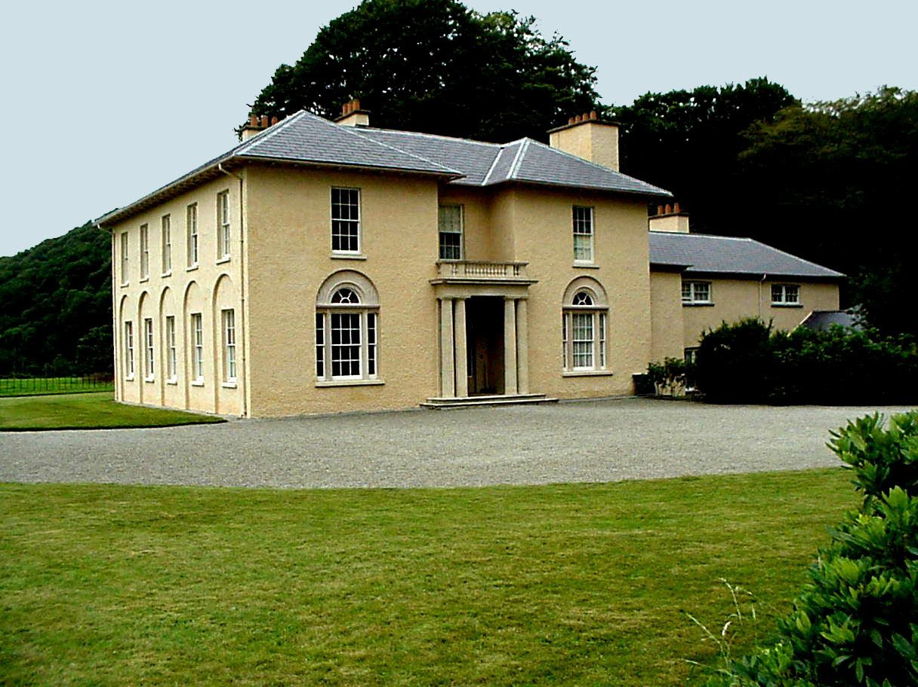
Fig. 1 Llanerchaeron, Ceredigion
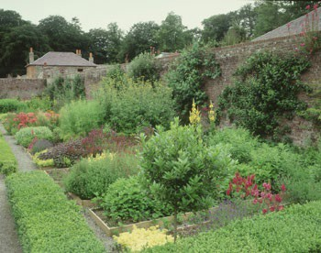
Fig. 2 Llanerchaeron Walled Garden

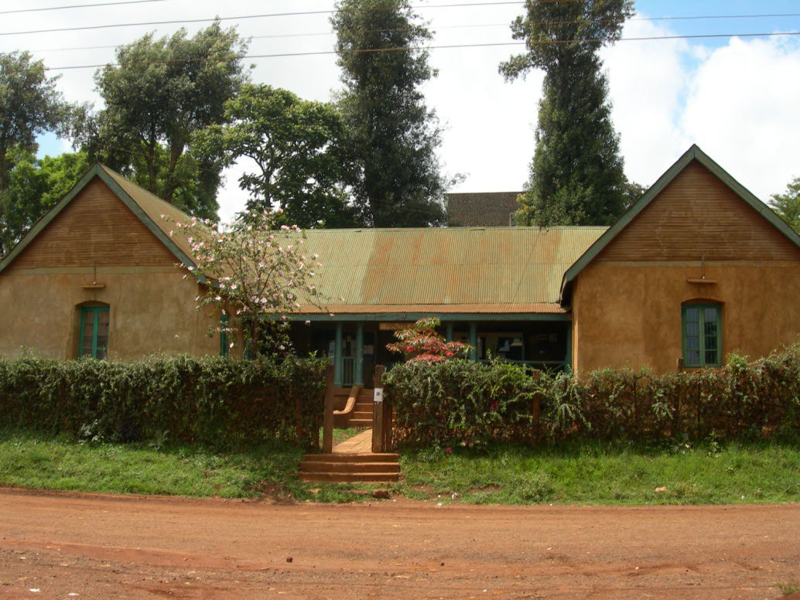

Fig. 3 Meru Museum, Kenya
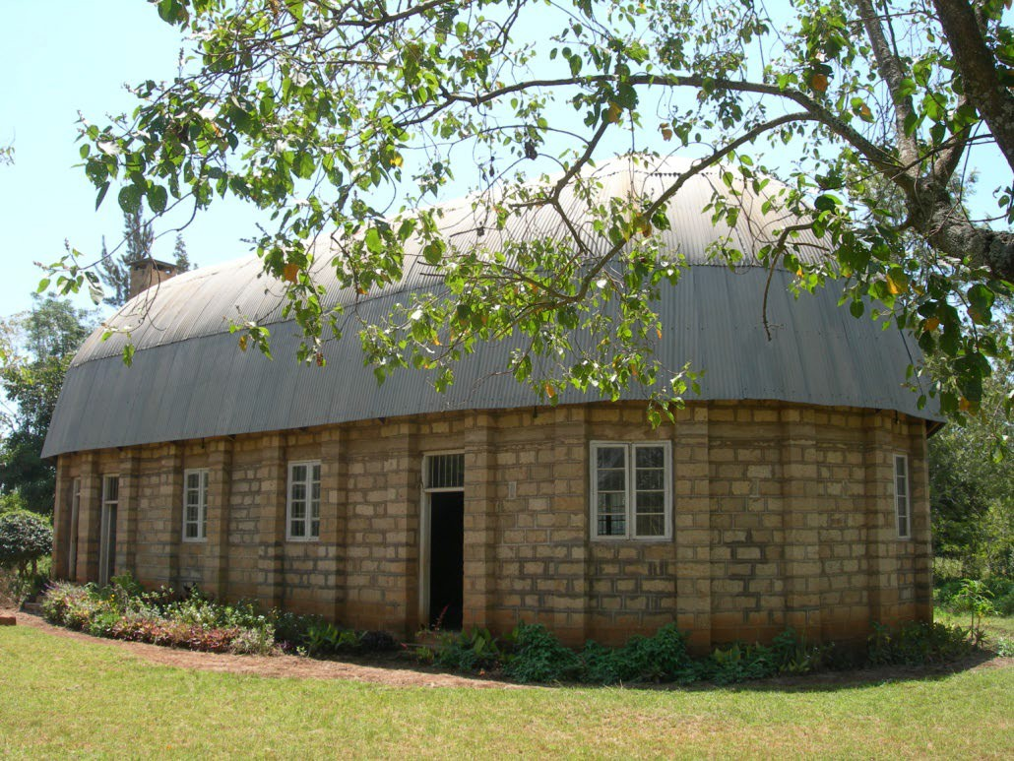

Fig. 4 The Courthouse of he Njûrincheke at Nchîrû

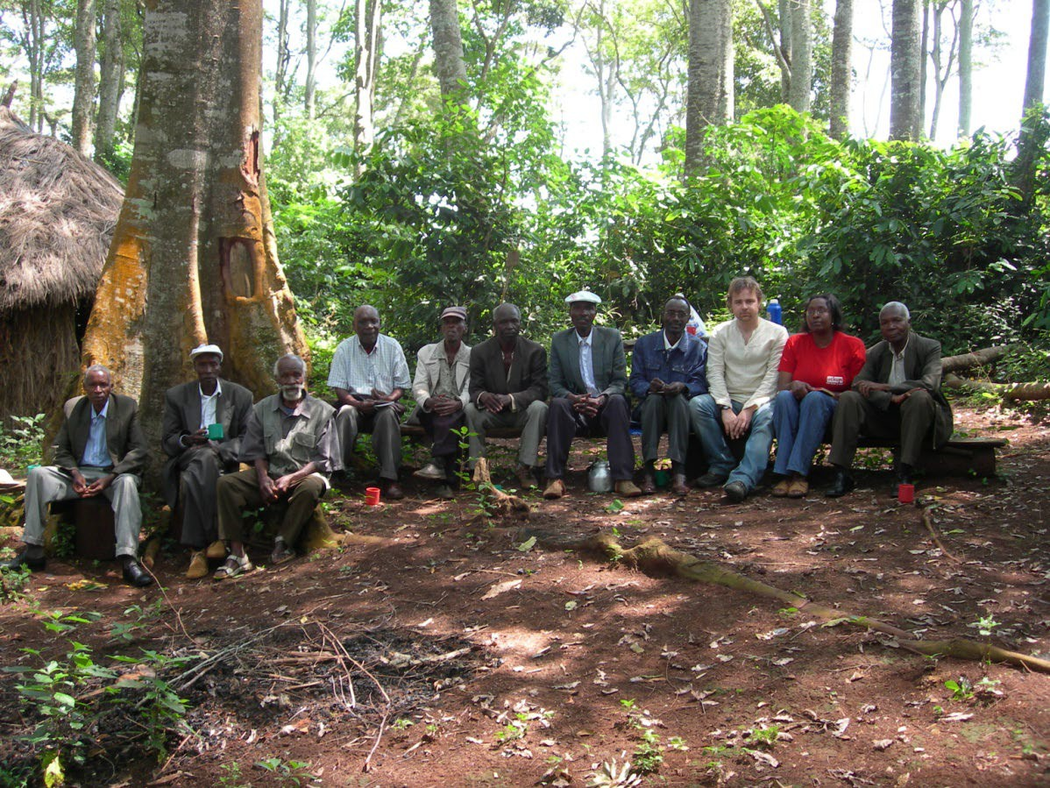

Fig. 5 The Author and the Elders of the sacred forest at Gituune
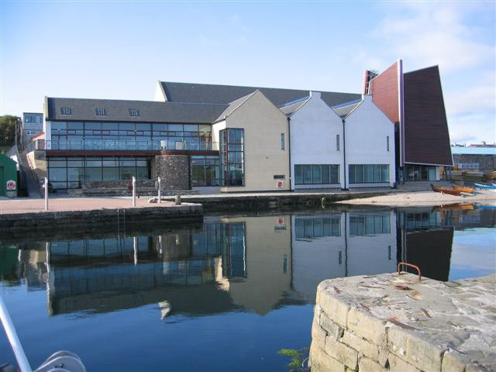
Fig. 6 Shetland Museum

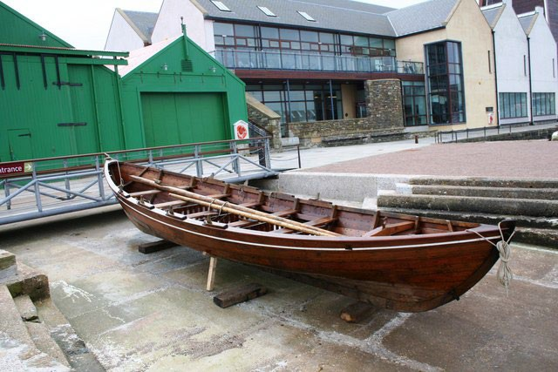
Fig. 7 A rebuilt ‘sixareen’ outside the boathouses of Shetland Museum

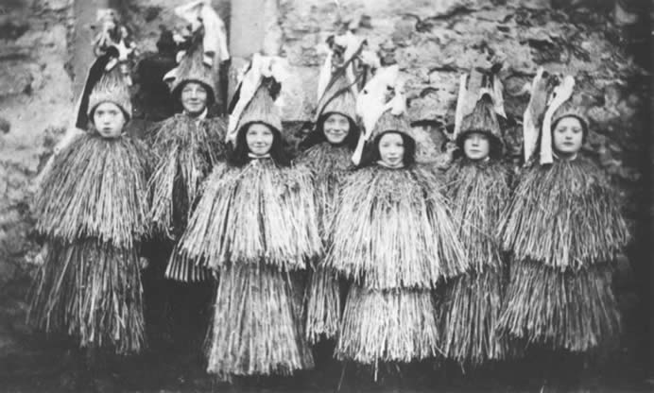

Fig. 8 Skekklers from the early 20th century, one of the thousands of images available from Shetland Museum and Archives photo library

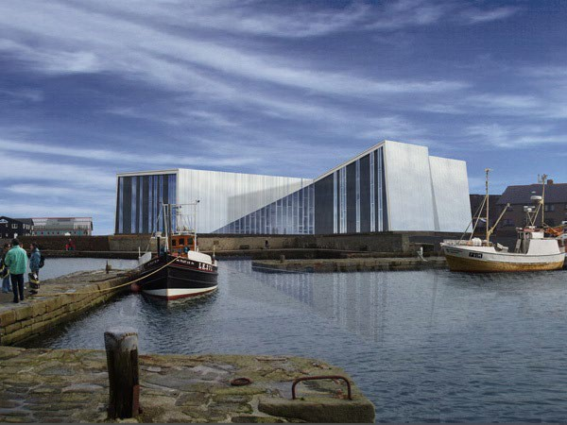
Fig. 9 & 10 Above and below - An artists impression of the Mareel cinema and music venue

